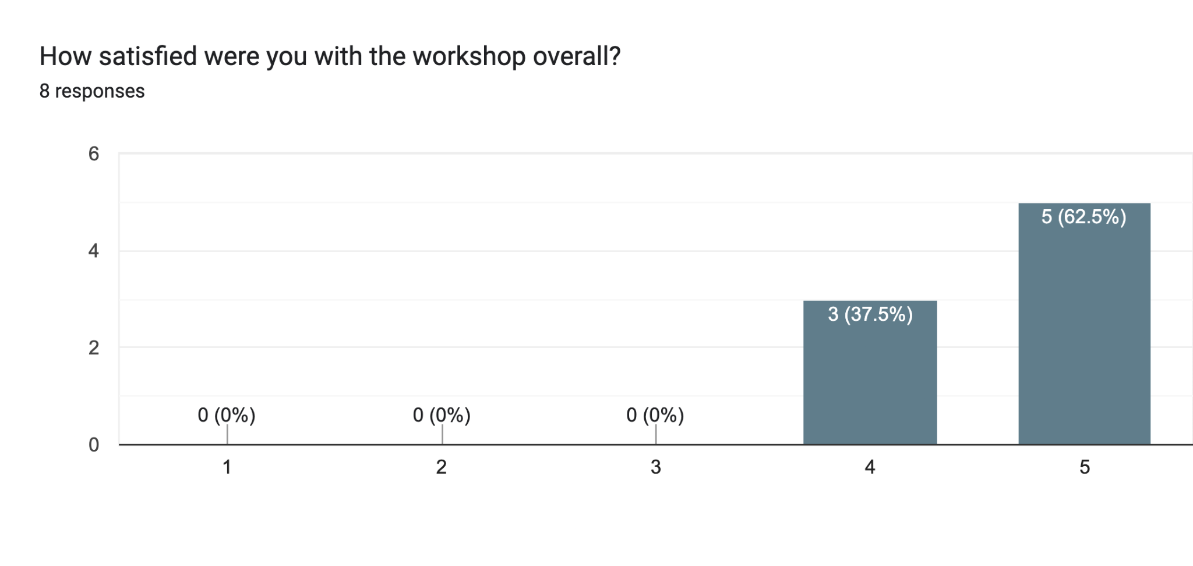

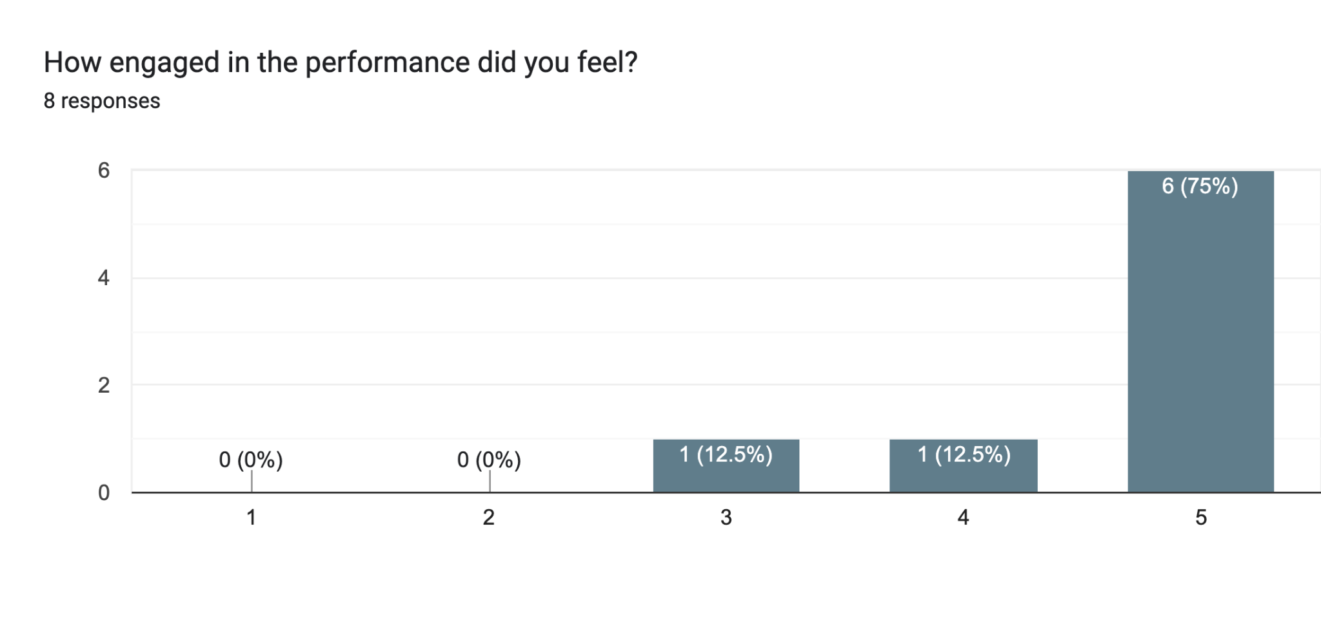

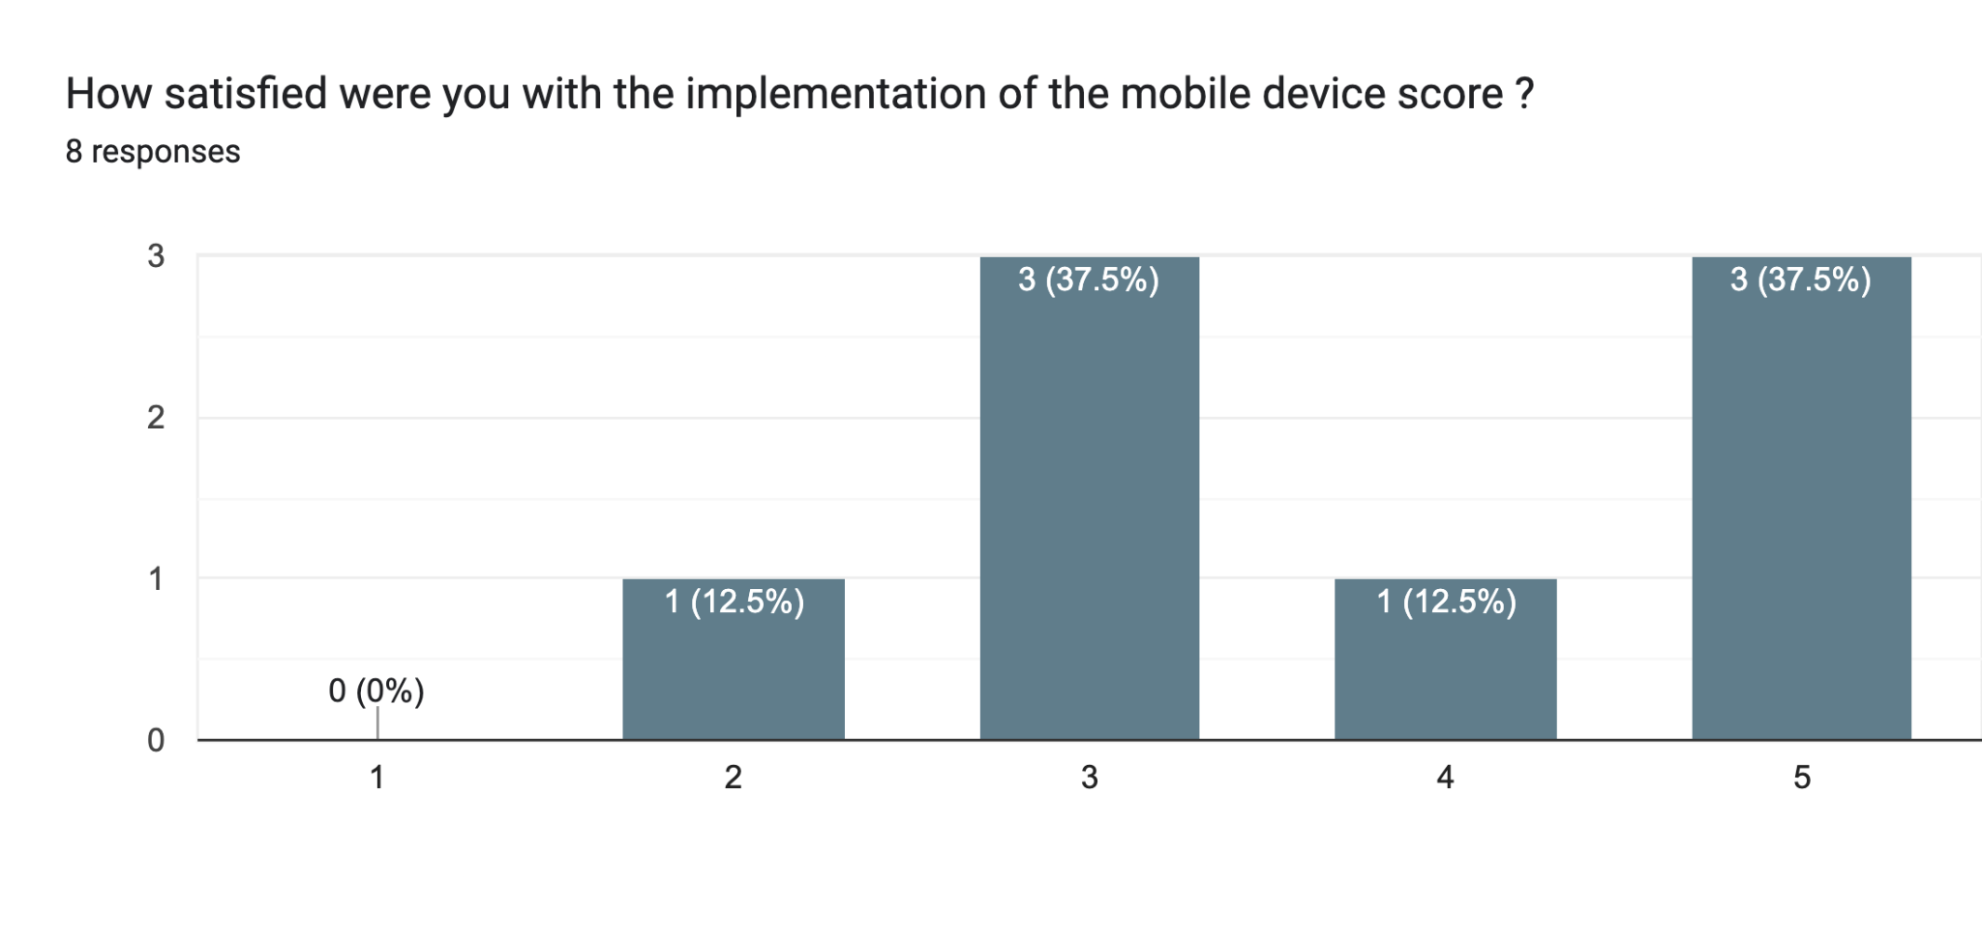

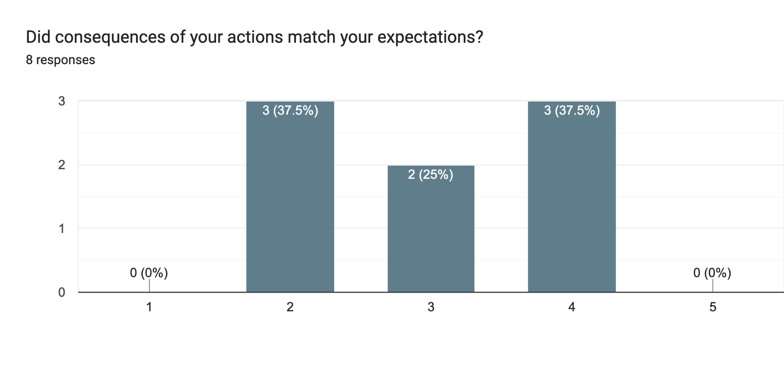

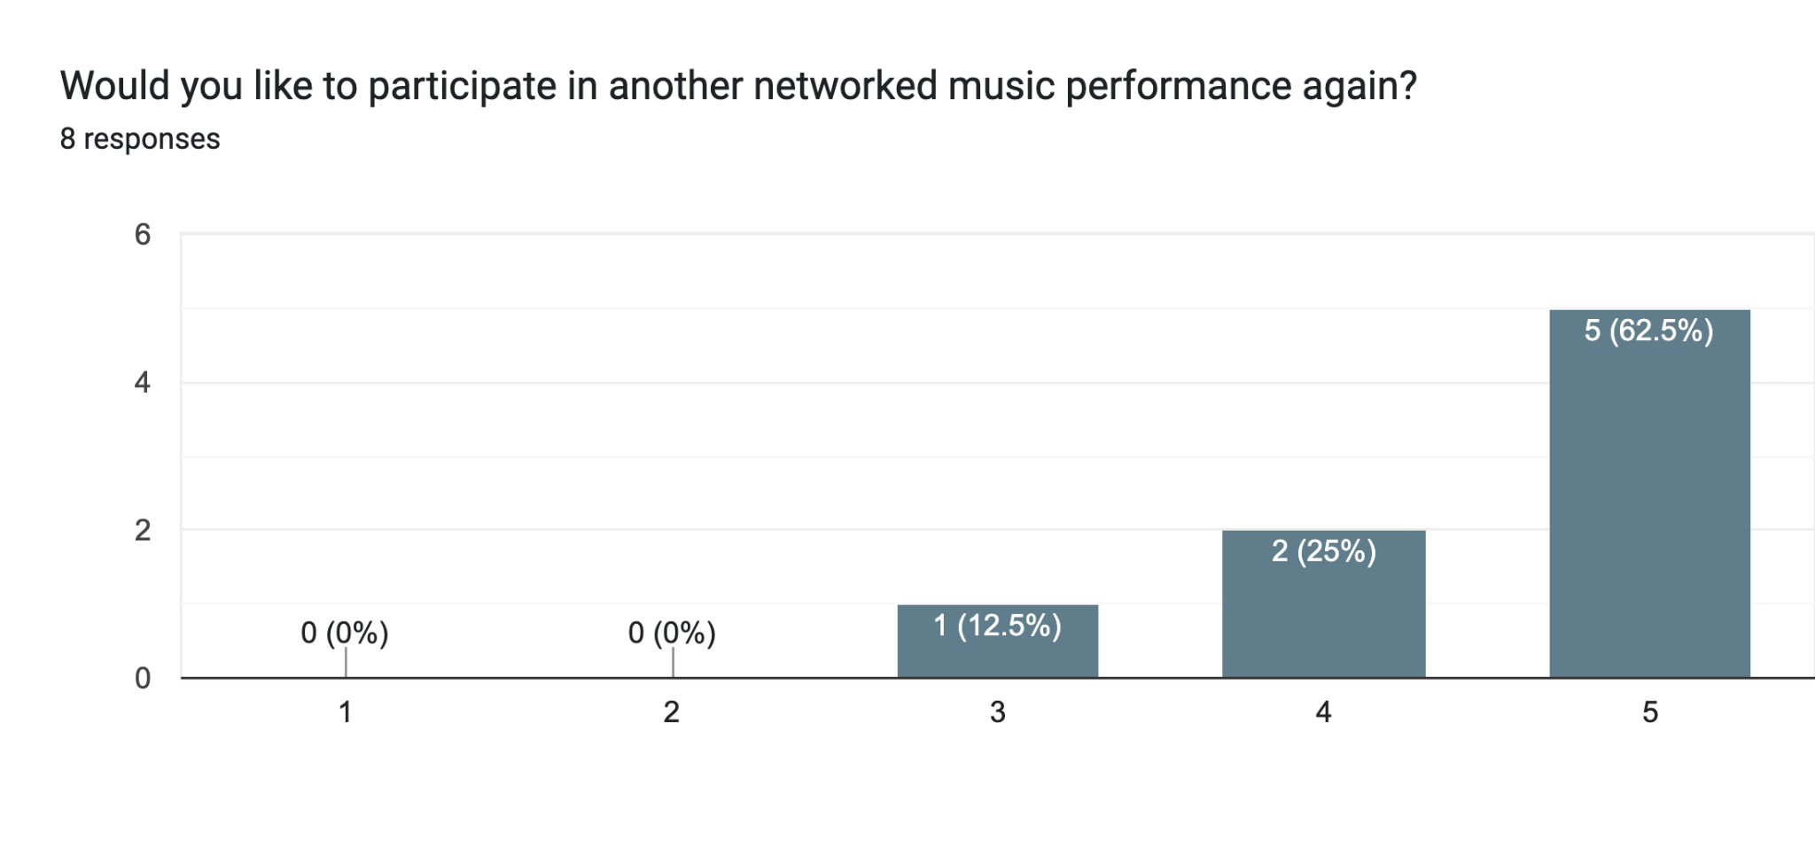

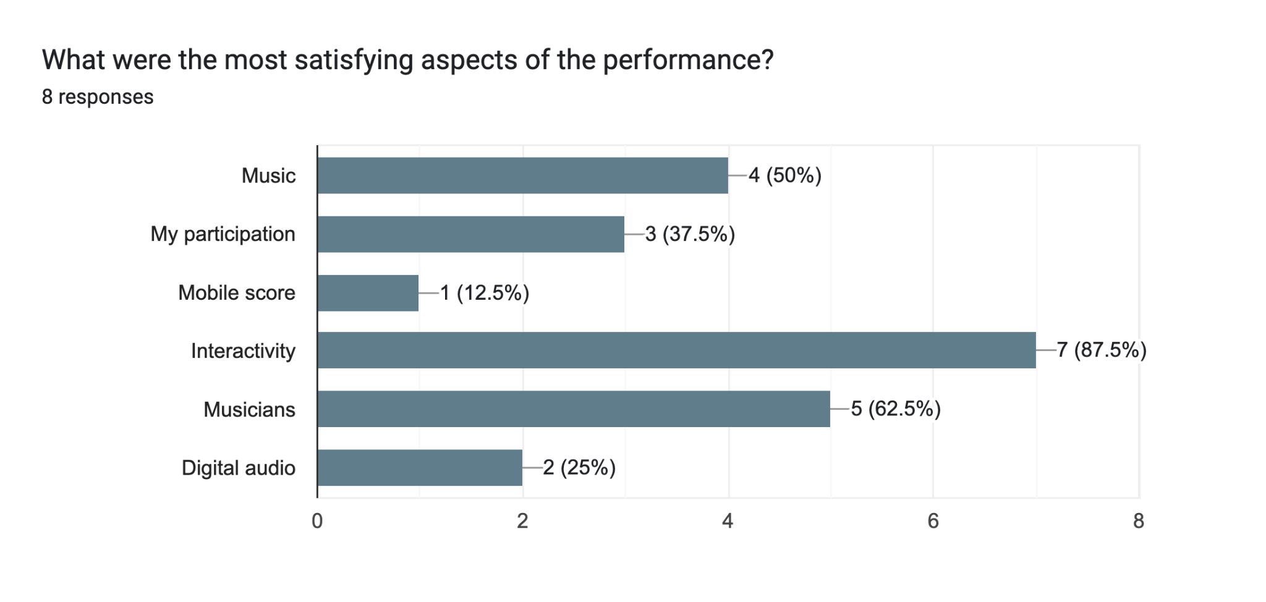

Any additional comments regarding the workshop?5 responses

It would be great to play more notes together as an audience. Maybe choose (rate) a certain segment of music that our phones play together, so we all feel like an instrument

A great experience, I am happy to be involved in

Is it possible for the audience to have autonomy on how much they have control on the influence? Personally I feel that satisfaction comes a lot from the revealed impact of interaction.

Better relation between input & output would be great. Optionally, multi-modal input should be fun to try.

I came late so I didn't quite understand what was going on but once I started interacting it was really fun and I didn't mind that much about understanding. Music & expression is what interests me the most and I was very impressed and satisfied with what I was hearing.