Socket Dialogues Workshop Audience Feedback 9 Jan 2023

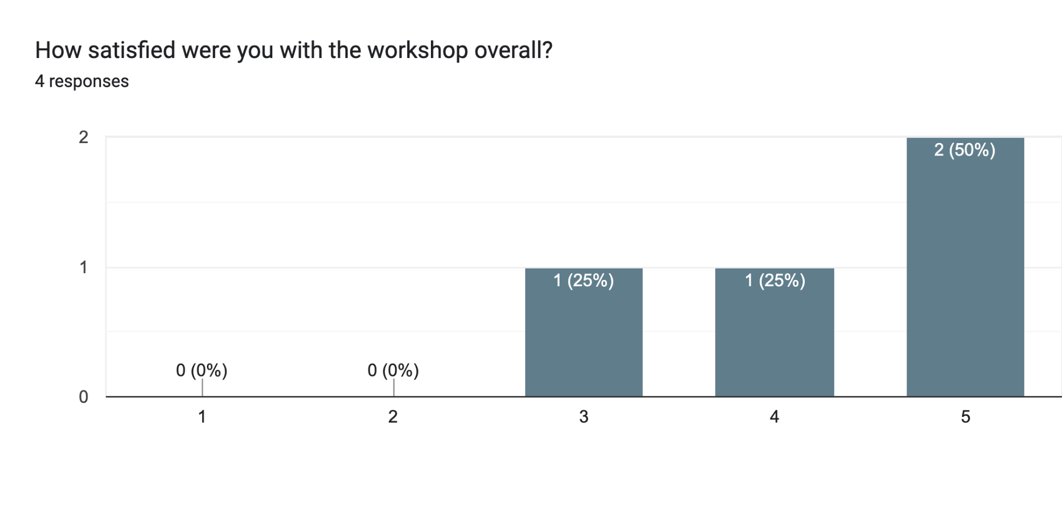

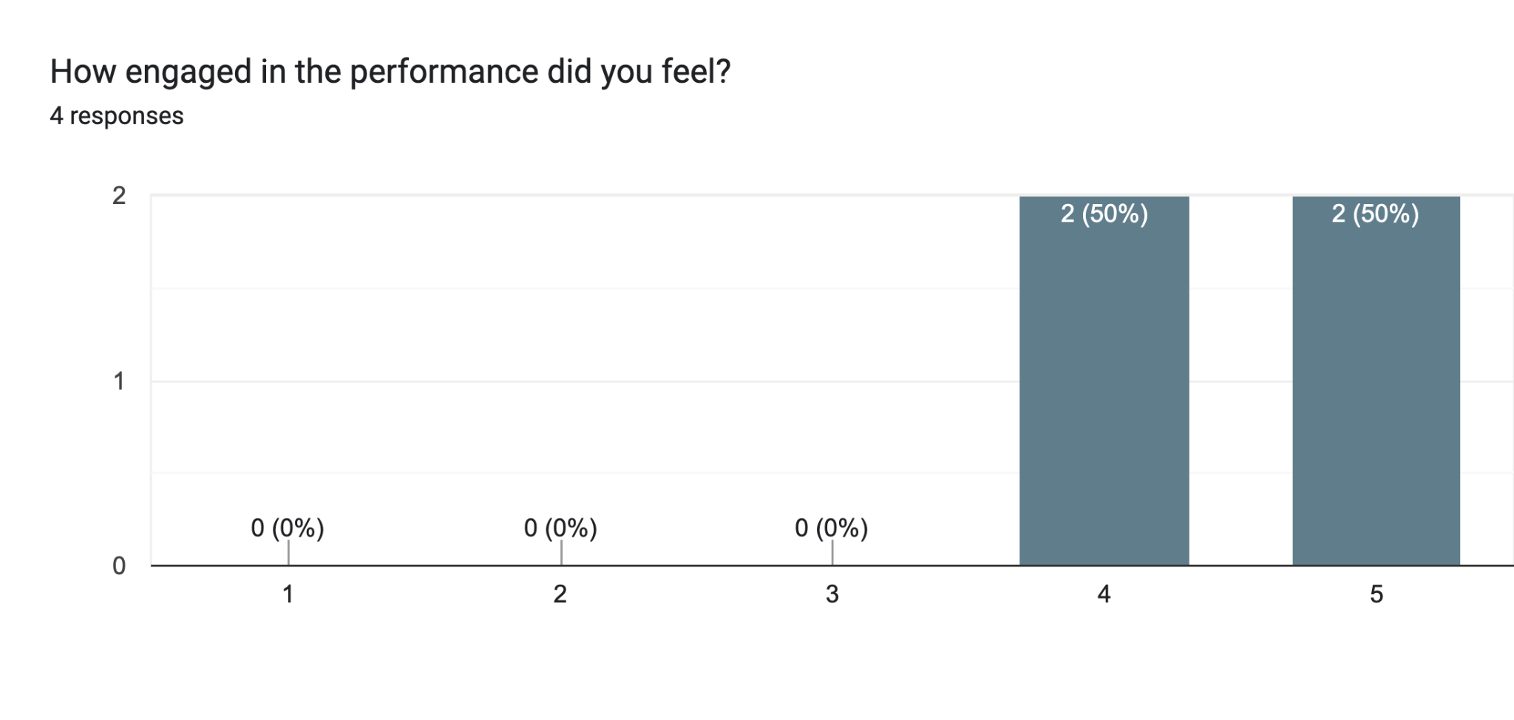

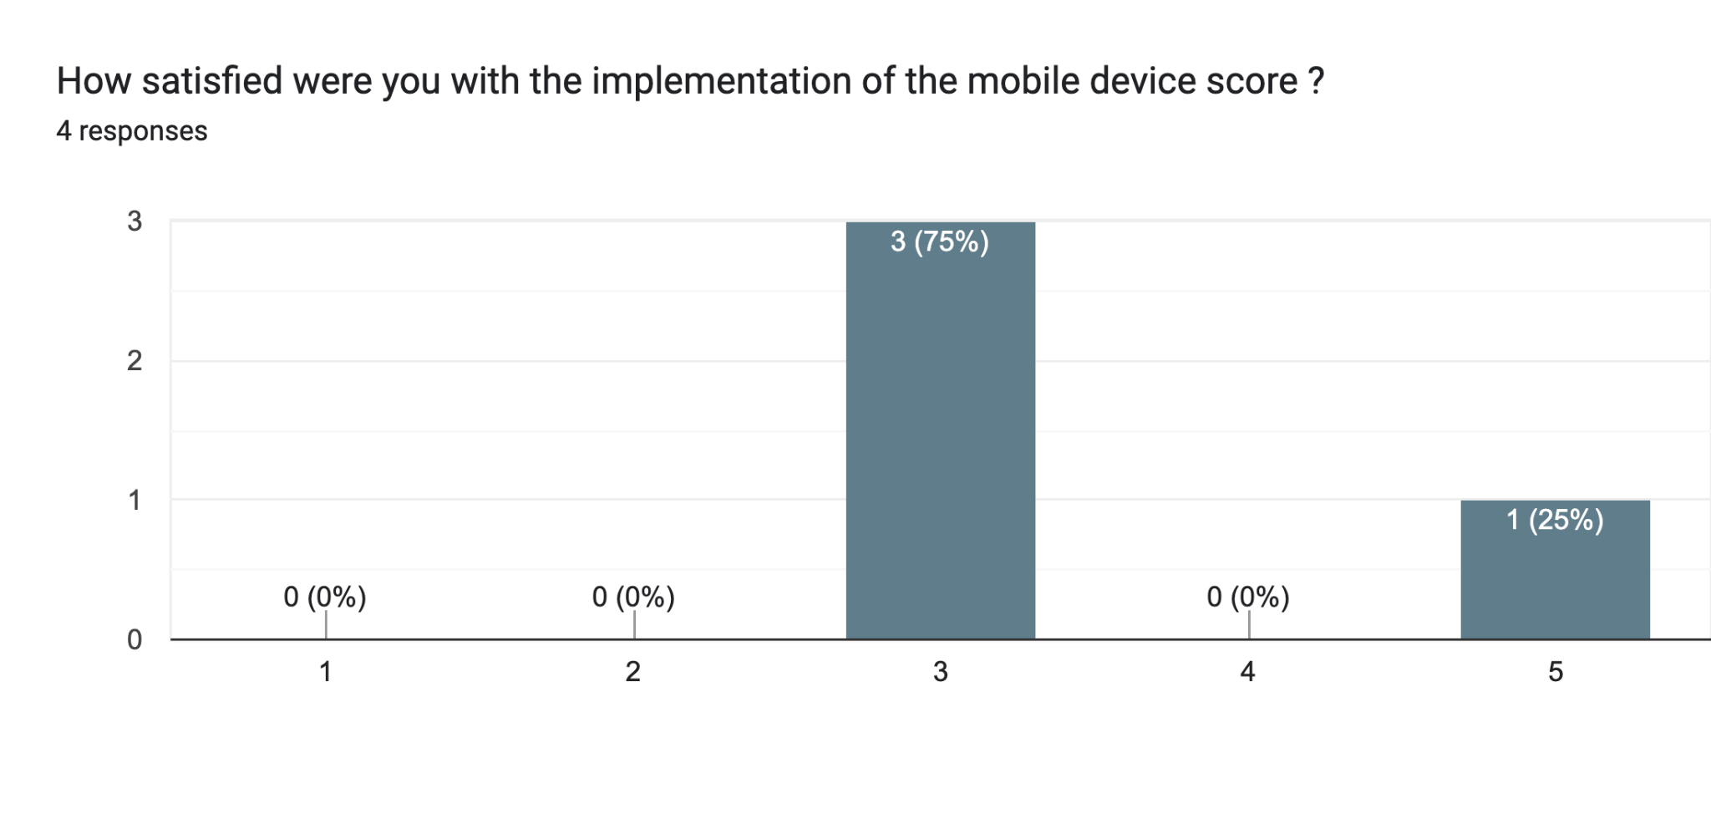

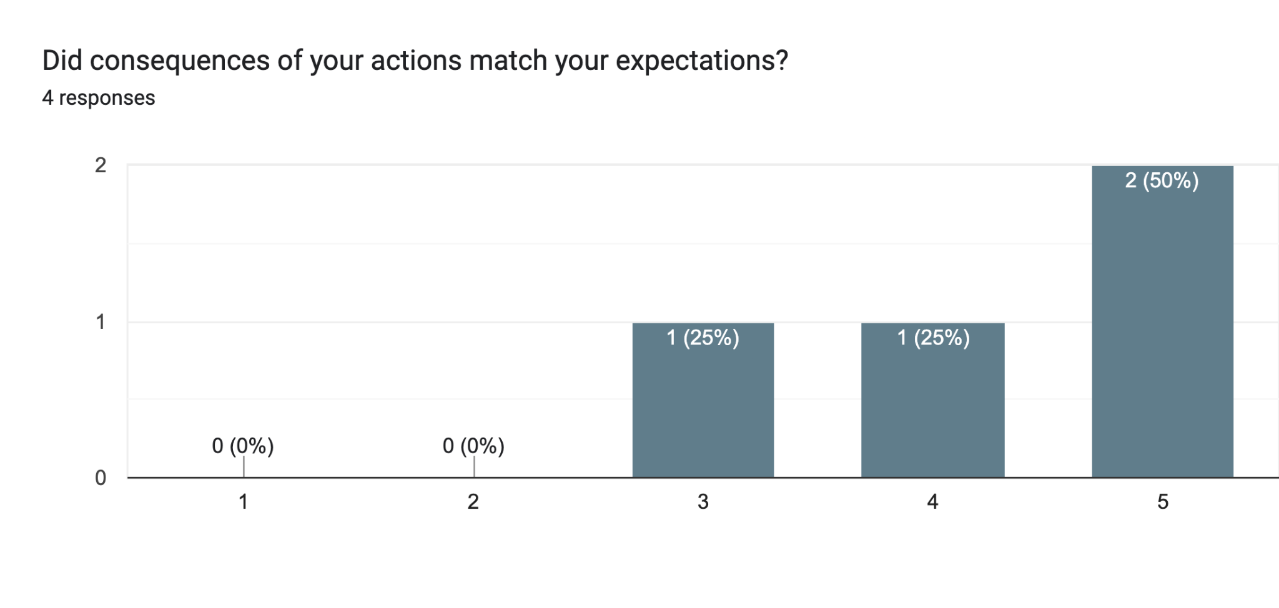

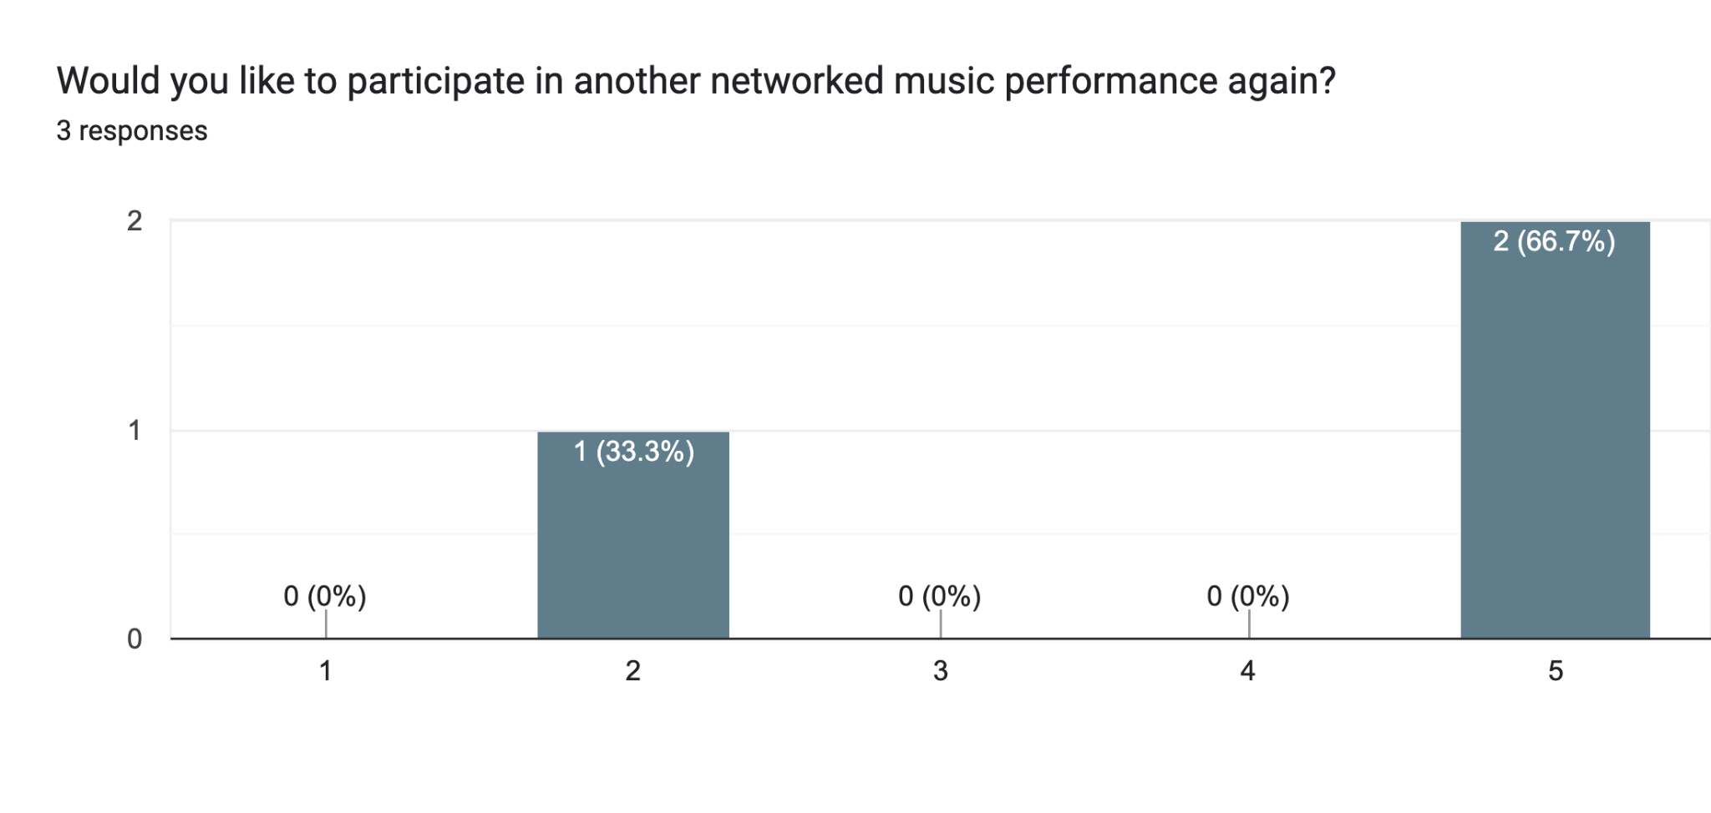

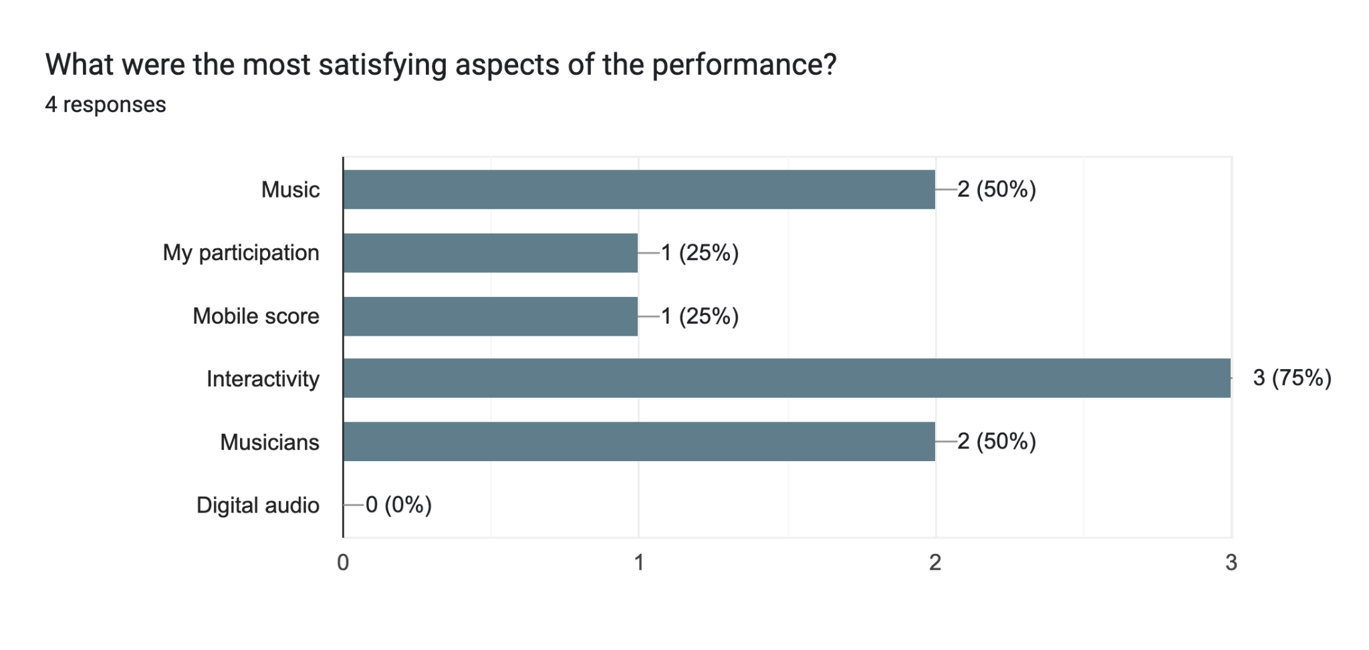

Any additional comments regarding the workshop?3 responses

Found it uncomfortable to say 'dislike'. Enjoyed the note part the most & the noise on the improv - participation was clear here.

Interesting work. Would like to be in the know of future reseaches / develpoment. Enjoyed interaction and collective participation --- increasing dynamic. The presentation - was informative though I probably expected a bit more performance -- (elements)

Regarding the sounds, I believe the sounds should tonally match the musicians. This occurred well during the "pitch" section.