Audience Feedback Union Rose Worshop 23 Feb 2022

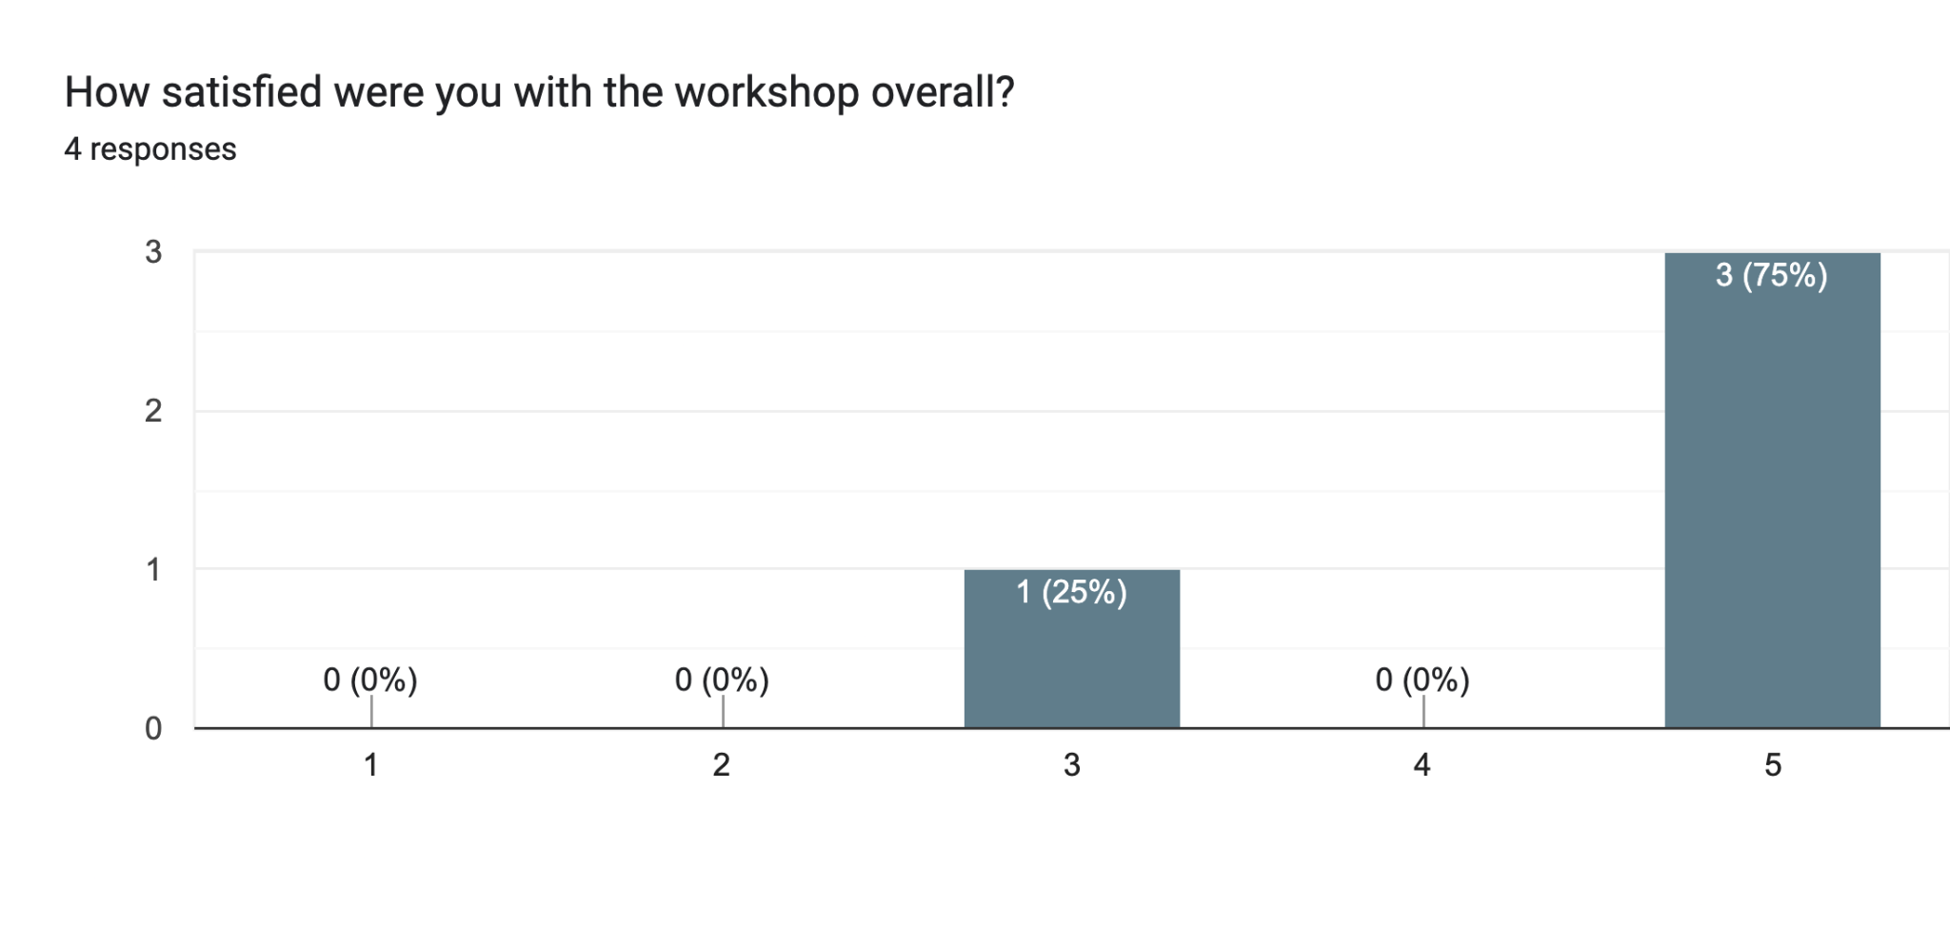

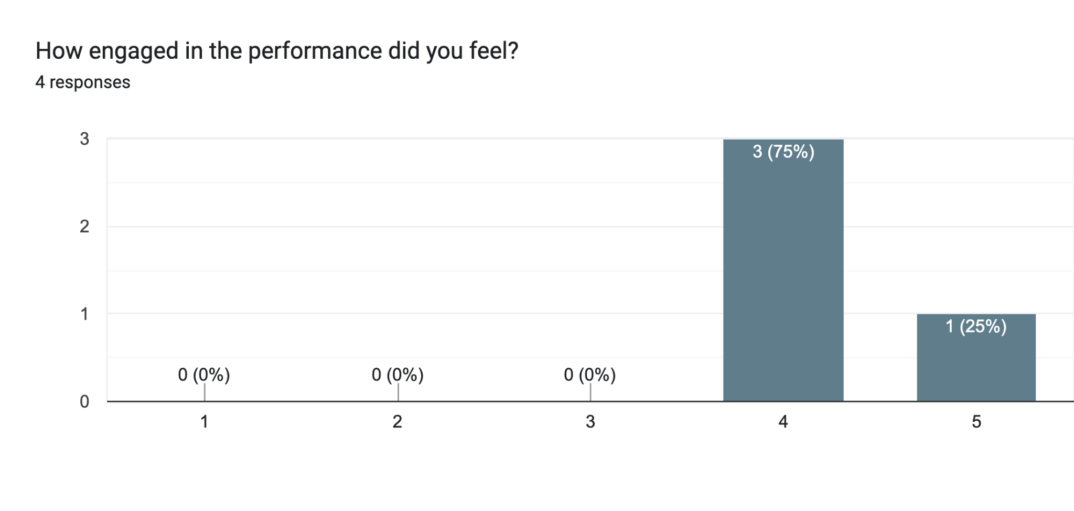

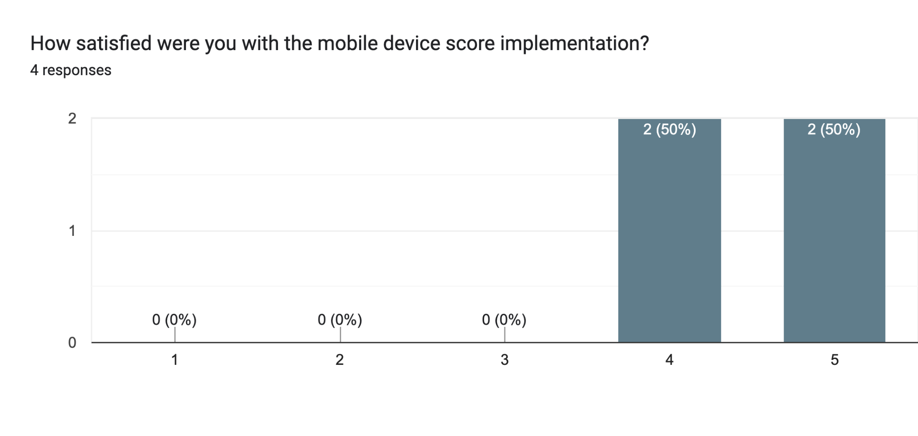

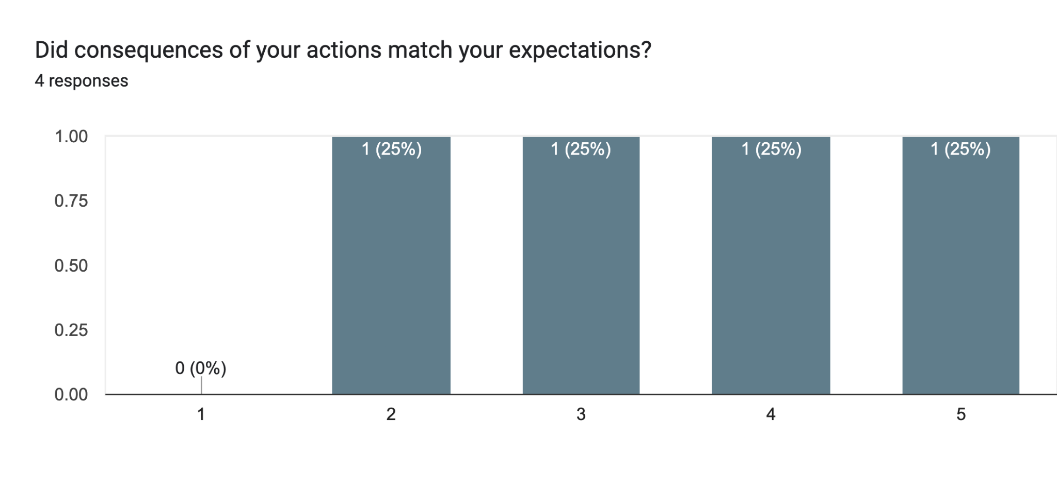

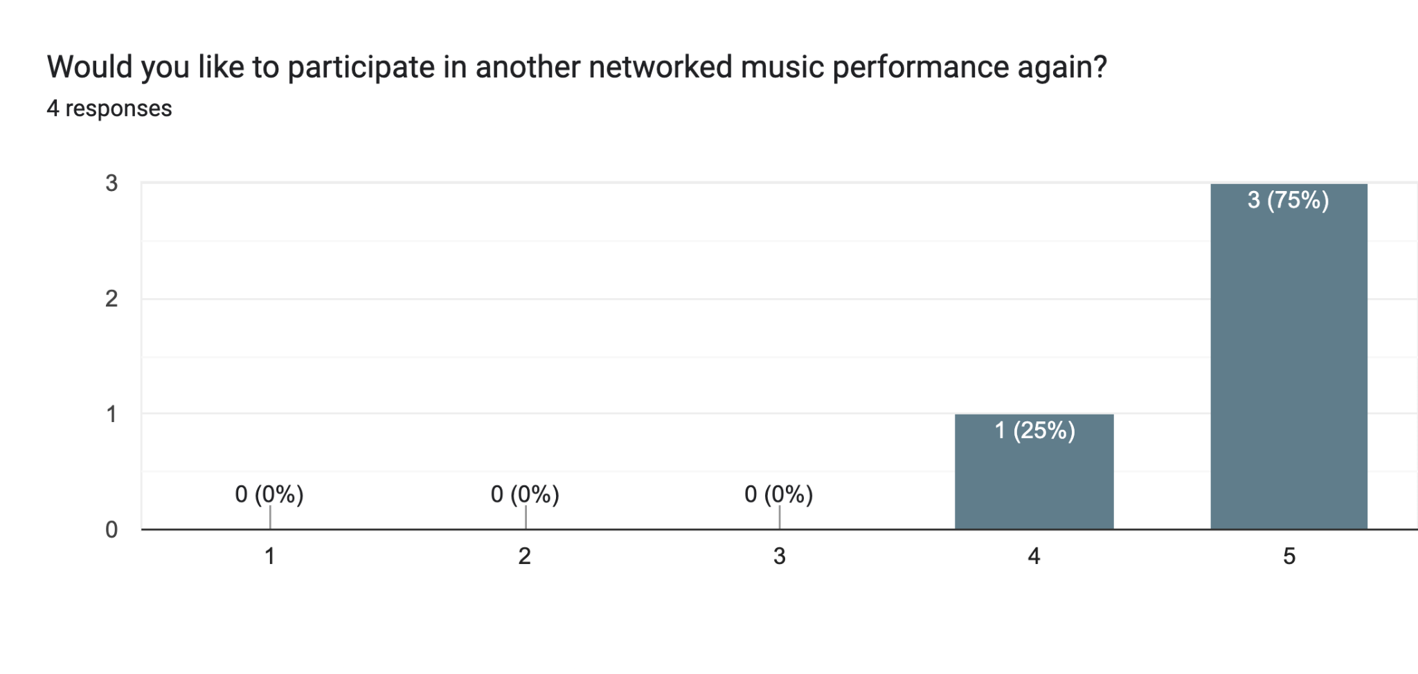

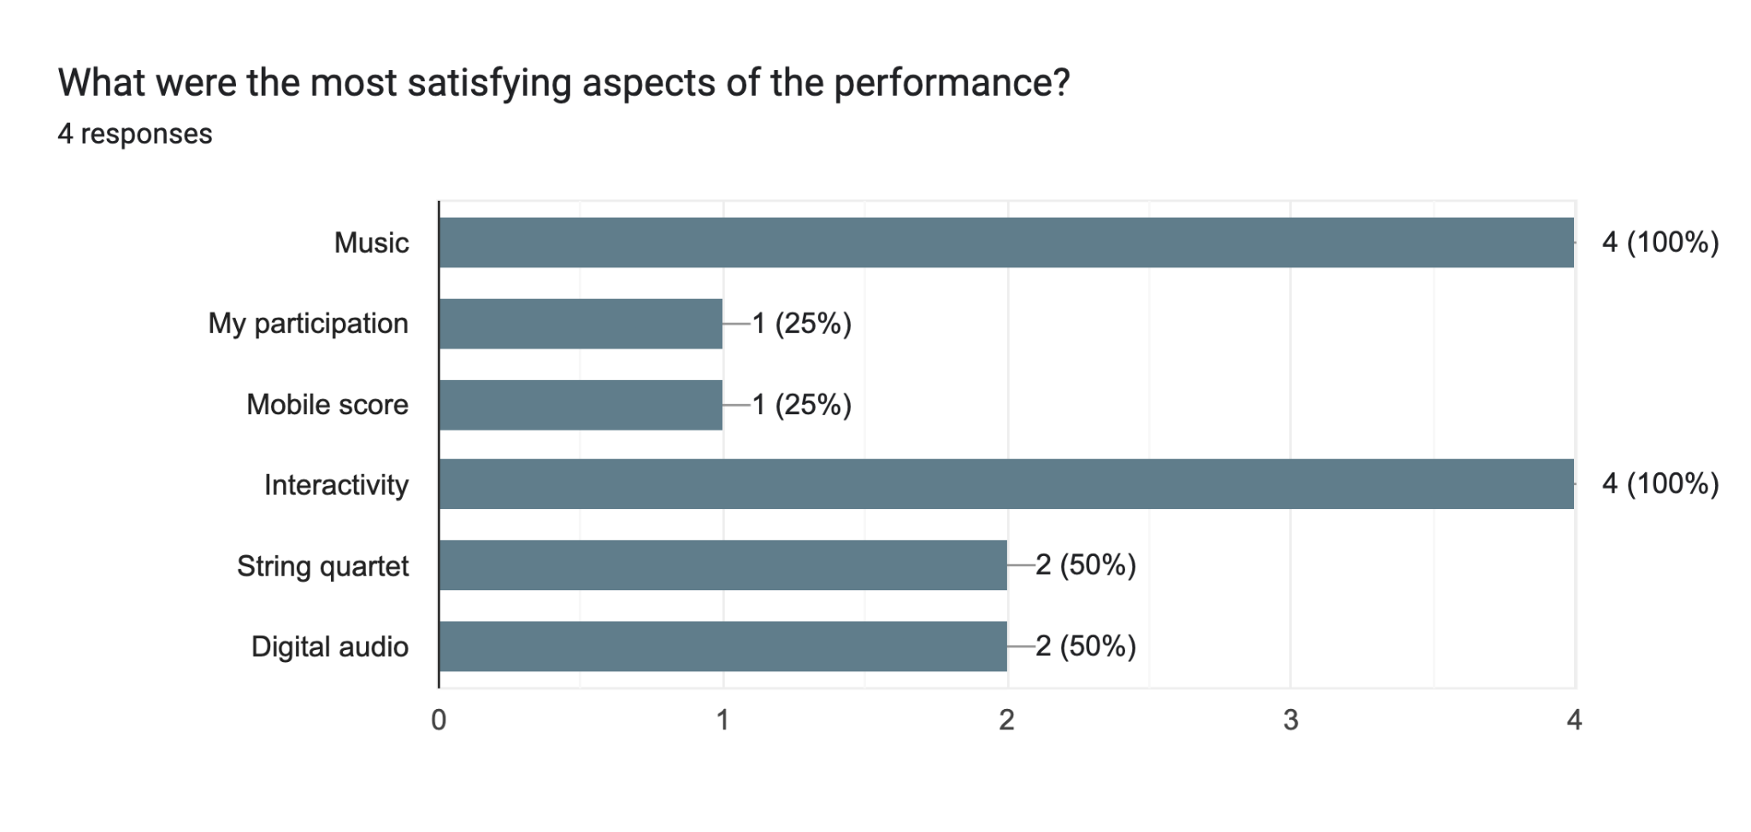

Any additional comments regarding the workshop?3 responses

Nice Job! I'd like to see a bigger audience. We can talk more MZ

This was like therapy for me. Krystal

1. The music decided my different choice is quite similar, difficult to feel strong change (can feel a little bit, not too much). 2. Maybe the visualisation of the pattern behind the tile could also be changed by decision. (colour, shape, maybe use touch designer for program). 3. It's remind me the cooperation between jazz player, maybe they could also vote for their performance. 4. Maybe it's good for audience to see how the script change...