Vexilla Musician Feedback 1 May 2018

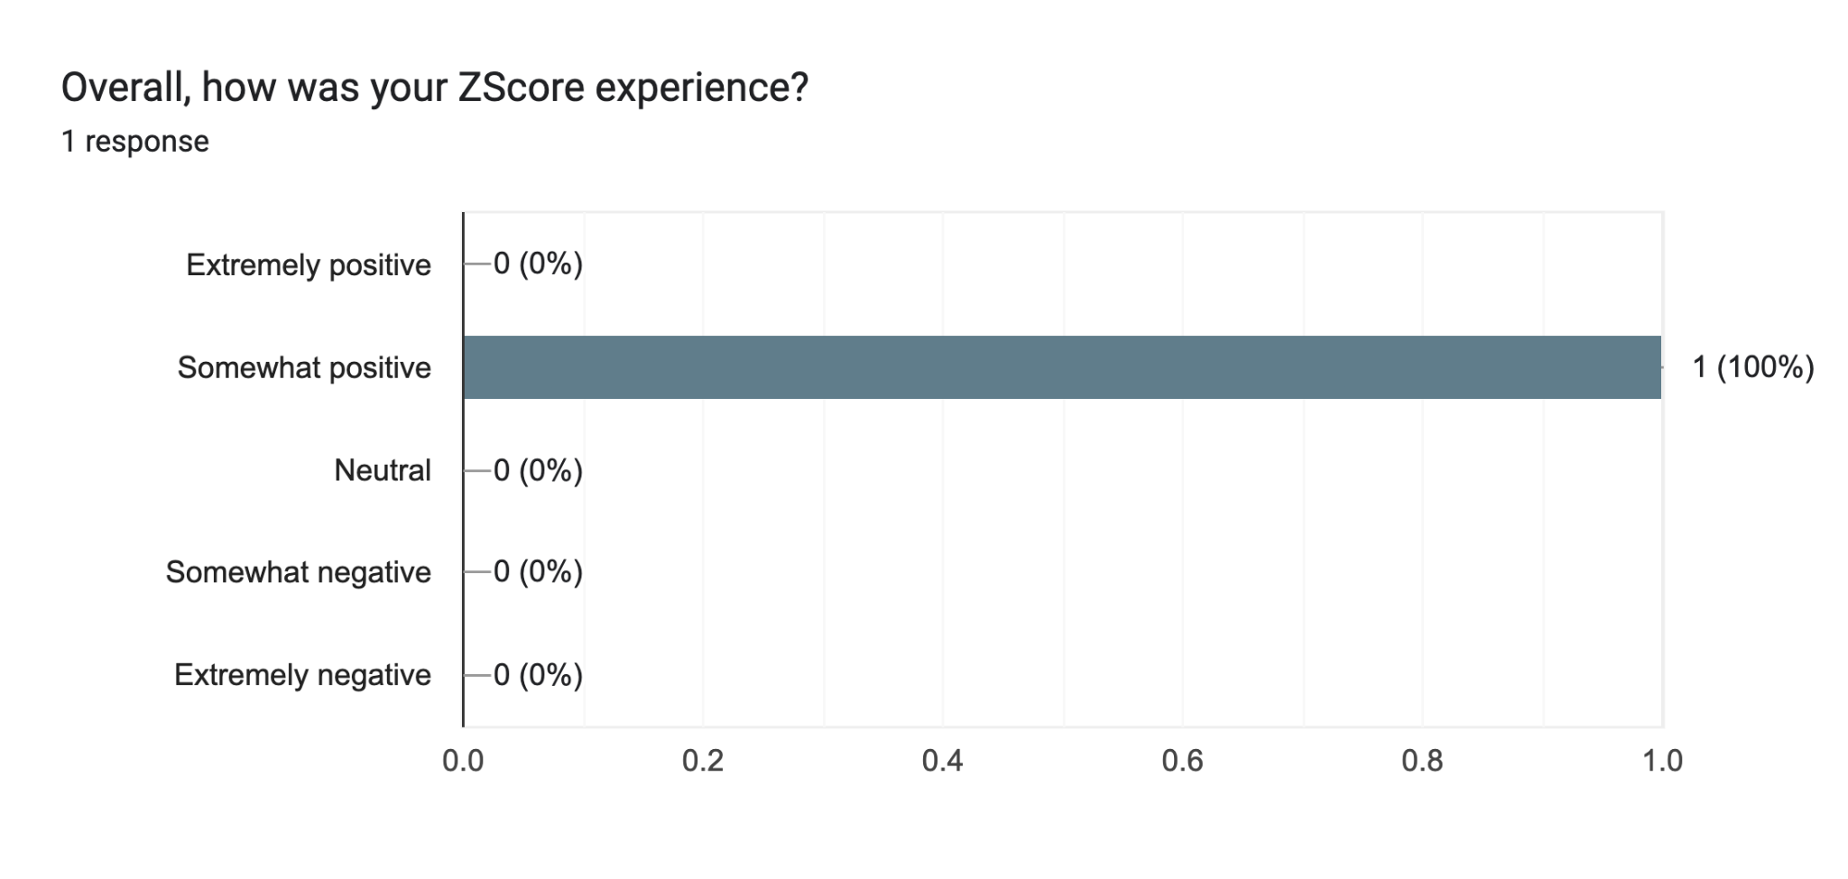

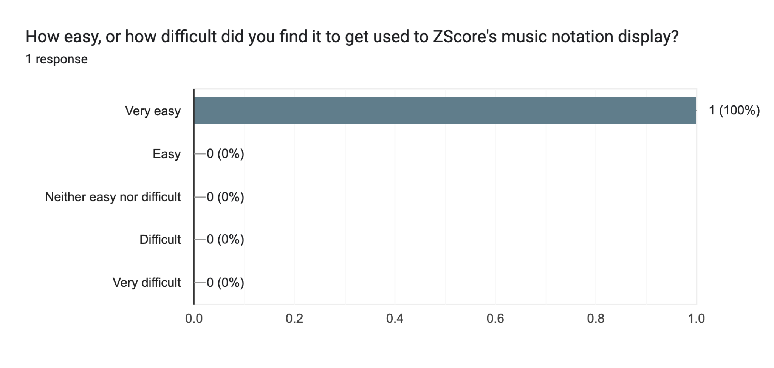

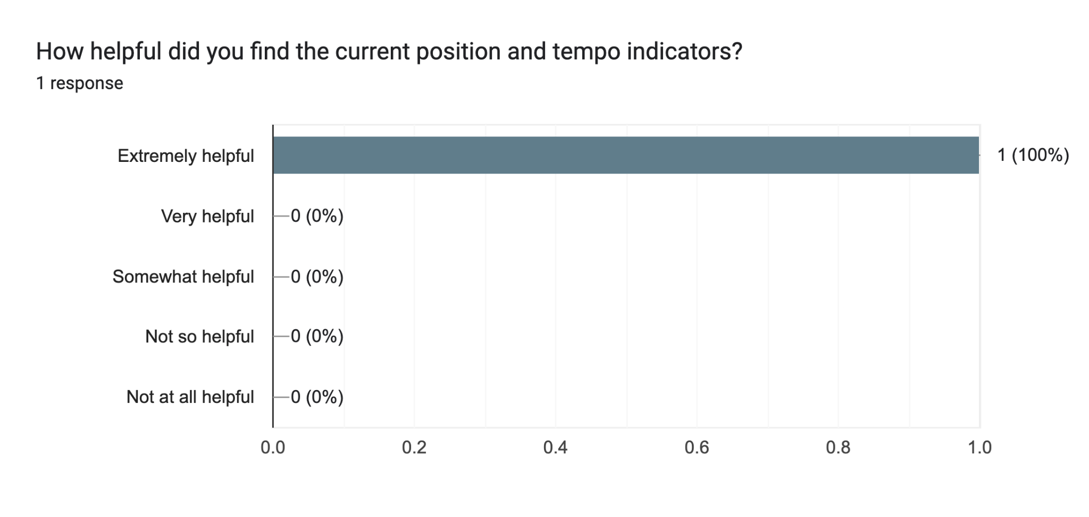

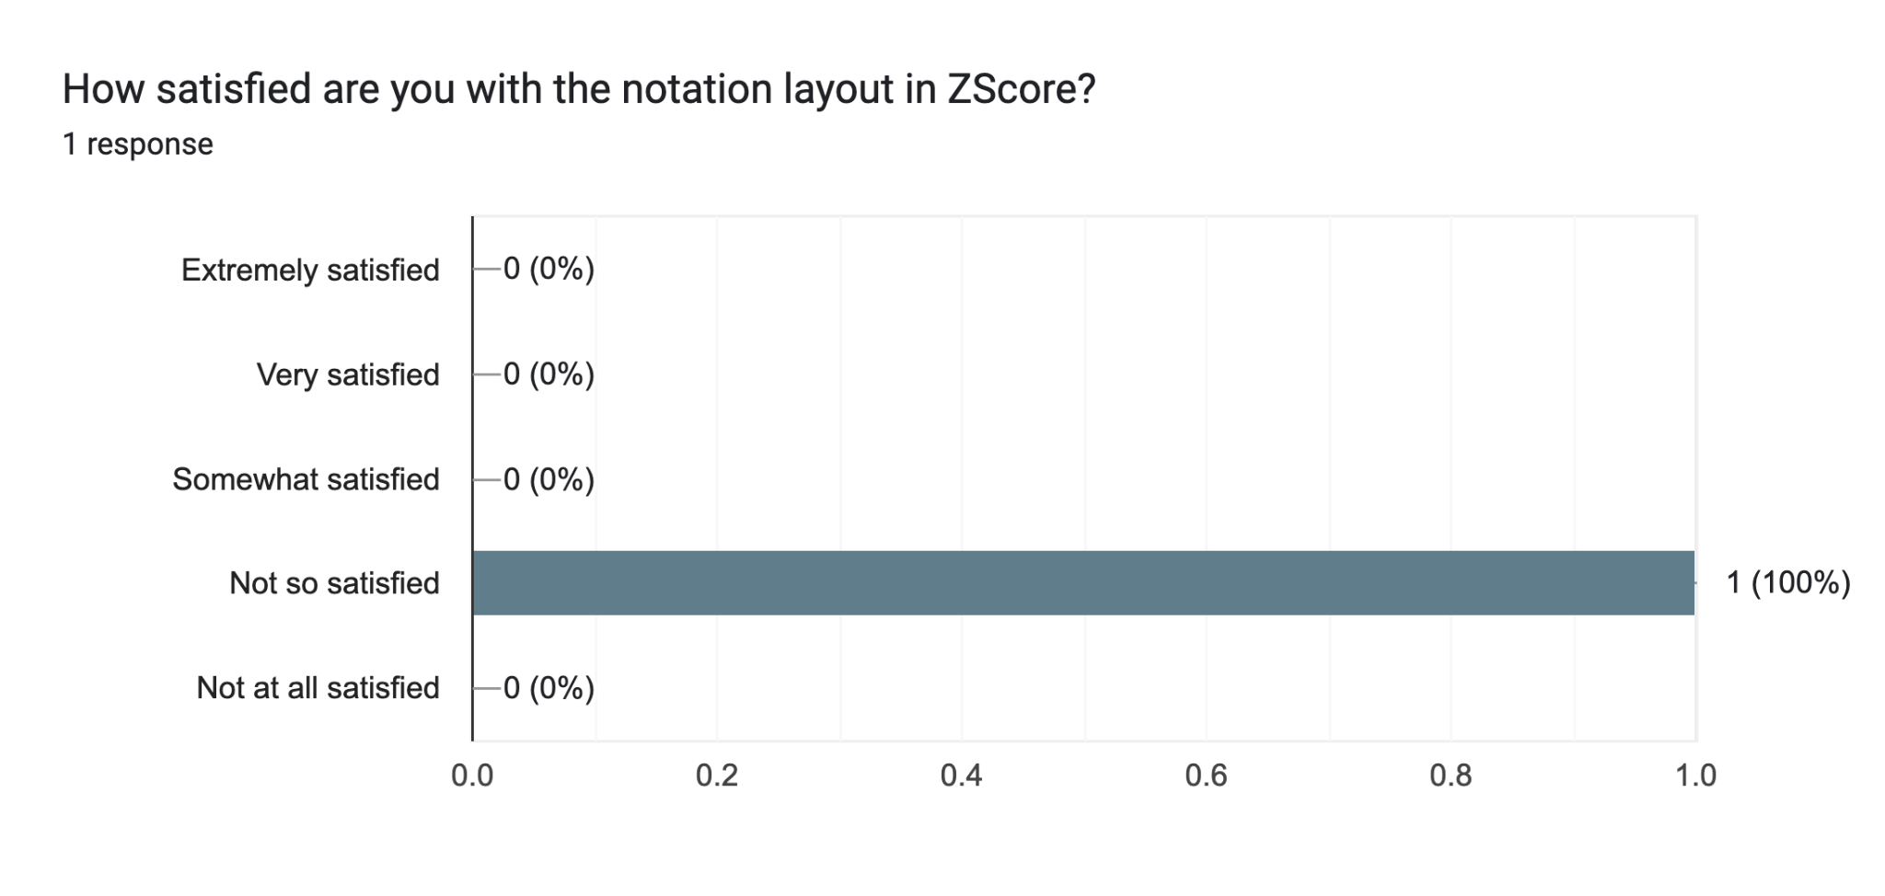

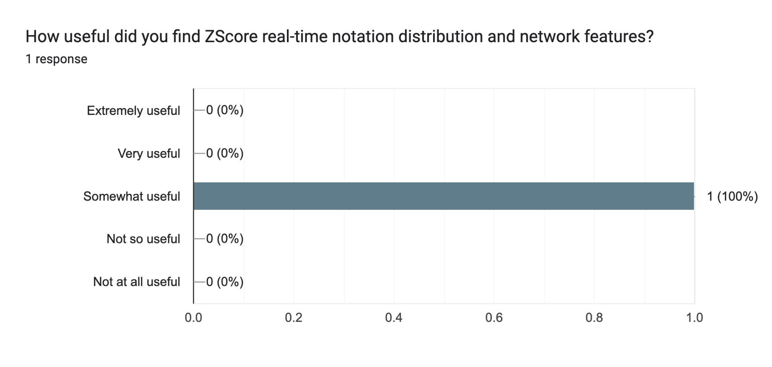

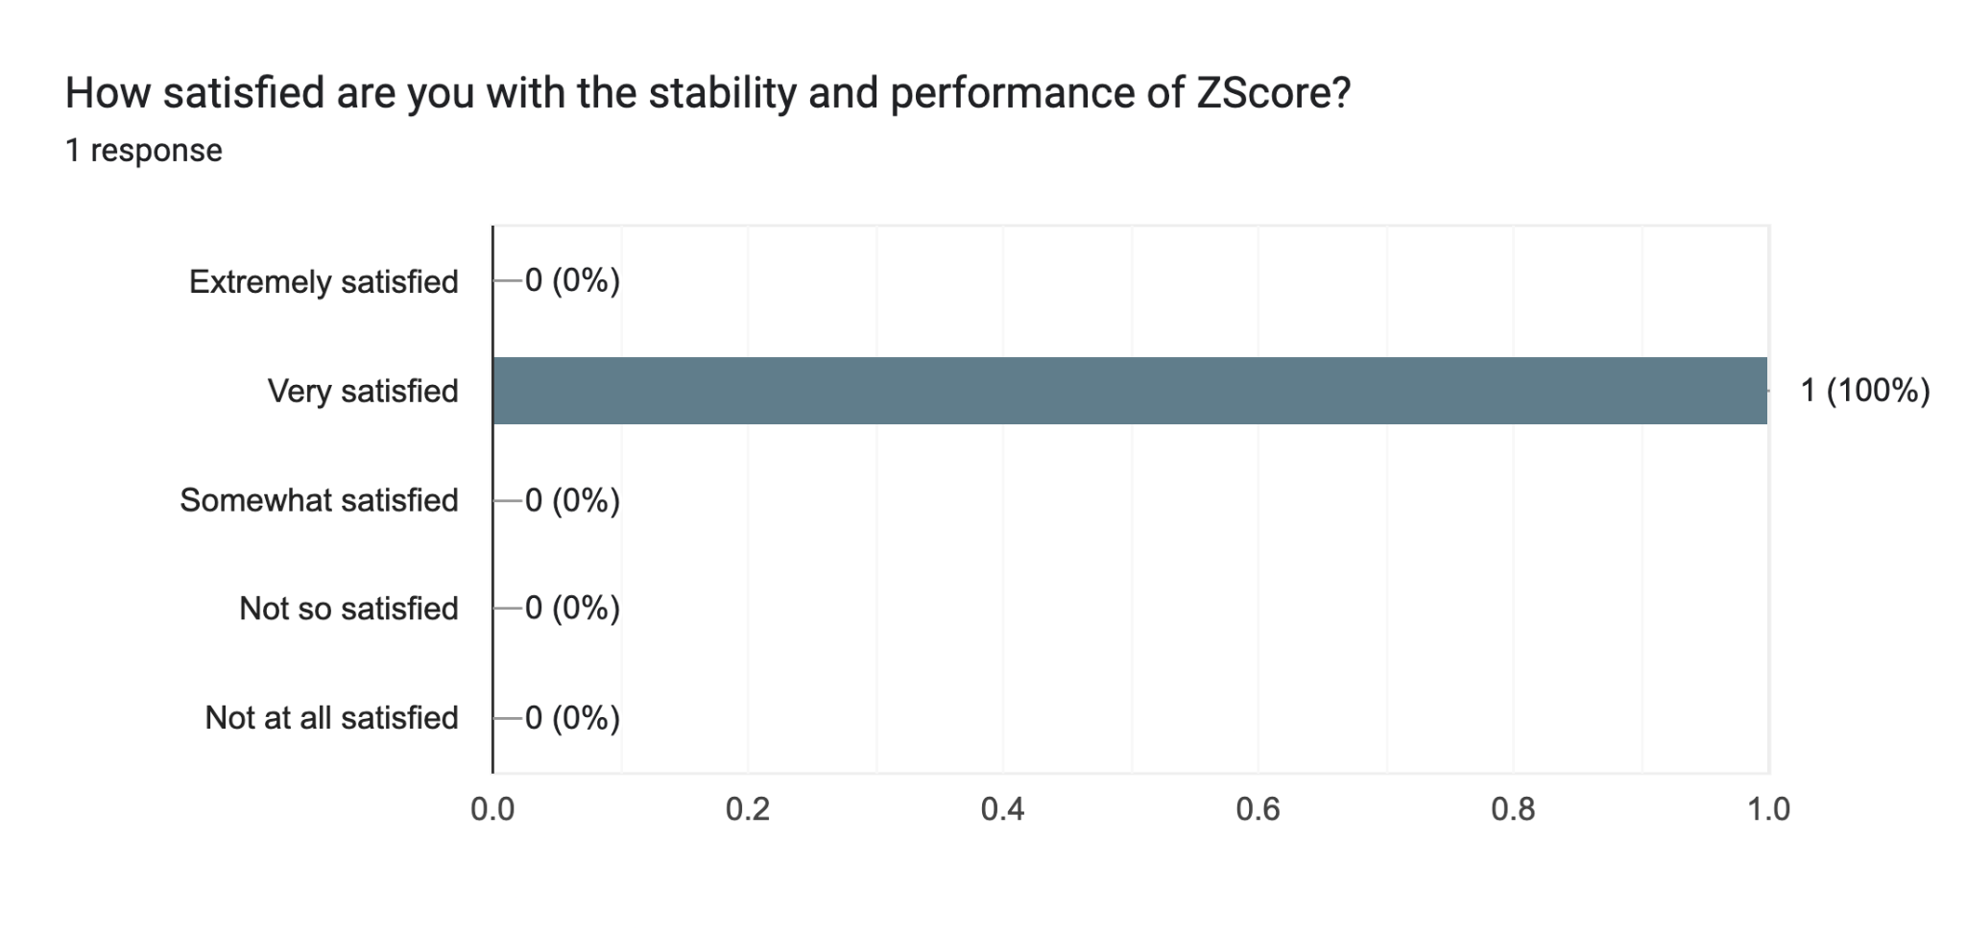

Please list the most negative aspects of ZScore1 response

The spacing of the clarinet stave made it rather difficult to read the rhythms. I'm also not sure why it had to be networked - if you'd given us a score we could have just as easily played this as chamber music. But the real problem (and this is true of any animated score) is that you can't annotate. So any notes you give us or things we want to focus on we just have to remember. And this is just not how musicians work. If you could find a solution for this you would immediately make this kind of work 10x more viable.

Please list the most positive aspects of ZScore1 response

Easy to know where we were at all times