Union Rose Workshop Musician's Feedback 22 Feb 2022

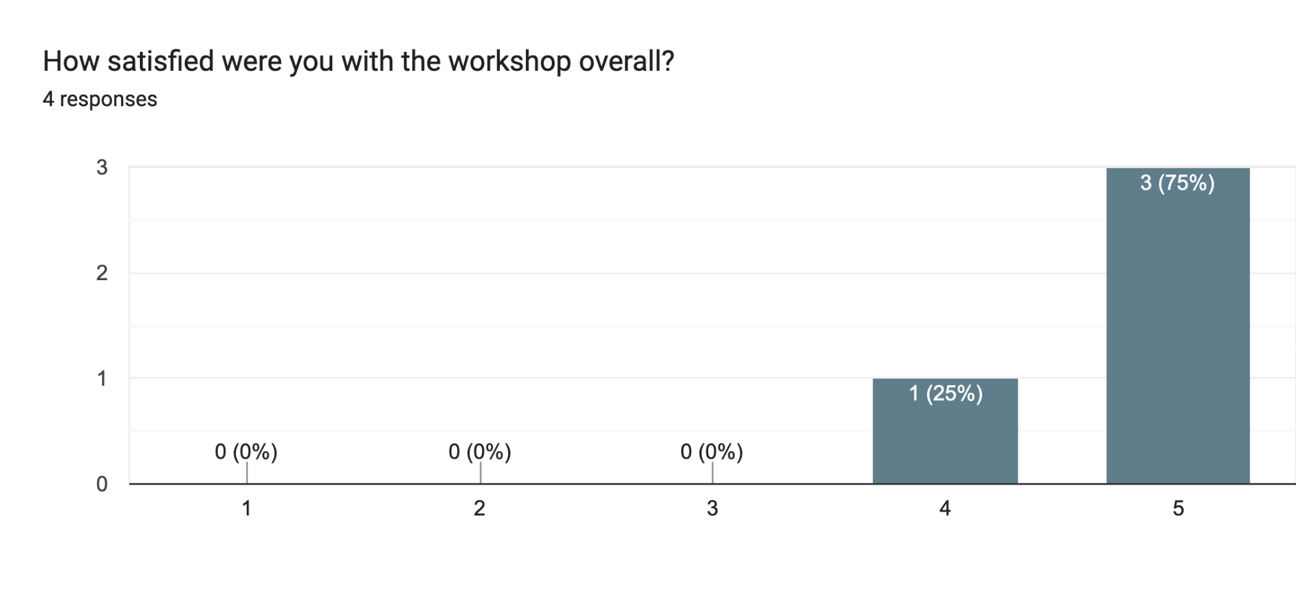

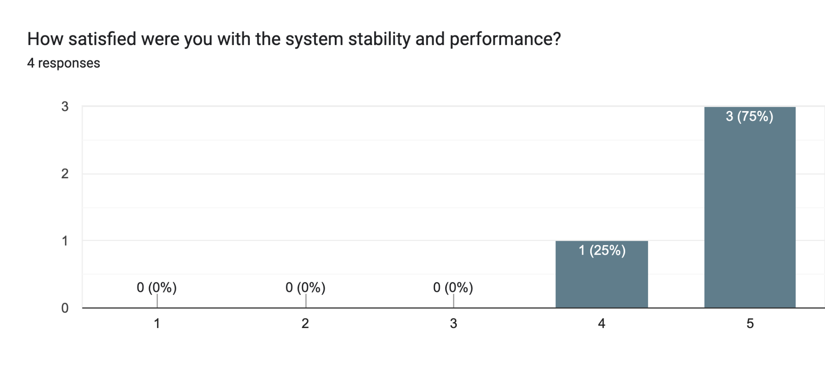

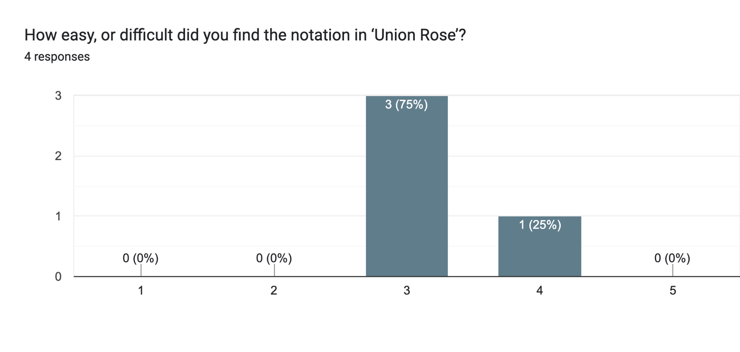

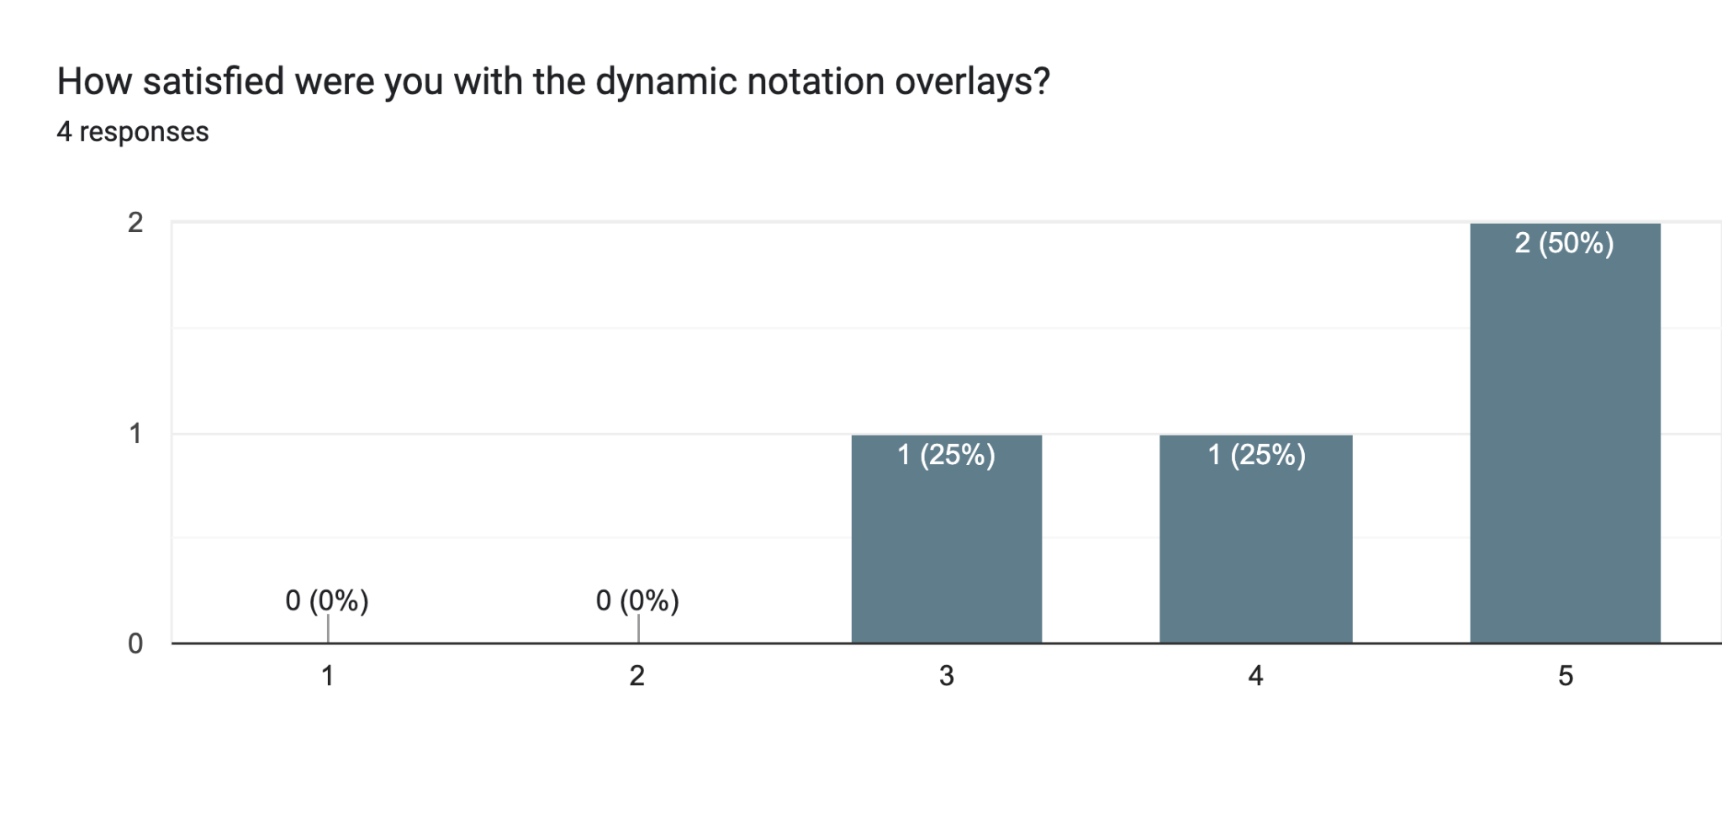

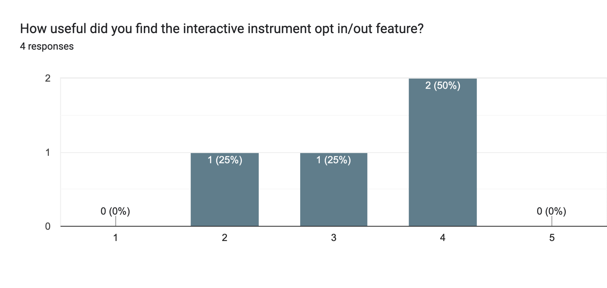

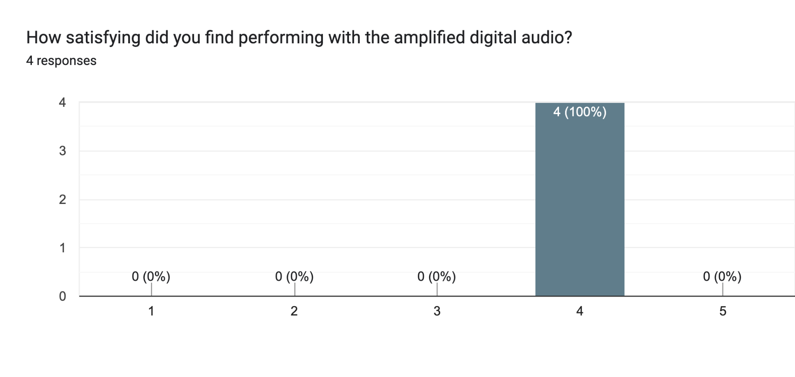

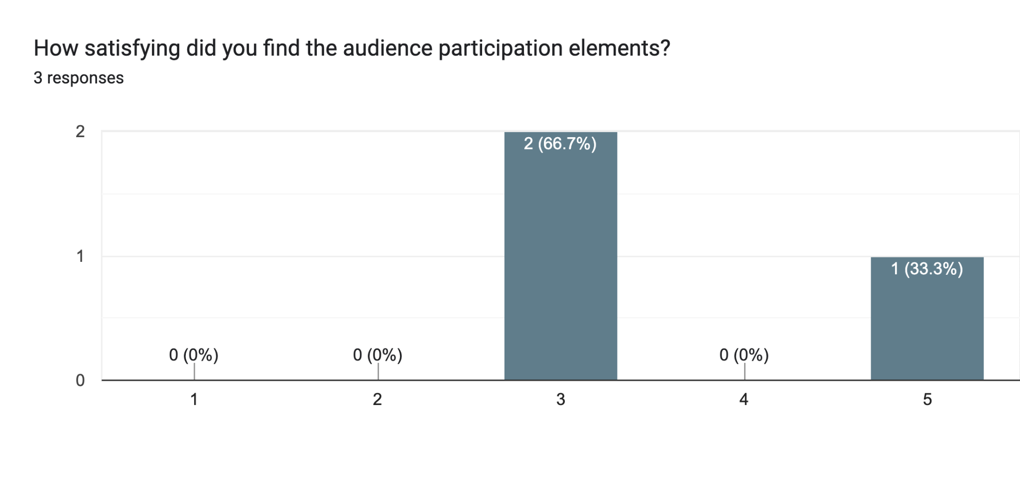

What system or notation improvements would be the most beneficial in the future?3 responses

Having a beat's rest before the start of a next line when the music needs a sfz or solid start. Q3) difficult but very "performable". Q4) once in a while it was too quick to jump to the next line so I messed the first few notes. Q5) I used it rarely. Q7) wasn't particularly aware of the effects

Probably longer duration / larger scale. Q5) wanted more!

Indicate where any gesture must be in unison in the quartet (in the parts)

Great, thank you for involving us!!!

I'd be interested in people (not the composer) having more control e/g/ pitch, who plays etc.