Interactive score for mobile phones
Mobile phones select material (events), actor grouping
Audience performance score

A SCHEME FOR MUSIC INTERACTION DESIGN AND NOTATION BASED ON DYNAMIC SOCIOMETRY
Affiliation network model (Stefano Kalonaris Tenor 2020), events and actors, mapping
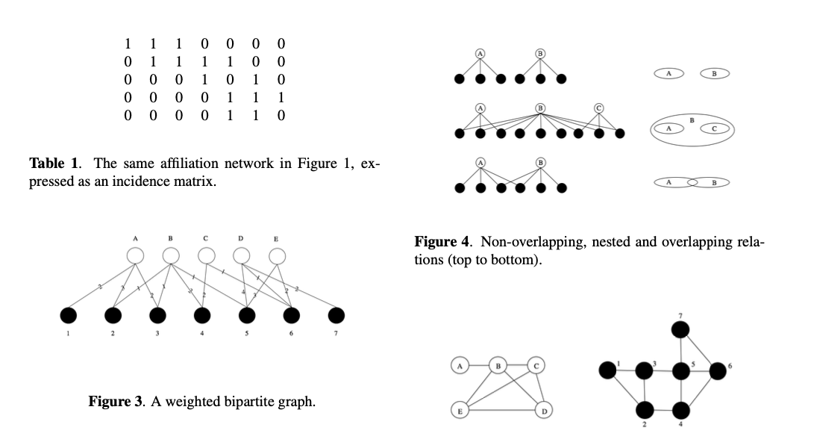
SymPhonea Sinphonea Symphonet (Mobile Symphony)
Events
id | What | When
1 | Notation 1 | Mov 1, bar 1
2 | Notation 2 | Mov 1, bar 2
3 | Timbre
4 | Dynamics

Actors
id | type | Event Id choice
1 | Audience | 1
2 | Musician | 1, 2
3 | Audience | 2, 4
4 | Audience | 3, 4

Symphony structure
Movement | form | tempo | character
1 | sonata | 100 | Fast
2 | AB | 60 | Mellow
3 | Scherzo | 80 | Move to the beat
4 | Rondo | 100 | Inspire

Composition flow
- conductor starts movement
- available movement events are shown to the audience (conductor available event management)
- audience selects events to be played ( min/max events restriction, majority algo )
- musicians select event they want to play (bottom menu, automated default assignment)
- event is inserted into next page slot during time window
- conductor changes available events to modify play (event set preset?)

multiple simultaneous event visualisation?
audience controls one event only – or audience controls a set of events that are then distributed to musicians / digiaud?

