ZScore Comprovisation Strategies

Abstract

Introduction
Composition and improvisation are often regarded as a mutually exclusive music-making categories. In practice, however, it is not possible to define a clear boundary between composed and improvised. Bhagwati {“SANDEEP BHAGWATI COMPROVISATION – CONCEPTS AND TECHNIQUES”} argues that no score can totally determine all aspects of a musical performance and some elements of music making will always be contingent. Likewise, a performer’s free improvisation is built on years of practice and performance stemming from a particular tradition and aesthetic context. A free improviser also adheres to a set of rules and regulations that might be imperceptible to a performer. It follows that any music performance lays somewhere on the spectrum between composed and improvised. The portmanteau word ‘comprovisation’ is often used to describe this mix. This paper considers music-making strategies that blur the boundaries and intentionally sit in the middle of the comprovisation spectrum.
A piece of music, whether composed or improvised, is conceived through a decision making process defining what sound or action is to be performed and at what time. Constanzo {Constanzo: Comprov analysis} developed a formal methodology for analysis of the decision making process in improvised works. His segmentation of the music-making decisions into: material, formal, interface and interaction is not too dissimilar to a traditional composer concerns regarding pitch, duration, harmony, form and instrumentation. Another way of looking at a difference between composed and improvised is to observe who the decision makers are, when and how these music-making decisions are made. In a composed piece most of the music material decisions are pre-determined by the composer and preserved in a static score. However, even in the most meticulously notated scores many subtle decisions are left to performers who interpret given notation based on their experience and knowledge of the particular music tradition. Improvisers, on the other hand, are more adept at real-time dynamic decision making in an interactive group performance environment.
Figure 1: Comprovisation decision making spectrum
Pre-Determined
Static
Real-Time
Dynamic

Concepts such as static data containers, networking, interactivity and real-time dynamic event processing are ubiquitous in modern computer technology, therefore, the technology is well placed for modelling and enhancements of comprovised music-making data and decision processes. Furthermore, the technology could democratise control of the dial on the Comprovisation decision making spectrum (Figure 1), by allowing any performance participant (composer, performer, conductor, audience …) to fundamentally alter nature of the performed piece.


Event Processor
Decision Algo
Composer
Conductor
Performers
Audience
Score Processor

Music notations developed in different musical traditions tend to optimise amount of written information to what is regarded as essential and omit performance elements that are ubiquitous, verbose or too difficult to notate{Baghwati Notational perspective and comprovisation}. Traditions rely on performer’s understanding of the style, playing techniques and aesthetics to complete required information gaps. In the contemporary context, this notational bias, described as ‘notational perspective’ {Baghwati Notational perspective and comprovisation}, has a more granular scope that can help identify individual comprovisation practices. Networked notation technology further extends this concept by allowing creation of dynamic notational perspectives that can be modified in real-time. A number of software solutions suitable for networked comprovisation have been developed such as: InScore [1], Quin-tet.net [2], Bach [5], Decibel ScorePlayer [6] and dfs-core [7].
ZScore {Zagorac: ZSCORE: A DISTRIBUTED SYSTEM FOR INTEGRATED MIXED MUSICCOMPOSITION AND PERFORMANCE } is a networked notation system providing real-time notation distribution and performance flow control. This paper outlines recently added features allowing for the comprovisation decision making control (Figure 1) and controller role assignment. Furthermore, the paper examines ZScore’s notational perspective focusing on the performance parameter separation and their decoupling from the traditional performance practice expectations.

Networked Notational Perspective
Conventionally, a music score consists of notation which acts as a set of instructions for performers on how to realise a piece of music. Networked notation systems allow heterogeneous clients to connect and exchange data and events over a computer network. In such systems a music score can be modelled as a collection of data and algorithms driven by scheduled or triggered events. All participants in a networked music performance (musicians, composer, conductor, audience, digital audio and video engines, etc.) can communicate with each other through an interactive system in real-time. This democratisation of information flow blurs boundaries between traditional music-making roles as any participant in a performance can be assigned a decision making or a sound production agency. In a way, networked systems provide an environment reminiscent of an ancient communal music-making. Audience members, as networked system participants, can actively engage in a performance through personal mobile devices, a composer and musicians can interact in real-time during a performance to modify a composition flow, a conductor can change generative algorithm parameters to alter notation sent to performers, a computer running an algorithmic engine can trigger score visualisation on audience mobile devices etc.
A heterogeneous client environment requires multiple score representations as each network client might require a different input type. For example, a score on musician’s devices might be rendered as a symbolic notation while the same score on audience’s devices might be visualised as an animated graphics. In Simon Katan’s Conditional Love audience’s mobile devices are used both for score visualisation and as audio sources. Audience’s score representation can also contain notation, as in Slavio Zagorac’s TBD where audience members are asked to vocalise certain words or click on interactive score elements on mobile devices. A part of the same score might be sent to a digital video engine translated to a device-dependent data protocol such as in Slavko Zagorac Vexilla. All these different notation aspects constitute a networked notational perspective.

Networked Comprovisation Notation Strategies
Western classical music notation symbols focus on representation of pitch and duration leaving many performance parameters to the discretion of performers. Through time various stylistic strands of the western classical tradition extended notation vocabulary to suit their artistic needs. Ferneyhough and other New Complexity composers developed extremely detailed, dense symbolic notation which on one hand reduced contingent performance elements but, at the same time, introduced indeterminacy due to extreme cognitive and physical demands on performers. Lachenmann and his followers use a combination of symbolic and graphic notation with reduced focus on pitch and increased detail of non-pitched sound production performance parameters. Many composers (Cage, Cardew, Brown, Penderecki, Ligeti etc.) chose to use purely graphic scores in order to emphasise contingent performance elements. Advances in computer technology influenced developments of different approaches to notation such as animated scores by Ryan Ross Smith {http://ryanrosssmith.com/scores.html} and real-time networked scores by Georg Hajdu (http://georghajdu.de/compositions/).
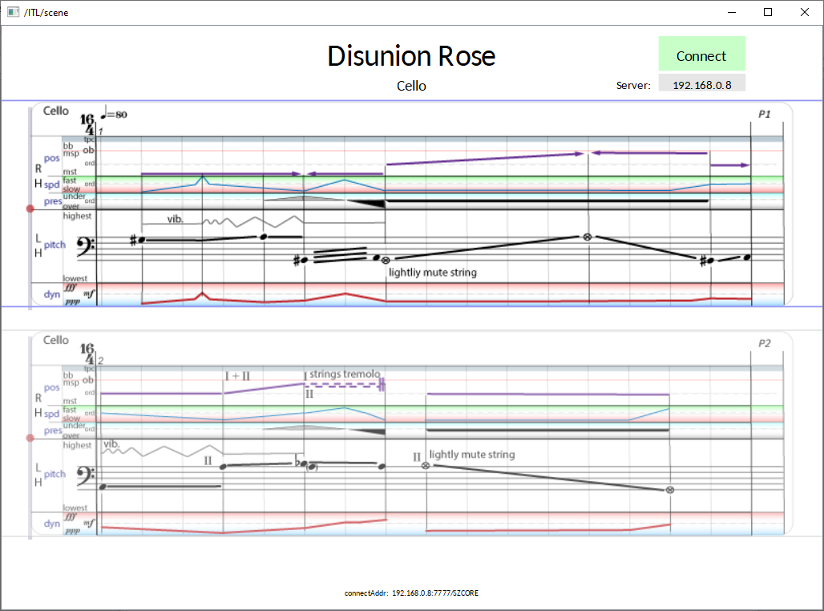Figure 2: Alternating pane layout from Disunion Rose by Slavko Zagorac
Networked dynamic notation views for instrumental parts require refresh strategy designs that do not interfere with currently played notation and leave enough time to musicians to prepare for upcoming material. The alternating pane notation strategy in ZSCore {Zagorac: ZSCORE: A DISTRIBUTED SYSTEM FOR INTEGRATED MIXED MUSICCOMPOSITION AND PERFORMANCE} aims to resolve dynamic notation update issues by providing familiar left-to-right and top-to-bottom reading direction and pre-defined time windows when upcoming notation can be updated {Figure 2}.
Performance parameter separation
The idea behind Zscore’s design was to provide a hybrid symbolic and graphical notation framework suitable for multiple dynamic notation styles while preserving a consistent layout familiar to classically trained musicians. After several iteration of the notation layout it became clear that performers prefer distinct and consistent positioning of different performance parameters rather than a mixed space utilisation. Likewise, some notation element positioning orders felt more ‘natural’ to performers then others, such as having dynamics markings displayed below the pitch information. Another important factor in notation layout design was the separation of playing techniques that are implicitly coupled in standard symbolic music notation, such as bowing speed and pressure. This was done in a conscious attempt to subvert musician’s built-in reactions to the conventional notation.
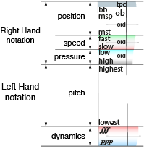Figure 3: Strings Notation Layout in Union Rose by Slavko Zagorac

Overlays, Parameter value visualisation, range, current value
Dynamic line positioning, Overlay colour hue. Current value attached to current position indicator

- Pre-composed part
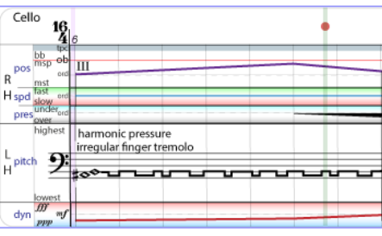

The same part with overlays switched on
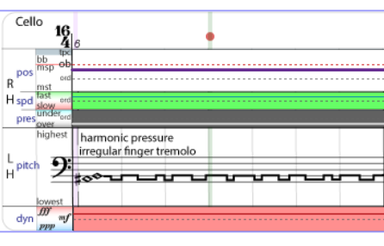

The same part with pitch overlay on others off
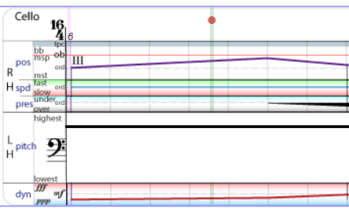

Real-time controls
Interactive performance control

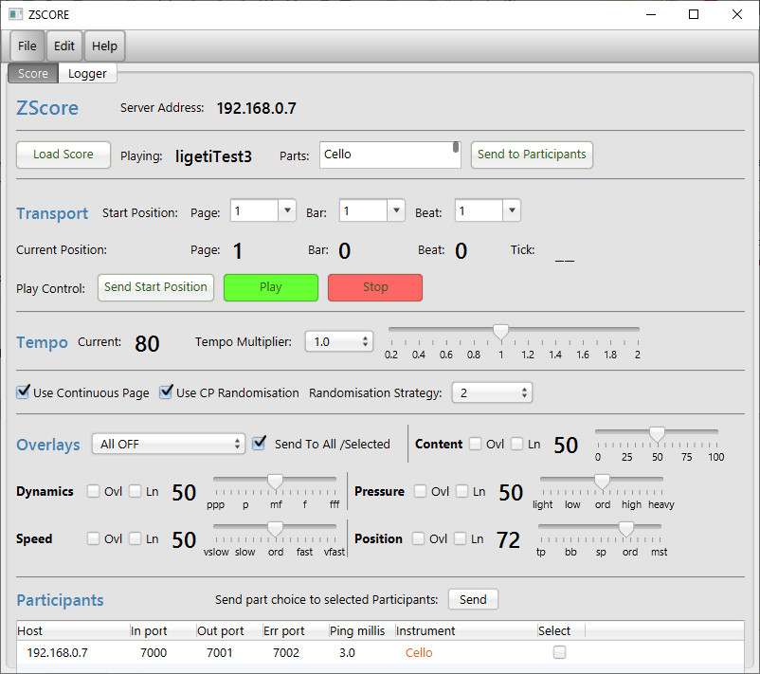

Randomisation strategy
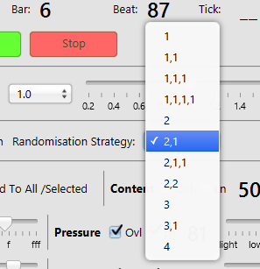

Musician controlls
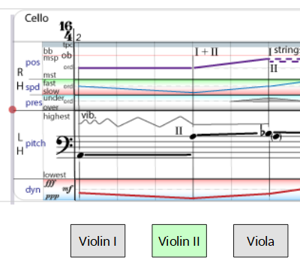

Audience score representation
Not implemented yet


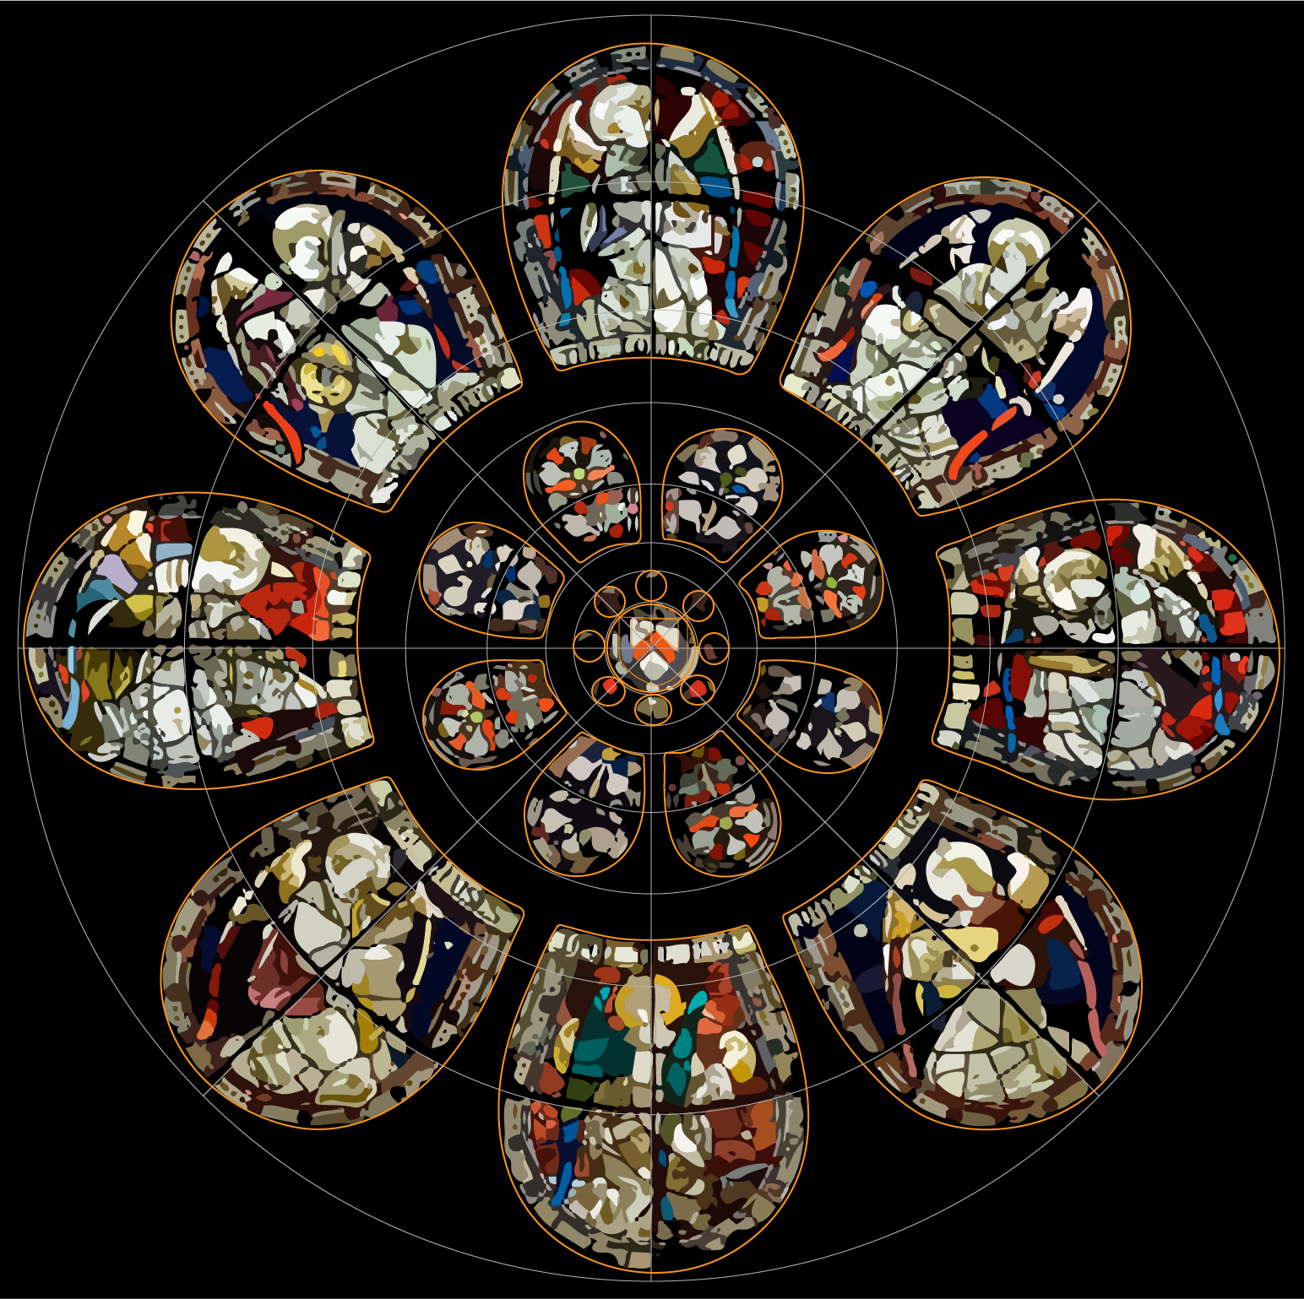

Overlay Controls

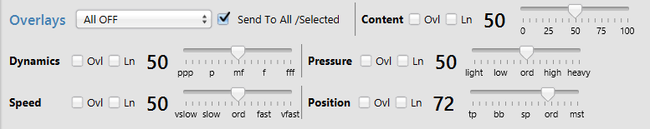

Embedded scripting
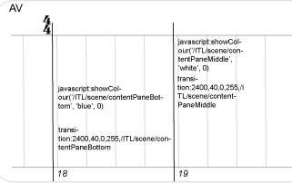

Future Work

Conclusions

