ZScore User Guide

For Ukodus

This guide explains basic ZScore system features, such as the score loading and playing.
For more advanced features please contact the author via email slavko@zagorac.com
ZScore feature explanations were correct at the time of writing (Jun 2023).

Download
Use the URL below to download ZScore package for the Ukodus score:
https://bit.ly/zspackukodus

Package Content
The package contains following directories:
- scores (score data)
- zscore (application data)

Installation

ZScore software can be run on any desktop operating system, providing that the third-party software dependencies outlined below are correctly installed.

Required third-party software
Java | ZScore GUI and server require Java jdk 1.8 (Java SE Development Kit)  which can be installed from:  https://www.oracle.com/java/technologies/javase/javase8u211-later-archive-downloads.html  Once jdk is installed, please check that that the installation is valid  (version check is good enough):  https://www.baeldung.com/java-check-is-installed
Inscore | ZScore Ukodus utilises standalone application INscore Viewer v1.21  The application can be downloaded and installed from:  https://inscore.grame.fr/
ZScore | Download and unzip zscoreUkodus.zip into any directory  That directory is referred to as <installDir> in this document

How to run ZScore
Navigate to the directory where ZScore packages were unzipped (<installDir>), either through the computer’s file system browser (Finder, Windows explorer...) or via a command line.

Run integrated ZScore application (GUI + Server)
Go to the “zscore” directory (<installDir>/zscore).

On MacOS | double click zscore.command  or execute the command line script: ./zscore.sh  TIP: If you get macOS unidentified developer warning:  right click on zscore.command→ select Open → click Open button.
On Linux | execute the command line script: ./zscore.sh  TIP: works on any Unix OS flavour
On Windows | double click zscore.bat  or execute it from the command line.  TIP: If you get Windows Defender blue window warning:  click on More Info → Run Anyway.

The script execution above should open a new terminal window containing a startup log.
TIP: Do not close this window as it will terminate the application.

The ZScore GUI should appear after a while, if everything is ok.
Figure 14 illustrates what the ZScore GUI should look like.

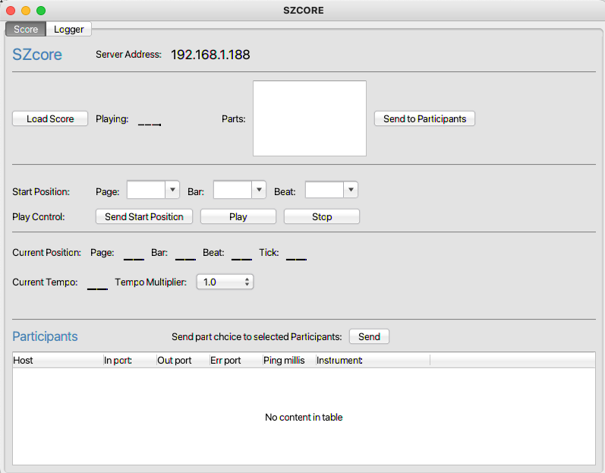Figure 1: ZScore performance control GUI

TIP: If this does not happen, or in case of any other issues, please check for any errors in the log file (szcoreApp.log).
The log file should be available in “zscore” directory (<installDir>/zscore), or in whatever directory the app was started from.

Load Score
In the ZScore GUI, click the “Load Score” button available in the top left corner.
Navigate to the installed “scores” directory and find the required composition subdirectory:
<installDir>/scores/ukodus/rsrc/
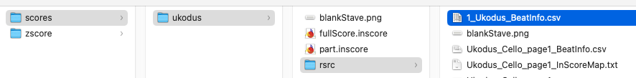Figure 2: Ukodus score directory
Select and open file 1_Ukodus_BeatInfo.csv
TIP: Required BeatInfo file should be at the top of the list if the file browser view is sorted by Name.
If the score load was successful, ZScore GUI should display the available parts and composition name as per image below.
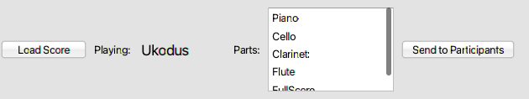Figure 3: Successfully loaded score
TIP: You can resize GUI as required by dragging its corners.

Inscore View
Start INscore standalone application. It should open as an empty window.
Drag and drop the appropriate *.inscore file into the opened INscore Viewer application window.
The files are stored in the installation directory:
<installDir>/scores/ukodus/
as illustrated in Figure 4.
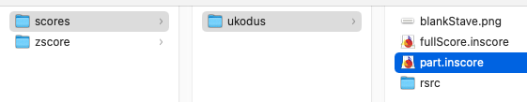Figure 4: Ukodus INscore files

The files used in Ukodus are:
part.inscore | Creates Instrument part with horizontal alternating pane layout
fullScore.inscore | Creates Full score with vertical alternating pane layout

Figure 5 illustrates the instrument part view created by the part.inscore file.
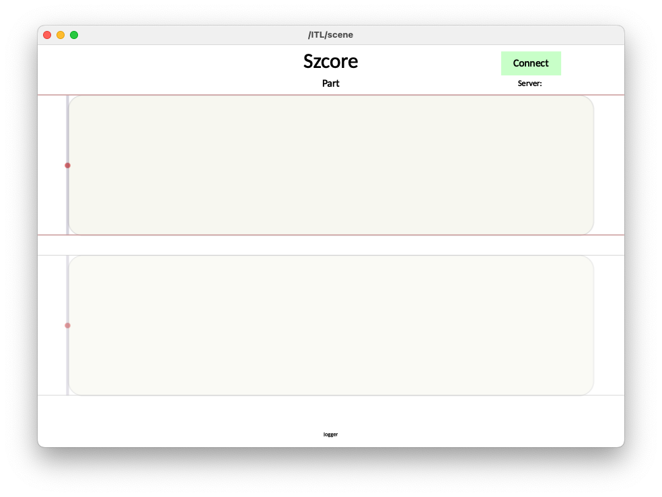Figure 5: INscore part view

Figure 6 illustrates the full score view created by the fullScore.inscore file.
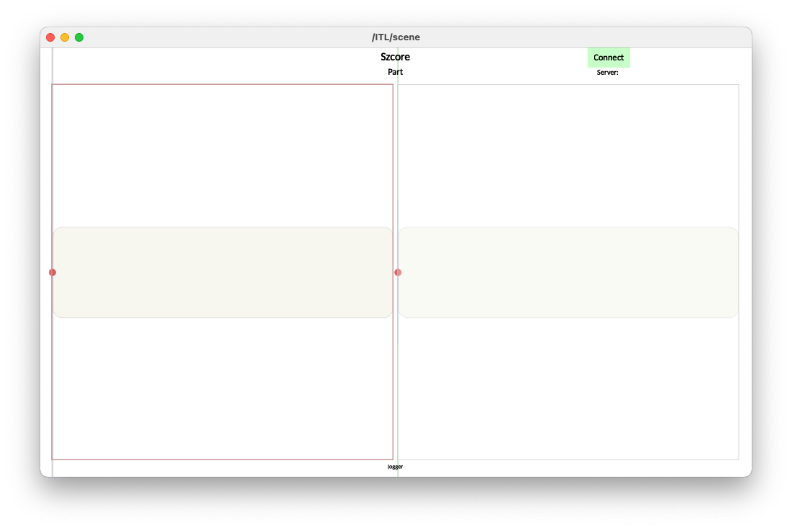Figure 6: INscore Full Score view

Connect INScore client
By default, the INscore client connects to IP address 127.0.0.1 representing the localhost.
If the ZScore GUI is running on the same host as the INscore client no changes are necessary
If the ZScore GUI is not running on the same host as the INscore client, please note the IP address displayed at the top of the ZScore GUI, illustrated in Figure 7, and modify INscore file properties as described below.
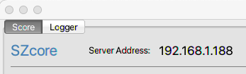Figure 7: ZScore server address

If the INscore client is not running on the same host as the ZScore GUI:
- Open required *.inscore file (fullScore.inscore or part.inscore) in any text editor. You should see settings shown in Figure 8.
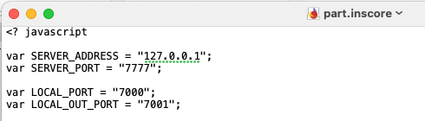Figure 8: INscore file settings

- Change the Sever IP address:
var SERVER_ADDRESS = "127.0.0.1";
to the same as the value displayed in the ZScore GUI, e.g:
var SERVER_ADDRESS = "192.168.1.188";
- Save the file.

Click the Connect button in the top right corner of the INscore Viewer.

If the connection is successful the Server label should become green and the client should be visible in the Participants list of the ZScore GUI.

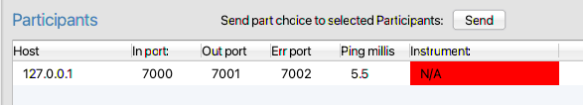Figure 9: ZScore Participants list

Part Selection
Once all clients are connected, click Send To Participants button on the ZScore GUI, highlighted in Figure 10.
Figure 10: ZScore send to participants button
A list of the available parts should be listed on all connected INscore clients as illustrated in Figure 11.
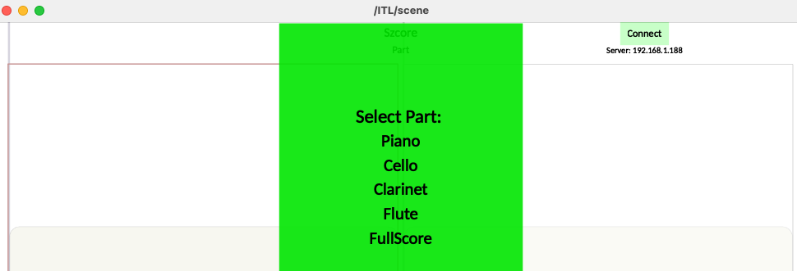Figure 11: Part selection
Select the required part.
The selected part should now be registered in the Participants list within ZScore GUI as illustrated in Figure 12.
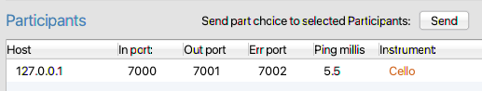Figure 12: Part Registration

TIP: Always select FullScore if fullScore.inscore file is loaded.
TIP: Use the Send to Participants button every time a new *.inscore file is loaded into the INscore Viewer, to register part change.

Play Score
Once all required parts are connected,
click the “Send Start Position” button in the ZScore GUI, highlighted in Figure 13.

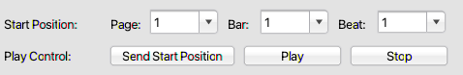Figure 13: Send Start Position

TIP: Always use “Send Start Position” before “Play”.
It is possible to change the start Page, Bar or Beat to any required value before sending the start position (Figure 13).

The selected Page should now be visible in the INscore viewer. Figure 14 shows the first page of the Ukodus score Cello part.
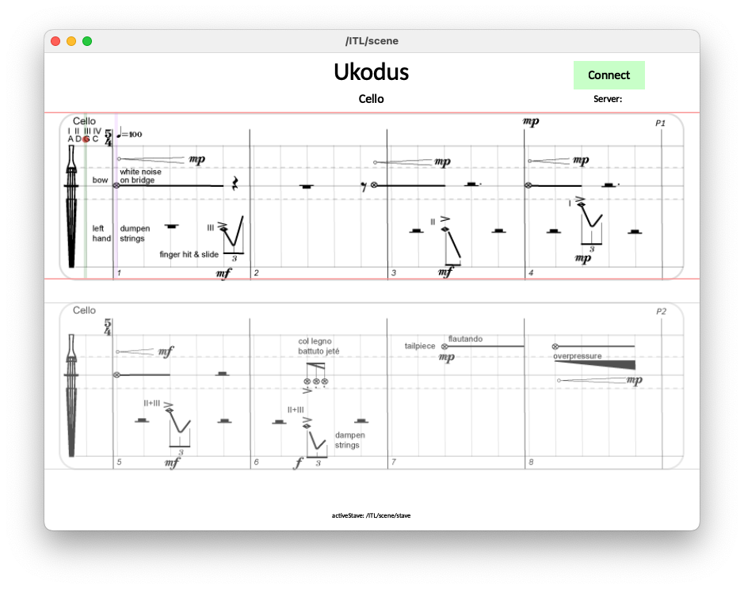Figure 14: Ukodus, Cello part, first page

Click the “Play” button in the ZScore GUI to start the score (Figure 13).
The semaphore in the top left corner of the web score should count down to the performance start.
Once the score is started, the position line will move to indicate current position in the score. Also, the bouncing ball on the top of the stave will indicate current tempo.
The score layout consists of two staves (top and bottom). One is always active (currently played) and the other one is preparatory (showing the upcoming notation).
Play starts from the beginning of the top stave and continues to the bottom stave. Once the bottom stave is completed, play continues from the beginning of the top stave.
To stop play click on the red “Stop” button in the ZScore GUI (Figure 13).

To replay the score please repeat the sequence “Send Start Position” → “Play” → “Stop”

