ZScore User Guide

For Socket Dialogues

This guide explains basic ZScore system features, such as the score loading and playing.
For more advanced features please contact the author via email slavko@zagorac.com
ZScore feature explanations were correct at the time of writing (Jun 2023).

Download
Use the URL below to download ZScore package for the Socket Dialogues score:
https://bit.ly/zspackdialogues

Package Content
The package contains following directories:
- max (Max patch and data)
- scores (score data)
- zscore (application data)
The zscore directory contains following subdirectories:
- zscore_jgui (ZScore GUI and server)
- webroot (Web Score content)
- audienceWebroot (Audience Web content)
A standalone Max 8 patch app for MacOS is available, if required. It does not require Max 8 installation, however, due to its size (> 1GB) Max 8 installation is preferable.

Installation
ZScore software can be run on any desktop operating system, providing that the third-party software dependencies outlined below are correctly installed.
Required third-party software
Java | ZScore GUI and server require Java jdk 1.8 (Java SE Development Kit)  which can be installed from:  https://www.oracle.com/java/technologies/javase/javase8u211-later-archive-downloads.html  Once jdk is installed, please check that that the installation is valid  (version check is good enough):  https://www.baeldung.com/java-check-is-installed
Max 8 | Some scores written for ZScore use Max 8 as the digital audio source.  If Max patches are required for the score, please install Max 8 (free for 30 days)  from:  https://cycling74.com/downloads  On mac computers with Apple silicon chips please run Max in Rosetta
ZScore | Download and unzip zscoreDialogues.zip into any directory (<installDir>)

How to run ZScore
Navigate to the directory where ZScore packages were unzipped (<installDir>), either through the computer’s file system browser (Finder, Windows explorer...) or via a command line.

Run integrated ZScore application (GUI + Server)
Go to the “zscore” directory (<installDir>/zscore).

On MacOS | double click zscore.command  or execute the command line script: ./zscore.sh  TIP: If you get macOS unidentified developer warning:  right click on zscore.command→ select Open → click Open button.
On Linux | execute the command line script: ./zscore.sh  TIP: works on any Unix OS flavour
On Windows | double click zscore.bat  or execute it from the command line.  TIP: If you get Windows Defender blue window warning:  click on More Info → Run Anyway.

The script execution above should open a new terminal window containing a startup log.
TIP: Do not close this window as it will terminate the application.

The ZScore GUI should appear after a while, if everything is ok.
Figure 1 illustrates what the ZScore GUI should look like.

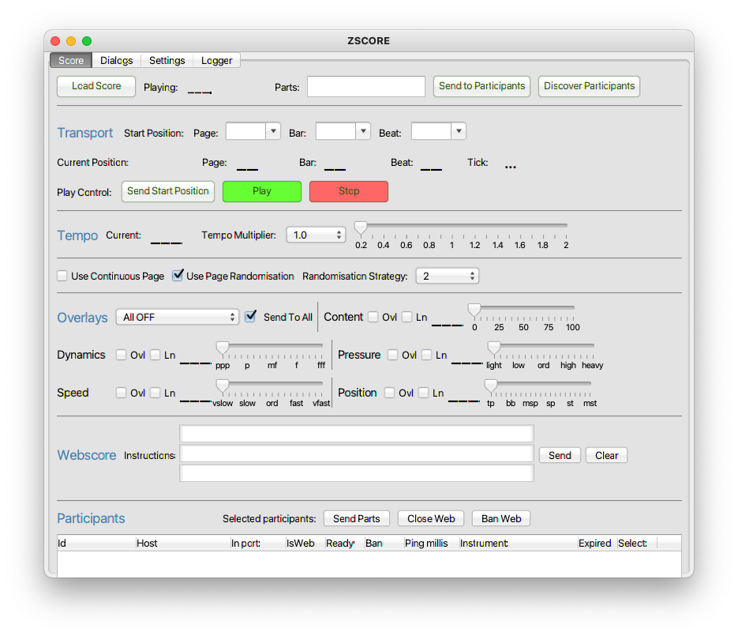Figure 1: ZScore performance control GUI
TIP: If this does not happen, or in case of any other issues, please check for any errors in the log file (szcoreApp.log).
The log file should be available in “zscore” directory (<installDir>/zscore), or in whatever directory the app was started from.

Load Score
In the ZScore GUI, click the “Load Score” button available in the top left corner of the “Score” tab.
Please note that Socket Dialogues name is shortened to dialogs in all file names.
Navigate to the installed “scores” directory and find the required composition subdirectory:
<installDir>/scores/dialogs
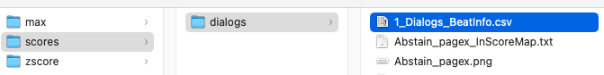Figure 2: Socket Dialogues score directory
Select and open file 1_Dialogs_BeatInfo.csv
TIP: Required BeatInfo file should be at the top of the list if the file browser’s view is sorted by name.
If the score load was successful, ZScore GUI should display all available parts and the composition name as illustrated in Figure 3.
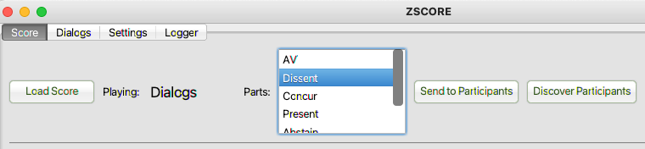Figure 3: Successfully loaded score view
TIP: You can resize GUI as required by dragging corners.
Socket Dialogues score is managed and run from the Dialogs tab illustrated in Figure 4
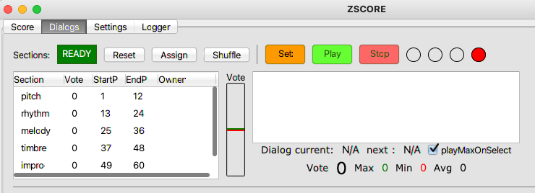Figure 4: Socket Dialogues Tab

Web Score View
The Web Score view displays music instrument notation and is usually hosted on 12” tablets. However, it can be viewed on any computer, including localhost.
Make sure ZScore GUI is running and the score is correctly loaded, as described above.
Open an Internet browser (the latest version of any modern browser should do).
If you have used the same browser previously to view another score, please clear the browser cache.
In the browser address bar at the top, put:
http://localhost:8080/ (if the browser is running on the same computer as ZScore GUI)
or
http://<host_ip_address>:8080/ (if the browser is running on another device on the same network)
where <host_ip_address> is the IP Address or hostname of the computer where ZScore GUI is running.
This IP address can be found in the ZScore GUI “Settings” tab, next to “Server Address”.
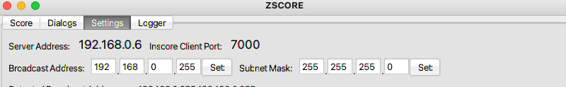Figure 5: Host IP Address example
TIP: In the custom ZScore performance environment this address is http://zscore:8080/
The browser should now display a menu of available scores as illustrated in Figure 6.
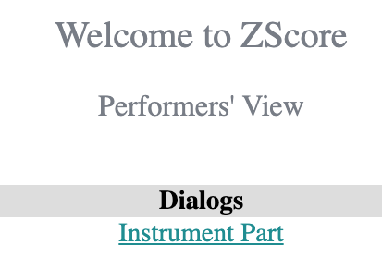Figure 6: Web Score default view

To view the instrument part, please click on the appropriate “Instrument Part” link.
The browser should now display the “Select Transposition” view shown in Figure 7.
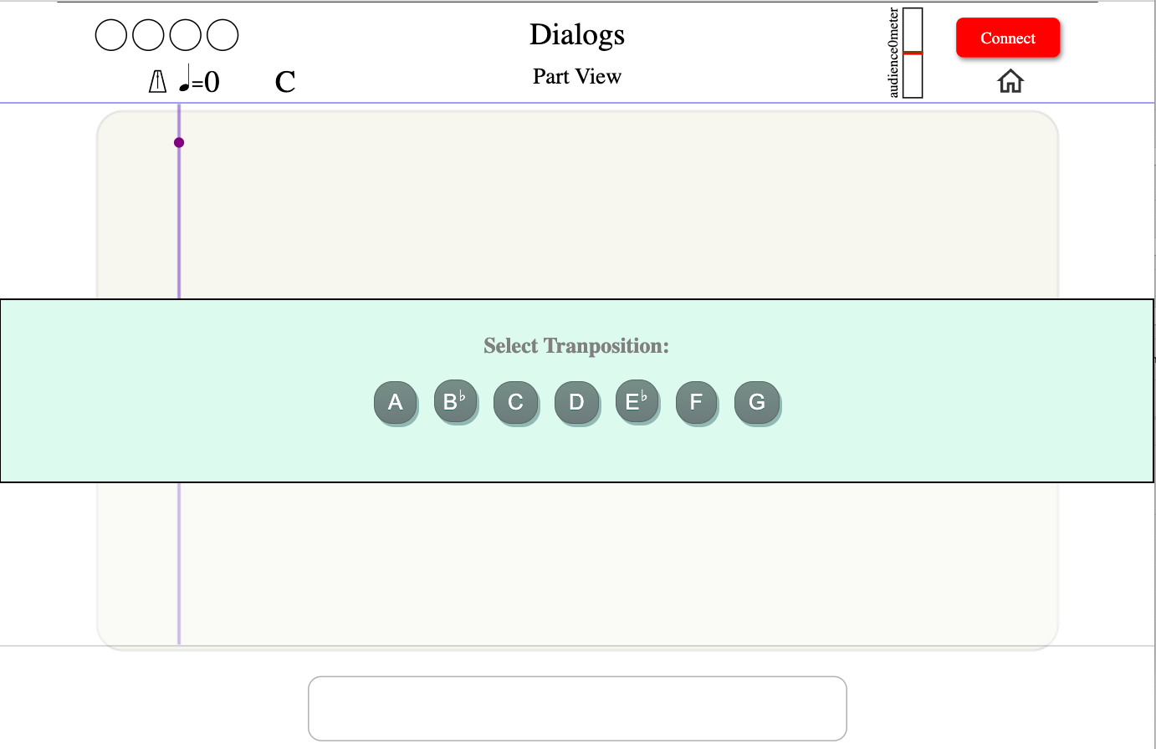Figure 7: Socket Dialogues, Web Score initial view
Select an appropriate transposition (C for the default notation).
The view should change to the Presenter selection view as illustrated in Figure 8.
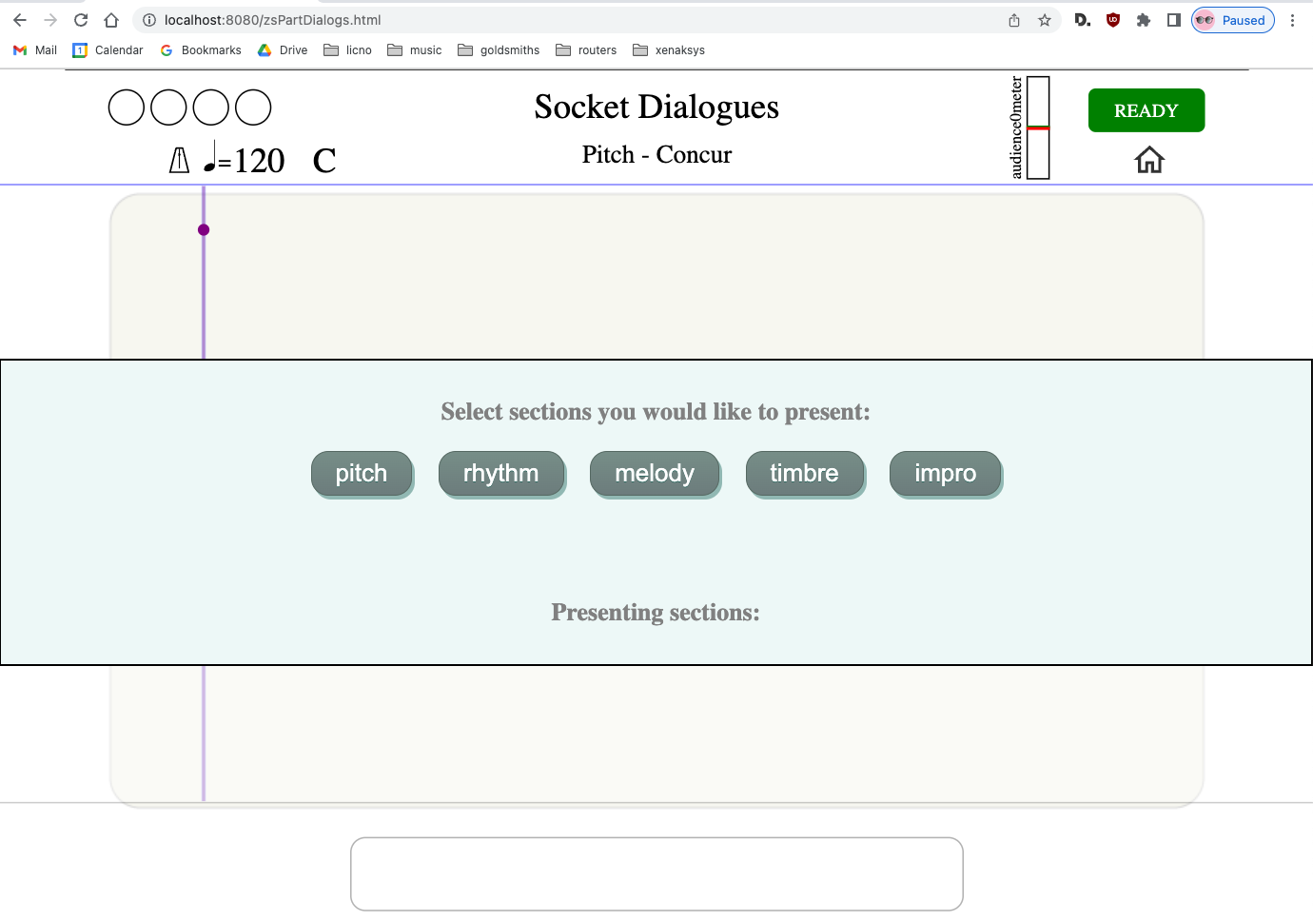Figure 8: Socket Dialogues, Presenter selection screen

Musicians should then select Dialogues they wish to present from the list illustrated in Figure 8.
The order of selection also sets the order of play. The selection order can be observed in the Dialogs tab. For the example illustrated in Figure 9, the order of play is:
melody → pitch→ rhythm→ impro → timbre
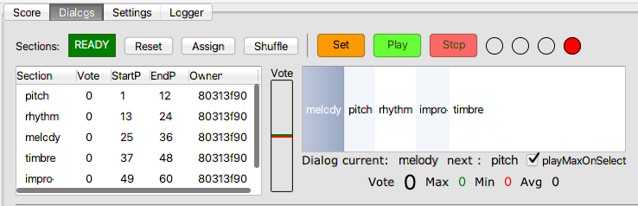Figure 9: Socket Dialogues, order of play
The conductor can change the order of play by selecting the dialogue name in the list on the right (Figure 9) and clicking the orange “Set” button.
All Dialogues have to be selected by the Presenters before the start of play.

Play Dialogue
Select Dialog tab in the ZScore GUI.
To manage the dialogue play, use buttons “Set”, “Play”, and “Stop” shown in Figure 10.
To play the selected dialogue, always use the sequence:
- “Set” (sends all required data to network clients for the selected dialogue)
- “Play” (starts dialogue play)
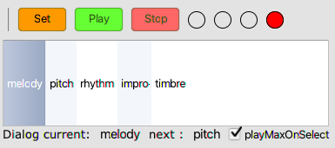Figure 10: Socket Dialogues, play management

To stop dialogue play at any point, use “Stop” button.
On “Set” button click, the Presenter’s view should be updated as illustrated in Figure 11.
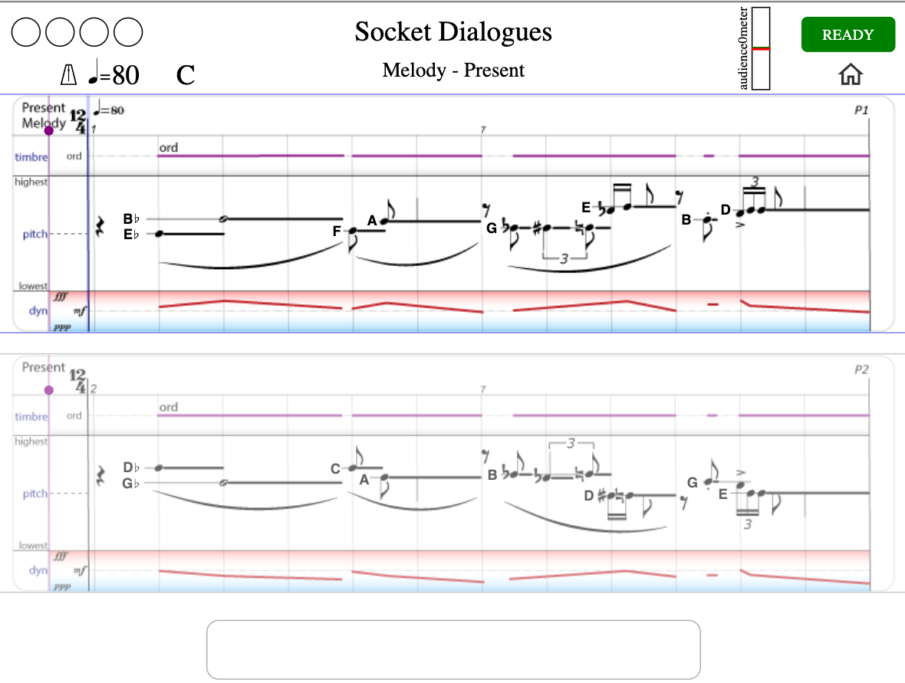Figure 11: Socket Dialogues, Presenter’s view on “Set”

On green “Play” button click (Figure 10), all clients should start playing the selected dialogue.
The semaphore in the top left corner of the web score should count down to the performance start.
Once the score is started, the position line will move to indicate current position in the score. Also, the bouncing ball on the top of the stave will indicate current tempo.
The score layout consists of two staves (top and bottom). One is always active (currently played) and the other one is preparatory (showing the upcoming notation).
Play starts from the beginning of the top stave and continues to the bottom stave. Once the bottom stave is completed, play continues from the beginning of the top stave.

Performer Actions
All connected musicians, apart from the Presenter, can choose their role in the Dialogue by selecting one of the options: “Concur”, “Dissent”, or “Abstain” as illustrated in Figure 12.
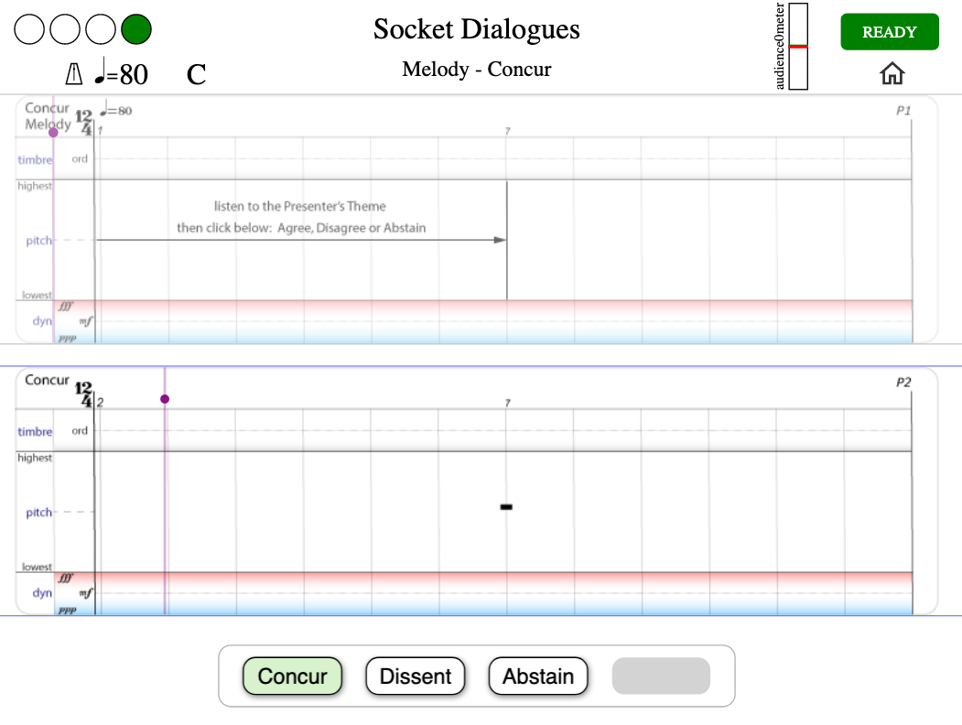Figure 12: Socket dialogues, musician's role selection
The notation for the selected role is displayed in the next time window.
Please Note: If you wish to run multiple Web Score Clients from the same machine, please use a different internet browser make for each client (e.g. Chrome for one client and FireFox for another), as the performer Id is unique for the combination of the hostname/browser make.

Audience Score View
Audience score is usually accessed via mobile devices, however, any computer can be used, including the localhost.
Open an Internet browser (the latest version of any modern browser should do).
If you have used the same browser previously to view another score, please clear the browser cache.
In the browser address bar at the top, put:
http://localhost (if the browser is running on the same computer as ZScore GUI)
or
http://<host_ip_address> (if the browser is running on another device on the same network)
where <host_ip_address> is the IP Address or hostname of the computer where ZScore GUI is running.
This address is available in the ZScore GUI “Settings” tab under “Server Address” (Figure 5).
In the custom ZScore performance environment, audience view address is: http://zscore/
The browser should now show the welcome page as illustrated in Figure 13.
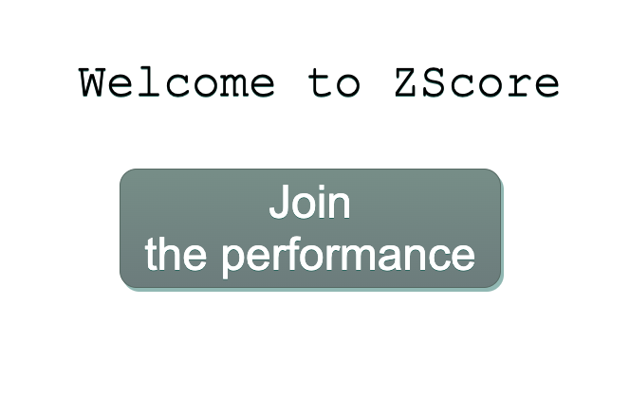Figure 13: Audience view welcome page

Click the “Join” button to connect to the ZScore audience server.
Once the browser is connected to the server, the view should change to the composition specific welcome page.
An example of the initial view for “Socket Dialogues” is shown in Figure 14.

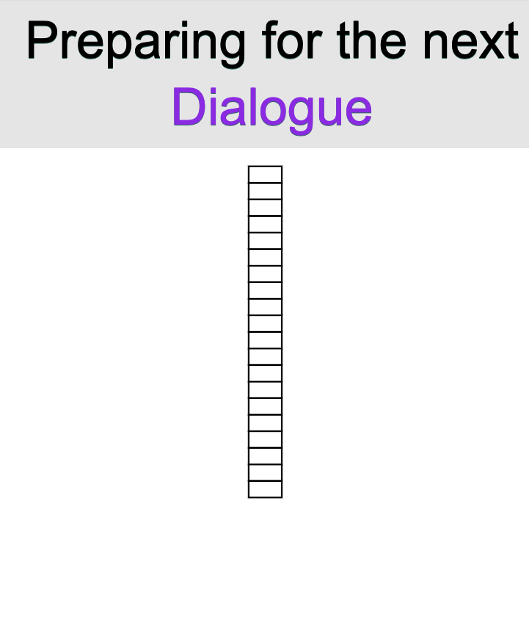Figure 14: Socket Dialogues, audience initial view

Once the score is started, as described above, the audience view will be played in sync with the performers’ score.
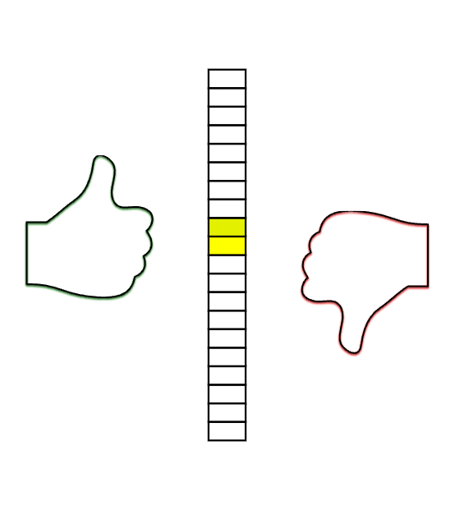Figure 15: Socket Dialogues, vote view

The Web Score and Audience view can be modified from ZScore GUI in real-time.
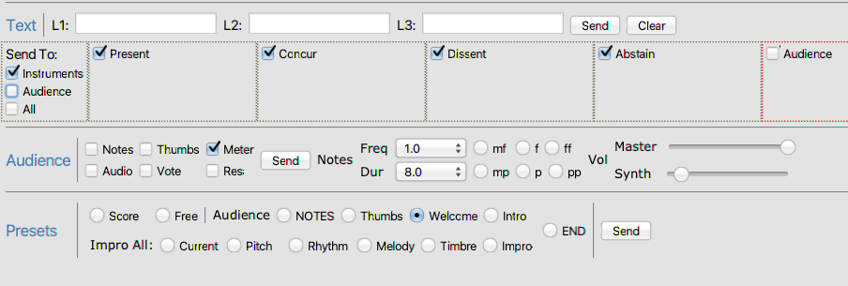Figure 16: Socket Dialogues, score view controls

Dialogs tab contains a number controls that can modify current views, such as Text lines, Audience view presets (notes, thumbs, meter, etc.).

ZScore Max
Some scores use Max 8 as a digital audio source.
On mac computers with Apple silicon chips please run Max in Rosetta (tick “Open using Rosetta” on Max.app Info window).
To open max patch, navigate to the installed max directory:
<installDir>/max
Double click 1_zscore.maxpat (it should be the first file on the list id the file browser is sorted by name)
After a while, the patch should appear as displayed in Figure 17.
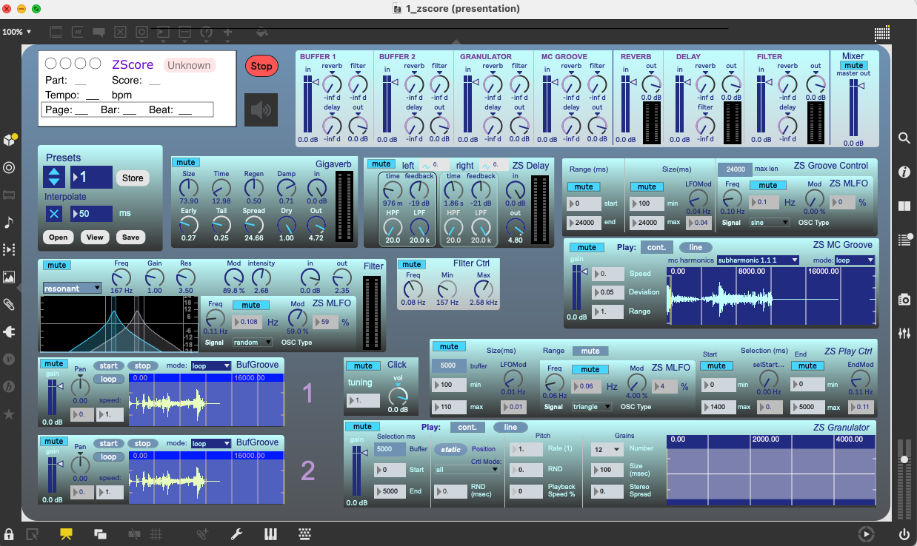Figure 17: ZScore Max 8 patch

Initialisation and verification
Click on the speaker icon (ezcac~) below the red Stop button (indicated in Figure 17)). It should turn blue.
Check the audio in/out devices are set as required (Options → Audio Status → Input/Output Device)
In the ZScore patch “Presets” box, increase the preset number to 2 ( highlighted in Figure 17).
Click the “start” button on the buffer 1 (highlighted in Figure 17).
You should hear the buffer content.
TIP: If there are any problems please check Max Console for errors.

OSC Device Connection (Including Max)
Max patch talks to ZScore server via OSC protocol.

To connect any OSC device (Inscore, Max...) first click on the “Discover Participants” button in the ZScore GUI Score tab.
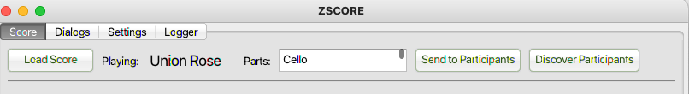Figure 18: OSC device discovery
After a while, available OSC devices should appear in the Participants table as shown in Figure 19.
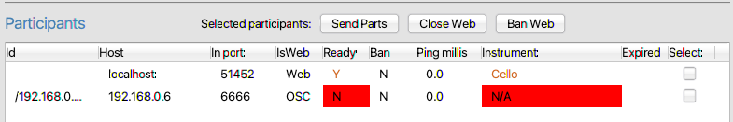Figure 19: OSC device registration
Once the OSC device is visible on the Participants list, click on the “Send to Participants” button in the ZScore GUI. This will send score information to all connected OSC devices.
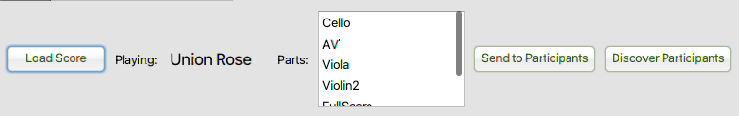Figure 20: Send to OSC Participants
Max device should be now recognised as “AV” instrument in the Participants list.
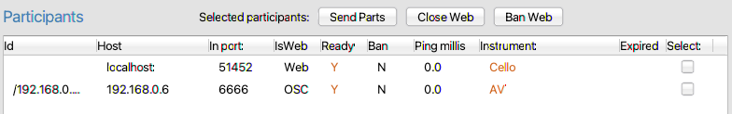

After the “Set” button in the Dialogs tab is clicked (Figure 10), as described above, Max patch should display the score name and current position.
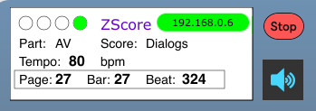Figure 21: Max patch score info

When the score is played, Max patch should play in sync with the performers’ and audience’s views.
Please note: it the check box playMaxOnSelect (Figure 10) is ticked, Max will play Granulator and MC Groove components on each Dialogue’s start of play. If you do not want this behaviour, please untick the box.
TIP: The sequence “Discover Participants” → “Send to Participants” described above should be executed every time an OSC device is opened/restarted.
TIP: Running Max and Web Audience clients on the same box may cause audio issues, depending on the host machine spec. To get the best results, run Max on a separate box.
TIP: if the Max zscore patch is closed then the entire Max 8 application needs to be shutdown before opening the patch again. Reopening the patch while Max 8 is running might cause errors (please check Max console for any errors)

Latency calibration and compensation
Currently, there is no automated latency compensation in ZScore.
As the Max patch introduces additional latency due to real-time network and audio processing, it is sometimes necessary to calibrate web score latency to be in sync with Max audio.
The calibration can be visual (by observing the current position line in the web score and system latencies in the Participants list) or auditory for a more accurate synchronisation.

Auditory calibration
Both web score and max client have a built-in audio click. The click is only heard during a score play.
To enable/disable the audio click in a Web Score client, click on the metronome icon available in the top left corner.
This should enable click control as illustrated in Figure 22.
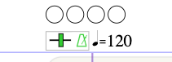Figure 22: Web score click controls

If required, the click pitch can be changed by dragging the green bar next to the metronome icon left or right.
To enable audio click in the Max patch, unmute Click box as illustrated in Figure 23.
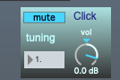Figure 23: Max 8 click controls

If required, change click tuning and volume in the Max patch.

Web Event Delay Setting
With both web score and Max click enabled, play the score to hear the time difference between web and Max clients.
TIP: mute all other Max sources apart from the click box.
To modify web score click timing, change Web Event Delay Ms value in the “Settings” tab of the performance control GUI, as illustrated below.
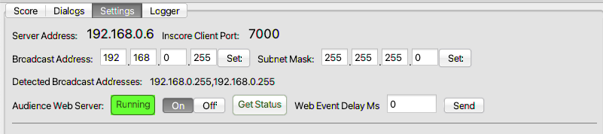Figure 24: Web score latency delay controls
TIP: Gradually increase web delay until Max and Web score click happen at the same time.
On a local host, a delay value of somewhere between 20 – 50 milliseconds is usually adequate, however, this value may vary significantly depending on the local network configuration.
Once the delay is set to a desired value, disable web score click by clicking on the metronome icon and mute Max 8 Click control.
TIP: In the dedicated ZScore performance environment all score devices are connected via Ethernet cable to minimise latency and jitter. Audience devices connect via Wi-Fi so the audience score view is designed to cope with higher latency variations.

