Networked Music Composition and Performance

Slavko Zagorac

Goldsmiths, University of London PhD

2023

I declare that the work submitted is my own, and does not contain any unacknowledged material from other sources.

Slavko Zagorac

Abstract
This theses explores utilisation of computer networks in music-making practice. It broadly consists of two components: the software development of ZScore networked music-making environment and a portfolio of compositions written for the ZScore system. The validity of the system’s technical capabilities and creative compositional intentions has been tested in numerous workshops and performances with musicians and live audience. The technical and creative aims, their implementation and results are presented below.
Networking technology allows all performance participants: musicians, audience, composers, conductors as well as audio and video artist and various digital engines, to connect and exchange data and events in real-time* (here it means instantly, not guaranteed response time). A music score, written to take an advantage of such an environment, becomes a set of data and algorithms dynamically distributed to all participants during a performance. In order to perform their part, different participant types require different score representations (e.g. notation, graphics, OSC messages etc.). Furthermore, networking technology can be used to democratise music composition and performance processes by distributing decision-making ability to different participant types. This blurring of the traditional music-making roles and inclusion of audience as an active performer and decision-maker requires a fresh approach to compositional aesthetics and invention of novel strategies to deal with unexpected outcomes.
ZScore is a collection of third-party and newly-developed components aiming to provide solutions for complex notation authoring, reliable score data distribution over a network to heterogeneous clients, precise performance scheduling and dynamic rendering of interactive stave-based scores, distributed decision-making agency for all participants, audience connectivity over mobile devices and score representations for immersive audience participation. The system specifications for ZScore have been drawn from the analysis of existing networked notation systems and state of the art solutions from other industries where high-throughput, low-latency systems have been successfully implemented.
The attached composition portfolio outlines the journey towards a new paradigm of music-making, starting from a traditional static score, fully defined by a composer and faithfully performed by musicians and ending with an interactive networked composition entirely driven and performed by the audience in real-time. Each score deals with a set of new challenges both technical and aesthetic. The composition commentary explains specific challenges for each score, strategies that were used to deal with the related issues and the outcomes of the applied solutions.
Table of Contents
Abstract 4
List of Figures 6
Acknowledgments 7
Introduction 8
To Music Is To Communicate 8
Decision-making Spectrum 9
Networked Music-making 11
Existing Solutions 12
Gaps and Research Aims 13
Approach to Music Composition and Aesthetics 15
ZScore 17
Portfolio: A Journey From A Static Score to Dynamic Music-making 19
Red Mass 19
Objective: Compositional Method 19
Score Commentary 19
Ukodus 24
Objective: Linear Networked Composition and Performance 24
Dynamic Notation 24
Alternating pane Layout 25
Time-space mapping and synchronization 26
Notation Authoring 26
Performance Control 29
Notation Rendering 30
Score Commentary 31
Vexilla 38
Objective: Audience View 38
Embedded Scripting 38
Event scheduling 38
Audience view 38
Use of colour in notation 38
Score Commentary 38
Results 48
General discussion 49
Conclusions 50
References 51
Appendices 52

List of Figures

Acknowledgments

I would like to thank Roger Redgate his knowledge, guidance, insight, and experience, and for being there throughout my PhD journey. I am grateful for the faith he showed in my ideas and research as they developed from project to project.
I also need to thank all my secondary supervisors who supported me through different periods of my research, starting with Patricia Alessandrini for her expertise, dedication and inspiration at the very beginning of my journey. I then had a privilege to work with Michael Zbyszynski whose in-depth technical and creative guidelines kept the scope of my work on track in the confusing middle period of this research. Finally, I would like to thank Jenn Kirby for her invaluable support, advice and help in my efforts to complete this work as well as our frequent, most enjoyable discussions on music and technology.

Thanks to the funding by Goldsmiths Music Department** and Graduate School I was able to collaborate with a number of incredible musicians and ensembles who provided me with invaluable experience and feedback that shaped ZScore system and this work. I would like to thank Ensemble Interface, Moscow Contemporary Ensemble, the incredible Ligeti Quartet and especially its members Patrick Dawkins and Val Wellbanks, as well as Heather Roche, Benedict Taylor, Tom Jackson, Anne Han and Khabat Abas for their superb musicianship, patience and an open mind.

Introduction

To Music Is To Communicate
Music is not an object or a noun but an activity that people take part in, therefore, a verb “to music” or its gerund “musicking” is a more adequate way of describing the essence of what happens during a musical performance, according to Christopher Small (Musicking). The meaning can not be found exclusively in the music material itself, the search focus needs to be expanded to include all the relationships between different actors in a music-making process:

The act of musicking establishes in the place where it is happening a set of relationships, and it is in those relationships that the meaning of the act lies. They are to be found not only between those organized sounds which are conventionally thought of as being the stuff of musical meaning but also between the people who are taking part, in whatever capacity, in the performance; and they model, or stand as metaphor for, ideal relationships as the participants in the performance imagine them to be: relationships between person and person, between individual and society, between humanity and the natural world and even perhaps the supernatural world. (Musicking p 13)

In order to create relationships between music-making participants it is necessary to establish communication channels that convey information required for enactment of a particular participant roles. The information content consumed and produced by each participant role differs, for example: a composer produces instructions for musicians encoded as a symbolic notation, a conductor sends physical gestures to musicians based on composer’s score, musicians consume notation and conductor gestures and produce sound waves consumed not only by audience but also by all other performance participants who react to generated sound in real-time. Therefor, Small’s observations about the essence of music-making could be extended by stating that in order “to music” we have “to communicate”.

The ultimate aim of music-making is to create an aural experience for audience and other performance participants. The human relationship with sound is much deeper and more ancient than our relationship with words (How Humans Communicate Through Sound, Kraus Slater). Our modern communication systems are the product of our ancient relationship with sound and movement, rooted in the physical world.
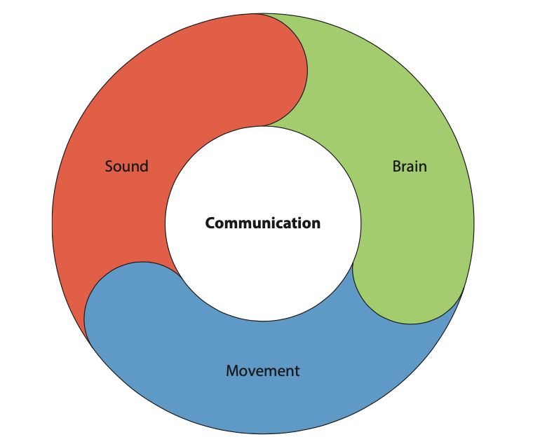Figure 1: Communication with sound is rooted in the physical world

Sound wave pressure detected by listeners’s ear sensors triggers complex processing in multiple areas of the human brain and causes physical reactions, subconscious emotions as well as conscious feelings and thoughts (Music and the brain). Music-making activity is built on top of these deeply embedded communication processes. An experienced musician can invoke a mental representation of a sound in isolation, without any external communication, just by looking at a music score, however, this is equivalent to recalling memories stored in a brain from previous lived experiences and is not identical to the experience itself (Small).

Traditionally, communication of information in music-making is a one-directional flow. For example, in a simplified classical music-making scenario, a composer creates a music score in isolation, prints it on paper and sends it to musicians. In a performance venue, musicians produce sound based on the score information. Although not described explicitly in the score, performers also produce conscious or subconscious visual gestures that form an important part of a performance context. Produced sound waves and visual information are consumed by the audience during a performance triggering internal reaction. There is no direct feedback loop in this scenario apart from the applause at the very end of a performance showing audience appreciation. Otherwise, audience is purely an information consumer during such a performance.

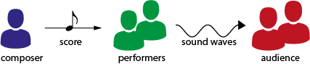Figure 2: Traditional music-making one-way communication flow

All participants in a music performance constantly evaluate received aural and visual signals and react based on their role and a performance context. Like any other form of communication, music-making requires some degree of common knowledge and shared experience between the communicators in order to be understood and adequately evaluated.

Decision-making Spectrum
Composition and improvisation are often regarded as mutually exclusive music-making categories. In practice, however, it is not possible to define a clear boundary between composed and improvised. Bhagwati [1] argues that no score can totally determine all aspects of a musical performance and that some elements of music-making will always be contingent. Likewise, a performer’s free improvisation is built on years of practice and performance, stemming from a particular tradition and aesthetic context. A free improviser also adheres to a set of rules and regulations that might be imperceptible to a performer. It follows that any music performance lies somewhere on the spectrum between composed and improvised. The portmanteau word ‘comprovisation’ is often used to describe this mix.

A piece of music, whether composed or improvised, is conceived through a decision-making process defining what sound or action is to be performed and at what time. In a composed piece, most music material decisions are made pre-performance in isolation by a composer who preserves these decisions as notation realised in a static score. Even in the most meticulously notated scores, however, many performance decisions are left to the performers who interpret the given notation based on their experience and knowledge of the particular music tradition. Rodrigo Constanzo [8] developed a formal methodology for analysis of the decision-making process in improvised works. His segmentation of the music-making decisions into material, formal, interface and interaction, illustrates the improviser’s real-time dynamic decision-making approach in an interactive group performance environment.

It could be postulated that all music-making exists within the comprovisation decision-making spectrum between predetermined statically notated decisions and dynamically made decisions in real-time (Figure x My Tenor 2018).

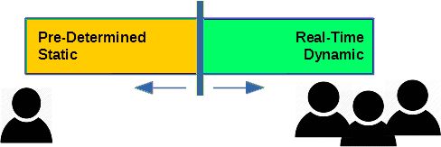Figure 3: Music performance decision making spectrum

An important consideration when discussing the comprovisation decision-making spectrum is to observe who the decision makers are, the type of the decisions made and their impact on the aesthetic evaluation of the piece of music. Traditionally, composers’ decisions are immutable. If a performer intentionally or accidentally modifies a statically notated piece of music during a performance, it is generally interpreted as the aesthetically unsatisfactory realisation of a piece. In a free improvisation performance, performers are allowed to make individual decisions at any time. Although there are no right or wrong decisions in this case, the aesthetic value of a performer’s decision is continually assessed within the context of a particular performance by the audience, the performer who made the decision, and by all other performers who react in a chain of decisions resulting in a self-regulating musical output. Comprovisation pieces that sit in the middle range of the decision-making spectrum contain both static immutable elements and a dynamic decision loop created by multiple decision makers in real-time.

Networked Music-making
Networked systems allow users to communicate and coordinate actions by passing messages over a computer network. All network systems, including Internet and Local Area Network (LAN) are based on Open Systems Interconnection model (OSI model wiki) that ensures connectivity between heterogeneous clients running on different hardware and software implementations. Modern high-throughput, low-latency messaging systems (Distruptor/others) are able to pass through thousands of messages per second with sub millisecond latencies. Network messages can both transfer large quantities of data from one place to another and carry events that trigger actions at different target nodes. Event-driven systems usually rely on a set of rules defining a type and timing of actions that need to be executed on event receipt. Considering that event-driven networked systems provide both fast communications between different actors and a decision-making functionality they are well suited to be used in a music-making activity.
Networked music-making systems allow all participant types: musicians, audience, composers, conductors as well as various digital audio and video engines, to connect and exchange data and events in real-time (doesn't mean guaranteed system response but very fast).

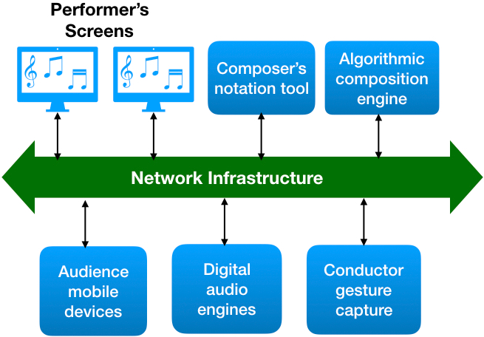Figure 4: Networked music-making system

Unlike traditional one-directional communication flows (Figure 2), networked systems allow for a multi-directional communication between all participants (Figure 5). Any participant in a networked system can be assigned sound production or decision-making ability, thereby blurring the boundaries between the traditional music-making roles. Furthermore, networking technology allows for unconstrained control of the comprovisation decision-making dial (Figure 3) as required by the context of a performed piece of music.

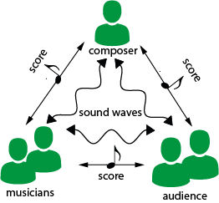Figure 5: Networked music performance multi-directional communication

Existing Solutions
A number of software solutions able to dynamically render music scores distributed over a local or wide area network have been developed in the last two decades. Amongst the available solutions are: MaxScore [] and related projects Drawsocket[], Symbolist [] and Quintet.net [], standalone or web browser hosted InScore [], Bach Composer [] built on MAX platform, Decibel ScorePlayer [] app which runs on iOS devices, dfscore [] which relies on Node.js server event distribution etc. Recent Odot[] developments also allow for OpenMusic [] notation integration over a network. Some composers and laptop orchestras in particular develop proprietary composition and performance software in programming environments such as MaxMSP, Processing, SuperColider and ChucK programming language. While all notation applications share common high level functional objectives, their internal data models, score rendering versatility, system dependencies, time synchronization strategy and modes of communication vary greatly. As a common feature they all have a front end running on a computer or a mobile device capable of rendering dynamic music notation and some kind of logic running either on a server (such as MAX, Node.js …) or directly on a client (Decibel ScorePlayer) that distributes data and events over a network.

Open Sound Control (OSC) messaging protocol has emerged as the leading choice for data and control message encoding and distribution between music notation applications over a computer network. The majority of OSC implementations rely on User Datagram Protocol (UDP) connectionless communication. InScore supports OSC natively, while MaxMSP based solutions use various third-party OSC implementations. Quintet.net additionally uses TCP protocol where reliable messaging is required.

Odot framework middleware oriented messaging [] is a welcome step towards network services abstraction. It wraps OSC protocol and provides transcoding to JSON, SVG and S-Expressions, as well as bindings to Javascript and Lisp. Landini [10] can also be classified as a form of a messaging middleware as it creates an additional layer between music applications communicating over OSC. Landini implements a reliable, ordered message delivery protocol which detects packet loss and attempt recovery. Furthermore, it monitors network latency and applies OSC timing corrections for more accurate event synchronization. Quintet.net also provides proprietary strategies which deal with network jitter and latency.

A recent trend has seen a move from various disparate client front end implementations towards solutions running in a common web browsers deploying Websocket point-to-point connectivity to a server, such as Drawsocket and dfscore as well as the latest version of InScore. Drawsocket and dfscore are implemented as proprietary javascript libraries while Inscore uses native WebAssembly[] that enables native code to run within web browser container. An excellent comparison of browser based score systems is available in J Bell’s Tenor 2021 article [].

Most of the existing compositional tools allow for the authoring of traditional symbolic notation. Support for graphical notation, custom symbols, staves or extended performance techniques, is commonly achieved by the layering of SVG of rendered graphics on top of rendered symbolic notation. The maximum number of parts allowed in a score is either restricted explicitly or by the available application memory. Delivery of larger instrumentation, such as a full-sized orchestra, remains a significant challenge, especially when tight timing synchronisation is required. The most impressive results scalability-wise have been achieved with Drawsocket for the performance in St. Pauli Elbe tunnel[] where 144 musicians spread out over 864 meters performed several live pieces.

Scores are typically composed off-line in a proprietary data model. If required, they are converted to one of the common notation formats for sharing with other notation applications. Currently, there is no clear winner between competing symbolic notation formats such as GUIDO, JMSL or MusicXML. Real-time notation generation and distribution is well supported, however, communication between heterogeneous applications normally requires transcoding of the native data models to OSC on all participating nodes [3].

For time synchronization between network nodes notation applications typically either rely on the system clocks or regular heartbeats sent from the master node. Network time protocol (NTP) is used by default on most LANs for system clocks synchronization, and by design, can cause inaccuracies of up to 100 ms between computer clocks. The application scheduling resolution which defines a minimum time interval between two scheduled events is normally defined in the milliseconds range.

Gaps and Research Aims
The original research questions at the outset of my research asked first: how to utilise full power of real-time event-driven systems in order to evolve existing music composition and performance methods, and second: can innovations in networked ensemble music composition and performance lead to an authentic musical aesthetics?
Subsequent research discovered several gaps in existing networked music solutions. Most of the existing solutions provide one-way communication flow (Figure 2). There are some interactive features in existing solutions allowing players to send feedback to performance controllers, however there is a lack of an interactive music composition and performance model for multi-directional communication flows [Figure 3] that include event distribution rules such as: who can take action, at what time, what the action outcomes are and who the outcome recipients are. An interactive model needs to accommodate different event distribution modes such as: one-to-many, many-to-one or many-to-many. This requires precise and flexible event scheduling and rule definition mechanism.
The premise that any participant can assume decision-making agency blurs boundaries between traditional music-making roles. An interactive music composition model needs to cater for multiple role definitions and their mapping to music material, available actions, action timings and outcomes. The impact of non-linear composition flows and a multitude of action outcomes on compositional aesthetics needs to be carefully considered. Interactive features (buttons, controls, etc.) need to be clearly visible and easily accessible on musicians’ and audience’s front ends. Users need time to notice and react to interactive features and, ideally, understand what the intended impact of their actions is.
A dynamic notation view requires a carefully thought out refresh strategy which does not interfere with the currently played notation, providing enough time and space for musicians to prepare for the upcoming material. The refresh strategy needs to take into account network and rendering latency and ensure that notation updates do not interfere with the score continuity.
A good dynamic score front end design should fully utilize available screen real estate and provide a clear view of the notation, available actions, and any additional information musicians should be aware of during a performance. If delivery to heterogeneous platforms is required, the notation should be legible when scaled to any of the common screen aspect ratios (4:3, 16:9 and 16:10), screen sizes (10 to 17in) and resolutions (1024x768 to 3840x2160).
Dynamic scores with linear stave notation typically either use the full page or stave update as in Richard Hoadley’s Calder’s Violin where the entire view is replaced with new notation at once, or the continuous scroll as in Cat Hope’s Longing and Luciano Azzigotti’s Spam where the notation moves continually from left to right. These strategies are suitable for particular score types. However, for complex notation scores, the full page refresh strategy does not provide much preparation time for musicians, especially where performance continuity is required at fast tempos. The continuous scroll strategy requires musicians to focus on a fixed point on the screen where the notation crosses a vertical synchronization line, thus reducing their capacity to look ahead and prepare for upcoming changes. It also requires continuous notation availability so it is not ideal for generative or free-timing scores.
Unconstrained mixture of complex symbolic and graphic notation with precise synchronisation is hard to achieve with current networked music tools. Scores are either entirely graphic or mostly symbolic with optional overlayed graphics. Composition process is usually completed off-line prior to a performance without a provision for real-time modifications during a performance.
Musicians’ notation devices are most frequently connected to a network over WiFi. While this is a simple and convenient solution it is only suitable for scores where latency spikes of more than 10 milliseconds do not have an impact on the composition aesthetics. WiFi intermittent latency spikes due to interference and internal message queuing can occasionally reach hundreds of milliseconds. Likewise, any system relying on local NTP clock synchronisation can produce synchronisation issues with similar delays.
Interactive music scores might require simultaneous access from multiple users to shared data on the server side. In order to protect shared data integrity, a common engineering approach is to allow only one user thread at the time to access shared resource and block all other others until the active user thread processing is completed. Unfortunately, this approach introduces additional latency and can have a significant impact on the performance flow. A number of non-blocking algorithms exist in industries where high-frequency low-latency solutions have been utilised for many decades, such as LMAX Disruptor pattern[]. Implementation of non-blocking data access is a requirement for any scalable networked performance system.
Intermittent message loss in networked system communications can happen for many reasons, especially when non-guaranteed UDP protocol is used for message dissemination. An interactive networked music-making system has to have a built-in strategy for dealing with a message loss in order to ensure an uninterrupted performance flow. There are a number of approaches that can be taken, ranging from a reliable UDP Multicast (PGM, TRDP, LBT-RM etc.), TCP/IP point-to-point connectivity such as Websocket [], application message redundancy (replay of missing data and events) etc.
ZScore networked music-making system developed specifically for this research ultimately aims to provide the following:
- An interactive networked music composition and performance environment providing connectivity, participation and decision-making agency for all participants
- Democratised music-making where participants can assume different roles and impact a performance in real-time
- Complex symbolic, graphic or mixed notation authoring for any instrumentation (e.g. full orchestra) and type (acoustic, digital, algorithmic etc.)
- Dynamic and interactive networked notation views on heterogeneous clients for multiple participant types allowing automated notation update, animation, position tracking, event triggering, clear notation visibility, user preparation time, and real-time comprovised music-making
- Ability to control a dial on the decision-making spectrum (Figure 3) in real-time
- Reliable and scalable low latency messaging where critical events are delivered and executed with humanly imperceptible latency (sub 10ms compound network and application latency)
- Accurate performance synchronization across all networked nodes which includes the effects of network latency and jitter
- Efficient score data encoding and segmentations strategies which minimize transcoding and avoid packet loss during network transport

Approach to Music Composition and Aesthetics
Contemporary attempts to define the nature of today’s post-postmodern world often merge features attributed to modernism and post-modernism. Akker and Vermeulen ('s metamodernism) metaphorically illustrate this as a pendulum constantly oscillating between the seriousness of modernism and the ironic playfulness of postmodernism. Unlike the post-modern ironic detachment of the late 20th century, recent metamodern [] thought draws from modernist aspirations for fresh forms of expression and innovative solutions, both creative and technical, particularly when dealing with the global challenges confronting humanity. Guido van der Werve's short film "Nummer acht, Everything is going to be alright" (2007) succinctly portrays the current human condition of being compelled to keep moving forward in the face of global issues. Critiques of modern society often highlight that the pervasive presence of technology and the constant connectedness facilitated by the Internet, mobile phones, interactive television and similar media can lead to superficial and shallow participation in culture (Alan Kirby "pseudo-modernism"). As outlined below, one of the primary motivations underpinning this research is to advance the integration of technology and enhance the participation experience in the processes of music composition, performance, and listening.

My approach to composition engages a dialogue between objective and subjective methods, thereby exhibiting a broad alignment with the principles of metamodernism. To avoid a superficial pastiche of polystylism, I draw upon an authentic lived experience and learned behaviour while constantly seeking new forms of expression whether through extended playing techniques or digital sound processing. One of my aesthetic goals is to treat acoustic and digital sound sources as equal with regards to their physical and textural position within the overall sound in a live performance environment. Often, stereo sound amplification in electro-acoustic performances creates an artificially blended sound field that removes a direct connection between the sound producer and the listener. While this is appropriate for some musical styles, my preference is to create direct relationships between musicians and the audience through aural, visual, and digital communication based on their physical location.

The composition process starts with a definition of a particular formal concept, generally extrinsic to the musical material. Comprehensive research and reasoning regarding this concept lead to the creation of an objective top-down structure that establishes a foundation for further compositional development. Rhythmic, harmonic, textural, and gestural components are constructed via a subjective response to formal structural aspects arising from personal experiences, conscious feelings, or subconscious emotional responses. The objective of this approach is to convey a state of human consciousness in a particular time and place while confronting an external objective reality. This compositional method can be characterized as a quest for a synthesis between objective and subjective elements through a continuous dialectical discourse.

In an interactive networked music-making environment, all participants, including audience, are given an ability to impact performance flow, generate sound and make music material selection. Each performance of the same score might be different depending on who participates are and what decisions and actions are taken by the participants. The participants in this democratised environment evaluate compositional aesthetics not only by the quality of the listening experience but also by the quality and outcomes of their active participation. The technical performance of the system, user front end design, clarity of interactive features, understanding of the user action outcomes all impact the quality of participant’s experience. Any aesthetical evaluation of a networked music-making has to take into consideration the type and quality of relationships between different participants as well as how well the performance outcomes match participants’ intentions.

From a compositional perspective however, each composition should have a clearly recognisable identity, regardless of who performs it, how many audience members there are, who they are, what decisions and actions are taken during a performance, what the venue is, its size, dimensions and available technical resources etc. Although, every performance might be different both aurally and visually, the score should be composed in a way that preserves composition’s identity in each performance.

Ultimately, the question is whether the networked composition and performance add value to and enhance the depth of participant’s experience compared both to the traditional one-directional performance flow and the superficial clickbait participation prevalent in the contemporary culture.

ZScore
ZScore is networked music composition and performance system developed during this research projects. It is a collection of third-party and newly-developed components aiming to fully implement requirements outlined in the research aims chapter[]. Figure 6 illustrates the main components of the system.
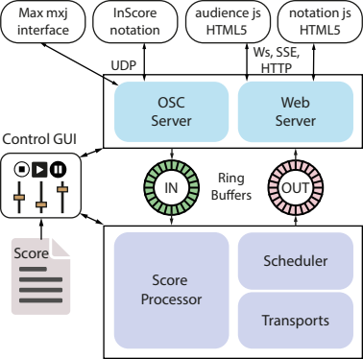Figure 6: ZScore high level architecture

All server side components are implemented in Java programming language and utilise techniques associated with high-throughput, low-latency financial trading systems. The core components: Score Processor, Scheduler and Transport handle all internal processing related to score data and timing of events. The core single threaded processing is separated from multi-threaded in/out handlers by two Disruptor pattern[] ring buffers. This provides guaranteed ordering of incoming and outgoing events based on their timestamp as well as the fast block-free processing inside the core components with minimal memory footprint.
Various clients such as: musicians’ tablets, audience’s mobile devices, MAX patch etc. connect either via Web Server or OSC handler. ZScore Web Server and JavaScript clients support Websocket, Server-Sent Events (SSE) or HTTP polling connectivity mechanism. The connection mechanism preference and fallback order is configurable in the client settings. Websocket connectivity is a point-to-point connection so it provides the most reliable message delivery. However, it is not the most scalable as a demand for server side resources increases with a number of connections. For smaller to medium size audiences and ensembles SSE is a preferred connectivity solution as it is relatively lightweight and implemented on top of a ubiquitous HTTP protocol, therefore widely supported, including most of the firewalls by default. OSC processor utilises UDP protocol for event distribution which is a more scalable communication solution as it does not require point-to-point connectivity, however, the message delivery is not guaranteed so it requires strategies to cope with message loss. ZScore provides message replay and frequent time synchronisation to alleviate issues related to message loss. Core component processing is transport agnostic due to clear separation of the external connectivity layer. At the moment all server side components are running within the same process but the intention is to eventually separate external communication layer including Web Server to a separate process.
The Score Processor is a hart of the performance system as it handles all score rules deciding what data and events should be distributed to whom and at what time. Its implementation follows the delegation pattern where each score specifies a delegate in charge of its execution logic. Scores can be configured to either reuse the base delegate implementation or have a custom delegate depending on the complexity of the required processing. Based on the score rules Score Processor sends time-dependent tasks to the Scheduler for their execution.
Scheduler and Transport are in charge of all timed operations. Minimal scheduling resolution is 1 millisecond meaning that the task execution can only be delayed up to 1 millisecond from its intended ideal timing. However, depending of the size of the task queue and their complexity the processing itself can cause delays. ZScore is configured to report any task processing delays of more than 5 milliseconds. Transports translate relative time in milliseconds into a tempo-relative time: beats, bars, pages etc. ZScore supports multiple transports for poly-temporal scores. Events can be scheduled either in elapsed time expressed in milliseconds or in tempo-relative time expressed in Base Beats. ZScore specific concept of Base Beat is defined as a fraction of the whole beat, usually 1/8. This means that an event can be scheduled with 1/8th (quaver) resolution within a score.
Control GUI is currently implemented as a JavaFx front end, running in the same process as the server. However, the design allows for its separation into a stand-alone application connecting via a communication layer as all other clients. Control GUI is in charge of the score performance aspects such as: loading a score, managing performance participants, starting/stopping play, setting position, changing score parameters, sending data to other participants etc. Complex scores can have a dedicated tab for performance management, including the comprovisation controls that manage content of the dynamic notation regions in real-time. All score management tabs share the same basic transport controls, such as play, stop, etc.
More detailed explanation of particular aspects of ZScore is available in the portfolio section. Any changes requiring a development or ZScore modifications are explained in the score’s commentary.

Portfolio:
A Journey From A Static Score to Dynamic Music-making

Red Mass
For:
Flute (C Flute, Bass Flute and Piccolo),
Clarinet (Bb and Bass Clarinet),
Percussion (Marimba and Tibetan Bowl),
Piano
Violin

Objective: Compositional Method
The starting point of my journey towards networked music-making, Red Mass was written for the workshop with Ensemble Interface in 2015. It is a conventional, static, linear score written in Sibelius software, printed on paper and manually distributed to musicians and the conductor. Although it does not contain any networked elements, Red Mass illustrates my approach to music composition that has been applied and developed further throughout this research.
The composition process for all portfolio pieces always starts with the definition of the seed concept which might be related to the intended musical material or based on an abstract, technical, philosophical or political idea. In the next step, a blend of objective and subjective methods is used to derive a top-down structure of the composition from the seed concept. The music material is defined form an amalgamation of the research into the ideas behind the seed concept usually expressed in mathematical form and a personal response to these ideas from a conscious or subconscious mental process that takes into account all learned and lived experiences. The compositional methods defined here have been applied and further developed throughout this research.

Score Commentary
The inspiration for this composition came from the fact that Interface is a ‘Pierrot plus’ ensemble (standard quintet + percussion). This fact prompted me to revisit Schoenberg’s seminal work Pierrot Lunaire [18]. Schoenberg’s composition is a setting of 21 poems from Otto Erich Hartleben’s German translation of Albert Giraud’s cycle written in French. Therefore, the piece inherited a process of material mapping (language translation) from its inception. The cycle structure split into three groups of seven poems is shown in Figure 2.20.

No/ | Part One | Part Two | Part Three
1 | Mondestrunken (Moondrunk) | Nacht (Passacaglia) (Night) | Heimweh (Homesickness)
2 | Columbine | Gebet an Pierrot (Prayer to Pierrot) | Gemeinheit! (Vulgarity)
3 | Der Dandy (The Dandy) | Raub (Theft) | Parodie (Parody)
4 | Eine blasse Wäscherin (An Ethereal Washerwoman) | Rote Messe (Red Mass) | Der Mondfleck (The Moonspot)
5 | Valse de Chopin (Chopin Waltz) | Galgenlied (Gallows Song) | Serenade
6 | Madonna | Enthauptung (Beheading) | Heimfahrt (Barcarole) (Homeward Bound)
7 | Der kranke Mond (The Sick Moon) | Die Kreuze (The Crosses) | O Alter Duft (O Ancient Fragrance)
Figure 7: “Pierrot Lunaire” poems (3 x 7)

As can be observed is Figure 20, the poem in the centre of the cycle (poem 4 in Section Two) is Rote Messe (English translation: Red Mass). In the original context of the poem, the word ‘Mass’ refers to a religious service (“At gruesome grim communion... Comes to the altar – Pierrot!”). The English word ‘mass’ is a homonym and can be used to describe a large number of people crowded together. The first response that came to my mind upon hearing the phrase ‘Red Mass’ was a childhood memory of large communist rallies with workers red flags and youth’s red scarves.
I followed the principle of taking the formal structural elements from the original poem as the basis of the piece, while transforming the material through the compositional process to reflect my personal reaction to the original material.
Each Pierrot Lunaire poem consists of thirteen lines (two four-line verses followed by a five-line verse). The first line of each poem occurs three times (being repeated as lines eight and thirteen). This poem structure (rondel), visualised in Figure 2.21, is used as the basis for my piece Red Mass.

A | B | b | a | a | b | B | A | a | b | b | a | A
Figure 8: “Pierot Lunaire” rondel poem structure

From the poem analysis and the fact that Schoenberg used numerology before the invention of the twelve-note serialism, recurring numbers 3, 7 and 13 were noted as structurally significant. As the first step in the pre-compositional structure definition, the duration of the piece was set to 7 minutes (420 seconds). The overall duration was then divided into 13 sections, each lasting approximately 32.3 seconds. As the poem’s rondel structure is effectively a ternary form, three distinctive composition parts were defined: ‘Motion’, ‘Stillness’ and ‘Return’ as displayed in Figure 2.22.
 | “Red Mass” ~ 7 min (420 sec)
Part | Motion (~ 2:10 min) |  |  |  | Stillness (~ 2:10 min) |  |  |  | Return (~ 2:40 min)
Section Id | 1A | 1B | 1b | 1a | 2a | 2b | 2B | 2A | 3a | 3b | 3b2 | 3a2 | 3A
Tempo bpm | 80 | 90 | 110 | 140 | 70 | 70 | 70 | 70 | 140 | 110 | 110 | 140 | 80
Figure 9: “Red Mass” Structure

The tempo curve was defined so that in part one (‘Motion’) the tempo increases in each consecutive section (80, 90, 110, 140 bpm), in part two (‘Stillness’) the tempo is constant at the lowest value (70 bpm) and in part three (‘Return’) each section is at the same tempo as the corresponding section from part one. Following the rondel cycle definition, it was decided to use only two basic compositional material types (‘A’ and ‘B’). Materials denoted as lower case ‘a’ and ‘b’ were to be derived from the corresponding main material. In subsequent sections where the type letters were repeated the material was transformed and given the version number (eg A1, A2 and A3). Each section was then broken down into individual bars as shown in Figure 2.23. The basic time signature for material A was set to 7/8 and for material B to 13/8 (subdivided into 8/8 + 5/8).
Section (32.3 sec) | bpm | beats | 1/8s | bars | start bar No | end bar No
1A | 80 | 43.0 | 86 | 11* 7/8 + 9/8 | 1 | 12
1B | 90 | 48.5 | 97 | 7 * 8/8 + 7 * 5/8 + 6/8 | 13 | 27
1b | 110 | 59.0 | 118 | 8 * 8/8 + 8 * 5/8 + 2 * 7/8 | 28 | 45
1a | 140 | 75.5 | 151 | 21 * 7/8+4/8 | 46 | 67
2a | 70 | 37.5 | 75 | 10 * 7/8 + 5/8 | 68 | 78
2b | 70 | 37.5 | 75 | 5 * 8/8+5 * 5/8+7/8 + 4/8 | 79 | 90
2B | 70 | 37.5 | 75 | 5 * 8/8+5 * 5/8+7/8 + 4/8 | 91 | 102
2A | 70 | 37.5 | 75 | 10 * 7/8 + 5/8 | 103 | 113
3a | 140 | 75.5 | 151 | 21 * 7/8+4/8 | 114 | 135
3b | 110 | 59.0 | 118 | 8 * 8/8 + 8 * 5/8 + 2 * 7/8 | 136 | 153
3b2 | 110 | 59.0 | 118 | 8 * 8/8 + 8 * 5/8 + 2 * 7/8 | 154 | 171
3a2 | 140 | 75.5 | 151 | 21 * 7/8+4/8 | 172 | 193
3A | 80 | 43.0 | 86 | 11 * 7/8 + 9/8 | 194 | 205
Figure 10: “Red Mass” Section info

The material ‘A’ pitch set (Figure 2.24) was derived from the notes played in the opening beat of Schoenberg’s Rote Messe by all instruments. The normal form pitch set was constructed according to the pitch set theory [6].
The material ‘A’ pitch set (Figure 24) was derived from the notes played in the opening beat of Schoenberg’s ‘Rote Messe’ by all instruments.

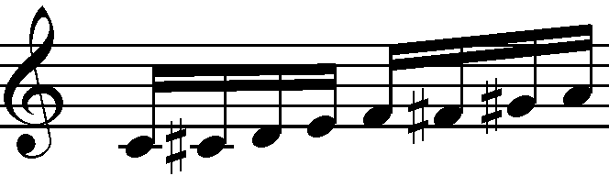
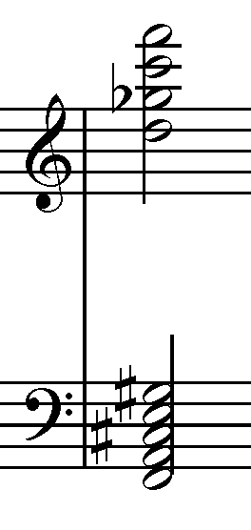
Figure 11: Pitches used in the first beat of “Rote Messe” as a chord and the normalised pitch set
In contrast to the descending opening piano figure in Rote Messe, the ascending sequence played by Piccolo and Clarinet was constructed from the defined pitch set and used as the opening in Red Mass (Figure 2.25).

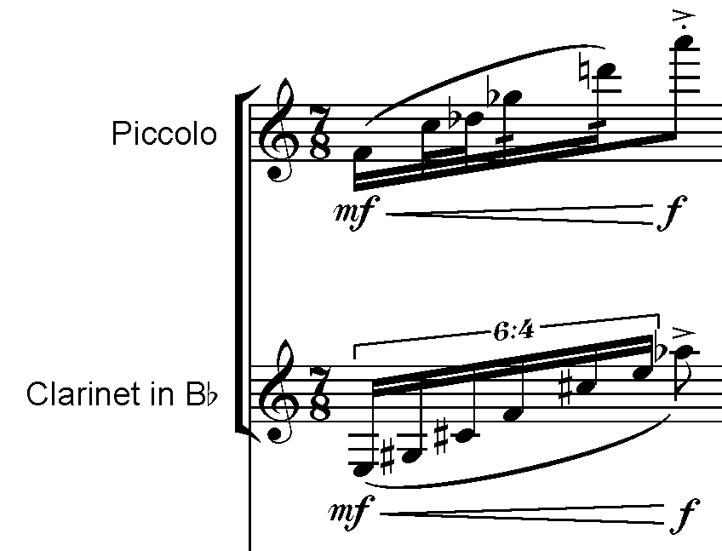
Figure 12: Opening ascending sequence in “Red Mass”

In the opening sequence all vertical pitches sounding at the same time are either 1 or 2 semitones away from each other in the normalised pitch set form. The idea to use close intervals (minor and major second and their inverted forms) was inspired by the chromatic parallel fifths movement of the Cello part in Rote Messe as shown in Figure 2.26.
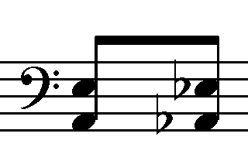
Figure 13: Cello part opening parallel fifths in “Rote Messe”

The material ‘A’ piano chord (Figure 2.27) was also derived from the Cello opening dyads (Figure 2.26). Instead of using descending parallel fifths, it was decided to sub- vert Schoenberg’s classical counterpoint subversion and move the base pitch semi- tone up as shown in Figure 2.27. The resulting chord was split into two augmented fourths intervals and two semitone intervals which were used extensively throughout the score (Figure 2.27).
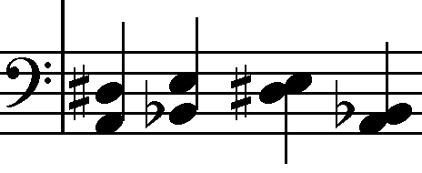
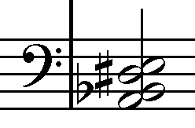
Figure 14: “Red Mass” material ‘A’ piano chord and derived intervals

The rest of material ‘A’ was derived either from the defined pitch set (Figure 2.24) or the piano chord (Figure 2.27). Most of the vertical pitch relationships use either semitone or augmented fourth intervals in the normal form pitch set.
The intention for material ‘B’ was to create a contrasting musical character to material ‘A’ by using unstable pitched and unpitched sounds such as multiphonics, air notes, staccato, pizzicato and tremolo. A different pitch set was defined for ’B’ material (Fig- ure 2.28) also extracted from Rote Messe.

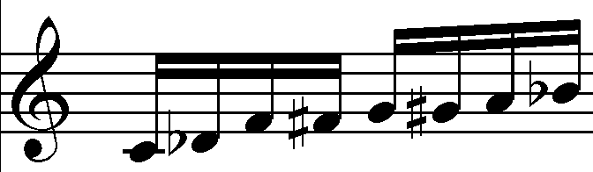Figure 15: “Red Mass” Material ‘B’ pitch set

Other important influences in the Red Mass compositional process include the Sprech- gesang singing technique from Pierrot Lunaire [18] and Ganga [20] traditional singing from rural Bosnia and Herzegovina. Video [21] illustrates ganga singing style. Both singing techniques use inflections of either continually rising or falling pitch. In Ganga singing vocal groups of up to five singers follow the lead vocalist by pitching their entry a semitone above or below the lead vocalist. Singers then gradually move between the semitone and unison with microtonal inflections and individual timings. The glissandi technique is used extensively in Red Mass to reflect the Sprechgesang and Ganga microtonal inflections.

Ukodus
For:
C flute,
Bb Clarinet,
Cello,
Piano

Objective: Linear Networked Composition and Performance
This piece was written in March 2017 for a workshop with Moscow Contemporary Music Ensemble (MCME). “Ukodus” was the first composition written for ZScore so the MCME workshop served as the system’s proof of concept.

Dynamic Notation
A composition data format produced by the score authoring tool needs to contain enough information to enable notation rendering tools to reliably reproduce the intended score layout and perform any time related operations. Semantic data models, such as GUIDO or MusicXML, define both spatial and temporal context for notation rendering. The problem with semantic representations is that both the score authoring tool and all participating notation rendering clients need to fully support the composer’s intended notational style. Due to a vast variety of contemporary composition styles, extended playing techniques and many contemporary composers’ intentional disregard of standardization, it would be very hard to create a generic yet comprehensive semantic representation solution. As a result, composers and performers are increasingly turning towards systems which allow for constraint-free, graphical notation representations.

Computers can process graphical information either in raster or vector form. Raster format defines actual pixel values that need to be displayed on the computer screen. It is therefore fast to render, however, the file size can grow significantly for higher resolution images, which is not ideal for real-time network transport. Raster format also does not scale optimally, for example, downscaling can cause visible quality loss and it cannot be easily modified. Vector graphics on the other hand define relative x and y positions, paths and attributes such as color, thickness, fill, shape and curve which need to be interpreted by the host application. Therefore, it is slower to render but much more flexible to modify and scale. Scalable Vector Graphics (SVG) is well supported by major Internet browsers and many other graphical applications. It can be extended with additional elements and attributes to provide musical context and can be scripted with JavaScript, thereby opening up possibilities for notation animation and automation.

As demonstrated by Gottfried [14], SVG format can be successfully transcoded to OSC and this work has been integrated into Odot library. Adobe recently announced its support for Node.js which could allow for the network integration of the SVG authoring tool, Adobe Illustrator. SVG is an XML-based format so it can be relatively easily extended with musical context such as the score element hierarchy and temporal information. The addition of time-space mapping allows for programmable synchronization and easier integration with notation rendering software such as InScore. Similar to computer font distribution, composers can create customized SVG symbol libraries which can then be distributed to networked clients and referenced in real-time scores. In this way, the amount of data that needs to be transferred in real-time can be significantly reduced.
After the extensive research of available networked dynamic notation tools and strategies, InScore standalone implementation was selected initially (2016) due to its networking capabilities, native OSC support, time-space mapping, built-in interactivity and scripting engine. It also supports multiple graphical file formats, although its SVG support depends on the underlying Qt library so some features such as symbol referencing via the xref attribute were not available when Ukodus was created. To work around this, all score pages were exported and distributed in PNG raster format.

Alternating pane Layout
The dynamic notation implementation in ZScore uses an innovative alternating pane dynamic notation update strategy. This strategy aims to resolve dynamic notation update issues by providing familiar left-to-right and top-to-bottom reading direction and ample preparation time to musicians. The notation is stationary while several animated objects are transposed on top, indicating tempo, current position during performance and conducting gestures. Furthermore, it defines a clear time window for upcoming notation generation and transport. Figure 16 shows main sections of the alternating pane layout for a full score and an instrumental part. In both cases, the notation view is divided into three main areas (panes). The top pane contains information about the score (title, part name, server status etc.), actionable buttons (for interaction with the server or other peers) and signalling information (tempo and start indicators). The main area, which takes approximately 80% of the screen real estate, is split into two notation panes, A and B. Each of the notation panes display an equivalent of a full score page or a single part stave. The notation is read left to right and top to bottom, the same as with static paper scores.
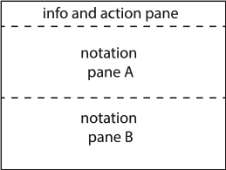
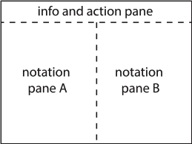Figure 16: Alternating pane layout for a multiple stave full score (left) and a single stave part (right)
At any point of time during a performance, there is always one active and one preparatory pane. At the very start, pane A is active and pane B is preparatory. When the notation content in pane A is completed, pane B becomes active and pane A preparatory. Once the musician’s focus is firmly moved to pane B, pane A is updated with the upcoming notation which is scheduled to be performed after pane B notation content is completed. The dynamic update process then continues in a similar fashion, following an ABAB sequence.

There are several time restrictions that should be taken into account when working with alternating notation panes. The notation to be played after the active pane notation is completed needs to be generated, transferred and rendered in the preparation pane by the time the active pane notation is around half way through its duration (T/2). This is to allow for performance continuity and preparation time for musicians. Furthermore, the preparation pane notation should only be refreshed once the active pane notation is played for an appropriate time duration (T1, e.g. longer than one beat) to allow for the musicians’ focus switch. This means that the minimum time window for notation preparation (generation, network transport, rendering etc) is from the active focus switch time (T1) to the active pane half duration time (T/2). If, for example, the composition tempo is 120 bpm and the active notation pane contains 5 bars with 4/4 time signature, then the minimum notation preparation time window is 4.5 seconds (T1 = 0.5s, T/2 = 5s). In most cases this would be sufficient time for the network transfer of graphical stave files or generation of algorithmic notation. This also creates clear timeline rules for the real-time notation generation and display when using alternating pane layout.

Time-space mapping and synchronization
ZScore utilizes tempo-relative time synchronization described above which takes advantage of InScore’s time-space mapping functionality. In this mode, the master server application sends regular synchronization messages carrying the global tempo-relative position to all clients. Each InScore client runs its internal clock and can synchronize independently if given a tempo and time-space mapping configuration. The master synchronization events effectively override internal client clocks with the global tempo-relative position and therefore ensure common time-space positions across the clients. The synchronization message frequency can be selected per composition and its choice depends on tempos and rhythmical structures used in the score.
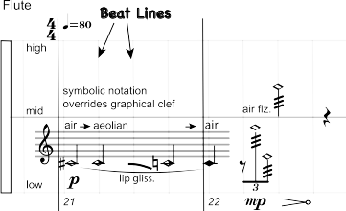Figure 17: An excerpt from “Ukodus” flute part with visible Beat Lines which are used for time-space mapping

The concepts of a Beat Line (BL, Figure 4) and Beat Division Unit (BDU) were introduced for easier time-space mapping and event scheduling workflows. The BDU value can be set to any fraction of a whole note (e.g. 1/8 which is equivalent to a quaver duration) and represents the lowest time resolution available for event scheduling and synchronization. The current minimum BDU value is 1/96. Beat Lines coincide with the bar beat onsets and contain information about their spatial and time position. The BL spatial position is set in terms of x and y coordinates on the score page while their time position is expressed in a number of BDU units from the composition start. Beat Lines are a form of proportional notation, however, there are 26no restrictions regarding consecutive spatial Beat Line positioning so they can be set individually to suite the score notation density. The time interval between Beat Lines is measured in BDU units. For example, if the BDU value is set to 1/8 then in a 4/4 bar each time interval between Beat Lines is 2 BDU units and in 5/8 bar with the beat division of 3+2/8, the first beat consists of 3 and the second beat of 2 BDU units. Beat Line spatial and time position is exported with the score data and is used in InScore client for space-time synchronization.

Notation Authoring
A functional requirement for a tool that can provide complex symbolic, graphic or mixed notation authoring for any acoustic or electronic instrument as well as the ability to export data in a suitable digital format for a distribution over a computer network eliminated most of the traditional notation tools. After a significant research effort, I settled on a vector graphics editor Adobe Illustrator. It allows for the unconstrained positioning of any notation type; export of SVG and multiple raster formats; import and creation of user defined symbol libraries; and is scriptable, which opens a range of opportunities for functional extensions and potential real-time network integration. Illustrator does not provide any musical context by default, therefore, a number of improvements have been implemented for more efficient music composition flows and integration with the networked software.
Inspired by Gottfried [], a hierarchical layer structure was created to provide a musical context in Illustrator and enable the automation of score creation and export. The hierarchical layer elements can contain one or more child layers (Figure 16).

Figure 18: Hierarchical score layer entity relationships

A Part layer has a one-to-one relationship to a Stave layer which contains all the graphical data required to display an instrument staff. The Bar layer contains all the graphical data required to render the notation and logical data required for synchronization such as tempo, time signature and beat line positions (Figure 17).

Figure 19: Bar layer content

The notation layer contains all the symbolic or graphical data required to display bar notation and can contain arbitrary notation types. The Illustrator layer structure is displayed in the screen capture in Figure 18.
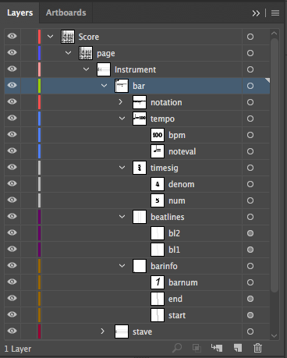Figure 20: Adobe Illustrator layer structure

To accelerate symbolic notation generation, a set of custom symbols based on open-source LilyPond notation font were imported into Illustrator (Figure 19). Due to the flexibility of a vector graphic editor, it was straight forward to extend the library with custom symbols, such as different note head types and sizes and instrument fingering charts etc. For variable length continuous lines, such as crescendo and decrescendo markings, a set of brushes were created and imported into Illustrator. An example of mixed symbolic and graphical notation created in Adobe Illustrator with the help of ZScore tools plugin and music symbol libraries is displayed in Figure 10.
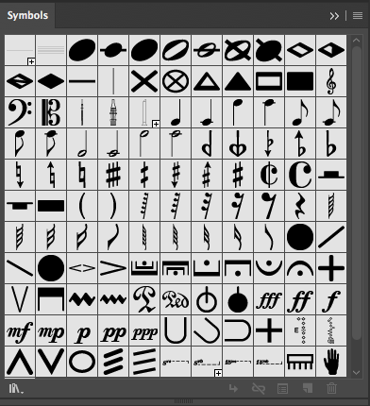Figure 21: Notation symbol library imported and extended in Adobe Illustrator

The set of JavaScript plugins were developed to speed up composition workflows and automate score export. Currently ZScore Tools includes: Layer, Page, Bar and Export plugins (Figure 9). The Layer plugin allows for Illustrator layer structure definition, editing, XML import/export and copying between one or more scores. Similarly, Page and Bar plugins help create required pages and bars at specified locations including any meter or tempo changes and Beat Line positioning.

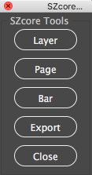Figure 22: ZScore Tools plugins for Adobe Illustrator

Export plugin allows for the export of the full score and parts in SVG or PNG graphical formats. In order to provide accurate and automated space-time mapping, the export process also creates necessary data for InScore in the required format:

( [Xstart, Xend [[Ystart, Yend[) ( [BDUtart, BDUend[)
where X and Y are space coordinates and BDU isthe number of Base Beats since the beginning of the section. The exported values define two-dimensional rectangles between two Beat Lines and the corresponding start/end tempo-relative time. Additionally, the export process automatically collates score meta data required by the score scheduling engine. This information about time signatures, tempo changes, other score events, BL positions and related BDU values is currently stored in a csv (comma separated values) formatted file.
An example of a score page authored in Adobe Illustrator is displayed in Figure 10.
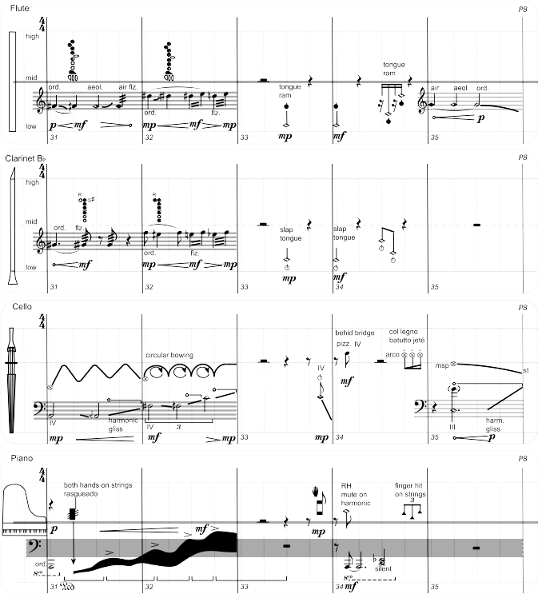Figure 23: An example of the Ukodus score page created in Adobe Illustrator demonstrating mixed clef and notation styles

Performance Control
The central hub in charge of scheduling and distributing the score data over a network in real-time is the ZScore server and management client written in Java programming language. ZScore Performance Control GUI client (Figure 24) can import and parse score definition data exported from the ZScore Tools Illustrator plugin and submit to the server, creating an internal representation of the score metadata. The internal score meta-data model mimics layer hierarchy shown in Figure 18.
The server listens to notation client connections and sends information about available parts to all the connected clients. When musicians select individual parts on their notation client, the server associates the selected score part with the client’s host address. From then on, all messages related to a particular part will be routed to the associated client host.
The server internal scheduling resolution is 1 millisecond with a maximum measured deviation of 0.8 milliseconds. It translates local absolute time to a tempo-relative value expressed in BDU units and evaluates any scheduled score events accordingly. The server supports multiple transports with different meters and tempos which allow for compositions and performances of polyrhythmic and polymetric scores. Events can be pre-loaded in score data or dynamically added during a performance according to the timing rules discussed above. ZScore’s real-time functionality is bounded by the timing rules, so any notation generated during the performance needs to be available in the time window defined by T1 and T/2 boundaries.
The Performance Control GUI (Figure 24) can load and start the score from any position defined in terms of the Page, Bar and Beat number on all participating networked clients. It also allows for tempo multiplication in the range from 0.1 to 2.0 for rehearsal purposes. Tempo can also be dynamically modified during the performance.
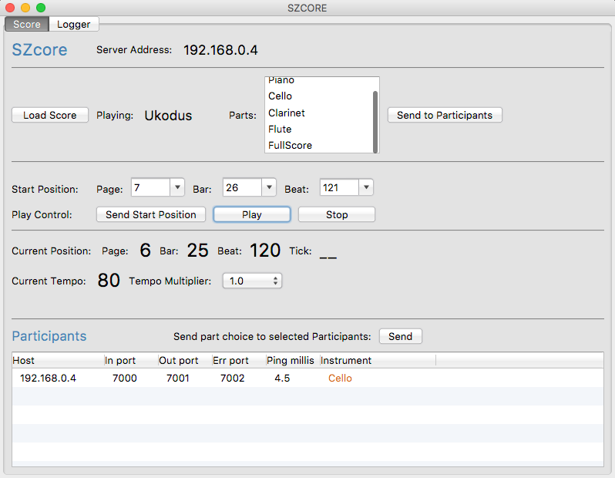Figure 24: ZScore Ukodus Performance Control GUI

Notation Rendering
Two InScore files (part.inscore and full.inscore) were created, one for full score vertical alternating pane and one for horizontal part alternating pane layout. These startup files contain layout configuration and the set of JavaScript functions which handle all interactive tasks. Once InScore startup file is opened, all communication with the server can be done directly from InScore client.

An example of the dynamic score with alternating pane layout is presented in Figure 25. The active notation pane is highlighted with red borders while the preparatory pane is slightly dimmed. Several features which aim to replace some of the conducting gestures have been added, such as the signalling traffic light at the top left corner which aims to draw the attention of musicians and provides an indication of the starting tempo, also showing the position line visible as the light green line on the upbeat leading to bar 28 (Figure 25). The position line also has the attached tempo indicator which is visible as the red circle on the top of the stave. For ease of orientation, the actual starting position is marked with a light purple line (on the first beat of bar 28 in Figure 25). The starting position can be set to any Beat Line from the network management client (Figure 24).

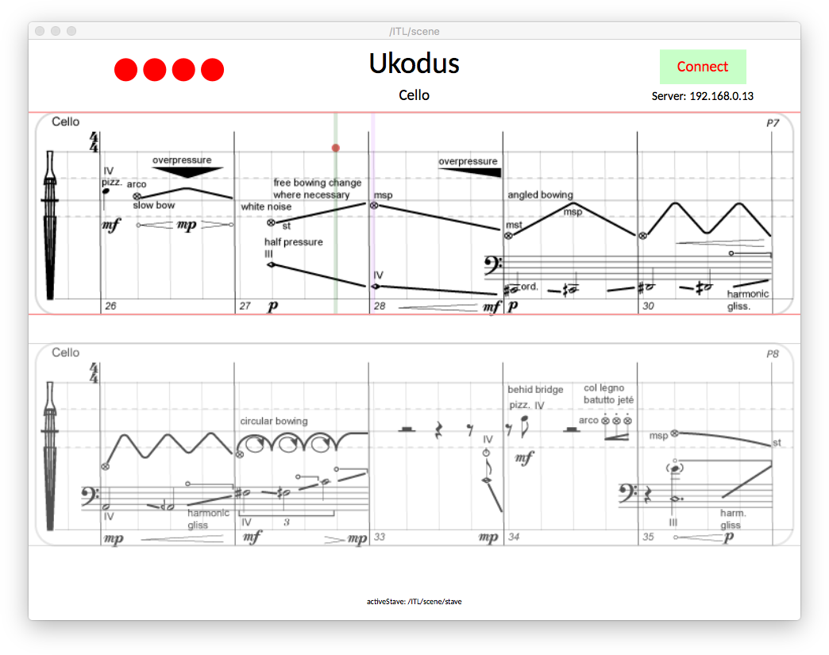Figure 25: Ukodus cello part dynamic notation in InScore alternating pane layout

When the score performance is started in the network management client (Figure 11), the traffic light signal flashes in the starting tempo frequency and the position line starts moving from left to right, indicating the current position on the screen. The attached tempo indicator ball starts simulating conductor signals with vertical movements calculated from the simplified pendulum motion formula where the ictus plane is at the top of the stave. The current position line always starts from the upbeat before the selected starting position in order to mimic the familiar conductor gesture on start. When the position line reaches the penultimate beat of the active pane stave, the preparatory pane current position line will start from the upbeat at the same time to provide notation view continuity.

Score Commentary
The inspiration came from a particular Sudoku puzzle with visually and numerically interesting symmetrical structures including multiple lines of symmetry. The name of the piece is the word Sudoku reversed.
Sudoku is a logic-based, combinatorial number-placement puzzle. The objective is to fill a 9×9 grid with digits so that each column, each row, and each of the nine sub-grids contain all of the digits from 1 to 9. The puzzle used for the composition structure of “Ukodus” is visualised in Figure 11.
It can be noted from Figure 11 that the initial setup for this particular puzzle contains symmetrical positioning of numerical values in both the horizontal and vertical direction. I attempted to define relationships between visual and numerical elements of this puzzle as a basis for the compositional structure of this piece.
In order to quantify positions of the puzzle’s initial numerical values, each row and column in the puzzle was given a sequence id (0 → 4) visible in the top row and the first column in Figure 11. Sequence id 0 was assigned to the central row and column. The upper contour of the puzzle in the West → East (W → E) direction was then extracted as a graph (Figure 12). Vertical values in the graph indicate the distance from the central row.
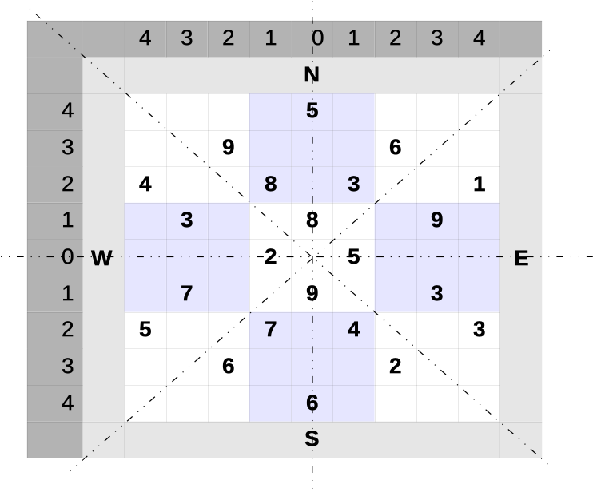
Figure 26: Sudoku puzzle used in “Ukodus” composition material

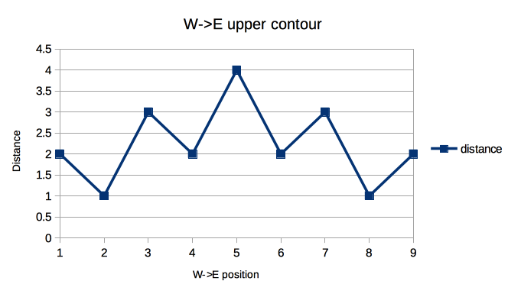Figure 27: Sudoku puzzle W → E upper contour

Actual numerical values of the puzzle’s upper area in the W → E direction were also plotted as a graph in Figure 13. As the upper area columns can contain up to two numerical values, separate curves were defined for the inner and outer numerical values.
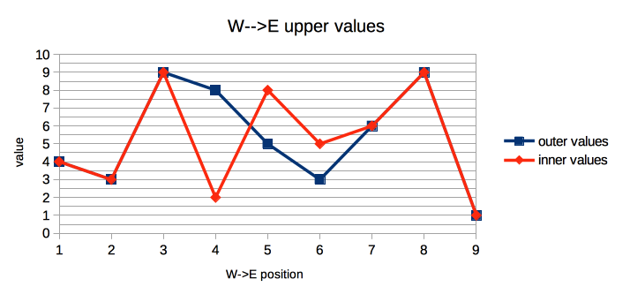Figure 28: Sudoku puzzle W → E upper values

Due to the horizontal symmetry, the lower area of the puzzle in the W → E direction has the same outer contour as the upper area. However, the actual numerical values are different, as displayed in Figure 14.
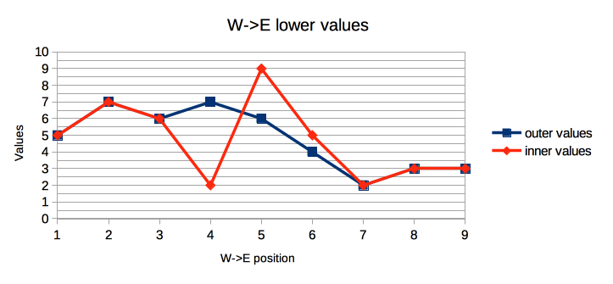Figure 29: Sudoku puzzle W → E lower values

Following the same approach, graphs for the vertical contour in the North → South (N → S) direction and the corresponding numerical value graphs were extracted and plotted.
The basic structure of the piece was derived from the obtained graphs and resulting data sets (Figure 15). The composition was split into nine sections reflecting sudoku’s intrinsic divisions. The tempo and the length of each section was calculated from the upper contour values (Figure 12). The starting tempo value was set to 100 bpm while the vertical unit value was set to 20 bpm. As can be deducted from the graph (Figure 12), the vertical contour value in the W → E direction decreases by one unit from position 1 to position 2. Therefore, the section 2 tempo can be calculated as:
100 (starting tempo) – 1 (direction) [1(number of steps) * 20 (tempo unit value)] = 80 bpm
The tempo and number of beat units for each section were then calculated by using the formula above. Pitch range for each section was selected to reflect the same contour curve, starting with the mid-range for each instrument.
Figure 30: “Ukodus” basic structure
By following similar rules, each section was split into nine parts. The length of each part was calculated from the section length and the upper contour (W → E) value for each step. Therefore, the part’s length is relative to the contour value for the equivalent position; the higher the contour value, the longer the part, and vice versa. The structure of Section 1 is displayed in Figure 16. Here, each part is defined by its length in terms of a number of beat units (1/8), a division of beat units into bars and a number of musical events based on W → E upper values graph (Figure 13).
Figure 31: “Ukodus” Section 1 structure
Other sections were defined in a similar way. The structure of Sections 2 and 3 is displayed in Figure 17. All sections use different curves for event and material generation. For example, Section 2 uses the W→ E lower value graph, while Section 3 uses the W → E upper values in retrograde. The number of events in this context represents a guideline for the density of musical material in each part.
Figure 32: “Ukodus” Sections 2 and 3 structure
The instrumentation of: Flute, Clarinet, Cello and Piano was selected to reflect the symmetrical nature of the material and possibilities for flexible grouping and mirroring. For example, in Section 1 the instruments were split into two groups: Group 1 (Flute and Clarinet) and Group 2 (Cello and Piano). Group 1’s event density was extracted from the outer curve while Group 2’s event density was obtained from the inner curve.
The beginning of the piece (Section 1, Part 1) for Group 1 (Figure 18) illustrates how the extracted data is mapped to musical material. The number of events for Section 1 Part 1 can be looked up from Figure 16 and is the number 4 for both Group 1 and Group 2. The material for Section 1 (Figure 15) is set to “air/nose”. Therefore, four musical events were created for both instruments in Group 1 (Flute and Clarinet). Internally, instrument lines within the group were constructed as a mirrored response/call while the shape of both gestures resembles the W → E upper contour (Figure 12).
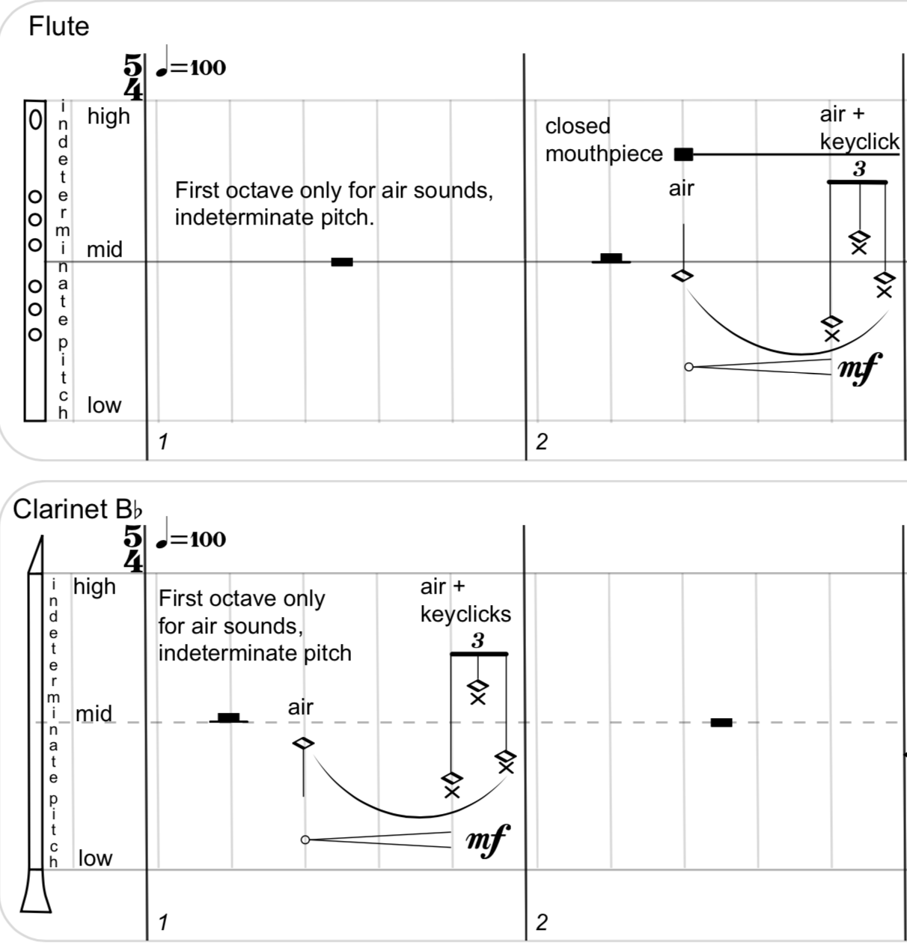Figure 33: “Ukodus” Group 1 events in Section 1 Part 1

Likewise, four “air/noise” Group 2 events have been created for each instrument (Cello and Piano) in Section 1 Part 1 as a response/call with a gesture shape reflection internally but also as a symmetrical response to Group 1 (Figure 19).

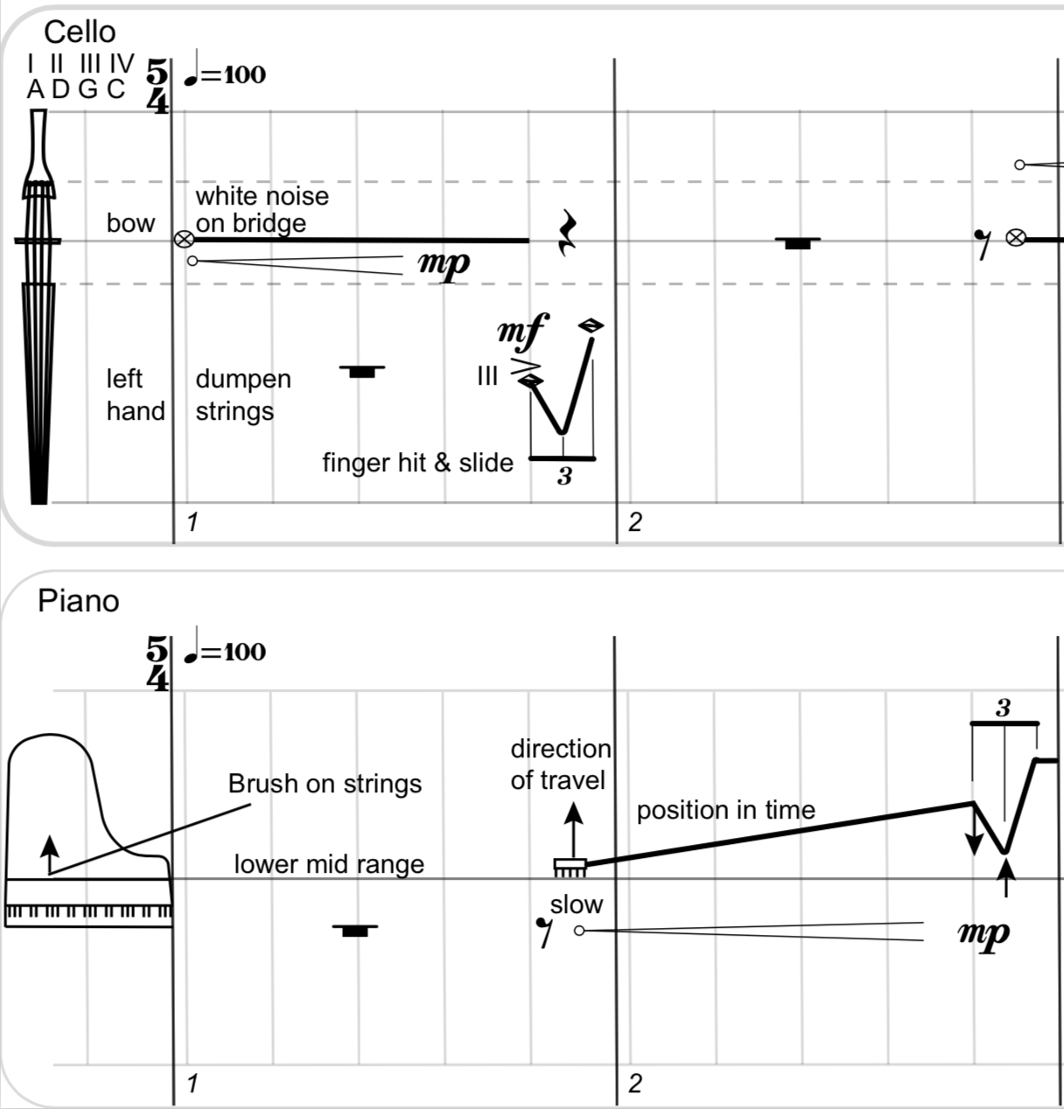Figure 34: “Ukodus” Group 2 events Section 1 Part 1

The rest of the material was created in a similar way to the described procedure. Due to the amount of work required on technical aspects of ZScore software development and Adobe illustrator score authoring, only the first 64 bars of the piece were completed in time for MCME workshop.

Vexilla
For:
Bass Clarinet,
Violin,
Violoncello
Video Projector

Objective: Audience View
This piece was written for ZScore in early 2018 and was performed on 1 May 2018 at Deptford Town Hall by Heather Roche (Bass Clarinet), Valerie Welbanks (Cello) and Patrick Dawkins (Violin) thanks to Goldsmiths Graduate School and Music Department funding.

Embedded Scripting

Event scheduling

Audience view

Use of colour in notation

Score Commentary

Vexilla were flag-like objects used as a military standard by units in the ancient Roman army. Later on, the meaning of the word extended to represent any object such as a relic or icon carried as a standard into battle. This piece explores the emotional and rational responses to various flags I have encountered throughout my lifetime, from fervent teenage patriotism to deep distrust of any ceremony which requires enthusiastic flag waving.
Structurally, the composition is split into three main sections: Yugoslavia (1945 – 1992), Europe (1992 – 2018) and Epilogue. Each main section is then further divided into smaller parts. Section 1 (Yugoslavia) is split into seven parts: six representing former SFR Yugoslavia republic’s flag and one for the main SFR Yugoslavia state flag. Section 2 (Europe) is divided into three parts (EU, New Bosnia and UK flags) while the final Section 3 (Epilogue) contains only one part and references all flags used in the piece.
Figure 35: “Vexilla” Structure
Each main section duration is less than a half of the previous section, symbolising the perceived acceleration of the passage of time with age. However, each part duration is the same (35.2 sec), reflecting equal importance (or unimportance) of flags in my life. The original plan was to write a 10 minute piece split into 17 parts of equal duration, therefore, each part duration was set to 35.2 secs. Due to time pressures, the overall number of parts was reduced to 11 but the individual part duration remained the same.
The tempo of Section 1 is set to 90 bpm, being the same as the Yugoslav national anthem used as the source for the compositional material in Part 7. The tempo of Sections 2 and 3 is set to 120 bpm, after the official EU “Anthem to Europe” which in turn is based on Beethoven’s 9th Symphony fourth movement (“Ode to Joy”).
As a starting point, I wrote down immediate factual and emotional responses to each section and part description (as displayed in Figure 1). It was instantly apparent that responses to the first section were more about memories and nostalgia while the second section gravitated towards the realities of living, survival and the daily grind of life. I also used associative memory to note the first song or melody that came to my mind when thinking about a particular flag. Extracts from these songs and melodies were used to construct compositional material for each part.
The common overarching thread across all composition parts is a personal reflection on the processes of othering, belonging and separation. The process of othering is frequently used in political discourse where ‘others’ are defined as different to ‘us’, representing a physical or economic threat to be feared. Almost invariably othering rhetoric involves mythology and symbology, including flags, serving to define ‘us’ as different to ‘others’.
Another important process utilised in the compositional material generation is the decomposition of flags into graphical facets and their mapping to sound categories and gestures. For example, the SFR Yugoslavia tricolour flag was made up of red, blue and white stripes with the socialist red star in the middle (Addendum A). These flag features are mapped to sound categories as shown in Figure 2.
Flag visual feature | Sound category
Red colour | Warm, fully pitched sound
Blue colour | Cold, harmonic and multiphonic sounds
White colour | Air noise, percussive non-pitched sounds
Star | Pointillist glissandi gestures resembling the shape of a star
Figure 36: Flag feature mapping to sound
Also, the position of individual stripes on the flag is mapped to the instrument range in a vertical order; e.g. the bottom stripe is mapped to the lower instrument register and so on. Angled lines on flags are mapped to the pitch movement, so if a line is sloping downwards when looking left to right, the sound starts at a higher register and gradually slides down to a lower register.
Figure 4 illustrates the principles of the generation of compositional material in this piece. Part 1 represents the flag of Slovenia (Figure 1). Following the associative memory approach described above, the first song I could recall when thinking about Slovenia was the simple traditional folk melody “Na Planincah” (Figure 3), being one of the first melodies I learned to play as a child on the piano.
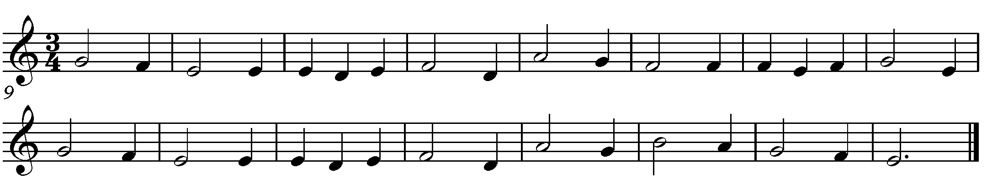Figure 37: "Na Planincah", traditional folk song from Slovenia
The time signature for Part 1 of “Vexilla” was therefore set to 3 / 4, as in the selected folk song. From the length of the part (35.2 sec) and the preset tempo (90 bpm) it was calculated that there should be 53 beats in the part. The bar structure of the part was then constructed from the calculated number of beats as:
16 bars * 3 /4 + 1 bar * 5 / 4 = 17 bars
This bar structure was then presented in tabular form as shown in Figure 4. Visual features of the Slovenian flag (Appendix A) were mapped into the structural tables serving as a meta data for musical content generation.
Figure 38: “Vexilla” Part 1 Structure
The common feature appearing on all flags used in Section 1 is a red star. It was mapped to a recognisable musical gesture and repeated in all structural parts, albeit in slightly different form. In Part 1, the star gesture (Figure 6) is placed in the middle of the temporal structure (Figure 4).
On either side of the star gesture, the flag’s coloured stripes are laid out in vertical order and mapped to a sound category as described in Figure 2. This creates a ternary form also used in other parts with a similar flag layout.
The “Na Planincah” melody inspired compositional material for all instruments. Excerpts from the Cello part shown in Figure 5 are the most recognisable.
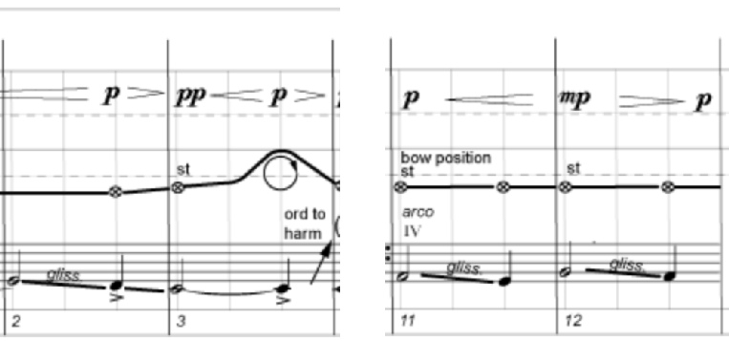Figure 39: “Vexilla” Cello part using "Na Planincah" melody elements

Other parts were constructed in similar way to the process described above. The tabular structure representation of parts in Section 1 is shown in Figure 8 while Sections 2 and 3 parts structure is shown in Figure 9.

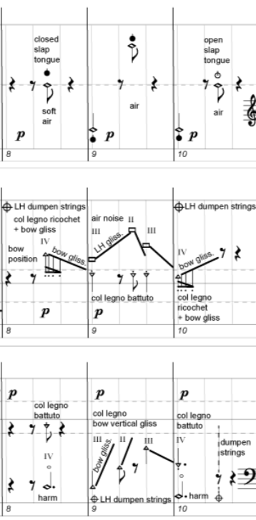Figure 40: “Vexilla” Part 1 star gesture

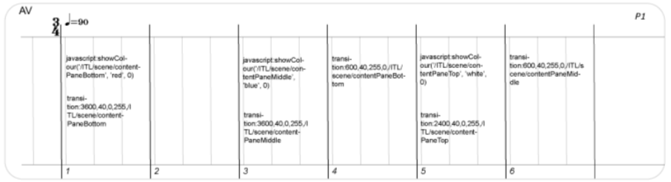Figure 41: “Vexilla” score video elements scripting
The video part material was created from the deconstructed flag elements as a series of graphical files. In order to ensure the synchronisation of visual and audio output during the performance, visualisation of the flag elements was performed through the scripts directly embedded into the score as shown in Figure 7. Video elements composition was based on the tabular structure (Figure 4).

Figure 42: “Vexilla” Section 1 Parts structure

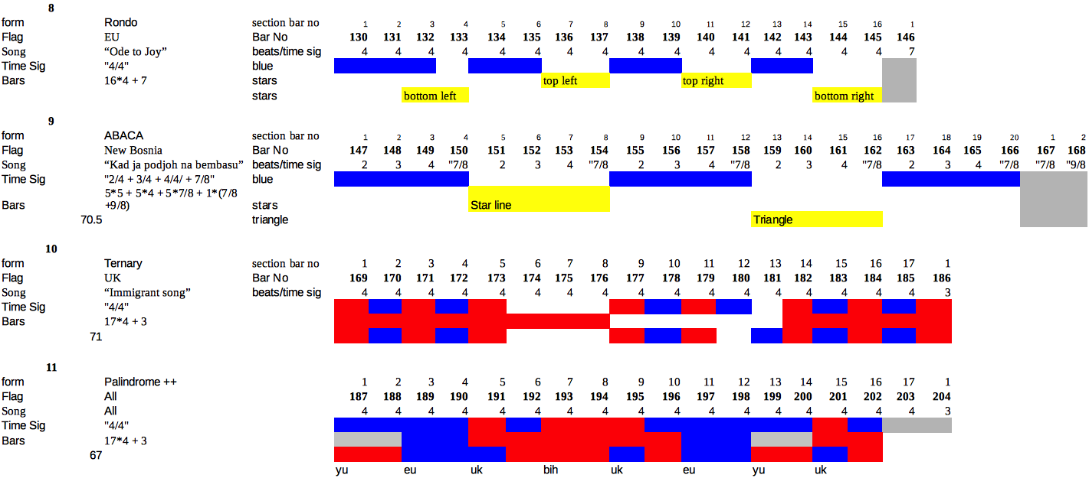Figure 43: “Vexilla” Sections 2 and 3 parts structure
The additional experimentation was done with the use of colour in a graphic score as shown in Figure 10. The idea here was to associate a colour with the specific playing technique in order to increase the player’s score reading and comprehension speed compared to standard symbolic notation. In this instance, Bass Clarinet multiphonics are associated to the colour blue. Although the idea received a positive feedback, it was concluded that the colour should be used sparingly and might be better suited to dynamics visualisation.

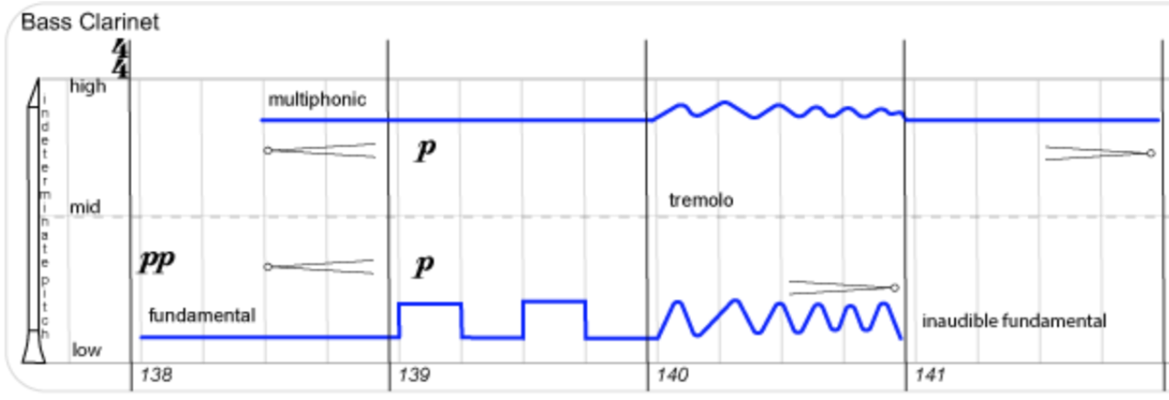Figure 44: Use of colour in “Vexilla” score

2 Ukodus (fl, cl, vc, pf)
Networked linear composition
Alternate Pane Notation Layout
Notation synchronisation

3 Vexilla (fl, vn, vc)
Embedded Scripting
Event scheduling
Audience view (projector)
Use of colour in notation

4 Perpetual Union Rose v1 (string quartet)
Real-time conductor interaction
Notation Overlays
Continuous page randomisation
Conductor led comprovisation
Strategy: Randomisation

5 Union Rose v2 (string quartet)
Conductor, musician and audience interaction
Audience View
Audience interaction page selection + audio
Player interaction part selection
Audio engine MAX patch

6 Socket Dialogues (acoustic instruments, Max and audience)
Conductor, musician and audience comprovisation
Role composition
Generic instrument notation
Audience vote impact
Strategy: Builder

7 Symphonea (audience, acoustic instruments and Max) (work in progress)
Entirely dynamic, audience driven composition performance
Audience decides material and timing of notation/digital audio

Results
Compositions and concepts realised successfully
Workshops / concerts
Musician / Audience feedback
Technical tests
Conference papers

General discussion
Interactive composition model works
Requires coding, complex data mapping
Time consuming processes
Large scale testing not done
Audience front end functionality not entirely successful

Conclusions
suggestions for further work

References

Adorno, Theodor W. 2002. "On The Fetish-Character in Music and the Regression of Listening". In his Essays on Music, selected, with introductions, commentary, and notes by Richard Leppert; new translations by Susan H. Gillespie. Berkeley, 288–317. Los Angeles, and London: University of California Press. ISBN 0-520-22672-0.

- City as Landscape: A Post Post-modern View of Design and Planning, (Taylor & Francis: London 1995).

2006 paper The Death of Postmodernism and Beyond, the British scholar Alan Kirby

https://www.e-flux.com/announcements/38261/altermodern-manifesto/

Vermeulen, Timotheus; van den Akker, Robin (2010). "Notes on metamodernism". Journal of Aesthetics & Culture. 2 (1): 5677. doi:10.3402/jac.v2i0.5677. ISSN 2000-4214.

Guido van der Werve - Nummer acht - Everything is going to be alright (fragment) – 2007
https://www.moma.org/collection/works/126286
https://www.youtube.com/watch?v=OUq2nN6V6xU

Appendices

