ZScore User Guide

For Union Rose

This guide explains basic ZScore system features, such as the score loading and playing.
For more advanced features please contact the author via email slavko@zagorac.com
ZScore feature explanations were correct at the time of writing (Jun 2023).

Download
Use the URL below to download ZScore package for the Union Rose score:
https://bit.ly/zspackunionrose

Package Content
The package contains following directories:
- max (Max patch and data)
- scores (score data)
- zscore (application data)
The zscore directory contains following subdirectories:
- zscore_jgui (ZScore GUI and server)
- webroot (Web Score content)
- audienceWebroot (Audience Web content)
A standalone Max 8 patch app for MacOS is available, if required. It does not require Max 8 installation, however, due to its size (> 1GB) Max 8 installation is preferable.

Installation

ZScore software can be run on any desktop operating system, providing that the third-party software dependencies outlined below are correctly installed.

Required third-party software
Java | ZScore GUI and server require Java jdk 1.8 (Java SE Development Kit)  which can be installed from:  https://www.oracle.com/java/technologies/javase/javase8u211-later-archive-downloads.html  Once jdk is installed, please check that that the installation is valid  (version check is good enough):  https://www.baeldung.com/java-check-is-installed
Max 8 | Some scores written for ZScore use Max 8 as the digital audio source.  If Max patches are required for the score, please install Max 8 (free for 30 days)  from:  https://cycling74.com/downloads  On mac computers with Apple M silicon chips, please run Max in Rosetta
ZScore | Download and unzip zscoreUnionRose.zip into any directory (<installDir>)

How to run ZScore
Navigate to the directory where ZScore packages were unzipped (<installDir>), either through the computer’s file system browser (Finder, Windows explorer...) or via a command line.

Run integrated ZScore application (GUI + Server)
Go to the “zscore” directory (<installDir>/zscore).

On MacOS | double click zscore.command  or execute the command line script: ./zscore.sh  TIP: If you get macOS unidentified developer warning:  right click on zscore.command→ select Open → click Open button.
On Linux | execute the command line script: ./zscore.sh  TIP: works on any Unix OS flavour
On Windows | double click zscore.bat  or execute it from the command line.  TIP: If you get Windows Defender blue window warning:  click on More Info → Run Anyway.

The script execution above should open a new terminal window containing a startup log.
TIP: Do not close this window as it will terminate the application.

The ZScore GUI should appear after a while, if everything is ok.
Figure 1 illustrates what the ZScore GUI should look like.

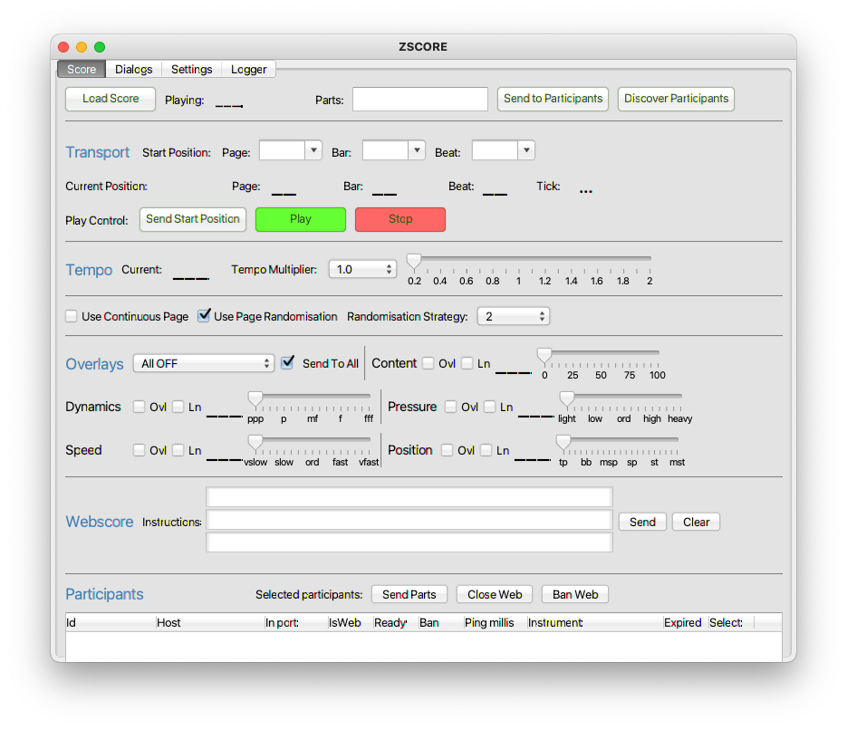Figure 1: ZScore performance control GUI
TIP: If this does not happen, or in case of any other issues, please check for any errors in the log file (szcoreApp.log).
The log file should be available in “zscore” directory (<installDir>/zscore), or in whatever directory the app was started from.

Load Score
In the ZScore GUI, click the “Load Score” button available in the top left corner of the “Score” tab.
Please note that Socket Dialogues name is shortened to dialogs in all file names.
Navigate to the installed “scores” directory and find the required composition subdirectory:
<installDir>/scores/UnionRose/
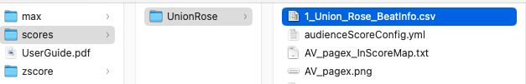Figure 2: Union Rose score directory
Select and open file 1_Union_Rose_BeatInfo.csv
TIP: Required BeatInfo file should be at the top of the list if the file browser view is sorted by Name.
If the score load was successful, ZScore GUI should display the available parts and composition name as per image below.
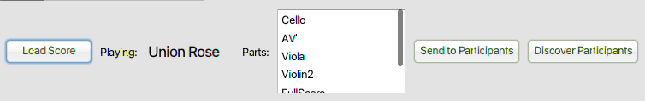Figure 3: Successfully loaded score
TIP: You can resize GUI as required by dragging its corners.

Web Score View
The Web Score view displays music instrument notation and is usually hosted on 12” tablets. However, it can be viewed on any computer, including localhost.
Make sure ZScore GUI is running and the score is correctly loaded, as described above.
Open an Internet browser (the latest version of any modern browser should do).
If you have used the same browser previously to view another score, please clear the browser cache.
In the browser address bar at the top, put:
http://localhost:8080/ (if the browser is running on the same computer as ZScore GUI)
or
http://<host_ip_address>:8080/ (if the browser is running on another device on the same network)
where <host_ip_address> is the IP Address or hostname of the computer where ZScore GUI is running.
This IP address can be found in the ZScore GUI “Settings” tab, next to “Server Address”.
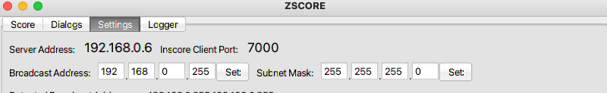Figure 4: Host IP Address example
TIP: In the custom ZScore performance environment this address is http://zscore:8080/
The browser should now display a menu of available scores as illustrated in Figure 5.
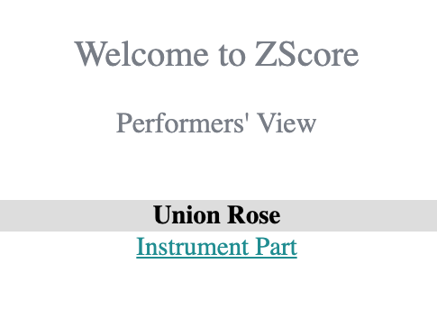Figure 5: Available scores menu

To view an instrument part for a score, please click on the appropriate “Instrument Part” link.
The browser should now display a blank score page similar to Figure 6.

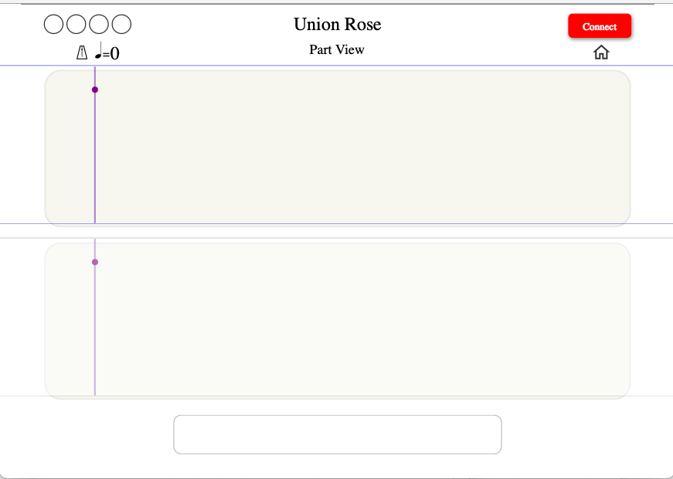Figure 6: Initial blank score page layout

If the “Connect” button at the top right corner is red, please click the “Connect” button.
If the top left button is green and displays “Connected” there is no need to click the button as the browser has automatically re-connected.

The browser should now display a menu of choices, such as available parts as per Figure 7.
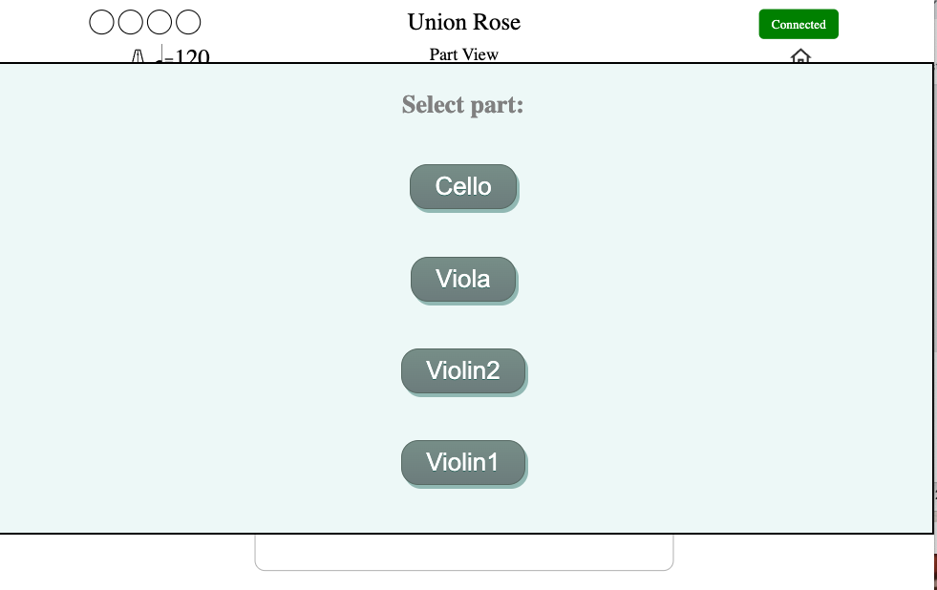Figure 7: Part selection menu

Click on the required part name.

The selected part should now be visible in the ZScore GUI “Participants” grid at the bottom of the “Score” tab.
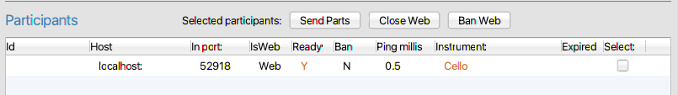Figure 8: Connected clients
The Web Score view should now displayed blanc page for the selected Part with status showing Ready in the top right corner, as illustrated in Figure Figure 9.

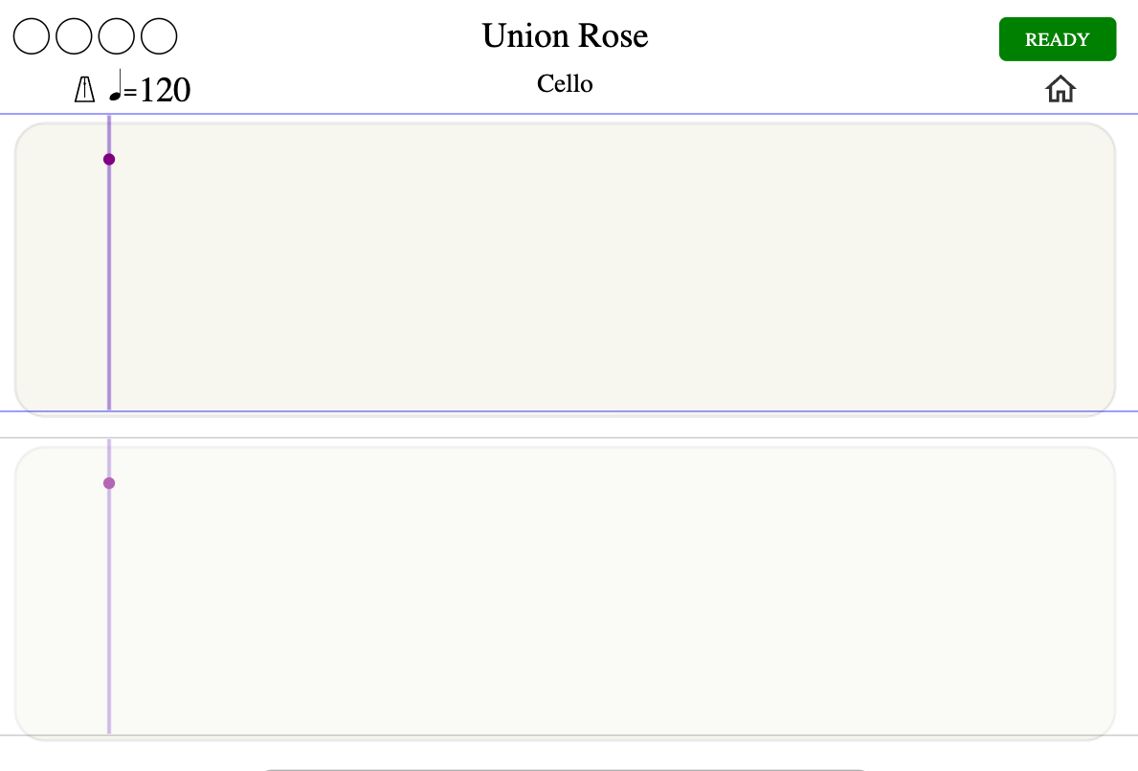Figure 9: Selected part blanc page in Ready state

Play Score
Once all required parts are connected,
click the “Send Start Position” button in ZScore GUI, highlighted in Figure 10.
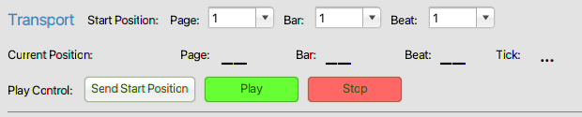Figure 10: Send Start Position

TIP: Always use “Send Start Position” before “Play”.
It is possible to change the start Page, Bar or Beat to any required value before sending the start position (Figure 8).

The selected Page should now be visible in the web score browser. Figure 11 shows the first page of the Union Rose score Cello part.
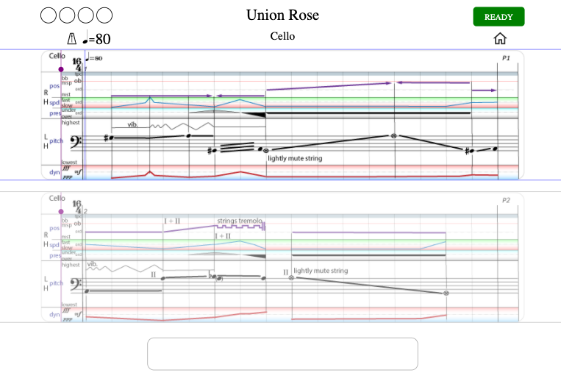Figure 11: The first page of Union Rose Cello part.

Click the green “Play” button in the ZScore GUI to start the score (Figure 10).
The semaphore in the top left corner of the web score should count down to the performance start.
Once the score is started, the position line will move to indicate current position in the score. Also, the bouncing ball on the top of the stave will indicate current tempo.
The score layout consists of two staves (top and bottom). One is always active (currently played) and the other one is preparatory (showing the upcoming notation).
Play starts from the beginning of the top stave and continues to the bottom stave. Once the bottom stave is completed, play continues from the beginning of the top stave.
To stop play click on the red “Stop” button in the ZScore GUI (Figure 10).

To replay the score please repeat the sequence “Send Start Position” → “Play” → “Stop”

Performer Actions
Some scores allow for performer interaction with the system and other participants via the web score browser. These actions are displayed at the bottom of the score view. The figure below shows an example where individual players can opt in/out from the next page play by clicking on their part name.
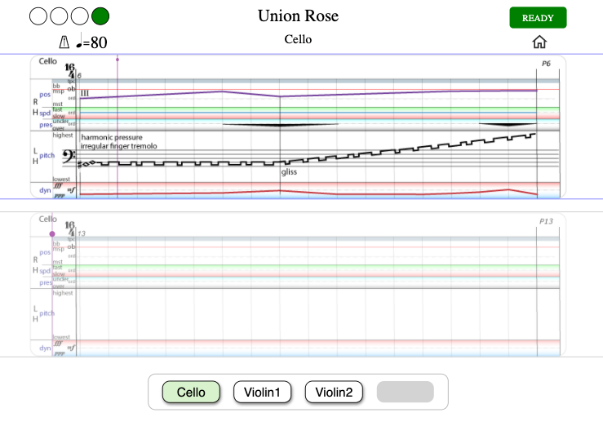Figure 12: Performer actions

Audience Score View
Audience score is usually accessed via mobile devices, however, any computer can be used, including the localhost.
Open an Internet browser (the latest version of any modern browser should do).
If you have used the same browser previously to view another score, please clear the browser cache.
In the browser address bar at the top, put:
http://localhost (if the browser is running on the same computer as ZScore GUI)
or
http://<host_ip_address> (if the browser is running on another device on the same network)
where <host_ip_address> is the IP Address or hostname of the computer where ZScore GUI is running.
This address is available in the ZScore GUI “Settings” tab under “Server Address” (Figure 4).
In the custom ZScore performance environment, audience view address is: http://zscore/
The browser should now show the welcome page as illustrated in Figure 13.
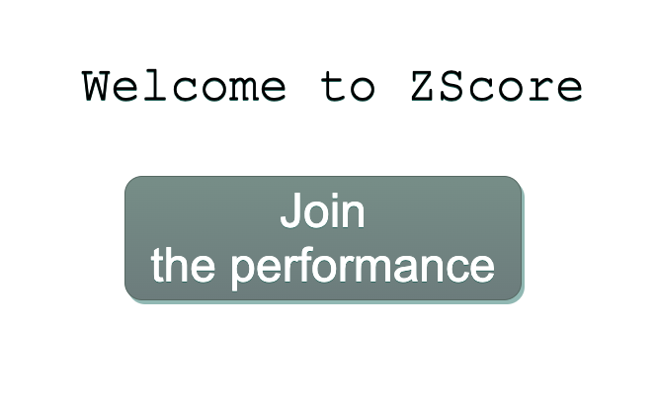Figure 13: Audience view welcome page

Click the “Join” button to connect to the ZScore audience server.

Once the browser is connected to the server, the view should change to the composition specific welcome page.
An example of the welcome page for Union Rose is shown in Figure 14.

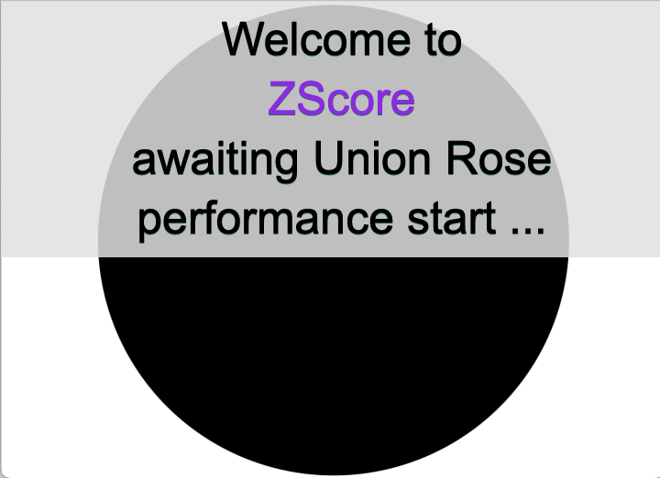Figure 14: Union Rose audience view welcome page

Once the score is started, as described above, the audience view should be played in sync with the performers’ score.

ZScore Max
Some scores use Max 8 as a digital audio source.
On mac computers with Apple M silicon chips, please run Max in Rosetta (tick “Open using Rosetta” on Max.app Info window).
To open max patch, navigate to the installed max directory:
<installDir>/max
Double click 1_zscore.maxpat (it should be the first file on the list id the file browser is sorted by name)
After a while, the patch should appear as displayed in Figure 15.
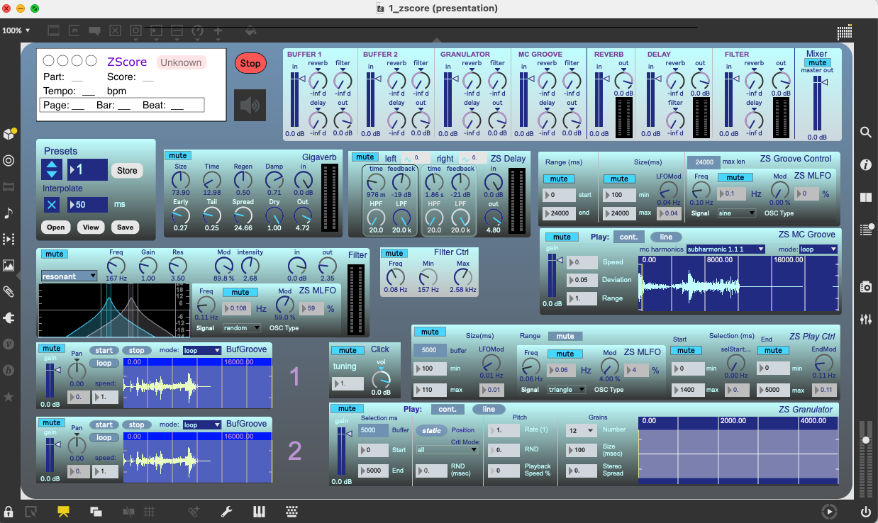Figure 15: ZScore Max 8 patch

Initialisation and verification
Click on the speaker icon (ezcac~) below the red Stop button (indicated in Figure 15)). It should turn blue.
Check the audio in/out devices are set as required (Options → Audio Status → Input/Output Device)
In the ZScore patch “Presets” box, increase the preset number to 2 (highlighted in Figure 15).
Click the “start” button on the buffer 1 (highlighted in Figure 15).
You should hear the buffer content.
TIP: If there are any problems please check Max Console for errors.

OSC Device Connection (Including Max)
Max patch talks to ZScore via OSC protocol.

To connect any OSC device (Inscore, Max...) click first on the “Discover Participants” button in ZScore performance control GUI
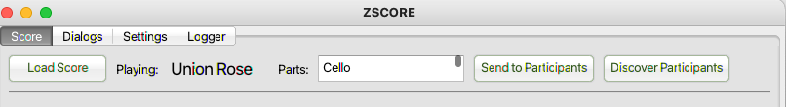Figure 16: OSC device discovery
Available OSC devices should appear in the Participants table as shown in Figure 17.
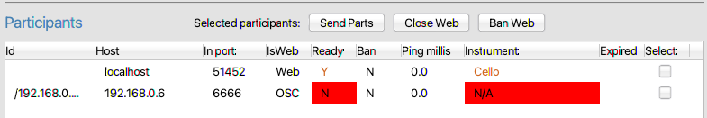Figure 17: OSC device registration
Once the OSC device is visible on the Participants list, click on the “Send to Participants” button in the ZScore GUI. This will send score information to all connected OSC devices.
Figure 18: Send to OSC Participants
Max device should be now recognised as “AV” instrument in the Participants list.
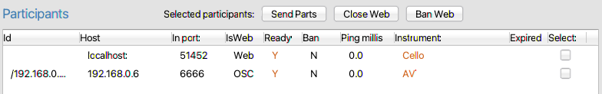

When the “Send Start Position” button is used, as described above, Max patch should display the score name and current position.
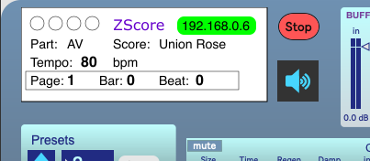Figure 19: Correctly initialised Max patch

When the score is played, Max patch should play in sync with the performers’ and audience’s views.
TIP: The sequence “Discover Participants” → “Send to Participants” described above should be executed every time an OSC device is opened/restarted.
TIP: Running Max and Web Audience clients on the same box may cause audio issues, depending on the host machine spec. To get the best results, run Max on a separate box.
TIP: if the Max zscore patch is closed then the entire Max 8 application needs to be shutdown before opening the patch again. Reopening the patch while Max 8 is running might cause errors (please check Max console for any errors)

Latency calibration and compensation
Currently, there is no automated latency compensation in ZScore.
As the Max patch introduces additional latency due to real-time network and audio processing, it is usually necessary to calibrate web score latency to be in sync with Max audio.
The calibration can be visual (by observing the current position line in the web score and system latencies in the Participants list) or auditory for a more accurate synchronisation.

Auditory calibration
Both web score and max client have built-in audio click.
To enable/disable audio click in a Web Score client, click on the metronome icon available in the top left corner.
This should enable click control as displayed in the figure below
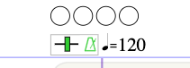Figure 20: Web score click controls

If required, the click pitch can be changed by dragging the green bar next to the metronome icon left or right.
To enable click in the Max 8 patch, unmute Click box displayed below.
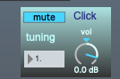Figure 21: Max 8 click controls

If required, change click tuning and volume in the Max patch.

Web Event Delay Setting
With both web score and Max click enabled, play the score to hear the time difference between web and Max clients.
TIP: mute all other Max sources apart from the click box.
To modify web score click timing, change Web Event Delay Ms value in the “Settings” tab of the performance control GUI, as illustrated below.
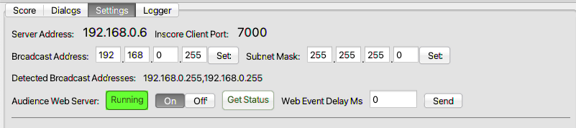Figure 22: Web score latency delay controls
TIP: Gradually increase web delay until Max and Web score click happen at the same time.
On a local host, a delay value of somewhere between 20 – 50 milliseconds is usually adequate, however, this value may vary significantly depending on the local network configuration.
Once the delay is set to a desired value, disable web score click by clicking on the metronome icon and mute Max 8 Click control.
TIP: In the dedicated ZScore performance environment all score devices are connected via Ethernet cable to minimise latency and jitter. Audience devices connect via Wi-Fi so the audience score view is designed to cope with higher latency variations.

