Slavko Zagorac

Ukodus
Cello

(For Information Only)

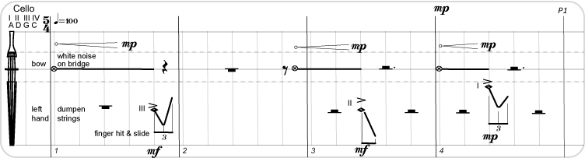
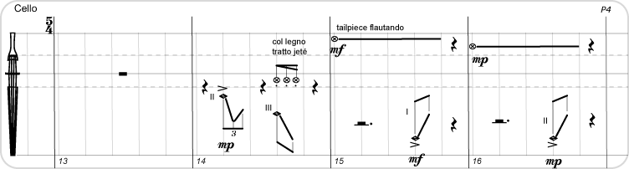
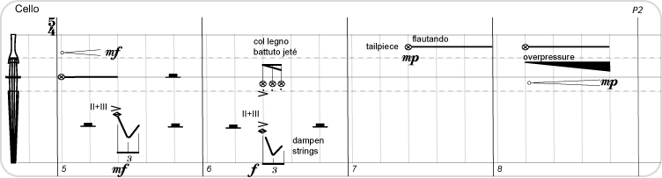
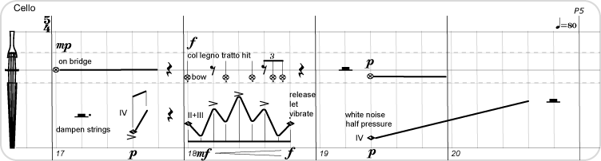
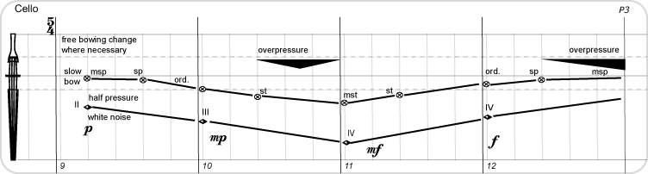
2
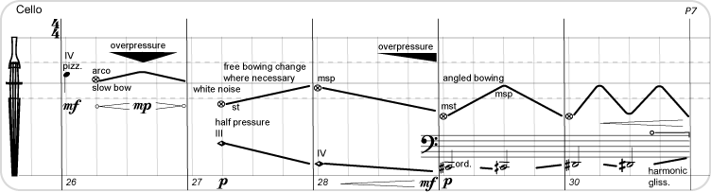
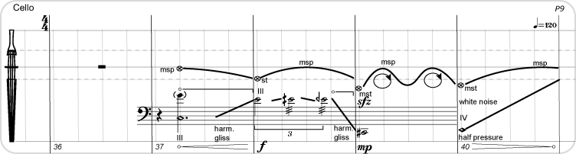
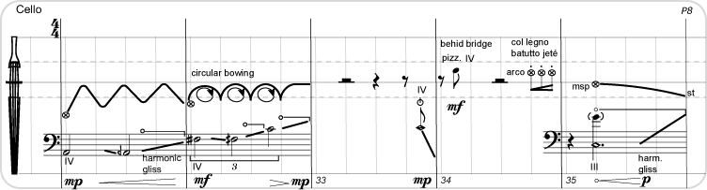
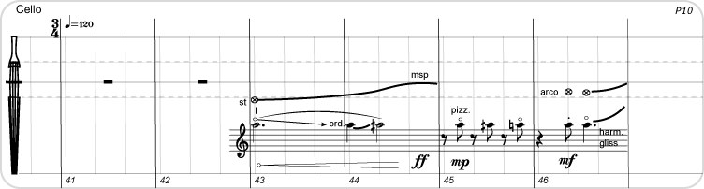
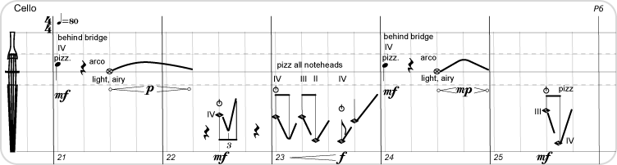

3
