Slavko Zagorac

Ukodus
C Flute

(For Information Only)

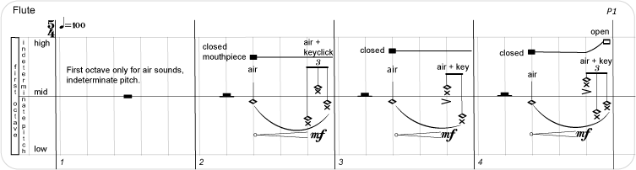
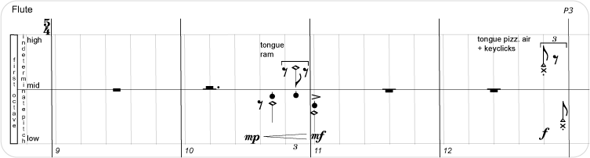
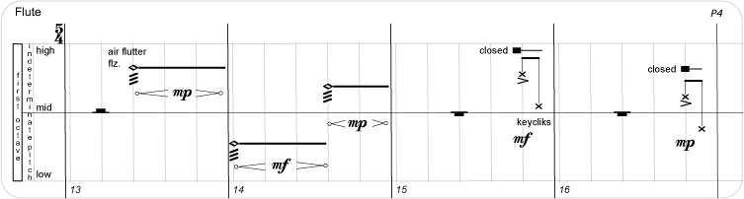
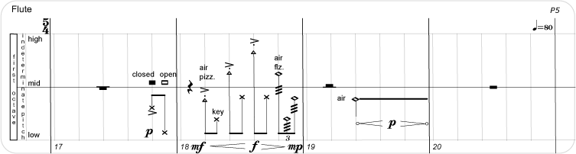
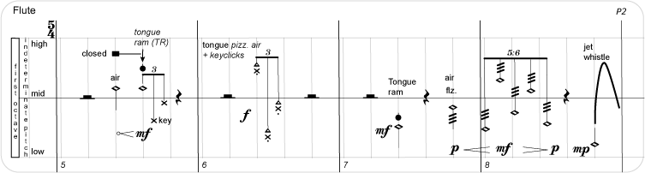

2
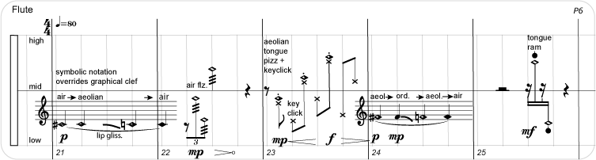
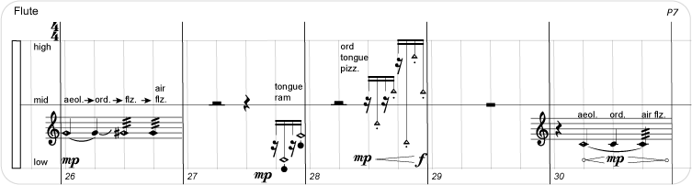
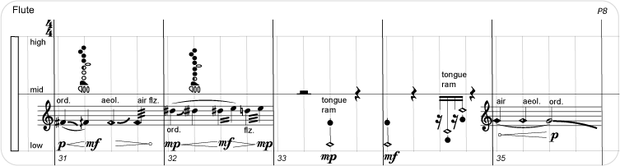
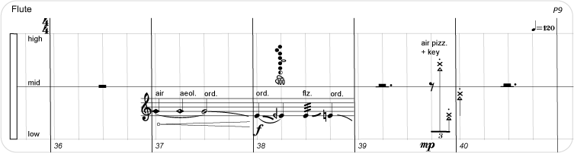
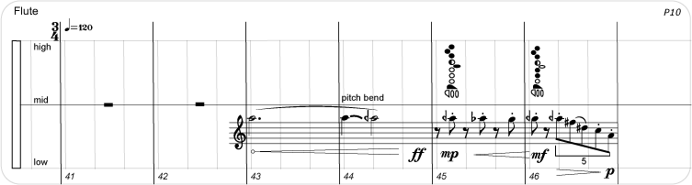

3
