Slavko Zagorac

Ukodus
Piano

(For Information Only)

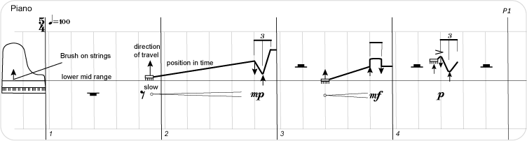
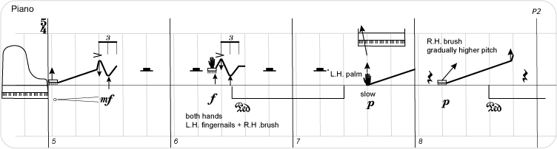
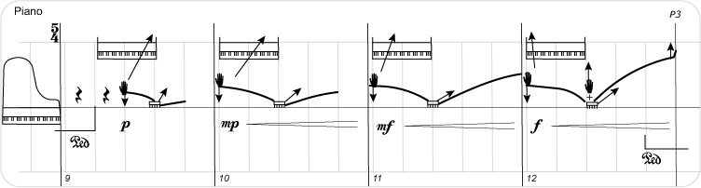
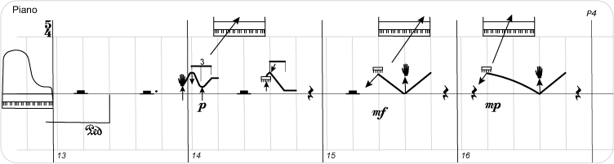
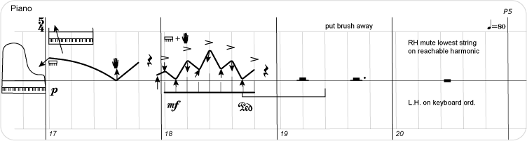
2
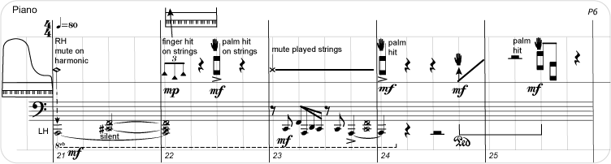
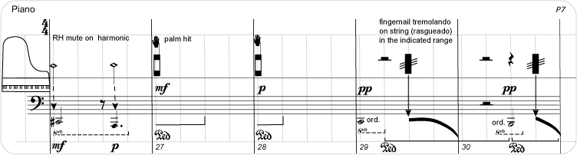
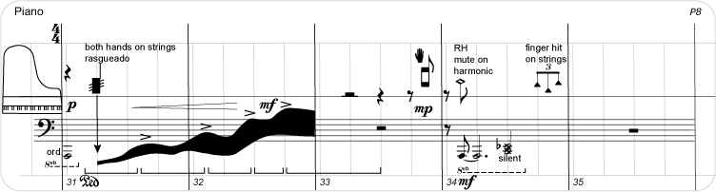
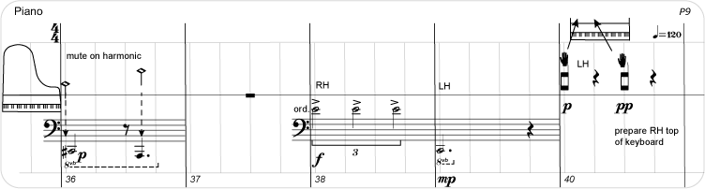
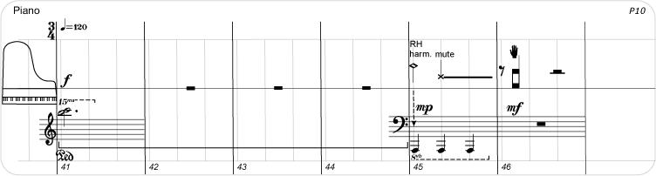
3
