ZScore User Guide

Table of Contents
Download 1
Installation 1
Required third-party software 2
Java 2
Max 8 2
ZScore software 2
How to run ZScore 2
Start up ZScore Peformance Control GUI 2
Load Score 3
View Web Score 4
Play Score 6
Performer Actions 7
Audience Score View 7
Max 8 Patch 8
Initialisation and verification 9
OSC Device Connection 9
Latency calibration and compensation 11
Auditory calibration 11
Web Event Delay Setting 11

This guide explains basic ZScore software features, such as score loading and playing. For more advanced features please contact the author via email slavko@zagorac.com
ZScore feature explanations were correct at the time of writing (Dec 2021), however, the software functionality might change in the future as the project gradually evolves.

Download
Use the URL below to download ZScore packages.
https://drive.google.com/drive/folders/1F8qE1NYexNxKyNp2l7jjRBslh6ptNlZc?usp=sharing
ZScore is split into multiple components. The main software package (zscore.zip) contains Java performance control graphical user interface (GUI) (zscore_jgui folder) and the web content (webroot folder). Score resources can be found in scores.zip while Max 8 patches are stored in max.zip file.
Standalone Max 8 patch app for MacOS is available, if required. It does not require Max 8 installation, however, due to its size (> 1GB) Max 8 installation is preferable.

Installation
ZScore software can be run on any desktop operating system, providing that the third-party software dependencies outlined below are installed.

Required third-party software

Java
ZScore performance control GUI and server require Java jdk 1.8 (Java SE Development Kit) which can be installed from
https://www.oracle.com/java/technologies/javase/javase8u211-later-archive-downloads.html
Once jdk is installed please check that that the installation is valid (version check is good enough):
https://www.baeldung.com/java-check-is-installed

Max 8
Some scores written for ZScore use Max 8 as a digital audio source. If Max patches are required to play the score, please install Max 8 (free for 30 days) or download the standalone ZScore patch app (MacOS only).
https://cycling74.com/downloads

ZScore software
To play musicians’ scores only, please download and unzip zscore.zip and scores.zip, preferably into the same directory (<installDir>).
Some scores use digital audio source (Max 8). If a digital audio source is required please download and unzip max.zip (if Max 8 is installed) OR the standalone app zscoreMacOSMaxApp.zip (if Max 8 is not available, macOS only).

How to run ZScore
Navigate to the directory where ZScore packages were unzipped, either through the computer’s file system browser (Finder, Windows explorer...) or via a command line.

Start up ZScore Peformance Control GUI
Go to the “zscore” directory (<installDir>/zscore).
On MacOS, either double click zscore.command or execute the command line script: ./zscore.sh
TIP: If you get macOS unidentified developer warning, right click on zscore.command→ select Open → click Open button.
On Linux, or any other Unix like OS, execute the command line script: ./zscore.sh
On Windows, double click zscore.bat or execute it from the command line.
TIP: If you get Windows Defender blue window warning, click on More Info → Run Anyway.
The script execution above should open a new terminal window containing a startup log.
TIP: Do not close this window as it will terminate the application.
If everything is ok after a while the ZScore GUI should appear. The figure below shows what the ZScore GUI should look like.
TIP: If this does not happen, or in case of any other issues, please check for any errors in the log file (szcoreApp.log). The log file should be available in “zscore” directory (<installDir>/zscore), or in whatever directory the app was started from.
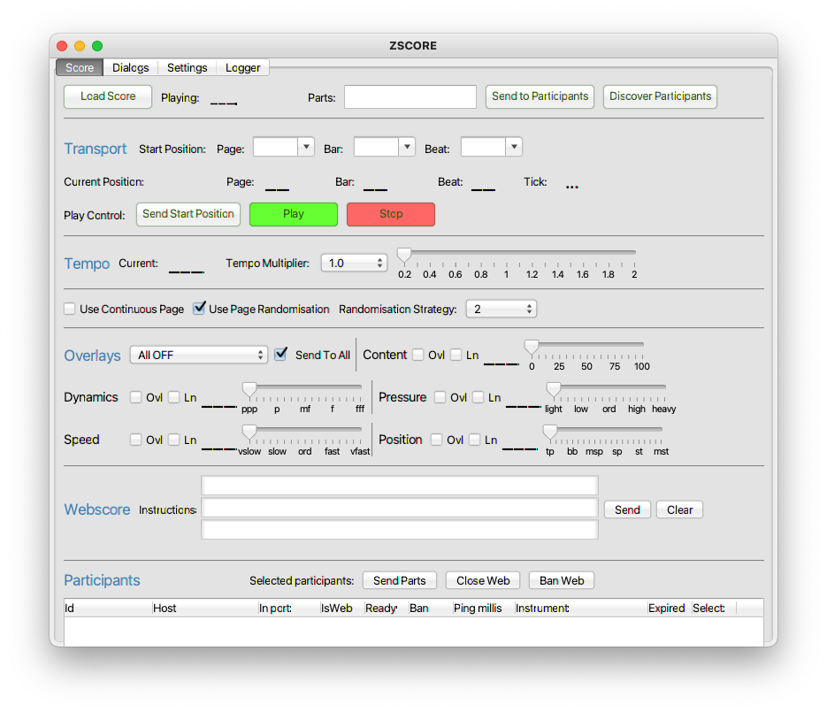Figure 1: ZScore performance control GUI

Load Score
In ZScore GUI click on the “Load Score” button available in the top left corner.
Navigate to the installed “scores” directory and find the required composition subdirectory. Under the composition directory go to “rsrc” folder (<installDir>/scores/<scoreName>/rsrc)
E.g. for “Union Rose” score the “rsrc” directory should be available as per image below.
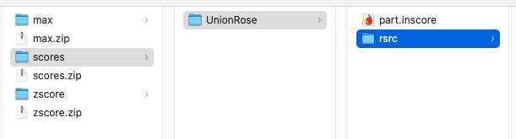Figure 2: “Union Rose” score rsrc directory
In the “rsrc” directory find file 1_<Score_Name>_BeatInfo.csv and Open it.
E.g. for “Union Rose” score open file 1_Union_Rose_BeatInfo.csv
TIP: Required BeatInfo file should be at the top of the list if the file browser view is sorted by Name.
If the score load was successful, ZScore GUI should display the available parts and composition name as per image below.
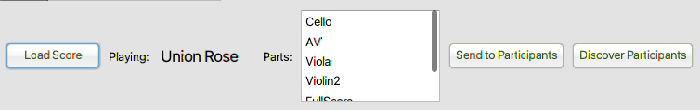Figure 3: Successfully loaded score
TIP: You can resize GUI as required by dragging its corners.

View Web Score
Open any available internet browser (Chrome, Safari, Brave, Firefox, Edge, Opera ….)
TIP: Update the browser to the latest version if required.
In the browser address bar at the top, type (or copy and paste):
http://localhost:8080/ (if the browser is running on the same computer as ZScore GUI) OR
http://<host_ip_address>:8080/ (if the browser is running on another device on the same network)
where host_ip_address is the IP Address of the computer running ZScore GUI. This address can be found in the ZScore GUI “Settings” tab, next to “Server Address”.
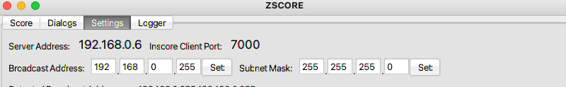Figure 4: Host IP Address example
TIP: In the custom ZScore performance environment this address is http://zscore:8080/
The browser should now display a menu of available scores as per the figure below.
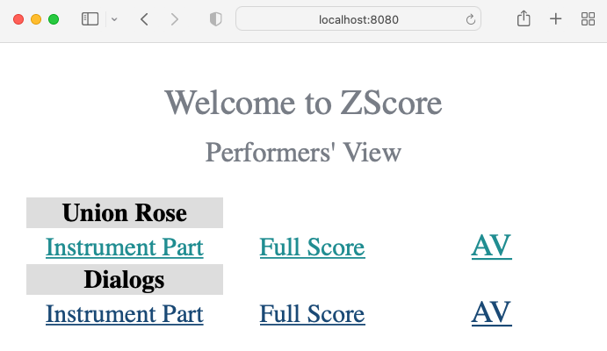Figure 5: Available scores menu

To view an instrument part for a score, please click on the appropriate “Instrument Part” link.
The browser should now display a blank score page similar to the figure below.
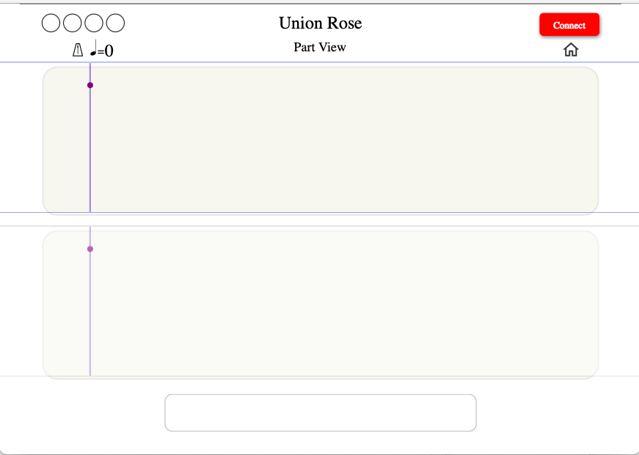Figure 6: Initial blank score page layout

If the “Connect” button at the top right corner is red, please click the “Connect” button.
If the top left button is green and displays “Connected” there is no need to click the button as the browser has automatically re-connected.
Depending on the score, the browser should now display a menu of choices, such as available parts as per the figure below.
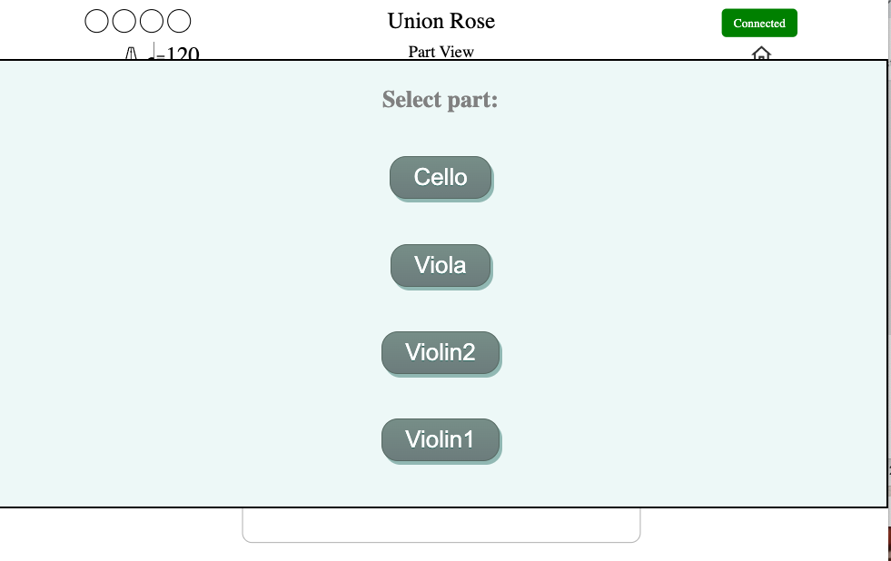Figure 7: Part selection menu

Click on the required menu selection (e.g. Part name).
The selected part should now be visible in the ZScore GUI “Participants” grid at the bottom of the “Score” tab.
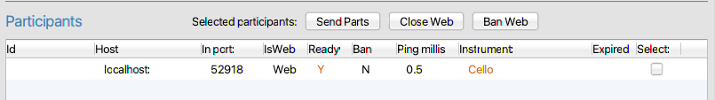

Play Score
Once all required parts are connected, click the “Send Start Position” button in ZScore performance control GUI.
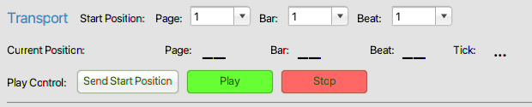Figure 8: Send Start Position

TIP: Always click “Send Start Position” before hitting “Play”.
It is possible to change the start Page, Bar or Beat to any required value before sending the start position (Figure 8).
The selected Page should now be visible in the web score browser. The figure below shows the first page of the “Union Rose” score Cello part.
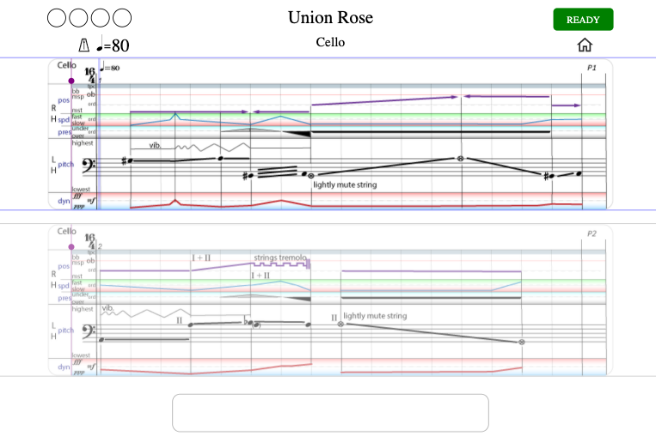Figure 9: The first page of “Union Rose” Cello part.

Click the green “Play” button in the ZScore performance control GUI to play the score (Figure 8).
The semaphore in the top left corner of the web score should count down to the performance start.
Once the score is started, the position line will move to indicate current position in the score. Also, the bouncing ball on the top of the stave will indicate current tempo.
The score layout consists of two staves (top and bottom). One is always active (currently played) and the other one is preparatory (showing the upcoming notation).
Play starts from the beginning of the top stave and continues to the bottom stave. Once the bottom stave is completed, play continues from the beginning of the top stave.
To stop play click on the red “Stop” button in the ZScore performance control GUI (Figure 8).
To replay the score please repeat the sequence “Send Start Position” → “Play” → “Stop”

Performer Actions
Some scores allow for performer interaction with the system and other participants via the web score browser. These actions are displayed at the bottom of the score view. The figure below shows an example where individual players can opt in/out from the next page play by clicking on their part name.
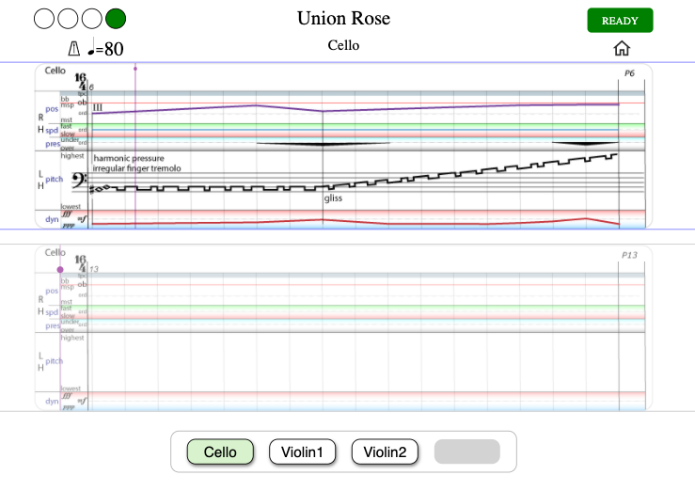Figure 10: Performer actions

Audience Score View
Some scores provide an audience view. If available, it can be viewed on any computer or mobile device. To view an audience score, open any available internet browser (Chrome, Safari, Brave, Firefox, Edge, Opera ….)
TIP: Update the browser to the latest version if required.
In the browser address bar at the top, type (or copy and paste):
http://localhost/audience.html (if the browser is running on the same computer as ZScore GUI) OR
http://<host_ip_address>/audience.html (if the browser is running on another device on the same network), where host_ip_address is the IP Address of the computer running ZScore GUI. This address is available in the ZScore GUI “Settings” tab under “Server Address” (Figure 4).
In the custom ZScore performance environment, audience view address is:
http://zscore/ or http://z/
The browser should now show the welcome page as illustrated below.
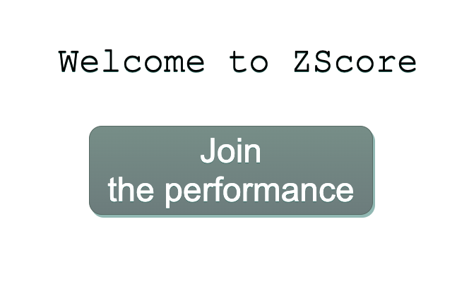Figure 11: Audience view welcome page

Click on the “Join” button to connect to the ZScore audience server.
Once the browser is connected to the server, the view should change to the composition specific welcome page. An example of the welcome page for “Union Rose” is shown below.

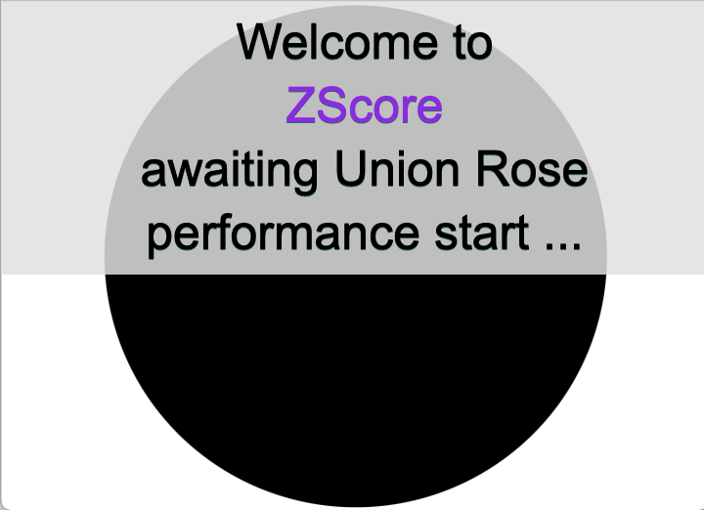Figure 12: Union Rose audience view welcome page

Once the score is started, as described above, the audience view will be played in sync with the performers’ score.

Max 8 Patch
Some scores use Max 8 as a digital audio source. To open max patch, navigate to the installed max directory (<installDir>/max) and either double click 1_zscore.maxpat (if Max 8 is installed) or 1_zscore.app (Standalone app for macOS). After a while, the patch should appear as displayed in the figure below.

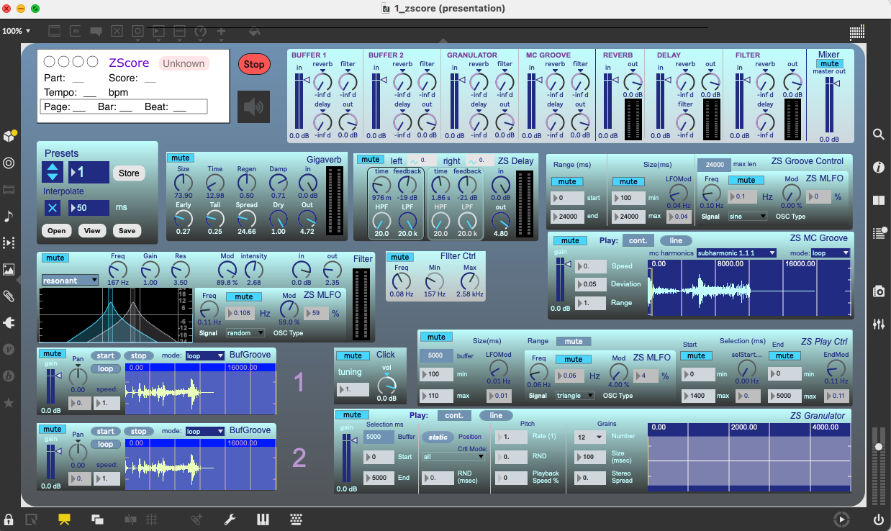Figure 13: ZScore Max 8 patch

Initialisation and verification
Click on the speaker icon (ezcac~) below the red Stop button (indicated in Figure 13). It should turn blue.
If Max 8 is installed, check the audio in/out devices are set as required (Options → Audio Status → Input/Output Device)
In the ZScore patch “Presets” box, increase the preset number to 2 (indicated in Figure 13).
Click the “start” button on the buffer 1 (indicated in Figure 13).
You should hear the buffer content.
TIP: If there are any problems please check Max Console for errors.

OSC Device Connection
Max patch talks to ZScore via OSC protocol.
To connect any OSC device (Inscore, Max...) click first on the “Discover Participants” button in ZScore performance control GUI
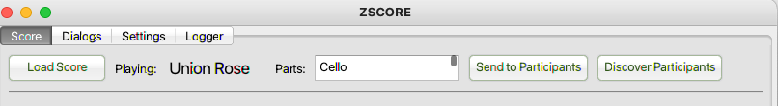Figure 14: OSC device discovery
Available OSC devices should appear in the Participants table as shown in the figure below.
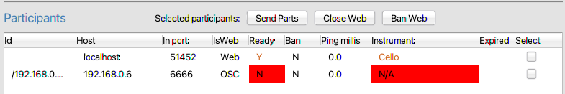Figure 15: OSC device registration
Once the OSC device is visible on the Participants list, click on the “Send to Participants” button in ZScore performance control GUI. This will send score information to all connected OSC devices.
Figure 16: Send to OSC Participants
Max device should be now recognised as “AV” instrument in the Participants list.
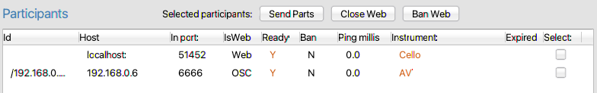
Now when the “Send Start Position” is used, as described above, Max patch should display the score name and current position.
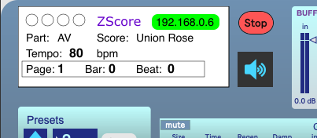Figure 17: Correctly initialised Max patch

When the score is played, as described above, Max patch should play in sync with the performers’ and audience views.
TIP: The sequence “Discover Participants” → “Send to Participants” described above should be executed every time an OSC device is opened/restarted.
TIP: if the Max zscore patch is closed then the entire Max 8 application needs to be shutdown before opening the patch again. Reopening the patch while Max 8 is running might cause errors (please check Max console for any errors)

Latency calibration and compensation
Currently, there is no automated latency compensation in ZScore.
As the Max patch introduces additional latency due to real-time network and audio processing, it is usually necessary to calibrate web score latency to be in sync with Max audio.
The calibration can be visual (by observing the current position line in the web score and system latencies in the Participants list) or auditory for a more accurate synchronisation.

Auditory calibration
Both web score and max client have built-in audio click.
To enable/disable audio click in a Web Score client, click on the metronome icon available in the top left corner.
This should enable click control as displayed in the figure below
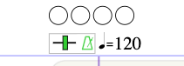Figure 18: Web score click controls

If required, the click pitch can be changed by dragging the green bar next to the metronome icon left or right.
To enable click in the Max 8 patch, unmute Click box displayed below.
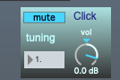Figure 19: Max 8 click controls

If required, change click tuning and volume in the Max patch.

Web Event Delay Setting
With both web score and Max click enabled, play the score to hear the time difference between web and Max clients.
TIP: mute all other Max sources apart from the click box.
To modify web score click timing, change Web Event Delay Ms value in the “Settings” tab of the performance control GUI, as illustrated below.
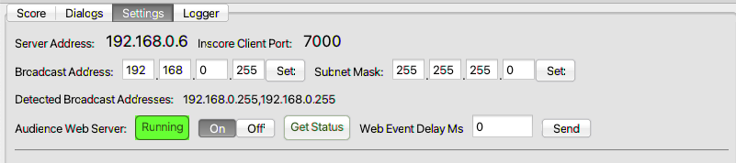Figure 20: Web score latency delay controls
TIP: Gradually increase web delay until Max and Web score click happen at the same time.
On a local host, a delay value of somewhere between 20 – 50 milliseconds is usually adequate, however, this value may vary significantly depending on the local network configuration.
Once the delay is set to a desired value, disable web score click by clicking on the metronome icon and mute Max 8 Click control.
TIP: In the dedicated ZScore performance environment all score devices are connected via Ethernet cable to minimise latency and jitter. Audience devices connect via Wi-Fi so the audience score view is designed to cope with higher latency variations.

