ZScore Web Server Testing

Testing Scope
The purpose of this testing was to verify ZScore’s web server behaviour under the typical use case scenario and find system performance limits by increasing the web traffic load until the system breaking point is found (i.e system load and stress tests). ZScore’s web front end is currently used to render score views on audience’s mobile devices. Under the typical load conditions the system is expected to serve up to 100 connected web interface users without any network packet loss and any adverse impact on the internal network score distribution. The maximum allowed web page load time in these tests was set to 5 seconds while the maximum server state data push latency was set to 1 second. The tests included client connectivity over the wired (Ethernet) and wireless (WiFi) connections for both HTTP and Websocket protocols. Furthermore, a set of tests was devised to assess the impact of the firewall filtering on the system throughput. The testing scope did not include wireless access point range tests and Open Sound Control UDP messaging to musicians’ front ends.

Testing Environment
ZScore web server is currently integrated into the ZScore application written in Java (1.8). The server utilises Undertow library (v2.0.1) to provide HTTP, Websockets and SSE service. In this test the ZScore application was run on 16” MacBook Pro laptop connected to the Mikrotik hAP ac router via Ethernet cable, as illustrated in Figure 1. The test clients (custom Java and Apache jmeter) were run on a separate MacBook Pro laptop (Figure 1). The testing client laptop was either wired or connected wirelessly to the router, depending on a test scenario.
Figure 1: Test Environment
ZScore
Web Server
Java 1.8 (Undertow)

16” Macbook Pro
2.3 GHz 8 core i9
32GB DDR4
Router
Mikrotik hAP ac

5 Gigabit ports
2.4/5GHz AP
802.11ac/a/n/b/g

ZScore
Test Client
Java 1.8 (Undertow)
And
Apache jmeter 5.3

15” Macbook Pro
2.5 GHz core i7
16GB DDR3
Ethernet or WiFi
Ethernet
CAT 5e
cable

Router setup
In a public performance situation audience’s mobile device access to ZScore’s internal network presents a potential security risk. A network firewall is an industry standard protection mechanism which isolates internal network and limits external users’ access. In order to assess impact of the router’s firewall on both wired and wireless connections a separate network bridge (guestBridge) with its own IP address subnet range was created on the router. One of the ethernet ports on the router (port 5) and both virtual wireless Guest WLANs (wlanGuest and wlanGuest5g) were assigned to the created guest bridge (Figure 2).
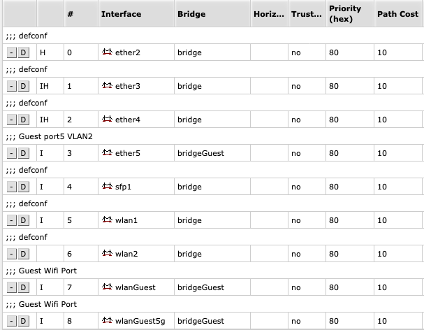Figure 2: Router bridge ports assignment

A set of firewall rules was then added to prevent guest bridge access to all standard ports on the internal network except DNS (port 53) and HTTP (port 80). Additionally, a network address translation (NAT) rule was added to route all HTTP requests coming from the guest bridge subnet to the ZScore server (Figures 3 and 4).
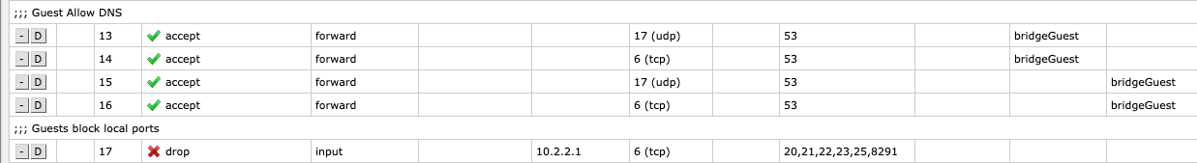Figure 3: Guest bridge firewall rules
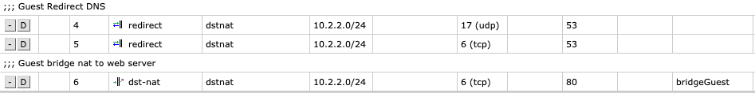Figure 4: Guest bridge NAT rules
In order to limit the bandwidth available to guest users and prevent the congestion on the network a couple of router queues (one for the internal and one for the guest connections) were created (Figure 5). Both queues were setup to use SFQ (Stochastic Fairness Queuing) algorithm which ensures fair round-robin distribution to all sub-streams. Guest users were limited to 200Mbps overall bandwidth after the initial testing and calculations showed that it was a sufficient limit for the typical use case scenario.
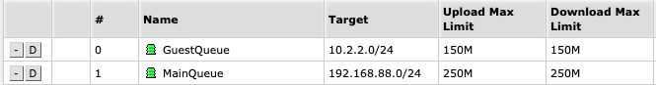Figure 5: Router Queue setup

Wifi setup
Mikrotik hAP ac router provides 2.4GHz b/g/n and 5GHz a/n modes. In this test both WLANs (2.4 and 5GHz wireless LANs) were set to the same SSID, so the test client’s wireless adapter was left in charge of the best connection mode. In a real-life performance scenario audience mobile devices will be allowed to select wireless connection mode in order to simplify user connection process.
The router’s channel selection setting for both 2.4 and 5GHz WLANs was set to ‘auto’ (router’s algorithm automatically selects the least congested channel). 2.4GHz WLAN channel width was set to 20MHz, while 5GHz WLAN channel width was set to 20/40MHz XX, where the XX mode allows for the automated control channel frequency selection. According to the Mikrotik product specifications, maximum theoretical hAP ac throughput for 2.4GHz mode is 450 Mbit/s and for 5GHz it is 1300 Mbit/s. The actual maximum throughput achieved during testing was around 120 Mb/s. This aligned with the expectations as the maximum theoretical throughput for a single wireless stream is 150Mbps. Mikrotik AP provides multiple streams (MIMO) so when multiple WiFi clients are connected the overall throughput should increase up to five times (2x at 2.4 and 3x at 5GHz).
It is worth pointing out that there was a significant congestion and interference from the neighbouring wireless access points during testing. 34 access points with better than -75 dBm wireless signal strength were scanned from the testing site. It is unlikely that any performance site would have much worse wireless congestion and interference problems.

Testing Procedure
A number of testing scenarios were created to cover all permutations of the testing scope. These permutations included wired and wireless test client connections on both guest and internal bridge. Each scenario was run five times in order to get average results.
Union Rose score was loaded into the server as a typical example of the scores written for ZScore system. The initial HTTP load for this score was approximately 1.9MB of data. This included required HTML, Javascript, CSS and MP3 files. The average server state data update size was approximately 18KB.
The firewall contained 20 filter rules set up as described above. In the tests where the client was connected through the guest bridge all data had to pass through the firewall. If the test client was connected through the internal bridge the data bypassed the firewall. Wired connections on the internal bridge had the additional advantage of the hardware switch optimisation.
For the wireless tests, the client host was positioned approximately 2 meters from the access point. As described above, the scope did not include wireless range testing.
Two types of testing clients were used: custom Java (Undertow) and Apache jmeter.

Jmeter tests
ZScore’s web client uses HTTP polling mechanism when neither SSE nor Websocket transports are available on the client side. Jmeter tests cover this worst case scenario. The client’s behaviour was first recorded through the Jmeter proxy, starting with the index page retrieval which included HTML, Javascript, CSS and MP3 content (1.9MB overall). The captured scenario then issued 23 HTTP polling requests for the server state data in 500 millisecond intervals. Each server data state update size was around 18KB. The ramp-up time to reach desired client number was set to 10 sec. After the ramp-up time all clients simultaneously issued recorded requests. Jmeter tests were primarily used to stress test ZScore server and find out the system limits.

Custom Undertow client tests
The custom Java tests included the typical HTTP client content retrieval and Websocket server data push scenarios.
HTTP tests first created the specified number of HTTP clients and then issued index HTML page request for each client which downloaded the initial content (HTML, Javascript, CSS and MP3 files; overall size ~ 1.9MB). The index page requests were staggered to mimic real-life scenario. A random number of clients (between 1 and 5) requested the index page at the same time. After a random time interval (between 0 and 1000 seconds) a next group of clients was randomly selected to send their requests. This process was repeated until all test clients submitted index page requests. For 200 HTTP clients the average duration of the test was around 50 seconds.
Likewise, Websocket tests first initialised the required number of clients and then listened for the server state updates. For these tests ZScore server replayed server side events for the first 16 beats of Union Rose. This included 8 server state data updates, each of approximately 18KB size. A single test lasted approximately 12 seconds.

Findings and Analysis
Generally, the test results confirmed expected performance patterns. The most important findings can be outlined as follows:
- In its current form, ZScore server can cope with a significantly higher load than the typical use case scenario. Test results show that network data back pressure and packet loss start at around 1500 concurrent users.
- Router’s switch can successfully serve 200 concurrent wired connections going through the firewall, without any packet loss and the latency below the test criteria (HTTP: average 1.03, 90th percentile 2.1, max 4.4 sec; Websocket: average 0.054, 90th percentile 0.2, max 1.3 sec).
- Router’s wireless AP can successfully serve up to 100 wireless users connected through the firewall. The maximum number of Wifi connections that did not suffer any packet loss was 125. However, the max latency for 100 wireless connections reached 9 sec (average: 1.6 sec, 90th percentile: 3.3 sec).
- Firewall filtering significantly impacted wired clients throughput, however, for the wireless connections the benefits of a secure firewall outweigh a negligible performance difference between open and firewalled connections.
- Wireless tests latency Variance was almost 4 times higher then the wired tests variance. The most likely cause for such a large difference was the significant interference from the neighbouring wireless access points during testing, as described above.
The most significant difference between a real-life performance situation and these tests is that, in the real world, there would be multiple hosts (mobile devices) making a single connection to the server. This difference could have multiple consequences. The AP would have to manage and route a number of connections which might impede its performance. On the other hand, router’s multiple wireless streams (2 for 2.4GXz and 3 for 5GHz) would be better utilised when multiple client adapters are connected. This could theoretically increase available bandwidth fivefold. The only way to measure this impact would be to have multiple (50+) mobile devices connected to the router’s AP in a controlled environment.
In wired HTTP tests it was not possible to connect more than 235 clients and in wireless tests the maximum was 150 clients. The initial suspicion was that this was down to the test laptop’s operating system file descriptor limits. However, even after increasing the number of OSX file descriptors the tests failed at the same point. As Jmeter tests managed to create successfully 2000 connections it is likely that this could be a limitation of the Undertow client implementation (multiple non-blocking threads and OS resource utilisation).
ZScore server memory heap size never went over 250MB during the testing, indicating a fairly light memory usage and no significant memory leaks when dealing with the web traffic. The maximum JVM CPU load during testing was 1.5% which, again, indicates fairly low server side load.
The Mikrotik Queue size reached the peak at around 110Mbps for 100 connected users. This aligns with expectations as each connection had to download 1.9MB of initial files and the limitation of the single wireless stream is 150 Mbps. The queue size needs to be reviewed whenever the maximum throughput or a number of connected users change.
In a real-life situation, WiFi user’s experience will depend heavily on the performance site’s wireless channel congestion, however, it is unlikely that the throughput will be much worse then the testing data numbers, due to the reasons described above.

Scalability Ramifications And Possible Solutions
From the ZScore web user’s perspective, two factors can impact the system’s performance the most: a size of data to push through the network and a number of connected users. If it is assumed that Union Rose is a typical score and the data load used in ZScore system, then the number of connected users becomes critical for system scalability planning. The system design discussion could be framed by the number of expected users (audience members) as follows.

System design for up to 100 WiFi users
Based on the test results, current system architecture should cope well with 100 users connected over Wifi and going through the firewall.
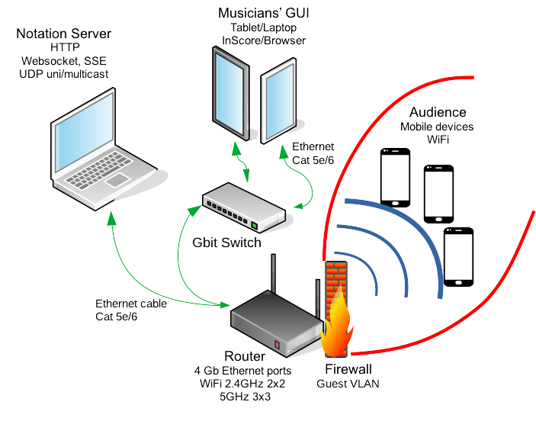Figure 6: System architecture for up to 100 WiFi users

System design for 200 to ~500 WiFi users
For 200 connected WiFi users the typical required throughput would increase to around 400Mps. Although Mikrotik’s theoretical wireless throughput is much higher, the tests have shown that additional wireless access points might be required. Based on the testing results, it could be extrapolated that for each additional 100 users one more wireless AP of the similar specifications to the test AP is required. Alternatively, a more powerful MU MIMO AP (such as Unifi UAP AC HD) could be used to cater for more than 100 users. This expansion could be done until the router’s switch becomes a bottleneck. By extrapolating test results it can be concluded that the current router could serve up to 500 users, which would require 4 additional MIMO or 2-3 MU MIMO access points. A system design suggestion for up to 200 connected WiFi users is shown in Figure 7.
Any additional AP needs to be connected to the router via Ethernet cable for stability and sufficient throughput. A shielded CAT 6e Ethernet cable would be a good choice for this purpose as it provides reduced interference and high throughput (up to 10Gb). Furthermore, CAT 6a can feed power over Ethernet (PoE) to AP if required. PoE would simplify system installation as it replaces conventional power cabling.
Additional APs should have similar specifications to hAP ac AP (MIMO 2x2 at 2,4GHz and 3x3 at 5Ghz) or better in order to provide required throughput (e.g. Unifi AP AC PRO). The additional AP should be set up with the same guest SSID as the router’s AP to simplify user connection procedure. In this design, there are no guarantees where mobile devices are going to connect to, however, most modern WiFi adapters have built-in algorithms to choose an AP with the strongest signal.
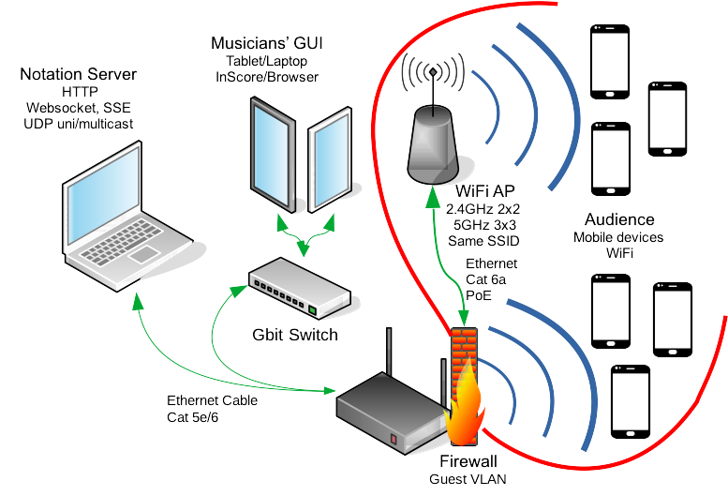Figure 7: System design for up to 200 WiFi users

A potential issue could arise for audience members positioned in the middle between two access points with similar signal quality. In this case a mobile device WiFi adapter could switch intermittently between two access points. The switching process might take several seconds during which users’ interaction with the network would be interrupted. This would create issues for any continuous streaming (audio/video). Websocket and SSE clients should be able to reconnect on mobile device rejoining the network, therefore, ZScore server would synchronise mobile device state on reconnection. Depending on a current content in mobile device’s web browser users might not notice AP switching at all. However, the web front end and server state update logic should be designed with this problem in mind.

Wireless mesh vs multiple APs
Another option for the scenario above would be to deploy a wireless mesh solution. Mesh systems automatically negotiate client connectivity between wireless nodes so they provide a superior network client switching logic. However, as all network traffic over a mesh system is wireless, it would create a throughput bottleneck on the router’s entry point.
On the other hand, network traffic coming from multiple wired APs can be split through hardware switches thus allowing for much higher aggregated bandwidth. Therefore, multiple APs are a recommended solution where high network throughput is required.

System design for ~500 to ~1500 WiFi users
Assuming that the required bandwidth requirement for 100 users is 200Mbps then 1Gbit router would not be able to cope with the typical network traffic as the number of connected WiFi users approaches 500. An enterprise grade 10Gbit router or a router providing independent Gigabit Ethernet ports (such as Mikrotik CCR1009-7G-1C-1S+PC) is required in this case. Ordinarily, enterprise grade routers do not provide any extra functionality, such as a built-in wireless AP, so the complexity and the cost of the system design would increase.
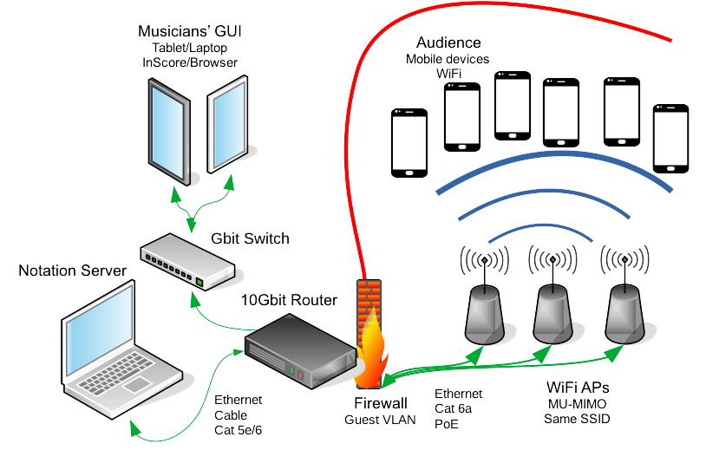Figure 8: System design for 500 WiFi users

System design for 1500+ WiFi users
Tests have shown that ZScore server can successfully deal with up to 1500 connected users. Once the user number goes over this limit ZScore server becomes the bottleneck. In order to deal with such a load, ZScore server design needs to be modified. Web server needs to be hosted externally and possibly on multiple hosts. A load balancing proxy sitting in front of the web server instances could be utilised to marshal clients connections. Websocket functionality needs to be validated if any connection proxying is used.

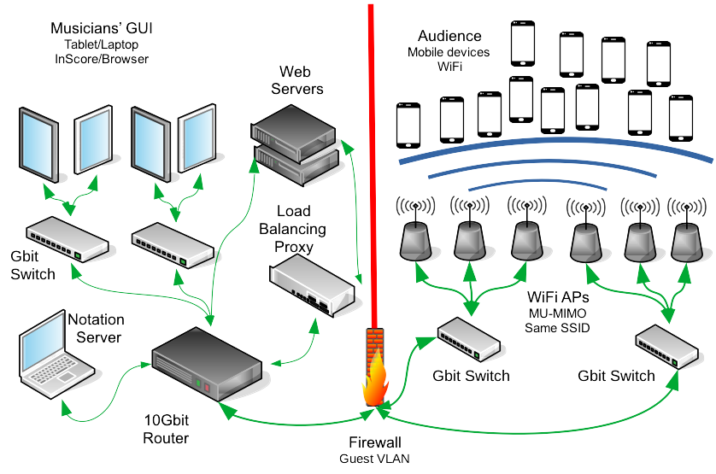Figure 9: System design for 1000+ WiFi users
If the number of users exceeds 2000 then one 10Gbit router would not be able to cope with the load and a more comprehensive solution with multiple routers connected via optical cables is required. At that point the cost and complexity of the system deployment increases significantly.

Detailed Test Results

Test Case 1: Undertow Websocket, Wired, No Firewall, 200 Clients

Test Case 2: Undertow Websocket, Wired, No Firewall, 100 Clients

Test Case 3: Undertow Websocket, Wired, With Firewall, 200 Clients

Test Case 4: Undertow Websocket, Wired, With Firewall, 100 Clients

Test Case 5: Undertow Websocket, Wireless, With Firewall, 200 Clients

Test Case 6: Undertow Websocket, Wireless, With Firewall, 100 Clients

Test Case 7: Undertow Websocket, Wireless, No Firewall, 200 Clients

Test Case 8: Undertow Websocket, Wireless, No Firewall, 100 Clients

Test Case 9: Undertow HTTP, Wired, No Firewall, 200 Clients

Test Case 10: Undertow HTTP, Wired, With Firewall, 200 Clients

Test Case 11: Undertow HTTP, Wireless, With Firewall, 100 Clients

Test Case 12: Undertow HTTP, Wireless, With Firewall, 50 Clients

Test Case 13: Undertow HTTP, Wireless, No Firewall, 100 Clients

Test Case 14: Undertow HTTP, Wireless, No Firewall, 100 Clients

Test Case 15: Jmeter, Wired, No Firewall, 100 Clients

Test Case 16: Jmeter, Wired, No Firewall, 500 Clients

Test Case 17: Jmeter, Wired, No Firewall, 1000 Clients

Test Case 18: Jmeter, Wired, No Firewall, 1500 Clients

Test Case 19: Jmeter, Wireless, With Firewall, 100 Clients

Test Case 20: Jmeter, Wireless, With Firewall, 200 Clients

Test Case 21: Jmeter, Wireless, No Firewall, 100 Clients

Test Case 22: Jmeter, Wireless, No Firewall, 200 Clients

