*EVENT MANAGEMENT*

project charter

LITE Version *1.0*

*12/21/2017*

VERSION HISTORY

|  |  |  |  |  |  |
| --- | --- | --- | --- | --- | --- |
| **Version #** | **Implemented**  **By** | **Revision**  **Date** | **Approved**  **By** | **Approval**  **Date** | **Reason** |
| 1.0 | *Surbhi Zalpuri* | *12/21/17* |  |  | *Initial Version* |
|  | *Jerome Sobrecaray* |  |  |  |  |
|  | *Phani Atluri* |  |  |  |  |
|  |  |  |  |  |  |
|  |  |  |  |  |  |

TABLE OF CONTENTS

1 Introduction 6

1.1 Purpose of LITE Project Charter 6

2 project And Product Overview 6

3 Scope 6

3.1 Objectives 6

3.2 High-Level Requirements 7

3.3 Major Deliverables/Milestones 7

4 Duration 7

4.1 Timeline 7

5 budget Estimate 8

5.1 Funding Source 8

5.2 Estimate 8

6 project Charter approval 9

APPENDIX A: REFERENCES 10

APPENDIX B: KEY TERMS 11

# introduction

## Purpose of LITE Project Charter

*Event Management* Project Charter documents and tracks the necessary information required by decision maker(s) to approve the project for funding.

The intended audience of *Event management* Charter is the project sponsor and senior leadership.

# project And Product Overview

With the hectic and busy schedule of people in Ontario, health is being compromised as people don’t get much time to contribute towards their well-being and lifestyle. This directly impacts their fitness and make them feel stressed and low at all times. One should have easy access and motivation to get going in order to maintain their physical well-being.

The establishment of a website would provide promotion of the upcoming events happening at the Place, it would also boost the company’s profile and would project the business as an ideal partner for suppliers, banks, investors, etc.

They want the website created in 4 months and since it is basically a medium scale business relying solely on the Canadian Cultural Seasons especially the Christmas and New Year with occasional boost coming from tourists from around the world, they would only pursue this project with a budget not exceeding $30,000.

# Scope

## Objectives

The objectives of the website are as follows:

* Show information on what the business is all about
* List down the current events and upcoming events throughout the year
* Introducing Subscribers Membership with Feedback to be registered in the system
* Providing Contact Information for Sponsors and Customers alike in order to expand the Business
* Providing videos and content to demonstrate the idea around events

## High-Level Requirement

The following table presents the requirements that the project’s product, service or result must meet in order for the project objectives to be satisfied.

| Req. # | I Requirement Description |
| --- | --- |
| 1. | Events should be correctly displayed with venue and other details |
| 2. | Provide a Feedback Form |
| 3. | Display Food Menu available at the venue |
| 4. | Contact Module should include location details for the venues |
| 5. | Blog Section Providing Past Events Videos |
| 6. | Miscellaneous Section for Best Tourist Destinations around the world |

## 

## Major Deliverables/Milestones

| Major Deliverable | I Deliverable Description |
| --- | --- |
| Event Management Website | Website about a tourist spot where events are organised for fun and leisure of people. This website will solely promote the business. |

# 

# Duration

## Timeline

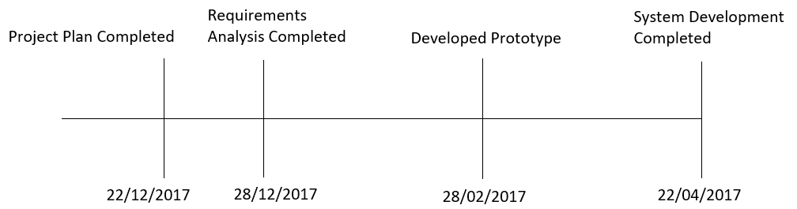

# budget Estimate

## Funding Source

The expense for this project will be taken from the operational budget of the company.

## Estimate

This section provides a summary of estimated spending to meet the objectives of the Event Management project as described in this Project Charter. This summary of spending is preliminary, and should reflect costs for the entire investment lifecycle. It is intended to present probable funding requirements and to assist in obtaining budgeting support.

# project Charter approval

The undersigned acknowledge they have reviewed the **LITE Project Charter** and authorize and fund the ***Event Management*** project. Changes to this **LITE Project Charter** will be coordinated with and approved by the undersigned or their designated representatives.

|  |  |  |  |
| --- | --- | --- | --- |
| Signature: | Surbhi Zalpuri | Date: | 12/21/2017 |
| Print Name: | Surbhi Zalpuri |  |  |
| Title: | Author & Owner |  |  |
| Role: | Author & Owner |  |  |

APPENDIX A: REFERENCES

The following table summarizes the documents referenced in this document.

|  |  |  |
| --- | --- | --- |
| **Document Name and Version** | **Description** | **Location** |
|  |  |  |

APPENDIX B: KEY TERMS

The following table provides definitions for terms relevant to this document.

|  |  |
| --- | --- |
| **Term** | **Definition** |
|  |  |
|  |  |