Final Exam (PROG1245) Fall 2017

You will develop a website by following specific steps and inserting all required elements. You will only write HTML code (the CSS is provided for you) to create the expected web page. See the screenshot on the next page for guidance.

You have 2 hours to complete this exam.

# Instructions

* The HTML starter template, CSS and media are in the directory HTML
* The images you need are in the sub-directory labelled ‘media’
* The CSS stylesheet is in the sub-directory labelled ‘styles’
* Perform each of the following steps in the sequence given.
* When you finish developing and testing your webpage, create a zip archive of your work and submit it to the eConestoga *PROG1245-17F-Sec1-Programming: Web Foundations* **Final Exam** Dropbox.

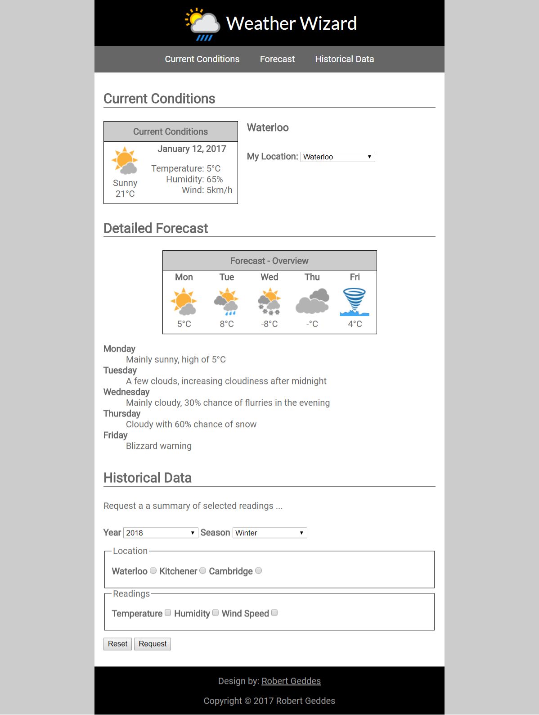

# Steps:

1. Open the starter HTML document named index.htmland insert a DOCTYPE declaration for HTML5
2. Insert an html comment between the DOCTYPE declaration and HTML element with your name and student ID.
3. Add a TITLE in the HEAD section with the text content “Weather Wizard”
4. Use the external stylesheet provided in the styles sub-folder named default.css
5. Add an html BODY element to the document after the HEAD section
6. Insert the following three top-level html elements HEADER, NAV, MAIN, and FOOTER
7. In the HEADERsection add an IMG with ID “logo”. Use the image source file *logo.png* from the media folder. Set an image width of 75px and add some alternative text
8. In the HEADER add an H1 heading with the text content “Weather Wizard”
9. In the NAV section, code an unordered list of three links. These links form the top navigation bar as show in the diagram. The links are internal links (anchor links) to HTML heading elements that will be added in later steps.
   1. First link: ID “conditions”, text content “Current Conditions”
   2. Second link: ID “forecast”, text content “Forecast”
   3. Third link: ID “historical”, text content “Historical Data”
10. In the FOOTERelement insert two paragraphs
    1. The first paragraph is a sentence describing who did the design (you), with an email link to the author’s email address
    2. The second paragraph will contain a copyright notice using a character entity to code the copyright character
11. In the MAIN section add an H2 heading with an ID attribute “conditions” and the text content “Current Conditions”
12. Next Insert a TABLE with the ID attribute “current”. The TABLE will have three columns, two rows and will look like the following image when completed:

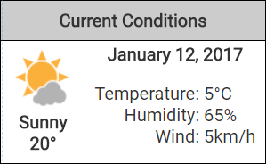

1. After the opening TABLE element, add a CAPTION with the text content “Current Conditions”
2. The First Row:
   1. Insert a table data cell that spans 2 rows and contains an image of the current weather conditions (pick an image from the supplied media. The example above uses “media/02.png”). The table cell will also contain some descriptive text (“Sunny” or “Cloudy”, etc. as shown), and a temperature in degrees Celsius. The image, description and temperature are each on a new line. Use a character entity to code the *degrees* character
   2. The next cell in the first row is a table header element containing the current date and spans 2 columns
3. The Second Row:
   1. Insert a table data cell with CLASS attribute “right”that contains the following text entries (each on a new line): “Temperature:”, “Humidity:”, and “Wind:”
   2. Insert a table cell with the CLASS attribute “left*”* that contains the following text entries, each on a separate line: “5°C”, “65%”, and “SW 5km/h”. Again, use a character entity to code the degrees character.
4. After the current conditions table add an H3 heading with the text content “Waterloo”
5. Add a form for selecting the current location. The form will have a drop-down list with the LABEL “My Location:” and the OPTIONs “Waterloo*”*, “Kitchener*”*, and “Cambridge*”*. The form will look like the following when completed:



1. After the form insert an H2 heading with the ID “forecast” and the text content “Detailed Forecast”
2. Insert an html TABLE with the ID attribute “overview” to contain the forecast overview information (using the various supplied weather icons). The table will have 2 rows and 5 columns and look like the following when completed:

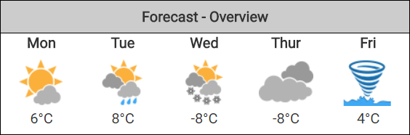

1. Add a CAPTION element to the TABLE with the text content “Forecast – Overview”
2. First row
   * Add 5 table heading cells, one for each day of the work week (Mon to Fri)
3. Second row:
   * Add table data cells containing images for the forecasted weather conditions, and the expected temperature on a new line
4. After the overview table, add detailed forecast information using a description list. The description list will look like the illustration when completed. The text below can be copied and pasted into your work:

**Monday**

Mainly sunny, high of 5°C

**Tuesday**

A few clouds, increasing cloudiness after midnight

**Wednesday**

Mainly cloudy, 30% chance of flurries in the evening

**Thursday**

Cloudy with 60% chance of snow

**Friday**

Blizzard warning

1. Next insert an H2 header with ID “historical” and the text content “Historical Data”
2. Add a paragraph with the text content “Request a summary of selected readings …”
3. Add a form for requesting historical data. The form will be coded in the following 4 steps and look like the following image when completed:

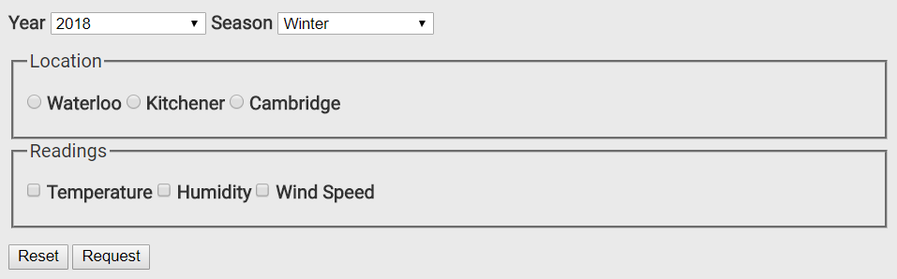

Insert the LABEL “Year” and a corresponding SELECT list into the form. Insert the LABEL “Season” and a corresponding SELECT list into the form

1. Include OPTIONs to select any year or season in the last 4 years (2015-2018 and Spring/Summer/Fall/Winter respectively). The active selections in the lists will be “2018” and “Winter”
2. Next, add a set of three radio buttons to the form for selecting a location with the values “Waterloo*”*, “Kitchener*”*, and “Cambridge*”*. Each button should have a LABEL and the buttons should be grouped together into a set with the LEGEND “Location” as shown in the illustration
3. Next add a set of three check boxes to select different readings to be retrieved; “Temperature*”*, “Humidity*”*, and “Wind Speed*”*. Each checkbox should have a LABEL and the boxes should be grouped together into a set with the LEGEND “Readings”
4. Below that, insert 2 buttons – a reset button which will reset the form, and a submit button which has the text “Request” on it.

Final Checks (optional):

* 1. Check that your web page looks like the illustration. If not, check instructions for a detail you might have missed and/or make sure the code is complete and correct
  2. Test that the menu links work, ie. make sure target element IDs (heading IDs) match the anchor links
  3. Validate the code using the W3C HTML validator to quickly check for any minor coding errors you can fix before submitting

**Evaluation:** 1 mark for each completed task for a total of 30 marks.