Math Odyssey

Matthew Bojey

Duncan Szarmes

OVERVIEW
Math Odyssey is an educational game targeted at children aged 9-11 years (grades 4-6). In the game the user is given the task of retrieving the golden calculator, which was stolen from the Intergalactic Math Museum by the notorious Captain Conjugate. The player chooses a companion to accompany them on their mission and chases Captain Conjugate from planet to planet. Each planet focuses on a separate mathematical concept and contains several exercises to introduce the concept and familiarize the user with how to use it. For example, on the second planet the user is introduced to the concept of multiplication and asked to find patterns produced by repeatedly adding a number over and over. In the next level on this planet the user is told that multiplication can be thought of as repeated addition and is asked to find an equivalent addition expression to the given multiplication expression e.g. 4x5 = 4+4+4+4+4. In the final level on this planet the user evaluates simple multiplication problems by selecting the numerical answer from a list of given choices. Some planets also have optional moons where a user can apply the skills they learned on the planet to other areas. For example, there is a moon on the multiplication planet where users can apply their multiplication skills to find perimeters and areas of simple shapes.
In addition, the game also features a mode where users can create simple arithmetic questions and then practice solving them. In future versions of the game users will be able to share these created questions and solve questions created by other users.

GAME SCREENSHOTS

Splash Page with Menu Options
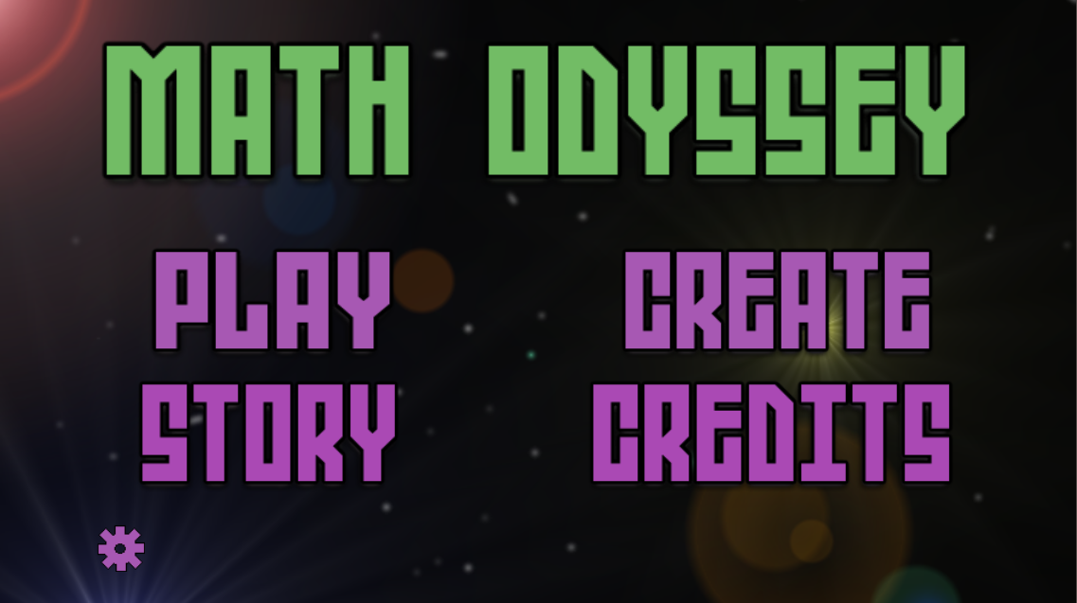
Figure 1. The menu screen of Math Odyssey. The main game mode is in “PLAY” with an explanation of the story in the “STORY” and a question creation mode in “CREATE”. The credits for the game can be found in “CREDITS” and the gear at the bottom left leads to the settings screen.

Credits Screen
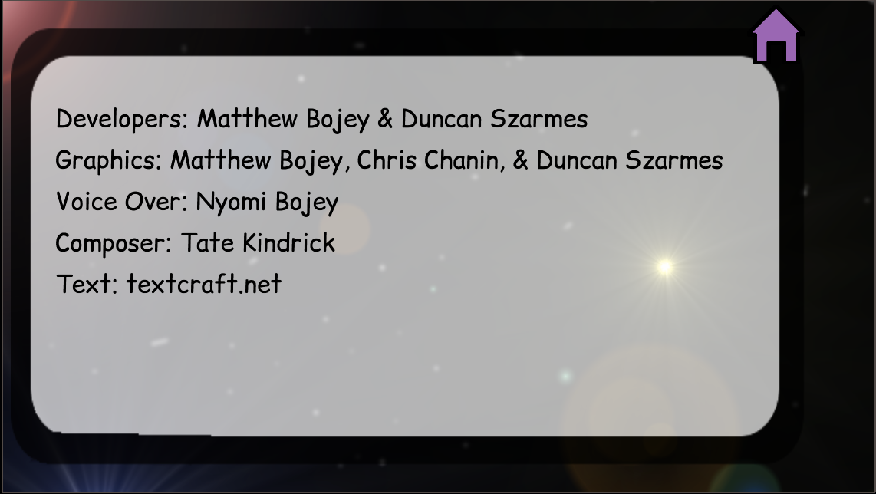
Figure 2. All graphical text is from textcraft.net and is used under the MIT license and needs no credit for commercial or private use.

Tutorial Screen(s)
We choose to have a separate tutorial for each activity, to save space we only show one here. We also have an explanation of the story available from the main menu.
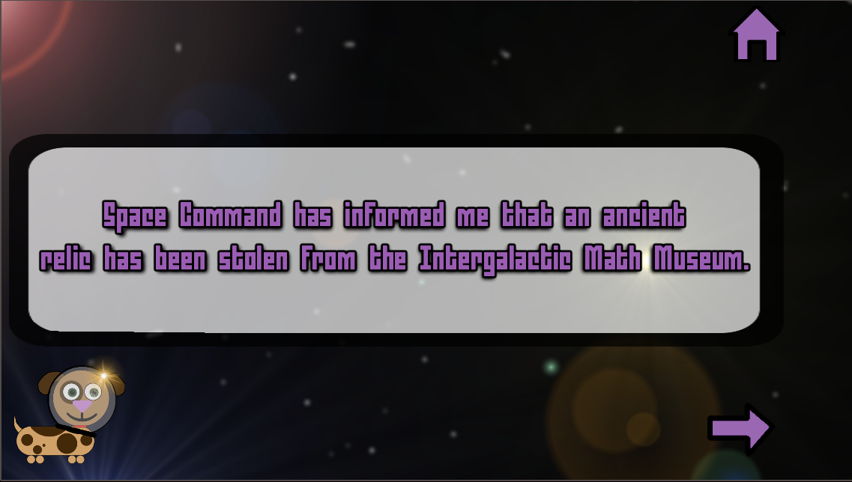
Figure 3. An example screen explaining the story. The text will be narrated in the final version of the game. Our narrator is out of the country so this feature is not yet implemented.
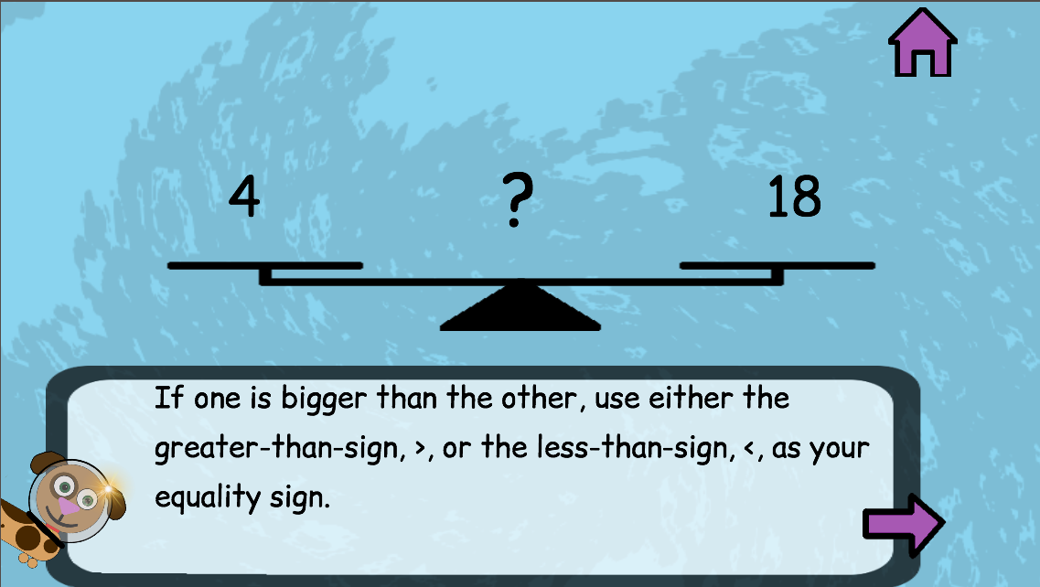
Figure 4. An example of the tutorial presented in the game. This will also be narrated in the final version of the game.

Consent Screen
The first time that a user opens the game they will be presented with 2 screens as in Figure 5 and Figure 6.
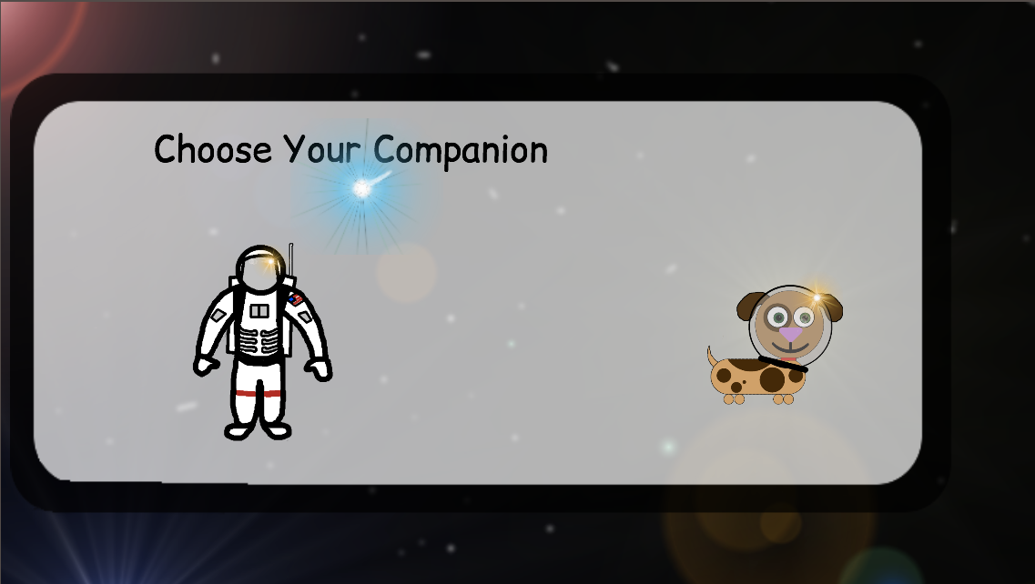
Figure 5. The first screen that a user sees where they can choose their companion to accompany them throughout the game.
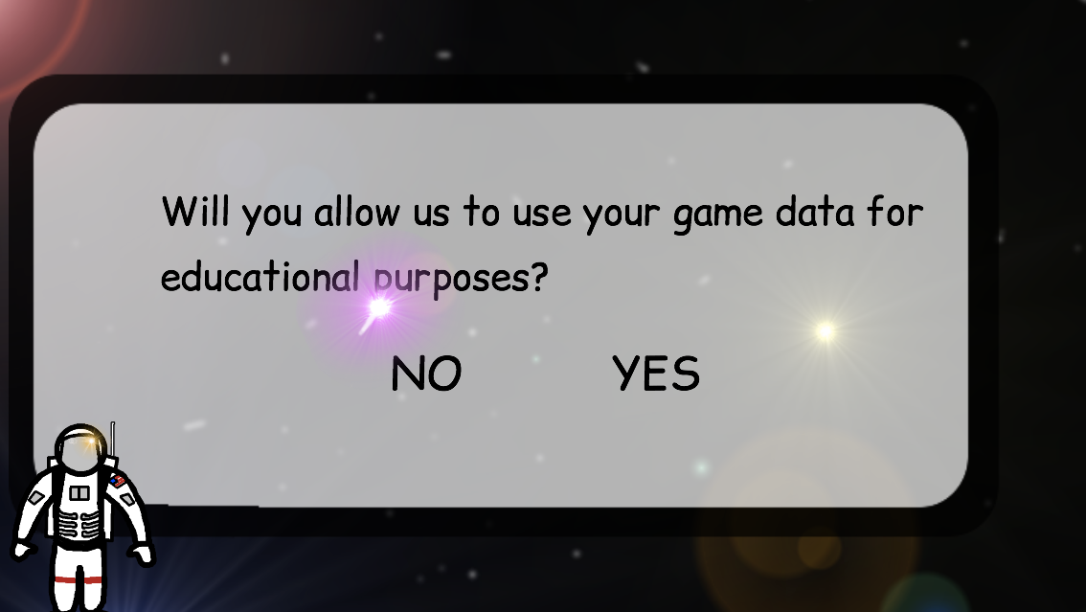
Figure 6. A consent screen that is presented to the user upon using the game for the first time. The response is stored in a database along with the choice of companion from Figure 4.

Game Play Screens
Note that only small samples of the gameplay screens are shown here. For a full demonstration of the game please see the attached video.
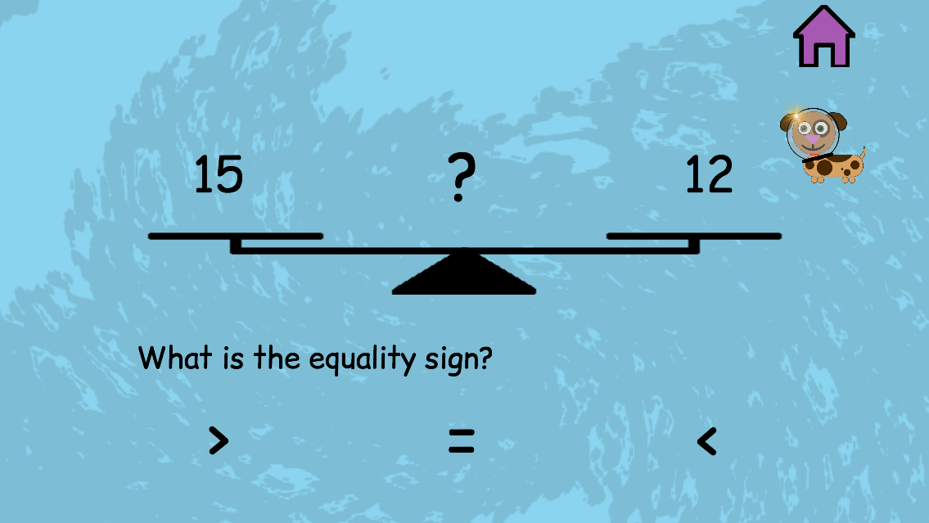
Figure 7. A gameplay screen for the first activity in the game. The user is given the task of finding which equality sign will make the above expression true.
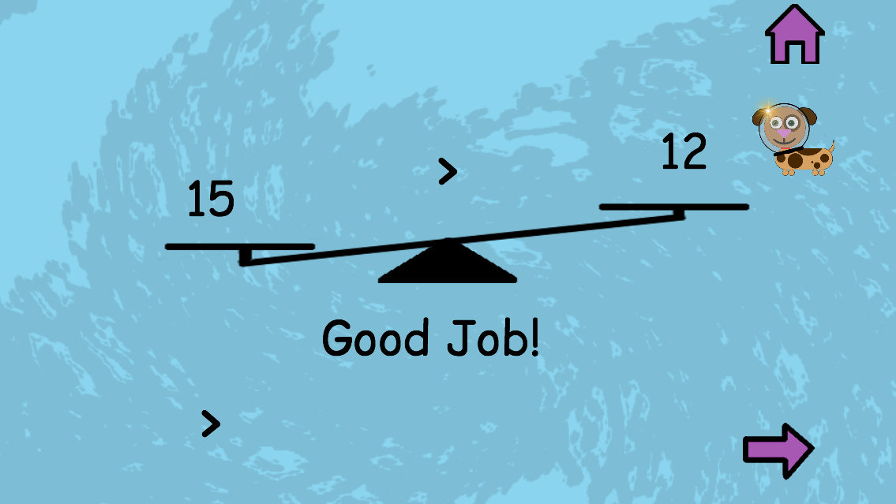
Figure 8. After the user has chosen the correct answer to the exercise in Figure 7 they are congratulated and the balance board shifts to represent which side is “heavier” or larger.
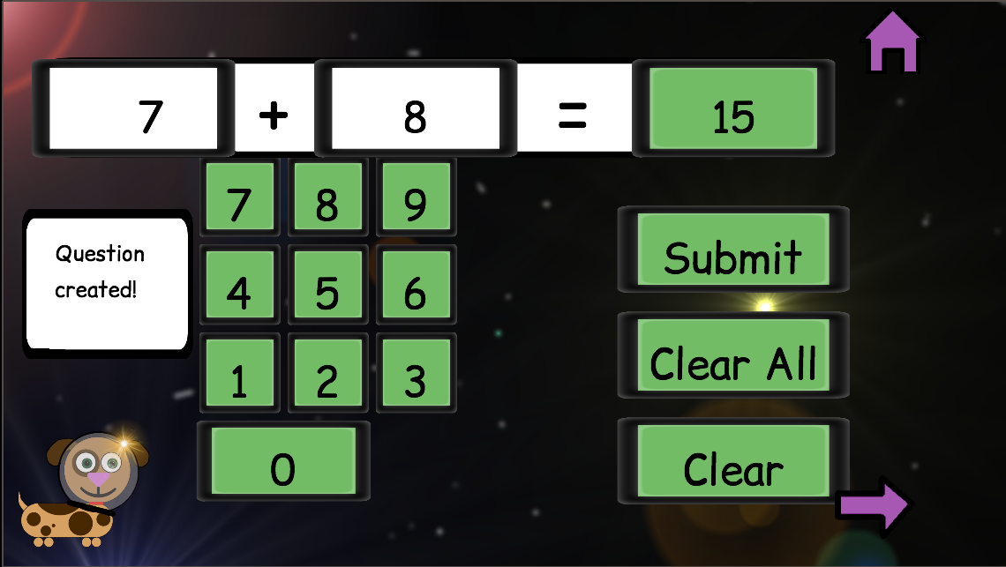
Figure 9. The screen that a user see when creating a question. To enter this mode a user must choose which operator they will be creating a question with and then fill in the 3 blanks for each operand and the answer.

INTELLECTUAL PROPERTY
Any sound or image files not listed here are created by those credited in the in-game credit screen. For a full list of sound and image files please see the attached .zip folder.

Image Files
All title text, such as that seen in Figure 1 and 3, provided by textcraft.net and is free to use under the MIT license. All other text, such as that seen in Figure 4 and 5, provided by http://www.fontsquirrel.com/ and is free to use commercially without reference. The settings gear seen in Figure 1 and the home icon seen in Figure 1, 2, 3 are both provided by https://www.iconfinder.com/ and are both free to use commercially without reference.

Sound Files
The explosion.wav file is provided by http://www.freesound.org and is public domain.

DESIGN RATIONALE
In evaluating the user interface design and pedagogy of our game versus other similar games in use we will use the same criteria from assignment 1. That is, the same 7 user interface criteria and Bloom’s Taxonomy and Gagne’s Nine Events of Instruction to provide a basis for our pedagogical analysis.

Rationale for Better UI Design
- Aesthetics – Our game has a unified theme, which was common to other games evaluated. By adding in narration to the instructions we will be able to eliminate the feeling that there is too much reading, as it will be done for the user.
- Suitability of graphics and characters for target audience – By allowing the user to choose their companion we encourage user engagement and the graphics are not too childish for out target audience, which was a common theme in the previously evaluated games.
- Cognitive overload –By partitioning concepts into small tasks and having few distractions on the screen we are able to better reduce cognitive overload than the evaluated games.
- Discoverability – Our game has many features and we feel that our menu makes use of common icons, e.g. the home icon, to have these features easy to navigate between.
- Interruptability – Our game only interrupts the user to tell them if they were correct or incorrect and there is no minimum time on this notification. Due to this we feel that our game is much better in this attribute than the games evaluated.
- Learnability of interface – We feel that through a common design, most levels are multiple choice, and having the companion explain those that are not we are stronger in this area than the games evaluated as well.
- Learnability of activity – By having the chosen companion explain the activity and concept to the user we feel that we are much better than the evaluated games with respect to this criteria.

Rationale for Better Pedagogy
First we review how our game performs versus the evaluated games with respect to Gagne’s Nine Events of Instruction.
- Gain Attention – With our aesthetic and story driven gameplay we feel that we are able to gain attention as well as any games evaluated.
- Inform of Objectives – We make the overall goal and the level specific tasks very clear to the user and feel that we have done this better than the game evaluated.
- Stimulate Recall – With the way that our game is laid out we are able to consistently stimulate recall, either of knowledge that a user would know before using the game, e.g. addition, or material presented in the game e.g. recalling multiplication in the finding of area. We feel that we accomplish this much more successfully than any other game evaluated.
- Present Lesson – By having the companion explain the level to the user the first time that they play the level as well as proving an answer to an example question we feel that we provide lessons much better than any other game evaluated.
- Provide Learner Guidance – In this area we perform better than any game evaluated as when a user is stuck they can ask their chosen companion for a hint specific to the current level.
- Elicit Performance – We have the student practice the lesson in each level and we feel that this elicits performance as well as, or better than, any game previously evaluated.
- Provide Feedback – We inform a student after each question if they were successful. We feel that this feedback is as effective as that provided in any other game evaluated.
- Assess Performance - We inform a student after each level how they performed as we provide them with a score. We feel that this assessment is as effective as that provided in any other game evaluated, as the student is immediately aware of how they did in the level.
- Retention and Transfer – By using information from previous levels in the later levels, such as using the fact that exponents are repeated multiplication, we feel that we are much more successful at encouraging the transfer of skills that any other game evaluated. We also feel that this applies to the bonus moon levels that we included.
Now we move to a comparison of how our game fares with respect to Bloom’s Taxonomy versus the other games previously evaluated.
- Remembering – By having an example shown to the user we are able to have them remember the answer to simple questions. This is as successful as the other games previously evaluated.
- Understanding – We show users questions that require them to understand the concepts in order to answer. For example, by presenting the user with two clocks and asking them to find the time difference we expect that a user will understand how to tell time and how to apply addition or subtraction operations to these times. This is as successful as the other games previously evaluated.
- Applying – We feel that our use of alternative situations related to the presented skills encourages the application of these skills more successfully than any other game evaluated. For example, we have student use their knowledge of multiplication to find area of simple shapes.
- Analyzing – We have users analyze a situation much more successfully than other games. For example, by allowing users to move shapes around to become familiar with division we encourage them to be able to analyze the group of objects to answer the question.
- Evaluating – When we have users able to answer the questions of other users we will be able evaluate each other. This was non-existent in other games evaluated.
- Creating – Unlike any other game evaluated we have an entire mode dedicated to having users create the drill-and-practice type questions. We therefore feel that we are much more successful in this area than any other game evaluated.

PROPOSED DATA LOG

Questions to Address
In the design of Math Odyssey the 4 questions that we decided to focus on are:
- What activity is the most/least enjoyed by users?
- Are users just playing the game or do they want to learn what the game is trying to teach?
- Are users creating questions and using created questions? If so, what type is most popular?
- What do users find to hard/easy in the game?

Data to Collect
The data that we believe we will need to collect to answer each question is:
- Amount of time spent per question in a level. Amount of questions done in a level.
- Number of times a level is played after it is cleared. Amount of time spent in a level after it has been cleared. Amount of time spend on optional moon levels. Score during each successive play of a level.
- Amount of questions created per user, total and per type (addition, subtraction, division, multiplication). Amount of questions practiced per user, total and per type. Time spent per question.
- Score in each mini game per user. Store incorrect answer and correct answer each time so that we can try to find where difficulties are coming from i.e. does a specific multiplier increase the errors?

