Math Odyssey Final Report

Matthew Bojey
Duncan Szarmes

ABSTRACT
Math Odyssey is a game developed for mobile platforms, specifically iOS and Android, which is targeted towards students in grades 4-6. The game features a companion who takes users on a trip through a solar system where each planet has several activities for the user to complete related to a mathematics concept such as telling time or multiplication. The game also features a training mode where users can create and practice questions testing their arithmetic skills. Finally the game has an in-game store where users can spend currency earned in the practice mode on new ships or companions.
Keywords
Educational game, Mathematics game, Mobile development, Multi-user interaction

DESIGN PROBLEM
The game we chose to make is an elementary math adventure game. The user embarks on a journey, accompanied by a companion, to several planets throughout a fictitious solar system. On each planet there are several levels and in each level a user is presented with a question belonging to a certain area of mathematics and 4 possible answers. The user then selects an answer and are told if they were correct. This continues until a user has completed a round on that level, which is around 10 questions. When a user answers enough questions correctly in a round the next level is unlocked and the user can use the new activity. The game works to not only help students practice the material presented but also to motivate them as they progress to different levels and planets. This, combined with the training mode where users can solve questions created by others, aims to motivate the user into continuing to use the game as we feel that practice helps the user become stronger with the material.
From our experience with math games for mobile platforms we see that there are many games that incorporate this type of questions and answer system (1,2,3). What we found however was that none of the game we found had any user generated content and that the atmosphere and story was not as developed as we have. Also, we did not see any games with a multi-user functionality like what we have in our game with users being able to solve problems created by other users. We feel that these features help to make our game more engaging and fun for the users so that they will keep coming back.

DESIGN GOALS
In designing the game we aimed to make a game that would keep users interested and expose them to different areas of mathematics. We feel that when a student cares about the material being taught they will be able to perform better than if they are simply memorizing facts because a teacher told them to. With this in mind we wanted to focus on exposing students to applications of the concepts that are taught. We also wanted to have the game itself be fun and engaging to the student. We realize that our gameplay mechanics are very limited, as questions are presented and students simply click on the correct answer, but we wanted to build atmosphere around the game and help create the feeling for students that they were visiting these other planets.

Pedagogical Goals
After completing the game users should have learned:
- Comparisons of numbers and simple equations
- Multiplication and applications such as area
- Division and basic understanding of fractions
- How to tell time
- Concept of exponents
- Addition and subtraction
We do not expect students to be masters in all of these areas after the game but they should at least be familiar with the concepts. With simple concepts such as arithmetic operations we hope that students become confident and capable through use of the training mode.

Entertainment Goals
We hope that users will:
- Want to complete the story and rescue the golden calculator
- Find the training mode and associated rewards enticing enough that they will use the mode long enough to earn enough coins to unlock all items from the in game store. This will also help with our pedagogical goal or having the users become stronger in using the basic arithmetic operators: addition, subtraction, multiplication, and division.

Development Goals
We hope that the game is accessible enough for all students to find something that they can do in the game. With the in game mini-lessons presented in each level and multiple choice nature of the questions we feel that users in the target age range should find something in the game that suits their needs. We also hope that the game has a sufficient replay value so that users will find a reason to continue returning to the game. This could be either to complete the story or to play more in the training mode to earn more coins and unlock more ships and companions.
Conference’10, Month 1–2, 2010, City, State, Country.
Copyright 2010 ACM 1-58113-000-0/00/0010 …$15.00.

Permission to make digital or hard copies of all or part of this work for personal or classroom use is granted without fee provided that copies are not made or distributed for profit or commercial advantage and that copies bear this notice and the full citation on the first page. To copy otherwise, or republish, to post on servers or to redistribute to lists, requires prior specific permission and/or a fee.

Math Odyssey
As discussed above, the game that we have developed has two main game modes, the story mode and the train mode. We will discuss each in more detail here.

Story Mode
In the story mode the user travels to different planets within the solar system and on each planet completes several levels related to a mathematical concept (Figure 1). 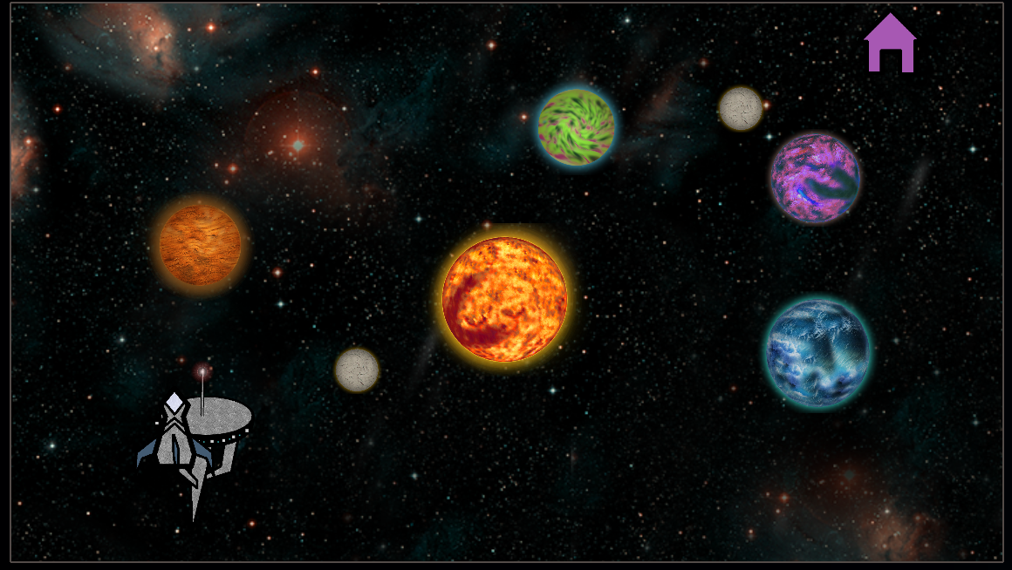
Figure 1. Solar System
These levels are designed to guide the user from being introduced to the concept to being able to apply it to problems. For example, when the user first land on the multiplication planet the first level shows the user a grid of numbers and ask them to pick out the multiples of “x” to show how multiplication can be seen as a pattern (Figure 2). 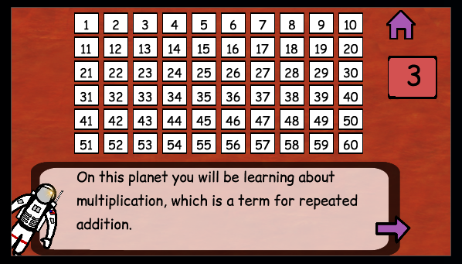
Figure 2. Multiplication Level 1 – Users find patterns
The second level shows the user how multiplication can be thought of as repeated addition by showing a multiplication question and the associated addition equation (Figure 3).
The final level has the user answering multiplication questions. This mode also sometimes presents users with optional moons to see related concepts. Again using multiplication as an example, users can visit the moon to learn how multiplication can be used to solve problems such as finding the area of a square.
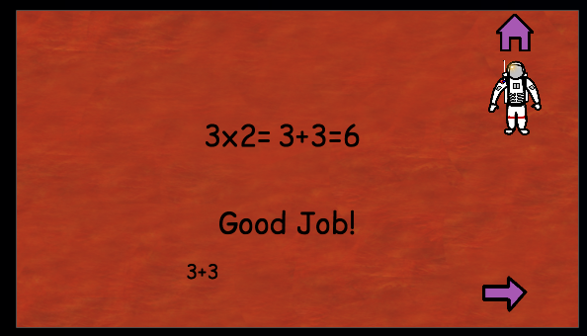
Figure 3. Multiplication Level 2 – Multiplication as repeated addition

Train Mode
In this mode users have 2 options, create or practice arithmetic questions. In either mode the user is presented with a calculator to enter numbers into the spaces provided (Figure 4). 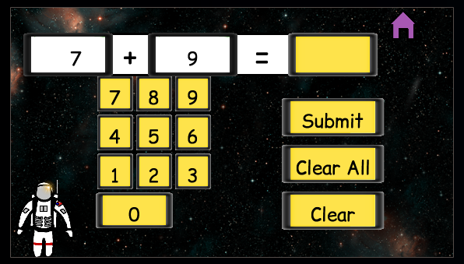
Figure 4 – Train Mode. Buttons are gold when game is completed.
In create mode all three numbers are entered by the user where as in practice mode the user only enters the answer to the provided question. This mode awards users with coins when they are correct and these coins can be used in an in-game store to purchase new companions or ships to be used in the story mode (Figure 5).
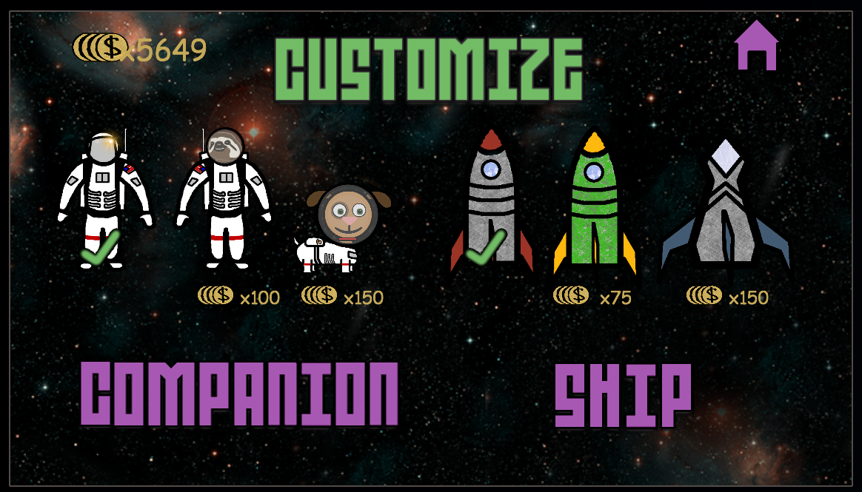
Figure 5. In-Game Store

Summary of Features
The major features of our game are:
- User generated and shared content via train mode
- Analytics of usage data
- In-game store and currency
- Immersive setting and story

Availability
The game is currently not available on any mobile stores, however, all source files can be found at https://github.com/szarmes/mathodyssey

INITIAL FEEDBACK

Data Analytics
With the data that we collected we wanted to see how much users are playing the game after they have completed it. This information will tell us if we reached our design goal of having the game be replayable as well as both of our entertainment goals. We also want to see how well users are doing on each of the levels so that we can see how well they are doing with respect to each of our pedagogical goals. Finally, we want to focus on our second entertainment goal by seeing how often users are creating and practicing questions in train mode to see if our rewards are seen as valuable by the users.

Participants
The participants of the study were not members of the target audience. We had the roommate of one of our developers test the system as well as the spouse of another.

Procedure
The users were told to use the game for up to an hour each. One of the participants did not do this all at once and instead used the game for short bursts over the course of several days.

Results
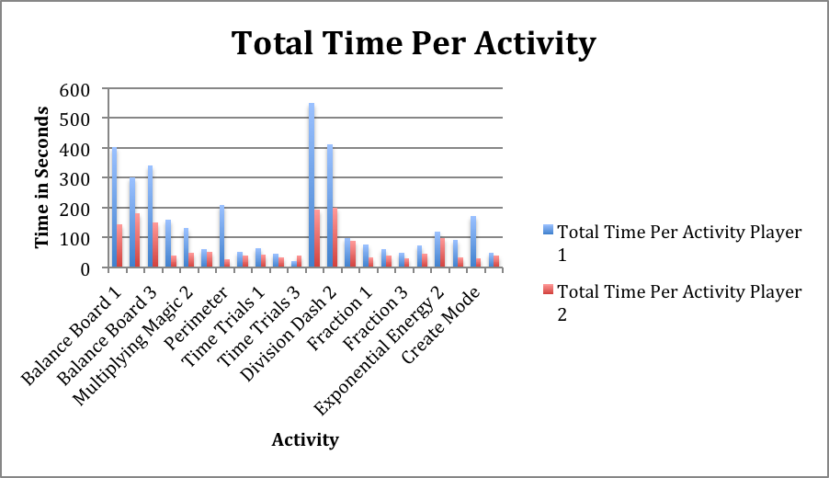
Chart 1 – Total Time per Activiy
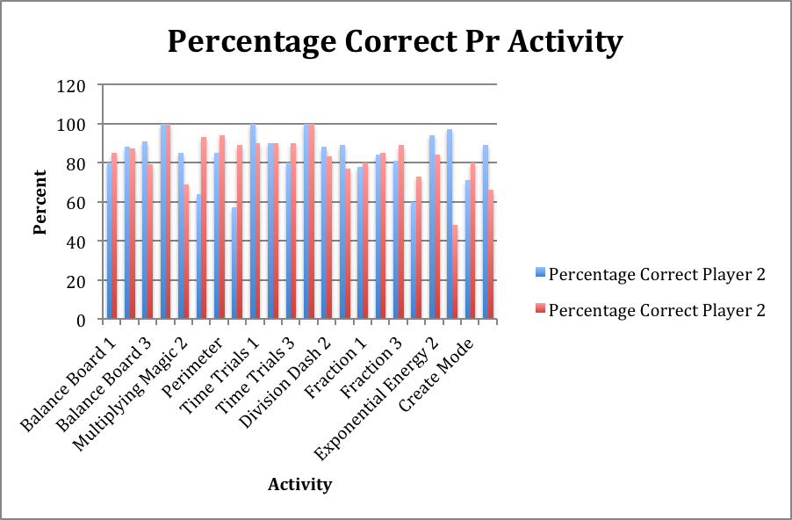
Chart 2 – Percentage Correct per Activity
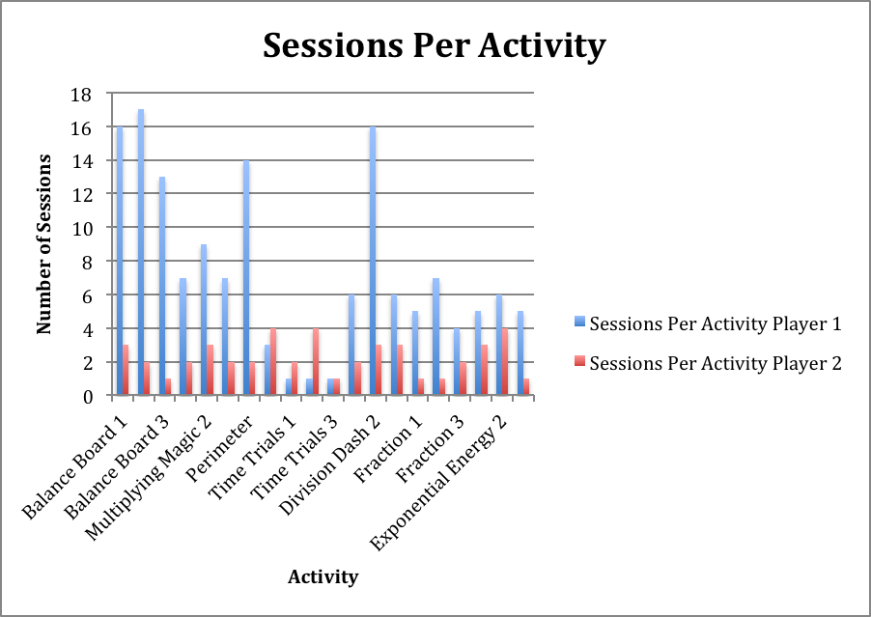
Chart 3 – Sessions per Activity
This data shows that users are usually only playing a level enough to complete it. It does however show that users are getting most of the questions correct. This make sense as the participants are not in the target audience. We did see however that users are finding value in the create mode which shows that our rewards are meaningful and worthwhile to users.

ACKNOWLEDGMENTS
Any sound or image files not listed here are created by those credited in the in-game credit screen. For a full list of sound and image files please see the attached .zip folder.

Image Files
All title text, such as that seen in Figure 1 and 3, provided by textcraft.net and is free to use under the MIT license. All other text, such as that seen in Figure 4 and 5, provided by http://www.fontsquirrel.com/ and is free to use commercially without reference. The settings gear seen in Figure 1 and the home icon seen in Figure 1, 2, 3 are both provided by https://www.iconfinder.com/ and are both free to use commercially without reference.

Sound Files
The explosion.wav file is provided by http://www.freesound.org and is public domain.

REFERENCES
[1] App Gate Inc., Math Academy. 2013. Ipad.
[2] RT Amersfoort, Math Times Tables. 2014. Ipad.
[3] Hein Ton, Kids Math Ace Games Lite Free. 2013. Ipad.

