Bazy danych lab 2

Wiktor Łęczyński

Sprawozdanie

Cel ćwiczenia .

Rozszerz/zaimplementuj aplikację Blog wg własnego pomysłu.

Wykonanie

-Dodałem User do classy Blog

- Uzyłem komendy Add-Migrations i Update-Datebase do zaktualizowania bazy

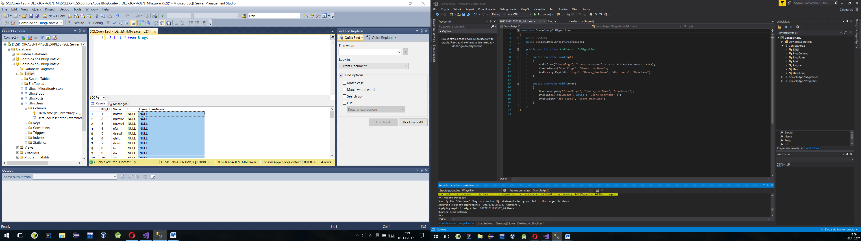

-Stworzylem formularz UsersForm , który ma wyswietlac liste blogow danego uzytkownika

-Zmodyfikowałem maina aby pobieral nazwe uzytkownika

User user=new User();

BlogContext blogContext = new BlogContext();

Console.Write("Enter a name for a new Blog: ");

var name = Console.ReadLine();

Console.Write("Enter a name of User: ");

var nameUser = Console.ReadLine();

var query2 = from b in blogContext.Users

orderby b.UserName

select b;

foreach (var item in query2)

{

if (item.UserName.Equals(nameUser))

{

user = item;

}

}

var blog = new Blog { Name = name, Users = user };

//Zakladam ze uzytkownik poda dobra nazwe , w przyszlosci zamierzam dodac haslo I weryfikowac uzytkownika

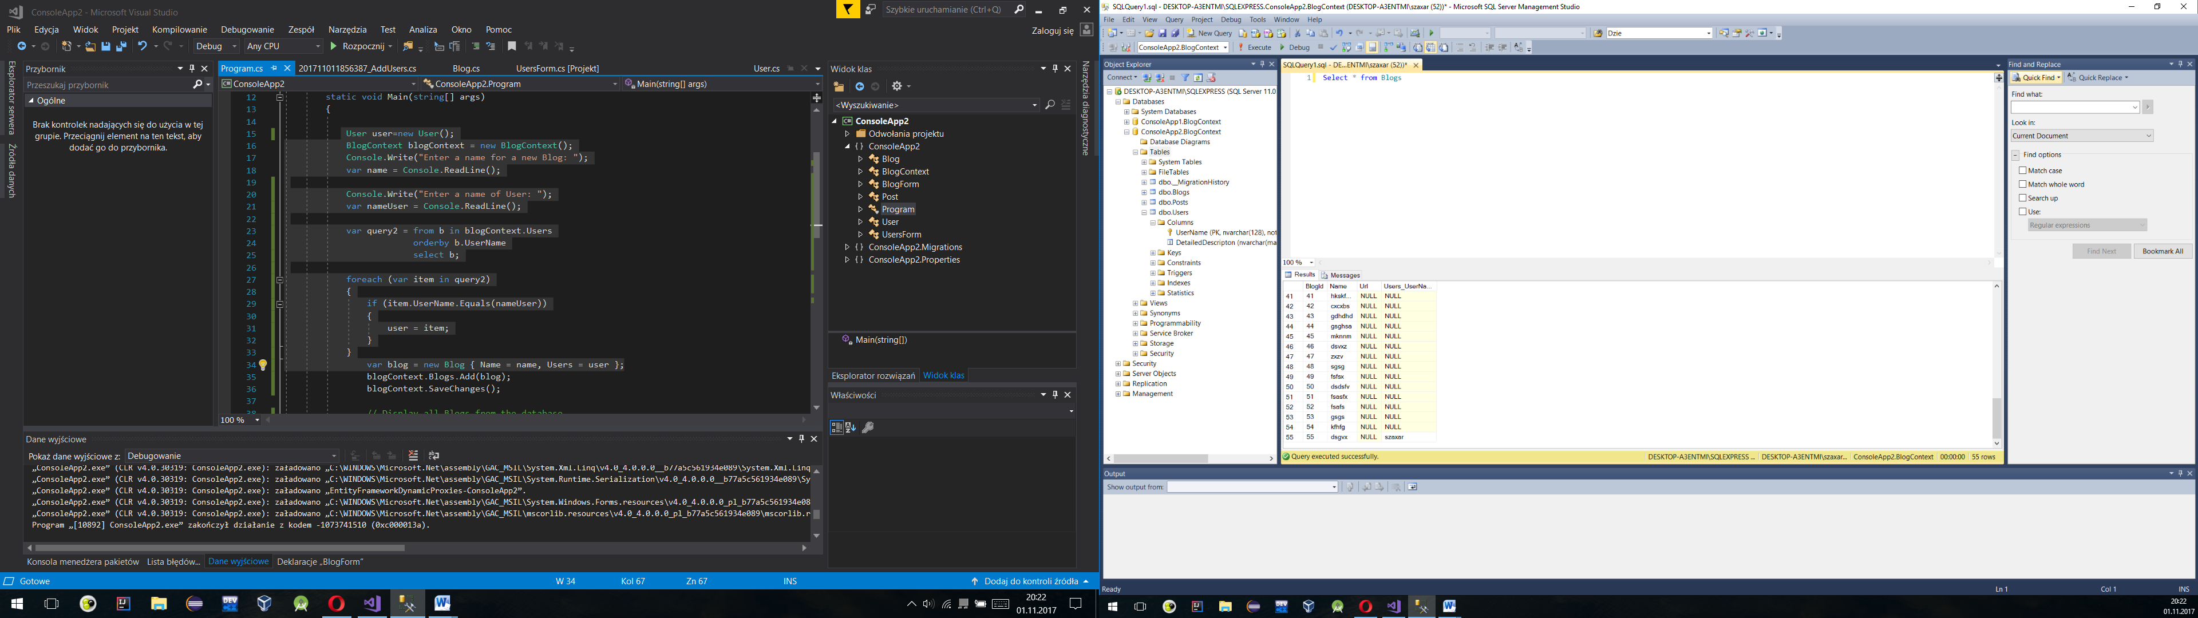

-Zaimplementowanie UsersForms

using System;

using System.Collections.Generic;

using System.ComponentModel;

using System.Data;

using System.Drawing;

using System.Linq;

using System.Text;

using System.Threading.Tasks;

using System.Windows.Forms;

using System.Data.SqlClient;

using System.Data.Entity;

namespace ConsoleApp2

{

public partial class UsersForm : Form

{

SqlConnection cn;

SqlDataAdapter da;

DataSet ds;

BlogContext blogContext;

BindingSource blogBindingSource;

public UsersForm()

{

InitializeComponent();

cn = new SqlConnection("Server=DESKTOP-A3ENTMI\\SQLEXPRESS;Database=ConsoleApp2.BlogContext;Integrated Security=true");

cn.Open();

}

private void UsersForm_Load(object sender, EventArgs e)

{

blogBindingSource = new BindingSource(); ;

blogContext = new BlogContext();

blogContext.Users.Load();

blogContext.Posts.Load();

blogBindingSource.DataSource = blogContext.Users.Local.ToBindingList();

//da = new SqlDataAdapter("Select * from Blogs",cn);

//ds = new DataSet();

// da.Fill(ds);

dataGridView1.AutoGenerateColumns = true;

dataGridView1.DataSource = blogBindingSource;

}

private void dataGridView1_CellContentClick(object sender, DataGridViewCellEventArgs e)

{

var query = from b in blogContext.Users

orderby b.UserName

select b;

int zmienna = 0;

User users = new User();

foreach(var item in query)

{

if (zmienna == e.RowIndex)

{

users = item;

}

zmienna++;

}

da = new SqlDataAdapter("Select * from Blogs where Users_UserName='" + users.UserName+"';", cn);

ds = new DataSet();

da.Fill(ds);

// blogBindingSource.DataSource = blogContext.Posts.Local.ToBindingList();

dataGridView1.AutoGenerateColumns = true;

dataGridView1.DataSource = ds;

dataGridView1.DataSource = ds.Tables[0];

}

}

}

