PetSmart Relational Database

Pat Carney, Eddie Lehr, and Sarah Zazyczny will be working together to complete PetSmart Database Design, Creation, and Queries.

**PetSmart Background:**

PetSmart, Inc. is the largest specialty pet retailer of services and solutions for the lifetime needs of pets. PetSmart opened in 198, and has grown as it was acquitted by BC Partners in 2014, followed by PetSmart’s acquisition of Chewy in 2017. PetSmart’s product lines include dog products, cat products, bird, fish, and small animal products, horse products, and a PetsHotel. PetSmart employs approximately 55,000 associates and operate more than 1,500 pet stores in the United States, Canada and Puerto Rico as well as more than 200 in-store PetSmart® PetsHotel® dog and cat boarding facilities. PetSmart provides a broad range of competitively priced pet food and pet products and offers dog training, pet grooming, pet boarding, PetSmart Doggie Day Camp services and pet adoption services in-store.

**ERD:**

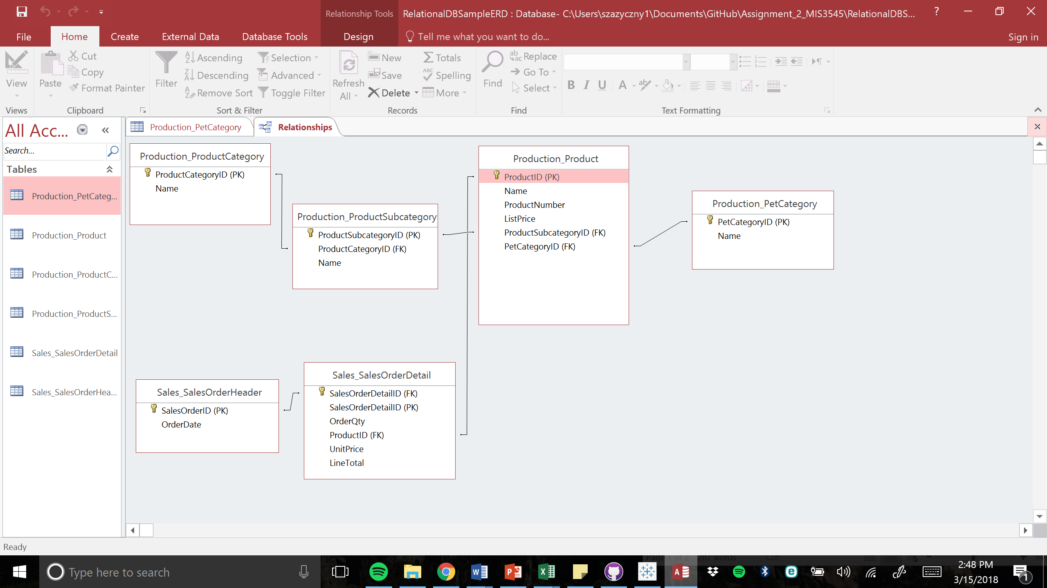

**Database Design**

* Human Resources
  + Sales Employees – one to many
    - EmployeeID (PK)
    - ContactID (FK)
    - TerritoryID (FK) – assuming sales people only serve one territory
* Person
  + Contact – one to one
    - ContactID (PK)
    - FirstName
    - LastName
* Production
  + Product – many to many
    - ProductID (PK)
    - Name
    - ListPrice
    - ProductSubcategoryID (FK)
    - PetCategory (FK)
  + ProductCategory – one to many
    - ProductCategoryID (PK)
    - Name - food, toys, accessories, treats, hygiene, medical
  + ProductSubcategory – one to many
    - ProductSubCategoryID (PK)
    - ProductCategory (FK)
    - Name - ball, leash, brush, bed, litter, soap, cage, dry food, wet food, flea repellant
  + ProductPetCategory – one to many
    - ProductPetCategoryID (PK)
    - Name - dog, fish, bird, reptile, small pet, horse
* Sales
  + Customer – one to many
    - CustomerID (PK)
    - ContactID (FK)
    - TerritoryID (FK)
  + SalesOrder – one to many
    - SalesOrderID (PK)
    - OrderQty
    - ProductID (FK)
    - SalesEmployeeID (FK) – assuming one sales person per order
    - CustomerID (FK)
  + SalesTerritory – one to many
    - TerritoryID (PK)
    - Name – Northeast, Southeast, Central, Southwest, West, Puerto Rico, Canada