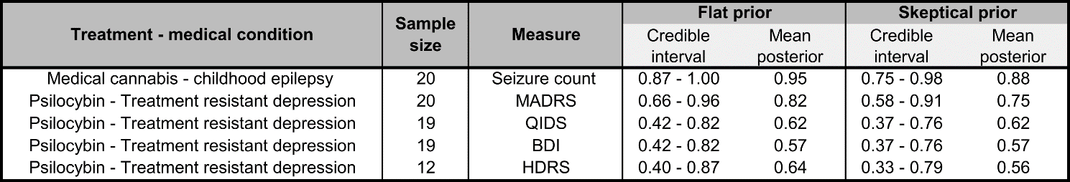

Table 1: 95% credible intervals of the probability of patient improvement using the medical cannabis for childhood epilepsy and psilocybin for treatment resistant-depression datasets. Results are shown for both flat and sceptical priors, for posterior probability distributions see Figure 1.