**LONG TERM TREATMENT OF PWS MIGHT REQUIRE A NEW DUAL THERAPY CONSISTING OF INDUCTION AND MAINTENANCE**

**Bartłomiej Kwiek**, Assoc. Prof. Lazarski University, Klinika Ambroziak, Warsaw, Poland

**Michał Paprocki** Lazarski University, Klinika Ambroziak, Warsaw, Poland

**Anna Mataczyńska** Lazarski University, Klinika Ambroziak, Warsaw, Poland

**Jan Szczękulski**, Bachelor of Science, University of Liverpool, employee of The Hut Group, Manchester, UK

**Background and Aim:** The previous studies have shown the efficacy of PWS treatment with a large spot 532 nm laser, with median maximal improvement achieved during treatment (GCEmax) ranging from 50% to 70%.

To assess the efficacy of PWS treatment with the use of a large spot 532 nm laser over a prolonged period.

**Study Design and methods:** Sixty-four Caucasian patients aged 6 to 59 treated with 2 to 30 laser sessions were included in this study. Patients had 3D photography performed before and after treatment with a 532 nm Nd:YAG laser with large spot and contact cooling. An objective analysis of percentage improvement based on a 3D digital assessment of combined colour and area improvement (global clearance effect [GCE]) was performed.

**Results and conclusions**:The median maximal improvement achieved during the treatment (GCEmax) was 59.1 % (GCE59). The first two laser procedures had a median maximal improvement of 28.46%, while the first 5,10,15 and 20 laser procedures had respectively 45.48%, 56.57%, 56.97% and 56.96% total maximal improvements. The procedures have been divided into time groups, based on time passed in-between procedures, and the relation between time-group and negative total clearance improvements has been found.

Analysis indicates that a large spot 532 nm laser is highly effective in the treatment of PWS. Further analysis proves the first five laser procedures have higher efficacy and improvements start plateauing around the 10th visit. The established correlation between time groups and the efficacy of treatment could be explained by the exacerbation of PWS over time, indicating further bi-annual treatment is needed to counteract deterioration.

**Key words:** 532 nm; Nd:YAG; port-wine stain; capillary malformation; 3D analysis

**Introduction**

Najczęstszymi malformacjami kapilarnymi skóry są plamy typu Wina Porto (ang. Port Wine Stains - PWS), nazywane tak ze względu na charakterystyczny wygląd czerwonego wina rozlanego na skórze. Pojawiają się one już w życiu płodowym w związku z mutacjami somatycznymi, powiększają się wraz ze wzrostem skóry i utrzymują przez całe życie. Występują u około 0,3%–0,5% niemowląt w wyniku współdziałania różnych czynników etiologicznych, najczęściej w wyniku nieprawidłowej morfogenezy. Charakteryzują się rozszerzeniem naczyń włosowatych skórnych i żył pozawłośniczkowych.

PWS najczęściej występują na twarzy i szyi, jednak mogą wystąpić w dowolnym miejscu na ciele. Zmiany te należy leczyć we wczesnym dzieciństwie [1].

Standardową terapią w leczeniu malformacji kapilarnych typu PWS jest leczenie laserowe.

W naszym badaniu analizowaliśmy długofalową terapię, składającą się z leczenia indukującego, a także z terapii podtrzymującej.

**Aim of study**

Celem tego badania jest ocena skuteczności leczenia PWS za pomocą lasera w dłuższych okresach czasu oraz ustalenie optymalnego planu leczenia.

**Patients and methods**

W naszym badaniu użyliśmy lasera Nd: YAG o podwójnej częstotliwości 532 nm, charakteryzujący się dużą plamką (do 12 mm), krótkim impulsem i chłodzeniem kontaktowym zapewnianym przez szkło szafirowe (ExcelV; Cutera Inc, Brisbane, CA, USA) [4-7].

Większość pacjentów osiąga zadowalające wyniki, ale leczenie wymaga kilku sesji. Część pacjentów ma słabą odpowiedź lub jej brak. Wynik leczenia PWS zależy między innymi od: fototypu skóry wg skali Fitpatricka, lokalizacji zmiany i historii wcześniejszego leczenia [2,3].

Do analizy obrazu wykorzystaliśmy obiektywną trójwymiarową (3D) fotografię cyfrową aparatem Vectra1 XT (Canfield Scientific, NJ) w standardowych warunkach zgodnie z wytycznymi producenta dotyczącymi obrazu twarzy. W pomiarach uwzględniliśmy zmianę pola powierzchni (cm2) i zmianę średniego koloru powierzchni (opisanego współrzędnymi L * a * b). Jak tylko było to możliwe, jako kontrolę do oceny koloru zmierzyliśmy obszar zdrowej skóry o symetrycznej do badanej powierzchni. W innych przypadkach mierzyliśmy jako kontrolę skórę przylegającą do zmiany[8].

Our previous studies have shown the efficacy of treating PWS with a 532 nm large-spot laser over several treatment sessions, with a median of maximum improvement in treatment (GCE max) of up to 70%.

We gathered data on PWS laser treatment for 64(czy dzielic na kobiety I męzczyzn) patients for up to a maximum of 37 laser treatment sessions. We used 3D imaging to assess the efficacy of laser therapy.

Caucasian patients aged 6 to 59 treated with 2 to 30 laser sessions were included in this study. Patients had 3D photography performed before and after treatment with a 532 nm Nd:YAG laser with large spot and contact cooling. An objective analysis of percentage improvement based on a 3D digital assessment of combined colour and area improvement (global clearance effect [GCE]) was performed.

Number of laser sessions

% mean improvement (  
total clearence)

On the presented graph, we plotted the relationship between the mean Global Clearance relative to the beginning and the number of laser sessions. Previously proposed by our group, the objective GCE percentage rate was used, which takes into account the assessment of the changes in color and surface of PWS. We found that the first 5 treatments are particularly effective, with an average improvement of 45%. Notably, the first 2 treatments are also very effective and are responsible for an average improvement of 30%.

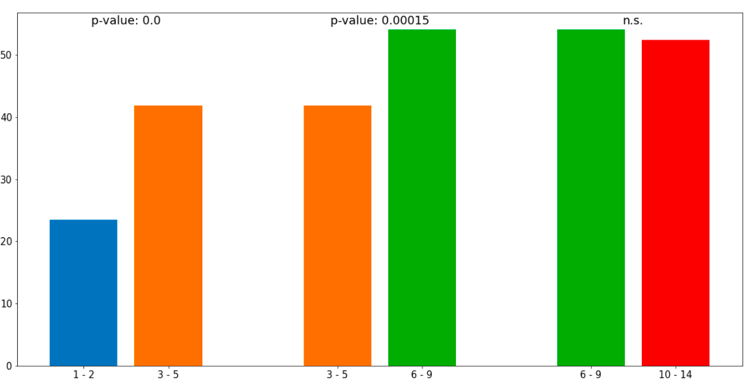

% mean improvement (total clearence)

Number of laser sessions (clustered into buckets)

One of the study aims was to pinpoint at which point intensive treatment is of no measurable benefit. To statistically find the plateau, we grouped the visits into buckets based on the visit's number. We statistically proved that visits from 3-5 had better improvement than visits from 1-2, and similarly, visits 6-9 had a better improvement than visits 3-5. There was no statistical significance for visits 10-14 (or, for this matter, any grouping of visits over 10) being statistically higher than visits 6-9. Given our results, we expect induction treatment to take 7-9 sessions.

% mean improvement inbetween visits

Days passed between two visits (clustered into buckets)

As another part of our study, we wanted to confirm our clinical observations that discontinuation of treatment could cause relapse, and to this end, we examined the intervals between visits and the impact of extending this interval on worsening the disease.

Further intensive treatment has no effect, but discontinuation of treatment causes a gradual recurrence of changes. As can be seen on the x-label of our graph, we grouped visits into buckets based on the number of days passed between two visits.   
  
We've applied a t-test on data divided into 2 groups, based on the time elapsed between the visits. We found that longer breaks between visits led to worse clearance, with breaks longer than 180 days leading to negative clearance. Therefore, we'd like to introduce a concept of maintenance therapy, with recommended treatment twice a year to sustain the therapy's initial results.

Frequencies:

Expected frequencies:

We've also used the chi-square test to prove the **correlation** between the negativity of mean clearance (between visits) and elapsed time (grouped in buckets). As can be seen below, the expected frequencies for visits with 180+ days break, far differ from the expected frequencies. The p-value of the chi-squared test was 0,014.

**The graph illustrates the percentage of the patients that had a maximal total improvement (GCE) of at least over x (where x is the GCE threshold). As can be seen from the graph, a major 77.42% of patients had GCE over 40, 50.00% of the patients had GCE over 60, but only around one in four(24.19%) of patients had GCE over 75.   
It's worth noting that some patients stopped the treatment early, so this is not representative of how much GCE improvement provides.**

**Results**

The median maximal improvement achieved during the treatment (GCEmax) was 59.1 % (GCE59). The first two laser procedures had a median maximal improvement of 28.46%, while the first 5,10,15, and 20 laser procedures had respectively 45.48%, 56.57%, 56.97% and 56.96% total maximal improvements. The procedures have been divided into time groups, based on time passed in-between procedures, and the relation between time-group and negative total clearance improvements has been found.

**Discussion**

**In our work, we've also briefly explored whether the treatment has a better effect on visitors who respond faster at the beginning. We've split data into 2 or 3 groups, using different percentiles, like in the example graph above. We've found that the GCE between fast and slow responders mostly evens out as the number of laser sessions increases.  
Unfortunately, we've lacked the data to further explore this topic and provide any statistically significant answers.**

**Conclusion**

For maintenance therapy, we recommend treatment twice a year to sustain results.

Summing up, we propose further intensive treatment on average up to 9 visits and maintenance sesions twice a year.

**References:**

1. Treatment Update of Port-Wine Stain: A Narrative Review

Regina Fölster-Holst, Ratnakar Shukla, Martin Kassir, Hassan Galadari, Torello Lotti, Uwe Wollina, Stephan Grabbe, Mohamad Goldust

PMID: 33938700 DOI: 10.36849/JDD.5005

J Drugs Dermatol. 2021 May 1;20(5):515-518. doi: 10.36849/JDD.5005.

1. Procaccini EM, Argenziano G, Staibano S, Ferrara G, Mon- frecola G. Epiluminescence microscopy for port-wine stains: Pretreatment evaluation. Dermatology 2001;203(4):329–332.
2. Kwiek B, Ambroziak M, Osipowicz K, Kowalewski C, Rozalski M. Treatment of previously treated facial capillary malformations: Results of single-center retrospec- tive objective 3-dimensional analysis of the efficacy of large spot 532nm lasers. Dermatol Surg 2018;44(6):803–813.
3. Woo WK, Jasim ZF, Handley JM. Evaluating the efficacy of treatment of resistant port-wine stains with variable-pulse 595-nm pulsed dye and 532-nm Nd:YAG lasers. Dermatol Surg 2004; 30: 158-62.
4. Lorenz S, Scherer K, Wimmershoff MB, et al. Variable pulse frequency-doubled Nd:YAG laser versus flashlamp-pumped pulsed dye laser in the treatment of port wine stains. Acta Derm Venereol 2003; 83: 210-3.
5. Pence B, Aybey B, Ergenekon G. Outcomes of 532 nm fre- quency-doubled Nd:YAG laser use in the treatment of port- wine stains. Dermatol Surg 2005; 31: 509-17.
6. Chowdhury MM, Harris S, Lanigan SW. Potassium titanyl phosphate laser treatment of resistant port-wine stains. Br J Dermatol 2001; 144: 814-7.
7. Kwiek B, Rozalski M, Kowalewski C, Ambroziak M. Retrospective single center study of the efficacy of large spot 532nm laser for the treatment of facial capillary malformations in 44 patients with the use of three- dimensional image analysis. Lasers Surg Med 2017;49(8): 743–749.