**ENGLISH VERSION**

**LONG TERM TREATMENT OF PWS REQUIREs DUAL THERAPY CONSISTING OF INDUCTION AND MAINTENANCE**

**Bartłomiej Kwiek**, Assoc. Prof. Lazarski University, Klinika Ambroziak, Warsaw, Poland

**Michał Paprocki** Lazarski University, Klinika Ambroziak, Warsaw, Poland

**Anna Mataczyńska** Lazarski University, Klinika Ambroziak, Warsaw, Poland

**Jan Szczękulski**, Bachelor of Science, University of Liverpool, employee of The Hut Group, Manchester, UK

**Background and Aim:**

Laser treatment of port wine stains (PWS) has proven its efficacy but total clearance is hardly ever achieved. The aim of this study was to establishe the optimal long term approach to PWS treatment with 532nm large spot laser.

**Study Design and methods:** Sixty-four Caucasian patients aged 6 to 59 treated with 2 to 30 laser sessions were included in this study. Patients had 3D photography performed before and after treatment with a 532 nm Nd:YAG laser with large spot and contact cooling. Retrospective objective analysis of percentage improvement based on a 3D digital images assessment of colour and area were performed in all patients. Prospective study in patients who have stopped their treatment for more than 4 years was additionally performed using the same method.

**Results**:The median maximal improvement achieved during the series of laser treatment was 59.1 %. The first two laser procedures had a median maximal improvement of 28.46%, while the first 5,10,15 and 20 laser procedures had respectively 45.48%, 56.57%, 56.97% and 56.96%.

worsening has been found. Lesions not treated for more than 4,5 years worsen by on average of 117% and improved after additional treatment.

**Conclusions**

Analysis indicates that large spot 532 nm laser is highly effective in the treatment of PWS. The first five laser procedures have higher efficacy and improvements start plateauing around the 10th visit. The established correlation between time groups and the efficacy of treatment could be explained by the exacerbation of PWS over time, indicating further bi-annual treatment is needed to counteract deterioration. Patients not treated for few years worsen but this can be reversed by the laser treatment reintroduction.

**Key words:** 532 nm; Nd:YAG; port-wine stain; capillary malformation; 3D analysis

**Introduction**

The most common capillary malformations of the skin are port wine stains (PWS). They occur in about 0.3-0.5% of infants and are characterized by an dilatation of the skin capillaries and post-capillary venules. PWS occur most often on the face and neck, but can occur anywhere on the body. They appear already in fetal life as a result of somatic mutations, increase with the growth of the skin and persist for a lifetime. Untreated PWS gradually darken and thicken with age and may form nodules on the surface [9, 16].

Vascular lasers are considered standard treatment for PWS with the pulse dye laser (PDL) being the fist-line option. Recently the large spot laser 532 nm was found to be similarly effective in patients with lighter skin phototypes.[8, 11]

The reports of recent years suggest that early treatment of PWS is particularly effective in newborns or infants and that should be the primary treatment strategy for PWS [12, 16, 19]. In clinical practice, there are still older children and adults who are either untreated or the previous treatment has not been fully effective [3]. The standard PWS laser treatment with PDL or 532nm spot laser requires a series of treatments to achieve the maximum possible effect. In most cases, this is a significant but not complete improvement ranging from 29% to 59% [8, 12, 3, 14, 17], Varying between patient population and assessment method. The outcome of the PWS treatment depends, among other things, on the Fitzpatrick phototype of the skin, the location of the lesion, the history of previous treatment and the type of vascular pattern in dermoscopy. The latter is mainly related to the depth of the enlarged vessels. Adequate laser setting, treatment protocol and schedule may also influence the outcome[11, 12, 15, 17, 18 ].

For the PDL laser, the appearance of a plateau after a series of 6-12 treatments is well documented and further treatment appears to be of little or no benefit [3, 13, 10, 22]

Our previous short- and medium-term studies show that a similar treatment response pattern occurs with the large spot 532nm laser and maximal response is present after 7 laser sessions in previously untreated PWS.(1), but detailed data are not available.

**Aim of study**

The aim of this study is to evaluate the efficacy of laser treatment of PWS over a longer period and to propose an optimal long term treatment plan.

**Patients and methods**

In our study, we analyzed data from the treatment of PWS with frequency doubled Nd:YAG 532 nm laser characterized by a large spot (up to 12 mm in the retrospective study and up to 14 mm in the prospective study), a short pulse and contact cooling by sapphire glass (Cutera Excel V and Cutera Excel V plus ; Cutera Inc, Brisbane, CA, USA). Treatment setting, pre and post laser procedures were performed as described previously [4-7].

For image analysis, we used objective 3D digital photography with the Vectra1 XT (Canfield Scientific, NJ) under standard conditions according to the facial image manufacturer guidelines. During the measurements we took into account the change in the lesion area (cm2) and the change in the mean color (described by the coordinates L \* a \* b). Healthy skin of symmetrical region served as control for color evaluation whenever it was possible. In other cases, we measured color of the skin adjacent to the lesion[8]. Percentage improvement based on this 3D digital assessment was calculated as global clearance effect [GCE] as described previously [8].

|  |  |
| --- | --- |
| Demography | |
| gender | M – 25 ,F – 36 |
| age | 6-59 (mean …) |
| location | Face - 61, Neck - 3 |
| previous treatment | 57% YES, 43% NO |

Table 1

We retrospectively analyzed patients treated in our clinic between 2012 – 2022. This cohort overlapped with the patients who were reported in our previous studies ({Kwiek, 2017 #17;Kwiek, 2018 #15;Kwiek, 2020 #19} but for current analysis only patients who had at least two digital 3D images available from two consecutive visits of facial, neck or trunk PWS were included. This resulted in 64 PWS and 428 images that were subjected to further analysis. (Table 1)

Both previously treated and never treated Caucasian patients, aged 6 to 59 with phototype I-III according to Fitzpatrick scale, who had been treated by us with 532nm large spot laser with the series of 2 to 37 laser sessions were included into this study. Patients had 3D photography performed before and after treatment.

The calculations, statistics and graphs were produced with help of Python's programming environment, including *Pandas*, *Matplotlib* & *SciPy* frameworks.

Throughout work, due to the limited data, we've bucketed sessions based on visit number or time elapsed in between sessions. In both cases, we've applied bucketing based on our clinical experience. Furthermore, we've tried applying multiple different bucketing types, which resulted in similar results. We've used an independent Student's t-test when comparing between two means of any bucketed sessions. When looking for a correlation between elapsed time and PWS worsening between two consecutive visits, we calculated a p-value of observed frequencies deviating from expected frequencies using the chi-squared test. Observed frequencies are all patients distributed between two categories - time buckets (5 buckets) and negativity of clearance (True/False). Expected frequencies are the distribution of patients between the same categories assuming there was no correlation between categories. Chi-squared test was used to calculate the p-value of the expected frequencies deviation from the observed.

**Results**:

**Finding the plateau**

One of the main goals of our study was to confirm the hypothesis of the existence of the plateau of maximal response after a certain number of laser procedures, beyond which further improvement is not seen. Firstly, we've plotted the relationship between the mean clearance (mean GCE) relative to the beginning (before the first treatment) and the number of laser sessions [Fig1]. Aligning with our experience, we've found that the first 2 sessions were extremely effective, accounting for 30% of absolute GCE improvement (GCE change relative to beginning). The first 5 sessions were also greatly effective, with an average absolute GCE improvement of 45%. Based on the graph [Fig1], we could conclude that around the 9th session, the improvement slows down, and after that, GCE plateaus and oscillates around the height reached somewhere after the aforementioned 9th session.

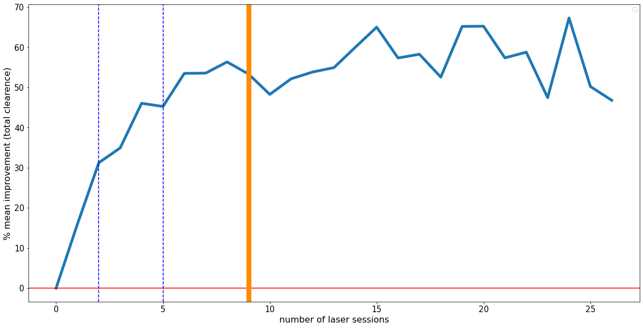

Figure 1.

- the percentage improvement of PWS (GCE%) related to number of laser sessions. Treatment plateaus is achieved on average around the 9th laser session, after which the absolute improvement oscillates around the reached height. The blue lines mark the 2nd and 5th session numbers, which have clear gradual improvement in mean GCE relative to the beginning The orange line marks the 9th session, around which the plateau is reached. The fluctuations/instability of the graph can be explained by limited data.

To statistically find the plateau, we decided to aggregate data into buckets based on the visit number and then compared the means between each bucket. Based on our experience in laser therapy, we've grouped our visits into the following buckets: [1-2, 3-5, 6-9 and 10+]. We got significant results when comparing means between each successive bucket, up to the last bucket with 10+ visits [Fig2]

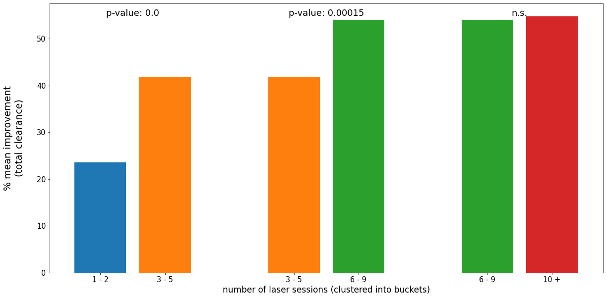

Figure 2,

Comparison of mean improvement (GCE%)- between bucketed treatment sessions shows the treatment is still significantly effective up to around the 9th session, after which the plateau is reached, and the further treatment stops being effective.

Based on the graph and our statistical tests, we believe that the treatment’s plateau is typically reached around 9th visits. Furthermore, for robustness, we've also aggregated data into other bucket combinations, but whatever the aggregation, we've always arrived at similar plateau results, varying by +/- 1 (data not shown).

**Confirming PWS worsens over time when treatment is not continued**  
In current study, we wanted to confirm our clinical observations that discontinuation of 532nm large spot laser treatment could cause relapse. To confirm our hypothesis, we've examined the intervals between the visits and the impact extending this interval has on worsening the disease.

Firstly, we've grouped our visits into buckets, this time based on the time elapsed between visits. The bucketing we applied was [0-60, 61-180, 181-360, 361+ days]. We've plotted a graph relating mean total clearance (GCE) between visits and time groups. Looking at the graph, we can see the worsening of treatment appears sometime after 180 days. [Fig 3]

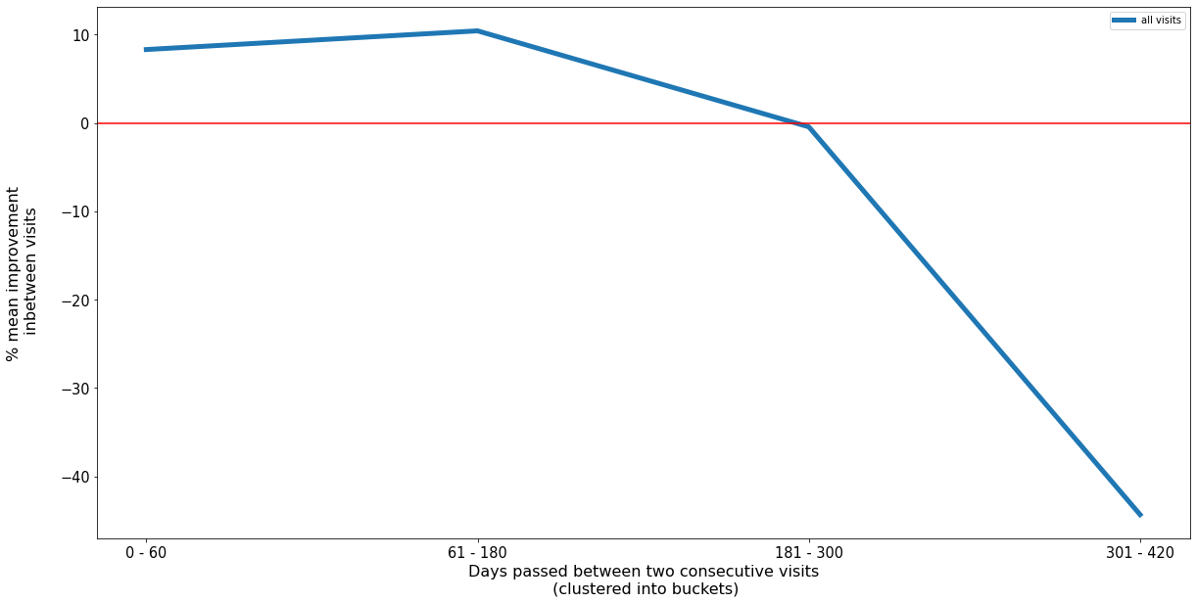

Figure 3.

The improvement achieved during any given single session of treatment is lost after around 180 days. Mean objective improvement based on 3D area, and colour assessment in-between any consecutive visits reach up to 10% when the assessment is performed for up to 180 days post-treatment and drops dramatically thereafter. This results in a complete loss of improvement and even worsening when two consecutive visits are spread for more than 300 days in-between.

Secondly, we've proven the relationship between the length of visit intervals (grouped in the same buckets as Fig3) and the negativity of clearance using the chi-squared test.

Finally, To statistically find the time after which the PWS worsens, we’ve compared separate means of bucketed visits using the same aforementioned buckets. We’ve seen a significant decrease in the healing effect for 180+ days buckets [Fig]. These results combined with the previous graph[Fig] and our clinical experience, point to the treatment worsening point being around 180 days.

We’ve also aimed to answer if a much longer break in treatment (eg. 1,000 days) results in further worsening of PWS compared to breaks around 180 days+, but we've reached no significant results. The lack of significance here might be due to a lack of data for patients with substantially longer breaks (1000 days +), and further research based on more data will be required.

Figure 4

A comparison of mean total clearance between bucketed treatment sessions shows that treatment effectiveness gets significantly worse for breaks longer than 180 days, with mean clearance in-between visits becoming negative for buckets with 180 days+. The figure showcases that the only two consecutive means that differ significantly (p-value <0.05) are means for buckets after and before 180 days, with shorter breaks having no significant effect on the treatment's efficacy.

**Worsening of PWS caused by long-lasting break in the treatment may be reversed by reintroduction of the treatment**

To further solidify our hypothesis that PWS worsens over time when not treated, we’ve chosen patients that had finished a full treatment and stopped their treatment when further improvement was not possible with consecutive laser sessions and were not treated for more than 4 years. Out of five patients who had such a brak three have responded to the proposal of 3D image evaluation and further treatment. Image analysis showed that their PWS has worsen **significantly** in relation to their last session. (Fig. 6) Their GCE compared to last session was on average 117% worse. (Fig. 6B) Furthermore their GCE in respect to the beginning was on average 24.67 percentage points worse – showcasing that a long break in treatment strikingly worsens PWS. (Fig. 6C).Patients were able to recover most of previous treatment’s progress within one session. Twoout of three patients completely recovered within one session, while third one recovered 23 percentage points of absolute GCE within a single session (Fig. 6A)

Figure 6. The worsening of PWS caused by a long break from treatment can be reversed by re-introduction of the treatment. The figure and pictures present data of 3 patients who have taken 4.5+ year break from treatment. The pictures show absolute GCE measurement of patients' PWS before and after induction treatment as well as absolute GCE post-treatment break and after treatment has been re-introduced. The graph shows the absolute mean GCE of the aforementioned 3 patients.

**Discussion**

In previous studies, we have shown that the large spot 532nm laser with contact cooling is effective in the treatment of PWS in Caucasian patients. We have shown that median maximum improvement (GCE) was 70.4 in previously untreated and xxx in previously treated PWS.

In our current work we have shown a GCEmax value of 59.1%, which is slightly worse than in those studies.. For the purpose of these study, we have chosen only patients who had at least two laser sessions documented with 3D photography in a row to be able to analyze the influence of the interval in between laser procedures for the result..

The evaluation of the efficacy of PWS treatment has so far been based largely on a subjective visual assessment by a doctor using a “one-view” approach [20] and few points scales (grades). This approach is not sensitive enough to measure minor changes The objective measurement with 3D color and area assessment gives accurate results on continous percentage scale. This is especially important when detailed examination of factors influencing the final treatment outcome is needed. [21].

Treatment of PWS with laser requires multiple sessions and overall result is achieved with several small steps. Traditional subjective methods of efficacy evaluation cannot be sensitive enough to measure small percentage improvement achieved in between visits, especially in the further course of treatment when the maximal improvement is about to be reached. Using objective and accurate method of efficacy assessment we could take a close look on the real life treatment scheduling and its influence on the clinical outcome.

There are number of new studies that suggest that early treatment of PWS within first months or even weeks of life could change the course of the disease and results in better outcomes. (piśm). However the majority of our patients are, and still be the ones who were not early treated or were not treated at all.

. Given the cost to the patient, it is important to limit the number of procedures to necessary minimum. Monitoring the treatment with objective 3D photography may help to find the plateau in individual patient but we have shown here that it will be after around 9th laser sessions. Planning the treatment, it is important to avoid long intervals between sessions to avoid worsening of the lesion that appear when the lesions is left untreated for more than 6 months. To obtain fast response one can shorten interval for even less than one month as our data suggest that his has no effect on single session efficacy. This will not reduce costs of treatment but obviously will help to achieve the best outcome in the shortest time and accomplish what we propose to call induction therapy (Fig 7). Simultaneously it seems not feasible to further intensively treat the patient as a clear plateu in GCE% was found in current study.

Our observation of disease relaps after cessation of of treatment for more than 180 days and tendency to further worsening within next months or even years hes led us to the proposal of a maintenance therapy concept (Fig.7). Natural course of PWS treatment leads to slow but continuous progression with lesion thickening and darkening Our finings suggest, that laser treatment only partially and temporarly reverts it. Thus to maintain optimal treatment outcome further non-intensive maintenance therapy with not less than two laser sessions annually should be encouraged.

If such maintenance treatment is not possible or feasible for patient the relapse appear and may be significant as shown here with more than 4 years follow up. Such patients may benefit from 1-3 recovery sessions with short 4-8 weeks interval and than thay may be on the maintenance regimen.

**Conclusion**

Based on our previous research, we can see that the large 532 nm dot laser is an effective method for the treatment of facial CM and can be used as a first-line therapy in patients with skin phototypes type I – III. Through objective evaluation of the efficacy of the treatment with 3D image analysis we recommend for intensive treatment up to 9 visits and maintenance sessions twice a year.

**References:**

1. Treatment Update of Port-Wine Stain: A Narrative Review Regina Fölster-Holst, Ratnakar Shukla, Martin Kassir, Hassan Galadari, Torello Lotti, Uwe Wollina, Stephan Grabbe, Mohamad Goldust PMID: 33938700 DOI: 10.36849/JDD.5005 J Drugs Dermatol. 2021 May 1;20(5):515-518. doi: 10.36849/JDD.5005.

2. Procaccini EM, Argenziano G, Staibano S, Ferrara G, Monfrecola G. Epiluminescence microscopy for port-wine stains: Pretreatment evaluation. Dermatology 2001;203(4):329–332.

3. Kwiek B, Ambroziak M, Osipowicz K, Kowalewski C, Rozalski M. Treatment of previously treated facial capillary malformations: Results of single-center retrospec- tive objective 3-dimensional analysis of the efficacy of large spot 532nm lasers. Dermatol Surg 2018;44(6):803–813.

4. Woo WK, Jasim ZF, Handley JM. Evaluating the efficacy of treatment of resistant port-wine stains with variable-pulse 595-nm pulsed dye and 532-nm Nd:YAG lasers. Dermatol Surg 2004; 30: 158-62.

5. Lorenz S, Scherer K, Wimmershoff MB, et al. Variable pulse frequency-doubled Nd:YAG laser versus flashlamp-pumped pulsed dye laser in the treatment of port wine stains. Acta Derm Venereol 2003; 83: 210-3.

6. Pence B, Aybey B, Ergenekon G. Outcomes of 532 nm fre- quency-doubled Nd:YAG laser use in the treatment of port- wine stains. Dermatol Surg 2005; 31: 509-17.

7. Chowdhury MM, Harris S, Lanigan SW. Potassium titanyl phosphate laser treatment of resistant port-wine stains. Br J Dermatol 2001; 144: 814-7.

8. Kwiek B, Rozalski M, Kowalewski C, Ambroziak M. Retrospective single center study of the efficacy of large spot 532nm laser for the treatment of facial capillary malformations in 44 patients with the use of three- dimensional image analysis. Lasers Surg Med 2017;49(8): 743–749.

9. Jeong Woo Lee, Ho Yun Chung, Eric W Cerrati, Teresa M O, Milton Waner The Natural History of Soft Tissue Hypertrophy, Bony Hypertrophy, and Nodule Formation in Patients With Untreated Head and Neck Capillary Malformations Dermatolog Surg. 2015 Nov;41(11):1241-5.

10. Leonid Izikson, J Stuart Nelson, R Rox Anderson Treatment of hypertrophic and resistant port wine stains with a 755 nm laser: a case series of 20 patients Lasers Surg Med. 2009 Aug;41(6):427-32.  doi: 10.1002/lsm.20793.

11. Reddy KK, Brauer JA, Idriss MH, Anolik R, Bernstein L, Brightman L, et al. Treatment of port-wine stains with a short pulse width 532-nm Nd:YAG laser. J Drugs Dermatol. 2013;12(1):66-71.

12. Sabeti S, Ball KL, Burkhart C, Eichenfield L, Fernandez Faith E, Frieden IJ, et al. Consensus Statement for the Management and Treatment of Port-Wine Birthmarks in Sturge-Weber Syndrome. JAMA Dermatol. 2021;157(1):98-104.

13.  Astner S, Anderson RR. Treating vascular lesions. *Dermatol Ther.*2005;18(3):267–281. [PubMed]

14. Kwiek B, Sieczych J, Rozalski M, Kowalewski C, Ambroziak M. Usefulness of three-dimensional digital image analysis for objective evaluation of the efficacy of non-facial port-wine stain treatment with large spot 532 nm laser. Postepy Dermatol Alergol. 2020;37(4):572-8.

15. Kwiek B, Rozalski M, Sieczych J, Paluch L, Kowalewski C, Ambroziak M. Predictive value of dermoscopy for the treatment of port-wine stains with large spot 532 nm laser. Lasers Surg Med. 2019;51(7):569-83.

16. Margo H Lederhandler, Hyemin Pomerantz, David Orbuch, Roy G Geronemus Treating pediatric port-wine stains in aesthetics Clin Dermatolog. 2022 Jan-Feb;40(1):11-18.

17. FITZPATRICK RE, LOWE NJ, GOLDMAN MP, BORDEN H, BEHR KL, RUIZ-ESPARZA J. Flashlamp-pumped Pulsed Dye Laser Treatment of Port-Wine Status. *J Dermatol Surg Oncol*. 1994. doi: 10.1111/j.1524-4725.1994.tb03197.x

18. M. Adamič, M.D. Pavlović, A. Troilius Rubin, M. Palmetun-Ekbäck, P. Boixeda Guidelines of care for vascular lasers and intense pulse light sources from the European Society for Laser Dermatology J Eur Acad Dermatol Venereol. 2015 Sep;29(9):1661-78.

19. Stier MF, Glick SA, Hirsch RJ. Laser treatment of pediatric vascular lesions: port wine stains and hemangiomas. J Am Acad Dermatol. 2008;58(2):261–285.

20. Micali G, Lacarrubba F, Massimino D, Schwartz RA. Dermatoscopy: Alternative uses in daily clinical practice. J Am Acad Dermatol 2011;64(6):1135–1146.

21. Szychta P, Al-Nakib K, Anderson W, et al. Quantitative meth- od for evaluation of aesthetic results after laser treatment for birthmarks. Lasers Med Sci 2013; 28: 1567-72.

22. Lori A Brightman, Roy G Geronemus,and  Kavitha K Reddy Laser treatment of port-wine stains 2015 Jan 12. doi: [10.2147/CCID.S53118](https://doi.org/10.2147%2FCCID.S53118" \t "_blank)

[Clin Cosmet Investig Dermatol.](https://www.ncbi.nlm.nih.gov/pmc/articles/PMC4296879/) 2015; 8: 27–33.