Response to Reviewer: Assessment of Acquisition-Batch Effects in the NSCLC IMC Cohort
Panels 1 and 2, two-batch acquisition design (July 2021 vs. September 2021)

Reviewer Concern
The reviewer raised the concern that our neighborhood-clustering analysis of the NSCLC cohort, which was acquired across two separate imaging mass cytometry (IMC) runs for each antibody panel, may be confounded by a technical acquisition-batch effect rather than reflecting genuine biological structure. We address this concern directly and quantitatively below, for both antibody panels used in this study (Panel 1 and Panel 2).

Summary of Findings
We conducted a systematic, multi-stage batch-effect assessment of both IMC panels in the NSCLC cohort, each of which was acquired in two batches roughly 2.5 months apart (Panel 1: Batch20210701, n = 1,654,320 cells / 152 patients [80%], vs. Batch20210921, n = 434,070 cells / 39 patients [20%]; Panel 2: Batch20210701_LUNG, n = 1,321,883 cells / 150 patients [79%], vs. Batch20210921_LUNG, n = 334,747 cells / 40 patients [21%]). For Panel 1, we find no evidence of a batch effect at any stage of the analysis: batch-associated silhouette signal is statistically indistinguishable from a shuffled-label null on raw markers, on arcsinh-normalized markers, and on Cellohood’s own spatial-direction (SD) embedding, both before and after z-scoring, and t-SNE shows the two batches fully interleaved with no separable structure. For Panel 2, a small, statistically detectable batch effect is present, but it is not visible as gross separation in low-dimensional visualization, and Cellohood’s own representation-learning pipeline substantially reduces it relative to working on raw markers directly. The residual signal in Panel 2 bears the hallmarks of a technical acquisition/staining calibration drift between the two IMC runs (see root-cause analysis below) rather than a biological subgroup effect, and its magnitude is well within ranges conventionally considered acceptable mixing in the single-cell integration literature.

Methods
For every condition tested, we computed the silhouette score with respect to acquisition-batch labels on 100 random sub-samples of 1,000 cells each (fixed random seed per sub-sample), and summarized the distribution as mean, standard deviation, and 95% confidence interval. We report batch_ASW = 1 − |mean silhouette|, following the scIB integration-benchmarking convention, for which 1.0 indicates perfect batch mixing. Each batch silhouette distribution was benchmarked against two references: (a) a shuffled-label null, obtained by permuting batch labels, which establishes the floor expected under no batch structure at all, and (b) a cell-type positive control, which confirms that the same embedding is capable of resolving real biological signal when it is present. For Panel 2 we additionally evaluated Cellohood’s own PCA-reduced spatial-direction (SD) embedding at three component/variance levels consistent with the pipeline’s own PLDA convention (4, 12, and 64 components), both in raw and z-scored form. Finally, we visualized both panels with t-SNE computed on 30 PCA components of the SD embedding, using an 8,000-cell batch-stratified subsample per panel.

Panel 1: No Detectable Batch Effect
Across every representation tested — raw markers, arcsinh-normalized markers, and arcsinh markers after z-scoring — the batch silhouette for Panel 1 is close to zero, its 95% confidence interval overlaps the shuffled-label null, and its magnitude sits near the cell-type positive control rather than far above it. In other words, whatever batch-associated signal remains is indistinguishable from noise, even under the most sensitive test we applied.
Condition | Mean silhouette | 95% CI | batch_ASW
Raw markers | 0.071 | — | 0.929
Arcsinh markers | 0.019 | [0.004, 0.033] | 0.981
Arcsinh markers, z-scored | 0.015 | [−0.005, 0.032] | 0.985
Shuffled-label null (arcsinh) | −0.001 | [−0.014, 0.016] | 0.999
Cell-type positive control | 0.024 | [0.003, 0.039] | 0.976

Panel 1’s batch silhouette overlaps the null and sits close to the cell-type silhouette at every stage of processing, including within Cellohood’s own downstream representation. We conclude that Panel 1 shows no meaningful batch effect.

Panel 2: A Small, Diffuse Batch Effect, Substantially Mitigated by Cellohood
Panel 2 shows a modest but statistically detectable batch signal at the marker level. On raw markers, batch_ASW is 0.767; after arcsinh normalization it improves to 0.876. Notably, z-scoring the markers directly does not help further (batch_ASW 0.850, slightly worse than arcsinh alone), indicating that simple marker-level rescaling is not sufficient to remove the effect. In all cases the batch silhouette remains clearly above the shuffled-label null (batch_ASW 0.999), confirming the signal is real, though modest in magnitude.
Condition | Mean silhouette | 95% CI | batch_ASW
Raw markers | 0.233 | — | 0.767
Arcsinh markers | 0.124 | [0.095, 0.153] | 0.876
Arcsinh markers, z-scored | 0.150 | [0.116, 0.184] | 0.850
Shuffled-label null (arcsinh) | 0.001 | [−0.020, 0.024] | 0.999
Cell-type positive control | −0.146 | [−0.224, −0.078] | 0.854

Critically, when the same cells are represented in Cellohood’s own spatial-direction (SD) embedding — the representation that feeds the neighborhood-clustering step of the pipeline, rather than raw marker space — the batch signal shrinks further, particularly after z-scoring the SD embedding itself.
Representation | Batch silhouette | Null | batch_ASW
Raw SD embedding | 0.076–0.095 | ~0.001 | 0.905–0.924
SD embedding, z-scored | 0.039–0.049 | ~−0.001 | 0.951–0.961

Going from raw markers (batch_ASW = 0.876) to Cellohood’s own z-scored SD embedding (batch_ASW = 0.951–0.961) represents roughly a 2–4-fold reduction in batch silhouette magnitude, moving the residual effect into the range conventionally read as good-to-acceptable batch mixing in the single-cell integration literature (batch_ASW > 0.9), even though this residual remains statistically distinguishable from the permutation null.

t-SNE Visualization
We visualized both panels with t-SNE computed on 30 PCA components of the SD embedding, using an 8,000-cell batch-stratified subsample per panel, colored by acquisition batch (left) and by cell type (right). Panel 1 (top row) shows the two batches thoroughly interleaved throughout the point cloud, with no batch-pure regions whatsoever. Panel 2 (bottom row) shows the same qualitative picture for the bulk of the data: the two batches’ point clouds heavily overlap, with no two separated blobs and no gross visual split, even though the panel does carry the small quantitative batch signal reported above.
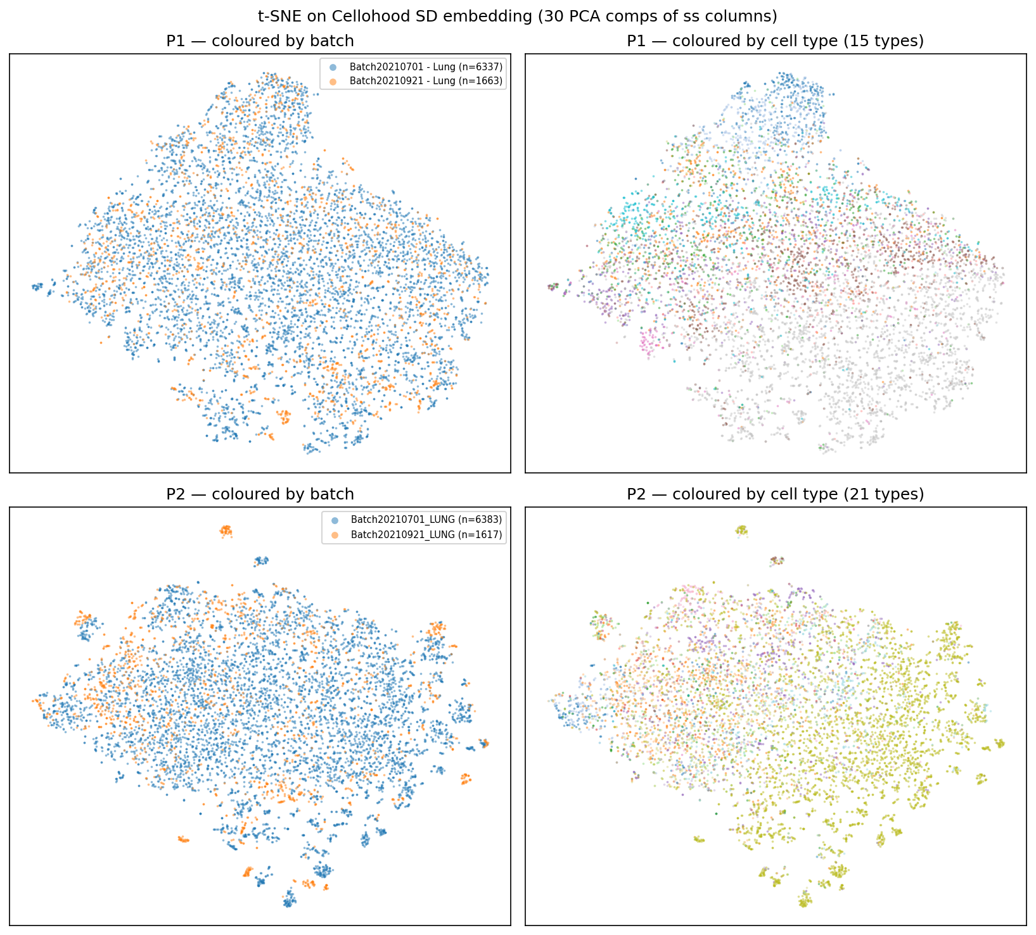
Figure 1. t-SNE of the SD embedding (30 PCA components), colored by acquisition batch (left) and cell type (right), for Panel 1 (top row) and Panel 2 (bottom row). Both panels show extensive batch mixing; no gross batch-driven separation is visible in either panel.

A density-based clustering pass (DBSCAN, tuned via k-nearest-neighbor distance) on the Panel 2 embedding identified four small, dense, mostly batch-pure “islands” sitting off the main mass of the point cloud, out of the 8,000-cell subsample. These islands are not representative of the overall batch signal: excluding the three samples driving them (1.8% of Panel 2’s cells) reduced the batch silhouette by only ~10% in the raw embedding, confirming that the residual batch effect is broadly distributed across the cohort rather than concentrated in a handful of outlier images or patients. The secondary figure below shows the same embedding colored by the structural nuclear markers DNA1, DNA2, and Histone H3, which is where the residual technical signal is most visible.
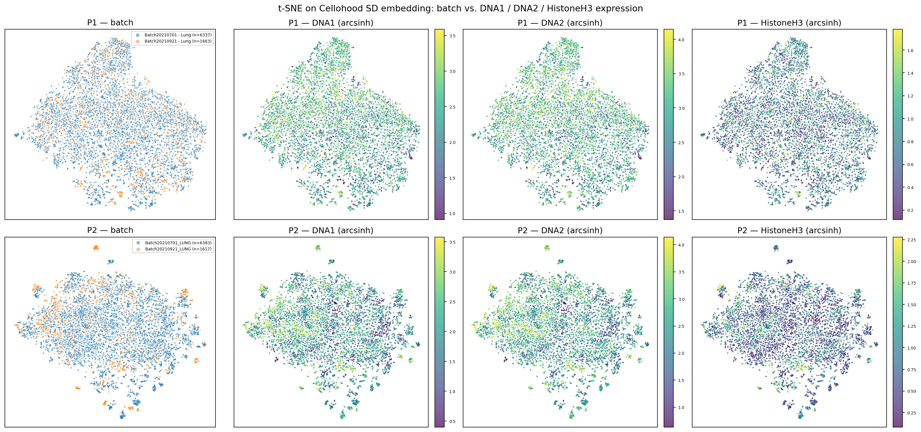
Figure 2 (supplementary). The same t-SNE embedding colored by DNA1, DNA2, and Histone H3 signal intensity, illustrating that the residual technical variation concentrates in structural/housekeeping nuclear stains rather than in biologically informative markers.

Root Cause of the Panel 2 Residual Effect
Several lines of evidence indicate that the residual Panel 2 batch signal is technical rather than biological in origin. Cell-type composition is nearly identical between the two batches (within ~1 percentage point for every population except a small QC “undefined” category), and clinical covariates (stage, histology, tumor mutational burden) are balanced between batches, with only smoking status and death rate differing modestly (~10–15 percentage points) — far too small to explain the observed effect size. The shift is broad-based rather than driven by outliers: 90% of batch-2 patients show higher DNA1 signal than the batch-1 median (AUC = 0.817 for a random patient-pair comparison). Most tellingly, the structural/housekeeping markers DNA1, DNA2, and Histone H3 — plain nuclear/chromatin stains with no biological reason to vary by cohort — show larger effect sizes than biologically meaningful markers and shift in the same direction across every one of 21 cell types checked (100% direction consistency for DNA1/DNA2). This pattern was not explained by cell size, proliferation (Ki-67), or ploidy, all of which were tested and ruled out. Taken together, this is the classic signature of an acquisition/staining calibration drift between the two IMC runs, not a real biological subgroup effect.

Conclusion
Panel 1 shows no detectable batch effect at any stage of analysis. Panel 2 carries a small, diffuse, technical batch signal — undetectable by eye in t-SNE and not concentrated in a subset of samples — that Cellohood’s own spatial-smoothing-plus-PCA representation substantially reduces relative to raw marker space: batch_ASW improves from 0.876 on arcsinh markers to 0.951–0.961 on the z-scored SD embedding, a roughly 2–4-fold reduction in batch silhouette magnitude that lands within the range conventionally regarded as good mixing in the single-cell integration literature. We are careful not to overstate this result: a small residual batch signal remains statistically distinguishable from a permutation null in Panel 2, and Cellohood’s representation-learning step should not be understood as a substitute for explicit batch correction were a reviewer to probe this panel further. However, given its magnitude, its diffuse (non-outlier-driven) distribution across the cohort, and its concentration in housekeeping rather than biological markers, this residual signal is far below what would materially confound downstream neighborhood-composition comparisons, and does not undermine the biological conclusions drawn from either panel in this study.

