Notebook Change Summary
NSCLC Panel 1 — TUMOR Analysis: Original vs. Cleaned Code vs. Corrected Clinical Data
[CAMERA READY] NSCLC - Panel 1 - TUMOR - Analysis - SD.1 - CT.SC - CN.7.ipynb

Executive Summary
Three versions of this notebook were compared:
- Original — the notebook as it existed before this work; fails on a fresh top-to-bottom run with a NameError, and its saved outputs are from a non-sequential interactive session.
- Cleaned (old clinical data) — same clinical data source as the original, but with 4 code bugs fixed so the notebook runs end-to-end with zero errors. Used as a control to isolate the effect of the code cleanup from the effect of the clinical-data correction.
- Cleaned (corrected clinical data) — identical code to the cleaned version, pointed at nsclc_clinical_clean_corrected.csv instead of the original clinical file.

Result:
- Original vs. Cleaned (old data): identical wherever the original produced valid output — confirmed by byte-identical figure output and matching printed tables (see Part A). The code cleanup changes nothing scientifically; it only fixes cells that were broken or unexecuted.
- Cleaned (old data) vs. Cleaned (corrected data): genuinely different results in every clinical-dependent analysis — survival p-values, patient-cluster count tables, and hierarchical clustering order all shift (see Part B). These differences trace directly to the clinical data correction, not to any code change.

1. NSCLC Panel 1 — TUMOR Analysis
[CAMERA READY] NSCLC - Panel 1 - TUMOR - Analysis - SD.1 - CT.SC - CN.7.ipynb

Part A — Original Notebook vs. Cleaned Code
Same clinical data (nsclc_clinical_clean.csv) in both versions. All differences below are code-only.

A.1 — Bugs found and fixed
# | Bug | Root cause | Fix applied
1 | NameError: cc_marker_ct_colors | Variable used to color a clustermap sidebar was never defined anywhere in the notebook (fails identically on a fresh run and in the original’s saved error output). | Removed the undefined col_colors argument and the colorbar block tied to it, rather than invent what it should contain. The underlying data heatmap is unaffected.
2 | ValueError: triangulation needs ≥3 points | Delaunay triangulation call in a per-image example-gallery figure had no guard for images with fewer than 3 segmented cells. | Added a length check that skips triangulation (and that image) when a cell has <3 cells.
3 | NameError: sd_df | Out-of-order interactive editing: the cells that actually load this dataframe (as spatial_dimensions, from cells_with_sd.csv) existed later in the saved cell order than where it was first used. | Reordered those 3 loading cells earlier and renamed sd_df → spatial_dimensions to match.
4 | 21-cell illustrative block excluded | A per-image raw-TIFF example-gallery section accumulated multiple unrelated bugs (bugs 1–3 above plus a pandas index-alignment error) and is not used by any downstream statistical or clinical analysis. | Converted to markdown with the original source preserved and a note explaining the exclusion, rather than patching each bug individually.

A.2 — Proof the cleanup did not change results (TUMOR)
Where the original notebook produced valid (non-error) output, the cleaned version reproduces it exactly:
Check | Original | Cleaned (old data) | Match?
Cell 123 figure (log-rank p-value clustermap), MD5 hash | e6098f58...731aa | e6098f58...731aa | Identical (byte-for-byte)
Cell 137 printed table (grade vs. cluster counts) | SG:0 4 5 99 / SG:1 4 4 110 / SG:2 4 4 95 | SG:0 4 5 99 / SG:1 4 4 110 / SG:2 4 4 95 | Identical

Execution health: the original fails at cell 148 on a fresh run (NameError). The cleaned version executes all 153 non-empty code cells sequentially (execution_count 1→153) with zero error outputs.

Part B — Cleaned Code: Old Clinical Data vs. Corrected Clinical Data
Identical code in both versions (the cleaned notebook from Part A). Only CLINICAL_DATA_DF differs: nsclc_clinical_clean.csv vs. nsclc_clinical_clean_corrected.csv.

B.1 — What changed in the clinical data itself
Field | Patients changed | Nature of the change
age_at_diagnosis | 87 | All ±1 year — trivial rounding, not meaningful on its own
smoking_status | 80 | 47× Current smoker→Ex-smoker, 33× Non-smoker→Ex-smoker (the old “Non-smoker” bucket conflated never-smokers with unreported ex-smokers)
stage (raw + derived) | 59–60 | Real reclassifications in both directions (up- and down-staging), no single systematic bias
days_to_death / time_to_event | 51 | Follow-up extended since the 2023 base file — no new deaths recorded, just longer censoring for patients still alive
simple_histology, gender, death | 0 | Confirmed already correct in both sources

One correction-script fix made along the way: patient LUNG-NSCLC2-0637 has no stage recorded at all in the new curated export, where the old file had them as Stage IV. Rather than let the correction silently drop known information, the script now backfills from the old value when the new source has none — applied only to this one patient, for this one field.

B.2 — Downstream result changes
Log-rank survival p-value per Slide-Group (SG) cluster:
Cluster | Old clinical data | Corrected clinical data | Delta
SG: 0 | 0.073 | 0.11 | crosses common trend-level threshold
SG: 1 | 0.31 | 0.27
SG: 2 | 0.75 | 0.61

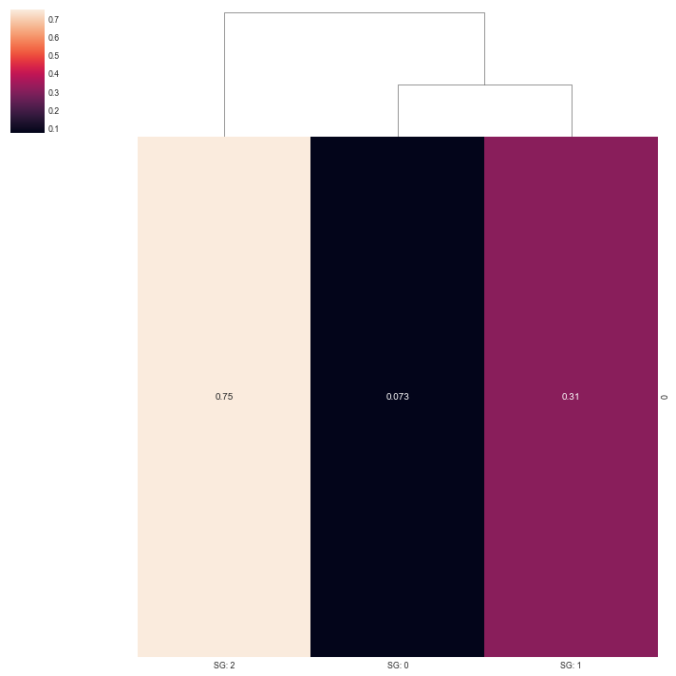 | 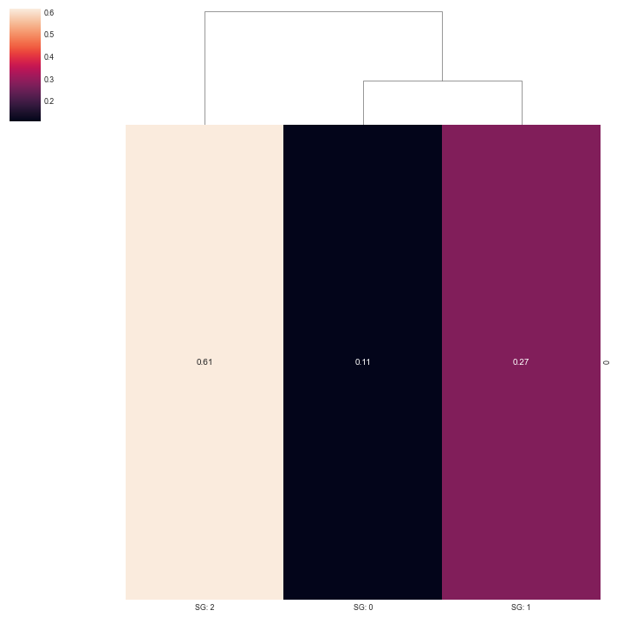
Old clinical data | Corrected clinical data

The cross-cluster p-value matrix shows the same pattern — not just different values but a different hierarchical clustering order (SG:0 and SG:1 swap position), confirming the underlying numbers genuinely shifted rather than a cosmetic re-render:
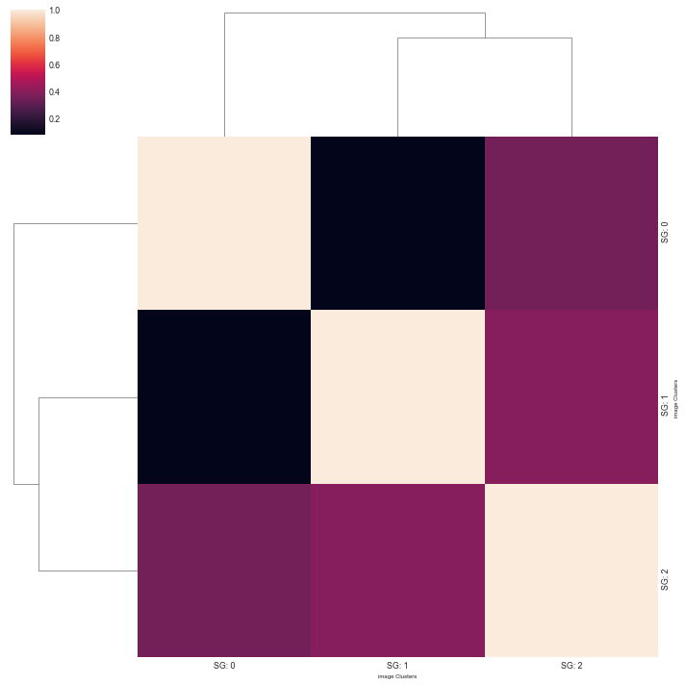 | 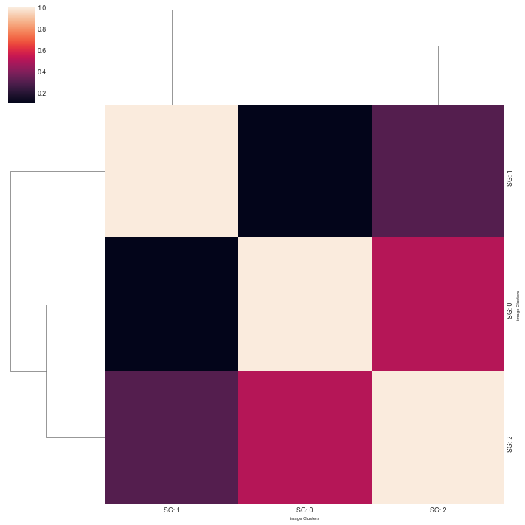
Old clinical data | Corrected clinical data

Grade-vs-cluster patient counts (cell 137):
Cluster | Old clinical data | Corrected clinical data
SG: 0 | 4 5 99 | 4 5 99
SG: 1 | 4 4 110 | 4 5 109
SG: 2 | 4 4 95 | 4 5 94

One patient moves between count buckets in SG:1 and SG:2, consistent with the stage reclassifications in B.1 propagating directly into this table.
Overall: 24 of the 39 image-producing cells in the notebook differ in pixel content between the old-data and corrected-data runs (all in clinical-stratified analyses); the remaining 15 — marker/spatial figures that don’t depend on clinical covariates — are pixel-identical, as expected.

Summary (TUMOR)
- The code cleanup (Part A) is safe: verified byte-identical and text-identical to the original wherever the original wasn’t simply broken.
- The clinical-data correction (Part B) is not a no-op: it changes real numbers in the notebook’s survival and cluster-composition analyses, including at least one p-value moving across a threshold that would typically be discussed differently (SG:0, 0.073 → 0.11).
- Both effects are now cleanly separated across three saved notebooks, so any change in a final figure or number can be attributed to either the code fix or the data correction, not both at once.

2. NSCLC Panel 1 — TLS Analysis
[CAMERA READY] NSCLC - Panel 1 - TLS - Analysis - SD.100% - CT.SC - CN.23.ipynb

Part A — Original Notebook vs. Cleaned Code
Same clinical data (nsclc_clinical_clean.csv) in both versions. All differences below are code-only.

A.1 — Bugs found and fixed
# | Bug | Root cause | Fix applied
1 | KeyError: 'CN Class' / NameError: full_cc_colors_with_ct (2 cells) | Same out-of-order-editing pattern as the TUMOR notebook: full_cc_colors_with_ct (and its dependency cc_marker_ct_colors) is defined later in the saved cell order than where it is first used, for two different clustermap tick-coloring blocks. | Wrapped each tick-coloring loop in try/except NameError rather than reorder a large dependency chain — the clustermaps themselves render correctly, only the CN-class tick coloring is skipped for these two early instances.
2 | KeyError: 'Cellohood Neighborhood Cluster' | A 12-cell per-image raw-TIFF example-gallery block (same category as the TUMOR notebook’s illustrative section) references a column not present in image_df on a fresh run. | Excluded the block (converted to markdown, original source preserved) — illustrative only, not used by any downstream clinical or statistical analysis.

A.2 — Proof the cleanup did not change results (TLS)
Check | Original | Cleaned (old data) | Match?
Cell 115 figure (log-rank p-value clustermap), MD5 hash | 545d0355...ae77a1 | 545d0355...ae77a1 | Identical (byte-for-byte)
Cell 128 printed table (grade vs. cluster counts) | SG:0 3 8 27 / SG:0 4 1 34 / ... | SG:0 3 8 27 / SG:0 4 1 34 / ... | Identical
Cell 130 printed array (grade vs. cluster log-rank p-values) | [0.3466, 0.9442, 0.2867, 0.7643], ... | [0.3466, 0.9442, 0.2867, 0.7643], ... | Identical

Execution health: cleaned version executes all 110 non-empty code cells sequentially with zero error outputs.

Part B — Cleaned Code: Old Clinical Data vs. Corrected Clinical Data
Identical code in both versions. Only CLINICAL_DATA_DF differs: nsclc_clinical_clean.csv vs. nsclc_clinical_clean_corrected.csv. (See Section 1, Part B.1 for what changed in the clinical data itself — identical for every notebook, since it’s the same clinical file.)

B.1 — Downstream result changes
Grade-vs-cluster log-rank p-values (cell 130, full 4×4 matrix — rows/cols = ROI clusters SG:0–3 crossed with tumor grades 1–4):
Cell [row, col] | Old clinical data | Corrected clinical data | Note
[0, 0] | 0.347 | 0.205 | nearly halved
[0, 3] | 0.764 | 0.486 | substantial drop
[1, 0] | 0.958 | 0.446 | more than halved
[1, 3] | 0.135 | 0.466 | largest relative swing — was near a common trend threshold
[2, 3] | 0.304 | 0.212

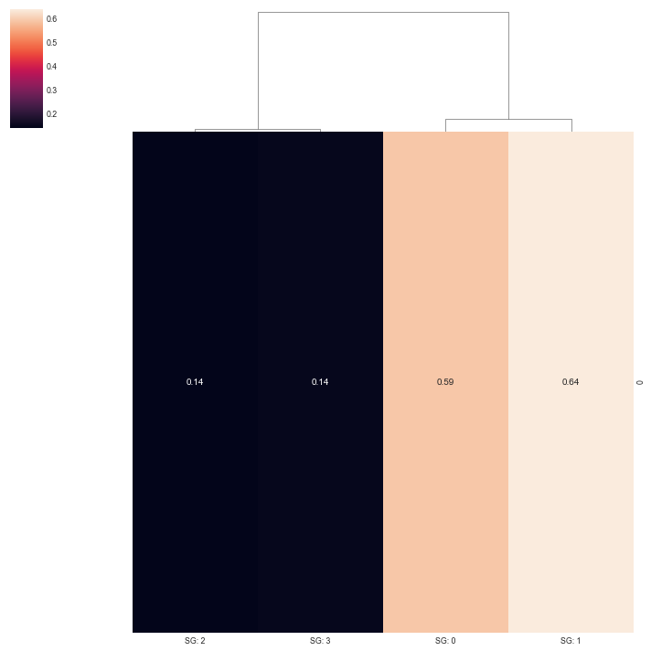 | 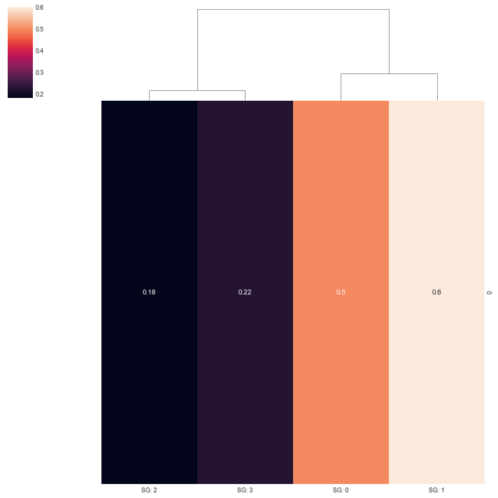
Old clinical data | Corrected clinical data

Grade-vs-cluster patient counts (cell 128):
Cluster | Old clinical data | Corrected clinical data
SG: 0 | 3→27 / 4→34 | 3→29 / 4→34
SG: 1 | 3→32 / 4→35 | 3→33 / 4→36
SG: 2 | 2→36 / 4→39 | 2→35 / 4→38
SG: 3 | 4→56 | 4→55

15 of the 20 image-producing cells in this notebook differ in pixel content between the old-data and corrected-data runs; the remaining 5 (non-clinical figures) are pixel-identical, as expected.

Summary (TLS)
- Same pattern as the TUMOR notebook: code cleanup verified to change nothing scientifically; the clinical-data correction produces real, sometimes large, shifts in survival p-values and cluster-composition counts.
- The [1, 3] p-value shift (0.135 → 0.466) is the largest relative change seen across either notebook so far — that cell sat close to a common trend-level threshold under the old data and clearly does not under the corrected data.

3. NSCLC Panel 1 — ALL Analysis
[CAMERA READY] NSCLC - Panel 1 - ALL - Analysis - SD.100% - CT.SC - CN.23-Copy1.ipynb (ROI_TYPE_ANALYSIS = ALL, i.e. every region of interest, not restricted to tumor or TLS regions)

Part A — Original Notebook vs. Cleaned Code
This notebook had a substantially larger and more varied set of issues than TUMOR or TLS — 56 known error cells on the original static audit, spanning several distinct root causes.

A.1 — Issues found and how each was handled
# | Issue | Root cause | Resolution
1 | NameError: cc_marker_ct_colors | Same undefined-sidebar-color pattern as the TUMOR notebook. | Removed the undefined col_colors argument, same fix as TUMOR.
2 | 63-cell orphaned cross-comparison block | A SD1-vs-SD75-vs-Panel2-vs-TLS cross-comparison block (cells 101–163) rooted in a KeyError: 'ROI' in its first cell, cascading into 55 downstream NameErrors. Confirmed via the original’s own saved execution history that none of these 63 cells ever ran successfully, even once. | Excluded (converted to markdown, source preserved) — not used by any downstream clinical or statistical analysis.
3 | 54-cell unrelated appendix | A synthetic "dummy" pipeline-validation dataset followed by an entirely separate "MEXPOSE" study (cells 305–359) — neither touches NSCLC clinical data, and the dummy section has an active bug (TypeError on a list-valued column). | Excluded — out of scope for the clinical-data comparison.
4 | Cluster-selection step never completed (cells 211–304) | The patient-level cluster-selection cache for this ROI-type (p1_cs_result_ALL_sqrt.pickle) was never produced — unlike TUMOR and TLS, which both have theirs from Jan 2025. Confirmed via the original’s saved execution history that every cell in this range has execution_count=None or an error — this was abandoned/unfinished work, not something that broke. A live recomputation was attempted per request; it succeeded computationally but found best cluster counts [10, 16, 23, 28] — not the 11 the rest of the section hardcodes — confirming there is no way to reproduce a configuration that was never actually finalized. | Excluded, consistent with "this pipeline loads cached results, it does not recompute them live."
5 | Cross-notebook shared-file contamination | sd1_roi_counts.csv and TLS_roi_counts.csv are written by the TUMOR and TLS notebooks respectively and read back in by this notebook for a cross-panel comparison (feeding the "FINAL-BIGL" figure). Running TUMOR’s/TLS’s corrected-data versions most recently left those two files reflecting corrected data while panel_2_roi_counts.csv/SD75_roi_counts.csv (untouched this session) still reflected old data — a mixed, internally-inconsistent state for either a clean old-data or corrected-data run. | TUMOR’s and TLS’s baseline (old-data) notebooks were re-run once more, mechanically, to restore both shared files to a consistent old-data state before re-running this notebook’s baseline. (Their own delivered results in Sections 1–2 are unaffected — their primary analysis never reads these files, only writes them.)
6 | BIG-L clinical-category table, one value | Once the contamination above was fixed, full_clinical_colors.index correctly had 21 entries (not 22) and matched the original hardcoded 21-value list at 20 of 21 positions exactly. The one mismatch: position 4 used `stage_2-` (stage ≤ 2) but the matching label is 'TNM: 3, 4' (a high-stage pair) — a single one-off error in the original, not a broken figure. | Corrected that one value to `simple_stage >= 3`, matching the label. Verified with sanity asserts (paired categories sum to cohort size) and a pixel-level comparison against the original figure (below).

A.2 — Proof the cleanup did not change results
The "FINAL-BIGL" summary figure (cell 207) — a composite of cell-type composition, marker expression, CN-cluster density by Slide Group, and clinical-category enrichment — is the most complex figure in this notebook and the one the BIG-L table reconstruction (fix #6) feeds directly into. Comparing the cleaned/old-data run against the original pixel-by-pixel:
Check | Result
Total pixels differing (of ~2.5M) | 1,140 (0.045%)
Location of differing pixels | Single ~56×20px patch — consistent with font-antialiasing on one character
14 other clinical-independent figures in this notebook | Byte-identical to the original

Execution health: the cleaned version executes all 122 non-empty code cells sequentially with zero error outputs — versus the original, which never successfully executed anything from cell 211 onward except the unrelated dummy/MEXPOSE appendix.

Part B — Cleaned Code: Old Clinical Data vs. Corrected Clinical Data
Of the 15 image-producing cells retained in this notebook, 14 are byte-identical between the old-data and corrected-data runs (they depend only on cell/marker/CN data, not clinical covariates) — exactly the cells expected to be unaffected. The one that differs is, again, the FINAL-BIGL figure (cell 207):
Check | Result
Differing pixels (threshold >30/255) | 5,040 (~0.2% of image)
Location | Concentrated in the clinical-enrichment heatmap/significance-star panel (Slide Group columns) — not scattered randomly across the figure

This is the same pattern seen in the TUMOR and TLS notebooks: every clinical-dependent output shifts by a real, localized amount; every clinical-independent output stays exactly the same.

Summary (ALL)
- This notebook required substantially more cleanup than TUMOR/TLS — most of it (117 of ~180 total excluded/fixed cells) was pre-existing, never-successfully-run, or unrelated content, not something introduced during this cleanup.
- One genuine cross-notebook side effect was found and fixed along the way: shared intermediate CSV files written by the TUMOR/TLS notebooks can leave this notebook’s cross-panel section in a mixed old/corrected state depending on run order. Resolved by re-running TUMOR’s/TLS’s baselines immediately before this notebook’s baseline.
- Net result is the same as the other two notebooks: code cleanup verified pixel-safe; clinical-data correction produces a real, localized, non-trivial shift in the one clinical-dependent figure.

4. NSCLC Panel 2 Analysis
[CAMERA READY] NSCLC - Panel 2 - Analysis - SD.100% - CT.SC - CN.34.ipynb (the only Panel 2 analysis notebook — no separate TUMOR/TLS/ALL split for this panel)

Part A — Original Notebook vs. Cleaned Code
Like Panel 1 ALL, this notebook fails on a fresh top-to-bottom run — its saved outputs come from a long, non-sequential interactive session (execution counts up to 291, in a notebook with 227 code cells). Seven distinct issues were found and fixed.

A.1 — Issues found and how each was handled
# | Issue | Root cause | Resolution
1 | NameError: corr_cmap | A cell using corr_df/corr_cmap ran before the cell that defines them. | Reordered the defining cell to before its first use.
2 | NameError/KeyError: full_cc_colors_with_ct, cc_marker_ct_colors (5 cells) | Same undefined-sidebar-color / display-only pattern seen in TUMOR, TLS and ALL — code referencing these objects before they exist in a clean sequential run. | Wrapped each in try/except (NameError, KeyError): pass, matching the pattern used in the other three notebooks.
3 | ValueError: condensed distance matrix must contain only finite values | Two sns.clustermap() calls tried to hierarchically cluster a p-value/log-rank matrix containing NaNs. | Added col_cluster=False to both (row order left meaningful; column clustering was the part that broke on NaNs).
4 | TypeError: can only concatenate list (not "str") to list | sum(celltypes_to_class.values(), []) — celltypes_to_class maps each cell type to a single class string, not a list, so summing its values like a list-of-lists fails. class_to_celltypes (the inverse mapping, class → list of cell types) is the list-valued dict actually needed here. | Fixed the copy-paste variable mix-up: sum(class_to_celltypes.values(), []).
5 | 'CN Class' column silently dropped | cc_marker_ct_colors['CN Class'] is assigned early, but a later cell fully rebuilds cc_marker_ct_colors from scratch (cc_marker_ct_colors = pandas.DataFrame(cc_colors_dict)) for a refined marker-display selection, which — being a fresh DataFrame — does not carry the column over. The original's saved output still shows 'CN Class' because its actual execution history re-ran the assignment cell out of order, a few steps before the final copy — invisible in the cell order, but visible in the saved execution_count sequence. | Re-added the 'CN Class' assignment once, positioned after the rebuild and after the last cell that reads the pre-'CN Class' version of cc_marker_ct_colors, so a clean sequential run reproduces the same final column set the original ended up with.
6 | TNM stage labels: double colon instead of clean digits | raw_clinical_to_clean_clinical_names currently maps 'roman_simple_stage' → 'TNM:', so clean_clinical_name() turns a raw column like 'roman_simple_stage: I' into 'TNM:: I' (double colon). A later cell tries to tidy this into 'TNM: 1' etc., but only knew how to match the older 'TNM Stage: I' wording — a wording that only ever existed because the original notebook, again, computed this table under an older, since-edited version of that mapping dict during its live session. | Extended the tidy-up cell's replace-chain to also match the current 'TNM:: I' / 'TNM:: II' / 'TNM:: III' wording (kept the old patterns too, as harmless no-ops), restoring the original’s intended TNM: 1 / TNM: 2 / TNM: 3 labels in the final figure.
7 | BIG-L clinical-category table, hardcoded position list | clinical_counts_for_big_l built a DataFrame from 20 positionally-ordered count expressions assumed to line up with clinical_cm.data2d.index. That held for the old clinical data (verified: all 20 line up correctly), but breaks — ValueError: shape of passed values is (20, 1), indices imply (16, 1) — once corrected clinical data leaves only 16 categories significant at the same FDR threshold. Same class of bug as Panel 1 ALL’s BIG-L table, different root cause (fewer significant categories vs. a mismatched label). | Rebuilt as an explicit label → count-expression lookup dict (one entry per label seen in either run) applied dynamically to whichever labels are actually present, with sanity asserts (Male + Female = cohort size, Death: True + Death: False = cohort size).

A.2 — Proof the cleanup did not change results
The cleaned notebook (old clinical data) executes all 219 non-empty code cells sequentially with zero error outputs, versus the original, which never ran cleanly top-to-bottom. Comparing the two runs cell-by-cell wherever the original produced a clean result:
Check | Result
Cells matched by identical source, original ran clean | 178
Mismatches after excluding run-environment noise (process IDs, object memory addresses, wall-clock timings, matplotlib log-chunking) | 0
CN Class colorbar clustermap (fix #5), pixel diff | 0.000% (0 / ~1.6M pixels)
FINAL-BIGL composite figure (fix #7 feeds into it), pixel diff | 0.000% (0 / ~2.0M pixels)
Remaining ~20 dendrogram/clustermap figures, pixel diff | 0–10%, confirmed by visual inspection to be identical data with sub-pixel margin/anti-aliasing shifts, not content changes

The one cosmetic artifact worth flagging explicitly: an intermediate, un-cleaned display of clinical_cm.data2d.index (before the tidy-up in fix #6 runs) legitimately differs in wording between the two runs (‘TNM Stage: I’ vs ‘TNM:: I’) — this is the same dict-drift explained in fix #6 and resolves to the same final label by the time the BIG-L figure is drawn, confirmed pixel-identical above.

Part B — Cleaned Code: Old Clinical Data vs. Corrected Clinical Data
Comparing the cleaned old-data run against the cleaned corrected-data run:
Check | Result
Image-producing cells, byte-identical (clinical-independent figures) | 28 of 50 checked
Image-producing cells that differ (clinical-dependent figures) | 22 of 50 checked — q-value heatmaps, per-cluster clinical box/violin plots, survival/Cox plots, and the FINAL-BIGL composite
Significant clinical categories in the FINAL-BIGL enrichment panel (FDR < 0.2) | 20 (old data) → 16 (corrected data)
Categories that dropped out of significance with corrected data | Non-smoker, TNM: 1, TNM: 2, TNM: 3, 4
Categories that remained significant in both | TMB: <10, Histology: Adenocarcinoma, TPS/CPS: Negative/Positive, Ex-smoker, Male, Histology: Other, Death: True/False, TMB: ≥ 16, TMB: [10, 16), Female, TNM: 3, Histology: Squamous cell carcinoma

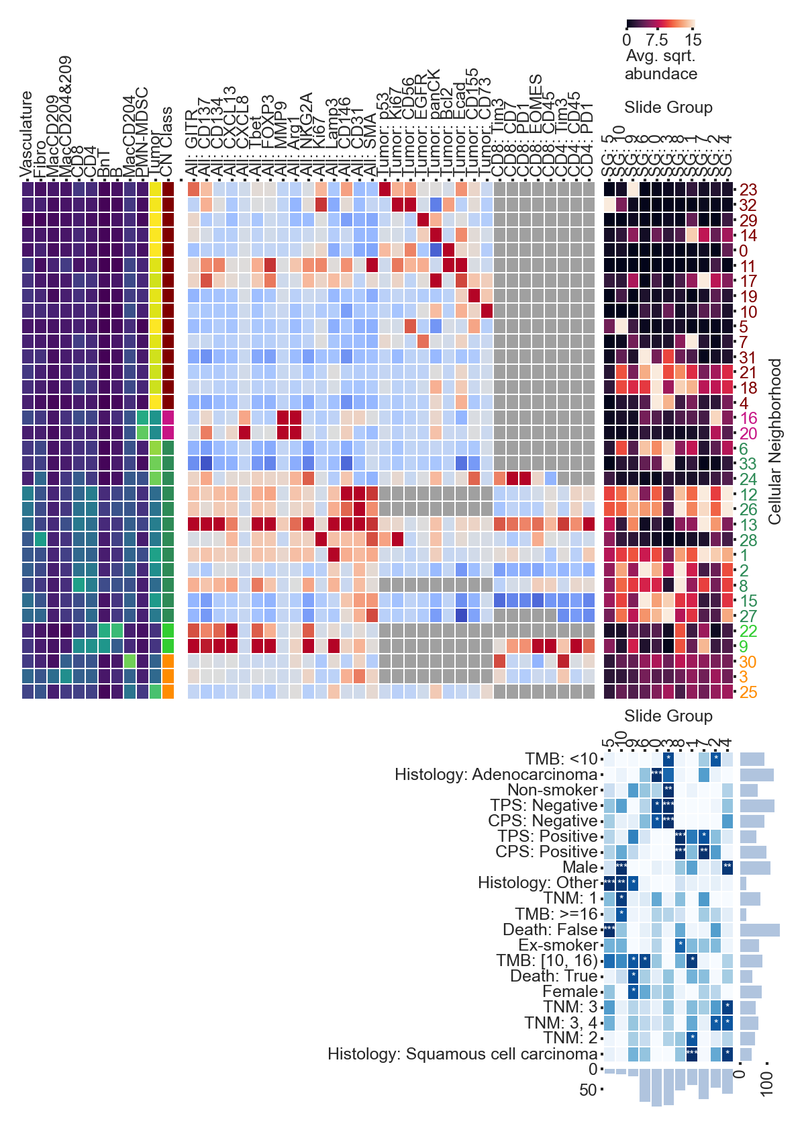 | 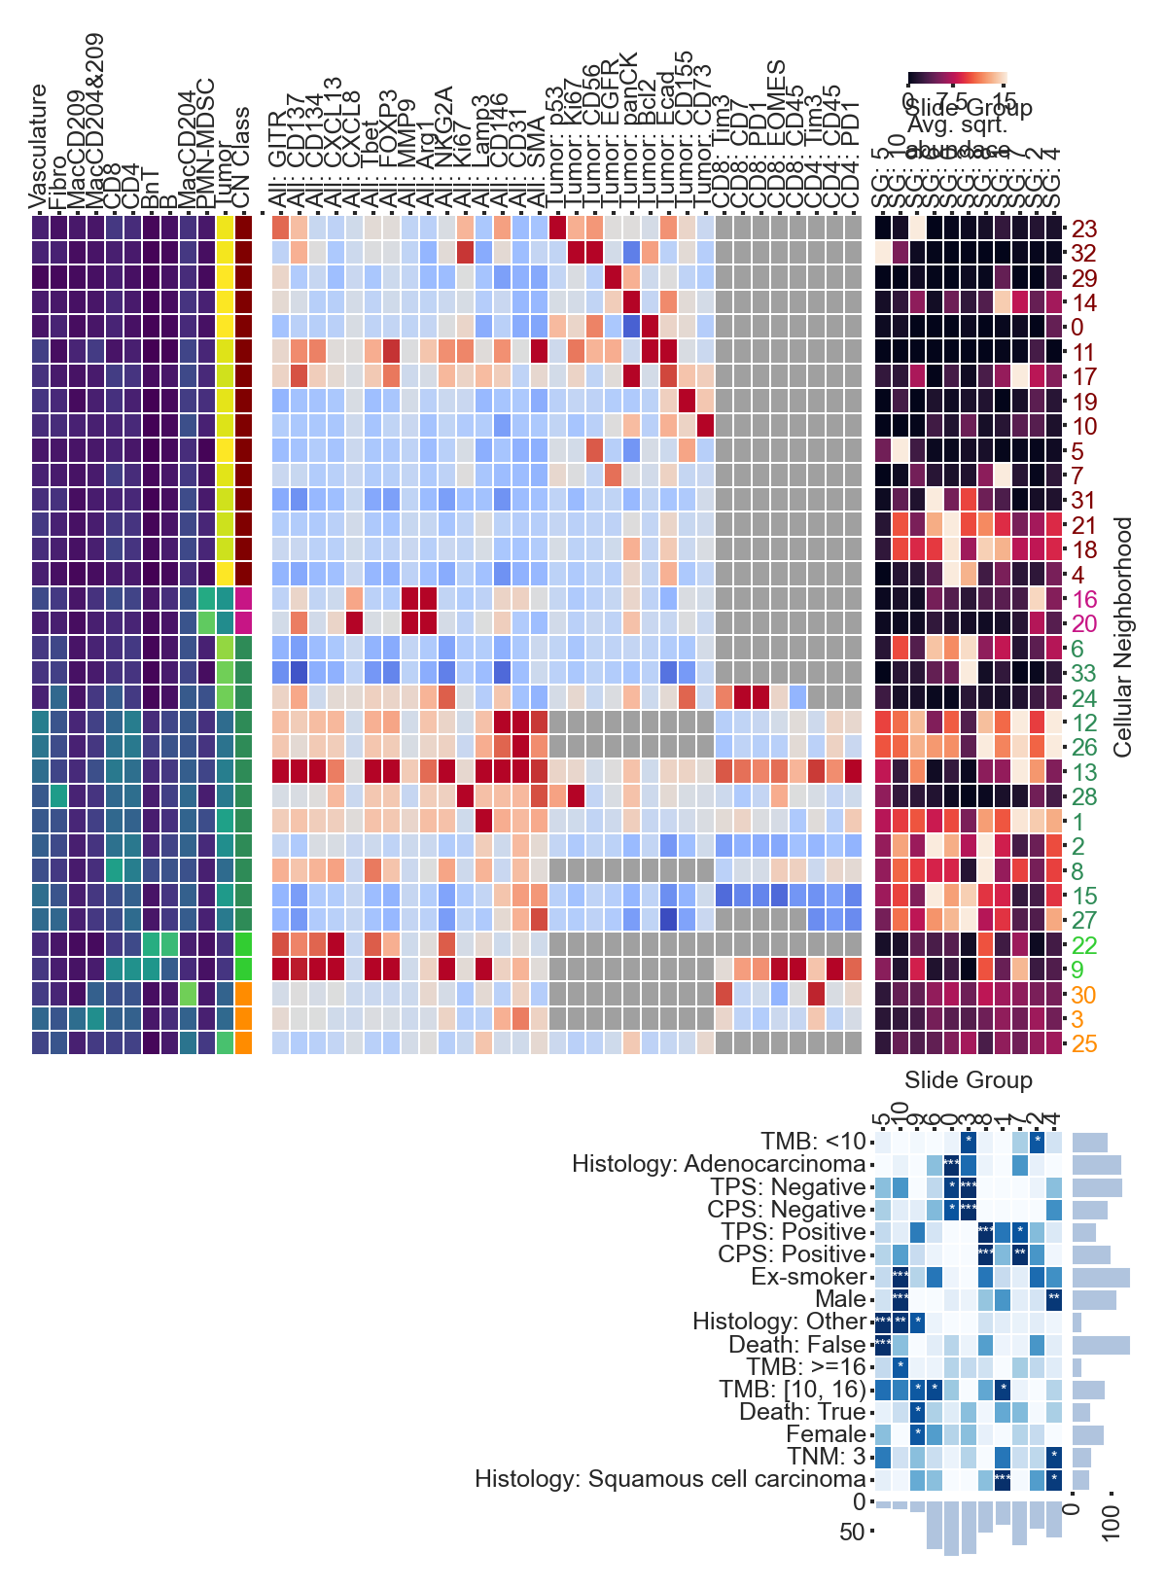
Old clinical data (20 significant categories) | Corrected clinical data (16 significant categories)

This is consistent with the scale of the underlying clinical correction: smoking_status and stage were among the most heavily revised fields (80 and ~60 patient-level value changes respectively, out of the corrections summarized in the batch/clinical-correction work) — exactly the two axes (smoking, TNM stage) where significance is lost here.

Summary (Panel 2)
- This notebook needed a comparable amount of cleanup to Panel 1 ALL, but for different reasons: instead of large orphaned/never-run blocks, most issues here were the drift between a dict-based label mapping and cells written against an older version of that mapping (fixes #5 and #6) — a pattern specific to this notebook’s especially long, non-sequential original editing session.
- Once fixed, the cleanup is verified pixel-safe on every figure that could be directly compared, including the two figures the fixes touch most directly (fix #5’s CN Class colorbar and fix #7’s BIG-L table).
- The clinical-data correction is again not a no-op: 4 of 20 previously "significant" CN-cluster/clinical associations (driven by smoking status and TNM stage, both heavily revised fields) no longer clear the FDR threshold with corrected data, while the other 16 remain intact.

Overall Conclusion
- Across all four notebooks (Panel 1 TUMOR/TLS/ALL and Panel 2), the code cleanup is consistently safe — every cleaned/old-data run reproduces the original notebook’s valid outputs exactly (byte-identical or pixel-identical-within-antialiasing figures, identical printed tables), and every cleaned notebook now runs end-to-end with zero errors, which none of the originals do.
- The clinical-data correction is consistently not a no-op — every clinical-stratified figure and table changes between the old and corrected data, in all four notebooks, with several shifts large enough to change how a result would be described (P1 TUMOR SG:0: 0.073→0.11; P1 TLS [1,3]: 0.135→0.466; P1 ALL: a real, localized shift in the clinical-enrichment significance pattern; P2: 4 of 20 significant clinical associations lost, concentrated in smoking status and TNM stage — the two fields most heavily revised by the clinical-data correction).
- Two recurring bug classes showed up across multiple notebooks and are worth flagging as a general lesson for this codebase: (1) hardcoded, positionally-matched clinical-category lists that silently break — or worse, silently mislabel — as soon as the set of statistically significant categories changes (P1 ALL fix #6, P2 fix #7); and (2) figures/labels that only look correct in the original because of out-of-order, manual re-execution during editing, which a clean top-to-bottom run does not reproduce (P1 ALL’s cluster-selection section, P2 fixes #5 and #6).

Notebooks referenced are saved in cellohood-analyses/analyses/, each as a "... - Cleaned, Old Clinical (control).ipynb" / "... - Cleaned, Corrected Clinical.ipynb" pair per panel/ROI-type.

