Prediction of PM2.5 concentration based on bidirectional attention cycle neural network

Ling Jiaqi
Abstract: To solve the problem of unstable effect and lack of migration ability of ${PM}_{2.5}$ concentration prediction model, a two-way attention recurrent neural network (TDA-RNN) was proposed based on recurrent neural network and attention mechanism. First, the TDA-RNN model obtains the temporal attention and category attention of the input data through the attention mechanism, and fuses them, and then encodes the fused data through the feature encoder to obtain the intermediate features. Finally, the intermediate features were fused with the historical information of ${PM}_{2.5}$ concentration, and the predicted values were obtained by the feature encoder. The ${PM}_{2.5}$ concentration in Nanchang area is predicted. The results show that compared with forward neural network, long short-term memory neural network, gated cyclic unit model and moving average model, the prediction accuracy of TDA-RNN model decreases slightly, but it is still higher than other models. This two-way attention cycle neural network has strong feature extraction ability and high prediction accuracy, and can be applied to multivariate time series prediction in other scenarios.
Keywords${:PM}_{2.5}$; Time Series Prediction; Deep Learning; Recurrent Neural Network; Attention Mechanism
With the fast development of industrialization and urbanization in our country, air pollution gradually becomes a problem that we cannot ignore in the process of development. ${PM}_{2.5}$ as an important indicator to measure air quality, fine particulate matter (${PM}_{2.5}$) has small particles, strong activity, long stay in the air, easy to carry toxic substances, more serious harm to the human body and the environment, resulting in the elderly, children and other weak system population easy to cause respiratory system and cardiovascular diseases^{[1]} .Accurate prediction of PM2.5 is conducive to the management and treatment of air problems by relevant departments, and can provide early warning of air pollution for residents and protect people's health.
At present, there is no unified understanding of the causes of ${PM}_{2.5}$ formation and the factors affecting its concentration. At the same time, various influencing factors have certain randomness, which increases the difficulty of predicting concentration^{[2]}. At present, the main forecasting methods are deterministic model and statistical model. Deterministic model is a theoretical simulation method, which can fully describe the complex physical and chemical changes during the diffusion and dilution of atmospheric pollutants. Shorshani et al.^{[3]} used the improved Gaussian model to simulate the change of ${PM}_{2.5}$ beside the highway, and Djalalova et al.^{[4]}used the Kalman filtering method to predict the change of PM2.5 concentration. Statistical model is a method to analyze a large amount of air quality data and meteorological data by using various data simulation techniques, and then explore their potential laws. Peng Yan et al.^{[5]}proposed a ${PM}_{2.5}$ concentration prediction model based on integrated tree-gradient enhancement decision tree. Luo Hongyuan et al. ^{[6]} carried out a concentration prediction study based on two-layer decomposition technology and an improved extreme learning machine model. Zhang Xilai et al.^{[7]}made prediction based on the dynamic adjustment model of single time series data. In addition, there are a large number of ${PM}_{2.5}$ concentration prediction models based on machine learning, such as support vector machine^{[8]}, Random Forest ^{[9]}, Seq2seq model ^{[10]}, etc.
The traditional statistical model method is to use vector auto-regressive ^{[11]},ARMAX^{[12]},ARIMAX^{[13]} and other models, but these methods can only extract relatively simple linear-features, it is difficult to effectively extract more complex nonlinear features. With the deepening of machine learning research, deep learning models have gradually been favored by researchers for their powerful nonlinear feature extraction and analysis capabilities. Recurrent Neural Network (RNN)^{[14]}, with its special structure, has shown better performance than other models in time series prediction tasks. However, standard RNN networks are prone to gradient disappearance and gradient explosion in the process of long sequence training. Therefore, researchers have proposed a special RNN network, Long Short-Term Memory neural network (LSTM)^{[15]}, which further improves the feature extraction ability of the model for time series data. In order to solve the problem of information overload, the researchers used the attention mechanism to allocate computational resources to more important tasks. Deep learning networks based on attention mechanisms tend to show stronger performance than their initial networks.
On the basis of the above research, this paper proposes a Two-Direction Attention-Based Recurrent Neural Network (TDA-RNN) model.

Data source and preprocessing

The PM_{2.5} air quality data set of Nanchang region was used for modeling and evaluation in this paper. The dataset recorded daily air quality in Nanchang from March 11, 2023 to March 9, 2024. There are 366 sets in total, containing data on eight different meteorological conditions: ${PM}_{2.5}$concentration，${PM}_{10}$concentration ，${SO}_{2}$ ，${NO}_{2}$ ，$O_{3}$ ，CO , highest temperature, lowest temperature.
Since different variables are measured by different units, in order to make the model
converge in the training process, it is necessary to conduct dimensionless processing on the original data before establishing the model:
${\hat{P}}_{i,j}=\frac{P_{i,j}-minP_{j}}{maxP_{j}-minP_{j}}$ （1）
Where: $P_{j}$ is the set of JTH class factors of the dataset, $P_{i,j}$is the i th original data of JTH class factors, ${\hat{P}}_{i,j}$ is $P_{i,j}$ is the data after data standardization.

TDA-RNN model construction

In order to improve the accuracy of the model's prediction of multivariable time series, Yao Q et^{[16]} al. designed a recurrent neural network based on two-stage attention. Inspired by this model, a two-stage attention recurrent neural network TDA-RNN is designed in this paper. The model uses the optimized network results to improve the model expression and generalization performance.
The main process of TDA-RNN is divided into four steps:① Firstly, through the category attention module, different variables of input multivariate data are analyzed, so as to obtain the category attention of different variable data;② Secondly, through the time attention module, the input multivariate data are analyzed with different time steps, so as to obtain the time attention of the data;③ Integrate time series attention and category attention, obtain the attention of each input data, update the input data and encode its features;④ The encoded feature matrix is fused with the historical PM2.5 concentration data, the input feature decoder is decoded, and the final predicted value is obtained. The network structure of TDA-RNN is shown in the following figure Figure 1 shows this.

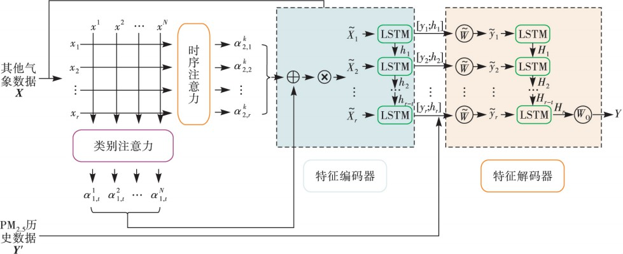
FIG. 1 TDA-RNN model structure
TDA-RNN is a multi-input single-output model, which requires the input of historical data Y 'and multivariate data X of the target sequence, and the output of predictive variables Y, where $X={\left(x_{1},x_{2},⋯x_{T}\right)}^{⊤}=\left(x^{1},x^{2},⋯x^{n}\right)$，Y’$=\left(y_{1},y_{2},⋯y_{n}\right)$，$x_{t}ϵR^{N}，Y，y_{t}ϵR$，N is the number of factors affecting the target sequence, and T is the length of the time window input to the input model. Therefore, the model TDA-RNN can be expressed as a nonlinear function that needs to be trained to obtain specific parameters
Y = F(Y′，X) = F (y1，y2， ⋯ ，yT，x¹，x²， ⋯ ，x^{N}) (2)

2.1 Category attention
RNN is a kind of recursive psychic network with sequence data as input the nature of the network, whose recursion in the evolution direction of the sequence makes RNN In speech recognition, machine translation, time series prediction and other aspects of performance^{[17]}. RNN is used for time series prediction, and the model is obtained Enter sequence data$\left(x_{1},x_{2},⋯x_{T}\right)$, where$x_{t}∈R^{n}$, n is and Mark the number of factors related to the sequence and will be trained to get non-lines Sex function f：
ℎ𝑡 = 𝑓(ℎ𝑡−1，𝑥𝑡) (3)
Where: is the hidden state of RNN at the moment; ℎ𝑡 ∈ 𝑅^{𝑚}𝑡 .m is the sequence length of the hidden state. 𝑓，the nonlinear function can be a standard RNN layer, LSTM layer, or GRU layer.
The LSTM layer not only retains the characteristics of the standard RNN layer that allow information persistence, but also improves the long-term dependence problem of RNN. The LSTM layer is used to extract the long - and short-term dependent features of the model from the sequence data. Each LSTM unit stores and updates the cell state$s_{t}$ and hidden state${ h}_{t}$ of the model at time t through three gate configurations: Forget gate $f_{t}$, input gate $i_{t}$ and output gate $o_{t}$:
$\left\{\begin{aligned} \\ \\ \\ \\ \end{aligned} （4）\right.$
Where: [$h_{t-1}；x_{t}$]$∈R^{m+n}$is composed of the hidden state $h_{t-1}$ at t-1 moment and the input $x_{t}$ at
t moment$W_{f}，W_{i}，W_{o}$,$W_{s}∈R^{m×(m+n)}$ and${ b}_{f}$，$b_{i}$，$b_{o}$，$b_{s}∈R^{m}$ are the parameters that the network needs to obtain through training;$σ$ is the sigmoid function, which $⊙$ is the Hadamard production.
Using the sequence data of the class k influencing factors of the input data $x^{k}$ and the cell sets and hidden states of the LSTM unit, we can construct different attention values for the different categories of influencing factors of the input data X:$s_{1,t}$,ℎ1, 𝑡−1$,e_{1,t}^{k}$:
Using the sequence data $x^{k}$ of the class k influencing factors of the input data x and the cell state ${ s}_{1,t}$ and hidden state ℎ1, 𝑡−1 of the LSTM unit, we can construct the different attention values $e_{1,t}^{k}$ of the influencing factors of different classes of the input data X:
$e_{1,t}^{k}=v_{1,e}^{T}$tanh ($W_{1,e}[h_{1,t-1};s_{1,t-1}]+U_{1,e}x^{k}$) （5）
Where:$v_{1,e}^{T}∈R^{T}$，$W_{1,e}∈R^{T×2m}$，$U_{1,e}∈R^{T×T}$,is the parameter that the network needs to obtain through training. 𝑣^{𝑇} ∈ 𝑅^{𝑇} ，𝑊1,𝑒 ∈𝑅^{𝑇×2𝑚}， 𝑈1,𝑒 ∈ 𝑅^{𝑇×𝑇}.In order to make the sum of attention weights 1，the SoftMax function needs to be utilized to get the final category attention value
$α_{1,t}^{k}$=$\frac{exp(e_{1,t}^{k})}{\sum_{i=1}^{n}{exp(e_{1,t}^{k})}}$（6）
  - Timing attention
Temporal attention is still computed through the LSTM level. Taking advantage of the difference in time t of the input data X affecting the data $x_{t}$ of the element and the cell state $s_{2}^{k}$ and the hidden state $h_{2}^{k-1}$of the LSTM unit, we can construct different attention values $e_{2,t}^{k}$ for different time steps of the input data X:
$e_{2,t}^{k}$=$v_{2,e}^{T}$tanh ($W_{2,e}[h_{2}^{k-1}；s_{2}^{k-1}]+U_{2，e}x_{t}$) （7）
Where:$v_{2,e}^{T}∈R^{n}，$𝑊2, 𝑒 ∈ R^{n×2T}，𝑈2, 𝑒 ∈ R^{n×n} is the parameter that the network needs to obtain through training. In order to make the sum of attention weight equal to 1,the SoftMax function is needed to obtain the final temporal attention value:$α_{2,t}^{k}$
$α_{2,t}^{k}$=$\frac{exp(e_{2,t}^{k})}{\sum_{i=1}^{n}{exp(e_{2,t}^{k})}} （8）$
  - Feature encoder
First, merge category attention with temporal attention to obtain comprehensive
attention${ α}_{t}^{k}$:
$α_{t}^{k}$ =$α_{1，t}^{k}$+$α_{2，t}^{k}$ （9）
At the same time, according to comprehensive attention, the input multivariate data X=$\left(x_{1},x_{2},⋯x_{T}\right)$.where,$x_{t}={\left(α_{t}^{1}x_{t}^{1},α_{t}^{2}x_{t}^{2},⋯{，α}_{t}^{n}x_{t}^{n}\right)}^{⊤}$. By integrating Category attention and time series attention, the network can pay more attention to the important information in the input multivariate data, weaken the adverse impact of interference information on the network, and improve the feature extraction ability of the network.
The new LSTM layer is used to encode the updated multivariate data, obtain the hidden state of LSTM unit at different time t, ℎ𝑡and use it as the encoded feature matrix:
ℎ𝑡 = 𝑓(ℎ𝑡−1，𝑥𝑡) （10）
  - Feature decoder
In order to improve the prediction accuracy of the model, the historical data of the target
sequence and the historical data of other influencing factors are input into the model respectively, and the feature matrix obtained by the feature encoder is fused with the historical data of the
target sequence for the initial decoding:
𝑦𝑡−1 = 𝑤𝑇[𝑦𝑡−1；ℎ𝑡−1] + $\tilde{b}$ （11）
Where: ẽ ϵR^{1+m} and $\tilde{b }ϵ$R, are the parameters that the network needs to obtain through training;
[$y_{t-1}；h_{t-1}$]$ϵR^{1+m}$is input for the layer after data fusion.
The 𝑦𝑡−1 obtained from the initial decoding can be used to update the feature decoder's hidden state 𝐻𝑡 at time t.
$H_{t}$ =$f_{2}(H_{t-1}，y_{t-1})$ （12）Use the LSTM unit as a nonlinear function $f_{2}$.$H_{t}$ Updated by equations (13) :
$\left\{\begin{aligned}f_{t}^{'}=σ(W_{f}^{'}[H_{t-1}；y_{t-1}]+b_{f}^{'}) \\ i_{t}^{'}=σ(W_{i}^{'}[H_{t-1}；y_{t-1}]+b_{i}^{'}) \\ o_{t}^{'}=σ(W_{o}^{'}[H_{t-1}；y_{t-1}]+b_{o}^{'}) \\ s_{t}^{'}=f_{t}^{'}⊙s_{t-1}^{'}+i_{t}^{'}⊙tanh((W_{s}^{'}[H_{t-1}；y_{t-1}]+b_{s}^{'})) \\ h_{t}^{'}=o_{t}^{'}⊙tanh(s_{t}^{'}) \end{aligned}\right.$ （13）
Where:$W_{f}^{'}$，$W_{i}^{'}$，$W_{o}^{'}$，$W_{s}^{'}$ϵ$R^{m×(m+1)}；b_{f}^{'}，b_{i}^{'}，b_{o}^{'}，b_{s}^{'}∈R^{m}$ is the network needs to obtain through training.
For the up acted ones, the final decoding is carried out to obtain the predicted value of the model:$H_{t}$
Y=$w_{o}^{t}H_{t}+b_{o}$ （14）Where: and are the parameters that the network needs to obtain through training:$w_{o}∈R^{m}$and $b_{o}∈R$; Y is the final predicted value of the model.

2.5 Parameter setting
Divide the data set into training set, validation set and test set in a ratio of 0.7225:0.1275:0.15, set the loss function as MSE, and use Adam as the optimizer for model training. At the same time, in order to reduce the unnecessary training time, the "early stop method" was adopted, that is, when the model's loss function on the verification set did not decrease in the 20 rounds of training, the model stopped the training.

Experimental results and analysis

3.1Model evaluation criteria
In order to measure the predictive performance of the model, goodness of fit ($R^{2}$), mean variance (RMSE), mean absolute error (MAE) and mean absolute percentage error (MAPE) are selected as evaluation indexes in this paper.
$R^{2}$ measures the overall fit between the independent variable and the dependent variable. RMSE
can reflect the precision of measurement well. MAE can effectively solve the problem of deviation cancelling each other and describe the degree of data dispersion. MAPE The relative error between measured and observed values. The closer R2 is to 1, the higher the fitting degree of the final predicted value relative to the observed value, and the better the model performance. The smaller the RMSE, MAE and MAPE, the better the prediction performance of the model. $y_{i}$is defined as the observed value, ${\tilde{y}}_{i}$ as the predicted value, and each evaluation index is defined as follows:
$R^{2}=1-\frac{{\sum_{i=1}^{n}{(y_{i}-{\hat{y}}_{i})}}^{2}}{{\sum_{i=1}^{n}{(y_{i}-{\overline{y}}_{i})}}^{2}}$ （15）
$RMSE=\sqrt{{\frac{1}{n} \sum_{i=1}^{n}{\left|y_{i}-\overline{y_{i}}\right|}}^{2} }$ （16）
$MAE=\frac{1}{n}\sum_{i=1}^{n}{\left|y_{i}-{\tilde{y}}_{i}\right|}$ （17）
$MAPE=\frac{100\%}{N}\sum_{i=1}^{n}{\left|\frac{y_{i}-{\hat{y}}_{i}}{y_{i}}\right|}$ （18）
  - Performance comparison of different models
In the TDA-RNN network, there are two main parameters, which are the length of the time window T and the length of the hidden state sequence m. The T∈ {3,6,9,12,15}difference in parameter selection will lead to the difference in model performance. T$∈\{3,6,9,12,15\}$and 8,16,32,64,128} were selected and trained respectively. The experimental results show that when m=128, T=15, the prediction accuracy of TDA-RNN model is the highest.
In order to fully evaluate the predictive performance of the model, Black Propagation Neural Network (BPNN), Gate Recurrent Unit (Gate Recurrent Unit), and Black Propagation Neural Network (BPNN) are used. GRU Model, LSTM model and Moving Average Model (MA) were used as control models. BPNN model is one of the most widely used neural networks with the most standardized construction process. MA is one of the spectral analysis methods of model parameter method, and it is also a commonly used model in modern spectral estimation. Both GRU and LSTM are modified structures of standard recurrent neural networks, which are the best time series prediction models at present.
Table 1 shows the evaluation results of different models, from which it can be seen that the TDA-RNN model proposed in the paper has the best performance in predicting PM2.5 concentration. TDA-RNN outperformed several other models in all evaluation results: R² value reached 0.9375 higher than LSTM (0.9295) and BPNN (0.9034), RMSE lower than LSTM (5.4657), GRU (6.1851) and BPNN (6.3627); Moreover, the MAE and MAPE values of the TDA-RNN model are smaller than those of other models, indicating that the prediction effect and error are minimal. In addition, due to the poor linear feature extraction ability of MA model, all evaluation indexes (R²=0.6035, RMSE=12.2431, MAE=7.6766, MAPE=31.51%) are the worst, which is difficult to meet the needs of PM2.5 concentration prediction.
Table 1 Evaluation results of different models
指标 | BPNN | GRU | LSTM | MA | TDA-RNN
R² | 0.9034 | 0.9111 | 0.9295 | 0.6035 | 0.9375
RMSE | 6.3627 | 6.1851 | 5.4657 | 12.2431 | 5.1807
MAE | 4.1134 | 4.1623 | 3.6696 | 7.6766 | 3.3457
MAPE | 19.19 | 18.17 | 15.82 | 31.51 | 12.99
Figure 2 shows the bottom of the APE box for the predicted results of different models on the
test set. As can be seen from FIG. 2, the average and upper edge values of the relative percentage error of the predicted value of the TDA-RNN model on the test set are lower than those of the control model, and the distribution of the predicted value error is more concentrated. FIG. 2 further illustrates that TDA-RNN has higher prediction performance on this data set from the perspective of error distribution.
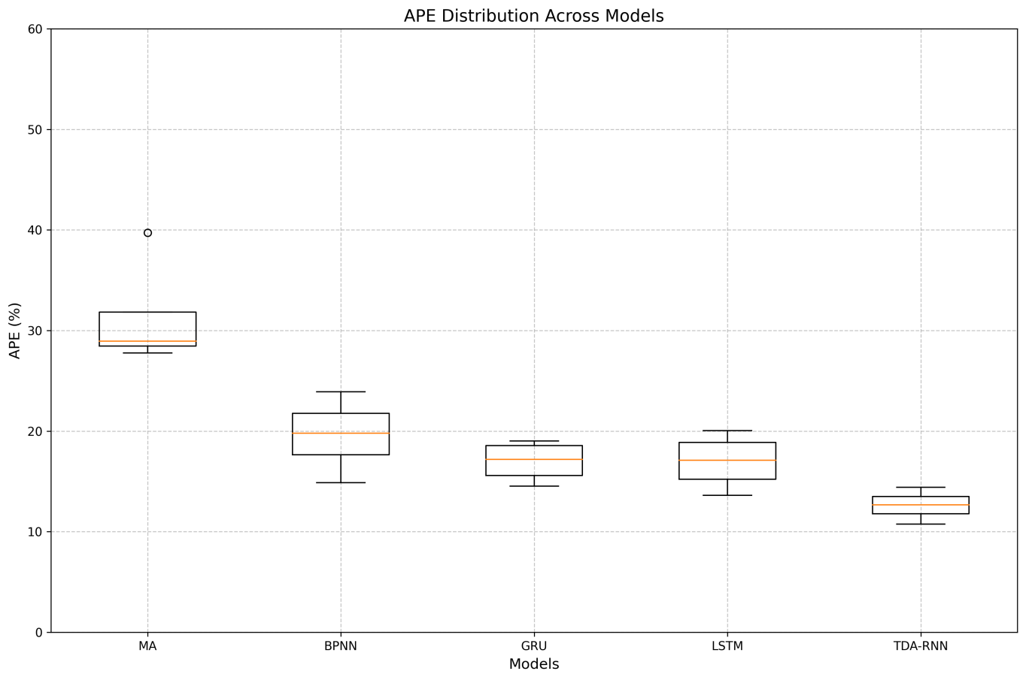
FIG. 2 Bottom of APE box for prediction results of different models
  - Parameter Sensitivity
Different parameters may lead to great differences in the performance of deep learning models. In this paper, parameter sensitivity experiments are performed on the main parameters T and m of the TDA-RNN model. When T or m is changed, the other parameters are kept unchanged and the model is trained. The results are shown in Figure 3
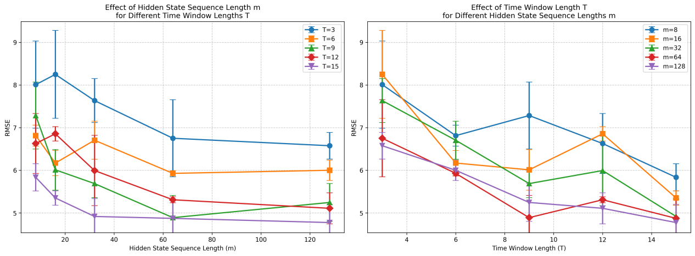
Change only parameter m a) Change only parameter T b)
Figure 3 RMSE of the model with different parameters on the test set When (T, m) = (3, 32), (3, 64) and (6, 64), the TDA-RNN model has the same output for any input, and the gradient disappears in the training of the model, resulting in the failure of the model to effectively train the data set. This can be clearly observed from Figure 3(b), when T=3, the RMSE values of m=32 and m=64 are both higher, about 7.3 and 6.8 respectively. It can be seen from Figure 3(a) that RMSE of TDA-RNN on the test set presents different trends with the change of parameter m. When T=3, RMSE showed a decreasing trend with the increase of m, from about 8.2 when m=20 to about 6.6 when m=128. When T=15, RMSE showed an upward trend with the increase of m, from about 5.3 when m=20 to about 4.8 when m=128. For the cases of T=6 and T=9, the change of RMSE is relatively flat, basically maintaining between 5.0-6.0. This shows that the optimal value of m is closely related to the choice of T, and it is necessary to determine the best combination by experiment. As can be seen from FIG. 3(b), for most m values (m=8, 16, 32, 64, 128), when the value of T is in the range of 8-12, the prediction error of the model is minimal, and the RMSE is generally below 5.0. In particular, when m=64, the lowest point is reached at T=10 and the RMSE is about 4.9. When the value of T is small (3-6) or large (>12), the model prediction error will increase. This is because when the value of T is small, the historical information obtained by the model is insufficient, and there is insufficient time series dependent information to make accurate prediction. However, when the value of T is large, although the model obtains longer time series information, too long-time window may introduce too much noise, which increases the difficulty of the model to extract and analyze key information. Especially when T>12, RMSE corresponding to almost all m values showed a clear upward trend, for example, RMSE rose from about 6.8 at T=12 to about 5.4 at T=14 when m=16.
  - Anti-interference ability detection
Due to the complex causes of PM2.5 formation, other air direction data used in PM2.5 concentration prediction may not be related to PM2.5 concentration. At this time, it is equivalent to introducing interference factors to the network. Therefore, it is very necessary to test the anti-interference performance of the network.
Firstly, a column of data satisfying the normal distribution is randomly generated and added to the input X of the model as a class of data. Then the TDA-RNN and other control models are trained without adjusting the model parameters and structure.
Table 2 shows the evaluation structures of different models on datasets containing interference factors. When m=128 and T =15, the four evaluation indexes R², RMSE, MAE and MAPE of TDA-RNN are 0.9350,5.1807,3.3457 and 12.99. respectively, which are better than the control model. FIG. 4 shows the APE box plot of the predicted results of different models on the test set.
Table 2 shows the evaluation results of different models on the data set containing interference factors
指标 | BPNN | GRU | LSTM | MA | TDA-RNN
R² | 0.8672 | 0.9118 | 0.9325 | 0.6071 | 0.9350
RMSE | 7.3659 | 5.9609 | 5.3138 | 12.2149 | 5.1530
MAE | 4.4794 | 3.9931 | 3.8650 | 7.7352 | 3.3732
MAPE | 18.13 | 18.12 | 17.92 | 31.81 | 13.61

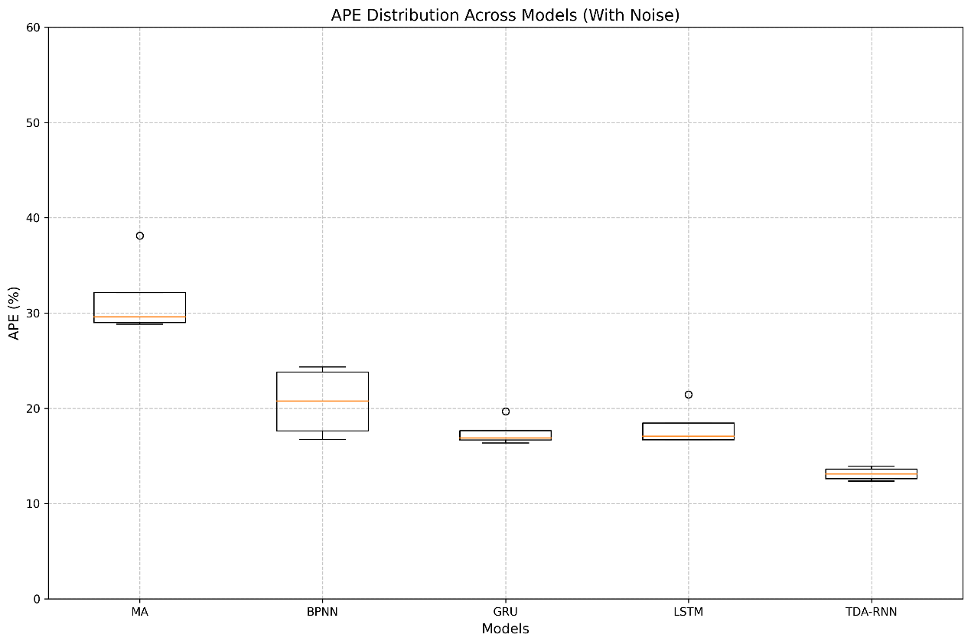Figure 4 APE box plot of the predicted results of different models
As can be seen from Figure 4, without adjusting model parameters and structure, the prediction accuracy of various models on data sets containing interference factors will vary to different degrees. Among them, the TDA-RNN model shows the strongest anti-interference ability, and its APE box plot changes the least when there is no interference, and the increase of median and quartile distance is not obvious. In contrast, the MA model is most significantly affected by interference, and its upper quartile and outlier both increase significantly. The BPNN, GRU and LSTM models show a moderate degree of interference resistance, with GRU slightly superior to LSTM. By comparing the evaluation results of TDA-RNN and traditional recurrent neural network models (GRU and LSTM), we can see that the proposed two-way attention mechanism significantly enhances the anti-jamming ability of the model. This is mainly due to the fact that the feature attention mechanism is able to recognize and focus on more robust input features, while the time attention mechanism is able to capture longer-term temporal dependencies, which together reduce the influence of interference factors on the prediction results.

- . Epilogue

To solve the problem of unstable effect and poor generalization ability of existing concentration
prediction models, a two-way attention loop neural network (TDA-RNN) is proposed in this paper.
PM₂.5In this model, the attention mechanism is introduced into the characteristic dimension and the mathematical dimension respectively, which realizes the optimal utilization of computing resources. The attention mechanism of the feature dimension can identify the importance weights of different indicators adaptively, and the attention mechanism of the time series dimension can effectively capture the long- and short-term dependence of time training. The accurate prediction of concentration is realized. PM₂.5The model adopts multi-layer LSTM structure to enhance the ability of feature extraction, designs the effective integration of time sequence and feature information of fusion encoder, and uses decoder to improve the accuracy of prediction. Abnormal values can be automatically filtered out directly through the attention weight, the multi-head attention mechanism provides multi-angle feature representation, and the dropout mechanism is introduced to improve the robustness of the model and enhance the model's anti-interference ability. The experimental results show that the TDA-RNN model has a significant improvement in the prediction accuracy and model stability. The model is not only suitable for air quality prediction, but also for multivariate time series prediction of other application scenarios, and has a wide range of engineering application prospects.

References

- 汤宇磊, 杨复沫, 詹宇. 四川盆地 PM 2.5 与 PM 10 高分辨率时空分布及关联分析[J]. 中国环境科学, 2019, 39(12): 4950-4958.
- 刘杰, 杨鹏, 吕文生, 等. 模糊时序与支持向量机建模相结合的 PM 2.5 质量浓度预测[J]. 北京科技大学学报, 2014, 36(12): 1694-1702.
- Shorshani M F, Seigneur C, Rehn L P, et al. Atmospheric dispersion modeling near a roadway under calm meteorological conditions[J]. Transportation Research Part D: Tr ansport and Environment, 2015, 34: 137-154.
- Djalalova I, Delle Monache L, Wilczak J. PM2. 5 analog forecast and Kalman filter p ost-processing for the Community Multiscale Air Quality (CMAQ) model[J]. Atmospher ic Environment, 2015, 108: 76-87.
- 彭岩, 赵梓如, 吴婷娴, 等. PM 2.5 浓度预测与影响因素分析[J]. 2019.
- 罗宏远, 王德运, 刘艳玲, 等. 基于二层分解技术和改进极限学习机模型的 PM2. 5 浓度预测研究[J]. 系统工程理论与实践, 2018, 38(5): 1321-1330.
- 张熙来, 赵俭辉, 蔡波. 针对 PM2. 5 单时间序列数据的动态调整预测模型[J]. 自动化学报, 2018, 44(10): 1790-1798．
- 张长江, 戴李杰, 马雷鸣. 应用 SVM 的 PM2. 5 未来一小时浓度动态预报模型[J]. 红外与激光工程, 2017, 46(2): 226002-0226002 (8).
- 任才溶, 谢刚. 基于随机森林和气象参数的 PM_ (2.5) 浓度等级预测[J]. 计算机工程与应用, 2019, 55(2): 213-220.
- 马井会, 曹钰, 余钟奇, 等. 深度学习方法在上海市 PM 2.5 浓度预报中的应用[J]. 中国环境科学, 2020, 40(2): 530-538.
- Zou J J, Jiang G F, Xie X X, et al. Application of a combined model with seasonal autoregressive integrated moving average and support vector regression in forecasting hand-foot-mouth disease incidence in Wuhan, China[J]. Medicine, 2019, 98(6): e14195.
- Choi S B, Ahn I. Forecasting seasonal influenza-like illness in South Korea after 2 an d 30 weeks using Google Trends and influenza data from Argentina[J]. PLoS One, 2020, 15(7): e0233855.
- Sabharwal A, Grover G, Kaushik S, et al. Modelling and forecasting P ositive and N egative S yndrome S cale scores to achieve remission using time series analysis[J]. International journal of methods in psychiatric research, 2019, 28(1): e1763.
- Cui, Ruoxuan, Manhua Liu, and Alzheimer's Disease Neuroimaging Initiative. "RNN-ba sed longitudinal analysis for diagnosis of Alzheimer’s disease." Computerized Medical Imaging and Graphics 73 (2019): 1-10.
- Maragatham, G., and Shobana Devi. "Retracted article: LSTM model for prediction of heart failure in big data." Journal of medical systems 43.5 (2019): 111.
- Qin, Yao, et al. "A dual-stage attention-based recurrent neural network for time seri es prediction." arXiv preprint arXiv:1704.02971 (2017).
- Goodfellow I, Bengio Y. Courville., A.: Deep Learning[J]. Deep learning, 2016: 800.

