**Team Vitellary**

**Collision Detection System Specification for Team Rhodopsin**

**Abstract**

The collision detection system will consist of six sensors mounted on the perimeter of the bot. It is the responsibility of the contracted team to design and construct the electrical system required to condition the signals from the switches. The system will have six inputs, one for each switch, and seven outputs. Six of the outputs will be taken directly from the switches and one will be these six signals logically OR’d together. The system should run off of the 5V pin of the Arduino and draw absolutely no more than 50 mA. A working prototype (breadboard circuit is acceptable) is required no later than March 4, 2014. The fully assembled and working system is required no later than March 11, 2014.

**Input Stage**

*Figure 1: Input Logic*

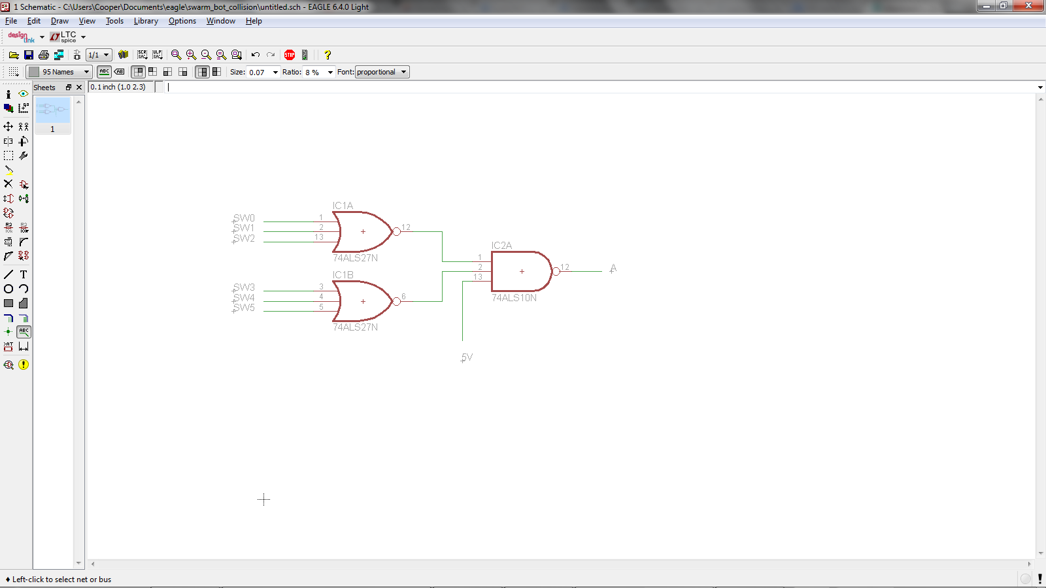

This logic is to be implemented for the input stage of the detection system

*Components:*

* 74LS27 (NOR)
* 74LS10 (NAND)

**De-bounce Stage**

*Figure 2: De-bouncing and output*

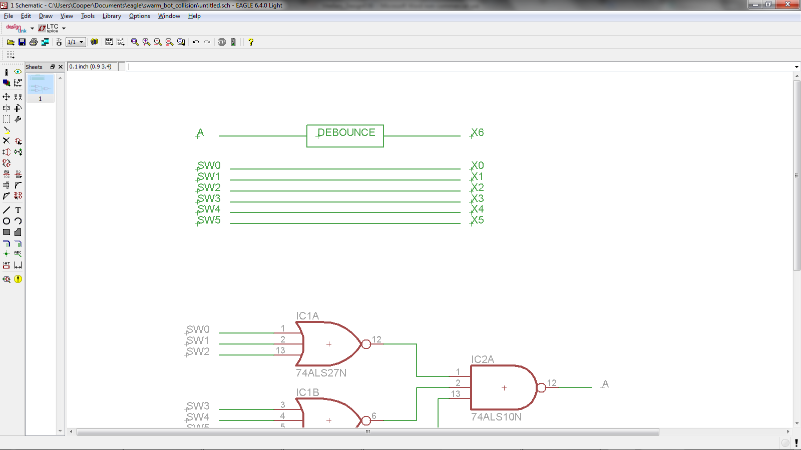

Signal A and SW(n) are those designated in *Figure 1*

The de-bounce circuit will generate a 100 μs pulse when the output A goes high (5V). When the board is assembled, the outputs X0-X5 must be made easily accessible for wiring directly to digital input pins on the Arduino.

**Power**

* Must run off 5V pin of the Arduino
* Consume AT MOST 50 mA

**Deliverables**

*March 4, 2014*

* A working breadboard prototype that shows the functionality of the input logic and de-bouncing circuit.

*March 11, 2014*

* A fully assembled and tested circuit board occupying no more than a 2” x 2” square

*Dates are subject to change (deliverable dates will only be extended) based on Vitellary’s progress