The potential of alien *Solidago* ×*niederederi* Khek (Asteraceae) to compete for insect pollinators with its parental species

Artur Pliszko1*, Edyta Jermakowicz2, Agata Kostro-Ambroziak3, Paweł Trzciński4, Marcin Stocki5, Tomasz Wójcik6, Piotr Szefer7,8

1 Department of Taxonomy, Phytogeography and Palaeobotany, Institute of Botany, Faculty of Biology, Jagiellonian University, Gronostajowa 3, 30-387 Kraków, Poland, e-mail: artur.pliszko@uj.edu.pl

ORCID: 0000-0003-3620-6695

*corresponding author

2 Department of Plant Biology and Ecology, Faculty of Biology, University of Bialystok, Ciołkowskiego 1J, 15-245, Białystok, Poland, e-mail: edytabot@uwb.edu.pl

ORCID: 0000-0003-1061-0366

3 Department of Zoology and Genetics, Faculty of Biology, University of Bialystok, Ciołkowskiego 1J, 15-245, Białystok, Poland, e-mail: ambro@uwb.edu.pl

ORCID: 0000-0001-8172-2985

4 Department of Monitoring and Signalling of Agrophages, Institute of Plant Protection-National Research Institute, Władysława Węgorka 20, 60-318 Poznań, Poland, e-mail: p.trzcinski@iorpib.poznan.pl

ORCID: 0000-0002-8961-330X

5 Institute of Forest Sciences, Faculty of Civil Engineering and Environmental Sciences, Białystok University of Technology, Wiejska 45E, 15-351 Białystok, Poland, e-mail: m.stocki@pb.edu.pl

ORCID: 0000-0002-9430-7892

6 Department of Nature Protection and Landscape Ecology, Institute of Agricultural Sciences, Environment Management and Protection, College of Natural Sciences, University of Rzeszów, Zelwerowicza 4, 35-601 Rzeszów, Poland, e-mail: twojcik@ur.edu.pl

ORCID: 0000-0003-0990-5132

7Faculty of Science, University of South Bohemia, České Budějovice, Branišovská 1645/31a,

370 05 České Budějovice, Czech Republic,

8 Biology Centre, Institute of Entomology, Czech Academy of Sciences, Branišovská 31, 370 05 České Budějovice, Czech Republic, e-mail: szefer@gmail.com

ORCID: 0000-0002-7332-2516

* Corresponding author, e-mail: artur.pliszko@uj.edu.pl

Abstract

Interspecific competition for pollinators is a common and widely studied phenomenon, but in the case of spontaneous hybrids between alien and native plant species, it is poorly understood. Morphological similarity of hybrids to their parents may result in attracting the same pollinators, and thus increase the risk of introgression in mixed populations, which in turn may cause genetic erosion and even the extinction of pure populations of native parental species. To persist in the environment, animal-pollinated hybrids must maximize their reproductive success by effectively competing for pollinators, especially if they show reduced pollen viability. We tested the potential for competition for insect pollinators in *Solidago* ×*niederederi*, a natural hybrid between the invasive *S*. *canadensis* and the native *S*. *virgaurea*, including three mixed populations in north-eastern Poland. We collected and video recorded flower visitors as well as measured selected morphological traits of the hybrid and its parental species, in August 2022. We also performed comparative biochemical analyses of volatile compounds emitted by inflorescences (capitula), using headspace solid-phase microextraction and gas chromatography with mass spectrometry (HS-SPME/GC-MS). The hybrid and its parental species were visited mostly by Diptera (Syrphidae) and they produced a complex scent with the dominance of α- and ß-pinene, myrcene, limonene, and germacrene D. However, a competitive hierarchy may be established between the three *Solidago* taxa, depending on the site, with stronger competition from *S*. *canadensis*. Moreover, the differences in insect visitation numbers between the hybrid and its parental species were strongly attributed to morphological variations. We assumed that visit duration may be more closely related to successful pollen transfer than the sheer number of insect visits, potentially increasing evolutionary pressure on the hybrid and its native parental species. Furthermore, the similarity of the floral scent between the hybrid and its parental species may enhance interspecific exchange of pollen and thus increase introgression, which may be particularly dangerous for the gene pool and persistence of native populations of *S*. *virgaurea*.

Keywords

floral scent, interspecific competition, invasive alien species, plant hybridization, *Solidago canadensis*; Syrphidae, volatile compounds

Acknowledgements

AP received financial support from the National Science Centre in Poland (the project Miniatura 5, 2021/05/X/N28/01322) and Institute of Botany of the Jagiellonian University in Kraków (N18/DBS/000002). The authors thank Joanna Grala and Patryk Grala for their assistant during the field study.

Author contributions

**Artur Pliszko**: conceptualization (lead), data curation (equal), formal analysis (equal), investigation (equal), methodology (equal), project administration (lead), visualization (equal), writing – original draft (lead). **Edyta Jermakowicz**: data curation (equal), formal analysis (equal), investigation (equal), methodology (equal), writing – original draft (equal). **Agata Kostro-Ambroziak**: data curation (equal), investigation (equal), methodology (equal), writing – original draft (equal). **Paweł Trzciński**: data curation (equal), investigation (equal). **Marcin Stocki**: data curation (equal), investigation (equal), methodology (equal), writing – original draft (equal). **Tomasz Wójcik**: formal analysis (equal), methodology (equal), writing – original draft (equal). **Piotr Szefer**: formal analysis (equal); methodology (equal); writing – original draft (equal).

Competing interests

The authors have no competing interests to declare that are relevant to the content of this article.

Introduction

Global changes such as the introduction of alien species and climate warming increase the risk of hybridization by breaking prezygotic barriers between species (Chunco 2014; Vallejo-Marín and Hiscock 2016). Spontaneous hybrids between introduced and native plant species are well documented worldwide; however, in many cases, their influence on wildlife is poorly understood (Vilà et al. 2000; Bleeker et al. 2007; Preston and Pearman 2015). Nevertheless, if they are viable and fertile, or show strong vegetative reproduction, they can effectively compete with other species, even leading to their displacement (Vallejo-Marín and Hiscock 2016). Moreover, they can threaten the genetic diversity of the native parental species, causing genetic erosion of the gene pool through introgressive hybridization (Abbott 1992; Ellstrand and Schierenbeck 2006; Vallejo-Marín and Hiscock 2016). It is also worth mentioning that plant hybrids can undergo relatively rapid speciation, becoming new invasive species (Vallejo-Marín and Hiscock 2016).

Despite the high interest in plant hybridization among ecologists and evolutionists, studies on competition for pollinators between hybrids and their parental species are rarely undertaken, especially in the context of biological invasions (Vilà et al. 2000; Daehler and Carino 2001; Bartomeus et al. 2008; Vallejo-Marín and Hiscock 2016). Generally, hybrids between alien and native plant species are treated as alien taxa (Pyšek et al. 2004) and their invasiveness can be manifested by strong competition for space, light, water, nutrients, pollinators, etc. (Ellstrand and Schierenbeck 2006; Vallejo-Marín and Hiscock 2016). Since plant hybrids usually share a habitat with their parental species, competition is inevitable (Daehler and Carino 2001; Stace et al. 2015). In the case of insect-pollinated plants, the effective attracting of pollinators by an alien species and a hybrid may result in a reduction in seed production in the parental native species and, consequently, even in the disappearance of its population (Bartomeus et al. 2008).

*Solidago* ×*niederederi* Khek (Asteraceae), a natural hybrid between the North American *S*. *canadensis* L. and the European *S*. *virgaurea* L., has originated in the late 19th century in Austria and now occurs in many European countries (Skokanová et al. 2020). The hybrid and its parental species prefer mineral soils with a wide range of texture and pH and often occur in proximity (Pliszko et al. 2021, 2023). They are usually found in semi-natural and ruderal areas such as abandoned fields and meadows, roadsides, railway embankments, disused open-pit mines, and forest clearings (Pliszko and Kostrakiewicz-Gierałt 2017; Skokanová et al. 2020). *Solidago* ×*niederederi* is a perennial plant that forms small clonal clumps like those of *S*. *virgaurea,* but with more shoots (ramets=structural individuals of the clone). However, its vegetative reproduction is limited due to a lack of long underground rhizomes and it spreads mostly by wind-dispersed cypselas (Pliszko and Kostrakiewicz-Gierałt 2017, 2019). The competitive abilities of *S*. ×*niederederi* are poorly recognized. Based on the biomass of sexual ramets and synflorescences (capitula arranged in panicles), it is assumed that the hybrid may be competitively close to *S*. *canadensis* or *S*. *virgaurea*, depending on habitat conditions (Pliszko et al. 2023). However, Lysenkov and Galkina (2023) suggested that *S*. *virgaurea* can be outcompeted by *S*. ×*niedereder**i.*

*Solidago* ×*niederederi* and its parental species are self-incompatible (Nilsson 1976) and insect-pollinated (Sakurai and Takahashi 2017; Pliszko and Kostrakiewicz-Gierałt 2018; Ustinova and Lysenkov 2020). They produce bright yellow flowers gathered in small capitula (flower heads), which are arranged in more complex inflorescences (synflorescences) in the form of panicles. The flowers within each capitulum are differentiated into the outer zygomorphic, female ray flowers and the inner actinomorphic, bisexual disc flowers, and both types of flowers produce nectar (Prell 1954; Nilsson 1976; Jachuła et al. 2020). Considering that *S*. ×*niederederi* and its parental species often share a habitat, their flowering periods overlap and the hybrid usually shows intermediate morphology (Nilsson 1976; Szymura and Szymura 2013; Karpavičienė and Radušienė 2016; Pliszko et al. 2023), they constitute an interesting system for studying interspecific competition for pollinators. *Solidago* species attract their insect pollinators mainly with the color of flowers, floral reward (pollen and nectar), as well as the scent of flowers (Amtmann 2010; Jachuła et al. 2020). Although panicles of *S*. ×*niederederi* and its parental species have been analyzed phytochemically (Radušienė et al. 2018, 2022), so far, the scent signal of their capitula in the context of competition for pollinators has not been the subject of detailed study.

Therefore, in this study, we focused on the potential of *S*. ×*niederederi* to compete for insect pollinators with its parental species. Specifically, we asked:

(1) How do the morphological characteristics of the shoots and inflorescences of the hybrid and its parental species affect the number, diversity, and visit duration of flower visitors?

(2) How do weather conditions and time of day affect the number, diversity, and visit duration of flower visitors between the hybrid and its parental species?

(3) Are there qualitative and quantitative differences in the scent signal of capitula between the hybrid and its parental species?

Materials and methods

Study area

Field study was carried out at three sites (Olecko, Suwałki, and Dąbrowskie) in the Polish part of the Lithuanian Lakeland, north-eastern Poland, between August 18 and 27, 2022, during the optimal flowering period of *Solidago* spp. (Table 1, Fig, 1A). The study area is in the temperate climate zone with a continental climate influence (Richling and Solon 2021). In 2011–2020, the average annual air temperature and precipitation in Suwałki were 7.8 °C and 628 mm, respectively (Statistics Poland 2024).

At each site, a half-hectare area of an abandoned field was included for sample collection. The investigated fields were excluded from agricultural use more than ten years ago and are spontaneously overgrown by woody species (secondary succession), mainly *Betula pendula* Roth and *Pinus sylvestris* L. (Fig. 1B–D). There were 35, 45, and 35 plant species at the flowering phase within 0.5 ha areas in OLE, SUW, and DAB, respectively; however, *S*. *canadensis* was the dominant flowering species at all three sites during the study (Table 1). To better characterize the plant cover and plant species diversity, five phytosociological plots (5 m × 5 m squares) per site were randomly established using the Braun-Blanquet method (Braun-Blanquet 1964).The cover coefficient was calculated for each species and the nomenclature of the distinguished communities was determined based on the species that achieved the highest cover coefficient values. In addition, the Shannon-Wiener diversity index (H´) was calculated for plant communities, using the JUICE program (Tichý 2002). In OLE and SUW, the species characteristic of the *Molinio-Arrhenatheretea* class had the highest share and cover coefficient, while in DAB, the species typical of the *Artemisietea vulgaris* class predominated. Moreover, the Shannon-Wiener diversity index (H´) was the highest in the *Arrhenatherum elatius-Picris hieracioides* community in SUW, and the lowest in the *Arrhenatherum elatius-Solidago canadensis* community in OLE (Table 1).

A three-day study of flower visitors was carried out at each site, during sunny and rainless weather. Air temperature, wind speed, cloud cover, and air humidity of study sites were retrieved from https://pogoda.interia.pl and calculated as average values for hour ranges in each day of the study.

Flower visitor collection and identification

Flower visitors were collected at three times of the day (10:00–11:00, 12:00–13:00, and 14:00–15:00), using hand-held sweep nets with a frame of 40 cm. On each day of the study, 15 flowering shoots of each *Solidago* taxon were randomly selected (5 shoots per hour range). Catching of flower visitors was carried out alternately from investigated *Solidago* taxa, at intervals of 1–3 minutes. In each case, a net was placed over a panicle once and the captured arthropods were kept in it for a while in a plastic container with cotton pads soaked in ethyl acetate. Then the animals were placed into plastic tubes and after completing field investigation, they were transported to the laboratory and kept in a freezer. All flower visitors were sorted into orders and dominant taxa were identified to families and species (van Veen 2004; Oosterbroek 2006). Voucher specimens were deposited in the Laboratory of Insect Evolutionary Biology and Ecology, Faculty of Biology, University of Bialystok in Białystok.

Flower visitor video recording and analysis

Flower visitors were video recorded at three times of the day (11:00–12:00, 13:00–14:00, and 15:00–16:00), using the Sony FDR-AX53 and HDR-PJ780 sensitive cameras. On each day of the study, three flowering shoots per *Solidago* taxon were randomly selected and marked for this task. The cameras were placed on stable stands at approximately 1 m from the plants (one camera per taxon) and in each case, recording a single panicle took about 20 min.

The pollinator foraging time and visitation frequency might be important for enthomogamous plant fecundity (Ohara et al. 1994), thus furthering the possibility of hybridization. In the laboratory, 42 hours of the video recordings were thoroughly analyzed for 1) the number of visits to one *Solidago* inflorescence within 20 minutes and 2) the duration of a single visit per taxon and site. The flower visitors were classified into three groups that could be distinguished in the recordings: hoverflies (family Syrphidae), other flies (other insects from the order Diptera), and insects from the orders Hymenoptera, Coleoptera, and Lepidoptera. Since dipterans made most of the insect visits (93–98.7%), only this group (with no internal division) was included in further analysis. The duration of the visit was recorded from the moment the insect landed on the inflorescence (t1) to the moment it left the inflorescence (t2). Due to the complex structure of the inflorescences, especially in the case of *S*. *canadensis*, it was impossible to capture the whole visit for each visitor. Thus, the unclear cases were excluded from the analysis.

Morphometrical analysis of *Solidago* taxa

A total of 405 flowering shoots from which flower visitors were collected and 81 flowering shoots from which flower visitors were video recorded were subjected to morphometric analysis. The following characters were included: panicle location (PLO), shoot length (SLE), fresh shoot biomass (FSB), panicle length (PLE), panicle width (PWI), fresh panicle biomass (FPB), number of secondary branches within panicle (NSB), number of capitula in a panicle (NCA), and the ratio of the number of ray flowers to disc flowers (RRD). The panicle indicates a synflorescence composed of capitula (flower heads), PLO means the distance in a perpendicular line between the ground level and the base of the panicle, NSB refers to the branches extending directly from the main axis of the panicle, and NCA refers to open (flowering) capitula. All the characters were measured in the field, except NSB, NCA, and RRD which were estimated in the laboratory, after collecting the panicles, drying at room temperature, and keeping them in paper bags. To keep the natural position of the panicle, PLO was measured before catching flower visitors. The characters of PLO, SLE, PLE, and PWI were measured using a self-retracting tape with an accuracy of 0.1 cm, while FSB and FPB were measured using a field scale with an accuracy of 0.05 g. Moreover, RRD was estimated as an average value for five capitula selected from different parts of the panicle.

Capitula sampling and chemical analysis

At each study site, five samples per *Solidago* taxon were randomly collected on August 24, 2022. Each sample represented a different individual and consisted of five open capitula collected from different secondary branches of the panicle. The samples were placed in the Büchi glass tubes, labeled, and then transported to the laboratory. Individuals from which the capitula were taken for chemical analysis were not included in the morphometric analysis.

A total of 45 samples were subjected to chemical analysis. Volatile compounds emitted by the capitula of *S*. *canadensis* (N=15), *S*. ×*niederederi* (N=15), and *S*. *virgaurea* (N=15) were analyzed using headspace solid-phase microextraction and gas chromatography with mass spectrometry (HS-SPME/GC-MS). The sample placed in the tube, which closed screw-cap with a septum, was heated at 40 °C for 30 min. Afterward, the septum was pierced and SPME fiber (Supelco) with divinylbenzene/carboxen/polydimethylsiloxane stationary phase (DVB/CAR/PDMS) was exposed for 30 min in the headspace gas phase. After the exposition, the SPME fiber was inserted for 10 min into an injector of a GC-MS apparatus.

The analysis of volatiles was performed using an Agilent 7890A gas chromatograph coupled with an Agilent 5975C mass spectrometer. The injector was operated in splitless mode at a temperature of 250 °C. The chromatographic separation was done on a capillary column HP-5MS (30 m, 0.25 mm, 0.25 μm) at a helium flow rate of 1 mL/min. The starting column temperature was 35 °C and increased to 250 °C at a rate of 5 °C/min. The temperatures of the quadrupole and ion source were 150 °C and 230 °C, respectively. Mass spectra were obtained at 70 eV ionization energy. Detection was performed for a range of 29–600 atomic mass units in full scan mode. After the integration of peaks, the percentage of each compound in the total ion current (% TIC) was calculated. Both mass spectral data and retention indices were used for volatile identification. The analysis of mass spectra was done using the NIST 2020 Mass Spectral Library and Wiley Registry of Mass Spectral Data (12th edition, 2020), as well as Adams (2007) and Tkachev (2008) collections. The experimental retention indices were calculated with the use of n-alkane retention times.

Statistical analysis

All analyses were performed in R Statistical Software, version 4.3.2 (R Core Team 2023). We examined the following descriptors for each of the investigated plant taxon: 1) total number of insect visits, 2) number of Diptera visits, 3) number of Diptera species, 4) diversity of Diptera (Shannon Index), and 5) visit duration of Diptera. Diptera were further emphasized in our analysis as they constituted the largest group of visiting insects (Fig. S1).

A Principal Component Analysis (PCA) was conducted on the nine morphological characteristics of *S*. ×*niederederi* and its parental species using the *princomp* function. To focus on the most significant morphological characteristics, we extracted the first two PCA axes for use in our models. These two axes explained 92.4% of the total variation in morphological characteristics (Fig. S2). For each descriptor, we built two models: one without the morphological characteristics of plants and one including them, to assess the significance of morphology in explaining the differences. Likelihood ratio tests were used to compare the models and determine whether the inclusion of morphological characteristics improved model performance.

Each statistical model also incorporated local weather conditions (wind, temperature, and cloud cover) as covariates to provide as much statistical control as possible when comparing the *Solidago* taxa. Although humidity was recorded during each sampling session, it was excluded due to its high correlation with air temperature.

To evaluate model performance, we tested various error distributions The Akaike Information Criterion (AIC) was used to select the best-performing model. Response variables were normalized, when needed, using log transformation or a log-shift transformation. For each characteristic, models with a following structures were compared:

$$Y∼β_{plantspecies×location}​+β_{plantspecies×timewindow}​+β_{temperature}​+β_{wind}​+β_{cloud}​+ε$$

$$Y∼β_{plantspecies×location}​+β_{PCA1×plantspecies}​+β_{PCA2×plantspecies}​+β_{plantspecies×timewindow}​+β_{temperature}​+β_{wind}​+β_{cloud}​+ε$$

Where $ε∼N\left(μ,σres​\right)$ in all cases. We used the adjusted R² values of each model to evaluate its explanatory power. For the best-performing models, total visits, Diptera visits, and Diptera species richness were log-shift transformed prior to analysis, while Diptera visit duration was log-transformed. Species diversity (Shannon Index) did not require transformation. After normalization all models assumed a Gaussian error distribution. Post-hoc tests with Tukey correction were conducted to evaluate the significance of differences between the Solidago taxa.

We performed a Redundancy Analysis (RDA) on the chemical composition of individual species to identify significant differences between the Solidago taxa. However, these chemical composition data were not linked to the insect sampling data, which limited our ability to evaluate the direct impacts of specific chemical compounds on visitation counts and visitation duration.

Results

Flower visitors of *Solidago* ×*niederederi* and its parental species

The invertebrates collected from the inflorescences of *S*. ×*niederederi* and its parental species represented six orders of insects (i.e. Diptera, Coleoptera, Hemiptera, Hymenoptera, Lepidoptera, Neuroptera and Thysanoptera), as well as spiders (Araneae) (Table S1). In each *Solidago* taxon and site, dipterans were the dominant group of flower visitors (Figure S1). Among Diptera, hoverflies (Syrphidae), together with blow flies (Calliphoridae), house flies (Muscidae) and flesh flies (Sarcophagidae), were the most numerous. Moreover, four species of hoverflies, namely *Eristalis arbustorum* L., *E*. *interrupta* Poda, *E*. *tenax* L. and *Sphaerophoria* *scripta* L.,had the highest number of individuals within flower visitors (Table S1).

A total of 3390 insect visits were noticed based on analysis of video recordings and the overall visit frequency was variable across taxon and study site. The fewest visits during 20-minute recordings were noticed for *S*. *virgaurea* (11–33), while in general the most such visits were found for *S*. *canadensis* (21–37) and *S*. ×*niederederi* (14–38). All flower visitor groups were present at each site, except for OLE, where the group of Lepidoptera was absent. Moreover, Diptera visits durations varied across taxa, study sites, and time windows. They also showed a certain pattern of longer visit durations for *S*. *canadensis* (30.13(±3.63)–41.68(±2.85)) and *S*. ×*niederederi* (25.27(±1.7)–48.94(±3.30)) and generally shorter visits for *S*. *virgaurea* (22.35(±2.98)–35.76(±2.79)).

Differences in inflorescence visitation between *Solidago ×niederederi* and its parental species

For each descriptor (number of visits, species richness, diversity, and visit duration for Diptera), the most complex model that included all covariates and morphology, with a log-shifted response, exhibited the lowest AIC (Table S2). Models with morphological characteristics always outperformed models without theses characteristics based on the log-likelihood ration tests (Table S3). Results of the best models are showed in Table 2.

In the model for the number of visits without considering morphological characteristics, *S*. *canadensis* exhibited the highest number of visitations among the three studied taxa for both the total number of visits (Fig. 2A, Table S4) and specifically for Diptera (Fig. 3A, Table S5). This dominance was consistent across all three study sites and generally across all time windows, except for the early time window in OLE and SUW (Fig. 2A). When morphological characteristics were incorporated into the model, we observed a significant qualitative shift in the results for both total and Diptera-only visitations: the differences between *Solidago* taxa in the total number of visitations were generally non-existent, except for the DAB population where *S*. *canadensis* had a higher number of visits than *S*. ×*niederederi* in the middle and late time windows (Fig. 2B). For Diptera, *S*. *canadensis* had a higher number of visitations than *S*. ×*niederederi* only in the DAB population during the middle time window (Fig. 3B).

Without considering morphological characteristics, *S*. *canadensis* individuals exhibited the highest richness (total number of species) of Diptera, primarily influenced by plants from the DAB location, where this species dominated across all time windows (Fig. 4A). In OLE and SUW, there were no differences in species richness among the three studied *Solidago* taxa in the early time window. In OLE, *S*. *canadensis* had higher species richness than *S*. *virgaurea* but not than *S*. ×*niederederi* in the late time window, and in SUW during the middle and late time windows (Fig. 4A). When morphological features were included, there was a significant difference in species richness of Diptera between *S*. *canadensis* and *S*. ×*niederederi* in DAB, but no difference between any taxon in OLE and SUW in any time window (Fig. 4B).

Patterns in Diptera species diversity (Shannon’s index) were slightly more intricate. *Solidago canadensis* dominated in the middle-time windows and surpassed *S*. *virgaurea* in the late-time window in OLE, while in SUW, it was only more diverse than *S*. *virgaurea* in the middle and late-time windows (Fig. 5A). Moreover, when morphological features were included, *S*. *canadensis* exhibited higher diversity than *S*. *virgaurea* in the middle and late-time windows (Fig. 5B).

The models of duration without considering morphological characteristics showed significantly higher duration for *S*. *canadensis* in DAB during the early time window and lowest for *S*. ×*niederederi* in the two consecutive time windows. In contrast, *S*. ×*niederederi* in OLE exhibited the longest duration in the early time window. In SUW, *S*. *virgaurea* had shorter visit duration than *S*. ×*niederederi* in the early time window, but not *S*. *canadensis* (Fig. 6A). The model that included morphological characteristics was only able to account for approximately 5% of the variation in visit duration. There were no significant differences between taxa in DAB. In OLE, *S*. *canadensis* had a lower duration than *S*. ×*niederederi* in the early time window and the shortest duration in the middle and late time windows. In SUW, *S*. *canadensis* had a lower duration than *S*. ×*niederederi* but not *S*. *virgaurea* in the early- and middle-time windows, and the lowest in the late-time window (Fig. 6B).

The effect of morphological features and weather conditions on flower visitors

The second PCA axis of morphological characteristics reduced the number of visitors for both total visits and Diptera, as well as on the number of Diptera species and diversity (Tab. 2). This axis represents a linear combination primarily comprising fresh biomass of synflorescence, width of synflorescence, and fresh biomass of the shoot, with lesser contributions from the number of capitula, length of the shoot, length of synflorescence, and number of secondary branches in the synflorescence. Moreover, it was correlated with the ratio of the number of ray flowers to the number of disc flowers in the capitulum (Table S6). This relationship remained consistent across the three plant species for both total visits and Diptera visits, indicating that morphological characteristics have a similar effect on visitations regardless of species identity. Interestingly, the duration of a visit was positively correlated with the first PCA axis, and in the case of *S*. ×*niederederi* and *S*. *virgaurea*, also with the second PCA axis of morphological traits (Table S6). However, this relationship was notably stronger in *S*. *virgaurea*.

High temperature was found to positively influence the number of total flower visitors, as well as their richness and diversity. Conversely, cloud cover exhibited a negative effect on the number of visitors, although it did not impact richness and diversity (Table S3 and S4). **Moreover, the duration of insect visits was negatively affected by increases in wind speed and temperature, but only in models that excluded morphological traits (Table S7).**

Volatile compounds emitted by *Solidago* capitula

A total of 83 volatile compounds were found in the investigated capitula of *S*. ×*niederederi* and its parental species, including 34 monoterpenes, 41 sesquiterpenes, and 8 others (Table S8). The highest number of compounds was found in *S*. *virgaurea* (75) and the lowest in the hybrid (61). All three taxa shared 50 compounds. Moreover, 14 compounds were present only in the *S*. *virgaurea* samples (e.g. cis-sabinenehydrate, linalool, 2,6-dimethyl-1,3(E),5(E),7-octatetraene, allo-ocimene, and iso-pinocamphone), three compounds only in *S*. *canadensis* (i.e. epi-zonarene, cis-furanolinalool oxide, and cis-limonene oxide) and no compounds specific to the hybrid were detected. Nevertheless, six compounds were found only in the hybrid and *S*. *virgaurea* (e.g. verbenene, aromadendrene, and borneol) and five compounds only in the hybrid and *S*. *canadensis* (e.g. guaia-6,9-diene, ß-selinene, and n-hexane). There were also five compounds present only in the *S*. *virgaurea* and *S*. *canadensis* samples (e.g. neo-allo-ocimene, verbenone, and ß-cubebene) (Table S8).

Overall, each taxon had a complex scent with predominance of α- and ß-pinene, myrcene, limonene, and germacrene D. Nevertheless, the RDA analysis revealed that *S*. ×*niederederi* is significantly different from its parental species by a high concentration of (E)-2-methyl-1,3-pentadiene and α-pinene (Fig. 7, Tab. S9, S10). Moreover, there were no significant differences in chemical composition between the study sites.

Discussion

Competition for insect pollinators between *Solidago × niederederi* and its parental species

The arrangement of capitula in the complex inflorescences and the tendency to form clusters of flowering shoots make the display of *Solidago* flowers very visible to insects, even from a distance (Jachuła et al. 2020). Moreover, mass-flowering plants, such as *S*. *canadensis*, mainly strongly attract some groups of pollinators, including bumblebees and bees, but also hoverflies (Holzschuh et al. 2016), thus strongly influencing interactions between local, native plant species and their pollinators. The dominance of Diptera (especially hoverflies) among flower visitors in *S*. ×*niederederi* and its parental species is consistent with previous findings (Sakurai and Takahashi 2017; Pliszko and Kostrakiewicz-Gierałt 2018; Ustinova and Lysenkov 2020). The yellow color of the ray and disc flowers, common in *Solidago* (Semple 2024), is particularly attractive to hoverflies (Primante and Dötterl 2010; Ustinova and Lysenkov 2020). Moreover, many muscoid flies (Anthomyiidae, Calliphoridae, Muscidae, Sarcophagidae, and Tachinidae) are attracted to *Solidago* nectar (Ustinova and Lysenkov 2020). Although the invasion of *S*. *canadensis* usually does not reduce on the number of honeybees (*Apis mellifera*) (Moroń et al. 2009; Ustinova and Lysenkov 2020), these insects were almost absent in our study. Nevertheless, Ustinova and Lysenkov (2020) suggested that floral visitation by honeybees is greatly dependent on the accessibility of hives and other plant resources and may vary greatly between study sites. Furthermore, a low number of beetles and butterflies is not surprising because these insects usually rarely visit *Solidago* inflorescences (Ustinova and Lysenkov 2020). It is also relevant to mention that the panicles of *S*. *canadensis* are attractive to predatory arthropods (Hurej et al. 2012; Dudek et al. 2016; Ustinova and Lysenkov 2020), which we confirmed by finding Araneae and Neuroptera among the caught invertebrates.

A previous study conducted in a domestic garden revealed that the number of insects visiting the capitula of *S*. ×*niederederi* is positively correlated with morphological features such as the length and width of panicles, number of secondary branches within panicle, and number of capitula (Pliszko and Kostrakiewicz-Gierałt 2018). Similarly, we confirmed the positive influence of these characters on the number of flower visitors not only in the hybrid but also in the case of its parental species. Moreover, we found that the biomass of flowering shoots and panicles has a positive effect on the number of flower visitors, while the ratio of the number of ray flowers to the number of disc flowers in the capitulum shows an opposite effect. *Solidago canadensis* produces fewer disc (pollen) flowers per capitulum than *S*. *virgaurea*, but the total number of capitula in *S*. *canadensis* is much higher than in the latter. Moreover, there are clear differences in the size of the capitulum between these species and the hybrid usually shows intermediate characteristics (Nilsson 1976). Because *S*. *canadensis* produces significantly heavier flowering shoots with a higher number of capitula than *S*. ×*niederederi* and *S*. v*irgaurea*, this may be the reason for its advantage in attracting insects. However, there are many genetic and environmental factors affecting biomass in plant hybrids and their parental species (Pliszko et al. 2023). The dominance of F1 hybrids with a small number of supposed introgressants and the lack of transgressive segregation (Skokanová et al. 2022) causes that *S*. ×*niederederi* is usually intermediate in morphology. Interestingly, in NE Poland, in mixed clones (composed of generative and vegetative shoots) of the hybrid, the biomass of flowering shoots and panicles, as well as the length of panicles, decrease with increasing soil pH, and the biomass of panicles increases with elevation, while in *S*. *canadensis*, the length of panicles is positively affected by the content of clay in the soil (Pliszko et al. 2023). It is also worth emphasizing that differences in the method of using agricultural land affect the composition of plant species and, consequently, the diversity and number of pollinators (Kühsel and Blüthgen 2015). Generally, *S*. *canadensis* is a strong competitor to many native species, especially in abandoned fields and meadows. It grows fast and creates dense and extensive patches, thereby reducing the cover of native plant species (Moroń et al. 2009; Fenesi et al. 2015). In contrast, *S*. ×*niederederi* and *S*. *virgaurea* form small clumps due to the absence of long underground rhizomes (Pliszko et al. 2023).

Our results suggest a competitive hierarchy among the three studied *Solidago* taxa, with *S*. *canadensis* displaying higher competitive abilities in DAB. However, this hierarchy appears to be less pronounced in the other two sites (OLE and SUW). Differences in visitation numbers between the hybrid and its parental species were largely attributed to morphological variations. In all models, incorporating information on morphological features caused qualitative changes in the results, particularly for visit duration, suggesting a closer relationship between duration and morphological traits, especially in *S*. ×*niederederi* and *S*. *virgaurea*. This implies that visit duration may be more closely tied to successful pollen transfer than the sheer number of insect visits, potentially increasing evolutionary pressure on the hybrid and its native parental species. According to Jalali et al. (2022), there is a strong pollen competition between different cross-compatible species and the time of pollen arrival on stigmas is crucial for reproductive and hybridization success. Therefore, pollinator behavior appears to be more important than the number of flower visitors and frequency of visitation (Ohara et al. 1994). Moreover, the activity of insect pollinators is highly correlated with air temperature (Kühsel and Blüthgen 2015). In this study, we observed a positive impact of air temperature and a negative impact of wind speed on the number of flower visitors which corresponds with previous findings (Pliszko and Kostrakiewicz-Gierałt 2018). However, in our study, the morphological features of plants had a stronger effect on visitation numbers.

With a relatively low number of individuals usually found in populations (Skokanová et al. 2020) and reduced pollen viability (Migdałek et al. 2014; Karpavičienė and Radušienė 2016), it seems that *S*. ×*niederederi* mainly rely on the parental species as pollen donors. Unfortunately, we do not know what the impact of the quantity and quality of pollen and nectar produced by the flowers of the examined *Solidago* taxa could be on the number and diversity of flower visitors. Nevertheless, attracting common hoverfly species such as *Eristalis arbustorum*, *E*. *interrupta*, *E*. *tenax*, and *Sphaerophoria scripta* may enhance the pollination and in turn seed production in *S*. ×*niederederi*, especially in isolated populations, because these insects are highly migratory and can transport pollen over long distances (Doyle et al. 2020).

Chemical potential of *Solidago × niederederi* to attract insect pollinators

Plant hybrids usually produce the same phytochemicals as their parental species, although they may vary quantitatively depending on organs and environmental conditions (Orians 2000). This pattern has recently been confirmed in *S*. ×*niederederi* based on the accumulation of phenolic compounds and essential oil terpenes in leaves and inflorescences (Radušienė et al. 2018, 2022). Interestingly, *S*. ×*niederederi* is significantly different from its parental species by the concentration of chlorogenic acid and quercitrin in leaves, as well as rutin and isoquercitrin in inflorescences (Radušienė et al. 2018). Moreover, *S*. *canadensis* and *S*. ×*niederederi* are distinguished from *S*. *virgaurea* by the accumulation of oxygenated monoterpenes in inflorescences such as α-campholenal, trans-pinocarveol, pinocarvone, verbenone, cis-verbenol, trans-verbenol, and myrtenal (Radušienė et al. 2022). Similarly, we showed quantitative differences between *S*. ×*niederederi* and its parental species in the volatile composition of the capitula scent, especially in the case of (E)-2-methyl-1,3-pentadiene and α-pinene. So far, no new compounds typical of the hybrid have been detected (Radušienė et al. 2018, 2022). Interestingly, Radušienė et al. (2018) suggested that this may be related to its diploidy and the use of F1 individuals in the study, because novel compounds are rarely found in plant hybrids and usually as a result of polyploidization or the formation of subsequent generations of hybrids (Orians 2000).

*Solidago* ×*niederederi* and its parental species produce many volatile compounds that can attract different insect pollinators. The monoterpenes α- and ß-pinene, sabinene, myrcene, limonene and ß-ocimene, the sesquiterpenes α-copaene, ß-caryophyllene and germacrene D, as well as the hydrocarbon (E)-4,8-dimethyl-1,3,7-nonatriene, are commonly found in floral scent in many plant families (Knudsen et al. 2006). They are acting mostly as general, long-distance floral attractants that initiate a response in a broad range of nectar-feeding insects (Dobson 2006; Dötter and Gershenzon 2023). Interestingly, α-pinene is one of the major aphid alarm pheromones that attract hoverfly females and encourage oviposition (Stökl et al. 2010). Therefore, a high concentration of this monoterpene in the scent signal of *S*. ×*niederederi* and its parental species, together with the yellow color of the flowers, appears to be responsible for the dominance of hoverflies among flower visitors. Moreover, the visits of Calliphoridae, Muscidae, and Sarcophagidae can be explained by the emission of p-cymene, δ-cadinene, and β-caryophyllene which are present in cow dung and produced by flowers pollinated by coprophagous flies (Gfrerer et al. 2022). Although we did not observe a high proportion of Apidae (Hymenoptera) among flower visitors during the study, the investigated *Solidago* taxa produced ß-ocimene which is considered highly attractive to honeybees and bumblebees (Dekebo et al. 2022; Slavković and Bendahmane 2023). It is also relevant to mention that α-humulene, α-phellandrene, and β-caryophyllene are strong repellents to some phytophagous insects and pathogens (Slavković and Bendahmane 2023) and therefore they can contribute to the reproductive success of *S*. ×*niederederi* by protecting the flowers from biological damage. Furthermore, some plant hybrids exhibit a competitive advantage over the parental species due to higher phytochemical resistance to pests through transgressive segregation (Cheng et al. 2011). This mechanism may also occur in *S*. ×*niederederi* but requires scientific confirmation.

Producing a complex floral scent with high concentrations of volatiles that are commonly emitted by flowers of various taxa may enhance pollination success with generalist insects. On the other hand, it may increase competition with the parental species and other plants counting on the same pollinators. Moreover, the similarity of the floral scent between the hybrid and its parental species may magnify the interspecific exchange of pollen and thus increase introgression, which may be particularly dangerous for the gene pool and persistence of native populations of *S*. *virgaurea*. Recently, introgression has been discussed as one of the most likely effects of the displacement of *S*. *virgaurea* by *S*. ×*niederederi* in the Aleksin Bor Natural Monument in European Russia (Lysenkov and Galkina 2023).

Conclusions

The inflorescences of *S*. ×*niederederi* and its parental species are visited by various insects, with the dominance of generalists from the hoverfly family. Depending on the site, weather conditions, and time of day, the number and diversity of visiting insects, as well as the duration of the visit may vary. However, differences in visit duration are strongly affected by morphological characteristics, especially in the hybrid and *S*. *virgaurea*. In mixed populations, *S*. *canadensis* shows a competitive advantage over the hybrid and *S*. *virgaurea*. This may be due to the larger size of panicles, a higher number of capitula, and the formation of dense clusters of flowering shoots, which increase their visibility for pollinating insects. *Solidago* ×*niederederi* appears to be a strong competitor for generalist insects because it emits a complex odor signal from its capitula rich in α-pinene and other volatile compounds commonly found in various insect-pollinated plants. Further studies are necessary to determine the role of flower visitors in the reproductive success of the hybrid and to identify the ecological consequences of interspecific competition for pollinators between the hybrid and its parental species.

References

Abbott RJ (1992) Plant invasions, interspecific hybridization and the evolution of new plant taxa. Trends Ecol Evol 7:401-405. https://doi.org/10.1016/0169-5347(92)90020-C

Adams RP (2007) Identification of Essential Oil Components by Gas Chromatography/Mass Spectrometry, 4th ed. Allured Publishing Corporation, Carol Stream

Amtmann M (2010) The chemical relationship between the scent features of goldenrod (*Solidago canadensis* L.) flower and its unifloral honey. J Food Compos Anal 23:122-129. https://doi.org/10.1016/j.jfca.2009.10.001

Bartomeus I, Vilà M, Santamaría L (2008) Contrasting effects of invasive plants in plant-pollinator networks. Oecologia 155:761-770. https://doi.org/10.1007/s00442-007-0946-l

Bleeker W, Schmitz U, Ristow M (2007) Interspecific hybridisation between alien and native plant species in Germany and its consequences for native biodiversity. Biol Conserv 137:248-253. https://doi.org/10.1016/j.biocon.2007.02.004

Braun-Blanquet J (1964) Pflanzensoziologie. Springer Verlag, Wien

Cheng D, Vrieling K, Klinkhamer PGL (2011) The effect of hybridization on secondary metabolites and herbivore resistance: implications for the evolution of chemical diversity in plants. Phytochem Rev 10:107-117. https://doi.org/10.1007/s11101-010-9194-9

Chunco AJ (2014) Hybridization in a warmer world. Ecol Evol 4:2019-2031.

https://doi.org/10.1002/ece3.1052

Daehler CC, Carino DA (2001) Hybridization between native and alien plants and its consequences. In: Lockwood JL, McKinney ML (Eds), Biotic Homogenization. Springer, Boston, pp 81-102. https://doi.org/10.1007/978-1-4615-1261-5

Dekebo A, Kim M-J, Son M, Jung C (2022) Comparative analysis of volatile organic compounds from flowers attractive to honey bees and bumblebees. J Ecol Environ 46:07. https://doi.org/10.5141/jee.21.001

Dobson HEM (2006) Relationship between floral fragrance composition and type of pollinator. In: Dudareva N, Pichersky E (Eds), Biology of floral scent. CRC Press, Boca Raton, pp 147-198. https://doi.org/10.1201/9781420004007

Doyle T, Hawkes WLS, Massy R, Powney GD, Menz MHM, Wotton KR (2020) Pollination by hoverflies in the Anthropocene. Proc R Soc B: Biol Sci 287:20200508. https://doi.org/10.1098/rspb.2020.0508

Dötter S, Gershenzon J (2023) Chemistry, biosynthesis and biology of floral volatiles: Roles in pollination and other functions. Nat Prod Rep 40:1901-1937. https://doi.org/10.1039/d3np00024a

Dudek K, Michlewicz M, Dudek M, Tryjanowski P (2016) Invasive Canadian goldenrod (*Solidago canadensis* L.) as a preferred foraging habitat for spiders. Arthropod Plant Interact 10:377-381. https://doi.org/10.1007/s11829-016-9455-7

Ellstrand NC, Schierenbeck KA (2006) Hybridization as a stimulus for the evolution of invasiveness in plants? Euphytica 148:35-46. https://doi.org/10.1007/s10681-006-5939-3

Fenesi A, Vágási CI, Beldean M, Földesi R, Kolcsár L-P, Shapiro JT, Török E, Kovács-Hostyánszki A (2015) *Solidago canadensis* impacts on native plant and pollinator communities in different-aged old fields. Basic Appl Ecol 16:335-346. https://doi.org/10.1016/j.baae.2015.03.003

Gfrerer E, Laina D, Wagner R, Gibernau M, Hörger AC, Comes HP, Dötterl S (2022) Antennae of psychodid and sphaerocerid flies respond to a high variety of floral scent compounds of deceptive *Arum maculatum* L. Sci Rep 12:5086. https://doi.org/10.1038/s41598-022-08196-y

Holzschuh A, Matteo D, González-Varo JP, Mudri-Stojnić S, Riedinger V, Rundlöf M, Scheper J, Wickens JB, Wickens VJ, Bommarco R, Kleijn D, Potts SG, Roberts SPM, Smith HG, Smith HG, Vilá M, Vujić A, Steffan-Dewenter I (2016) Mass-flowering crops dilute pollinators abundance in agricultural landscapes across Europe. Ecol Lett 19:1228-1236. https://doi.org/10.1111/ele.12657

Hurej M, Twardowski J, Łukowiak D, Wilczyńska K (2012) Beneficial arthropods visiting Canada goldenrod (*Solidago canadensis* L.) in selected habitats in Wrocław area. Prog Plant Prot 52:335–339.

Jachuła J, Denisow B, Strzałkowska-Abramek M (2020) Does an invader have a bright side? Floral reward in two *Solidago* species. J Apic Res 59:599-608. https://doi.org/10.1080/00218839.2019.1703086

Jalali T, Rosinger HS, Hodgins KA, Fournier‐Level AJ (2022) Pollen competition in hybridizing *Cakile* species: How does a latecomer win the race? Am J Bot 109:1290-1304. https://doi.org/10.1002/ajb2.16035

Karpavičienė B, Radušienė J (2016) Morphological and anatomical characterization of *Solidago* ×*niederederi* and other sympatric *Solidago* species. Weed Sci 64:61-70. https://doi.org/10.1614/WS-D-15-00066.1

Knudsen JT, Eriksson R, Gershenzon J, Ståhl B (2006) Diversity and Distribution of Floral Scent. Bot Rev 72:1–120

Kühsel S, Blüthgen N (2015) High diversity stabilizes the thermal resilience of pollinator communities in intensively managed grasslands. Nat Commun 6:7989. https://doi.org/10.1038/ncomms8989

Lysenkov SN, Galkina MA (2023) Genetic structure of *Solidago* ×*niederederi* (Asteraceae) population in the «Aleksin Bor» Natural Monument (European Russia). Nat Conserv Res 8:1­-8. https://doi.org/10.24189/ncr.2023.027

Migdałek G, Kolczyk J, Pliszko A, Kościńska-Pająk M, Słomka A (2014) Reduced pollen viability and achene development in *Solidago* × *niederederi* Khek from Poland. Acta Soc Bot Pol 83:251-255. https://doi.org/10.5586/asbp.2014.025

Moroń D, Lenda M, Skórka P, Szentgyörgyi H, Settele J, Woyciechowski M (2009) Wild pollinator communities are negatively affected by invasion of alien goldenrods in grassland landscapes. Biol Conserv 142:1322-1332. https://doi.org/10.1016/j.biocon.2008.12.036

Nilsson A (1976) Spontana gullrishybrider (*Solidago canadensis* × *virgaurea*) i Sverige och

Danmark. Sven Bot Tidskr 70:7–16

Ohara M, Higashi S, Ohara A (1994) Effects of inflorescence size on visits from pollinators and seed set of *Corydalis ambigua* (Papaveraceae). Oecologia 98:25-30. https://doi.org/10.1007/BF00326086

Orians CM (2000) The effects of hybridization in plants on secondary chemistry: implications for the ecology and evolution of plant-herbivore interactions. Am J Bot 87:1749–1756

Oosterbroek P (2006) The European Families of the Diptera. Identification, diagnosis, biology. KNNV Publishing, Utrecht

Pliszko A, Kostrakiewicz-Gierałt K, Makuch-Pietraś I (2023) The effect of site conditions and type of ramet clusters on sexual and asexual ramets of *Solidago* ×*niederederi* (Asteraceae). NeoBiota 85:125-143. https://doi.org/10.3897/neobiota.85.98796

Pliszko A, Kostrakiewicz-Gierałt K, Wójcik T (2021) Ecological characteristics of habitats suitable for *Solidago* ×*niederederi* Khek (Asteraceae) establishment. Pol J Environ Stud 30:1339-1348. https://doi.org/10.15244/pjoes/125522

Pliszko A, Kostrakiewicz-Gierałt K (2019) The importance of sexual, asexual and mixed ramet clusters in production of descendant ramets in populations of *Solidago* ×*niederederi* (Asteraceae). Biologia 74:953-960. https://doi.org/10.2478/s11756-019-00233-y

Pliszko A, Kostrakiewicz-Gierałt K (2018) Flower-visiting insects on *Solidago* ×*niederederi* (Asteraceae): an observation from a domestic garden. Botanica 24:162-171. https://doi.org/10.2478/botlit-2018-0016

Pliszko A, Kostrakiewicz-Gierałt K (2017) Resolving the naturalization strategy of *Solidago* ×*niederederi* (Asteraceae) by the production of sexual ramets and seedlings. Plant Ecol 218:1243-1253. https://doi.org/10.1007/s11258-017-0762-6

Prell HH (1954) A case of abnormal flower structures connected with reduced fertility in *Solidago virgaurea* L. Acta Bot Neerl 3:454–458

Preston CD, Pearman DA (2015) Plant hybrids in the wild: evidence from biological recording. Biol J Linn Soc 115:555-572. https://doi.org/10.1111/bij.12577

Primante C, Dötterl K (2010) A syrphid fly uses olfactory cues to find a non-yellow flower. J Chem Ecol 36:1207-1210. https://doi.org/10.1007/s10886-010-9871-6

Pyšek P, Richardson DM, Rejmánek M, Webster GL, Williamson M, Kirschner J (2004) Alien plants in checklists and floras: towards better communication between taxonomists and ecologists. Taxon 53:131–143

Radušienė J, Karpavičienė B, Marksa M, Ivanauskas L, Raudonė L (2022) Distribution patterns of essential oil terpenes in native and invasive *Solidago* species and their comparative assessment. Plants 11:1159. https://doi.org/10.3390/plants11091159

Radušienė J, Marksa M, Karpavičienė B (2018) Assessment of *Solidago* ×*niederederi* origin based on the accumulation of phenolic compounds in plant raw materials. Weed Sci 66:324-330. https://doi.org/10.1017/wsc.2018.8

Richling A, Solon J (2021) Pojezierze Litewskie (842.7). In: Richling A, Solon J, Macias A, Balon J, Borzykowski J, Kistowski M (Eds), Regionalna geografia fizyczna Polski. Bogucki Wydawnictwo Naukowe, Poznań, pp 545–563

Sakurai A, Takahashi K (2017) Flowering phenology and reproduction of the *Solidago virgaurea* L. complex along an elevational gradient on Mt Norikura, central Japan. Plant Species Biol 32:270-278. https://doi.org/10.1111/1442-1984.12153

Semple JC (2024) *Solidago*. Astereae Lab, University of Waterloo. https://uwaterloo.ca/astereae-lab/research/goldenrods

Skokanová K, Šingliarová B, Španiel S, Hodálová I, Mereďa Jr. P (2020) Tracking the expanding distribution of *Solidago* ×*niederederi* (Asteraceae) in Europe and first records from three countries within the Carpathian region. BioInvasions Rec 9:670-684. https://doi.org/10.3391/bir.2020.9.4.02

Skokanová K, Šingliarová B, Španiel S, Mereďa Jr P, Mártonfiová L, Zozomová-Lihová J (2022) Relative DNA content differences reliably identify *Solidago* ×*niederederi*, a hybrid between native and invasive alien species. Preslia 94:183-213. https://doi.org/10.23855/preslia.2022.183

Slavković F Bendahmane A (2023) Floral phytochemistry: Impact of volatile organic compounds and nectar secondary metabolites on pollinator behavior and health. Chem Biodivers 20:e202201139. https://doir.org/10.1002/cbdv.202201139

Stace CA, Preston CD, Pearman DA (2015) The Hybrid Flora of the British Isles. Botanical Society of Britain & Ireland, Bristol

Statistics Poland (2024) Statistical Yearbook of the Republic of Poland 2023. Statistics Poland, Warsaw

Stökl J, Brodmann J, Dafni A, Ayasse M, Hansson BS. 2010 Smells like aphids: orchid flowers mimic aphid alarm pheromones to attract hoverflies for pollination. Proc R Soc B Biol Sci 278:1216-1222. https://doi.org/10.1098/rspb.2010.1770

Szymura M, Szymura TH (2013) Soil preferences and morphological diversity of goldenrods (*Solidago* L.) from south-western Poland. Acta Soc Bot Pol 82:107-115. https://doi.org/10.5586/asbp.2013.005

Tichý L (2002) JUICE, software for vegetation classification. J Veg Sci 13:451-453. https://doi.org/10.1111/j.1654-1103.2002.tb02069.x

Tkachev AV (2008) Study of Plant’s Volatile Compounds. Offset Publishing House, Novosibirsk

Ustinova EN, Lysenkov SN (2020) Comparative study of the insect community visiting flowers of invasive goldenrods (*Solidago canadensis* and *S*. *gigantea*). Arthropod Plant Interact 14:825-837. https://doi.org/10.1007/s11829-020-09780-7

Vallejo-Marín M, Hiscock SJ (2016) Hybridization and hybrid speciation under global change. New Phytologist 211:1170-1187. https://doi.org/10.1111/nph.14004

Van Veen M (2004) Hoverflies of Northwest Europe: Identification Keys to the Syrphidae.

KNNV Publishing, Utrecht

Vilà M, Weber E, D’Antonio CM (2000) Conservation implications of invasion by plant hybridization. Biol Invasions 2:207–217

Figures

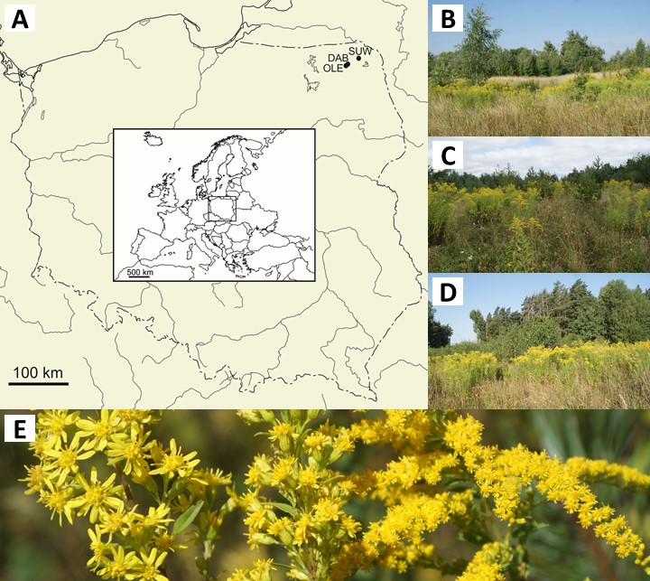

**Fig. 1.** Study sites and *Solidago* taxa (A – localization, B, C, D – abandoned fields in Olecko (OLE), Suwałki (SUW) and Dąbrowskie (DAB), respectively, E – inflorescences of *S*. *virgaurea* (left), *S*. ×*niederederi* (middle) and *S*. *canadensis* (right); photographed by A. Pliszko)

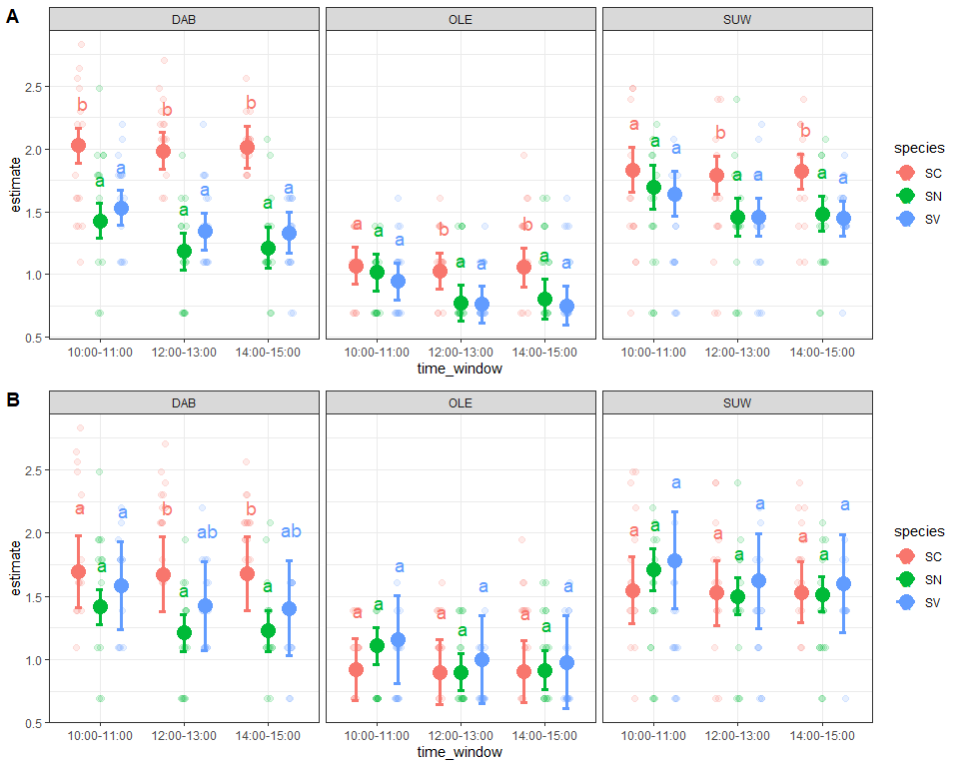

**Fig. 2.** Partial correlations of the log-transformed total insect visits in a model without (A) and with (B) morphological characteristics across three *Solidago* taxa (SC – *S*. *canadensis*, SN – *S*. ×*niederederi*, SV – *S*. *virgaurea*) in different sites (abbreviations are explained in Table 1) and time windows. Points indicate means and whiskers denote 95% confidence intervals. Letters denote significance levels from the post hoc test with Sidak’s correction

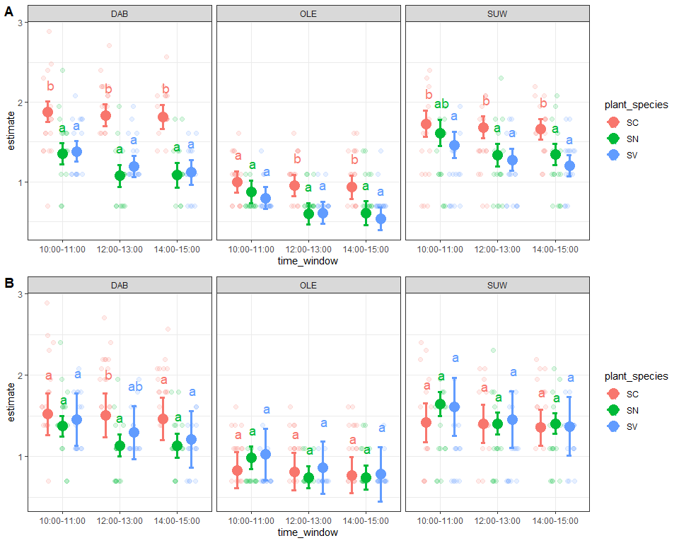

**Fig. 3.** Partial correlations of the log-transformed Diptera visit counts in a model without (A) and with (B) morphological characteristics across three *Solidago* taxa (SC – *S*. *canadensis*, SN – *S*. ×*niederederi*, SV – *S*. *virgaurea*) in different sites (abbreviations are explained in Table 1) and time windows. Points represent means, and whiskers indicate 95% confidence intervals. Letters denote significance levels from the post hoc test with Sidak’s correction

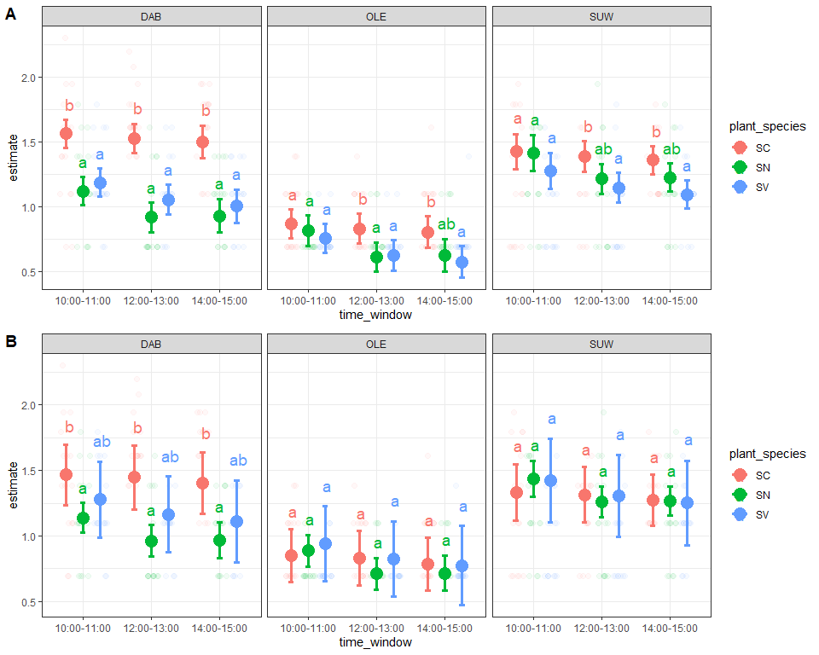

**Fig. 4.** Partial correlations of the log-transformed Diptera species richness for the model without (A) and with (B) morphological characteristics across three *Solidago* taxa (SC – *S*. *canadensis*, SN – *S*. ×*niederederi*, SV – *S*. *virgaurea*) in different sites (abbreviations are explained in Table 1) and time windows. Points denote means, while whiskers represent the 95% confidence intervals. Letters denote significance levels from the post hoc test with Sidak’s correction

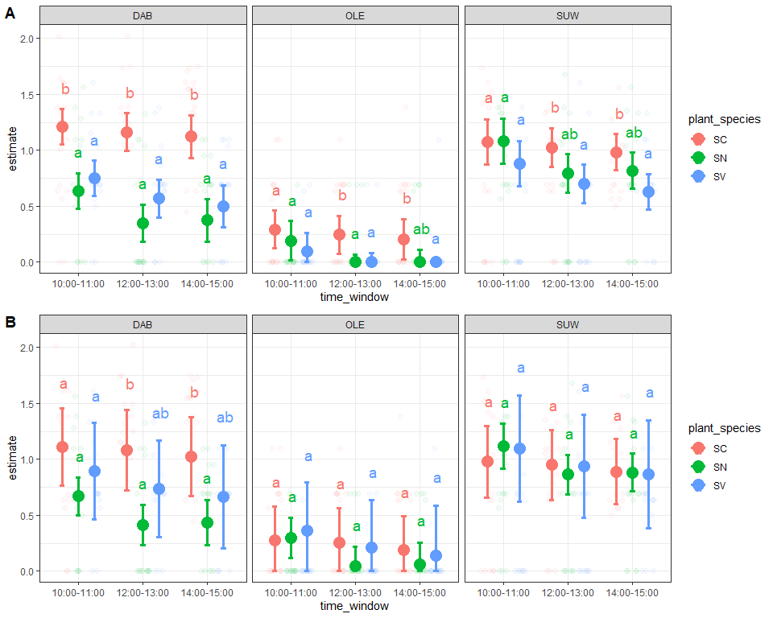

**Fig. 5.** Shannon diversity index of Diptera per individual for the model without (A) and with (B) morphological characteristics across three *Solidago* taxa (SC – *S*. *canadensis*, SN – *S*. ×*niederederi*, SV – *S*. *virgaurea*) in different sites (abbreviations are explained in Table 1) and time windows. Points indicate means, and whiskers denote the 95% confidence intervals. The points represent empirical observations

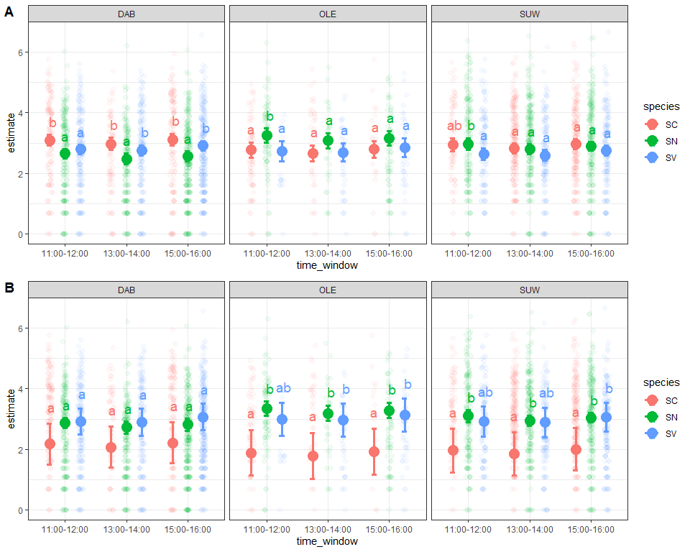

**Fig. 6.** Mean and 95% confidence intervals of the log-transformed duration of Diptera visits at individual inflorescences for three *Solidago* taxa (SC – *S*. *canadensis*, SN – *S*. ×*niederederi*, SV – *S*. *virgaurea*) in different sites (abbreviations are explained in Table 1) and time windows. Post-hoc estimates are compared between two models: without (A) and with morphological characteristics (B)

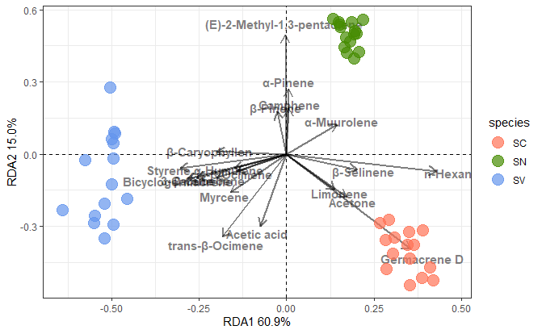

**Fig. 7.** The results of the RDA analysis showing quantitative differences in volatile compounds between the capitula of *Solidago* *canadensis* (SC), *S*. ×*niederederi* (SN) and *S*. *virgaurea* (SV). Most important (n=20, based on the vector lengths) compounds are plotted.

**Table 1.** Characteristics of study sites

|  |  |  |  |  |  |  |  |  |
| --- | --- | --- | --- | --- | --- | --- | --- | --- |
| Site (acronym) | GPS coordinates | Elevation  [m a.s.l.] | Total area of sampling [ha] | Number of phytosociological plots [25 m2] | Plant community | Mean value of Shannon-Wiener index (H´) in plots | Number of species at flowering phase in total area of sampling | Date of flower visitor sampling |
| Olecko (OLE) | 54°01.138'N 22°31.488'E | 170 | 0.5 | 5 | *Arrhenatherum elatius-Solidago canadensis* | 1.95 | 35 | 18–20 Aug 2022 |
| Suwałki (SUW) | 54°06.022'N 22°52.777'E | 180 | 0.5 | 5 | *Arrhenatherum elatius-Picris hieracioides* | 2.54 | 45 | 21–23 Aug 2022 |
| Dąbrowskie (DAB) | 54°05.040'N 22°33.953'E | 180 | 0.5 | 5 | *Elymus repens*- *Solidago canadensis* | 2.19 | 35 | 25–27 Aug 2022 |

Table 2. Duration was evaluated using different time windows to avoid interference with the sampling.

|  |  |  |  |  |  |  |  |  |  |  |  |  |  |  |  |
| --- | --- | --- | --- | --- | --- | --- | --- | --- | --- | --- | --- | --- | --- | --- | --- |
|  | M1 – Total Visits | | | M2 – Diptera Visits | | | M3 – Diptera Species Richness | | | M4: Species Divesrity (Shannon Index) | | | M5: Diptera Visit Duration | | |
| Predictors | Estimates | CI | p | Estimates | CI | p | Estimates | CI | p | Estimates | CI | p | Estimates | CI | p |
| (Intercept) | 0.60 | -0.19 – 1.39 | 0.138 | 0.15 | -0.58 – 0.88 | 0.681 | 0.20 | -0.45 – 0.85 | 0.552 | -0.80 | -1.77 – 0.17 | 0.107 | 5.26 | 4.13 – 6.40 | **<0.001** |
| species [SN] | -0.39 | -0.67 – -0.12 | **0.005** | -0.21 | -0.46 – 0.04 | 0.092 | -0.31 | -0.53 – -0.09 | **0.006** | -0.39 | -0.72 – -0.05 | **0.023** | 0.45 | -0.05 – 0.96 | 0.079 |
| species [SV] | -0.21 | -0.70 – 0.28 | 0.394 | -0.17 | -0.62 – 0.28 | 0.455 | -0.27 | -0.67 – 0.14 | 0.197 | -0.32 | -0.92 – 0.28 | 0.299 | 0.57 | -0.22 – 1.36 | 0.157 |
| location [OLE] | -0.77 | -0.93 – -0.61 | **<0.001** | -0.69 | -0.83 – -0.54 | **<0.001** | -0.61 | -0.74 – -0.48 | **<0.001** | -0.82 | -1.01 – -0.63 | **<0.001** | -0.26 | -0.60 – 0.09 | 0.141 |
| location [SUW] | -0.13 | -0.30 – 0.03 | 0.116 | -0.10 | -0.25 – 0.05 | 0.203 | -0.12 | -0.26 – 0.01 | 0.080 | -0.12 | -0.33 – 0.08 | 0.239 | -0.21 | -0.44 – 0.03 | 0.082 |
| pca1 | 0.01 | -0.09 – 0.11 | 0.828 | 0.02 | -0.07 – 0.11 | 0.654 | -0.04 | -0.12 – 0.04 | 0.331 | -0.06 | -0.18 – 0.07 | 0.361 | 0.11 | -0.12 – 0.35 | 0.346 |
| pca2 | -0.10 | -0.13 – -0.07 | **<0.001** | -0.10 | -0.13 – -0.07 | **<0.001** | -0.05 | -0.07 – -0.02 | **<0.001** | -0.05 | -0.09 – -0.02 | **0.005** | -0.04 | -0.14 – 0.07 | 0.482 |
| time_window12:00-13:00 | -0.02 | -0.17 – 0.12 | 0.772 | -0.01 | -0.15 – 0.12 | 0.832 | -0.01 | -0.13 – 0.11 | 0.817 | -0.02 | -0.20 – 0.16 | 0.823 |  |  |  |
| time_window14:00-15:00 | -0.02 | -0.19 – 0.14 | 0.768 | -0.07 | -0.21 – 0.08 | 0.388 | -0.07 | -0.20 – 0.07 | 0.331 | -0.09 | -0.29 – 0.11 | 0.369 |  |  |  |
| temp | 0.05 | 0.02 – 0.08 | **<0.001** | 0.06 | 0.03 – 0.09 | **<0.001** | 0.05 | 0.03 – 0.07 | **<0.001** | 0.07 | 0.04 – 0.11 | **<0.001** | -0.08 | -0.12 – -0.04 | **<0.001** |
| wind | 0.00 | -0.01 – 0.01 | 0.994 | 0.00 | -0.01 – 0.01 | 0.363 | 0.00 | -0.00 – 0.01 | 0.277 | 0.01 | -0.01 – 0.02 | 0.268 | -0.02 | -0.04 – 0.00 | 0.101 |
| cloud | -0.00 | -0.00 – -0.00 | **0.001** | -0.00 | -0.00 – -0.00 | **0.007** | -0.00 | -0.00 – 0.00 | 0.069 | -0.00 | -0.00 – 0.00 | 0.103 | 0.00 | -0.00 – 0.00 | 0.303 |
| species [SN] × location [OLE] | 0.48 | 0.27 – 0.68 | **<0.001** | 0.30 | 0.11 – 0.49 | **0.002** | 0.36 | 0.19 – 0.53 | **<0.001** | 0.45 | 0.19 – 0.70 | **0.001** | 0.79 | 0.37 – 1.22 | **<0.001** |
| species [SV] × location [OLE] | 0.36 | 0.14 – 0.57 | **0.001** | 0.27 | 0.07 – 0.47 | **0.008** | 0.28 | 0.11 – 0.46 | **0.002** | 0.31 | 0.05 – 0.57 | **0.020** | 0.26 | -0.20 – 0.73 | 0.268 |
| species [SN] × location [SUW] | 0.43 | 0.24 – 0.63 | **<0.001** | 0.38 | 0.20 – 0.56 | **<0.001** | 0.43 | 0.27 – 0.59 | **<0.001** | 0.58 | 0.34 – 0.82 | **<0.001** | 0.50 | 0.26 – 0.74 | **<0.001** |
| species [SV] × location [SUW] | 0.34 | 0.14 – 0.54 | **0.001** | 0.26 | 0.08 – 0.44 | **0.004** | 0.26 | 0.10 – 0.42 | **0.001** | 0.32 | 0.08 – 0.56 | **0.009** | 0.23 | -0.03 – 0.50 | 0.088 |
| species [SN] × pca1 | -0.05 | -0.19 – 0.09 | 0.461 | -0.00 | -0.13 – 0.13 | 0.953 | 0.07 | -0.05 – 0.18 | 0.253 | 0.10 | -0.07 – 0.27 | 0.240 | 0.25 | -0.04 – 0.55 | 0.090 |
| species [SV] × pca1 | -0.02 | -0.18 – 0.13 | 0.776 | -0.02 | -0.17 – 0.12 | 0.745 | 0.04 | -0.09 – 0.16 | 0.570 | 0.05 | -0.14 – 0.24 | 0.592 | 0.03 | -0.26 – 0.32 | 0.829 |
| species [SN] × pca2 | 0.01 | -0.04 – 0.06 | 0.791 | 0.00 | -0.04 – 0.05 | 0.849 | -0.02 | -0.06 – 0.02 | 0.431 | -0.04 | -0.10 – 0.02 | 0.213 | -0.11 | -0.22 – 0.01 | 0.078 |
| species [SV] × pca2 | -0.01 | -0.08 – 0.07 | 0.817 | -0.00 | -0.07 – 0.06 | 0.901 | -0.02 | -0.08 – 0.04 | 0.525 | -0.04 | -0.13 – 0.05 | 0.356 | -0.16 | -0.30 – -0.01 | **0.034** |
| speciesSN:time_window12:00-13:00 | -0.19 | -0.38 – 0.01 | 0.060 | -0.23 | -0.40 – -0.05 | **0.014** | -0.16 | -0.32 – -0.00 | **0.048** | -0.23 | -0.47 – 0.01 | 0.055 |  |  |  |
| speciesSV:time_window12:00-13:00 | -0.14 | -0.34 – 0.05 | 0.150 | -0.15 | -0.32 – 0.03 | 0.110 | -0.10 | -0.26 – 0.06 | 0.224 | -0.13 | -0.37 – 0.10 | 0.267 |  |  |  |
| speciesSN:time_window14:00-15:00 | -0.16 | -0.36 – 0.03 | 0.096 | -0.18 | -0.36 – 0.00 | 0.050 | -0.11 | -0.27 – 0.05 | 0.189 | -0.15 | -0.39 – 0.09 | 0.224 |  |  |  |
| speciesSV:time_window14:00-15:00 | -0.17 | -0.36 – 0.03 | 0.094 | -0.18 | -0.36 – -0.01 | **0.043** | -0.11 | -0.26 – 0.05 | 0.190 | -0.14 | -0.38 – 0.09 | 0.233 |  |  |  |
| time_window13:00-14:00 |  |  |  |  |  |  |  |  |  |  |  |  | -0.09 | -0.31 – 0.13 | 0.436 |
| time_window15:00-16:00 |  |  |  |  |  |  |  |  |  |  |  |  | 0.05 | -0.17 – 0.28 | 0.642 |
| speciesSN:time_window13:00-14:00 |  |  |  |  |  |  |  |  |  |  |  |  | -0.03 | -0.31 – 0.25 | 0.843 |
| speciesSV:time_window13:00-14:00 |  |  |  |  |  |  |  |  |  |  |  |  | 0.07 | -0.22 – 0.36 | 0.649 |
| speciesSN:time_window15:00-16:00 |  |  |  |  |  |  |  |  |  |  |  |  | -0.10 | -0.36 – 0.17 | 0.463 |
| speciesSV:time_window15:00-16:00 |  |  |  |  |  |  |  |  |  |  |  |  | 0.09 | -0.19 – 0.37 | 0.537 |
| Observations | 405 | | | 398 | | | 398 | | | 398 | | | 3425 | | |
| R2 / R2 adjusted | 0.601 / 0.577 | | | 0.642 / 0.620 | | | 0.534 / 0.505 | | | 0.498 / 0.468 | | | 0.055 / 0.048 | | |