# Supporting Information

## *Polyphagy of the Oribius sp. beetle*

Photo and graph

## *Within- and between- treatment beta-diversity*

To analyse changes to community structure we calculated multiple-site abundance-based Bray-Curtis dissimilarity (Baselga, 2017). We partitioned total beta-diversity into the component derived from species turnover (balance) and the component based on species gain and loss derived from nestedness (gradient). The balanced variation component is independent or total abundance difference and yields the maximum value (1) when no species is present in more than one site. In turn, the abundance-gradient component yields the minimum value (0) when there are no species in common, and accounts for the abundance differences conditioned to the degree to which the assemblage with lower abundance is a subset of the assemblage with higher abundance.

All values of within-treatment dissimilarity are high and above 0.75, and component related to species turnover between sites dominates in all cases. Additionally component related to nestedness is low, suggesting that community mainly changes through species turnover. This situation is noticeably different only in the insecticide treatment, where we can expect, that the community is relatively less dissimilar.

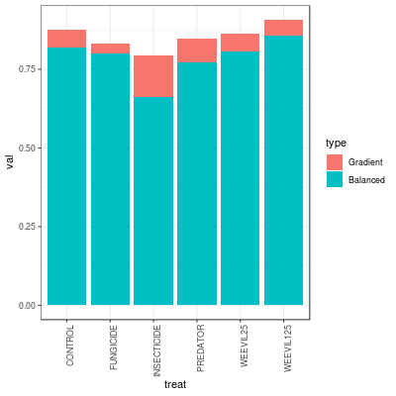Fig S2. Total within-treatment beta diversity values partitioned into turnover (Balanced) and and nestedness (Gradient) variation components.

## *Analysis of the most prevalent species*

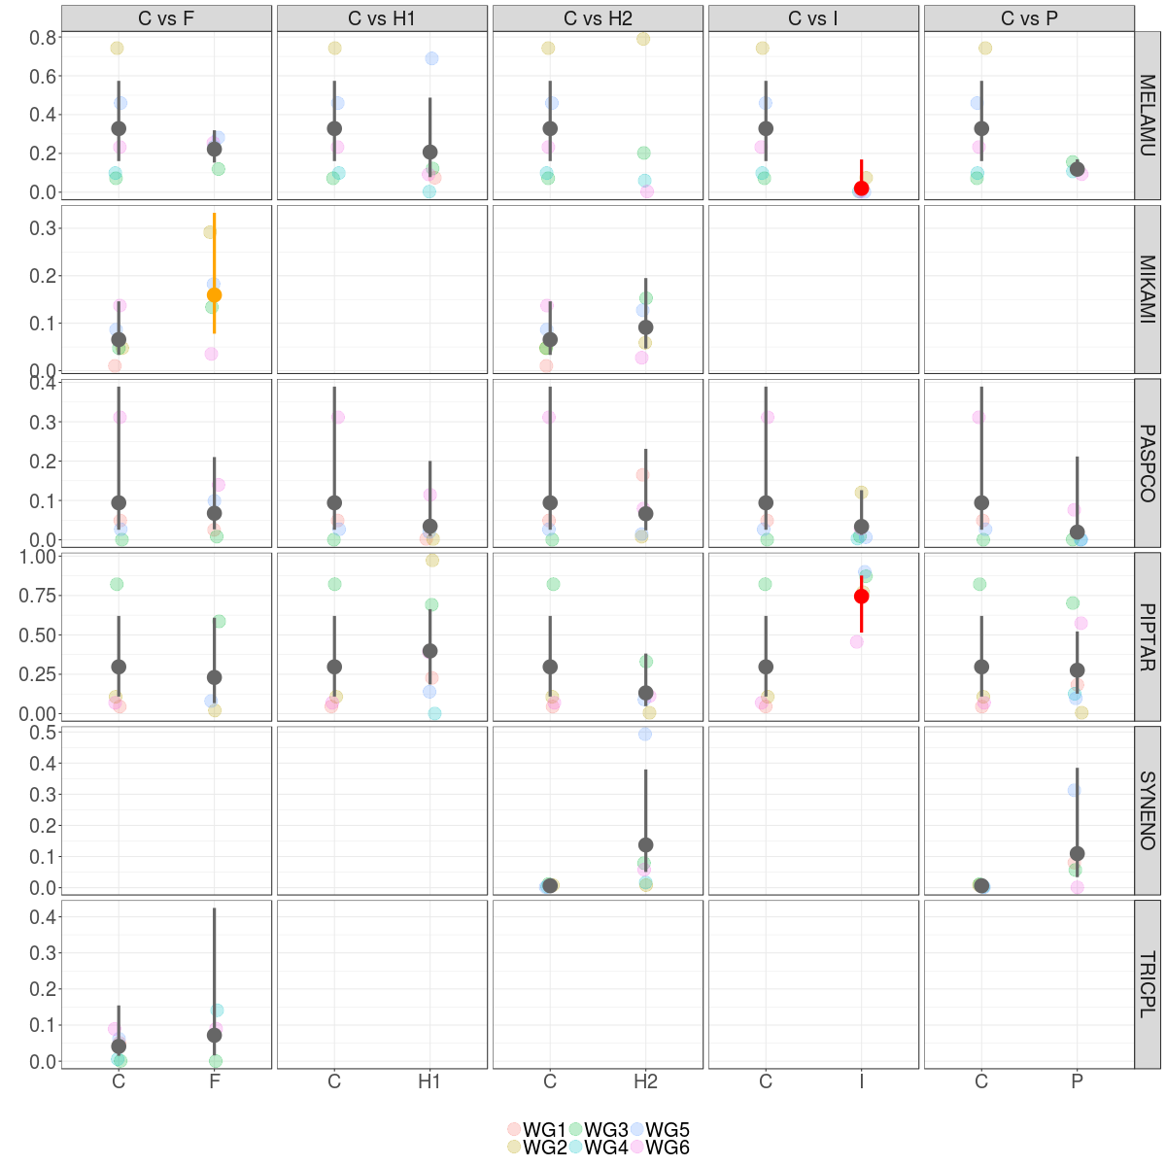

Fig S3. Relative abundance of most prevalent species across exeprimental communities in pairwise comparisons. Maximum likelihood estimaties for the average and 95% CI for the are plotted. Significance of differences were determined using linear model with beta error distribution.

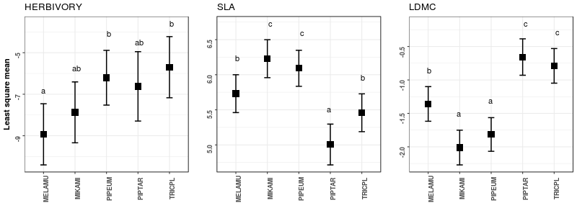Fig. S4. Average trait values evaluated on the control plots for five most prevalent species in our experiments.