**Impact of pathogenic fungi, herbivores and predators have on secondary succession of a tropical rainforest vegetation**

Piotr Szefer1,2, Kenneth Molem3, Austin Sau3, and Vojtech Novotny1,2

1 Faculty of Science, University of South Bohemia, Branišovská 31, 370-05 České Budějovice, Czech Republic.

2 Institute of Entomology, Biology Centre, Czech Academy of Sciences, České Budějovice, Czech Republic

3 New Guinea Binatang Research Center, Madang, Papua New Guinea

**Key Words**: secondary forest, tropics, Papua New Guinea, insect herbivory, pathogenic fungi, predator exclosures, successional dynamics, top down factors, food webs.

**Abstract**

1. Successional theories emphasizes plant performance and competitive ability as key drivers of early successional dynamics, in contrast to top-down biotic factors maintaining plant diversity in mature tropical forests.

2. Here we are testing, for the first time, the effects of food web interactions on the early successional dynamics in a lowland tropical forest in Papua New Guinea. On 36 vegetation plots (25 sq. meters) we initiated secondary succession and for one year experimentally manipulated insect herbivores, fungal pathogens and predators using broad spectrum insecticides, fungicides, predator exclosures and herbivore introductions.

3. Insects were responsible for increased diversity and total biomass of the community in early successional stages of tropical rainforest. Nonetheless, increasing pressure of generalist herbivores didn’t further amplify that effects result and their strong pressure caused biomass to decrease. Fungal pathogens increase abundance, measured as stem density, of woody plants. Presence of both insects and top predators increased predictability of community assembly processes possibly through decrease in number of random events during community assembly processes.

*4. Synthesis*. In early successional communities, as opposed to primary forests, insects control biomass and community composition. Simplified or disturbed aboveground insect communities and their predators can increase randomness of the community assembly processes, which potentially can slow down regeneration of tropical forests. On the other hand, importance of pathogenic fungi may increase later in the succession.

**Introduction**

Ecological succession is one of the few complex, community-level processes that are underpinned by ecological theory allowing us to predict, to some extent, its trajectory, both in terms of species composition and species traits of secondary vs. primary forest species (Turner 2001). Deterministic, rule based succession is believed to be driven mainly by inter-specific competition and environmental filtering (van Breugel et al. 2012, Asefa et al. 2017, Craven et al. 2018). Forest regeneration patterns are thus hypothesized to be mainly shaped by plant traits and abiotic conditions (Yamamoto 2000, Schnitzer & Bongers 2002), while the effect of top-down biotic interactions is rarely considered. This situation is in sharp contrast with increasing attention paid to top-down control of plant composition in primary tropical forest. The Janzen-Connell hypothesis suggest that diversity of these forests could be maintained by the density-dependent mortality by plant pathogens and herbivores (Janzen 1970, Connell 1971). In tropical forests herbivorous insects (Gillet 1962), their predators (Richards & Coley 2007) and pathogenic fungi (Augspurger 1983, Clark & Clark 1989) are ubiquitous, abundant and are known to have the ability to affect plant population dynamics and ecosystem processes (Crawley 1989). Recent manipulative experiments in Neotropical old-growth forest have shown that pathogenic fungi, acting at the seedling stage, are important density-dependent mortality agents. Herbivorous insects were able to affect community compositon, but they were killing seedlings independently of their density (Bagchi et al 2010, 2014). To our knowledge there are no studies extending these experiments to the effects of predators despite the fact that the importance of trophic cascades is well recognized in tropical forests (Letourneau et al 1998, Milton and Kaspari 2007, Leles et al. 2017).

Early successional communities assemble under specific ecological conditions: they arise as a result of unpredictable disturbance and for a short period of time offer environment with high light intensity, often also high mineral resources, and free from competition by other plants. This leads to environmental filtering for pioneer plant species with species traits maximizing dispersal and growth rate at the expense of anti-herbivore defences (Coley et al. 1985, Denslow 1987, Herms & Mattson 1992). Therefore, pool of early successional species is relatively small and more closely related phylogenetically than expected by chance (Norden 2009, Whitfeld et al. 2012).

Herbivorous insects are more abundant on secondary than primary forest vegetation because of the higher abundance of more palatable and poorly defended young foliage (Lepš et al. 2001, Whitfeld et al. 2012). On the other hand pathogenic fungi, potential density-dependent mortality factors, have higher infection rates in shade tolerant species (García-Guzmán & Heil 2014). Mobile natural enemies, like bats and birds, tend to follow more abundant prey into the canopy gaps (Richards & Coley 2007). Importantly, the impact of pathogens, herbivores, or predators on plants cannot be inferred solely from the frequency of trophic interactions. For instance, high herbivory could be compensated by fast growing pioneer species, but not slow-growing primary forest species (Trumble et al. 1993, Strauss and Agrawal 1999). Manipulative experiments are therefore key approach to assess the importance of top-down biotic information on plants.

In the course of secondary succession specific leaf area (SLA) tends to decrease and leaf dry-matter content (LDMC) to increase (Buzzard et al. 2015, Boukili & Chazdon 2016). High community weighted mean (CWM) SLA values and low LDMC values often indicate low competitive pressure within the community (Kunstler et al. 2016). So far, these traits have been evaluated in terms of their performance in plant competition, (Lasky et al. 2014), but the impact of plant-based food webs on the functional trait composition in plant communities has not been examined yet.

Even low variability in environmental conditions often leads to alternative, divergent successional pathways (Mesquita et al. 2001, Suding et al. 2004, Williamson et al. 2012). The unpredictability is assigned to random, neutral dynamics (Hubbel 2001) including colonization, extinction and ecological drift. Some of these random changes in the structure of early successional plant communities may persist for decades (Saldarriaga et al. 1988). These trajectories often lead to significant differences in community structure (Norden et al. 2015), species composition (Guariguata & Ostertag 2001, Barlow et al. 2007) and species turnover rates (Mesquita et al. 2015), therefore, making prediction of successional outcome a challenging task. Whether biotic factors can increase predictability of succession hasn’t been evaluated yet for secondary tropical rainforests.

In this paper we experimentally test the general hypothesis that above-ground biotic factors: fungal pathogens, insect herbivores and predators can have significant impact on the initial secondary succession of tropical rainforest vegetation. More specifically, we hypothesise that herbivores control productivity, richness and composition of the early successional plant community through stabilizing effects on the community (Chesson 2000). Contrarily predators could, by limiting herbivores abundance, cause simplifications in community composition. We also test if we would be able to further magnify these impacts of herbivores by increasing abundance of generalist herbivores under no predatory pressure. Impact of pathogenic fungi, at least for the initial stages of secondary succession, may be weaker than in primary forest because of the unfavourable micro-climatic conditions, but we consider this treatment as important in the view of their importance in primary forests. Finally we hypothesize that the biotic factors, by responding to the initial plant composition, determined mostly by dispersal, can in predictable manner shift succession trajectories by increasing determinism in community assembly process.

**Materials and methods**

*Study sites*

The experiment was conducted in tropical rainforest surrounding the Wanang vilage (145°5′32″E, 5°14′26″S) located in the Wanang Conservation Area in the Ramu River basin, Madang Province, Papua New Guinea. The climate in the region is humid, with a mild dry season from July to September. Annual rainfall averages at around 3500 mm and mean monthly temperature is 26°C (McAlpine et al. 1983). The study was conducted in abandoned food gardens created during slash-and-burn subsistence agriculture within the primary forest matrix. Abandoned gardens originate from forest patches cleared for cultivation. The cleared vegetation is burned, gardens planted with mixed crops and after a few harvests, typically after two years, gardens are abandoned and left to spontaneous forest regeneration, thus creating an excellent opportunity to study secondary succession. Old abandoned gardens have open canopy and mostly undisturbed seed bank, required for a secondary growth to initiate. The forest regeneration follows the same trajectory as that in the nearby natural forest tree gaps (pers. obs.). Moreover, the lack of tillage, usage of pesticides or fertilizers during cultivation leaves soil properties and microbial biomass unchanged, making local conditions practically indistinguishable form soil in naturally created forest gaps (Kukla et al. in press).

*Experimental design*

Within the radius of three km from the center of the village we selected six experimental blocks (gardens) 3-5 years old, each covering an area of approximately 400 m2, with minimal distance of 200 m between blocks. Within each block we cleared all aboveground vegetation and removed all the rocks and dead wood in order to keep exposed bare soil in >95% of the plot area. We also removed all tree stumps and tree roots from top 30 cm of soil to prevent re-sprouting. These initial preparations should not have an effect on the seed bank and soil conditions (Chazdon 2014). Within each block six 5x5 m experimental plots were established, resulting in 36 experimental plots (6 plots within each of 6 blocks). We separated the plots by at least one meter and established also three meter cleared margins around the block to minimize edge effects. Control plot and five experimental treatments were randomly assigned to plots within each block according to the randomized complete block (RCB) design. Following treatments were applied continuously for 12 months:

1. Control (C) and was sprayed weekly with appropriate amount of water. The plot was surrounded by a 0.5 m high dummy plastic fence with a gap left at the ground level to allow easy access to insect herbivores, lizards and rodents, in order to simulate possible effect of fencing used in I, P, H1 and H2 treatments (see below) on plants.

2. Exclusion of pathogenic fungi (F). To reduce infections by wide range of fungal pathogens, contact fungicide mancozeb (12.5 g soluble powder per 5l, commercial name: Mancozeb) was applied on above ground plants according to manufacturer’s instructions at weekly intervals. A dummy fence was used as in C.

3. Herbivorous insect exclusion (I). To achieve both systemic and non-systemic protection we applied two types of broad spectrum insecticides: lambda cychalothrin (5 ml per 5l, commercial name: Thunder) and imidacloprid (1.5ml per 5l**,** commercial name: Mustang). Because of intensive vegetation growth insecticide applications were repeated every week according to the manufacturer’s instructions. The plot was surrounded by a 50 cm high plastic fence that continued 20 cm below the ground. Insect glue (tanglefoot) was repeatedly applied on the top of the fence. The fence prevented colonization by crawling insects.

4. Exclusion of predatory ants, insectivorous birds, and bats (P). Transparent fishing net (1.5-2.0 cm mesh size) was secured over the plot to protect vegetation from foraging birds and bats. Further, we used poisonous tuna baits (Permethrin 0.5%) exposed inside the plot in monthly intervals to reduce ants as key insect predators. The plot was surrounded by the plastic fence as in the treatment I to prevent ants from re-colonizing the plot.

5. Increased herbivory – moderate (H1). We used locally common, highly polyphagous and flightless *Oribius* sp. weevils to increase herbivory pressure within the plot. Weevils from this genus were previously documented from the local secondary vegetation and their wide polyphagy was established by feeding tests [Supplementary Information - Vojta] . Every two weeks, 25 weevils were collected in surrounding forest, starved for 24 hours and released into the plot to sustain their population size. Plots were additionally protected from predators with exclosures (see treatment P), and fenced with insect glue applied on the top of the fence to prevent weevils from dispersing on the remaining plots.

6. Increased herbivory – high (H2). The same treatment was applied as above but with 125 *Oribius* sp. weevils per plot introduced every two weeks.

*Sampling*

After 12 months of undisturbed growth complete above ground vegetation from all 36 plots was destructively sampled. At each plot all plant species were sorted and identified to species and weighed with 1 g accuracy. During sampling we also counted and measured all the stems with diameter at breast height (DBH) ≥1cm. We calculated leaf area by randomly picking leaves from a pool of all available leaves for a given species at a given plot until we filled a 50x50 cm area (“leaf frame”) with leaves that was photographed and processed using ImageJ software (Schneider et al. 2012) to obtain complete leaf area and its estimated loss due to insect feeding. Herbivory was expressed as the proportion of the leaf area consumed by herbivores. The leaf samples were then oven dried, weighted and leaf dry matter content (LDMC) was estimated. We obtained measurements of specific leaf area (SLA) by dividing leaf area by its dry mass. In the text we will always use community community-weighted means (CWM) for LDMC and SLA values, where each species is weighted by its biomass.

*Data analysis*

To compare different community descriptors of our treatment plots to the control we used generalized linear mixed models with blocks (garden) treated as a random factor. We modelled logarithm of the total biomass of the plots and traits using *lmer* function. LDMC values were logit transformed, and SLA log transformed prior to the analyses to obtain Gaussian error distributions. For the number of species within the plot we used Poisson distribution and function *glmer*. Due to over-dispersion we modelled number of stems per plot using the negative binomial distribution, and estimated parameters of the model using *glmer.nb* function. All the above analysis were performed in R (R Core Team 2018) using lme4 package (Bates et al. 2015). For the above analyses we obtained p-values for our comparisons with control plot we used *lmerTest* package (Kuznetsova et al. 2017).

To test if our treatments significantly affected community composition we used RDA ordination conditioned on block as implemented in vegan package (Oksanen et al. 2016). Significance of differences were assessed by permutation tests (999 randomizations) preserving the random structure of blocks determined by the experimental design. Because of differences in local biomass of plant communities between locations we standardized individual plant biomass by total biomass of the community within each plot.

To determine if the relative importance of random and deterministic processes during community assembly was affected by our treatments we used null model approach proposed by Chase et al. (2011), initially modified by Stegen et al. (2013) and further by Alberti et al. (2017) to account for species abundance. In our case we adapted this procedure to species’ biomass instead of number of individuals [I should try to run these models using individual dbh and not biomass] . We also modified previous approaches further and performed randomizations for each pair of control and treatment plant communities. It ensured that plots with experimental treatments (30 plots vs. 6 control plots) would not be over-represented in the randomization procedure. Therefore, we sub-setted full community dataset to 12 plots (six control plots and six treatment plots) for each of the five different comparisons between control plot and experimental treatments. For any given pair of plots plant communities from control and treatment plots were randomly assembled using following constraints: (1) For a given plot the number of species and total biomass in randomly assembled community was restricted to their observed values. (2) Probability of sampling given species was calculated based on occurrence frequencies in all plots (sum of occurrences within a plot across all 12 plots for a given pair of control and treatment blocks) for a given pair of treatments. To randomly assemble a community instead of individuals [I should sample individuals until biomass/total dbh value is achieved!] we were sampling units of biomass equal to 1g, the lowest biomass measured in our plots. [will results change if I increase this value?] (3) Cumulative biomass for a given plot was set to be equal to the empirical biomass collected from that plot and (4) the probability of increasing biomass of a given species in a community by one unit was proportional to the relative biomass of that species across all 12 plots for a given control and treatment combination. For each pair of plots random assembly process was repeated 999 times and at each randomization Bray-Curtis (BC) dissimilarity of randomized communities was calculated to quantify compositional turnover. These randomized BC values were then compared to the empirically observed similarity values for a given pair of plots. Next we calculated proportion of iterations, where the BC index was smaller or equal to its empirical value. To obtain Raup–Crick index we subtracted 0.5 from that proportion and divided this difference by two, so that it ranges from a negative one to one (Chase et al. 2011). This index has a useful interpretation as it indicates whether a pair of plots is less similar, or as similar as the community composition expected by chance. It therefore can be used to measures importance of deterministic processes in community assembly process and values close to negative one show that community is assembled in a deterministic and convergent fashion, whereas values of RC close to 1 are driven also by deterministic but divergent processes. By following procedure developed in Alberti et al. (2017), we tested if treatments had an effect on community assembly process using linear mixed models. We averaged Raup-Crick values for all of the comparison of that plot with all the other plots of the same treatment to be the response (five comparisons for each replicated treatment, i.e.: 1 vs. 2, 1vs. 3, 1 vs. 4, 1 vs. 5, 1 vs. 6). We used treatment as a fixed effect, block as a random effect and performed our analysis using *lmer* function as described above and we used likelihood ratios to test the significant differences between the control and treatment plots. BC index of dissimilarity was calculated using *vegdist* function from vegan package.

**Results**

After one year of growth, richness across all experimental plots amounted to 96 plant species (Table S1), with 40 woody species. One insecticide treated plot was overgrown by a *Calopogonium mucunoides* Desv. vine making up to 72% of the total biomass of the plot. This plot was treated as an outlier and was removed from analyses.

Average biomass per plot was 82.156 kg (CI: 46.81516, 144.175). Most abundant species included *Trema orientalis*, *Melanolepis multiglandulosa* and *Pipturus argenteus*. Highest biomass, nearly 129 kg, was reached by Melochia sp. 1. From non-woody plants vein *Mikania micrantha* had highest biomass among the control plots (Figure S1). However, this species was present only at one block. We observed high variability in community composition between blocks. Average Bray-Curtis dissimilarity of the above-ground community on control plots was 0.8 with minimum and maximum 0.42 and 0.99, respectively and similarly (mean 0.81, minimum 0.39 and maximum 0.99) for woody species communities.

High herbivory increase (H2) was the only treatment able to significantly decrease plant biomass (Fig. 1) both in the whole community and the woody plants (t-value = -3.594, P = 0.001 and t-value = -3.576, P = 0.001 respectively), therefore on figure 1 we plotted only values for the whole community. This treatment also significantly reduced the number of stems per plot (t-value = -6.707, P < 0.001). Similarly woody plants density was lower at fungicide (F) treated plots (z-value = -2.507, P = 0.012). Insecticide (I) treated plots had lower number of species per plot (t-value = -2.291, p = 0.031) and lower diversity measured by Shannon’s H’ (T value = -2.543, P = 0.018) in the whole plant community. Moreover, insecticide caused increase in LDMC (t-value = 2.228, p = 0.035) and the decrease in SLA was marginally significant (t-value = -1.991, p = 0.058). Similar pattern for LDMC was observed for woody plant community (t-value = 2.071, p = 0.049). No other treatment had significant effect on evenness or richness of experimental communities.

Only insecticide treatment (I) altered the species composition of the entire vegetation (Fig X, F=3.135 p = 0.019) resulting in shift in the dominance structure comparing to control (Supplementary Information, Fig. S2 [individual treatment community compositions]). Similar effect on woody plant community was only marginally significant (F=…, p = ...). No significance was found for other treatments, however, high increase in herbivory pressure effect was marginally significant. Composition was highly variable which resulted in R2 ~ 15%. Significant shifts in community composition was mainly caused by consistent decrease in relative abundance of *Melanolepis multiglandulosa* and *Pipturus umbellatum (Fig 4.)*. For most of the species we can observe interaction effects, however it is difficult to test them with a small sample size available. In our experiments *P. argenteus* suffered greater herbivory across control plots than *M. multiglandulosa* ([paired t test? No! mixed effect model with individuals as a response?] Supplementary Information, Fig. S4). High herbivory pressure (H2) had an effect opposite to the insecticide treatment and was marginally significant only for the full community (F = 2.017, P = 0.052). In our data high increase in abundance of *Oribius* sp. caused shift in plant community composition which resulted in increased abundance of *M. multiglandulosa* which was otherwise losing in competition with *P. argenteus* on insecticide treated plots (Fig. 2), whereas *Melochia* sp. Showed increased abundance on H1 plots.

The RC dissimilarity values among the control plots showed highly variable, but non-random composition (Fig. 4). When these values were compared with RC dissimilarity within plots for each treatment, none of the treatment had an effect on the entire community, but the insecticide treatment (χ2 = 3.892, P = 0.048) and predator exclusion (χ2 = 4.923, P = 0.026) significantly decreased within treatment dissimilarity and increased randomness of community assembly (mean RC index values closer to zero) for woody plants (Fig. 4).

*The idea of d-d effect is interesting and Fig S3 should be discussed but for predator and insecticide treatment; if you want to discuss all plants then you have to show the graphs] Tentative exploration of this pattern in our data showed that species most abundant in the control plots were also the ones suffering highest biomass losses in plots, where predators were removed (Supplementary Information, Fig. S2 and S3 [i should make one graph with two regression lines]).*

**Discussion**

Our study shows that invertebrate herbivores, their predators (birds, bats and ants) and fungal pathogens, influence early successional rainforest vegetation in lowland Papua New Guinea. Our hypothesis that herbivorous insects control biomass, species richness and diversity of plant community, was partially supported by our results. Our experimental application of insecticide had, similarly to the results from the primary forest (Bagchi et al. 2014), strong effect on the plant community composition. Kempel et al. (2015) argued that this can be driven by preferences of invertebrate herbivores. Similarly to our results previous studies showed that herbivorous insects preferred *P. argenteus* (Basset 1996) over *M. multiglandulosa* (Novotny et al. 2004). Insecticide treatment was also responsible for decreased richness, diversity and evenness of our experimental plant communities, which is in agreement with majority of large herbivore exclusion experiments from temperate grasslands (Stein et al. 2010, Mortensen et al. 2017, Jia et al. 2018). The mechanism responsible for these patterns has been proposed by Agrawal et al. (2012). He showed that when herbivores were removed, plant competition intensified and led to higher dominance of a few competitively superior plant species. Low SLA and high LDMC are characteristic for plant communities driven by strong interspecific competition (Kunstler et al. 2016). Even though we found some support for this hypothesis in increased values of LDMC, results for SLA decrease was only marginally significant. Somewhat unexpectedly, herbivore removal had no effect on stem density or biomass. Herbivore removal experiments in the tropics usually result in higher biomass and abundance of plants (Jia et al. 2018). However, successional theory can predict no effect of herbivores on the biomass of pioneer stages if plants would attempt to maximize their growth in competition for light and, in accordance with resource availability hypothesis (Coley et al. 1985), they can compensate for biomass loss due to herbivores (Maron et al. 2014).

Predictably, artificially increased herbivory led to lower biomass, lower stem density and higher herbivory in woody plants, although only for the high level of additional herbivores. Interestingly, this large structural change did not indicated a response in species richness, diversity and evenness. The fact that two levels of artificial increase of herbivory had no effect on richness, diversity nor evenness may confirm conclusions based on simple simulations performed by Freckleton and Lewis (2006) which showed that density dependence caused by generalist natural enemies acting through total community density, as opposed to individual species density, would not affects richness, diversity and evenness. We show here that this might be the case at least for insect herbivores in the early successional tree communities in the tropics with increase ~5 and ~10 fold having respectively low and high impact on biomass and abundance. Nevertheless, it is difficult to explain marginally significant decrease in richness and evenness of the whole community on moderate herbivory increase plots.

As discussed in review by Mooney et al. (2010) effects of vertebrate predators on plant communities are stronger, whenever predaceous arthropods are abundant and there is a strong intra-guild predation. However, decrease in plant biomass was only marginally significant and that effect was not present in the woody plant community. The lack of effects on plant biomass from the focal predators that partially reduce herbivores is not surprising considering that even the complete removal of insect herbivores in the insecticide treatment did not have such effect. Another possible explanation is that the high abilities of pioneer trees to compensate for herbivory damage, as well as higher abundance of species least attractive to herbivores (e.g. *M. multiglandulosa*, Fig. S4), may cause biomasses of experimental communities not to differ greatly from those in the control plots. Moreover, Schmitz et al. (2000) argued that top-down effects of predators are more likely to be present in communities where plants have anti-herbivore defences. In our experiment, even though some level of variation in herbivore defences can be observed, in general we would not expect them to be strong (Kardol et al 2006, Lasky et al. 2014).

No effect on community composition in case of pathogenic fungi removal might confirm our predictions of their generally smaller role early in the succession. Fungal pathogens can drive species turnover through accumulation of host specific pathogens in time (Kardol et al. 2006). For example Mangan et al. (2010) showed that old-growth forest dynamics are driven by plants-soil feedbacks mediated by pathogenic fungi. This may suggest that stronger effects of fungal pathogens can be expected later in the succession, where there are more mature leaves and environmental conditions facilitating fungal infections (Marquis et al. 2001). Effect of pathogenic fungi on community richness might not be noticable also in the situation where dominant pathogens are generalists (Freckleton & Lewis 2006), which is a safe prediction for an early successional plant communities (Koziol & Bever 2016) as specialists usually accumulate in the community later (Pandit et al. 2009, Novotny et al. 2010). Low host specificity of pathogenic fungi might be the case in our experiment as we found that fungicide application decreased significantly the number of stems within the plot, similarly to predator exclusion (P) and generalist herbivore (H2) treatments, where increased abundances of generalist herbivores are assumed to take place.

RC values at the control plots revealed that species composition of the communities showed higher than random variability between sites (divergent but deterministic community composition). This result confirms predictions that in highly productive plant communities growing in nutrient rich environment would show deterministic but divergent assembly processes due to priority effects (Chase and Liebold 2002, Chalcraft et al 2004, Chase 2010). The RC values for communities without herbivores and with predators excluded were closer to zero, similarly as in herbivore exclosures from grassland communities (Alberti et al. 2017). More random community assembly with suppressed herbivores might be caused by random colonization of the plots by plant species from the forest matrix. In case of predators exclusion Chase et al. (2009) argued that abundant consumers, in our case herbivorous insects, can increase stochasticity during community assembly process by decreasing number of individuals in the community, and boost their chance of local extinction. We found partial support for this hypothesis in our data, where we observed lower number of stems in plots without predators. Fungicide treatment did not increase randomness of the community assembly processes despite their negative effect on stem density. Mordecai (2011) presented two hypotheses for pathogenic fungi diversity promoting mechanisms, which would produce similar patterns to the ones observed in our data: (1) reduction of fitness differences between pioneer trees and (2) changing the competitive structure between species. Second explanation is less probable as it should also result in significant and consistent changes in plant community structure. Therefore, we conclude that pathogenic fungi promote richness through differential effects on dominant plant species, where abundant species experience negative feedback, and rare species are positively affected or are neutral to fungal infections. Additionally, fungal infection can change herbivore preferences and performance on infected plants (Fernandez-Conradi et al. 2018), which introduces another level of complexity to fungi-plant-herbivore interactions.

Despite our considerable effort to [keep the treatments true] few pitfalls regarding our methods were identified. Our evaluation of the ant abundance performed on the ground, did not show significant decrease within predatry exclusion plots compared with the control. Despite that, during plant sampling we generally observed low abundance of small sized, non-predatory canopy ants.

Important side effect of mancozeb is that it can accumulate in soil and may have negative effects on ammonification and nitrification (Walia et al 2014). However we expected that these undesirable effect would be minimized due to short half-life times of this compound (Xu 2000) and easy biodegradability in tropical soil conditions (Racke et al 1997). Also netting used to build exclosure might have boosted web building spiders abundances in an addition to the general increase of arachnids abundance under their natural enemies suppression. Exclosure frames might provide base for building webs by spiders, which were not sampled when exclosures were removed. Number of blocks used for the experiments was limited by suitable locations available and our abilities to maintain and sample them. Therefore, some effects may have not been detected and increased sample size could result in higher statistical power of performed tests.

Our results point out on an important role of local scale interaction web of pathogenic fungi, predators and herbivorous insects for an initial successional processes and for shaping future community composition. It also identifies potential factors which can be used to decrease the high unpredictability of successional trajectories found in empirical data. From our results we can conclude that without a rich network of consumers successful regeneration of plant communities may be inhibited and importance of random contingent effects during assembly processes increase. We show that in tropics biotic factors have the ability to change the competitive structure within regenerating communities, resulting in secondary effects on the community composition. For the understudied initial succession of tropical rain forest we described various complex effects of biotic factors involved and having potential to affect later stages of succession, form which herbivorous insects proved to take part in shaping major characteristics of the stucture and diversity. Pathogenic fungi, previously identified as important factors in shaping diversity of primary forests, can gain on importance later in the succession, when the canopy formation would dominate and micro-climatic conditions change. To get deeper insight into mechanisms at place and to validate above-stated hypotheses additional information on seed rain, mortality of newly established seedlings in the route of succession would have to be collected. Detailed demographical data combined with information on individual species competitive abilities and functional traits, including soil biota, all tested in greenhouse experiments would allow for better understanding of exact mechanisms of biotic control of successional communities and possibly in the future better understand how can we facilitate more effective regeneration of tropical forests. Another, natural step forward would be to study these biotic factors in combination to identify possible complementary effects on plant composition and succession.

**Acknowledgments**

Tereza Holicova for processing leaf frames data. Jan Leps, Juan Alberti and Leonardo Re Jorge for useful discussions, Binatang Rerearch Center staff in Papua New Guinea for support during field work. Grants: GACR 17-23862S and the ERC grant 669609 to VN.

**Authors’ contribution**

VN and PS conceived the ideas and designed methodology; KM, AS and PS managed experiments and collected the data; KM identified plants; PS analysed the data and led the writing of the manuscript. All authors contributed critically to the drafts and gave final approval for publication.

**References**

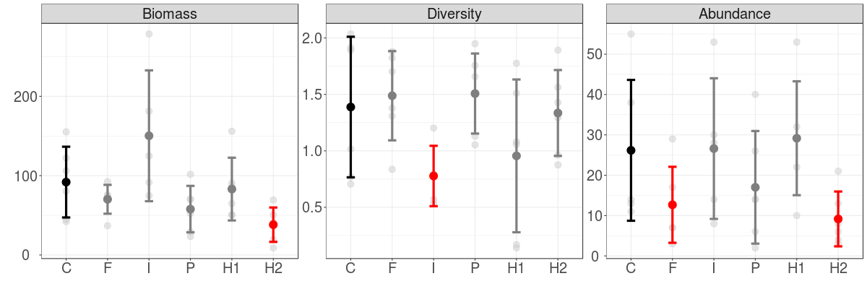

Figure 1. Community descriptors based on all species present in the experimental plot from Wanang. Red colour indicates that the mean for a treatment is significantly different from the control at the alpha = 0.05 level. Biomass is measured in kilograms. To evaluate diversity of vegetation plots we used Shannon’s index. Abundance represents number of stems above one cm DBH per plot. C – control, F – fungicide, I – insecticide, H1 – moderate increase in herbivory pressure, H2 – high increase in herbivory pressure.

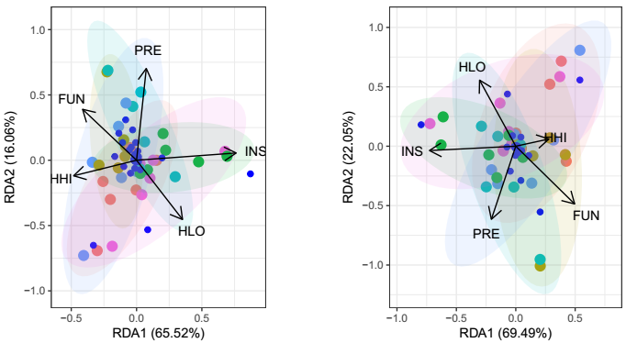

Figure 3. Redundancy analysis of the plant biomass data, conditioned on their blocks. Results for the whole community (A) and woody species (B). [explain percentages meaning, add names for the main species, remove blue dots representing them]

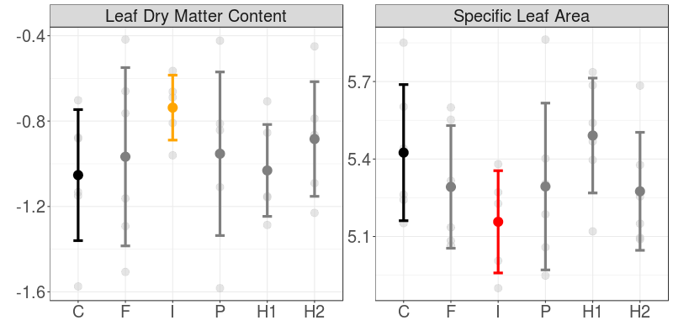

Figure 2. Community weighted means of measured leaf traits for the whole community and for the woody plant species. Grey point represents experimental plot overgrown by *Callopogonium mucunoides*, and was excluded from the analyses. Values of LDMC and herbivory are logit transformed, and SLA are log transformed.

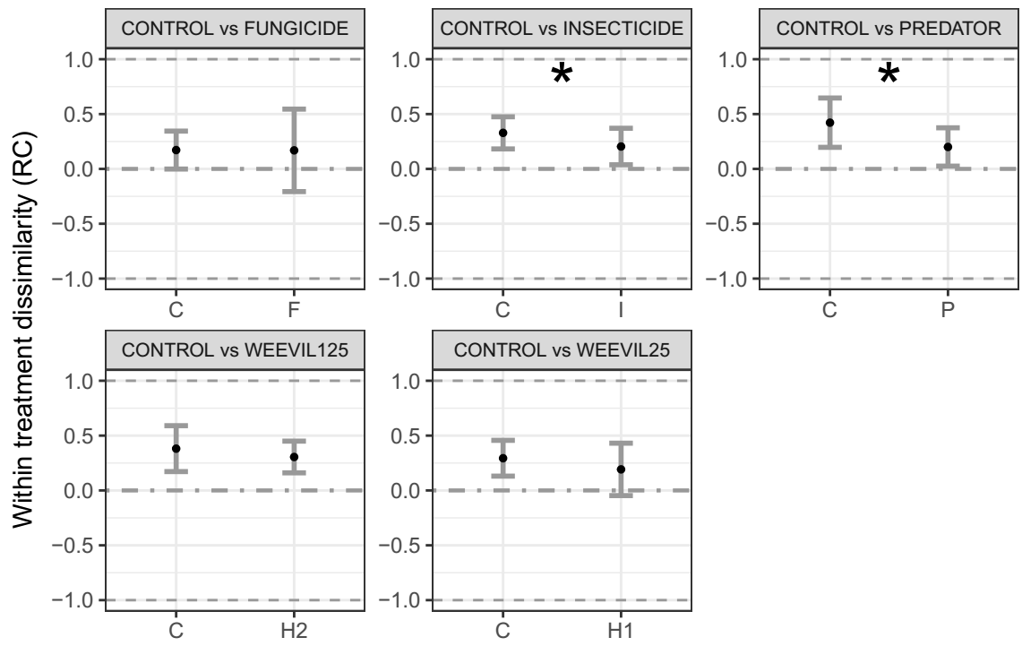

Fig 4. [plot only significant ones?]Within treatment dissimilarity (mean ± SE) according to a modified Raup-Crick dissimilarity metric (RC) for the woody plant community (no significant differences were found for the whole community). This metric ranges from -1 to 1, indicating whether a pair of plots are more similar (approaching 1), , or less similar (approaching -1) than expected by chance. Dashed horizontal line denotes a stochastic community assembly. Asterisks denote significant differences between treatments (P<0.05). The whole plant community including also herbaceous vegetation and grasses are shown in the Supplementary Information.