**Impact of pathogenic fungi, herbivores and predators on secondary succession of tropical rainforest vegetation**

Piotr Szefer1,2, Kenneth Molem3, Austin Sau3, and Vojtech Novotny1,2

1 Faculty of Science, University of South Bohemia, Branišovská 31, 370-05 České Budějovice, Czech Republic.

2 Institute of Entomology, Biology Centre, Czech Academy of Sciences, České Budějovice, Czech Republic

3 New Guinea Binatang Research Center, Madang, Papua New Guinea

**Abstract**

1. Successional theories emphasize plant performance and competitive abilities as key drivers of early successional dynamics, in contrast to top-down biotic factors maintaining plant diversity in mature tropical forests.

2. Here we are testing, for the first time, the effects of food web interactions on the early successional dynamics in a lowland tropical forest in Papua New Guinea. We initiated secondary succession on 36 vegetation plots (5 x 5m) organized in six blocks and followed successional trajectory in control plots, with experimentally excluded insects by insecticides, fungal pathogens by fungicides, and vertebrate predators by exclosures, and plots with introduced additional generalist herbivores, over the course of one year.

3. Insects were responsible for increased plant diversity, shifts in plant community composition and lower community mean leaf dry matter content. However, experimentally elevated density of generalist herbivores did not have the same diversifying effect, only reduced plant biomass and stem density. No other treatment had a significant effect on plant diversity, biomass or density during succession.

4. Community composition varied greatly between control plots from different experimental blocks. Using null model approach, we showed that the presence of insects and their vertebrate predators increased predictability of community assembly processes for woody plants, whilst the same effect was not found for fungi or additional herbivores.

*4. Synthesis*. The early rainforest succession is not entirely plant-driven. In early successional communities, insects impacted plant diversity, abundance, species and leaf trait community composition. As expected, the early succession trajectories are highly variable, but insects and vertebrate predators can reduce that unpredictability. Simplified or disturbed insect and vertebrate communities can thus impact the regeneration dynamics of tropical forests.

**Key Words**: insect herbivory, Papua New Guinea, pathogenic fungi, predator exclosures, secondary forest, successional dynamics, top down factors, tropics.

**Introduction**

Ecological succession is one of the few complex, community-level processes that are underpinned by ecological theory allowing us to predict its trajectory, including the dynamics of species composition and species functional traits (Turner, 2008). Succession can be seen as an outcome of deterministic, rule-based process driven mainly by inter-specific competition and environmental filtering, acting however on an initial species pool determined by often unpredictable dispersal events (van Breugel et al., 2012; Asefa et al., 2017; Craven et al., 2018). Forest regeneration patterns are thus hypothesized to be mainly shaped by plant traits and abiotic conditions (Yamamoto, 2000; Schnitzer & Bongers, 2002), while the effects of top-down biotic interactions have been rarely considered. This situation is in sharp contrast with increasing attention paid to top-down control of plant community composition in primary tropical forests. The Janzen-Connell hypothesis suggests that the diversity of these forests could be maintained by density-dependent mortality, caused by plant pathogens and herbivores (Janzen, 1970; Connell, 1971). In tropical forests, herbivorous insects (Gillet, 1962), their predators (Richards & Coley, 2007) and pathogenic fungi (Augspurger, 1983; Clark & Clark, 1989) are ubiquitous, abundant and have the ability to affect plant population dynamics and ecosystem processes (Crawley, 1989). Recent manipulative experiments in Neotropical old-growth forest have shown that pathogenic fungi, acting at the seedling stage, are important density-dependent mortality agents. Herbivorous insects were able to affect community composition, but they were killing seedlings independently of their density (Bagchi et al., 2010; 2014). To our knowledge, there are no studies extending manipulative experiments to key predators of herbivores despite the fact that the importance of trophic cascades in tropical forests is well recognized (Letourneau et al., 1998; Milton & Kaspari, 2007; Leles et al., 2017).

Early successional communities assemble under specific ecological conditions: they arise as a result of unpredictable disturbance and, for a short period of time, offer an environment rich in sunlight, often rich in mineral resources, and with competition-free space. This environmental filtering favours traits that maximize dispersal and growth rate at the expense of anti-herbivore defences (Coley et al., 1985; Denslow, 1987; Herms & Mattson, 1992). Therefore, the pool of early successional species is relatively small and more closely related phylogenetically than expected by chance (Norden, 2009; Whitfeld et al., 2012). This can have important implications for the structure of interactions with their natural enemies.

Herbivorous insects reach higher density on secondary than primary forest foliage because of the higher abundance of more palatable and poorly defended young foliage in secondary forests (Lepš et al., 2001; Whitfeld et al., 2012). In contrast, pathogenic fungi, potential density-dependent mortality factors, have higher infection rates in shade tolerant species (García-Guzmán & Heil, 2014). Mobile predators, including bats and birds, tend to follow more abundant prey into the canopy gaps (Richards & Coley, 2007). Importantly, the impact of pathogens, herbivores, or predators on plants cannot be inferred solely from the frequency of trophic interactions. For instance, high herbivory could be compensated for by fast growing pioneer species, but not slow-growing primary forest species (Trumble et al., 1993; Strauss & Agrawal, 1999). Manipulative experiments are therefore key for assessing the importance of top-down biotic factors on plants.

In the course of secondary succession, specific leaf area (SLA) tends to decrease and leaf dry-matter content (LDMC) tends to increase (Buzzard et al., 2015; Boukili & Chazdon, 2016). High community weighted mean (CWM) SLA values and low LDMC values often indicate low competitive pressure within the community (Kunstler et al., 2016). So far, these traits were shown to be connected to plant competition (Lasky et al., 2014), but their role in mediating plant community responses to biotic factors such as herbivory during succession has not been examined.

Even under uniform environmental conditions succession can progress by alternative, divergent pathways (Mesquita et al., 2001; Suding et al., 2004; Williamson et al., 2012). This unpredictability is assigned to random, neutral dynamics (Hubbel, 2001) including colonization, extinction, and ecological drift. Some of these random changes in the structure of early successional plant communities may persist for decades (Saldarriaga et al., 1988). Early changes in successional trajectories often lead to significant differences in community structure (Norden et al., 2015), species composition (Guariguata & Ostertag, 2001; Barlow et al., 2007), and species turnover rates (Mesquita et al., 2015). Therefore, making predictions on the outcome of successional processes is a challenging task. In theory, Janzen-Connell type of density dependent response by herbivores and/or their predators can increase the predictability of succession, but this hypothesis has yet to be tested in secondary tropical rainforests.

In this paper we experimentally test the hypothesis that above-ground biotic factors (fungal pathogens, insect herbivores, and predators) can have significant impact on the direction of initial secondary succession of tropical rainforest vegetation. More specifically, we hypothesise that herbivores control productivity, richness, and composition of the early successional plant community by mitigating inter-specific competition between plants (Chesson, 2000). Contrarily, predators could, by limiting herbivore abundance, cause simplification of the plant community composition through increased inter-specific competition. We hypothesize that the impact of pathogenic fungi, at least for the initial stages of secondary succession, may be weaker than in primary forest because of the relatively unfavourable micro-climatic conditions and fewer opportunities for seedling infection from conspecific mature trees. Finally, we hypothesize that the biotic factors, by responding to the initial plant composition mostly determined by stochastic dispersal, can shift succession trajectories in a predictable manner by increasing determinism in community assembly processes.

**Materials and methods**

*Study sites*

The experiment was conducted in tropical rainforest surrounding the Wanang village (145°5′32″E, 5°14′26″S) located in the Wanang Conservation Area in the Ramu River basin, Madang Province, Papua New Guinea. The climate in the region is humid, with a mild dry season from July to September. Annual rainfall averages around 3500 mm and the mean annual temperature 26°C (McAlpine et al., 1983). The study was conducted in abandoned food gardens created during slash-and-burn subsistence agriculture within the primary forest matrix. After clearance, vegetation is burned, gardens are planted with mixed crops and after a few harvests (typically after two years) gardens are abandoned and left to spontaneous forest regeneration. This setup creates an excellent opportunity to study secondary succession starting on bare ground. Old abandoned gardens have an open canopy and a mostly undisturbed seed bank, which is required for initiation of secondary growth. The lack of tillage and the lack of pesticide or fertilizer use during cultivation leaves soil properties and microbial biomass unchanged, making local conditions practically indistinguishable from soil in naturally created forest gaps (Kukla et al., 2019). Usually the structure of regenerating forests resembles that of the nearby natural forest tree gaps (Richards et al. 1996).

*Experimental design*

Within a radius of 3 km from the village we selected six experimental gardens (blocks) 3-5 years old, each covering an area of approximately 400 m2, separated by a minimal distance of 200 m. Within each block we cleared all aboveground vegetation and removed all the rocks and dead wood so that bare soil covered ≥95% of each plot. We also removed all tree stumps and tree roots from the top 30 cm of soil to prevent re-sprouting. These initial preparations were shown to have no effect on the seed bank and soil conditions (Chazdon, 2014). Within each block, six 5x5 m experimental plots were established, resulting in 36 experimental plots in total (six plots within each of the six blocks). Individual plots were separated by 1-meter gaps. We also cleared 3-meter margins around each block to minimize edge effects. A control plot and five experimental treatments were randomly assigned within each block according to a randomized design. The following treatments were applied continuously for 12 months:

1. Control (C) was sprayed weekly with an appropriate amount of water to simulate application of pesticides. In order to account for the possible effect of fencing used in I, P, H1 and H2 treatments (see below) a 50 cm high dummy plastic fence with a 10-20 cm gap left at the ground level was built to allow for easy access to crawling insects, lizards, and rodents.

2. Exclusion of pathogenic fungi (F). To reduce infections by a wide range of fungal pathogens, a contact fungicide mancozeb (12.5 g soluble powder per 5l, commercial name: Mancozeb) was applied on above ground plants according to manufacturer instructions at weekly intervals. A dummy fence was also used, as in C.

3. Insect exclusion (I). To achieve both systemic and non-systemic protection we applied two types of broad spectrum insecticides: lambda cychalothrin (5 ml per 5l, commercial name: Thunder) and imidacloprid (1.5ml per 5l**,** commercial name: Mustang). Because of intensive vegetation growth, insecticide applications were repeated every week according to the manufacturer’s instructions. The plot was surrounded by a 50 cm high plastic fence which continued 20 cm below the ground. Insect glue (tanglefoot) was repeatedly applied on the top of the fence to prevent insect colonization.

4. Exclusion of predatory ants, insectivorous birds, and bats (P). A transparent fishing net (1.5-2.0 cm mesh size) was secured over the plot to protect vegetation from foraging birds and bats. To reduce key invertebrate predators – ants – we used poisonous tuna baits (Permethrin 0.5%) exposed in the enclosed traps accessible to ants but not to flying insects (used also in Klimes et al. 2011) inside the plot in monthly intervals. The plot was surrounded by a plastic fence as in treatment I to prevent ants from re-colonizing the plot.

5. Increased herbivory – moderate level (H1). We used locally common, highly polyphagous and flightless *Oribius* sp. weevils to increase herbivory pressure within the plot. Weevils from this genus were previously documented from the local secondary vegetation and their wide polyphagy was established by feeding tests (Supporting Information, Fig. S1). Every two weeks, 25 weevils were collected in surrounding forest, starved for 24 hours and released into the plot every two weeks to sustain their population size. Plots were additionally protected from predators with exclosures (see treatment P) and fenced with insect glue applied on the top of the fence to prevent weevils from dispersing to the remaining plots.

6. Increased herbivory – high level (H2). The same treatment was applied as above but with 125 *Oribius* sp. weevils per plot introduced every two weeks.

*Sampling*

After 12 months of undisturbed growth, the complete above-ground vegetation from all 36 plots was destructively sampled. In each plot, all plant species were sorted and identified to species and weighed with 1g accuracy. During sampling all the stems with diameter at breast height (DBH) ≥1cm were counted and their DBH value measured. Leaf area was calculated by randomly sampling leaves from the pool of all leaves for each species at a given plot until 50x50 cm area (“leaf frame”) was filled. The frame was then photographed and processed using ImageJ software (Schneider et al. 2012). Herbivory, defined as a proportion of leaf area loss due to insect feeding, was obtained by comparing leaf area measured to the total estimated area for intact leaves. Leaf frame samples were then oven dried and weighed, and leaf dry matter content (LDMC) was recorded. The specific leaf area (SLA, in cm2g-1) was calculated as a ratio of leaf area to its dry mass. The community-weighted mean (CWM) was used for LDMC and SLA in the analysis.. CWMs are average trait values where each species’ contribution is weighted by its biomass.

*Data analysis*

All analyses were performed in R (R Core Team, 2018). To evaluate the effects of treatments on various community characteristics, we developed linear and generalized linear mixed-models using the *lme4* package (Bates et al., 2015) where we considered block (garden) as a random factor. We modelled diversity, logarithm of the plot biomass and CWM for traits using *lmer* function. Herbivory and LDMC values were logit-transformed, and SLA values log-transformed prior to the analyses, to obtain Gaussian error distributions. For the number of species within the plot we used Poisson distribution and the function *glmer*. Due to over-dispersion in the data we assumed negative binomial distribution for the stem abundance and estimated parameters of the model using the *glmer.nb* function. For the above analyses we obtained p-values for our models using the *lmerTest* package (Kuznetsova et al., 2017).

We used RDA ordination conditioned on block as implemented in the *vegan* package (Oksanen et al., 2016) to test for differences in community composition. Significance of observed differences were assessed by permutation tests (999 randomizations), while preserving the random structure of blocks determined by the experimental design. Because of the differences in plant community biomass among plots, individual plant biomass was expressed as the proportion of the total biomass of the community. To test for dominance shifts in our communities we selected a few species to compare their relative abundance in control plots and treatment plots. For meaningful comparisons, we chose species which were present in control and treatment plots in at least three blocks, and which on average represented >5% of the community biomass. We compared average proportions for a given species between control and treatment using *betareg* function in the *betareg* package (Cribari-Neto & Zeileis, 2010). To see if there were differences in trait values between species responsible for the community composition shifts, we built a linear mixed-effects model with trait values from the control plots as a response and blocks included as a random effect. For multiple comparisons we used the *lsmeans* and *cdt* functions from the *emmeans* package (Lenth, 2019) with Tukey’s multiplicity adjustment.

To determine if the relative importance of random and deterministic processes during community assembly was affected by our treatments, we used a null model approach proposed by Chase et al. (2011). Instead of using presence-absence data, we adapted the procedure used by Stegen et al. (2013) and later by Alberti et al. (2017) based on species’ biomass. We performed separate randomizations for each of the five control and treatment combinations (i.e. C vs. F, C vs. I, C vs. P, C vs. H1, C vs. H2), each comprising six control and six treatment plots. This way we ensured that the experimental treatment plots (30 plots vs. 6 control plots) were not over-represented in the procedure. We set several constraints to the random community assembly process for a single plot: (1) Number of species and total biomass for a given plot was restricted to its empirical values. (2) For each species its sampling probability was proportional to their occurrence frequencies among all 12 plots for a given control and treatment combination. To randomly assemble a community, we sampled units of biomass equal to 0.1 kg (instead of individuals). This value was based on the approximated weight of the smallest woody plant individual among all experimental plots. (3) Probability of increasing biomass of a given species in the community by one unit was proportional to the relative biomass of that species evaluated across all 12 plots, for a given control and treatment combination. We randomly assembled each pair of plots 999 times. During each iteration we quantified compositional turnover using Bray-Curtis (BC) dissimilarity, calculated with the *vegdist* function from the *vegan* package. These randomized BC values were then compared to the empirically observed dissimilarity values and we recorded the proportion of iterations where the BC values were smaller or equal to the comparative empirical value. To obtain the Raup-Crick (RC) index, which is constrained between -1 one 1, we subtracted 0.5 and multiplied this difference by two. The RC index can be used to measure the importance of deterministic processes during community assembly. RC values close to -1 indicate that communities converge deterministically, resulting in a higher than random chance of observing more similar plant community composition. In contrast, RC values approaching 1 suggest that different communities diverge deterministically during the assembly process, resulting in a higher chance of observing more dissimilar plant community composition. Following the procedure developed by Alberti et al. (2017), we tested treatment effects on community assembly processes using linear mixed models. RC values for pairwise comparisons of plots within the treatment (five comparisons for each treatment, i.e. plots 1 vs. 2, 1 vs. 3, 1 vs. 4, 1 vs. 5, 1 vs. 6) was the chosen response variable. Models were built using the *lmer* function with treatment as a fixed factor and block as a random factor. We used likelihood-ratios to test any significant differences between the control and treatment plots.

**Results**

After one year of re-growth, plant community richness across all experimental plots amounted to 96 species (Table S1), including 40 woody species. The mean biomass per plot was 82.156 kg (95% CI: 46.815, 144.175). One insecticide treated plot was overgrown by a *Calopogonium mucunoides* Desv. vine which made up 72% of the total biomass of the plot. Presence of this species in such abundance arrested succession in that plot, therefore we decided not to consider it in further analyses.

High herbivory increase (H2) was the only treatment significantly decreasing plant biomass (Fig. 1), both in the whole community and when considering woody plants only (t-value = -3.594, P = 0.001 and t-value = -3.576, P = 0.001, respectively). This treatment also significantly reduced the number of stems per plot (t-value = -6.707, P < 0.001). Woody plant density was also lower in the fungicide (F) treated plots (z-value = -2.507, P = 0.012). Insect removal (I) caused a decrease in diversity of the whole plant community, measured by Shannon’s H’ index (t-value = -2.291 p = 0.031). A similar pattern was shown for Simpson’s diversity. Additionally, insecticide caused an increase in LDMC (Fig. 2, t-value = 2.228, p = 0.035) and marginally significant decrease in SLA (t-value = -1.991, p = 0.058). Similar patterns were observed in woody plant communities, but only for LDMC (t-value = 2.071, p = 0.049). None of the treatments significantly affected the evenness or species richness of our experimental communities.

Community composition was highly variable between gardens, mainly due to high species turnover rates, not merely changes in their dominance (Supporting Information, Fig. S2). Species composition was significantly altered only by the insecticide treatment (I) (permutation test Fig 3, F = 3.135 p = 0.019), resulting in shifts in the dominance structure in comparison with the control (Fig. 3). The first ordination axis explained 19.55 % of variation in community composition. Similar effects were present when we considered only woody plant communities (permutation test, F = 2.6154, p = 0.05, not shown in the figure). Except for the marginally significance of high herbivory plots (H2), community composition in other treatments didn’t show consistent and predictable patterns. Only a few species were present both in control and treatment plots, allowing comparison of their changes in relative abundance (Supporting Information, Fig. S3). Shifts in dominance structure in the insecticide treated plots were mainly caused by a consistent increase in relative abundance of one of the woody plant dominants: *Pipturus argenteu**s* (z-value = 2.427, p = 0.015)*.* This pattern coincided with decreased dominance of *Mikania micranth**a* (z-value = -2.060, p = 0.039) and *Melanolepis multiglandulos**a* (z-value = -2.804, p = 0.005). In these three species, there were no significant differences in leaf area loss due to herbivory (Supporting Information, Fig. S4). However, they differed significantly in their SLA and LDMC values, with *P. argenteus* having higher SLA and lower LDMC value than *M.micrantha* and *M. multiglandulosa* .

The RC index values among the control plots showed highly variable, but non-random community composition (Fig. 4). Insecticide treatment (χ2 = 4.272, p = 0.039) and predator exclusion (χ2 = 5.135, P = 0.023) significantly decreased RC values, and increased randomness of woody plants community assembly processes (mean RC index values closer to zero).

**Discussion**

Our study showed that invertebrate herbivores, their predators (birds, bats and ants), and fungal pathogens influence early successional rainforest vegetation in lowland Papua New Guinea. Our hypothesis that herbivorous insects control biomass, species richness, and diversity of the plant community was partially supported by our results. Similar to results from primary forest (Bagchi et al. 2014) our experimental application of insecticide simplified significantly the plant community composition. Kempel et al. (2015) argued that these changes can be driven by the preferences of invertebrate herbivores. Looking at the damage caused by herbivores for the species driving compositional shifts in our experimental communities provided some support for this explanation. In addition, previous studies showed that herbivorous insects usually prefer *P. argenteus* (Basset 1996) over *M. multiglandulosa* (Novotny et al. 2004). Insecticide treatment was also responsible for decreased diversity (but not richness and evenness) of our experimental plant communities, which is in partial agreement with the majority of large herbivore exclusion experiments from temperate grasslands (Stein et al., 2010; Mortensen et al., 2018; Jia et al., 2018). The mechanism responsible for these patterns has been proposed by Agrawal et al. (2012), who showed that when herbivores were removed, plant competition intensified and led to higher dominance of a few competitively superior plant species. Communities driven by strong inter-specific competition usually have low SLA and high LDMC (Kunstler et al., 2016). In our experiment, similar trait patterns suggest that diversity in insecticide treated plots could be affected by intensified inter-specific competition. Somewhat unexpectedly, herbivore removal showed no effect on stem density or biomass. Herbivore removal experiments in the tropics usually result in higher biomass and plant abundance (Jia et al., 2018). However, successional theory predicts no effect of herbivores on the biomass of pioneer stages if plants maximize their growth in competition for light and, in accordance with the resource availability hypothesis (Coley et al. 1985), they can compensate for biomass loss caused by herbivores (Maron et al. 2014).

Artificially increased herbivory predictably led to lower biomass and lower stem density, although only for the high level of herbivore additions. Interestingly, there were no significant differences in species richness, diversity, and evenness in these H2 plots. This lack of impact may confirm conclusions based on simple simulations performed by Freckleton and Lewis (2006), which showed that density dependence caused by generalist natural enemies (acting through total community density, as opposed to individual species density), would not affect richness, diversity, and evenness. We show here that this might be the case in early successional communities in the tropics (at least for insect herbivores).

As discussed in a review by Mooney et al. (2010), effects of vertebrate predators on plant communities are stronger whenever predaceous arthropods are abundant and there is strong intra-guild predation. However, the decrease in plant biomass was only marginally significant and not detected in the woody plant community. The lack of effects on plant biomass caused by focal predators partially reducing herbivores is not surprising considering that the complete removal of insect herbivores in the insecticide treatment did not have a significant effect. Another possible explanation is that the ability of pioneer trees to compensate for herbivory damage, as well as the high abundance of unpalatable species (e.g. *M. multiglandulosa*), may cause the biomass of experimental communities to not differ greatly from those in the control plots. Moreover, Schmitz et al. (2000) argued that top-down effects of predators are more likely to be present in communities where plants have anti-herbivore defences. In our experiment, despite some level of variation in herbivore defences, these are not expected to be strong (Kardol et al 2006, Lasky et al. 2014).

We found no effect of pathogenic fungi removal on community composition, which supports our prediction that their impacts would be reduced in early-stage succession. Fungal pathogens can drive species turnover through the accumulation of host-specific pathogens in time (Kardol et al. 2006). For example, Mangan et al. (2010) showed that old-growth forest dynamics are driven by plant-soil feedbacks mediated by pathogenic fungi. The importance of fungal pathogens could, therefore, be expected to increase later in succession and to correspond with increasing density of mature leaves and changes in environmental conditions facilitating fungal infections (Marquis et al. 2001). The effect of pathogenic fungi on community richness might not be noticeable in situations where dominant pathogens are generalists (Freckleton & Lewis 2006). This is a safe assumption for early successional plant communities, as host specialists usually need more time to establish their viable populations within a community (Koziol & Bever 2016). Moreover, fungicide application decreased the number of stems per plot, exactly as generalist natural enemies did in predator exclusion (P) and increased herbivory (H2) treatments.

RC values at the control plots revealed that species composition of the communities showed higher than random variability between sites (divergent but deterministic community composition). This result confirms predictions that highly productive plant communities growing in nutrient rich environments would show deterministic but divergent assembly processes due to priority effects (Chase and Liebold 2002, Chalcraft et al 2004, Chase 2010). The RC values for communities without herbivores and with predators excluded were closer to zero, similar to herbivore exclosures from grassland communities (Alberti et al. 2017). More random community assembly with suppressed herbivores might be caused by random colonization of the plots by plant species from the forest matrix. For predator exclusion, Chase et al. (2009) argued that abundant consumers (in our case herbivorous insects) can increase stochasticity during the community assembly process by decreasing the number of individuals in the community, and increase chances of local extinction. We found partial support for this hypothesis in our data, where we observed lower numbers of stems in plots without predators. Fungicide treatment did not increase randomness of the community assembly process despite their negative effect on stem density. Mordecai (2011) presented two hypotheses for pathogenic fungi diversity-promoting mechanisms, which would produce similar patterns to the ones observed in our data: (1) reduction of fitness differences between pioneer trees and (2) changing the competitive structure between species. The second explanation is less probable, as it should also result in significant and consistent changes in plant community structure. Therefore, we conclude that pathogenic fungi promote richness through differential effects on dominant plant species, where abundant species experience negative feedback and rare species are positively or neutrally affected by fungal infections. Additionally, fungal infection can change herbivore preferences and performance on infected plants (Fernandez-Conradi et al. 2018), which introduces another level of complexity to fungi-plant-herbivore interactions.

Despite our considerable effort to define and execute treatments, we identified a few pitfalls in our methods. During evaluation of the effectiveness of the ant eradication treatment, we didn’t find significant decreases in ant abundance on the ground. However, harvested vegetation generally had a low abundance of small sized, non-predatory canopy ants, suggesting the ant eradication was successful for aggressive and mobile dominants most likely to attend tuna baits. Fungicide used in our experiment can potentially accumulate in the soil, which at high concentrations can suppress ammonification and nitrification processes (Walia et al. 2014). However, we expected that these undesirable effects would be minimized due to the short half-life times of mancozeb (Xu 2000) and easy biodegradability in tropical soil conditions (Racke et al. 1997). In addition to the predicted increase of arachnid abundance from natural enemy suppression, netting used for the exclosure constructions could potentially boost the abundance of web-building spiders. The number of blocks used for the experiments was limited by the number of suitable locations available and our ability to maintain and sample them. Therefore, some effects may not have been detected and increased sample size could result in higher statistical power of performed tests.

Our results point to important roles of pathogenic fungi, predators, and herbivorous insects during initial successional processes which can shape future plant community composition. We identified potential factors that can decrease high unpredictability of successional trajectories found in empirical data. However, role of the dispersal limitation in shaping the composition of communities remains crucial. Our study suggests that plant-based food webs impact forest regeneration and that without them the strength of contingent effects during plant community assembly would increase due to intensified inter-specific competition of plants. We show that in the tropics herbivorous insects have the ability to change the competitive structure within regenerating communities, resulting in secondary effects on the community composition. The way plant species responses to biotic factors such as herbivores can be related to their functional traits. Importantly, we showed that pathogenic fungi, previously identified as important factor in shaping diversity of primary forests, have limited influence on the plant assembly process. However, we expect this could change later in succession. For deeper insights into the mechanisms of succession, information on seed rain and mortality of newly established seedlings would have to be collected. The next step forward would be to study the effects of biotic factors, such as pathogens, herbivores and predators, in combination, to identify possible synergic or antagonistic effects on plant composition and succession. Detailed demographic data for individual species combined with information on their competitive abilities, preferably tested in the greenhouse experiments, would allow for better understanding of the exact mechanisms of biotic control of successional communities. In future, disentangling the complex relationship between species functional traits and biotic factors could allow for a better understanding of how we can facilitate more effective regeneration of tropical forests.

**Acknowledgments**

We would like to thank Tereza Holicova for processing leaf frames data, Jan Leps, Juan Alberti, Leonardo Re Jorge, Nick Pardikes, and Moria Robinson for useful discussion, Joel Brown for improving the manuscript, New Guinea Binatang Research Center staff in Papua New Guinea for all their support during field work. This article was funded by grants: GACR 17-23862S and the ERC grant 669609 to VN.

**Authors’ contribution**

VN and PS conceived the ideas and designed methodology; KM, AS and PS managed experiments and collected the data; KM identified plants; PS analysed the data and led the writing of the manuscript. All authors contributed critically to the drafts and gave final approval for publication.

**Data accessibility**

Dataset, together with the R code for all of the analyses presented in the text are available on the github repository: <https://github.com/szefer-piotr/garden_experiment>

**References**

Agrawal, A. A., Hastings, A. P., Johnson, M. T. J., Maron, J. L., & Salminen, J.-P. (2012). Insect herbivores drive real-time ecological and evolutionary change in plant populations. *Science (New York, N.Y.)*, *338*(6103), 113–116. doi:[10.1126/science.1225977](https://doi.org/10.1126/science.1225977)

Alberti, J., Bakker, E. S., van Klink, R., Olff, H., & Smit, C. (2017). Herbivore exclusion promotes a more stochastic plant community assembly in a natural grassland. *Ecology*, *98*(4), 961–970. doi:[10.1002/ecy.1741](https://doi.org/10.1002/ecy.1741)

Asefa, M., Cao, M., Zhang, G., Ci, X., Li, J., & Yang, J. (2017). Environmental filtering structures tree functional traits combination and lineages across space in tropical tree assemblages. *Scientific Reports*, *7*(1), 132. doi:[10.1038/s41598-017-00166-z](https://doi.org/10.1038/s41598-017-00166-z)

Augspurger, C. K. (1983). Seed Dispersal of the Tropical Tree, Platypodium Elegans, and the Escape of its Seedlings from Fungal Pathogens. *Journal of Ecology*, *71*(3), 759–771. doi:[10.2307/2259591](https://doi.org/10.2307/2259591)

Bagchi, R., Gallery, R. E., Gripenberg, S., Gurr, S. J., Narayan, L., Addis, C. E., … Lewis, O. T. (2014). Pathogens and insect herbivores drive rainforest plant diversity and composition. *Nature*, *506*(7486), 85–88. doi:[10.1038/nature12911](https://doi.org/10.1038/nature12911)

Bagchi, R., Swinfield, T., Gallery, R. E., Lewis, O. T., Gripenberg, S., Narayan, L., & Freckleton, R. P. (2010). Testing the Janzen-Connell mechanism: pathogens cause overcompensating density dependence in a tropical tree. *Ecology Letters*, *13*(10), 1262–1269. doi:[10.1111/j.1461-0248.2010.01520.x](https://doi.org/10.1111/j.1461-0248.2010.01520.x)

Barlow, J., Gardner, T. A., Araujo, I. S., Ávila-Pires, T. C., Bonaldo, A. B., Costa, J. E., … Peres, C. A. (2007). Quantifying the biodiversity value of tropical primary, secondary, and plantation forests. *Proceedings of the National Academy of Sciences*, *104*(47), 18555–18560. doi:[10.1073/pnas.0703333104](https://doi.org/10.1073/pnas.0703333104)

Basset, Y. (1996). Local Communities of Arboreal Herbivores in Papua New Guinea: Predictors of Insect Variables. *Ecology*, *77*(6), 1906–1919. doi:[10.2307/2265794](https://doi.org/10.2307/2265794)

Bates, D., Mächler, M., Bolker, B., & Walker, S. (2015). Fitting Linear Mixed-Effects Models Using lme4. *Journal of Statistical Software*, *67*(1), 1–48. doi:[10.18637/jss.v067.i01](https://doi.org/10.18637/jss.v067.i01)

Boukili, V. K., & Chazdon, R. L. (2017). Environmental filtering, local site factors and landscape context drive changes in functional trait composition during tropical forest succession. *Perspectives in Plant Ecology, Evolution and Systematics*, *24*, 37–47. doi:[10.1016/j.ppees.2016.11.003](https://doi.org/10.1016/j.ppees.2016.11.003)

Buzzard, V., Hulshof, C. M., Birt, T., Violle, C., & Enquist, B. J. (2016). Re-growing a tropical dry forest: functional plant trait composition and community assembly during succession. *Functional Ecology*, *30*(6), 1006–1013. doi:[10.1111/1365-2435.12579](https://doi.org/10.1111/1365-2435.12579)

Chalcraft, D. R., Williams, J. W., Smith, M. D., & Willig, M. R. (2004). Scale Dependence in the Species-Richness–Productivity Relationship: The Role of Species Turnover. *Ecology*, *85*(10), 2701–2708. doi:[10.1890/03-0561](https://doi.org/10.1890/03-0561)

Chase, J. M. (2010). Stochastic Community Assembly Causes Higher Biodiversity in More Productive Environments. *Science*, *328*(5984), 1388–1391. doi:[10.1126/science.1187820](https://doi.org/10.1126/science.1187820)

Chase, J. M., Biro, E. G., Ryberg, W. A., & Smith, K. G. (2009). Predators temper the relative importance of stochastic processes in the assembly of prey metacommunities. *Ecology Letters*, *12*(11), 1210–1218. doi:[10.1111/j.1461-0248.2009.01362.x](https://doi.org/10.1111/j.1461-0248.2009.01362.x)

Chase, J. M., Kraft, N. J. B., Smith, K. G., Vellend, M., & Inouye, B. D. (2011). Using null models to disentangle variation in community dissimilarity from variation in α-diversity. *Ecosphere*, *2*(2), art24. doi:[10.1890/ES10-00117.1](https://doi.org/10.1890/ES10-00117.1)

Chase, J. M., & Leibold, M. A. (2002). Spatial scale dictates the productivity–biodiversity relationship. *Nature*, *416*(6879), 427–430. doi:[10.1038/416427a](https://doi.org/10.1038/416427a)

Chazdon, R. L. (2014). *Second Growth: The Promise of Tropical Forest Regeneration in an Age of Deforestation*. University of Chicago Press.

Chesson, P. (2000). Mechanisms of Maintenance of Species Diversity. *Annual Review of Ecology and Systematics*, *31*(1), 343–366. doi:[10.1146/annurev.ecolsys.31.1.343](https://doi.org/10.1146/annurev.ecolsys.31.1.343)

Clark, D. B., & Clark, D. A. (1989). The Role of Physical Damage in the Seedling Mortality Regime of a Neotropical Rain Forest. *Oikos*, *55*(2), 225–230. doi:[10.2307/3565426](https://doi.org/10.2307/3565426)

Coley, P. D., Bryant, J. P., & Chapin, F. S. (1985a). Resource availability and plant antiherbivore defense. *Science (New York, N.Y.)*, *230*(4728), 895–899. doi:[10.1126/science.230.4728.895](https://doi.org/10.1126/science.230.4728.895)

Coley, P. D., Bryant, J. P., & Chapin, F. S. (1985b). Resource availability and plant antiherbivore defense. *Science (New York, N.Y.)*, *230*(4728), 895–899. doi:[10.1126/science.230.4728.895](https://doi.org/10.1126/science.230.4728.895)

Connell, J. H., Connell, J., & Connell, J. (1971). On the role of the natural enemies in preventing competitive exclusion in some marine animals and in rain forest trees. Retrieved from <https://www.scienceopen.com/document?vid=27c65cb8-4185-4276-8673-230e23e569c4>

Craven, D., Hall, J. S., Berlyn, G. P., Ashton, M. S., & Breugel, M. van. (2018). Environmental filtering limits functional diversity during succession in a seasonally wet tropical secondary forest. *Journal of Vegetation Science*, *29*(3), 511–520. doi:[10.1111/jvs.12632](https://doi.org/10.1111/jvs.12632)

Crawley, M. J. (1989). Insect Herbivores and Plant Population Dynamics. *Annual Review of Entomology*, *34*(1), 531–562. doi:[10.1146/annurev.en.34.010189.002531](https://doi.org/10.1146/annurev.en.34.010189.002531)

Cribari-Neto, F., & Zeileis, A. (2010). Beta Regression in R. *Journal of Statistical Software*, *34*(1), 1–24. doi:[10.18637/jss.v034.i02](https://doi.org/10.18637/jss.v034.i02)

Denslow, J. S. (1987). Tropical Rainforest Gaps and Tree Species Diversity. *Annual Review of Ecology and Systematics*, *18*(1), 431–451. doi:[10.1146/annurev.es.18.110187.002243](https://doi.org/10.1146/annurev.es.18.110187.002243)

Dpr, S. X. (n.d.). Environmental Fate of  Mancozeb, 10.

Fernandez‐Conradi, P., Jactel, H., Robin, C., Tack, A. J. M., & Castagneyrol, B. (2018). Fungi reduce preference and performance of insect herbivores on challenged plants. *Ecology*, *99*(2), 300–311. doi:[10.1002/ecy.2044](https://doi.org/10.1002/ecy.2044)

Freckleton, R. P., & Lewis, O. T. (2006). Pathogens, density dependence and the coexistence of tropical trees. *Proceedings of the Royal Society of London B: Biological Sciences*, *273*(1604), 2909–2916.

García-Guzmán, G., & Heil, M. (2014). Life histories of hosts and pathogens predict patterns in tropical fungal plant diseases. *The New Phytologist*, *201*(4), 1106–1120. doi:[10.1111/nph.12562](https://doi.org/10.1111/nph.12562)

Guariguata, M. R., & Ostertag, R. (2001). Neotropical secondary forest succession: changes in structural and functional characteristics. *Forest Ecology and Management*, *148*(1), 185–206. doi:[10.1016/S0378-1127(00)00535-1](https://doi.org/10.1016/S0378-1127(00)00535-1)

Herms, D. A., & Mattson, W. J. (1992). The Dilemma of Plants: To Grow or Defend. *The Quarterly Review of Biology*, *67*(3), 283–335. doi:[10.1086/417659](https://doi.org/10.1086/417659)

Hubbell, S. P. (2001). *The Unified Neutral Theory of Biodiversity and Biogeography (MPB-32)*. Princeton University Press.

Janzen, D. H. (1970). Herbivores and the Number of Tree Species in Tropical Forests. *The American Naturalist*, *104*(940), 501–528.

Jia, S., Wang, X., Yuan, Z., Lin, F., Ye, J., Hao, Z., & Luskin, M. S. (2018). Global signal of top-down control of terrestrial plant communities by herbivores. *Proceedings of the National Academy of Sciences*, *115*(24), 6237–6242. doi:[10.1073/pnas.1707984115](https://doi.org/10.1073/pnas.1707984115)

Kardol, P., Bezemer, T. M., & van der Putten, W. H. (2006). Temporal variation in plant-soil feedback controls succession. *Ecology Letters*, *9*(9), 1080–1088. doi:[10.1111/j.1461-0248.2006.00953.x](https://doi.org/10.1111/j.1461-0248.2006.00953.x)

Kempel, A., Razanajatovo, M., Stein, C., Unsicker, S. B., Auge, H., Weisser, W. W., … Prati, D. (2015). Herbivore preference drives plant community composition. *Ecology*, *96*(11), 2923–2934. doi:[10.1890/14-2125.1](https://doi.org/10.1890/14-2125.1)

Klimes, P., Janda, M., Ibalim, S., Kua, J., & Novotny, V. (2011). Experimental suppression of ants foraging on rainforest vegetation in New Guinea: testing methods for a whole-forest manipulation of insect communities. *Ecological Entomology*, *36*(1), 94–103. doi:10.1111/j.1365-2311.2010.01250.x

Koziol, L., & Bever, J. D. (2016). AMF, phylogeny, and succession: specificity of response to mycorrhizal fungi increases for late-successional plants. *Ecosphere*, *7*(11), e01555. doi:[10.1002/ecs2.1555](https://doi.org/10.1002/ecs2.1555)

Kukla, J., Whitfeld, T., Cajthaml, T., Baldrian, P., Veselá‐Šimáčková, H., Novotný, V., & Frouz, J. (2019). The effect of traditional slash-and-burn agriculture on soil organic matter, nutrient content, and microbiota in tropical ecosystems of Papua New Guinea. *Land Degradation & Development*, *30*(2), 166–177. doi:[10.1002/ldr.3203](https://doi.org/10.1002/ldr.3203)

Kunstler, G., Falster, D., Coomes, D. A., Hui, F., Kooyman, R. M., Laughlin, D. C., … Westoby, M. (2016). Plant functional traits have globally consistent effects on competition. *Nature*, *529*(7585), 204–207. doi:[10.1038/nature16476](https://doi.org/10.1038/nature16476)

Kuznetsova, A., Brockhoff, P. B., & Christensen, R. H. B. (2017). lmerTest Package: Tests in Linear Mixed Effects Models. *Journal of Statistical Software*, *82*(1), 1–26. doi:[10.18637/jss.v082.i13](https://doi.org/10.18637/jss.v082.i13)

Lasky, J. R., Uriarte, M., Boukili, V. K., & Chazdon, R. L. (2014). Trait-mediated assembly processes predict successional changes in community diversity of tropical forests. *Proceedings of the National Academy of Sciences*, *111*(15), 5616–5621. doi:[10.1073/pnas.1319342111](https://doi.org/10.1073/pnas.1319342111)

Leles, B., Xiao, X., Pasion, B. O., Nakamura, A., & Tomlinson, K. W. (2017). Does plant diversity increase top–down control of herbivorous insects in tropical forest? *Oikos*, *126*(8), 1142–1149. doi:[10.1111/oik.03562](https://doi.org/10.1111/oik.03562)

Lenth, R., Singmann, H., Love, J., Buerkner, P., & Herve, M. (2019). emmeans: Estimated Marginal Means, aka Least-Squares Means (Version 1.3.2). Retrieved from <https://CRAN.R-project.org/package=emmeans>

Lepš, J., Novotný, V., & Basset, Y. (2001). Habitat and Successional Status of Plants in Relation to the Communities of Their Leaf-Chewing Herbivores in Papua New Guinea. *Journal of Ecology*, *89*(2), 186–199.

Letourneau, D. K., & Dyer, L. A. (1998). Experimental Test in Lowland Tropical Forest Shows Top-down Effects Through Four Trophic Levels. *Ecology*, *79*(5), 1678–1687. doi:[10.1890/0012-9658(1998)079[1678:ETILTF]2.0.CO;2](https://doi.org/10.1890/0012-9658(1998)079%5B1678:ETILTF%5D2.0.CO;2)

Mangan, S. A., Schnitzer, S. A., Herre, E. A., Mack, K. M. L., Valencia, M. C., Sanchez, E. I., & Bever, J. D. (2010). Negative plant-soil feedback predicts tree-species relative abundance in a tropical forest. *Nature*, *466*(7307), 752–755. doi:[10.1038/nature09273](https://doi.org/10.1038/nature09273)

Marquis, R. J., Diniz, I. R., & Morais, H. C. (2001). Patterns and correlates of interspecific variation in foliar insect herbivory and pathogen attack in Brazilian cerrado. *Journal of Tropical Ecology*, *17*(1), 127–148. doi:[10.1017/S0266467401001080](https://doi.org/10.1017/S0266467401001080)

McAlpine, J. R., Keig, G., & Falls, R. (1983). *Climate of Papua New Guinea*. Commonwealth Scientific and Industrial Research Organization.

Mesquita, R. C. G., Ickes, K., Ganade, G., & Williamson, G. B. (2001). Alternative successional pathways in the Amazon Basin. *Journal of Ecology*, *89*(4), 528–537. doi:[10.1046/j.1365-2745.2001.00583.x](https://doi.org/10.1046/j.1365-2745.2001.00583.x)

Mesquita, R. de C. G., Massoca, P. E. dos S., Jakovac, C. C., Bentos, T. V., & Williamson, G. B. (2015). Amazon Rain Forest Succession: Stochasticity or Land-Use Legacy? *BioScience*, *65*(9), 849–861. doi:[10.1093/biosci/biv108](https://doi.org/10.1093/biosci/biv108)

Milton, Y., & Kaspari, M. (2007). Bottom-up and top-down regulation of decomposition in a tropical forest. *Oecologia*, *153*(1), 163–172. doi:[10.1007/s00442-007-0710-6](https://doi.org/10.1007/s00442-007-0710-6)

Mooney, K. A., Gruner, D. S., Barber, N. A., Bael, S. A. V., Philpott, S. M., & Greenberg, R. (2010). Interactions among predators and the cascading effects of vertebrate insectivores on arthropod communities and plants. *Proceedings of the National Academy of Sciences*, *107*(16), 7335–7340. doi:[10.1073/pnas.1001934107](https://doi.org/10.1073/pnas.1001934107)

Moran, E. F., Brondizio, E. S., Tucker, J. M., da Silva-Forsberg, M. C., McCracken, S., & Falesi, I. (2000). Effects of soil fertility and land-use on forest succession in Amazônia. *Forest Ecology and Management*, *139*(1–3), 93–108. doi:[10.1016/S0378-1127(99)00337-0](https://doi.org/10.1016/S0378-1127(99)00337-0)

Mordecai, E. A. (2011). Pathogen impacts on plant communities: unifying theory, concepts, and empirical work. *Ecological Monographs*, *81*(3), 429–441. doi:[10.1890/10-2241.1](https://doi.org/10.1890/10-2241.1)

Mortensen, B., Danielson, B., Harpole, W. S., Alberti, J., Arnillas, C. A., Biederman, L., … Seabloom, E. W. (2018). Herbivores safeguard plant diversity by reducing variability in dominance. *Journal of Ecology*, *106*(1), 101–112. doi:[10.1111/1365-2745.12821](https://doi.org/10.1111/1365-2745.12821)

Norden, N., Angarita, H. A., Bongers, F., Martínez-Ramos, M., Granzow-de la Cerda, I., van Breugel, M., … Chazdon, R. L. (2015). Successional dynamics in Neotropical forests are as uncertain as they are predictable. *Proceedings of the National Academy of Sciences of the United States of America*, *112*(26), 8013–8018. doi:[10.1073/pnas.1500403112](https://doi.org/10.1073/pnas.1500403112)

Norden, N., Chazdon, R. L., Chao, A., Jiang, Y.-H., & Vílchez-Alvarado, B. (2009). Resilience of tropical rain forests: tree community reassembly in secondary forests. *Ecology Letters*, *12*(5), 385–394. doi:[10.1111/j.1461-0248.2009.01292.x](https://doi.org/10.1111/j.1461-0248.2009.01292.x)

Novotny, V., Basset, Y., Miller, S. E., Kitching, R. L., Laidlaw, M., Drozd, P., & Cizek, L. (2004). Local Species Richness of Leaf-Chewing Insects Feeding on Woody Plants from One Hectare of a Lowland Rainforest. *Conservation Biology*, *18*(1), 227–237. doi:[10.1111/j.1523-1739.2004.00293.x](https://doi.org/10.1111/j.1523-1739.2004.00293.x)

Oksanen, J., Blanchet, F. G., Friendly, M., Kindt, R., Legendre, P., McGlinn, D., … Wagner, H. (2019). vegan: Community Ecology Package (Version 2.5-4). Retrieved from <https://CRAN.R-project.org/package=vegan>

Price, P. W., Diniz, I. R., Morais, H. C., & Marques, E. S. A. (1995). The Abundance of Insect Herbivore Species in the Tropics: The High Local Richness of Rare Species. *Biotropica*, *27*(4), 468–478. doi:[10.2307/2388960](https://doi.org/10.2307/2388960)

R: a language and environment for statistical computing. (n.d.). Retrieved February 18, 2019, from <https://www.gbif.org/tool/81287/r-a-language-and-environment-for-statistical-computing>

Racke, K. D., Skidmore, M. W., Hamilton, D. J., Unsworth, J. B., Miyamoto, J., & Cohen, S. Z. (1997). Pesticides Report 38. Pesticide fate in tropical soils (Technical Report). *Pure and Applied Chemistry*, *69*(6), 1349–1372. doi:[10.1351/pac199769061349](https://doi.org/10.1351/pac199769061349)

Richards, P. W., Walsh, R. P. D., Baillie, I. C., & Greig-Smith, P. (1996). *The Tropical Rain Forest: An Ecological Study* (2 edition). Cambridge ; New York: Cambridge University Press.

Richards, L. A., & Coley, P. D. (2007). Seasonal and habitat differences affect the impact of food and predation on herbivores: a comparison between gaps and understory of a tropical forest. *Oikos*, *116*(1), 31–40. doi:[10.1111/j.2006.0030-1299.15043.x](https://doi.org/10.1111/j.2006.0030-1299.15043.x)

Saldarriaga, J. G., West, D. C., Tharp, M. L., & Uhl, C. (1988). Long-Term Chronosequence of Forest Succession in the Upper Rio Negro of Colombia and Venezuela. *Journal of Ecology*, *76*(4), 938–958. doi:[10.2307/2260625](https://doi.org/10.2307/2260625)

Schmitz, O. J., Hambäck, P. A., & Beckerman, A. P. (2000). Trophic Cascades in Terrestrial Systems: A Review of the Effects of Carnivore Removals on Plants. *The American Naturalist*, *155*(2), 141–153. doi:[10.1086/303311](https://doi.org/10.1086/303311)

Schnitzer, S. A., & Bongers, F. (2002). The ecology of lianas and their role in forests. *Trends in Ecology & Evolution*, *17*(5), 223–230. doi:[10.1016/S0169-5347(02)02491-6](https://doi.org/10.1016/S0169-5347(02)02491-6)

Stegen, J. C., Lin, X., Fredrickson, J. K., Chen, X., Kennedy, D. W., Murray, C. J., … Konopka, A. (2013). Quantifying community assembly processes and identifying features that impose them. *The ISME Journal*, *7*(11), 2069–2079. doi:[10.1038/ismej.2013.93](https://doi.org/10.1038/ismej.2013.93)

Stein, C., Unsicker, S. B., Kahmen, A., Wagner, M., Audorff, V., Auge, H., … Weisser, W. W. (2010). Impact of invertebrate herbivory in grasslands depends on plant species diversity. *Ecology*, *91*(6), 1639–1650. doi:[10.1890/09-0600.1](https://doi.org/10.1890/09-0600.1)

Strauss, null, & Agrawal, null. (1999). The ecology and evolution of plant tolerance to herbivory. *Trends in Ecology & Evolution*, *14*(5), 179–185.

Suding, K. N., Gross, K. L., & Houseman, G. R. (2004). Alternative states and positive feedbacks in restoration ecology. *Trends in Ecology & Evolution*, *19*(1), 46–53. doi:[10.1016/j.tree.2003.10.005](https://doi.org/10.1016/j.tree.2003.10.005)

Trumble, J. T., Kolodny-Hirsch, D. M., & Ting, I. P. (1993). Plant Compensation for Arthropod Herbivory. *Annual Review of Entomology*, *38*(1), 93–119. doi:[10.1146/annurev.en.38.010193.000521](https://doi.org/10.1146/annurev.en.38.010193.000521)

[Turner, I. M. (2008).](https://doi.org/10.1017/CBO9780511542206) *The Ecology of Trees in the Tropical Rain Forest* (1 edition). Cambridge: Cambridge University Press.

van Breugel, M., van Breugel, P., Jansen, P. A., Martínez-Ramos, M., & Bongers, F. (2012). The relative importance of above- versus belowground competition for tree growth during early succession of a tropical moist forest. *Plant Ecology*, *213*(1), 25–34. doi:[10.1007/s11258-011-0003-3](https://doi.org/10.1007/s11258-011-0003-3)

Walia, A., Mehta, P., Guleria, S., Chauhan, A., & Shirkot, C. K. (2014). Impact of Fungicide Mancozeb at Different Application Rates on Soil Microbial Populations, Soil Biological Processes, and Enzyme Activities in Soil [Research article]. doi:[10.1155/2014/702909](https://doi.org/10.1155/2014/702909)

Whitfeld, T. J. S., Kress, W. J., Erickson, D. L., & Weiblen, G. D. (2012). Change in community phylogenetic structure during tropical forest succession: evidence from New Guinea. *Ecography*, *35*(9), 821–830. doi:[10.1111/j.1600-0587.2011.07181.x](https://doi.org/10.1111/j.1600-0587.2011.07181.x)

Whitfeld, Timothy J. S., Novotny, V., Miller, S. E., Hrcek, J., Klimes, P., & Weiblen, G. D. (2012). Predicting tropical insect herbivore abundance from host plant traits and phylogeny. *Ecology*, *93*(sp8), S211–S222. doi:[10.1890/11-0503.1](https://doi.org/10.1890/11-0503.1)

Williamson, G. B., Bentos, T. V., Longworth, J. B., & Mesquita, R. C. G. (2014). Convergence and divergence in alternative successional pathways in Central Amazonia. *Plant Ecology & Diversity*, *7*(1–2), 341–348. doi:[10.1080/17550874.2012.735714](https://doi.org/10.1080/17550874.2012.735714)

Yamamoto, S.-I. (2000). Forest gap dynamics and tree regeneration. *Journal of Forest Research*, *5*(4), 223–229. doi:[10.1007/BF02767114](https://doi.org/10.1007/BF02767114)

**Figures**

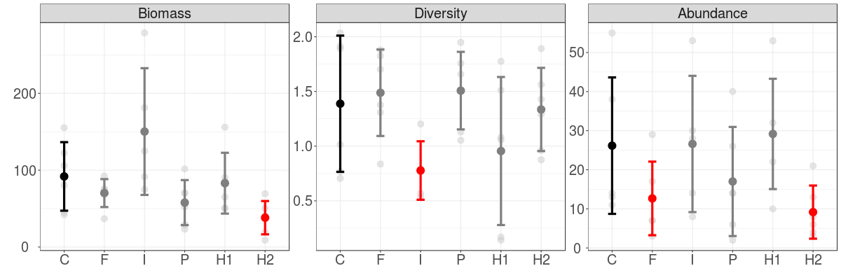

Figure 1. Community descriptors (means and standard deviations) based on all species present in the experimental plots from Wanang. Red colour indicates significant difference from the control at alpha=0.05. Biomass is measured in kilograms, diversity by Shannon’s H index, and abundance as a number of stems with DBH > 1cm, present in 5 x 5 m plot. Treatments are: C – control, F – fungicide, I – insecticide, P – predator exclosure, H1 – moderate increase in herbivory pressure, H2 – high increase in herbivory pressure.

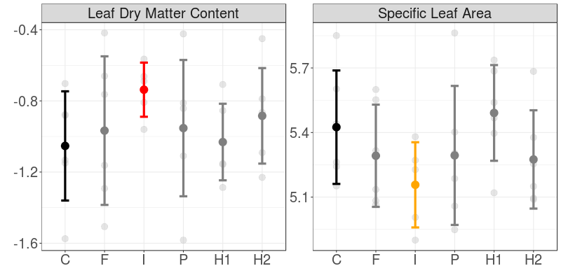

Figure 2. Community weighted means of leaf traits for different treatments from the whole community (means and standard deviations). Values of LDMC are logit-transformed, and SLA log-transformed. Red colour indicates significance at the alpha = 0.05, and orange at alpha = 0.05.

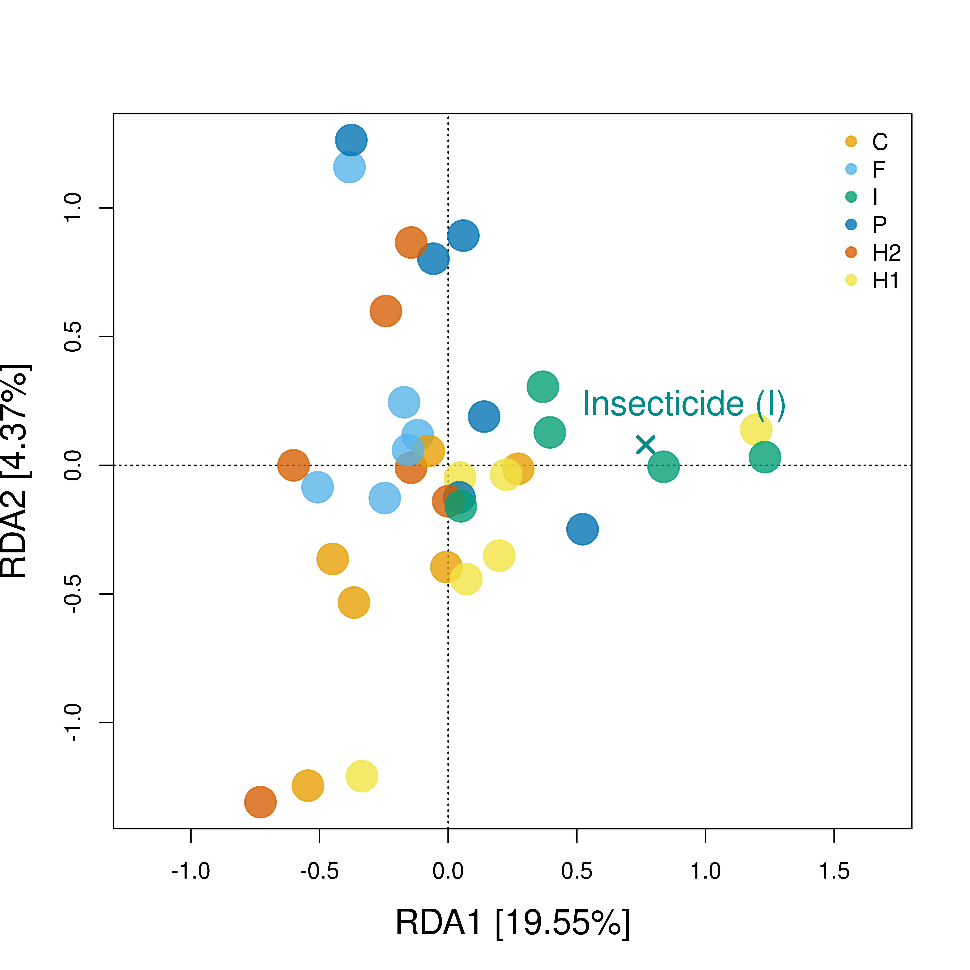

Figure 3. Redundancy analysis of the plant biomass data, conditioned on their blocks. Only one factor – insecticide – was significant and its centroid plotted. Each axis is described by their percentage of explained variance. Treatments are: C – control, F – fungicide, I – insecticide, P – predator exclosure, H1 – moderate increase in herbivory pressure, H2 – high increase in herbivory pressure.

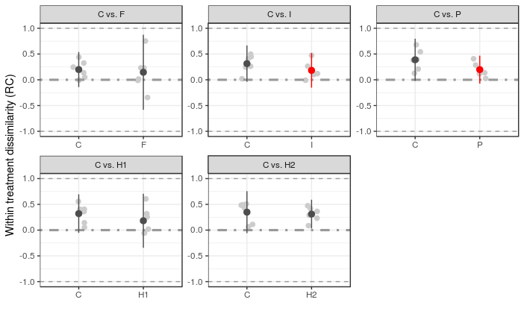

Figure 4. Within treatment dissimilarity (mean ± SD) according to a modified Raup-Crick dissimilarity metric (RC) for the woody plant community (no significant differences were found for the whole community). This metric ranges from -1 to 1, indicating whether a pair of plots converge (approaching 1)/diverge (approaching -1) deterministically to more similar/dissimilar community composition than expected by chance. Values close to zero indicate stochastic community assembly. Red colour denotes significant differences between treatments (alpha =0.05).