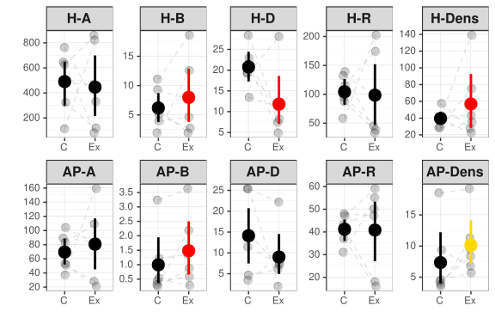
Figure 1. Mean and 95% bootstrapped CIs of the invertebrate herbivores (H) and arthropod predator (AP) community indices (A – no. of individuals, B – biomass in grams, D – inverse Simpson diversity, R – number of species, Dens – density [individuals/m² of the leaf area]) in the control (C) and exclosure (Ex) plots. Grey points indicate empirical values for six experimental blocks, and dashed lines connect plots within blocks. Red color indicates significance at the α = 0.05, and yellow at the α = 0.1.

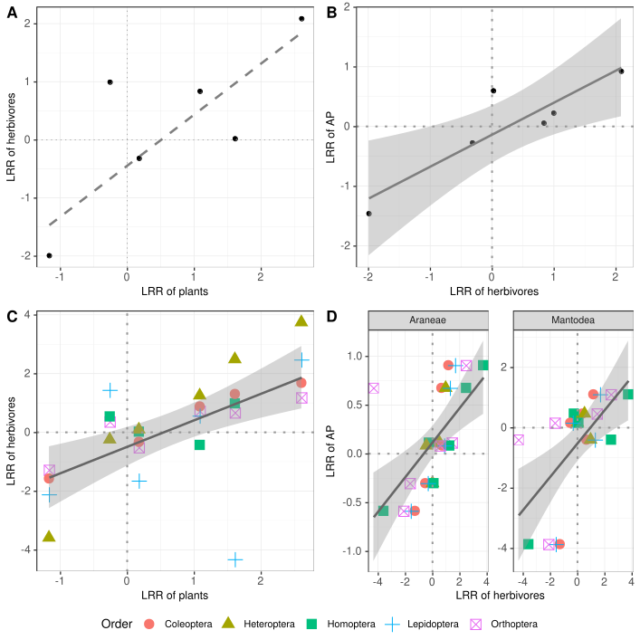
Figure 2. Relationships for predator effects on biomass (LRR – log response ratio) between different trophic levels in individual plots: A – herbivores vs plants; B – herbivores vs arthropod predators (AP); C) herbivore orders vs plants, and D) AP divided into orders vs herbivores. Solid line represents significance at the α = 0.05 level and dashed line at the α = 0.1 level. 95% CIs also plotted for significant relationships.

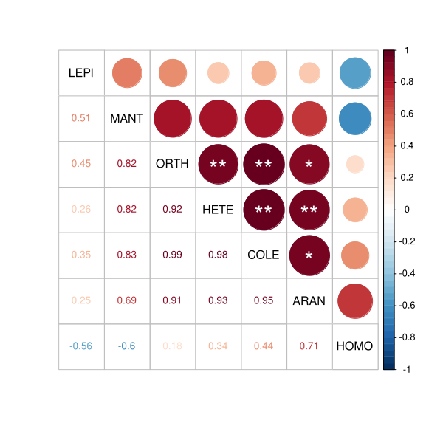

Figure 3. Pairwise Perason correlations of the effects of birds, bats and ants on arthropod abundance measure with log response ratios (LRR) between studied orders: LEPI – Lepidoptera; MANT – Mantodea; ORTH – Orthoptera; HETE – Heteroptera; COLE – Coleoptera; ARAN – Aarneae; HOMO – Homoptera. Significance is indicated with an asterisks: P < 0.001 (***); P < 0.01 (**); p < 0.05 (*).

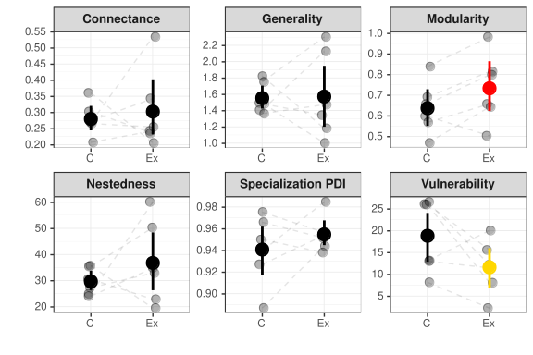
Figure 4. Mean and 95% bootstrapped CIs for plant-herbivore network descriptors in control (C) and exclosure (Ex) plots. Grey dots represent empirical data. Dashed lines connect treatment plots within the same experimental block. Significance is indicated with red color (α = 0.05).

