Predators have limited effects on plant-herbivore interaction network in early succession in tropical forest gaps

Piotr Szefer^{1,2}, Kenneth Molem³, Austin Sau³, Jan Lepš^{1,2} & Vojtěch Novotný^{1,2}

¹Faculty of Science, University of South Bohemia, České Budějovice, Czech Republic
²Biology Centre, Institute of Entomology, Czech Academy of Sciences, České Budějovice, Czech Republic
³New Guinea Binatang Research Center, Madang, Papua New Guinea

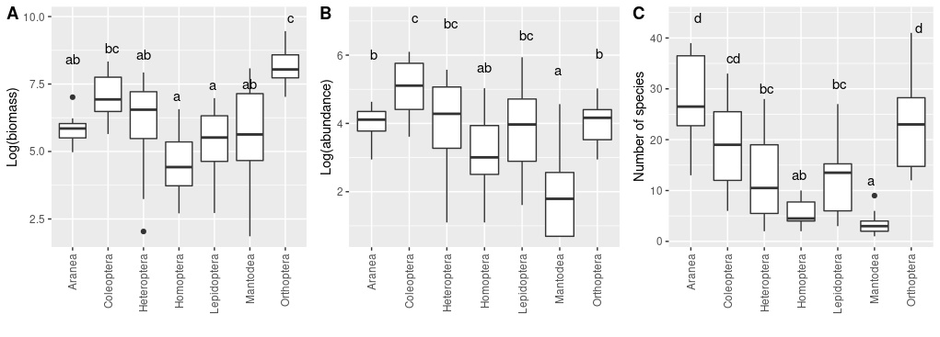
Figure S1. Comparisons of biomass (A), abundance (B) and number of species (C) of studied arthropod orders in both exclosure and control plots. Different letters indicate groups for which differences in mean values of the descriptor were statistically significant at the α = 0.05 level (pairwise comparisons with the Tukey correction for multiplicity). [biomass_comparisons_families.R]
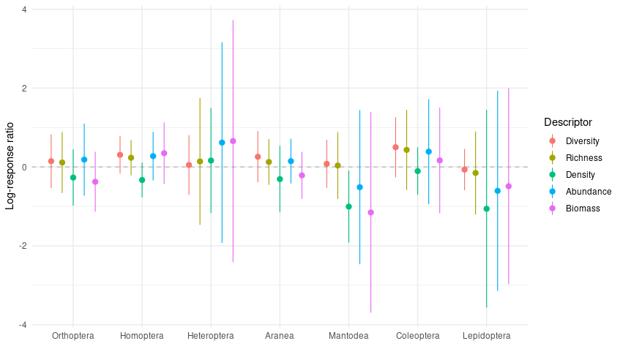
Figure S2. Log-response ratios (natural logarithm of exclosure to control value ratios) of various community descriptors for sampled insect orders. Mean and 95% bootstrapped CIs are presented. There was no significant treatment effect for any descriptor within any order. Diversity was measured with the inverse Simpson index. [biomass_abundance_comparisons.R]
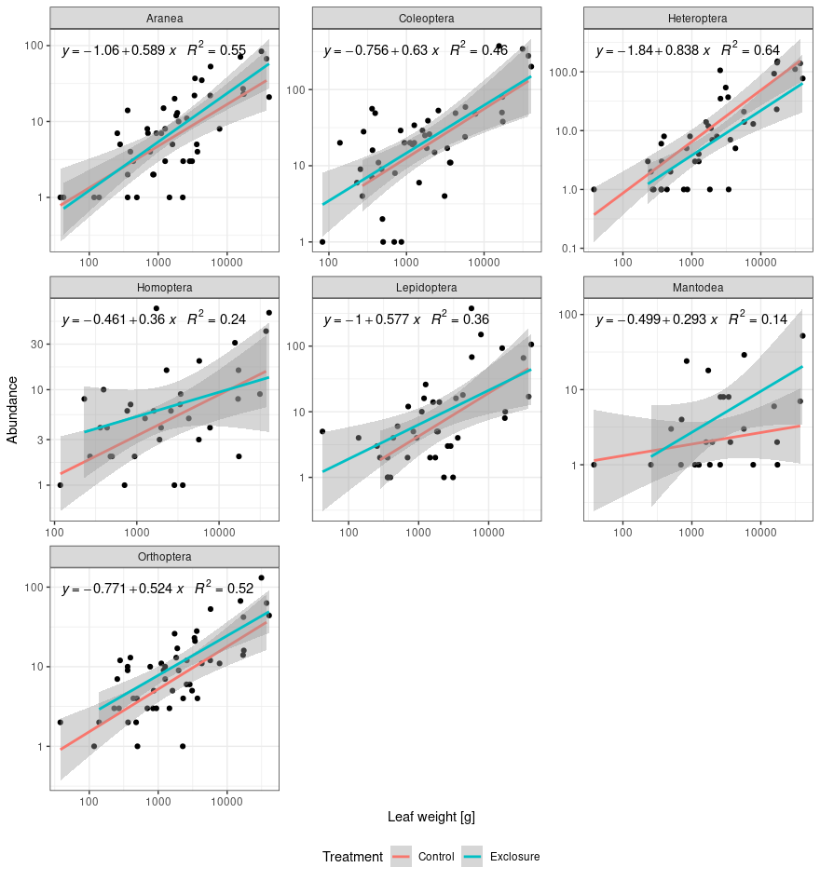
Figure S3. Statistical relationship between leaf biomass (in grams) and abundance of studied arthropod orders in exclosure and control plots. Points represent individual plants from experimental plots. Vertical and horizontal axis are in logarithmic scale. Presented equations are for the the overall regression as there was no significant interaction between treatments in any arthropod order. [plant biomass vs herb abundance.R]
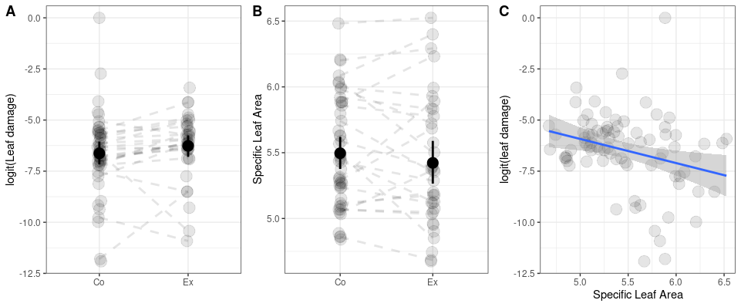
Figure S4. Comparison of (A) leaf damage (logit of the percentage of leaf area missing due to herbivore feeding) and (B) specific leaf area between woody plant individuals from control (Co) and exclosure (Ex) plots, and correlation (C) between specific leaf area and the logit of the leaf the leaf damage. Points represent individual plant species at each experimental block. Dashed lines connect plant species within the same block. Solid line indicates significant (T = -2.475, P = 0.015) correlation evaluated using a linear mixed effect model with random effects of plant species and block. Details of the statistical model can be found in Tab. S1,S2. [leaf_damage.R]
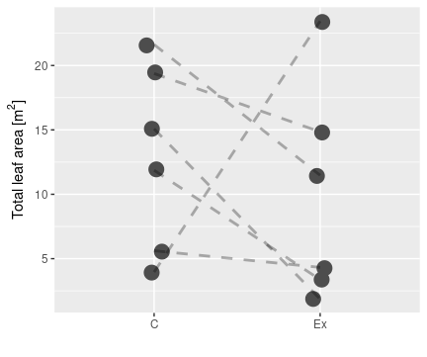
Figure S5. Total leaf area in control (C) and exclosure (Ex) plots. Lines connect values within an experimental block. Statistical significance of the difference was evaluated using linear mixed effect models with a random effect of block. [density.R]
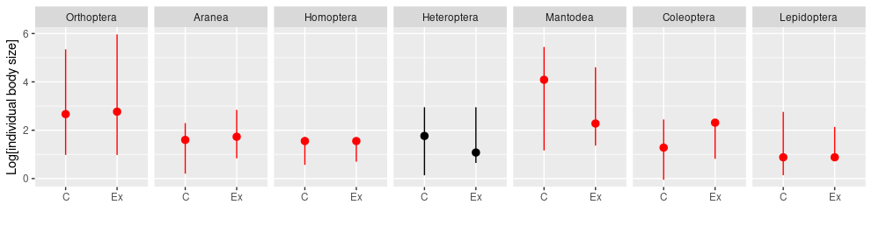
Figure S6. Median, 5th and 95th percentile for arthropod individuals body length distributions of studied insect orders in control (C) and exclosure (Ex) plots. Red color indicates significant differences of the medians evaluated using the non-parametric Mann-Whitney test. Log transformed values are plotted for better visualization of differences between sizes.

Table S1. Specifications of all statistical models used in our analyses.
Model | Description | Response | Variance | Mean | Random structure
Arthropod community characteristics
M.1 | Fig 1 H-A, AP-A. Abundance of herbivores or AP in control and exclosure plots. |  |  |  | -
M.2 | Fig 1 H-B, AP-B. Biomass of herbivores or AP in control and exclosure plots within an i-th block.
M.3 | Fig 1 H-R, AP-R. Number of species of herbivores or AP in control and exclosure plots. |  |  |  | -
M.4 | Fig 1 H-D, AP-D. Diversity (inverse Simpson’s index) of herbivores or AP in control and exclosure plots. |  |  |  | -
M.5 | Fig 1 H-Dens, AP-Dens. Density of herbivores or AP in control and exclosure plots within at i-th block .
Network descriptors
M6 | Connectance |  |  |  | -
M.6 | Generality |  |  |  | -
M.7 | Modularity
M.8 | Nestedness |  |  |  | -
M.9 | Specialization
M.10 | Vulnerability |  |  |  | -
Supplementary analyses
MS.1 | Biomass of an j-th order at i-th block
MS.2 | Abundance or richness of an j-th order at i-th block
MS.3 | LRR of community descriptors for individual arthropod orders |  |  |  | -
MS.4 | Plant biomass and herbivores abundance relationship |  |  |  | -
MS.5 | Leaf area
MS.6.1 | Leaf damage at different treatments: A,C (observation j on plant k)
MS.6.2 | SLA values at control and exclosure plots B
MS.7 | Herbivore species performance in relation to body size Fig. S6 |  |  |  | -
MS.8 | Figure S10. Response variable is weighted by cumulative abundance of each species. |  |  | A)  B)
MS.9 | Figure S11  Specialization
MS.10 | Figure S11  Abundance
MS.11 | Figure S12. Testing wether log response ratios are different from zero.
MS.12 | Case weighted (ln[herbivore species abundance]) beta regression
MS.13 | Figure S14. Mean LRR value for k-th quality, j-th specialization at i-th block. Quality and herbivore species interaction and LRR. For plant k, and PDI of species
MS.14 | Figure S15. LRR of j-th herbivore on k-th plant at i-th block, and PDI of species Water content of leaves and herbivore (Fig. S15). Water content of a j-th plant species on a block I. After modle selection that showed lack of interaction of herbivorous orders
MS.15 | Figure S16, S17: Trophic community composition (ratio of AP to herbivores) and distribution of interactions (evenness of plant degree distribution) in response to exclosure at i-th experimental block.

Table S2. Estimates, standard errors, test statistics and significance for parameter of selected statistical models defined in our experiments. Model names refer to model equations in table S.1.
Model | Parameter | Estimate | Std. Error | Statistic | P-value
M1. Herbivore abundance | α | 6.196 | 0.278 | T = 22.294 | <0.001
M1. Herbivore abundance | β | -0.095 | 0.393 | T = -0.242 | 0.809
M1. Herbivore abundance | k | 2.1673 | 0.832
M.1  AP abundance | α | 4.241 | 0.214 | T = 19.809 | <0.001
M.1  AP abundance | β | 0.149 | 0.302 | T = 0.493 | 0.622
M.1  AP abundance | k | 3.836 | 1.600
M.2  Herbivores | α | 8.481 | 0.264 | T = 32.120 | < 0.001
M.2  Herbivores | β | 0.402 | 0.186 | T = 2.160 | 0.031
M.2  Herbivores | σ_{block} | 1248.0
M.2  Herbivores | σ_{residual} | 2316.0
M.2 Arthropod predators | α | 6.693 | 0.313 | T = 21.399 | < 0.001
M.2 Arthropod predators | β | 0.275 | 0.134 | T = 2.055 | 0.040
M.2 Arthropod predators | σ_{block} | 260.9
M.2 Arthropod predators | σ_{residual} | 352.6
M.3  Richness Herbivore | α | 4.648 | 0.226 | T = 20.536 | <0.001
M.3  Richness Herbivore | β | -0.057 | 0.325 | T = -0.177 | 0.867
M.3  Richness Herbivore | θ | 32.064
M.3  Richness AP | α | 3.718 | 0.141 | T = 26.440 | <0.001
M.3  Richness AP | β | -0.008 | 0.199 | T = -0.041 | 0.968
M.3  Richness AP | θ | 4.883
M.4  Herbivores  (inverse Simpson’s index) | α | 20.763 | 2.791 | T = 7.438 | <0.001
M.4  Herbivores  (inverse Simpson’s index) | β | -8.935 | 3.948 | T = -2.263 | 0.047
M.4  Herbivores  (inverse Simpson’s index) | σ_{residual} | 6.837
M.4  AP  (inverse Simpson’s index) | α | 14.114 | 3.422 | T = 4.124 | 0.003
M.4  AP  (inverse Simpson’s index) | β | -5.116 | 4.840 | T = -1.057 | 0.315
M.4  AP  (inverse Simpson’s index) | σ_{residual} | 8.382
M.5 Density herbivores | α | 3.367 | 0.272 | T = 12.385 | <0.001
M.5 Density herbivores | β | 0.6351 | 0.232 | T = 2.743 | 0.006
M.5 Density herbivores | σ_{block} | 7.286
M.5 Density herbivores | σ_{residual} | 16.745
M.5 Density AP | α | 1.973 | 0.184 | T = 10.711 | <0.001
M.5 Density AP | β | 0.214 | 0.120 | T = 1.179 | 0.073
M.5 Density AP | σ_{block} | 0.689
M.5 Density AP | σ_{residual} | 2.077
Network Descriptors
M.6  Connectance | α | -0.920 | 0.159 | Z = -5.771 | <0.001
M.6  Connectance | β | 0.078 | 0.223 | Z = 0.348 | 0.728
M.6  Connectance | θ | 30.93 | 12.46 | Z = 2.482 | 0.013
M.7  Generality | α | 1.555 | 0.147 | T = 10.565 | <0.001
M.7  Generality | β | 0.019 | 0.208 | T = 0.090 | 0.928
M.7  Generality | σ_{residual} | 0.360
M.8  Modularity | α | 0.620 | 0.327 | Z = 1.893 | 0.058
M.8  Modularity | β | 0.533 | 0.249 | Z = 2.143 | 0.032
M.8  Modularity | σ_{block} | 0.451
M.8  Modularity | σ_{residual} | 0.671
M.8  Modularity | θ | 26.6
M.9  Nestedness | α | 29.790 | 4.803 | T = 6.202 | <0.001
M.9  Nestedness | β | 6.862 | 6.792 | T = 1.010 | 0.336
M.9  Nestedness | σ_{residual} | 11.765
M.10  Specialization | α | 2.780 | 0.183 | 15.316 | <0.001
M.10  Specialization | β | 0.024 | 0.254 | 0.931 | 0.352
M.10  Specialization | σ_{block} | 0.023
M.10  Specialization | σ_{residual} | 0.153
M.10  Specialization | θ | 102
M.11  Vulnerability | α | 18.775 | 2.9722 | T = 6.317 | <0.001
M.11  Vulnerability | β | -8.156 | 4.554 | T = -1.791 | 0.073
M.11  Vulnerability | σ_{residual} | 7.144
Selected Supplementary Analyses
MS.5.1 Herbivore damage (Best model) | α | 0.763 | 2.862 | T = 0.267 | 0.790
MS.5.1 Herbivore damage (Best model) | β | -1.307 | 0.526 | T = -2.486 | 0.015
MS.5.1 Herbivore damage (Best model) | σ_{plant} | 1.508
MS.5.1 Herbivore damage (Best model) | σ_{residual} | 1.288
MS.5.2 SLA | α | 5.382 | 0.094 | T = 56.943 | <0.001
MS.5.2 SLA | β | -0.044 | 0.060 | T = -0.737 | 0.464
MS.5.2 SLA | σ_{block} | 0.280
MS.5.2 SLA | σ_{plant} | 0.156
MS.5.2 SLA | σ_{residual} | 0.243

Table S3. Results of the Mann-Whitney’s tests for arthropod individual body lengths. NC – number of individuals in the control, NEx - number of individuals in the exclosure plots. HL – Hodges-Lehman centrality estimator (median of the differences between individuals from control and exclosure). Direction indicates how median changes from exclosure (no focal predators: birds, bats and ants) to the control (predators present), which is the predator effect on the arthropod sizes.
Order | NC | NEx | HL | P | Direction
Orthoptera | 422 | 369 | -2.77E+00 | <0.001 | decrease
Homoptera | 135 | 252 | -3.10E-05 | 0.019 | decrease
Heteroptera | 785 | 362 | -7.27E-05 | 0.208 | ns
Aranea | 362 | 351 | -8.88E-01 | <0.001 | decrease
Mantodea | 55 | 133 | 1.47E+01 | 0.006 | increase
Coleoptera | 1214 | 993 | -1.36E+00 | <0.001 | decrease
Lepidoptera | 389 | 702 | 1.10E-05 | 0.016 | increase

Table S4. Results of the Mann-Whitney’s tests for arthropod individual body lengths at individual plant species. NC – number of individuals in the control, NEx - number of individuals in the exclosure plots. HL – Hodges-Lehman centrality estimator (median of the differences between individuals from control and exclosure). Direction indicates how median changes from exclosure (no focal predators: birds, bats and ants) to the control (predators present), which is the predator effect on the arthropod sizes.
Order | Plant | NC | NEx | HL | P | Direction
Orthoptera | Pipturus argenteus | 84 | 147 | -3.87E+00 | 0.061 | ns
Orthoptera | Premna sp.1 | 2 | 13 | -1.67E-06 | 0.661 | ns
Orthoptera | Trichospermum pleiostigma | 22 | 17 | 2.89E-05 | 0.931 | ns
Orthoptera | Melochia sp.1 | 131 | 28 | -3.94E+01 | 0.000 | decrease
Orthoptera | Melanolepis multiglandulosa | 71 | 66 | 1.71E+00 | 0.162 | ns
Orthoptera | Macaranga tanarius | 17 | 3 | 4.03E+00 | 0.425 | ns
Orthoptera | Cordyline terminalis | 4 | 3 | 5.42E+00 | 0.858 | ns
Orthoptera | Breynia cernua | 6 | 7 | 9.45E+00 | 0.350 | ns
Orthoptera | Trema orientalis | 64 | 40 | 6.94E-01 | 0.137 | ns
Orthoptera | Manihota esculenta | 10 | 10 | -3.40E+01 | 0.047 | decrease
Homoptera | Trema orientalis | 24 | 17 | 1.45E-06 | 0.422 | ns
Homoptera | Piptrus argenteus | 47 | 106 | -4.42E-05 | 0.093 | ns
Homoptera | Melanolepis multiglandulosa | 34 | 81 | -4.21E-05 | 0.293 | ns
Homoptera | Trichospermum pleiostigma | 8 | 15 | -5.58E-05 | 0.893 | ns
Homoptera | Macaranga tanarius | 2 | 2 | 8.20E-01 | 0.617 | ns
Heteroptera | Trichospermum pleiostigma | 8 | 28 | -1.40E+00 | 0.379 | ns
Heteroptera | Melanolepis multiglandulosa | 356 | 60 | -3.83E-01 | 0.105 | ns
Heteroptera | Piptrus argenteus | 262 | 213 | 7.24E-05 | 0.963 | ns
Heteroptera | Melochia sp.1 | 111 | 7 | -1.92E+00 | 0.254 | ns
Heteroptera | Trema orientalis | 27 | 26 | 1.39E+01 | 0.002 | increase
Aranea | Melochia sp.1 | 84 | 5 | -4.37E+00 | 0.001 | decrease
Aranea | Trema orientalis | 61 | 62 | -8.06E-01 | 0.061 | ns
Aranea | Piptrus argenteus | 80 | 146 | -1.35E+00 | 0.000 | decrease
Aranea | Melanolepis multiglandulosa | 56 | 55 | -6.57E-01 | 0.189 | ns
Aranea | Cordyline terminalis | 12 | 8 | -3.26E-01 | 0.561 | ns
Aranea | Breynia cernua | 10 | 8 | 2.05E+00 | 0.032 | increase
Aranea | Trichospermum pleiostigma | 25 | 29 | 2.56E-01 | 0.459 | ns
Aranea | Macaranga tanarius | 6 | 7 | -1.07E+00 | 0.668 | ns
Mantodea | Piptrus argenteus | 11 | 67 | 1.62E-01 | 0.025 | increase
Mantodea | Melanolepis multiglandulosa | 3 | 18 | -1.48E-06 | 1.000 | ns
Mantodea | Trichospermum pleiostigma | 5 | 24 | 4.98E+01 | 0.000 | increase
Mantodea | Trema orientalis | 30 | 12 | -3.07E-05 | 0.740 | ns
Coleoptera | Piptrus argenteus | 393 | 662 | -3.65E-05 | 0.000 | decrease
Coleoptera | Trema orientalis | 107 | 44 | 5.80E-05 | 0.485 | ns
Coleoptera | Trichospermum pleiostigma | 50 | 79 | -4.99E-05 | 0.347 | ns
Coleoptera | Macaranga tanarius | 43 | 20 | -3.36E-05 | 0.860 | ns
Coleoptera | Melanolepis multiglandulosa | 148 | 81 | 8.67E-01 | 0.046 | increase
Coleoptera | Melochia sp.1 | 341 | 11 | -2.31E+00 | 0.078 | ns
Coleoptera | Premna sp.1 | 16 | 17 | -1.05E+00 | 0.824 | ns
Lepidoptera | Piptrus argenteus | 31 | 234 | -3.07E-01 | 0.002 | decrease
Lepidoptera | Trema orientalis | 218 | 417 | 3.64E-05 | 0.000 | increase
Lepidoptera | Trichospermum pleiostigma | 36 | 13 | -2.86E-01 | 0.527 | ns
Lepidoptera | Melanolepis multiglandulosa | 12 | 7 | 4.31E-05 | 0.966 | ns
Lepidoptera | Macaranga tanarius | 4 | 4 | 9.71E+00 | 0.142 | ns
Lepidoptera | Melochia sp.1 | 66 | 4 | 5.22E+00 | 0.323 | ns
Lepidoptera | Breynia cernua | 2 | 8 | -3.02E-01 | 0.891 | ns
Table S5. Results of the Mann-Whitney’s tests for arthropod individual body lengths at individual experimental blocks (g1, …, g6). NC – number of individuals/species in the control, NEx - number of individuals in the exclosure plots, HL – Hodges-Lehman centrality estimator (median of the differences between individuals from control and exclosure). Direction indicates how median changes from exclosure (no focal predators: birds, bats and ants) to the control (predators present), which is the predator effect on the arthropod sizes.
Order | Block | NC | NEx | HL | P | pred.eff
Orthoptera | g5 | 78 | 24 | -1.20E+01 | 0.010 | decrease
Orthoptera | g4 | 152 | 74 | -2.39E+01 | 0.000 | decrease
Orthoptera | g2 | 37 | 19 | -3.03E+01 | 0.072 | ns
Orthoptera | g1 | 60 | 42 | 4.53E-01 | 0.384 | ns
Orthoptera | g3 | 69 | 116 | -5.01E-01 | 0.560 | ns
Orthoptera | g6 | 26 | 94 | 2.06E+00 | 0.145 | ns
Homoptera | g1 | 29 | 17 | 1.83E+00 | 0.000 | increase
Homoptera | g4 | 11 | 17 | -2.67E-05 | 0.145 | ns
Homoptera | g2 | 8 | 3 | -5.03E-05 | 0.737 | ns
Homoptera | g3 | 63 | 62 | 6.31E-05 | 0.788 | ns
Heteroptera | g5 | 168 | 4 | -4.22E-01 | 0.734 | ns
Heteroptera | g3 | 156 | 143 | 2.19E+00 | 0.000 | increase
Heteroptera | g1 | 28 | 36 | 4.74E+00 | 0.000 | increase
Heteroptera | g6 | 3 | 109 | -3.02E+00 | 0.025 | decrease
Heteroptera | g2 | 263 | 22 | -1.34E+00 | 0.000 | decrease
Heteroptera | g4 | 167 | 48 | -6.91E-01 | 0.242 | ns
Aranea | g4 | 89 | 82 | -8.06E-01 | 0.050 | decrease
Aranea | g6 | 35 | 63 | 7.62E-01 | 0.047 | increase
Aranea | g3 | 76 | 103 | -2.02E+00 | 0.000 | decrease
Aranea | g2 | 49 | 25 | -2.92E+00 | 0.001 | decrease
Aranea | g1 | 66 | 59 | -7.54E-02 | 0.458 | ns
Aranea | g5 | 47 | 19 | -1.90E+00 | 0.003 | decrease
Mantodea | g3 | 7 | 6 | 7.96E-05 | 0.382 | ns
Mantodea | g6 | 2 | 96 | 1.62E-01 | 0.000 | increase
Mantodea | g5 | 6 | 2 | -1.47E+01 | 0.371 | ns
Mantodea | g2 | 2 | 3 | -6.35E-05 | 0.683 | ns
Mantodea | g1 | 38 | 24 | -4.87E-05 | 0.179 | ns
Coleoptera | g2 | 165 | 45 | -4.01E+00 | 0.000 | decrease
Coleoptera | g3 | 320 | 445 | -4.86E-05 | 0.000 | decrease
Coleoptera | g4 | 362 | 151 | -5.04E+00 | 0.000 | decrease
Coleoptera | g5 | 198 | 37 | -1.26E+00 | 0.000 | decrease
Coleoptera | g6 | 65 | 315 | 1.62E-06 | 0.294 | ns
Lepidoptera | g1 | 101 | 24 | 1.30E-01 | 0.658 | ns
Lepidoptera | g2 | 5 | 379 | 5.21E-05 | 0.000 | increase
Lepidoptera | g3 | 18 | 94 | 6.24E-05 | 0.965 | ns
Lepidoptera | g4 | 70 | 40 | 2.35E+00 | 0.001 | increase
Lepidoptera | g5 | 177 | 15 | -1.81E+00 | 0.000 | decrease
Lepidoptera | g6 | 18 | 150 | 1.48E+00 | 0.070 | ns
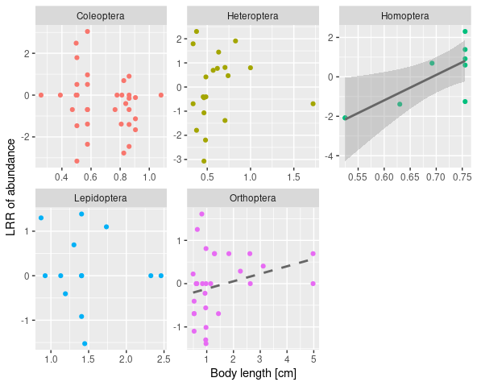
Figure S7. Relationship between the body length [cm] and the effect of birds, bats and ants (log-response ratio [control/exclosure] of herbivore species abundance) for studied arthropod herbivore orders. Significance is indicated with the line type: solid line: α = 0.05, dashed line α = 0.1. [plant_species_logratio.R]
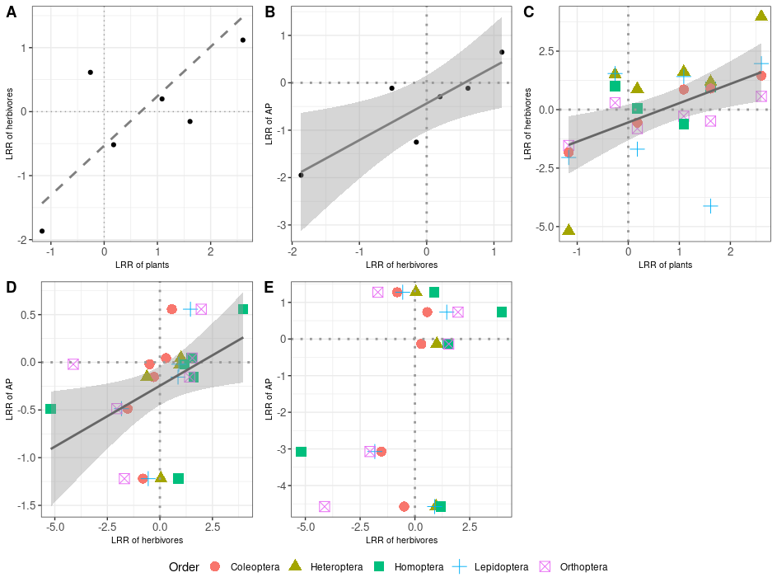
Figure S8. Correlations between predators effect (log response ratio [LRR] - logarithm of the control to the exclosure biomass ratio) of herbivores, plants and arthropod predators (AP). Significance is indicated with the line type: solid line: α = 0.05, dashed line α = 0.1. Correlations are present for: A – complete communities of herbivores and plants; B – complete communities of herbivores and AP. C – herbivores and plants for individual herbivore orders; D,E - predator effects of AP and herbivores for individual herbivorous orders and spiders (D) and mantids (E). [bio_log_ratio.R]
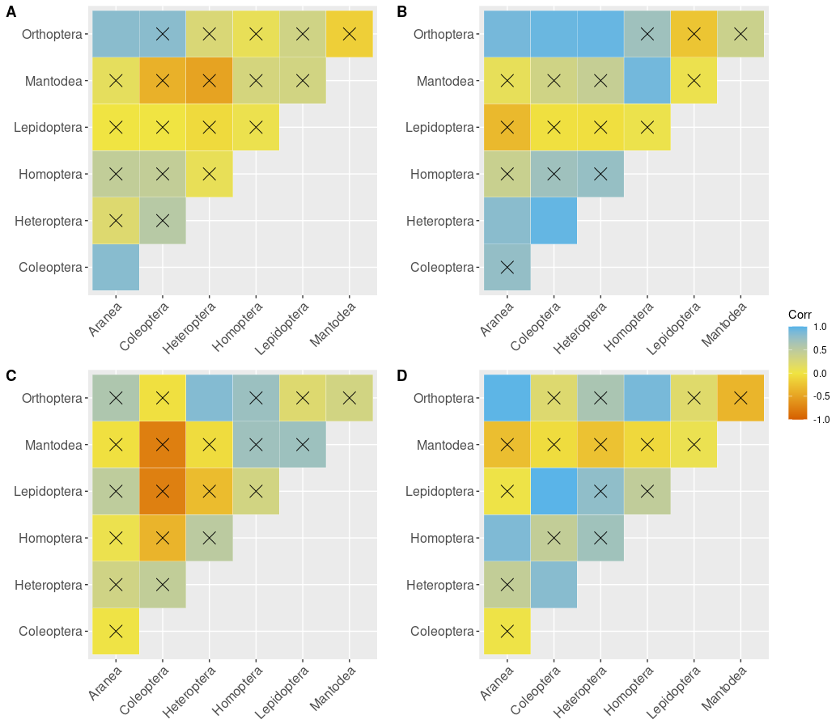
Figure S9. Abundance (A,B) and biomass (C,D) Pearson’s correlation plots of studied arthropod orders for both control (A,C) and exclosure (B,D) plots. Barrage indicates non-significant correlations.[correlation_cp.R]
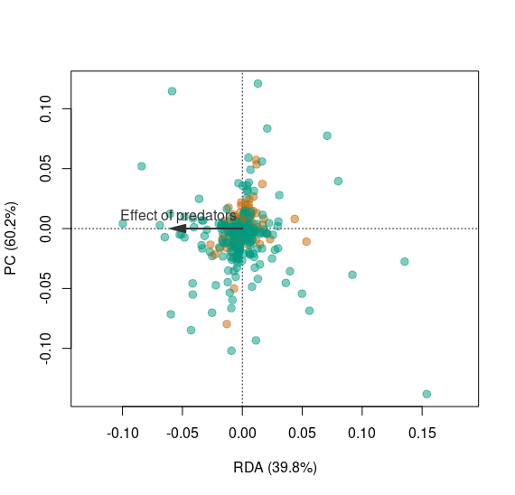
Figure S10. pRDA diagram for the predator effect on abundance based arthropod community composition constrained on the block (site) effect and first four plant composition PC axes, which explained ~ 91% of variation in vegetation composition (evaluated using pPCA on plant community composition constrained on the block effect). RDA axis represents the effect of birds, bats and ants on individual herbivore (green) and arthropod predator species (gold). Negative coordinates indicate reduced arthropod species’ abundance in presence of vertebrate predators. Conditional variables explained ~ 87.1 % of (conditioned) variation. Effect of predators was not significant overall and explained merely ~ 5.16 % variation in the arthropod community composition. The residual variance amounted to 7.8 %. Qualitatively similar results were obtained for biomass based community analysis [ordination_ms1.R]
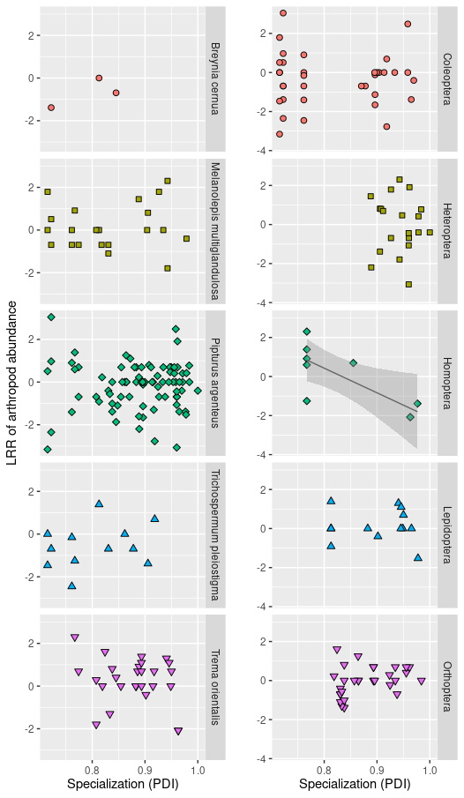
Figure S11. Effect of specialization (Paired Dissimilarity Index - PDI) on herbivore species performance (log response ratio - LRR) for plant species and insect orders. Each point represents a herbivore species for which ≥ 5 individuals sampled. Only plant species present in both control and treatment plots were analysed. Significance of the regression coefficient at the α = 0.05 level is indicated by a solid line with 95% CIs . For each morphospecies its cumulative abundance at control and exclosures was used as a weighting factor in the regression. [plant_species_log_ratio.R]
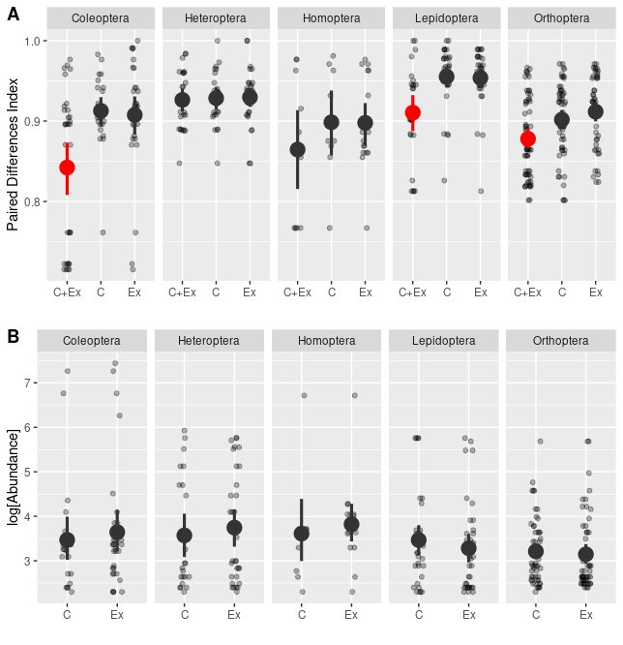
Figure S12. Specialization (paired differences index - PDI) of herbivore species assigned to three groups based on whether they were present in both exclosure and control plot (Ex+C), exclusively in the control (C) or in the exclosure (Ex) plots (A). We compared abundance of species exclusive to plots from one of the experimental treatments (B) to visualize traffic of highly specialized individuals within the experimental blocks. Minimal abundance for a species included in this analysis was 10 individuals. Red color indicates significant differences from any other group within the order. [resource_switching.R]
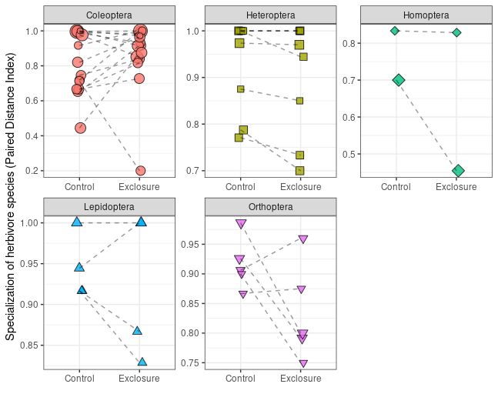
Figure S13. Specialization (paired differences index - PDI) values for comparable species in control vs exclosure plots for each morpho-species from studied herbivorous orders. Statistical significance of differences between means in the treatment was evaluated using linear mixed effect models with logarithm of the PDI value from control to exclosure ratios as a response and block treated as a random effect. Only Orthoptera was marginally significant (T = -2.13, P = 0.066). Points indicate morpho-species that were present in both control and exclosure plots in minimum abundance of 10 individuals. [pdi_response_to_treatment.R]
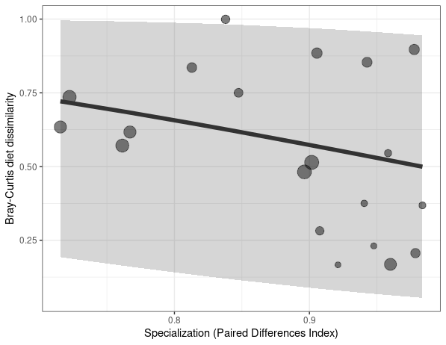
Figure S14. Weighted correlation between diet shifts (Bray-Curtis dissimilarity in resources use between exclosure and control plots) and specialization (paired differences index – PDI). Predicted values of a weighted beta regression model with 95% prediction quantiles are shown. Model is significant but explains only ~9% of variation. Each point represents a herbivore species, point size is proportional to natural logarithm of herbivore species abundance, which was also used as weights for each point in the regression. Herbivore species with minimum five individuals were included in the analysis. [pdi_diet_shift.R]

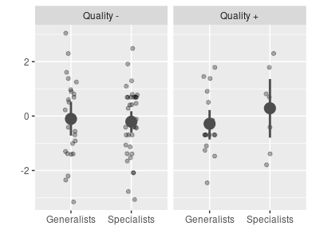
Figure S15. Interaction between plant quality (- low, + high, measured as the coordinates along a first axis of PCA performed on SLA and WATER content = predicted values of their correlation) and specialization (measured as PDI values on the left [generalists] or to the right [specialists] from the average) in predicting individual species responses to predation (y axis – log-response ratio). Mean values between groups and their interactions were not significantly different. [sla_ldmc_lrr.R]

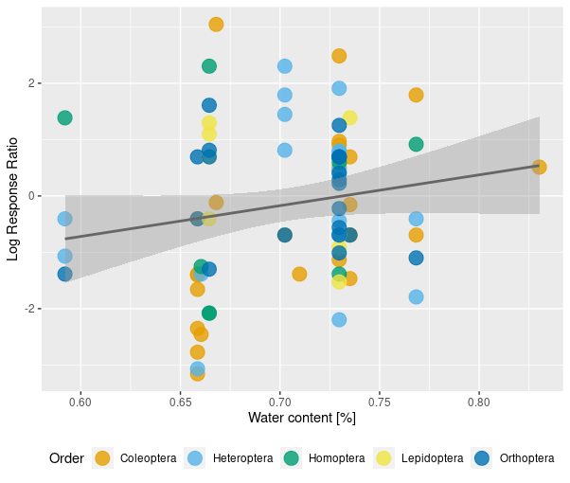

Figure S16. Correlation between leaf water content (a proxy for the leaf quality) and predators effect (logarithm of control to exclosure arthropod abundance ratio) on herbivorous species. Model includes random effect of the experimental block. Significant regression line (T = 3.341, P = 0.001) and 95% CIs are plotted. Points represent species from different experimental blocks.
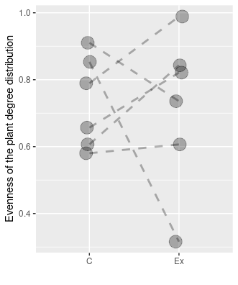
Figure S17. Evenness of the degree distribution of plants as a measure of distribution of links in plant – herbivore interaction networks in control (C) and exclosure (Ex) plots. Lines connect network descriptors within the same experimental block. Statistical significance of the difference was evaluated using a beta mixed effect models with logit link function and block treated as a random effect. [network descriptors.R]
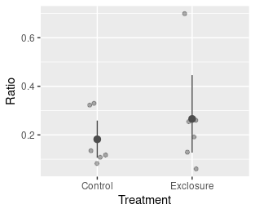
Figure S18. Arthropod predators (AP) to herbivores ratio in control and exclosure plots. Mean and 95% bootstrapped CIs are present. The ratio was not significantly affected by predators. Significance evaluated using mixed effect model with a random effect of block.

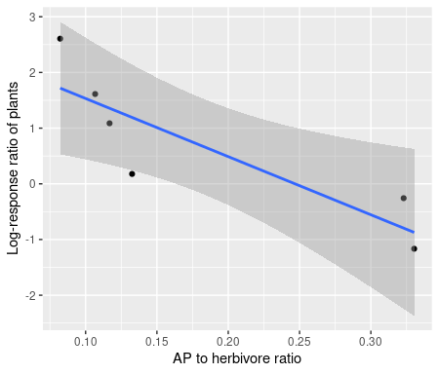
Figure S19. Correlation between the increase in arthropod community trophic composition (ratio of arthropod predators to herbivores in the presence of vertebrate predators: birds and bats) and indirect effect of focal predators on the woody plant biomass for each experimental block. Solid line indicates significance at the α = 0.05 level. Individual experimental block as points and 95% CIs are plotted. [bio_log_ratio.R]
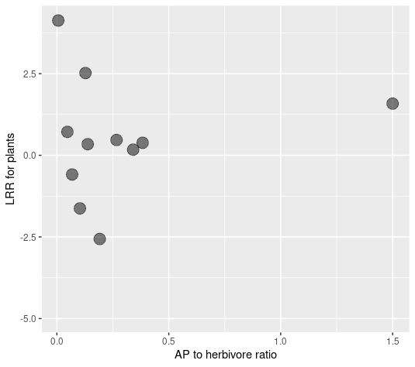
Figure S20. Arthropod community trophic composition (ratio of arthropod predators to herbivores in the presence of vertebrate predators: birds and bats) vs indirect effect of focal predators on the woody plant biomass (log[control/exclosure]) on individual plant species (grey points). Correlation was not significant.

