Results

1. We only find difference in abundance, diversity, and richness of herbivores and IAP's (Fig. 1) in high herbivore addition (HHA) plots.

2. Except for consistent decrease in plant biomass and herbivore abundance in HHA plots, there was no consistent pattern in neither plant biomass nor herbivore abundance. We found a strong relationship between herbivore log ratio and plant log ratio in the insecticide plot (P < 0.001). This relationship was getting weaker and was only marginally significant (P = 0.074) in exclosure plot and herbivore addition and was weak at the highest level of herbivore addition (Fig. 2). **This vanishing significance was related to high variability in the abundance of *Homoptera*, and *Lepidoptera*.**. Wonder why is that?

3. Linear relationships for log ratios of IAPs and herbivores were found in the insecticide treated and excosure plots (Fig. 3). Similarly these relationships were disrupted by generalist herbivore addition.

[Where am I going with this?] There are two topics here.
a) Herbivores seem to respond mainly to their food plants. But there is a question: is this caused only by the plant biomass? Or maybe that plant community composition (plant identity) matters.
b) what is the effect of herbivore addition on the plant, herbivore and IAP communities.

4. There was a high variability between sites, that was partially explained by their location, and treatments had little effect on community composition of the vegetation. Site identity explained approximately 50% of the total variance, 40% was attributed to the unconstrained (unexplained) variance, and the treatment only accounted for 9.19% of variance explained. (ordination)

A. There is limited evidence for top-down control of herbivores by vertebrate predators, and cascading effect on plant communities.
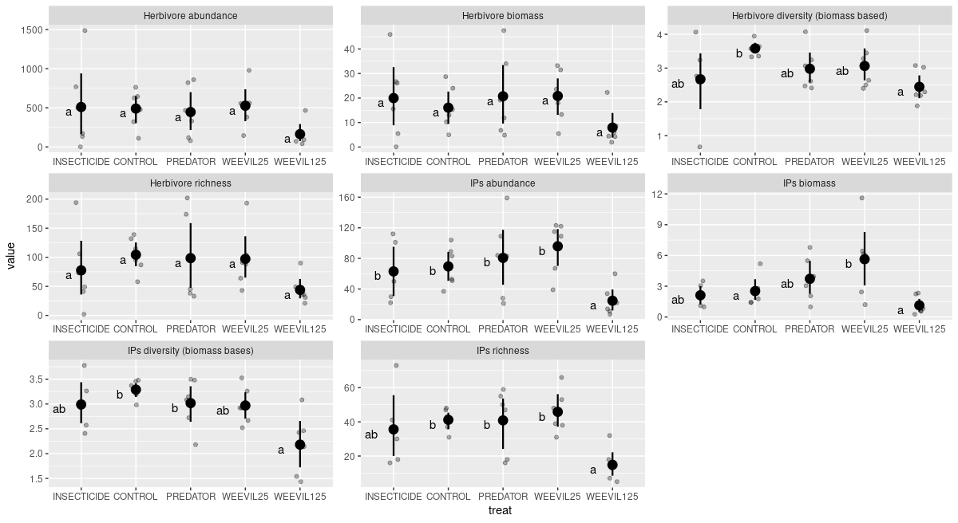
1. Plot: Comparison of abundance, diversity, richness of IP, Herb, [and plants?] in C,P,W125,I (?)(with all pairwise differences tested!) [should I add also the same graph for plants? Wouldn’t that repeat the results from our previous paper?]

We didn’t find difference in abundance, biomass, and community composition of herbivores, intermediate predators nor plants in exclosure plots– [evidence for a lack of effect]:
Herbivores, which are controlled by predators, should have lower abundance in control plots (negative log of C/P ratio).
Looking at community composition the there was no significant difference between control and predator plot. Using Control, Predator, Weevil 25 and Weevil 125 we found that for the plant community (no treatment significant), that the conditioned variance was relatively high, nearly as high as unconstrained variance. This suggests that there was high variability between sites, that was partially explained by their location, and treatments had little effect on vegetation.
Inertia Proportion
Total 0.44489 1.0000
Conditioned 0.22448 0.5046
Constrained 0.04089 0.0919
Unconstrained 0.17953 0.4035

2. Plot of I/C/P/W1/W2 for the insect community with pairwise comparisons between categories (plant effect removed in pRDA) https://rdrr.io/cran/BiodiversityR/man/multiconstrained.html
Effect of vegetation on herbivores (and IPs?) pRDA with treatment effect (and block? → Condition(treatment + block) removed.
Main pPCA axes of vegtation change: PC1, PC2, PC7, PC10:
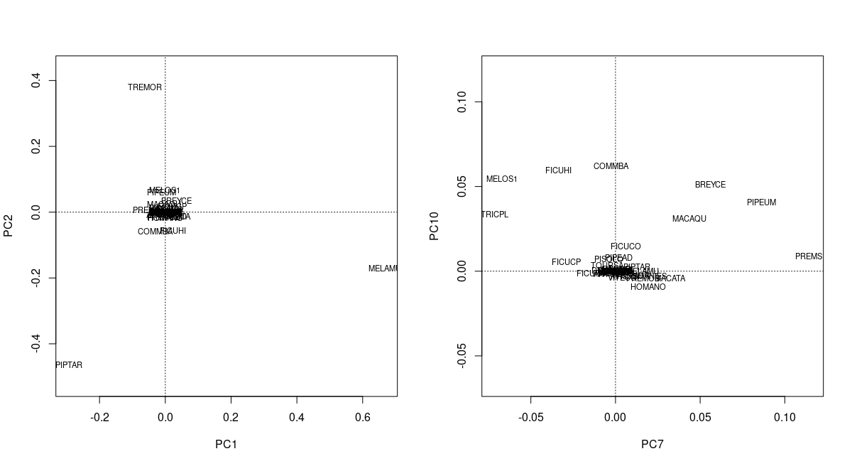
There was no effect of any pPCA axis nor IP community descriptors (abundance, richness, biomass, diversity) on herbivorous communities based on their biomass. For herbivore abundance I found that four pPCA axes of vegetation variability were significantly affecting herbivore community composition. These axes were used in pRDA that evaluates effect of PREDATOR, CONTROL, WEEVIL25 and WEEVIL 125 on herbivore community.
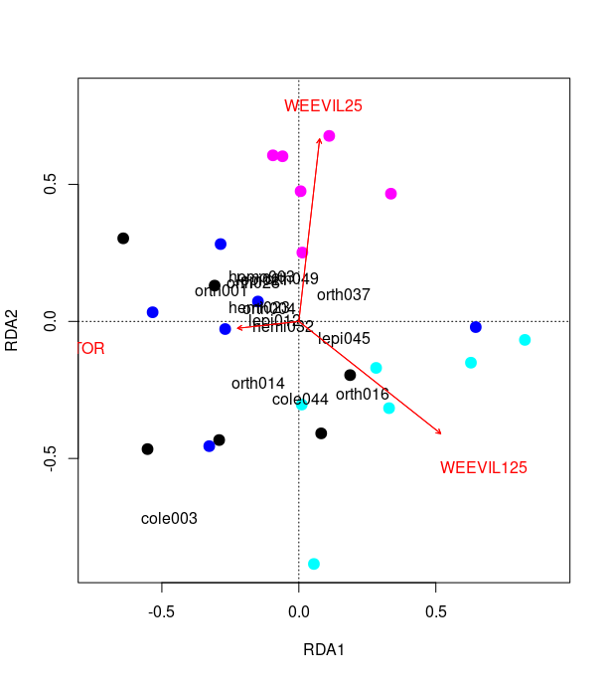
Final pRDA: There was no difference between control plot and predator plot. However both levels of herbivore additions resulted in change in herbivore community composition [characterized by reduction of abundnance of most of herbivore orders]. And w25 and w125 also differed [based on permutation tests, with changed basis for ordination]. Few herbivorous species, which abundance change in response to the treatments are labeled in ordination graph. This shows that we were able to increase the abundance of our Oribius sp. (cole001). When “cole001” is removed as an induced change in the herbivore community we get only marginal effect of W25 but still significant effect of W125

Is there an effect of predators on IP community? - perform similar analysis.

What are some of the likely effects

3. Plot: log response ratios of plants vs herbivores, herbivores vs IPs, IPs vs plants. (supplement, same plots but broken into families) [I don’t think I should also break plants into species, because even if I would be able to find species, which are in C and P plots, then their context varies in a way, that makes impossible to ascribe any effect to the treatment – this plant species context can be also characterized in the supplement]. (Upper – biomass, lower – abundance) Herbivores were both positively and negatively affected by predator removal. Plants were more often (in 4 cases) and stronger (maximal magnitude of log ration was nearly 3) positive effect on their biomass. There was a trend...
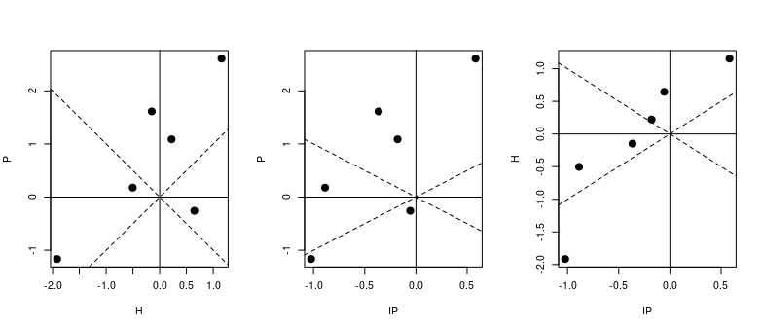

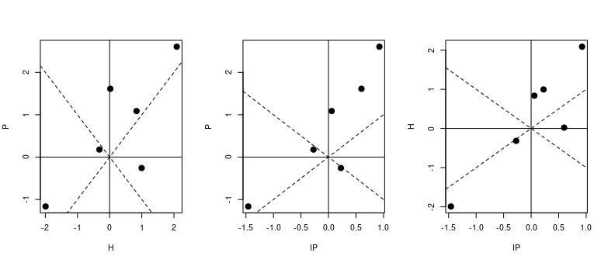
There might be no effect of predators on general community descriptors but we might expect to see cascading effect on plants. This can be explored using log-ratio responses of herbivores and plants to removal of their top, vertebrate predators. Effect of predators on IP is generally negative.

None of herbivore/intermediate predator biomass was affected by exclosure. Upper biomass, lower abundance. I need to perform better tests for significance !. [bio_log_ratio.R]
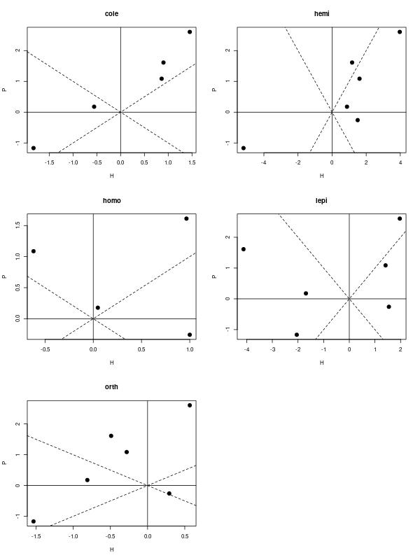
Majority of insect orders seem to react to changes in plant biomass more than to predators.

B. In order to state, that predators have no effect on herbivore community we need to rule out various form of possible compensation:
1. Change in size structure coupled with reduction/increase in abundance. Predators may be using mainly IPs, and not herbivores as prey (that would maybe cause shift in opposite direction – towards larger individuals, because IPs would feed more intensively on smaller prey). For arachnids (no change in the number of individuals) , Orthoptera (no change in ind no) and Coleoptera (neither) there was shift in body size distribution towards larger individuals, and for Hemiptera and Lepidoptera towards smaller individuals in the exclosure.
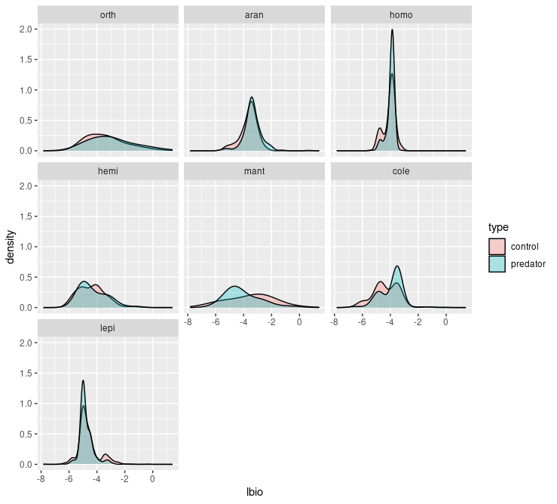
Plots: [3] Biomass of an average individual: Shift in size structure of herbivores and IPs. Linear mixed effect (random intercept for blocks) model for logarithm of body size.
There might be no effect for mantoids because of high number of smaller juveniles… seems like these were numerous in predatory exclusion plots… however, there is no difference in abundance.

2. Decrease in abundance/biomass in one group could be compensated by increases in other groups.

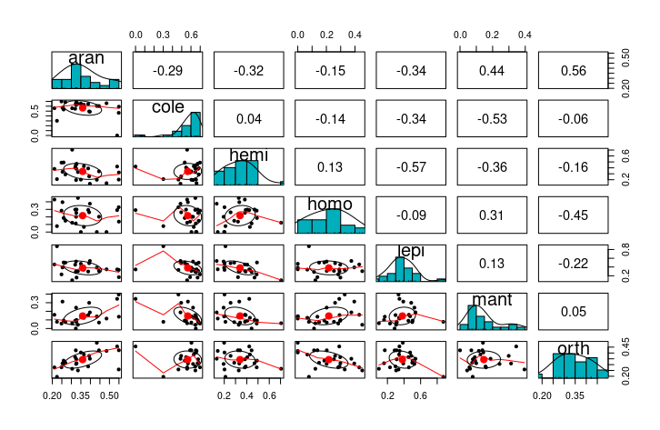
Plot [4] Paired correlation plots for all insect families based on Hellinger transformed abundance. I dont think this represents true correlations. I think pPCA plot is better suited for this, as it partials out variation explained by treatment and block prior to evaluating correlations.

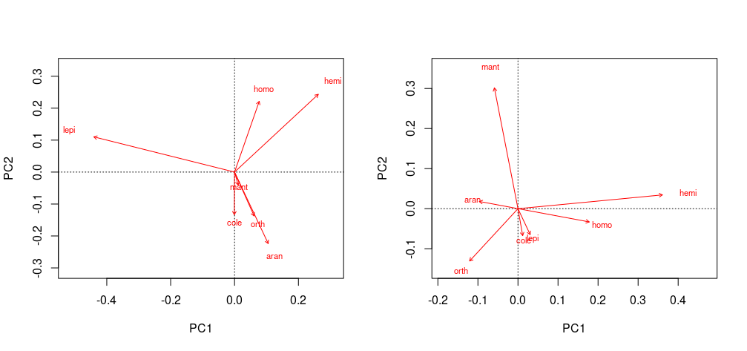
Plot [4b] Linear correlations in abundances between insect groups: abundance (left) and biomass (right) (pPCA on site/species matrix conditioned on block+treatment in case treatment changes character of the correlation).
We see that coleoptera, orthoptera and arachnids are correlated, these also showed increase in average individual size in predator exclosure plot. Increase in their abundance is correlated with decrease in abundnace of hemiptera and homoptera. Lepidoptera are increasing in numbers whenever general abundance of the rest of the groups decrease.

Ordination for insect orders rather than morpho-species:
Abundance: Ordination based on insect orders shows significant difference between control and weevil125 plot. In general all herbivore orders are decreasing there. However the effect is gone after removing the effect of invertebrate predator richness and PC2 of plants (PIPTAR → MELAMU → TREMOR variation). This suggest that the herbivore communities are driven by changes in plant community composition more than by other factors.
Biomass: There is no effect of weevil125 conditioned only on block. Selection of conditional variables revealed, that only intermediate predator richness significantly affected biomass. Including that variable in pRDA analysis we get significant reduction of herbivore biomass.
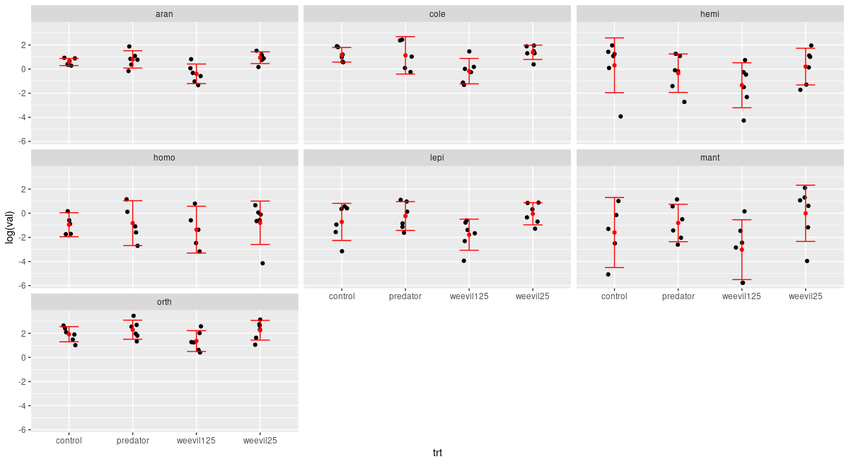

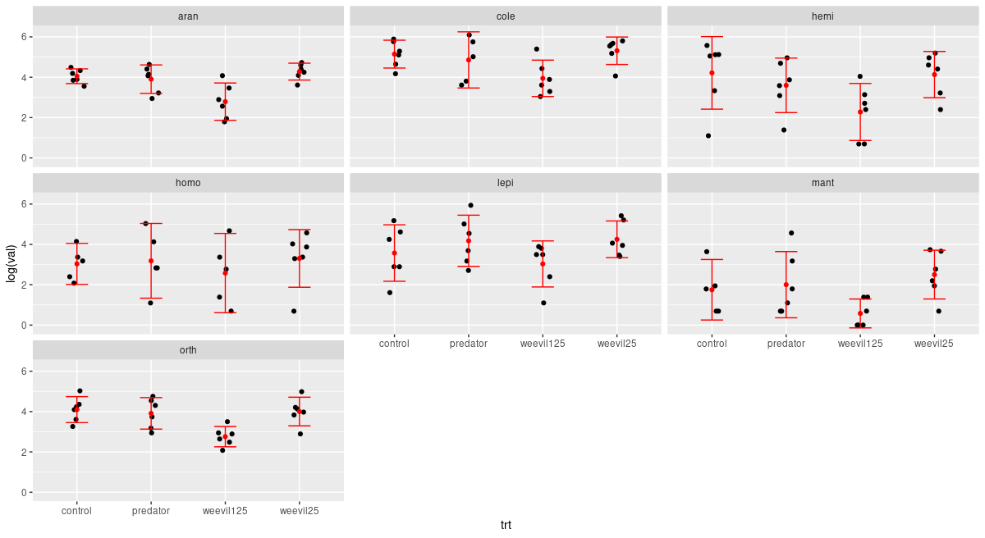
Run the tests: for now it is only good to see that according to pRDA community is degenrating.

Therefore, I conclude that generalist herbivores didn’t caused any directional change in plant community composition. Nevertheless, they decreased total biomass of plants, caused a degeneration of herbivore and intermediate predator community.

Hypothesizing possible mechanisms:
1. Community seems not to be “packed”. Low levels of herbivore increase didn’t affect the community (plant, herbivore, ip’s).:
- Insecticide treatment would have a most random composition of insects. Nevertheless, we didn’t found any differences between these treatments and the control (based on the network modularity analysis: measures niche partitioning within the community (Augustyn, Anderson, & Ellis, 2016) ).
2. What is going on in these modules? Cole001 seems to attach to each module but are not changing interaction within these modules. Maybe, however, they are changing only within the modules to which they attach. In general, we found that each plant species is its own module.

3. If community is controlled by predators TTI should apply in natural system [could predictions of TTI hypothesis mask effects of predator removal on the food chain (whole community) level?]: we should be able to observe decrease in generalists abundance and increase in specialists abundance. If there was a change in plant quality (as a community weighted mean of my only trait that measures quality: water content). These can be tested only on a subset of herbivore species we performed additional tests of the TTI hypothesis: no effect on individual species PDI [I don’t think this is of any use. We have nearly perfect relationship between herbivores’ abundance and the number of plant species utilized], when focus only on species, for which we have data in P and C treatment plots, therefore, estimated diet breadth range had no effect on individual species response.

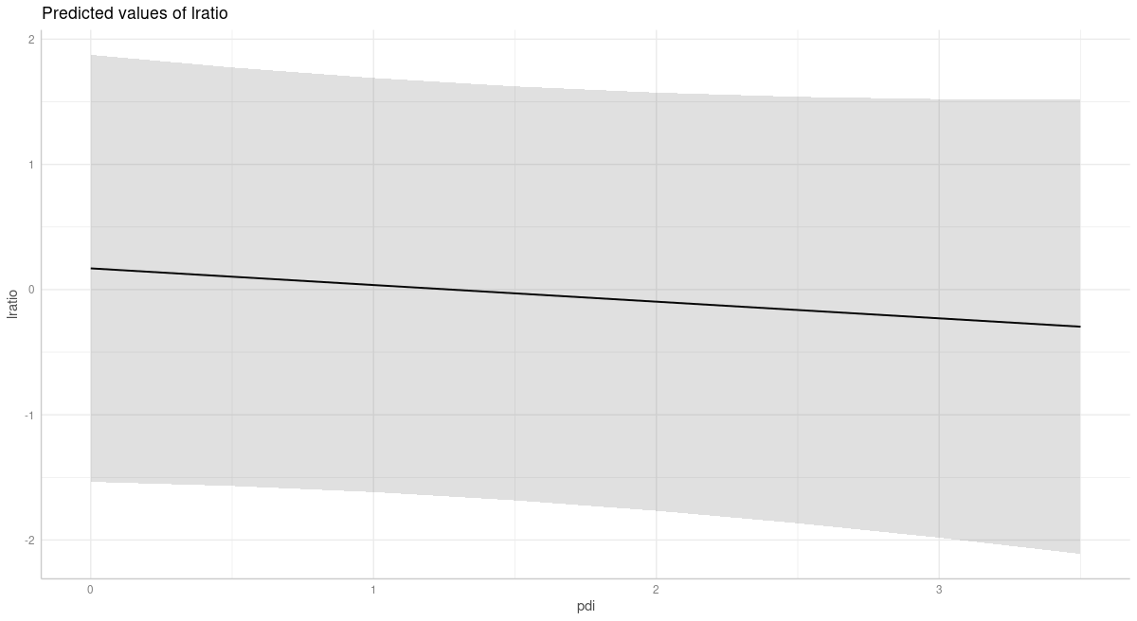
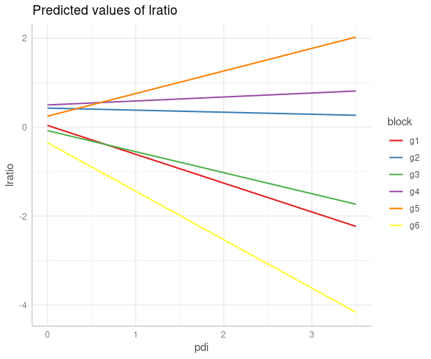
Plot [X] uncorrelated random intercepts and slopes with abundance as a weighting factor! Log ratio dependence on herbivore species specialization.

More specialized insects (PDI close to 1) are not positively affected by predators in control plots (log ratio as log[c/p]). There is significant if only random effect of block is included. But this might be related to plant community composition etc…. might be problematic to test with limited data. When random slope for each garden is included we see that it varies from positive to negative. I used nlme package and fitted random slope model and it showed no significant dependence of log-ratio on pdi. This result confirms again no effect of predtaors. Second plot is from lmer and ggeffects.
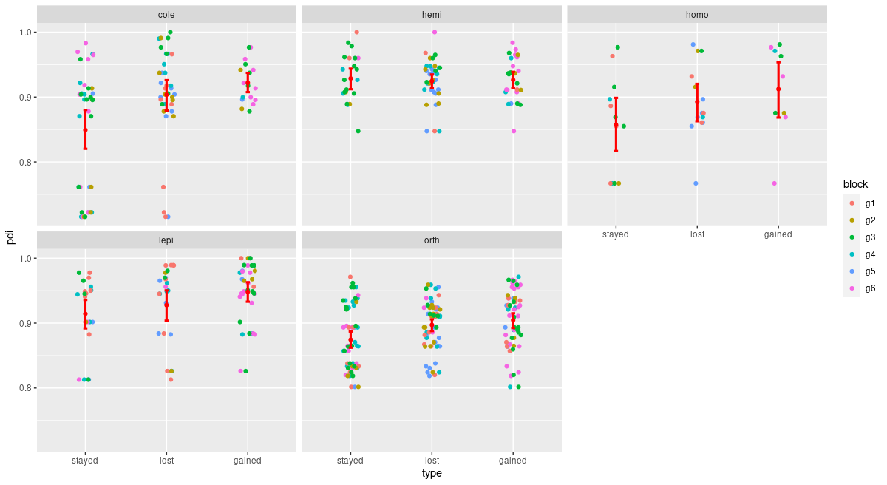
Plot [X] PDI values for species which were lost gained or stayed after applying predator treatment to control plot. Responses are specific to herbivore order. Removed species with abundance lower than 10 individuals.

C. If there is a limited cascading and top-down effect by predators control to what extend herbivores control plant populations.
Hypothesized effect of predators on herbivore community focuses on reducing interspecific competition: from Ponisio: “competitive or ecological release, increases population niche breadth by increasing among-individual variation (Bolnick et al., 2010)”. If we have such a limited effect of predators, inter-specific competition should drive herbivore communities. Herbivores may compete exploitatively for resources. To what extend these can also affect plants is unclear. Different feeding modes from Schmitz... We showed in our previous paper, that herbivores had positive effects on plant diversity, community and trait composition. We also showed that there was no significant increase (despite some increase visible) in plant biomass. This suggests that bottom-up control of herbivores by plants might be stronger (this is what log ratio plots would suggest). Also, no effect of predator removal on plants might suggest absolute food limitation, where all available resources are eaten by hrebivores, that are limited only by its avilability. When more food becomes available, it is being divided between present herbivore individuals. In this case predation only increase per capita share of plant resources for surviving herbivores – ecosystems like this should be largely “brown” (Schmitz 2010). Why IPs would then be affected so strongly?
Maybe not much is actually available for herbivores...
What is going on within herbivore community when weevils are added? Are they competing more strongly for resources? Hypotheses about herbivores on plants: Insecticide didn’t strongly increase productivity on our plots. This suggests, that herbivores are more restricted by their ability to digest and assimilate food and that community might not be saturated. Increased intra-specific competition should lead to increased modularity of plant-herbivore networks (Augustyn et al., 2016). This is not the case in our data (not for abundance nor biomass based networks). No increase compared with predator plot was observed for W125 and W25. PDI plots:
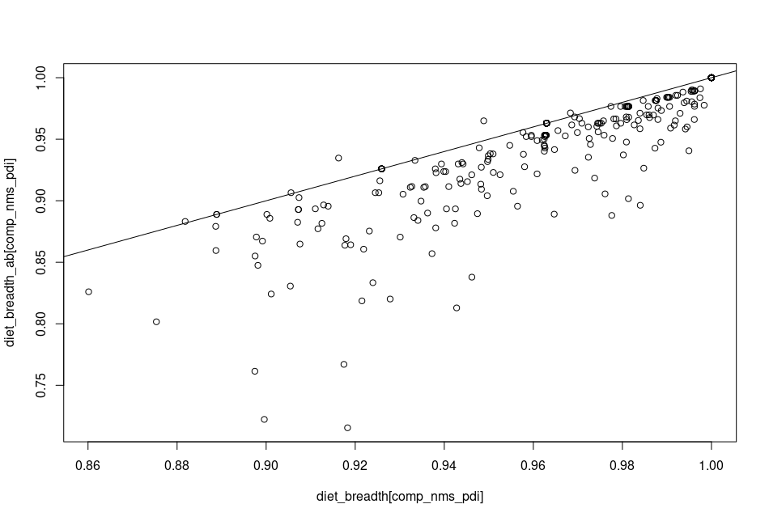
plot [x] PDI values calculated based on abundance vs based on biomass. Line is slope 1 and intercept 0 [pdi.R]
Fig [X] network descriptors for putative interaction networks based on herbivore abundances on plants. [still need to check significance for some of these]
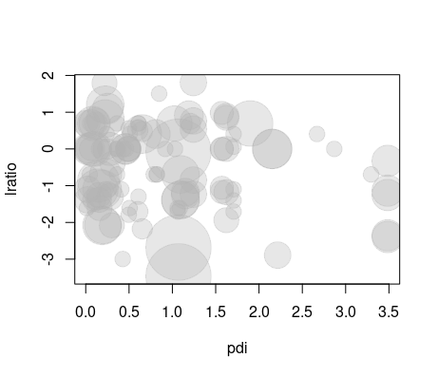

Fig [X] Similariliy no effect on PDI when comparing predatory plot with W125 plot. Size of circles is proportional to individual species’ abundance.

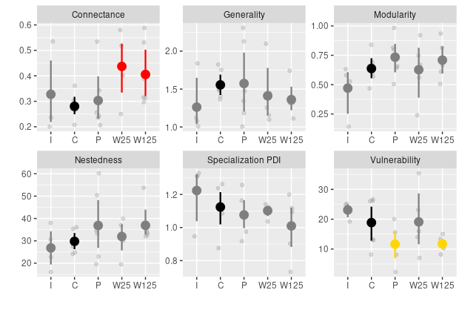
Fig [X] Network descriptors for putative interaction between plants-herbivores. Experimentally manipulated weevil species was removed form all networks before the analyses. Red color indicates significance at the

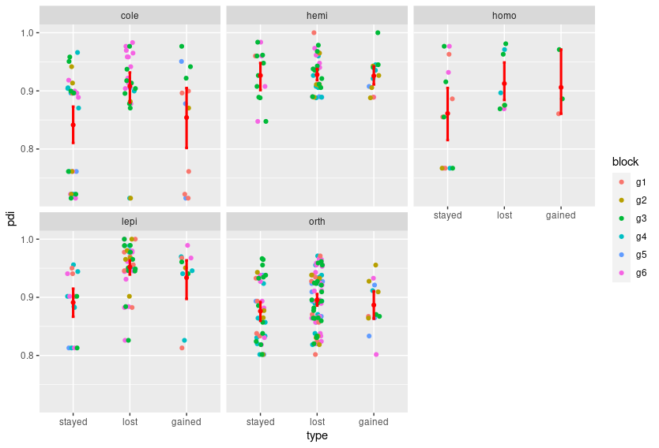
Plot [X] PDI values for species which were lost gained or stayed after applying weevil 125 treatment to predator plot. Responses are specific to herbivore order. Species for which abundance was higher than 10 ind.
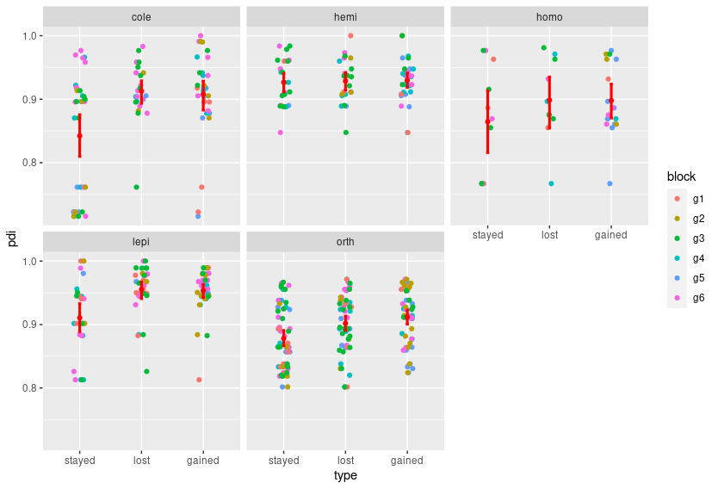
Plot [X] PDI values for species which were lost gained or stayed after applying weevil 25 treatment to predator plot. Responses are specific to herbivore order.

We test whether addition of generalist herbivores affected herbivore and IP invertebrate predator community. Questions asked here may concerning: A) to what extent insect community is controlled by plant community () B) saturation of herbivore community: would adding significant amount of herbivores force some changes in it, would some groups be affected more strongly than others. Comparison of P, I, and W125 plots (however the state of the community at the moment of sampling in case of biomass might not represent the effect well. [what type of results I expect here?].
Plots []: log ratio of P/W125 for biomass,
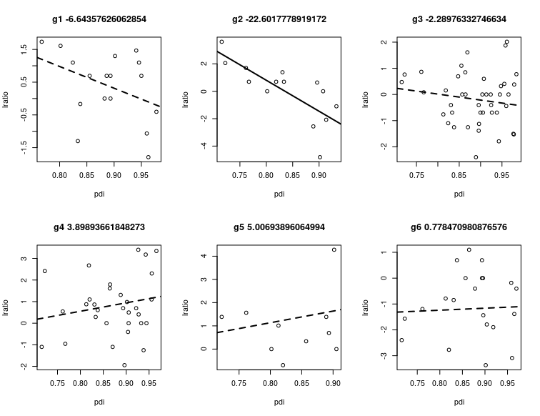
Plot[X] PRED/CONT log ratio vs PDI for individual gardens.
Plot []: Insect community I,P,C,W1,W2 / P, W1,W2 [should that be with or without IPs? Definitely the effect of vegetation would have to be removed, however, there were no significant PC axes. 1. Effect of vegetation on herbivore community composition [PCs from the plant community on the Herbivore community]. 2. Effect of the treatment on the herbivore community composition I/P/W25/W125 or P/W25/W125 [with plant effect removed]]
Plot [] Ordination with IP effect removed.
Plot [] How IPS are affecting herbivore species community? Log ratio plots and ordination.
We showed in our previous work, that insects affected plant community composition. Predators had an effect on plant community assembly process. To what extent herbivores are able to control plant biomass.
Addition of generalist – would it change the insect community composition? There was no effect on plants other than decease in biomass – no richness no diversity, what does that men?
Describe results step by step once again:
Is biomass of a plot a better description of the herbivory load than species identity? I compared models for species richness, diversity, abundance and biomass containing either only plant biomass or plant identity, and to each model I added missing species identity or species biomass and compared their performance. If these two components are important this would suggest that biomass itself is not enough to predict richness, abundance and diversity of herbivorous communities. Both biomass and species identity are important in predicting species abundance. However species identity can becomes negligible in some treatment plots. But this might not be a good approach as some species tend to occur at lower abundances. Maybe it would be better to test whether there are differences in species’ abilities to accumulate species: see if there is a significant interaction between species identity and biomass.

For biomass interaction of species and biomass was not significant, however in some cases we based our estimations on only three observations. Nevertheless, it suggests that species identity might have limited importance in the early successional communities, at least in case of the biomass. Qualitatively similar effects were shown for herbivores abundance.

In case of richness random effect of block was significant, nor the interaction term. Biomass of plants predictably increased richness, but this relationship was significantly higher only for Pipturus argenteum.
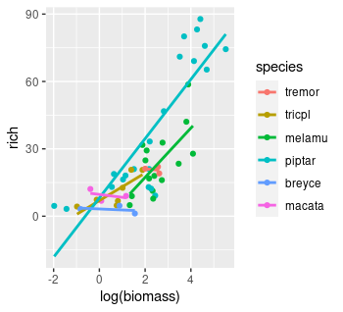
Significance of random effect in case of richness and its lack in case of biomass suggests that plots accumulate herbivores based on biomass, but richness most probably depend on local site properties.

What about the treatment? We were not able to find any relationship between accumulation slopes and treatment.

There is large variability in plant community composition, that was not explained by treatment, by local site conditions

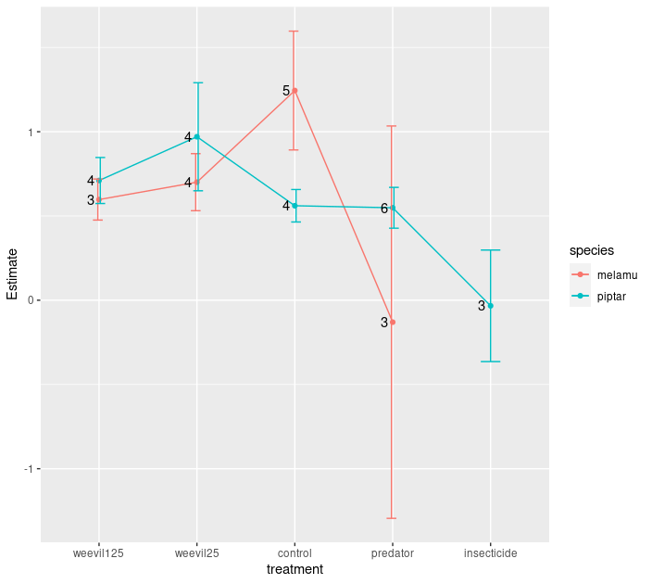
Figure X. Estimated slopes and their standard errors of logged plant biomass vs logged invertebrate abundance (individual accumulation curve on log-log plot), for two most prevalent plant species: Melanolepis multiglandulosa and Pipturus argenteum. Cole 001 removed from the analysis.

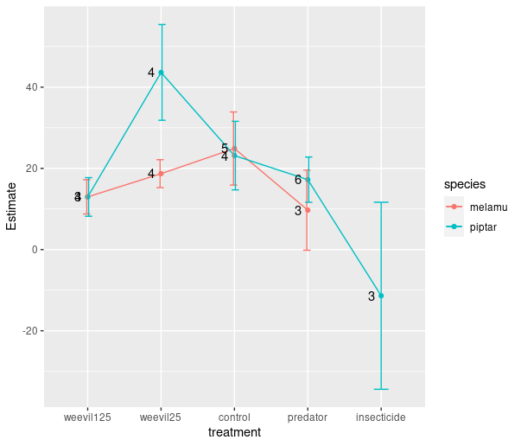

Figure X. Estimated slopes and their standard errors of logged plant biomass vs invertebrate richness (individual accumulation curve), for two most prevalent plant species: Melanolepis multiglandulosa and Pipturus argenteum. Cole 001 removed from the analysis.

I would like to have a variable that would indicate whether and to what extent a species was modifying its diet in response to the predator treatment (rda coordinates?). I guess PDI can serve as this.

Bayesian model with interaction (abundance/biomass (or log ratio) = quality*pdi*size [maybe instead of family] + random_element?). Family can be a random effect? I don’t think it should be. We want to evaluate predictive power of family and not to give it a random variability.

Basic test for TTI: bayesian model with interaction ( abundance/biomass [or log-ratio] = quality*pdi*db + random_element). I don’t think I have enough data.

2. How to test, whether some other effects can be important, are there some emergent patterns? Intermediate predation? Competition?

3. TTI hypothesis predicts that generalists should be more strongly affected by predation at the low quality plants. However, in a diverse plant community they can switch resources easily (depending on their mobility). Therefore, I would need to check how often generalists (estimated from our data) would stay within the plot more often than specialists. The latter would more often disappear and show up on the predator treatment plot. But this graph might be flawed in the sense that “specialists” might be less abundant [analysis needs to be revised with abundance being a weighting factor].

However, this relationship is not present in our data. [resource_switching.R ] Call:
glm(formula = totbio ~ db, family = gaussian(link = "log"), data = anip)

Deviance Residuals:
Min 1Q Median 3Q Max
-0.2045 -0.1782 -0.1536 -0.0728 9.2065

Coefficients:
Estimate Std. Error t value Pr(>|t|)
(Intercept) -2.615 1.250 -2.092 0.0365 *
db 1.029 1.319 0.780 0.4353

Where does this randomness come from?
I have examined turnover (Bray-Curtis dissimilarity index broken into balanced and gradient component) in herbivore and IPs community composition. Within each block I examined plant species which were present in both control and treatment plots. For these species I calculated insect community turnover caused by the treatment (within species turnover). Next I compared insect community on a given plant species in a control plot with insect community on all other species in the treatment plot within a given garden. This allowed to see how within species turnover compares with between species turnover [switch these names in the code, not done properly].
Figure 1: Herbivore species turnover rates calculated for plant species present in both control and a given treatment plot (Within) in a given experimental block, and for species in the control plot vs all other species in a treatment plot (Between). Turnover is based on Bray-Curtis dissimilarities. Mean and bootstrapped 95% CIs are shown. Grey points indicate empirical values. Only Control vs Weevil 25 was significantly different.

I.e. I wanted to see how dissimilar are communities on the same plant species compared with other species present in the same garden. If values of turnover within species are comparable with ones between species, this might suggest, that randomness in invertebrate community composition doesn’t stem from the plant species community. If turnover within plant species in low, this suggest, that plant species are influencing their community, and if there is randomness in herbivore community composition it Is probably primary caused by plant community composition.

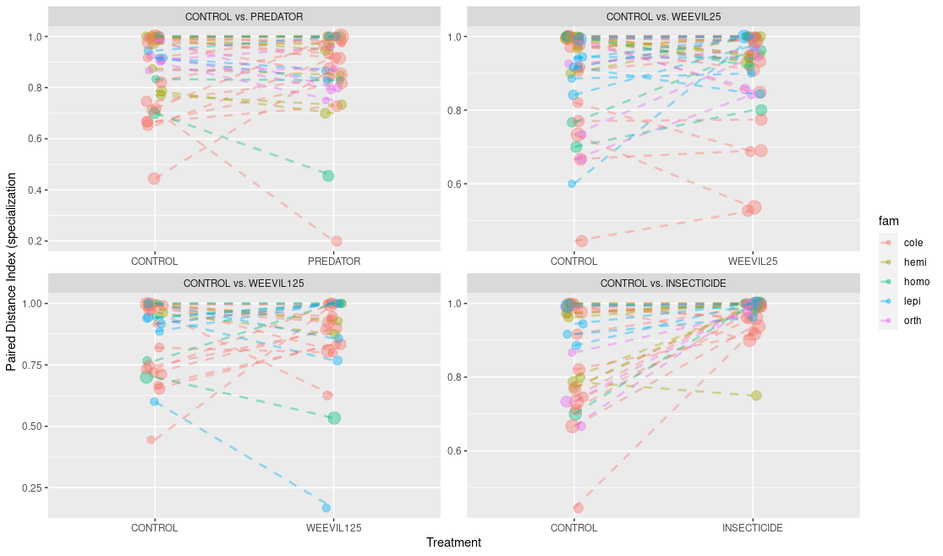
Fig X. [pdi_response_to_treatment.R]Comparison of species’ realized PDI values under treatments. Only herbivores with abundance higher than or equal to five in treatment and control plot. Logarithm of abundance is indicated by point size. Colors represent different morpho-species within gardens. Statistical significance was tested based on within garden, between species log ratios. We used linear mixed models to test for statistically significant difference of log ratios from zero. Significant are: PREDATOR: nothing; WEEVIL 25: Lepidopera increase, Orthoptera increase (marginally ~ 0.07); WEEVIL 125: nothing; INSECTICIDE: Orthoptera increase, Coleoptera, Hemiptera and Homoptera marginally increase (0.055, 0.09, 0.07 respectively)

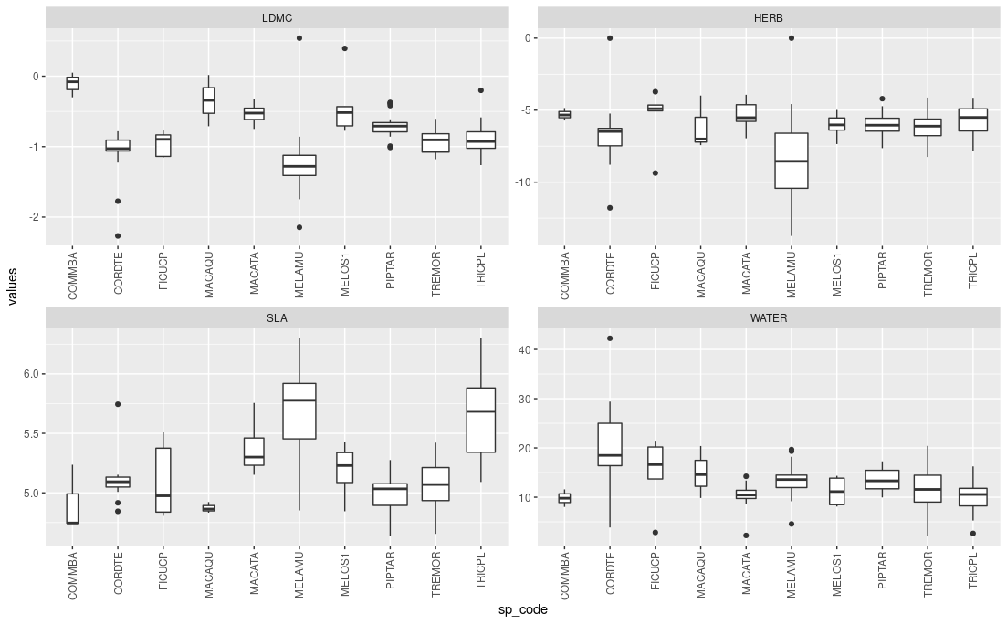
Available plant quality traits.

