Dear Editor,

We are happy to submit our manuscript entitled ‘Predators have limited effects on plant-herbivore interaction network in early succession in tropical forest gaps’ for consideration for review in ECOLOGY.
The current work is an evaluation of birds, bats, and ants effects on arthropod community and vegetation during early succession of tropical rain-forest gaps in Papua New Guinea. We tested multiple hypotheses related to the mediation of these effects by plant-herbivore interaction networks: specialization and species composition of herbivorous insects; presence of arthropod predators; plant compensation for damage, bottom-up regulation, and plant quality. This study was also meant to explain weak cascading effects, coupled with a considerable impact of herbivorous insects on shaping the structure of successional vegetation previously found in this system (Szefer et al. 2020). Therefore, we anticipated a strong compensation for the effects of focal predators by natural histories of arthropods and plants and their interaction networks.
We experimentally removed birds, bats, and ants during early stage of forest gap regeneration. In our data-set we combined diverse putative plant-insect herbivore interaction networks (with and without focal predators), predatory and herbivorous arthropod community composition, and functional traits of woody plant species associated to growth, defense, and leaf quality for herbivores.
We found that top-down effects of birds, bats and ants on arthropod communities at the early stages of tropical forest gap succession were weak, and insect herbivores were mainly bottom-up controlled by the vegetation. Moreover, quantity of foliage was more important in structuring herbivore abundance than its quality. However, the role of focal predators was not negligible. They affect interaction networks by decreasing body sizes of herbivores and arthropod predators, and modifying their diet breadth. It not only evaluates the effects of plants and predators on herbivores, but strives for mechanical understanding based on the established theory of tri-trophic interactions. It thus improves our understanding of the roles of higher trophic levels on successional process in tropical forests.
The manuscript is not being considered for publication elsewhere while publication in your journal is pending. All sources of funding are acknowledged in the manuscript, and all authors have declared any direct financial benefits that could result from publication. All appropriate ethics and other approvals were obtained, and the study was conducted after obtaining oral consent from managers of the land and in accordance with applicable law.
Thank you for your time and we hope that you consider our manuscript worth reviewing.

Kind regards,
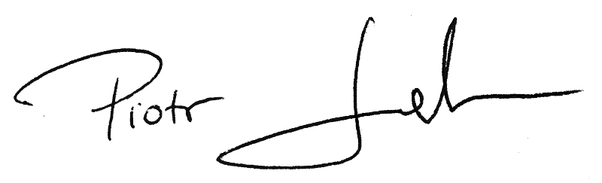
Piotr Szefer, on behalf of all of the co-authors.
Biology Centre, Institute of Entomology,
Czech Academy of Sciences,
České Budějovice, Czech Republic
szefer85@gmail.com
+48733328044

References:
Szefer, P., K. Molem, A. Sau, and V. Novotny. 2020. Impact of pathogenic fungi, herbivores and predators on secondary succession of tropical rainforest vegetation. Journal of Ecology 108:1978–1988.

