Piotr Szefer, Kenneth Molem, Austin Sau, Jan Lepš & Vojtěch Novotný. Predators have limited effects on plant-herbivore interaction network in early succession in tropical forest gaps. Ecology.

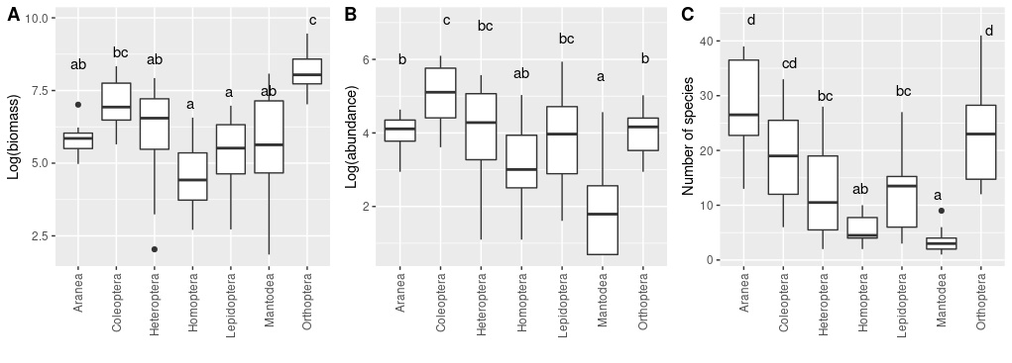
Figure S1. Characteristics of arthropod orders collected in exclosures and control plots: biomass (A), abundance (B), and number of species (C). Different Latin letters indicate groups for which differences in mean values were statistically significant at the α = 0.05 level (pairwise comparisons with the Tukey’s correction for multiplicity).
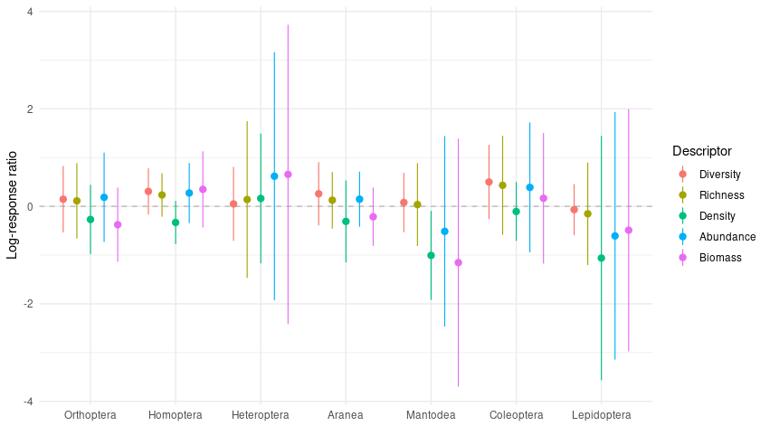
Figure S2. Predator effects on various community descriptors for individual insect orders. Predator effect were measured using the log-response ratio (LRR), which is a natural logarithm of a ratio of descriptor value from the control to the exclosure within a given experimental block. Negative/zero/positive value of the LRR indicate negative/no/positive effect of predators on a given descriptor. Mean and 95% bootstrapped confidence intervals for the log-response ratios are presented. No predator effect was different from zero (dashed line) for any descriptor within any arthropod Order. Diversity was measured with the inverse Simpson index, and density as a number of arthropod individuals per one square meter of foliage.
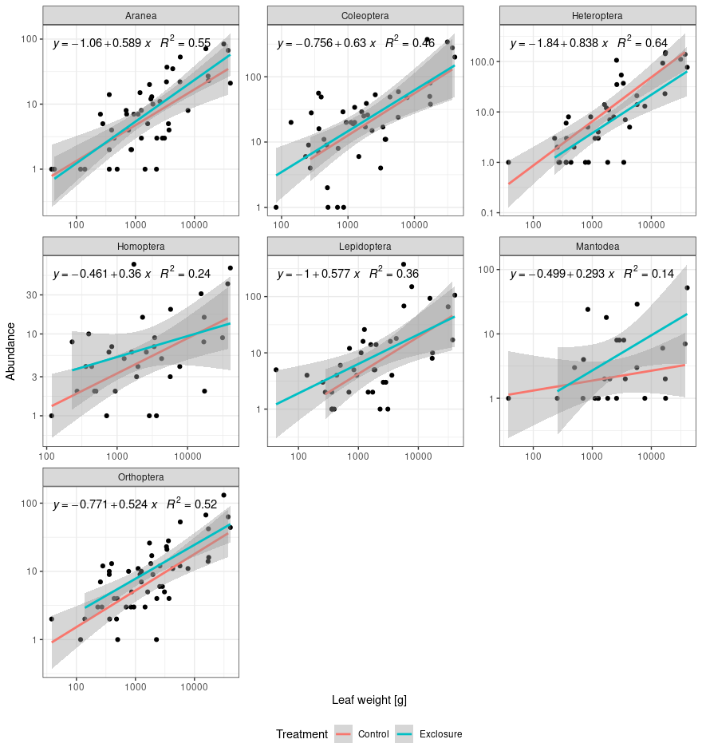
Figure S3. Linear relationship between leaf weight and the abundance of studied arthropod orders in exclosure (blue line) and control (red line) plots. Black points represent individual plant species from experimental plots. Vertical and horizontal axis are in logarithmic scales. For each Order presented r-square values and equations are for the the overall regression model because there was no significant interaction between the treatments.
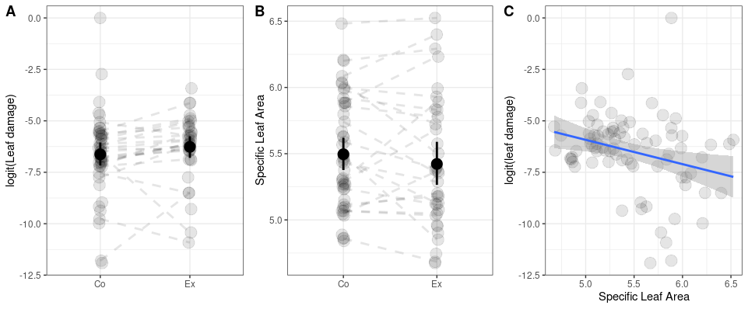
Figure S4. Comparison of (A) leaf damage and (B) specific leaf area between woody plant individuals from control (Co) and predator exclosure (Ex) plots, and correlation (C) between specific leaf area and the leaf damage. Leaf damage was measured as a logit percentage of leaf area lost due to herbivore feeding. Specific leaf area was evaluated as area of a leaf per one gram of its mass. Black points and whiskers on panels (A) ans (B) represent mean values and 95% CIs respectively. Grey points represent individual plant species at each experimental block. Dashed lines (if present) connect plant species within the same block but at different treatment plots. Solid line on the panel (C) indicates significant correlation (T = -2.475, P = 0.015) evaluated using a linear mixed-effect model with plant species and block as random effects. Details of the statistical models can be found in Tables S1 and S2.
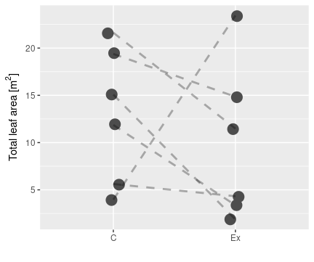
Figure S5. Total leaf area (in m²) of all woody plants in control (C) and predator exclosure plots (Ex). Points indicate total area for individual experimental plots. Lines connect values from different treatments within an experimental block. Linear mixed effect models with a random effect of block showed no difference in the total area between control and predator exclosure plots.
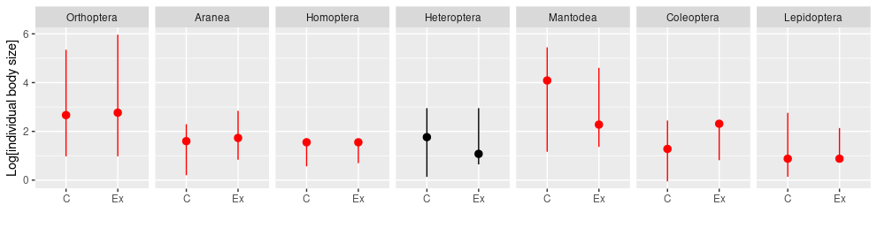
Figure S6. Distribution of body length (in cm) of individual arthropods in control (C) and exclosure plots (Ex). Dots represent log-transformed median values, whiskers 5th and 95th percentiles of studied insect Orders in control (C) and exclosure (Ex) plots. Red color indicates significant differences of the medians between the treatments evaluated using the non-parametric Mann-Whitney test.

Table S1. Specifications of all statistical models used in our analyses of 12 experimental (six control and six predator exclosure) plots grouped in six blocks. Explanations of indices and links to individual figures in the text and supplement are given in the Description column. The Response column indicates the distribution and parameters used by a model. The Variance column shows formula used to calculate variance of a descriptor, and linear predictors are defined in the Mean column. Random structure, if used, is defined in the last column.
Model | Description | Response | Variance | Mean | Random structure
Arthropod community characteristics
M.1 | Fig. 1, H-A, AP-A. Abundance of herbivores or arthropod predators in control and exclosure plots modeled as the negative binomial distribution. |  |  |  | -
M.2 | Fig. 1, H-B, AP-B. Biomass of herbivores or arthropod predators in control and exclosure plots within an i-th block.
M.3 | Fig. 1, H-R, AP-R. Number of species of herbivores or AP in control and exclosure plots modeled with the Poisson distribution. |  |  |  | -
M.4 | Fig. 1, H-D, AP-D. Diversity (inverse Simpson’s index) of herbivores or AP in control and exclosure plots. |  |  |  | -
M.5 | Fig. 1, H-Dens, AP-Dens. Density of herbivores or AP in control and exclosure plots within at i-th block .
Network descriptors
M6 | Fig. 4. Connectance modeled using the Beta distribution. |  |  |  | -
M.6 | Fig. 4. Generality modeled using the truncated normal distribution. |  |  |  | -
M.7 | Fig. 4. Modularity modelled using the Beta distribution. Mod_{i} indicates value of modularity at the i-th block.
M.8 | Fig. 4. Nestedness |  |  |  | -
M.9 | Fig. 4. Specialization modelled using the Beta distribution. PDI_{i} indicates value of specialization (paired difference index) at the i-th block.
M.10 | Fig. 4. Vulnerability, modeled with the truncated binomial distribution. |  |  |  | -
Supplementary analyses
MS.1 | Fig. S1A. Biomass of an j-th arthropod Order at i-th block
MS.2 | Fig. S1B,C. Abundance and richness modeled using the negative binomial distribution. X_{ij} is a descriptor value of an j-th arthropod Order at i-th block
MS.3 | Fig. S12. Log-response ratio (logged ratio of control to exclosure value) of community descriptors for individual arthropod orders |  |  |  | -
MS.4 | Fig. S3. Plant biomass and herbivores abundance relationship. Abundij indicates abundnace of i-th plant species at the j-th plot |  |  |  | -
MS.5.1 | Fig. S4 A,C. Leaf damage at different treatments: j-th observation on k-th plant.
MS.5.2 | Fig. S4B. SLA values at control and exclosure plots. SLA_{ij} indicates observation for the i-th block and j-th plant.
MS.6 | Fig S5. Leaf area (in m²)for i-th block.
MS.7 | Fig. S7. Herbivore species performance (measured as log-ratio of the abundance from the control to the predator exclosure plots) in relation to body size. LRR_{ij} indicate i-th order and j-th herbivore species. |  |  |  | -
MS.8 | Fig. S11. Response variable is weighted by cumulative abundance of each species. |  |  | A)  B)
MS.9 | Fig S12A. Specialization modeled with the Beta distribution. PDI_{ijk} indicates specialization value from the i-th group, j-th order, and k-th block
MS.10 | Figure S12B. Abundance modeled with the negative binomial distribution. Abu_{ijk} indicates abundance of the i-th group, j-th order, and k-th block
MS.11 | Figure S13. Testing whether log response ratios (log-ratio of the specialization from the control to the predator exclosure plots) are different from zero. lrrPDI_{i} indicate log-respons ratio of specialization at i-th block.
MS.12 | Fig. 14. Case-weighted (ln[herbivore species abundance]) beta regression of diet shift dependence on specialization of j-th herbivore species at i-th block.
MS.13 | Figure S15. Mean LRR value for k-th quality category, j-th herbivore species at i-th block.
MS.14 | Figure S16. Water content effect on LRR of j-th herbivore on k-th plant at i-th block. Model selection that showed lack of interaction with herbivore Orders
MS.15 | Figure S17: Evennnes of the degree distribution at i-th experimental block.  Figure S18: Trophic community composition at i-th experimental block.  Figure S19: Trophic community composition (ratio of AP to herbivores) and distribution of interactions (evenness of plant degree distribution) in response to exclosure at i-th experimental block.

Table S2. Estimates, standard errors, test statistics, and p-values for the parameter of selected statistical models defined for our experimental data of 12 experimental plots (six control and six predator exclosure plots) grouped within six blocks. Model names refer to the model equations in the Table S.1.
Model | Parameter | Estimate | Std. Error | Statistic | P-value
M1. H-A | α | 6.196 | 0.278 | T = 22.294 | <0.001
M1. H-A | β | -0.095 | 0.393 | T = -0.242 | 0.809
M1. H-A | k | 2.1673 | 0.832
M.1  AP-A | α | 4.241 | 0.214 | T = 19.809 | <0.001
M.1  AP-A | β | 0.149 | 0.302 | T = 0.493 | 0.622
M.1  AP-A | k | 3.836 | 1.600
M.2 H | α | 8.481 | 0.264 | T = 32.120 | < 0.001
M.2 H | β | 0.402 | 0.186 | T = 2.160 | 0.031
M.2 H | σ_{block} | 1248.0
M.2 H | σ_{residual} | 2316.0
M.2 AP | α | 6.693 | 0.313 | T = 21.399 | < 0.001
M.2 AP | β | 0.275 | 0.134 | T = 2.055 | 0.040
M.2 AP | σ_{block} | 260.9
M.2 AP | σ_{residual} | 352.6
M.3  Richness Herbivore | α | 4.648 | 0.226 | T = 20.536 | <0.001
M.3  Richness Herbivore | β | -0.057 | 0.325 | T = -0.177 | 0.867
M.3  Richness Herbivore | θ | 32.064
M.3  Richness AP | α | 3.718 | 0.141 | T = 26.440 | <0.001
M.3  Richness AP | β | -0.008 | 0.199 | T = -0.041 | 0.968
M.3  Richness AP | θ | 4.883
M.4  Herbivores  (inverse Simpson’s index) | α | 20.763 | 2.791 | T = 7.438 | <0.001
M.4  Herbivores  (inverse Simpson’s index) | β | -8.935 | 3.948 | T = -2.263 | 0.047
M.4  Herbivores  (inverse Simpson’s index) | σ_{residual} | 6.837
M.4  AP  (inverse Simpson’s index) | α | 14.114 | 3.422 | T = 4.124 | 0.003
M.4  AP  (inverse Simpson’s index) | β | -5.116 | 4.840 | T = -1.057 | 0.315
M.4  AP  (inverse Simpson’s index) | σ_{residual} | 8.382
M.5 Density herbivores | α | 3.367 | 0.272 | T = 12.385 | <0.001
M.5 Density herbivores | β | 0.6351 | 0.232 | T = 2.743 | 0.006
M.5 Density herbivores | σ_{block} | 7.286
M.5 Density herbivores | σ_{residual} | 16.745
M.5 Density AP | α | 1.973 | 0.184 | T = 10.711 | <0.001
M.5 Density AP | β | 0.214 | 0.120 | T = 1.179 | 0.073
M.5 Density AP | σ_{block} | 0.689
M.5 Density AP | σ_{residual} | 2.077
Network Descriptors
M.6  Connectance | α | -0.920 | 0.159 | Z = -5.771 | <0.001
M.6  Connectance | β | 0.078 | 0.223 | Z = 0.348 | 0.728
M.6  Connectance | θ | 30.93 | 12.46 | Z = 2.482 | 0.013
M.7  Generality | α | 1.555 | 0.147 | T = 10.565 | <0.001
M.7  Generality | β | 0.019 | 0.208 | T = 0.090 | 0.928
M.7  Generality | σ_{residual} | 0.360
M.8  Modularity | α | 0.620 | 0.327 | Z = 1.893 | 0.058
M.8  Modularity | β | 0.533 | 0.249 | Z = 2.143 | 0.032
M.8  Modularity | σ_{block} | 0.451
M.8  Modularity | σ_{residual} | 0.671
M.8  Modularity | θ | 26.6
M.9  Nestedness | α | 29.790 | 4.803 | T = 6.202 | <0.001
M.9  Nestedness | β | 6.862 | 6.792 | T = 1.010 | 0.336
M.9  Nestedness | σ_{residual} | 11.765
M.10  Specialization | α | 2.780 | 0.183 | 15.316 | <0.001
M.10  Specialization | β | 0.024 | 0.254 | 0.931 | 0.352
M.10  Specialization | σ_{block} | 0.023
M.10  Specialization | σ_{residual} | 0.153
M.10  Specialization | θ | 102
M.11  Vulnerability | α | 18.775 | 2.9722 | T = 6.317 | <0.001
M.11  Vulnerability | β | -8.156 | 4.554 | T = -1.791 | 0.073
M.11  Vulnerability | σ_{residual} | 7.144
Selected Supplementary Analyses
MS.5.1 Best model | α | 0.763 | 2.862 | T = 0.267 | 0.790
MS.5.1 Best model | β | -1.307 | 0.526 | T = -2.486 | 0.015
MS.5.1 Best model | σ_{plant} | 1.508
MS.5.1 Best model | σ_{residual} | 1.288
MS.5.2 SLA | α | 5.382 | 0.094 | T = 56.943 | <0.001
MS.5.2 SLA | β | -0.044 | 0.060 | T = -0.737 | 0.464
MS.5.2 SLA | σ_{block} | 0.280
MS.5.2 SLA | σ_{plant} | 0.156
MS.5.2 SLA | σ_{residual} | 0.243

Table S3. Arthropod individual body lengths analysed with the Mann-Whitney’s tests for comparisons of in control and predator exclosure plots. Abbreviations: NC – number of individuals in the control, NEx - number of individuals in the exclosure plots. HL – Hodges-Lehman centrality estimator (median of the differences between individuals from control and exclosure), ns – not significant. ‘Direction’ indicates how median changes from predator exclosure (no focal predators: birds, bats and ants) to the control plots (predators present).
Order | NC | NEx | HL | P | Direction
Orthoptera | 422 | 369 | -2.77E+00 | <0.001 | decrease
Homoptera | 135 | 252 | -3.10E-05 | 0.019 | decrease
Heteroptera | 785 | 362 | -7.27E-05 | 0.208 | ns
Aranea | 362 | 351 | -8.88E-01 | <0.001 | decrease
Mantodea | 55 | 133 | 1.47E+01 | 0.006 | increase
Coleoptera | 1214 | 993 | -1.36E+00 | <0.001 | decrease
Lepidoptera | 389 | 702 | 1.10E-05 | 0.016 | increase

Table S4. Arthropod individual body lengths at individual plant species analysed with the the Mann-Whitney’s tests. Abbreviations: NC – number of individuals in the control, NEx - number of individuals in the exclosure plots. HL – Hodges-Lehman centrality estimator (median of the differences between individuals from control and exclosure), ns – not significant. ‘Direction’ indicates how median changes from predator exclosure (no focal predators: birds, bats and ants) to the control plots (predators present).
Order | Plant | NC | NEx | HL | P | Direction
Orthoptera | Pipturus argenteus | 84 | 147 | -3.87E+00 | 0.061 | ns
Orthoptera | Premna sp.1 | 2 | 13 | -1.67E-06 | 0.661 | ns
Orthoptera | Trichospermum pleiostigma | 22 | 17 | 2.89E-05 | 0.931 | ns
Orthoptera | Melochia sp.1 | 131 | 28 | -3.94E+01 | 0.000 | decrease
Orthoptera | Melanolepis multiglandulosa | 71 | 66 | 1.71E+00 | 0.162 | ns
Orthoptera | Macaranga tanarius | 17 | 3 | 4.03E+00 | 0.425 | ns
Orthoptera | Cordyline terminalis | 4 | 3 | 5.42E+00 | 0.858 | ns
Orthoptera | Breynia cernua | 6 | 7 | 9.45E+00 | 0.350 | ns
Orthoptera | Trema orientalis | 64 | 40 | 6.94E-01 | 0.137 | ns
Orthoptera | Manihota esculenta | 10 | 10 | -3.40E+01 | 0.047 | decrease
Homoptera | Trema orientalis | 24 | 17 | 1.45E-06 | 0.422 | ns
Homoptera | Piptrus argenteus | 47 | 106 | -4.42E-05 | 0.093 | ns
Homoptera | Melanolepis multiglandulosa | 34 | 81 | -4.21E-05 | 0.293 | ns
Homoptera | Trichospermum pleiostigma | 8 | 15 | -5.58E-05 | 0.893 | ns
Homoptera | Macaranga tanarius | 2 | 2 | 8.20E-01 | 0.617 | ns
Heteroptera | Trichospermum pleiostigma | 8 | 28 | -1.40E+00 | 0.379 | ns
Heteroptera | Melanolepis multiglandulosa | 356 | 60 | -3.83E-01 | 0.105 | ns
Heteroptera | Piptrus argenteus | 262 | 213 | 7.24E-05 | 0.963 | ns
Heteroptera | Melochia sp.1 | 111 | 7 | -1.92E+00 | 0.254 | ns
Heteroptera | Trema orientalis | 27 | 26 | 1.39E+01 | 0.002 | increase
Aranea | Melochia sp.1 | 84 | 5 | -4.37E+00 | 0.001 | decrease
Aranea | Trema orientalis | 61 | 62 | -8.06E-01 | 0.061 | ns
Aranea | Piptrus argenteus | 80 | 146 | -1.35E+00 | 0.000 | decrease
Aranea | Melanolepis multiglandulosa | 56 | 55 | -6.57E-01 | 0.189 | ns
Aranea | Cordyline terminalis | 12 | 8 | -3.26E-01 | 0.561 | ns
Aranea | Breynia cernua | 10 | 8 | 2.05E+00 | 0.032 | increase
Aranea | Trichospermum pleiostigma | 25 | 29 | 2.56E-01 | 0.459 | ns
Aranea | Macaranga tanarius | 6 | 7 | -1.07E+00 | 0.668 | ns
Mantodea | Piptrus argenteus | 11 | 67 | 1.62E-01 | 0.025 | increase
Mantodea | Melanolepis multiglandulosa | 3 | 18 | -1.48E-06 | 1.000 | ns
Mantodea | Trichospermum pleiostigma | 5 | 24 | 4.98E+01 | 0.000 | increase
Mantodea | Trema orientalis | 30 | 12 | -3.07E-05 | 0.740 | ns
Coleoptera | Piptrus argenteus | 393 | 662 | -3.65E-05 | 0.000 | decrease
Coleoptera | Trema orientalis | 107 | 44 | 5.80E-05 | 0.485 | ns
Coleoptera | Trichospermum pleiostigma | 50 | 79 | -4.99E-05 | 0.347 | ns
Coleoptera | Macaranga tanarius | 43 | 20 | -3.36E-05 | 0.860 | ns
Coleoptera | Melanolepis multiglandulosa | 148 | 81 | 8.67E-01 | 0.046 | increase
Coleoptera | Melochia sp.1 | 341 | 11 | -2.31E+00 | 0.078 | ns
Coleoptera | Premna sp.1 | 16 | 17 | -1.05E+00 | 0.824 | ns
Lepidoptera | Piptrus argenteus | 31 | 234 | -3.07E-01 | 0.002 | decrease
Lepidoptera | Trema orientalis | 218 | 417 | 3.64E-05 | 0.000 | increase
Lepidoptera | Trichospermum pleiostigma | 36 | 13 | -2.86E-01 | 0.527 | ns
Lepidoptera | Melanolepis multiglandulosa | 12 | 7 | 4.31E-05 | 0.966 | ns
Lepidoptera | Macaranga tanarius | 4 | 4 | 9.71E+00 | 0.142 | ns
Lepidoptera | Melochia sp.1 | 66 | 4 | 5.22E+00 | 0.323 | ns
Lepidoptera | Breynia cernua | 2 | 8 | -3.02E-01 | 0.891 | ns
Table S5. Arthropod individual body lengths at individual experimental blocks (g1, …, g6) analysed with the Mann-Whitney’s tests. Abbreviations: NC – number of individuals in the control, NEx - number of individuals in the exclosure plots, HL – Hodges-Lehman centrality estimator (median of the differences between individuals from control and exclosure), ns – not significant. ‘Direction’ indicates how median changes from predator exclosure (no focal predators: birds, bats and ants) to the control plot (predators present).
Order | Block | NC | NEx | HL | P | pred.eff
Orthoptera | g5 | 78 | 24 | -1.20E+01 | 0.010 | decrease
Orthoptera | g4 | 152 | 74 | -2.39E+01 | 0.000 | decrease
Orthoptera | g2 | 37 | 19 | -3.03E+01 | 0.072 | ns
Orthoptera | g1 | 60 | 42 | 4.53E-01 | 0.384 | ns
Orthoptera | g3 | 69 | 116 | -5.01E-01 | 0.560 | ns
Orthoptera | g6 | 26 | 94 | 2.06E+00 | 0.145 | ns
Homoptera | g1 | 29 | 17 | 1.83E+00 | 0.000 | increase
Homoptera | g4 | 11 | 17 | -2.67E-05 | 0.145 | ns
Homoptera | g2 | 8 | 3 | -5.03E-05 | 0.737 | ns
Homoptera | g3 | 63 | 62 | 6.31E-05 | 0.788 | ns
Heteroptera | g5 | 168 | 4 | -4.22E-01 | 0.734 | ns
Heteroptera | g3 | 156 | 143 | 2.19E+00 | 0.000 | increase
Heteroptera | g1 | 28 | 36 | 4.74E+00 | 0.000 | increase
Heteroptera | g6 | 3 | 109 | -3.02E+00 | 0.025 | decrease
Heteroptera | g2 | 263 | 22 | -1.34E+00 | 0.000 | decrease
Heteroptera | g4 | 167 | 48 | -6.91E-01 | 0.242 | ns
Aranea | g4 | 89 | 82 | -8.06E-01 | 0.050 | decrease
Aranea | g6 | 35 | 63 | 7.62E-01 | 0.047 | increase
Aranea | g3 | 76 | 103 | -2.02E+00 | 0.000 | decrease
Aranea | g2 | 49 | 25 | -2.92E+00 | 0.001 | decrease
Aranea | g1 | 66 | 59 | -7.54E-02 | 0.458 | ns
Aranea | g5 | 47 | 19 | -1.90E+00 | 0.003 | decrease
Mantodea | g3 | 7 | 6 | 7.96E-05 | 0.382 | ns
Mantodea | g6 | 2 | 96 | 1.62E-01 | 0.000 | increase
Mantodea | g5 | 6 | 2 | -1.47E+01 | 0.371 | ns
Mantodea | g2 | 2 | 3 | -6.35E-05 | 0.683 | ns
Mantodea | g1 | 38 | 24 | -4.87E-05 | 0.179 | ns
Coleoptera | g2 | 165 | 45 | -4.01E+00 | 0.000 | decrease
Coleoptera | g3 | 320 | 445 | -4.86E-05 | 0.000 | decrease
Coleoptera | g4 | 362 | 151 | -5.04E+00 | 0.000 | decrease
Coleoptera | g5 | 198 | 37 | -1.26E+00 | 0.000 | decrease
Coleoptera | g6 | 65 | 315 | 1.62E-06 | 0.294 | ns
Lepidoptera | g1 | 101 | 24 | 1.30E-01 | 0.658 | ns
Lepidoptera | g2 | 5 | 379 | 5.21E-05 | 0.000 | increase
Lepidoptera | g3 | 18 | 94 | 6.24E-05 | 0.965 | ns
Lepidoptera | g4 | 70 | 40 | 2.35E+00 | 0.001 | increase
Lepidoptera | g5 | 177 | 15 | -1.81E+00 | 0.000 | decrease
Lepidoptera | g6 | 18 | 150 | 1.48E+00 | 0.070 | ns
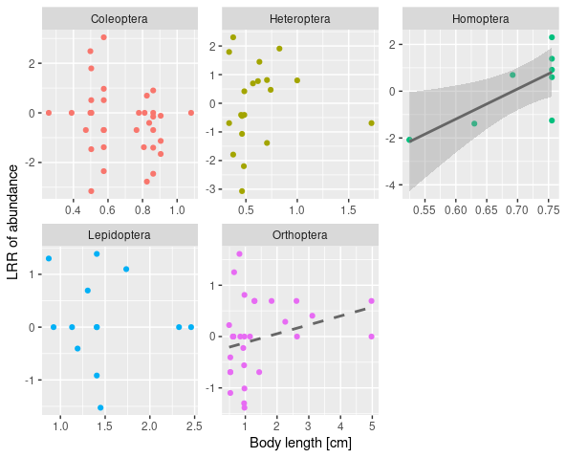
Figure S7. Relationships between body length of herbivorous insects and the effect of birds, bats and ants represented as logarithm of the control:exclosure abundance ratio for studied arthropod herbivore orders. Significance is indicated with the line type: solid line: α = 0.05, dashed line α = 0.1. In case of a significant regression 95% confidence intervals are plotted.
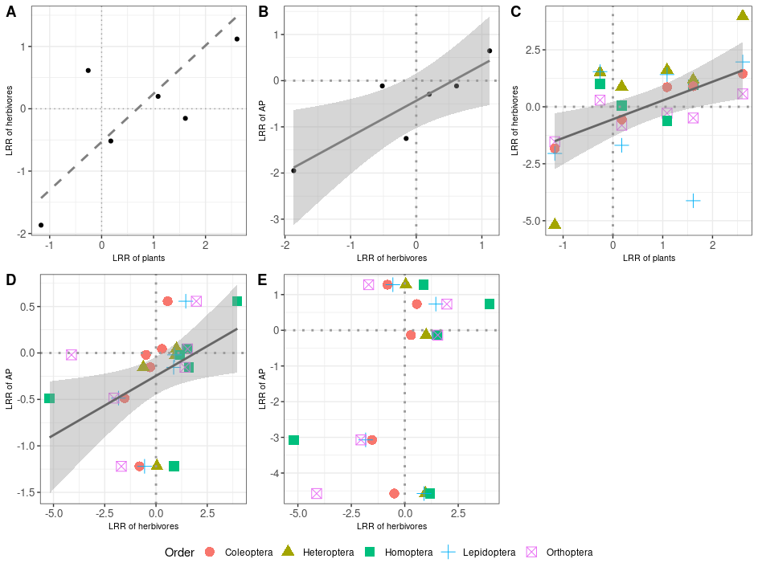
Figure S8. Relationships of predator (birds, bats and ants) effects on biomass between different trophic levels in individual plots: A – herbivores vs plants; B – herbivores vs arthropod predators (AP); C) herbivore Orders vs plants; D – spiders vs herbivores; E – mantoids vs herbivores. Predator effects were evaluated using log response ratios (LRR): the logarithm of the ratio between the biomass at the control and predator exclosure treatment within the same experimental block. Positive/negative values of the LRR indicate increase/decrease in biomass of a given trophic level in the presence of predators. Solid line represents significance at the α = 0.05 level and dashed line at the α = 0.1 level. 95% CIs also plotted for significant relationships.
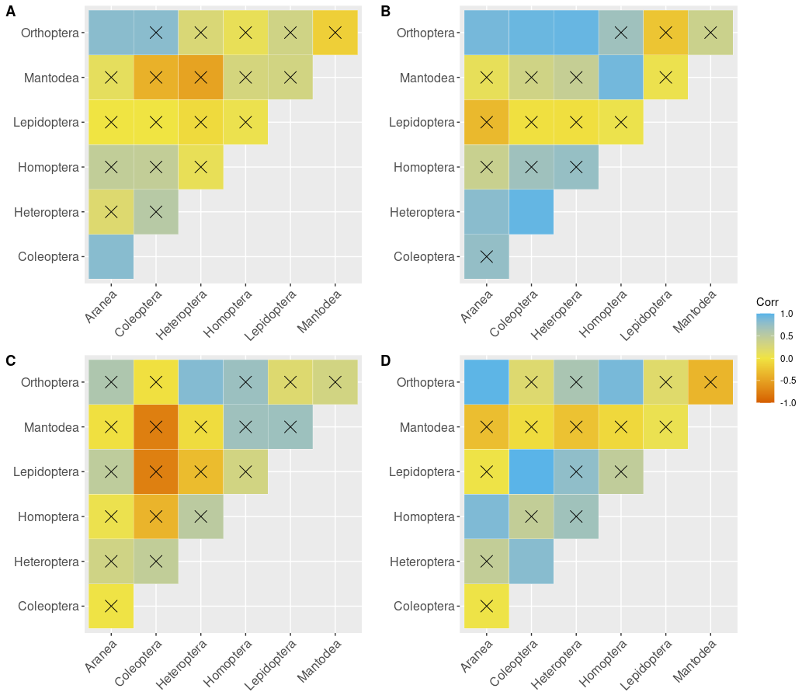
Figure S9. Pearson’s correlation plots for the raw abundance (A,B) and biomass (C,D) values of studied arthropod orders for each of the six control (A,C) and exclosure (B,D) plots. Barrage indicates non-significant correlations.
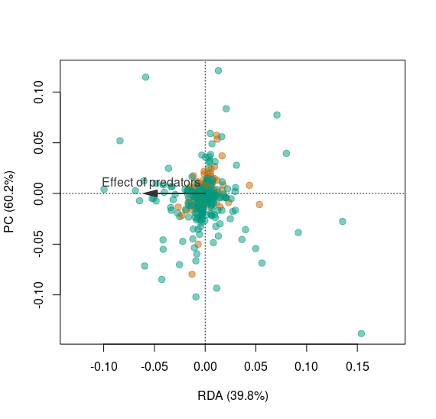
Figure S10. pRDA diagram for the predator effect on the abundance-based arthropod community composition. Analysis is constrained on the block (site) effect and first four plant composition PC axes, that together explained ~ 91% of variation in vegetation composition (evaluated using pPCA on plant community composition constrained on the block effect). RDA axis represents the effect of birds, bats and ants on individual herbivore (green) and arthropod predator species (gold). Negative coordinates indicate reduced arthropod species’ abundance in presence of vertebrate predators. Conditional variables explained ~ 87.1 % of (conditioned) variation. Effect of predators was not significant overall and explained merely ~ 5.16 % variation in the arthropod community composition. The residual variance amounted to 7.8 %. Qualitatively similar results were obtained for biomass based community analysis.
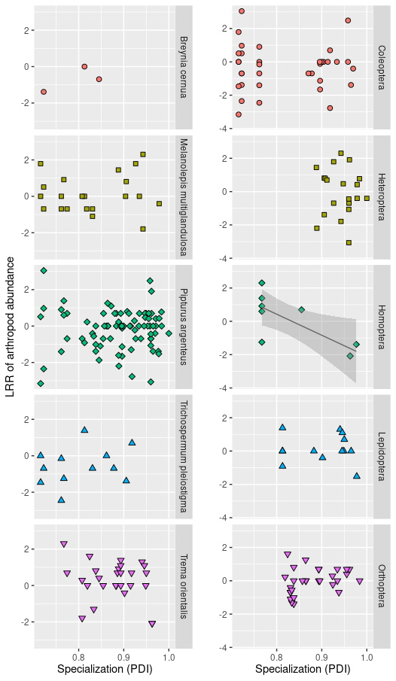
Figure S11. Effect of specialization (measured with the Paired Differences Index - PDI) on herbivore species performance (logarithm of control:exclosure abundance ratio) for most common plant species and studied herbivorous orders. Each point represents a herbivore species for which ≥ 5 individuals sampled. Significance of the regression coefficient at the α = 0.05 level is indicated by a solid line and for those 95% CIs are plotted. For each herbivore species its cumulative abundance at control and exclosures was used as a weighting factor in the regression.
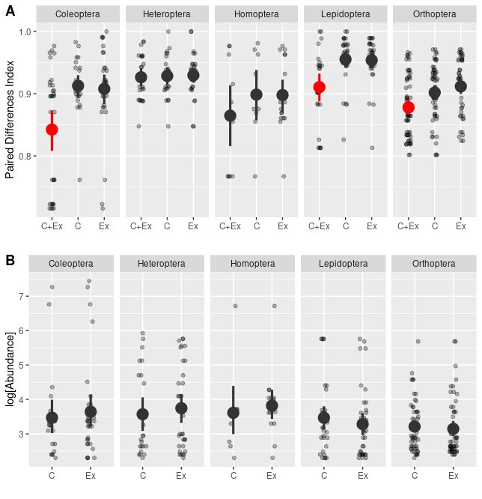
Figure S12. Specialization (measured with the Paired Differences Index - PDI) of herbivore species assigned to three groups (A) based on whether their incidence: present in both exclosure and control plot (Ex+C), exclusively in the control (C) or exclusively in the exclosure (Ex) plots. Abundance comparison for species found exclusively in control and experimental plots (B). Minimal abundance for a species included in this analysis was 10 individuals. Red color indicates significant differences from any other group within the order.
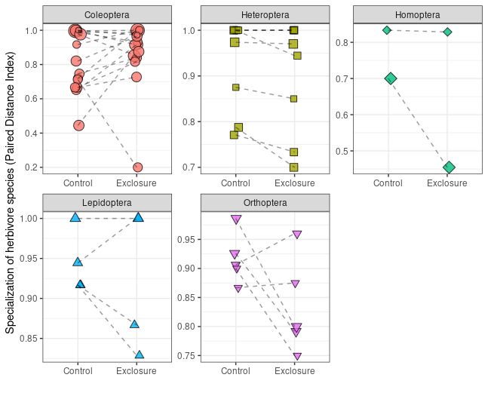
Figure S13. Specialization values, measured with the Paired Differences Index – PDI for comparable species in control vs predator exclosure plots for individual insect morpho-species from studied herbivorous orders. Statistical significance of differences between means between the treatments was evaluated using linear mixed effect models with block treated as a random effect. Only Orthoptera was marginally significant (T = -2.13, P = 0.066). Lines connect herbivore species in both control and exclosure within the same experimental block. Only species with minimum total abundance of 10 individuals were used fro the analysis.
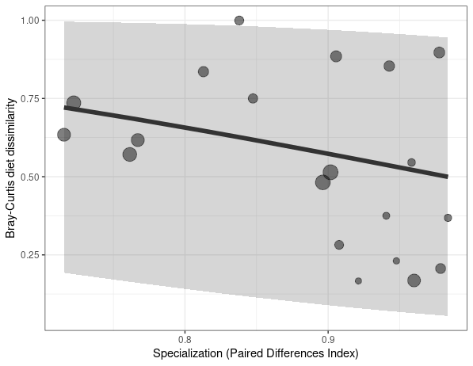
Figure S14. Weighted correlation between diet shifts (Bray-Curtis dissimilarity in resources use between exclosure and control plots) and specialization (Paired Differences Index – PDI). Line indicate predicted values of a weighted beta regression model with 95% prediction quantiles are shown. Model is significant but explains only ~9% of variation. Each point represents a herbivore species, and point size is proportional to natural logarithm of its species abundance, which was also used as weights in the regression. Herbivore species with a minimum total of five individuals were included in the analysis.

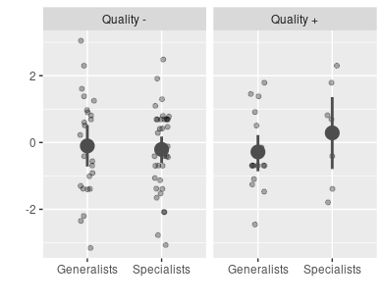
Figure S15. Interaction between plant quality (- low, + high, measured as the coordinates along a first axis of PCA performed on SLA and WATER content, i.e. predicted values of their correlation) and specialization (measured as the Paired Differences Index – PDI) in predicting individual species responses to predation (y axis), measured with the logarithm of control:exclosure abundance within the same experimental block. Positive/negative values indicate positive/negative effect of predators presence on given herbivore species. Each insect species was assigned to generalists/specialists group if their PDI value was to the left/right from the mean PDI value for all herbivorous species. Mean values between groups and their interactions were not significantly different.

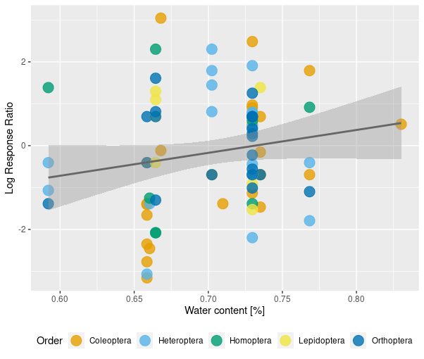
Figure S16. Correlation between leaf water content (a proxy for the leaf quality) and the effect of predators (measured with logarithm of control:exclosure abundance ratio). Points indicate individual herbivorous species from different experimental blocks, divided into different orders (colours). Model includes random effect of the block. Significant regression line (T = 3.341, P = 0.001) and 95% CIs are plotted.
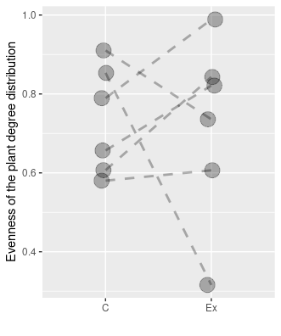
Figure S17. Comparison of the evenness values calculated from the degree distribution of plants (used as a measure of distribution of links) in plant-herbivore interaction networks between control (C) and exclosure (Ex) plots. Lines connect network descriptors within the same experimental block. Statistical significance of the difference was evaluated using a beta mixed-effect models with the logit link function and block treated as a random effect.
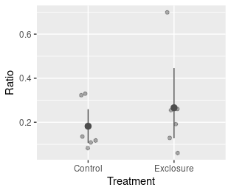
Figure S18. Comparison of the arthropod predators:herbivores ratio between control and focal predator exclosure plots. Mean and 95% bootstrapped CIs are present. The ratio was not significantly affected by the exclosure treatment. Significance was evaluated using mixed effect model with a random effect of block.

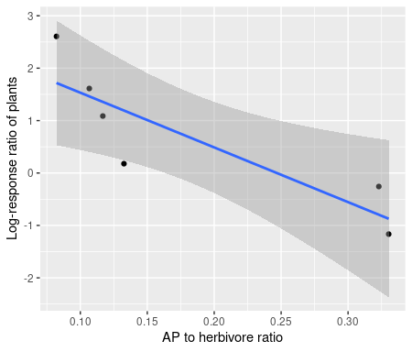
Figure S19. Correlation between the arthropod community trophic composition (ratio of arthropod predators to herbivores in the presence of focal predators: birds and bats, and ants) and indirect effect of focal predators on the woody plant biomass for each experimental block. Solid line indicates significance at the α = 0.05 level. Individual experimental block as points and 95% CIs are plotted.
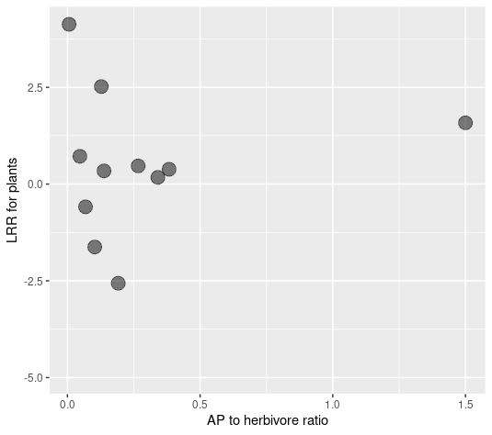
Figure S20. Trophic community composition of arthropods (ratio of arthropod predators to herbivores in the presence of focal predators: birds and bats, and ants) vs indirect effect of focal predators on the woody plant biomass (logarithm of the control:exclosure abundance ratio) on individual plant species (grey points). Correlation was not significant.

