Results

Predators decreased herbivore biomass and increased their diversity, but the latter effect was marginally significant (P = 0.052). Abundance and richness were not affected (Fig.1). We found no effect of predators on IAPs community. We found no changes in any order/guild in case of abundance nor biomass (Fig S1).

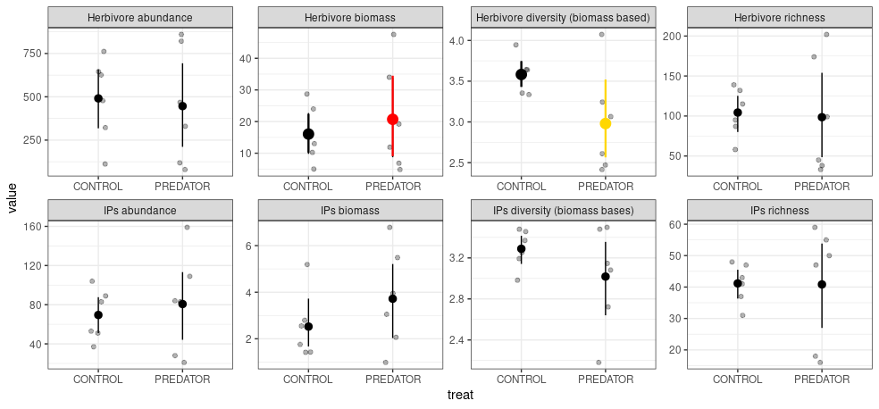
Figure 1. Mean and 95% bootstrapped CIs of the invertebrate and intermediate arthropod predator community indices in the control and exclosure plots. Grey points indicate empirical values for six experimental blocks. Differences between means were tested using generalized mixed effect models with experimental block as a random factor. Herbivore diversity is marginally significant (P = 0.052).

There was no effect of plant community composition nor IAP community descriptors (biomass, abundance, richness, diversity) on herbivore community composition independently of the treatment and site. In case of IAPs partial RDA analyses showed, that herbivore abundance influenced the abundance-based community composition. No variable influenced the biomass-based community composition. Partial RDA (conditioned on site) showed no difference in the community composition of herbivores and IAPs (both biomass- and abundance-based) between control and the exclosure treatment. Coleoptera and Hemiptera were positively, and Lepidoptera negatively affected by top predators (Fig. 2). Mantidae abundance and biomass was negatively affected and the latter effect was marginaly significant (based on RDA axis coordinates as a proxy for the strength of the predator effect – model without an intercept testing only difference from zero [to methods]).

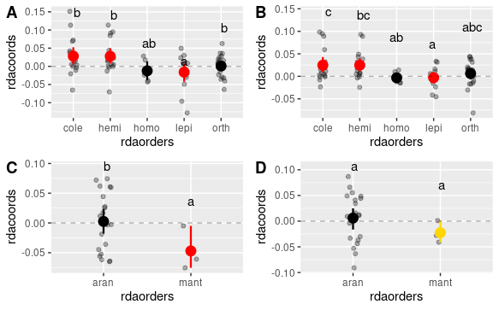
Figure 2. Predator effects on different herbivore and IAPs orders. A) herbivores based on abundance, B) herbivores based on biomass (qualitatively similar to the abundance based results), C) IAPs based on abundance, D) IAPs based on biomass. Differences were obtained using linear model with abundances used as weights for each species. Only species with abundances higher than 10 were included in the analysis. Red and gold color indicate significant and marginally significant (< 0.1) difference from zero respectively. Letters indicate significance at the 0.05 level obtained from pairwise comparisons with Tukey correction [ordination_ms1.R].

There was a marginally significant correlation between indirect effect of predators on plants and direct predator effect of herbivores (Fig 3, A). We found significant correlation between the effect of insectivorous predators on herbivores and IAPs (Fig 3, B) [add coefficients and probability to these plots]. However, when we performed regression analysis independently at the group level this relationhsip became significant and the group identity was not a significant factor. Similarly, positive correlation was significant for two intermediate predator orders, Araneae and Mantodea. The identity of herbivorous orders was also not significant. Qualitatively the same patterns were found for log ratios based on arthropod biomass (Fig. S4) with an exception of Mantodea, where the significance vanished. We only found positive correlation in all pairwise comparisons between Aranea, Orthoptera, Hemiptera and Coleoptera (Fig. S4).

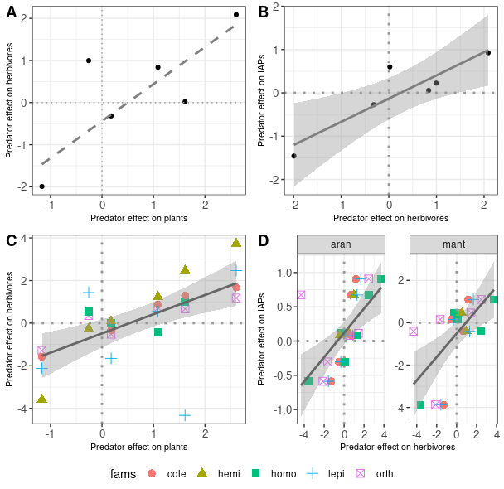

Figure 3. Relationships in carnivore effects between different trophic levels on individual plots: A – herbivores vs. plants; B – herbivores vs. herbivores, but I need to keep this plot as well, as an evidence for maybe detritus based channel, more platnt = more detritus, more detritivores as pray for spiders, do this for abundance and biomass) for individual orders/groups for herbivores general, broken into orders and for IAPs broken into orders [bio_log_ratio.R].

Pattern of abundance and biomass correlation between all groups did not remain qualitatively similar between control and exclosure plots i.e. exclosure did change the character of the correlation, however not dramatically (Fig. S4). However if change occurred it was always form a non-significant correlation into a significant positive one.
Diet breadth only affected performance Homoptera (Fig. 4) where more specialized species showed increasingly negative response to predators. Specialization had no effect on performance of the rest of the insects and this lack of effect was not characteristic to any order nor plant species. There was no interaction between specialization and predator effect for any herbivore group on any plant [perform tests]. (Fig. S_)
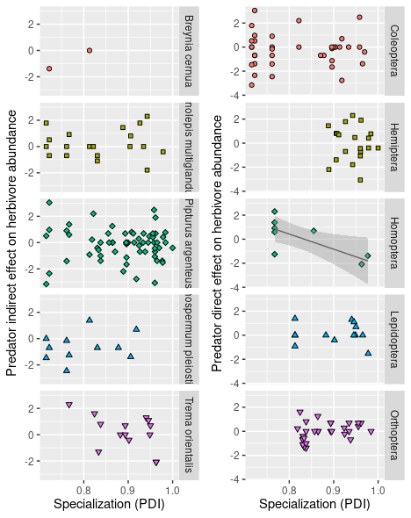

Figure 4. Effect of specialization on herbivore species performance on plants and in different orders/guilds. Each point represent a herbivore species for which we found at least ten individuals. Only in case of Homoptera this relationship was negatively correlated with PDI (for which regression line and confidence intervals were plotted). We tested this relationship based using mixed effect model with block as a random effect and weight proportional to their abundance was assigned assigned to each point (morpho-species). [plant_specie_slog_ratio.R].

Species size distribution of Orthoptera and Araneae shifted towards larger species in the exclosure (Fig. 5) . Size shift, however was not consistent between plant species (Table S1) nor sites [add analyses for sites].
There was no indication of the diet breadth shifts in herbivores (Fig. S_). However, we found that species with higher diet breadth were also more willing to shift their diets (Fig 6). Except for modularity no network descriptor responded to the exclosure treatment (Fig. 7).

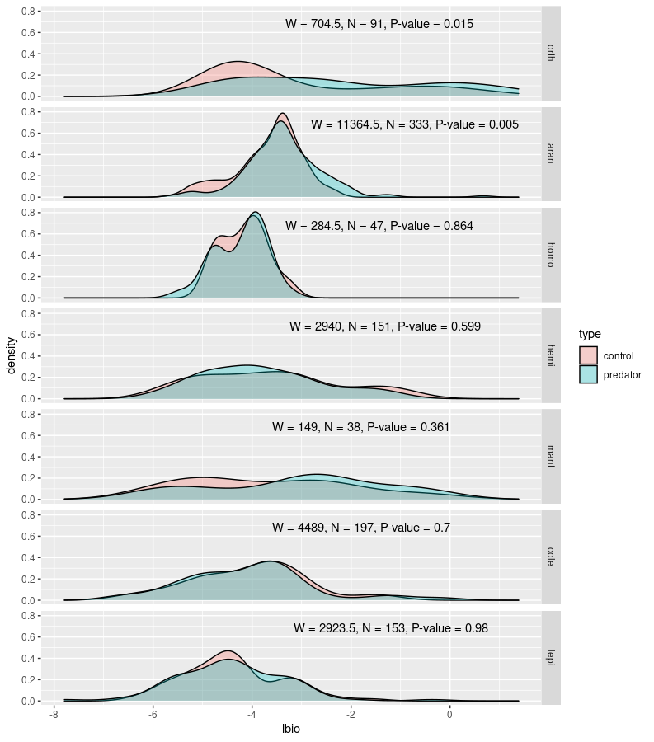
Figure 5. Species size distributions for studied insect orders in control and exclosure plots. [I have finally settled on species - and not individuals - size distributions. Firstly because of problematic analysis i.e. multi modal distributions and data somewhat artificially duplicated (I didn’t have estimates of size for each individual but instead I used average size over up to 20 randomly chosen individuals from a given morpho-species. Secondly because it might have been strongly dependent on general abundance of herbivores within a given plot. Because of no-normality I used Mann-Whitney tests to compare sizes. For size distributions based on individuals non-parametric tests resulted in significant differences in all insect orders (with different directions of these changes) – this is also interesting because it shows that size of the prey was affected, unfortunately it is difficult to evaluate the size of this change. Usinig power analysis I could provide maximum shift for each herbivore order that would be undetected by our comparisons in Fig. S1. I.e. perform power analysis to estimate how big of a change in biomass can we detect with given sample sizes and then compare that to detected changes in herbivore community But it might not be worth a shot. Moreover, these shifts in body size can also be constrained to different woody plant species and blocks only, resulting in no or]

[Some food quality comparisons here … However, if there is no effect of plant species on herbivore performance then there should be also no strong effect of more detailed plant quality measurement either]

No order changed specialization as a response to the treatment.

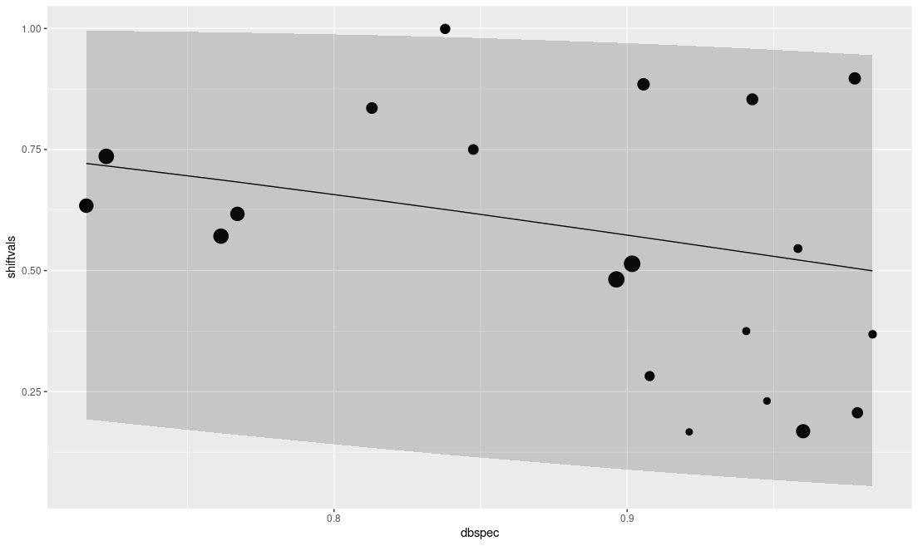
Figure 6. Weighted beta regression model with 95% prediction quantiles. Diet breadth (PDI) vs diet shifts tends to be lower for more specialized species, as expected. Beta regression was significant. Nevertheless their was some evidence of the diet shift, as much as we were able to detect it. Model explains only around 9% variation but it is significant.

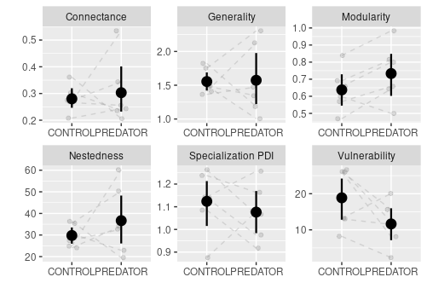
Figure 7. Mean and 95% CIs for different network descriptors in control and exclosure plots. Only modularity has decreased significantly (z value = 2.143, p = 0.032, beta family with the logit link function).

Supplementary figures
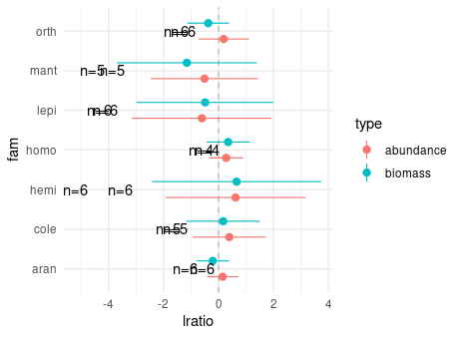

Figure S1. [Add diversity and richness for each order]. Log ratio of sampled insect orders in control and exclosure treatments. Mean and 95% bootstrapped CIs are present. No statistical difference from 0 was found for no order and biomass vs abundance. [biomass_abundance_comparisons.R]

[FIGURE 3]

Figure S2. Ordination, RDA1 axis determines variability explained by the exclosure treatment.

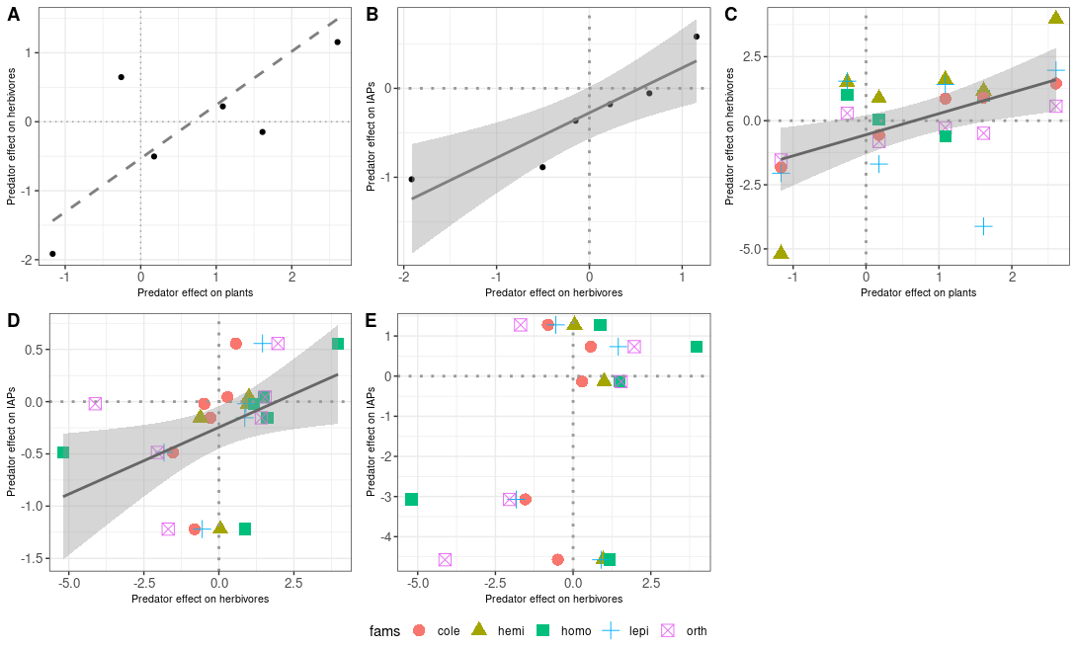

Figure S3. Correlation based on arthropod biomass [bio_log_ratio.R]

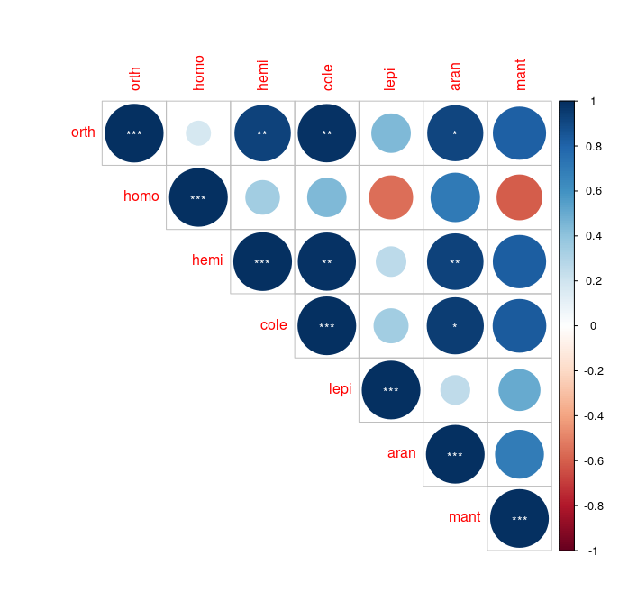
Figure S4. Pairwise correlation in log likelihood ratios between different insect orders. Significance is indicated by asterisks: p = 0.001 (***); p = 0.01 (**); p = 0.05 (*). [bio_log_ratio.R]. A Correlation between log ratio changes. B: Correlations between comparisons of abundance (top) and biomass (bottom) of various insect orders in control (left) and excolsure (right) plots.

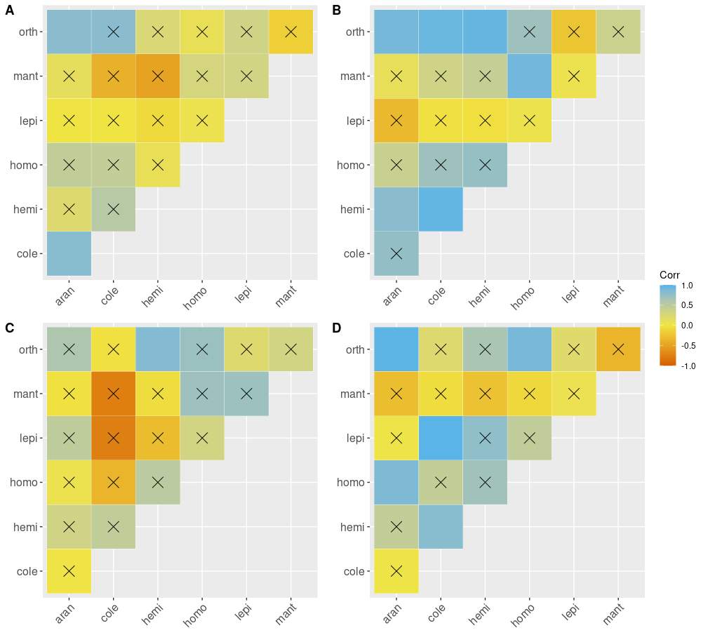
Figure S_. Correlation plots for studied arthropod groups. Barrage indicates non-significant correlations. Correlations were calculated for abundance (A,B) and biomass (C,D) for both control (A,C) and predator (B,D) plots. [correlation_cp.R]

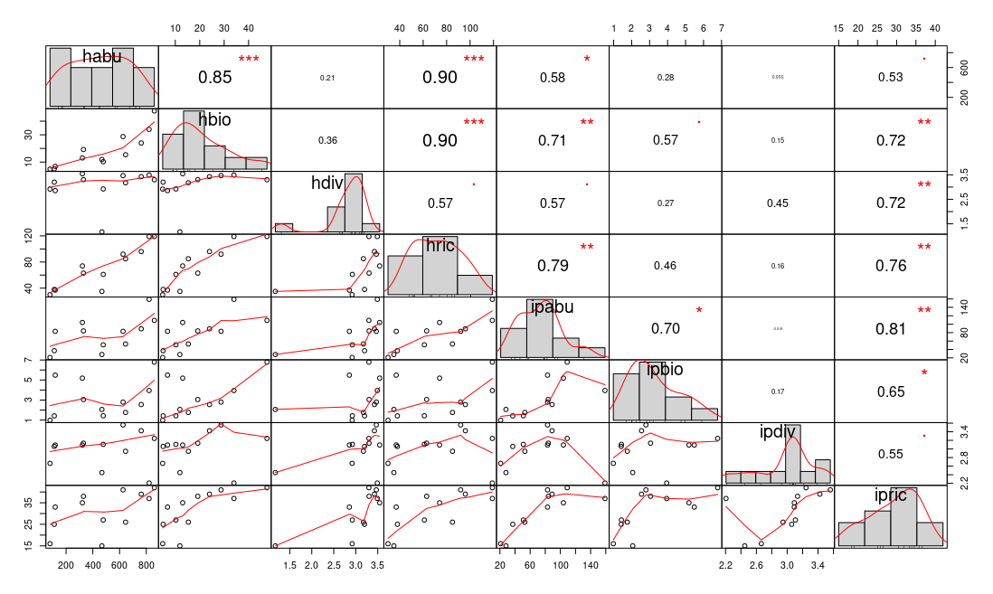
Figure S_. Correlations between general characteristics of herbivore and IAPs communities

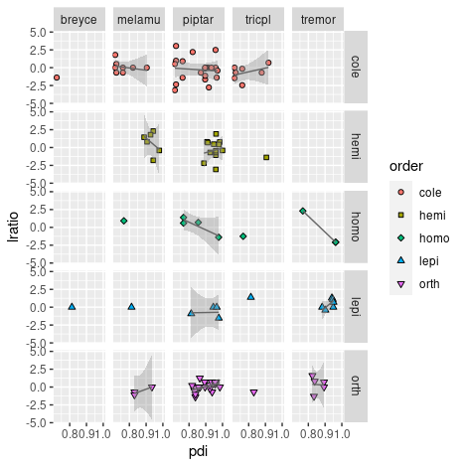
Figure S_. Interaction between order and plant species. Only melamu – hemi coomparison was marginally significant.

Table S1. Results of Wilcoxon tests comparing body sizes of control and exclosure plots for all possible combinations of insect order and plant species [add whether average decreased of increased].

Order | Plant | W | N | pval
orth | piptar | 136.5 | 33 | 0.409775691
orth | melamu | 15.0 | 18 | 0.246504693
orth | melos1 | 35.0 | 13 | 0.051282051
aran | piptar | 2281.5 | 124 | 0.008866179
aran | tremor | 400.5 | 54 | 0.342153682
aran | melamu | 201.0 | 48 | 0.789721088
aran | breyce | 11.0 | 12 | 0.294551629
aran | tricpl | 77.0 | 27 | 0.603975950
aran | melos1 | 123.5 | 40 | 0.021471960
homo | tremor | 23.5 | 13 | 0.771400399
homo | tricpl | 2.0 | 4 | 1.000000000
homo | melamu | 4.5 | 7 | 1.000000000
homo | piptar | 63.5 | 22 | 0.760895370
homo | melos1 | 3.5 | 6 | 0.766432716
hemi | piptar | 467.0 | 66 | 0.551552283
hemi | prems1 | 0.0 | 4 | 0.500000000
hemi | melamu | 148.0 | 33 | 0.420145955
hemi | tricpl | 2.5 | 8 | 0.826238366
hemi | tremor | 13.0 | 11 | 0.921212121
hemi | melos1 | 10.0 | 19 | 0.387459937
mant | piptar | 24.0 | 15 | 0.759795195
mant | tremor | 26.5 | 14 | 0.794703141
cole | prems1 | 7.0 | 10 | 0.334408999
cole | piptar | 1163.5 | 96 | 0.184662407
cole | breyce | 1.5 | 5 | 1.000000000
cole | melamu | 88.5 | 43 | 0.011557528
cole | tricpl | 71.0 | 26 | 0.722338992
cole | melos1 | 18.5 | 26 | 0.241432076
lepi | prems1 | 1.5 | 3 | 1.000000000
lepi | piptar | 434.5 | 59 | 0.033800433
lepi | breyce | 6.0 | 7 | 0.840730447
lepi | melamu | 3.5 | 6 | 0.766432716
lepi | tremor | 148.5 | 37 | 0.503148899
lepi | tricpl | 21.0 | 14 | 0.893697261
lepi | melos1 | 20.5 | 17 | 1.000000000

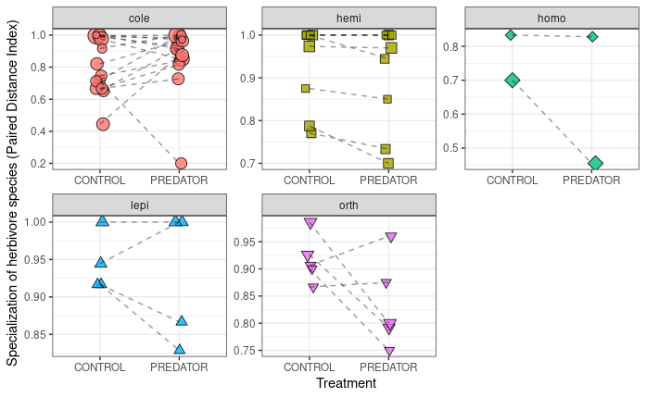

Figure S_. Specialzation (PDI) values for comparable species in control vs exclosure plots for each morpho-species from studied herbivorous order/guild. Statistical test was performed on log ratios of the PDI values. [pdi_response_to_treatment.R]. There might be a problem here: In some cases I might have species present in more than 3 blocks for control and exclosure treatment.

[FIGURE S_]
Figure S_. Interaction networks for control and exclosure plots.

