Appendix

Supplementary figures

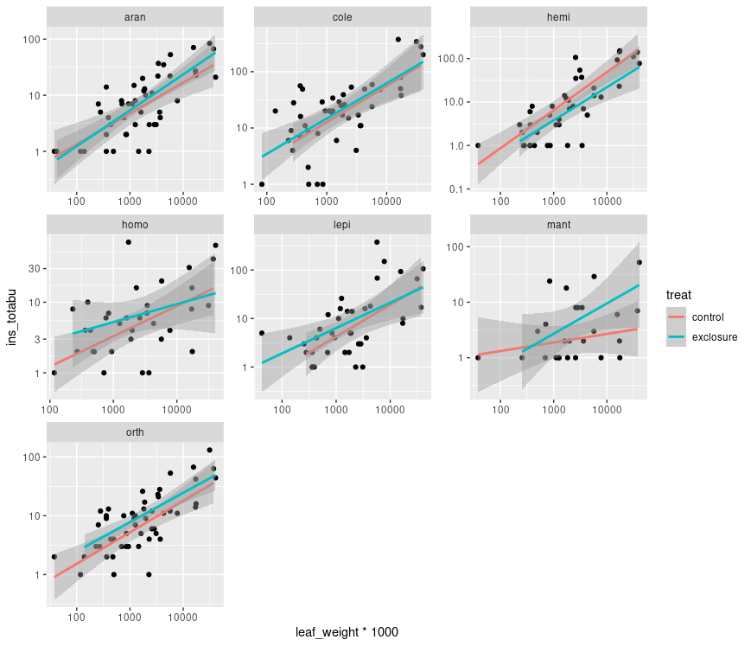
Figure S1. Statistical relationship between leaf biomass (in grams) and abundance of studied arthropod guilds for each plant species. Verical axis is in logarithmic scale. Points represent individual plants from experimental plots.

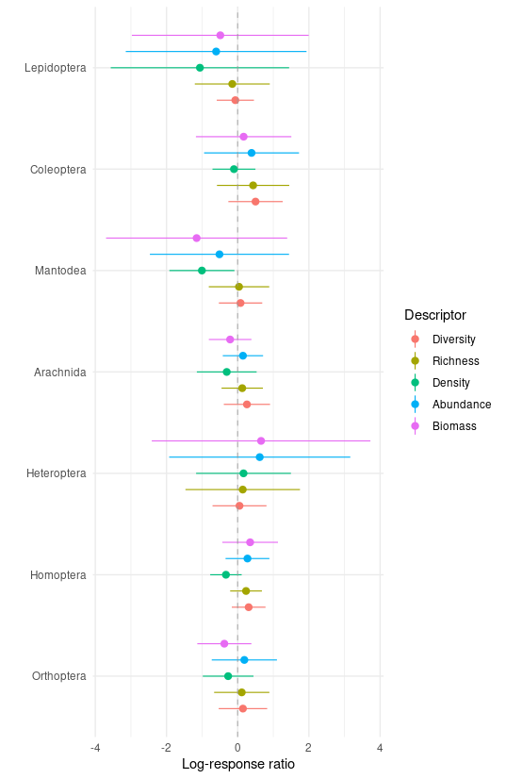
Figure S2. Log response ratios (log of values fof exclosure to control values ratios) of sampled insect orders. Mean and 95% bootstrapped CIs are presented. There is no significant treatment effect for abundance or biomass for any of the orders . [biomass_abundance_comparisons.R]

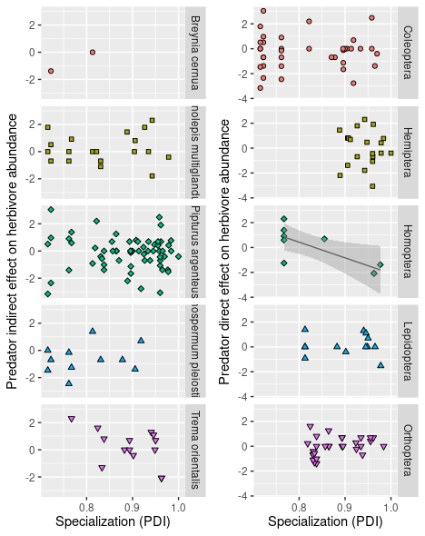
Figure NS3. Effect of specialization (Paired Dissimilarity Index - PDI) on herbivore species performance (log response ratio - LRR) for plant species and insect orders. Each point represents a herbivore species sampled as ≥ individuals . Only plant species present in both control and treatment plots could be analysed. Significance of the regression coefficient at the 0.05 level is indicated by a solid line with 95% CIs . Abundance at each site was used as a weighting factor for each morphospecies and block was set to be a random effect.. [plant_specie_slog_ratio.R]

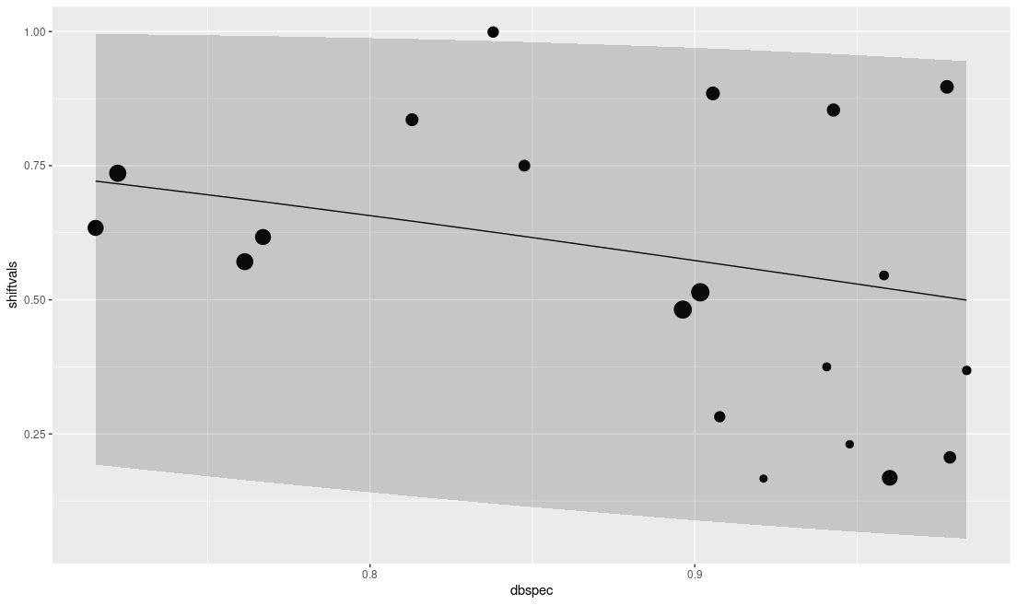
Figure NS5. Diet shifts between control and treatment plots tend to be larger for more generalist herbivores, as shown by a negative relationships between diet breadth (PDI) and diet shifts measured using the Bray-Curtis dissimilarity. Weighted beta regression model with 95% prediction quantiles is significant but explains only ~9% of variation . Earch point represent a herbivore species, point size shows log abundance.

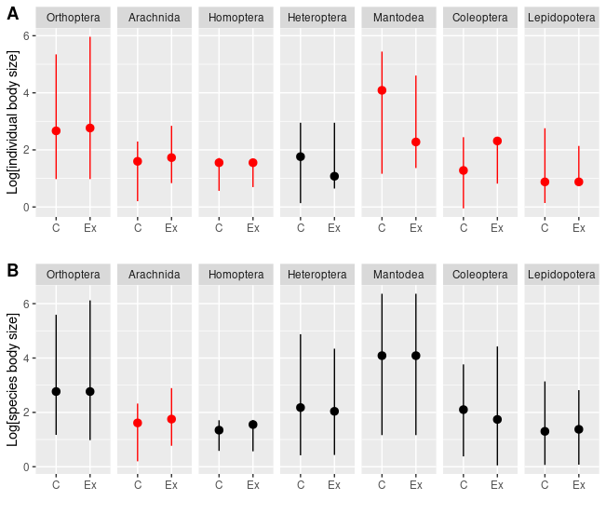
Figure S3. Individual and species size distributions with median and 5th and 95th percentile for studied insect orders in control and exclosure plots U-Mann Whitney test. Red color indicates significant differences of the medians. [I have finally settled on species - and not individuals - size distributions. Firstly because of problematic character of this data for analysis i.e. multi-modal distributions and data somewhat artificially duplicated (I didn’t have estimates of size for each individual but instead I used average size over up to 20 randomly chosen individuals from a given morpho-species). Secondly because individual based distribution might be strongly dependent on general abundance of herbivores within a given plot. Nevertheless I did perform some tests and because of non-normality I used Mann-Whitney’s test to compare distributions. For size distributions based on individuals non-parametric tests resulted in significant differences in all insect orders (with different directions of these changes) – this is also interesting because it shows that size of the prey was affected, unfortunately it is difficult to evaluate magnitude of this change in non-parametric signed rank tests. Using power analysis I could provide maximum shift for each herbivore order that would be undetected by our comparisons in Fig. S1. I.e. perform power analysis to estimate how big of a change in biomass can we detect with given sample sizes and then compare that to detected changes in herbivore community But it might not be worth a shot.

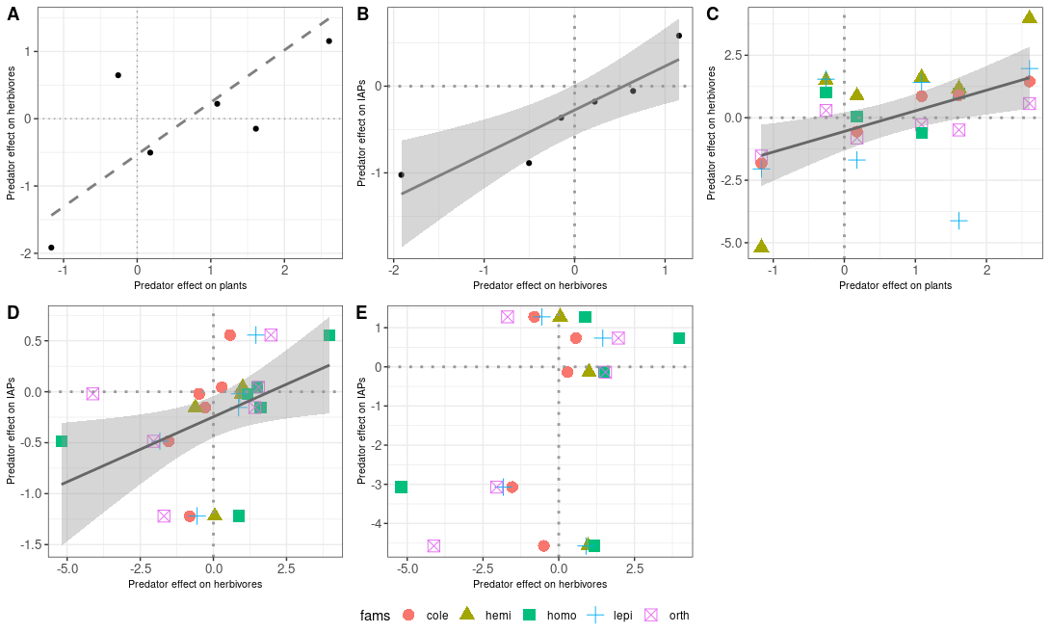
Figure S4. Correlation based on arthropod biomass [bio_log_ratio.R]

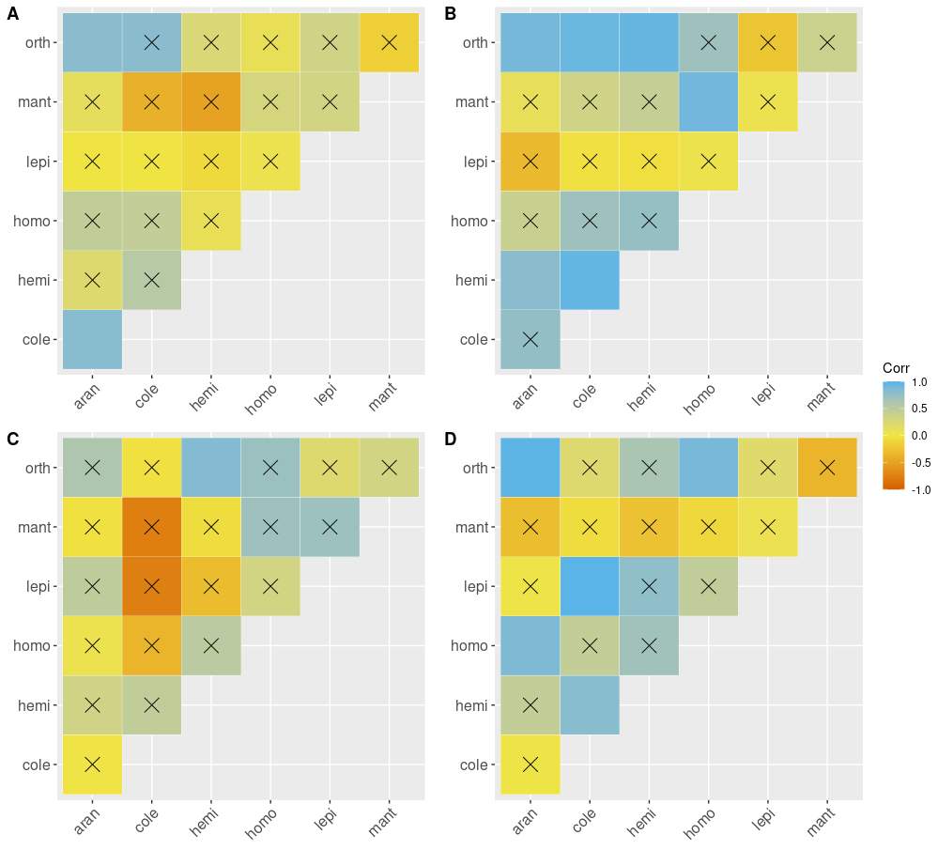
Figure 3. Abundance and biomass correlation plots for studied arthropod orders. Barrage indicates non-significant correlations. Correlations were calculated for abundance (A,B) and biomass (C,D) for both control (A,C) and exclosure (B,D) plots. [correlation_cp.R]

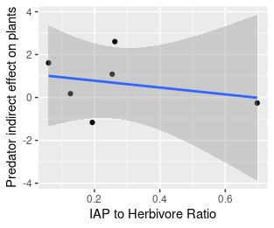
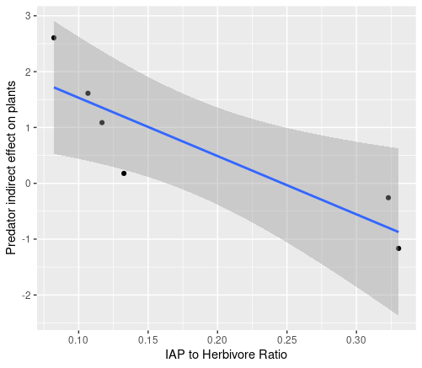
Figure S7. Relationship between predator indirect effect on plants and AP/Herbivore ratio in the presence of vertebrate predators [bio_log_ratio.R, individual_chain_analysis.Rrst] . Left: IAP to herbivore ratio and LRR at individual plots, Right) individual comparable plant species.(non-significant!!). [indicate significance with lines] f we take the exclosure plots as a base for the AP/HERBIVORE ratio then the significance vanishes.

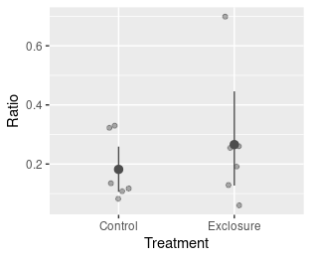
Fig Ratio TRT. There is no difference between AP/HERB ratio between control and exclosure plots.

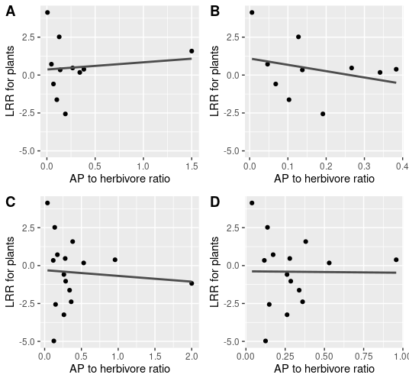

Figure XXX. Plant LRR response to increase in AP to herbivore ratio at individual plant species. None of the regressions are significant. However general pattern of points being concentrated around zero is visible.

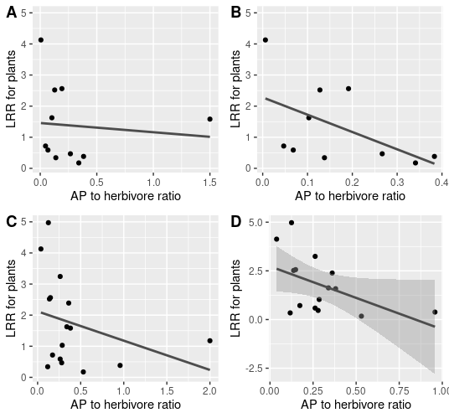
Fig XXX. Absolute responses to measure only the strength of a response withouth considering the direction. Only D is marginally significant (T = -2.010, P = 0.066). [individual_chain_analysis.R]

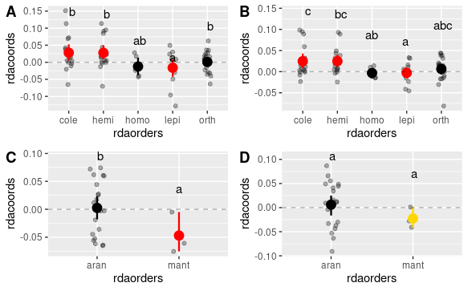
Figure S8. It shows NET zero difference [I think that I should remove singletones from this analysis as these species might pull averages closer to zero if there is many species only in one category either predator or control] Predator effects (species scores obtained in pRDA analysis) on different herbivore and IAPs orders. A) herbivores based on abundance, B) herbivores based on biomass (qualitatively similar to the abundance based results), C) IAPs based on abundance, D) IAPs based on biomass. Differences were evaluated using linear model with abundances used as weights for each species. Only species with abundances higher than 10 were included in the analysis. Red and gold color indicate significant and marginally significant (0.05< alpha< 0.1) difference from zero respectively. Letters indicate significance at the 0.05 level obtained from pairwise comparisons with Tukey correction [ordination_ms1.R]. Figure S2. Ordination, RDA1 axis determines variability explained by the exclosure treatment.

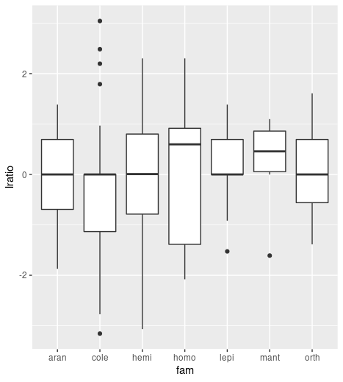
Figure S9. LRR of individual species for studied arthropod orders. Nothing significantly different from 0 nor there were no differences between orders [plant_species_logratio.R].

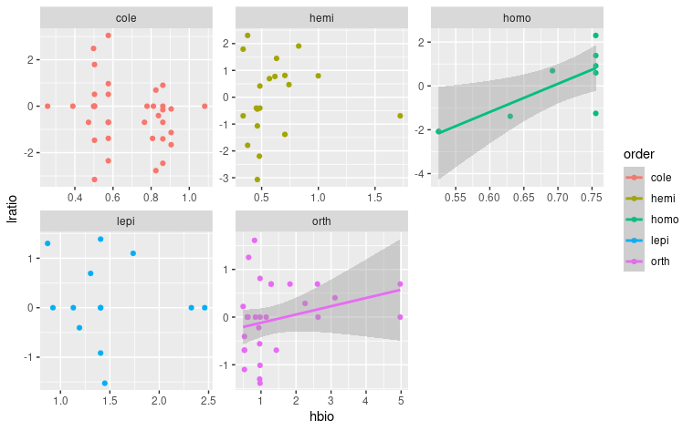
Figure S11. LRR as predicted by body length [cm]. Orthoptera is marginally significant. There is an evidence that at least some groups were performing better [perform better tests]. [plant_species_logratio.R, add IAPs] – [indicate significance with lines]

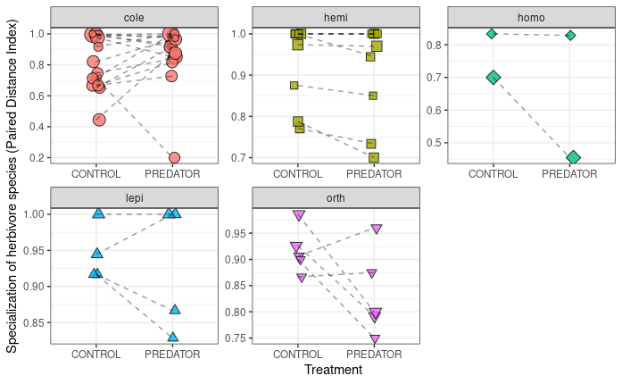
Figure S12. Specialization (PDI) values for comparable species in control vs exclosure (PREDATOR) plots for each morpho-species from studied herbivorous order/guild. Statistical test was performed on log ratios of the PDI values. [pdi_response_to_treatment.R]. [Orthoptera is marginally significant t = -2.13, p = 0.066]. If we drop random effects alltogether we get also hemiptera to significantly increase their diet breadth in exclosure (t = -2.16, p = 0.049). Points indicate any morphospecies that we were able to compare. Sometimes points are the same morphospecies from different blocks. Block was used as a random effect but it still treats same species from different blocks as independent observations.
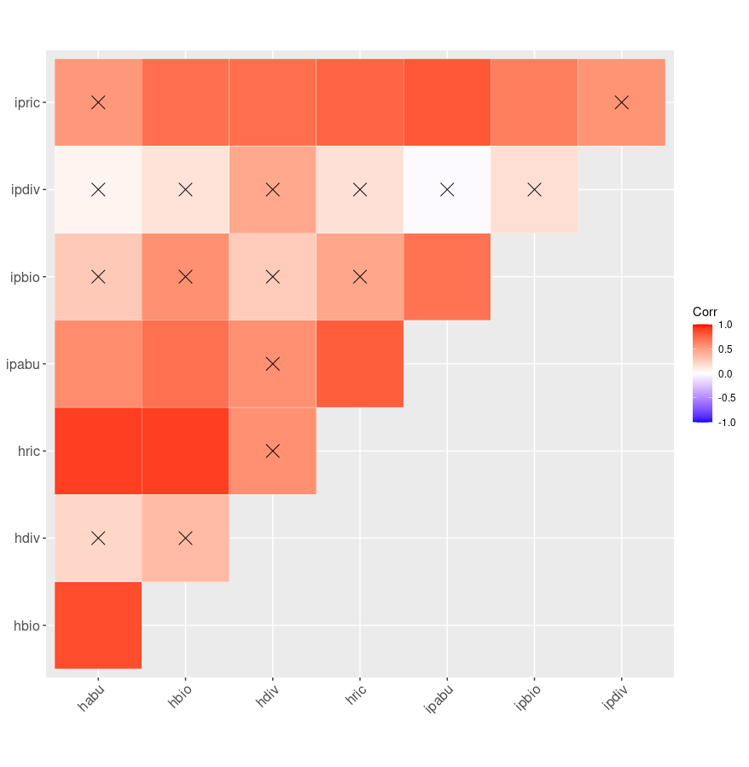

Figure S12. Correlations between general characteristics of herbivore and IAPs communities. H* - herbivores, ip* inermediate predators, *abu -abundance, *bio – biomass, *div – diversity, *rich - richness [Address that in the text]

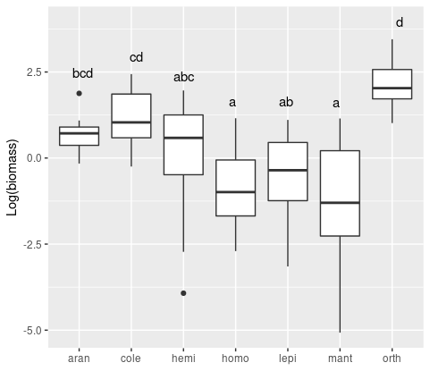
Figure S13. Comparison of logarithm of biomass for each studied insect order in both exclosure and treatment plots. Letters indicate groups obtained from Tukey comparisons. [biomass_comparisons_families.R]

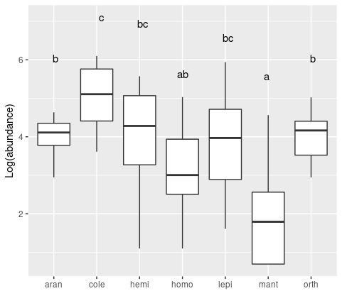
Figure S15. Abundance for studied arthropod orders.

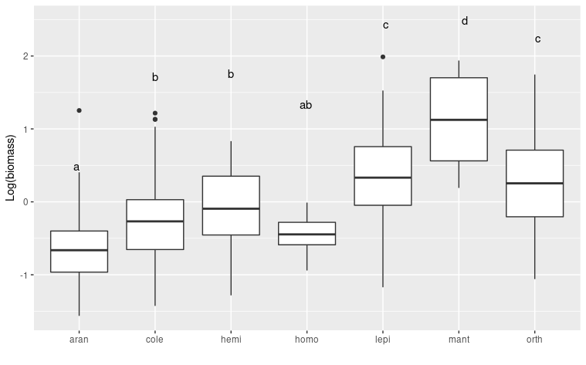
Figure S16. Comparison of individual biomasses of arthropods. Orthoptera and lepidoptera were the largest herbivores in our system [plant_species_logratio.R].

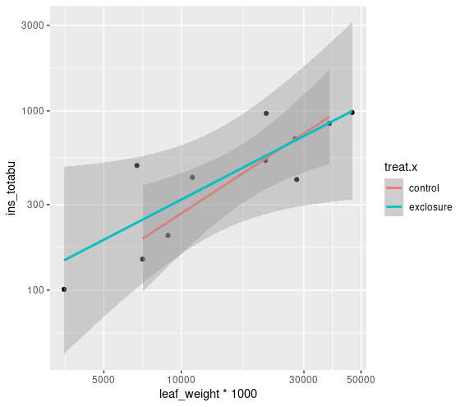
Multiple R-squared: 0.7311, Adjusted R-squared: 0.6159 [plant biomass_vs_herbivore abundance.R] Same as above but for cumulated abundance and leaf weight

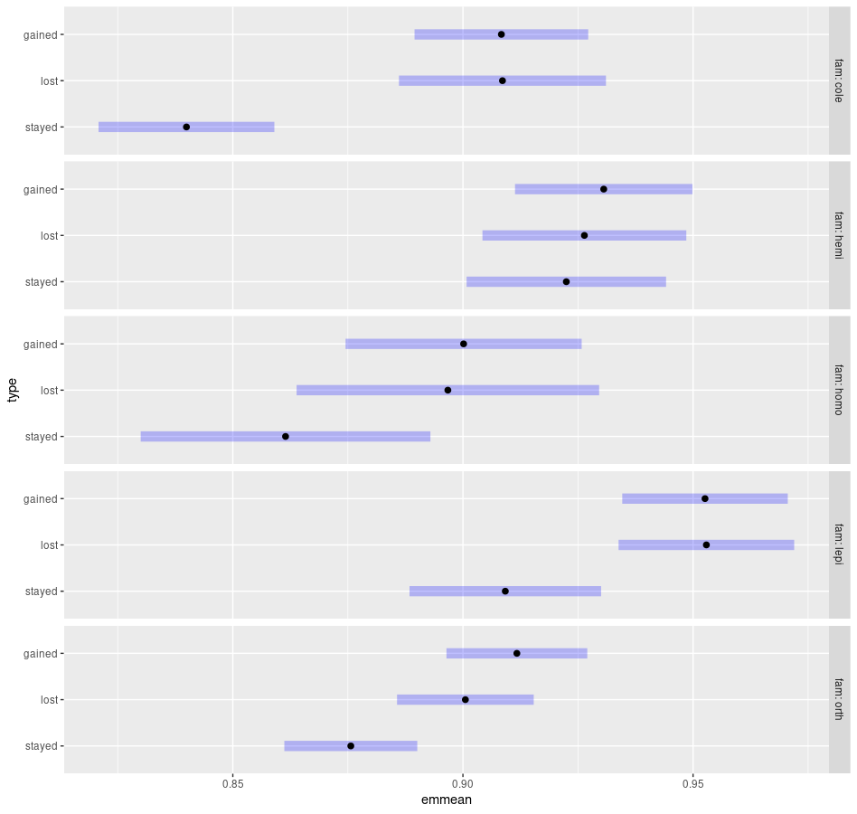
Figure XXX_specialization and colonization. Emmean here is the PDI value.
Contrasts for lost stayed gained analysis:

Statistical difference for the plot above showing pairwise comparisons.
fam = cole:
contrast estimate SE df t.ratio p.value
stayed - lost -0.068663 0.01421 450 -4.832 <.0001
stayed - gained -0.068428 0.01309 450 -5.227 <.0001
lost - gained 0.000235 0.01445 450 0.016 0.9999

fam = hemi:
contrast estimate SE df t.ratio p.value
stayed - lost -0.003923 0.01502 450 -0.261 0.9631
stayed - gained -0.008128 0.01424 450 -0.571 0.8358
lost - gained -0.004204 0.01443 450 -0.291 0.9543

fam = homo:
contrast estimate SE df t.ratio p.value
stayed - lost -0.035268 0.02271 450 -1.553 0.2673
stayed - gained -0.038687 0.02043 450 -1.894 0.1416
lost - gained -0.003419 0.02098 450 -0.163 0.9855

fam = lepi:
contrast estimate SE df t.ratio p.value
stayed - lost -0.043689 0.01372 450 -3.185 0.0044
stayed - gained -0.043394 0.01338 450 -3.242 0.0036
lost - gained 0.000296 0.01268 450 0.023 0.9997

fam = orth:
contrast estimate SE df t.ratio p.value
stayed - lost -0.024894 0.00962 450 -2.588 0.0269
stayed - gained -0.036083 0.00995 450 -3.627 0.0009
lost - gained -0.011189 0.01014 450 -1.104 0.5122

P value adjustment: tukey method for comparing a family of 3 estimates

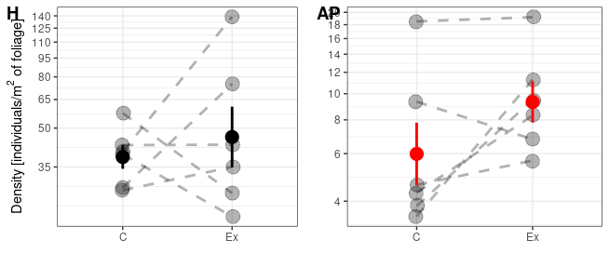

Figure XXX. Densities of herbivores and AP on foliage in control and exclosure treatments. Both differences are non-significant (liear mixed model of logged values, with block treated as a random effect). However, based on LRR analysis (pairwise comparisons and test whether log ratios are different from zero) density of AP is significantly decreased by predators P < 0.001).

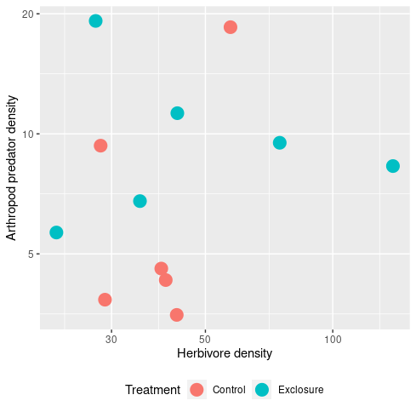

Figure XXX. Densities are uncorrelated.

Does plant quality and specialization affect species responses to predation?

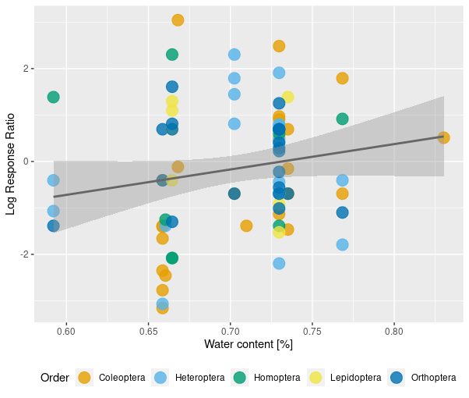

Figure S15. [sla_ldmc_lrr.R] If TTI was in place here we would expect, that with reduced quality (measured by water content and sla) relationship between PDI and LRR would be less negative. This is the case. Similar results were obtained in weighted regression (robably not necessary). Quality itself is not well defined here I think. I am not sure how well water content represents quality. That would mean that low PDI (generalists) would strongly negatively respond to predators, whereas specialists could be unaffected or affeced positively.

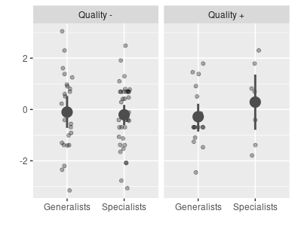
Figure S14. Quality (measured as the coordinates along a first axis of PCA performed on SLA and WATER content – or predicted values from their correlation) did not influence log response ratio. Interaction with specialization was not significant

