To see the pattern that we observe here, i.e. strong correlation between plants and herbivores in all orders, lack of accumulation differences on vegetation, and community composition unaffected by vertebrate predators, a constant influx of individuals would require rapid colonization of emptied bu= colonization success remains constant in time for all arthropod groups and for the vertebrate predator effects to be density dependent. Whether the second condition has previously been reported for bats (Wray et al., n.d.) equal colonization success seem to be less likely (Steyn et al., 2016) which suggest that the effect of predators are at most weak.

o see the pattern that we observe here, i.e. strong correlation between plants and herbivores in all orders, lack of accumulation differences on vegetation, and community composition unaffected by vertebrate predators, a constant influx of individuals would require rapid colonization of emptied niches and for the vertebrate predator effects to be density dependent. Whether the second condition has previously been reported for bats (Wray et al., n.d.) equal colonization success seem to be less likely (Steyn et al., 2016) which suggest that the effect of predators are at most weak.

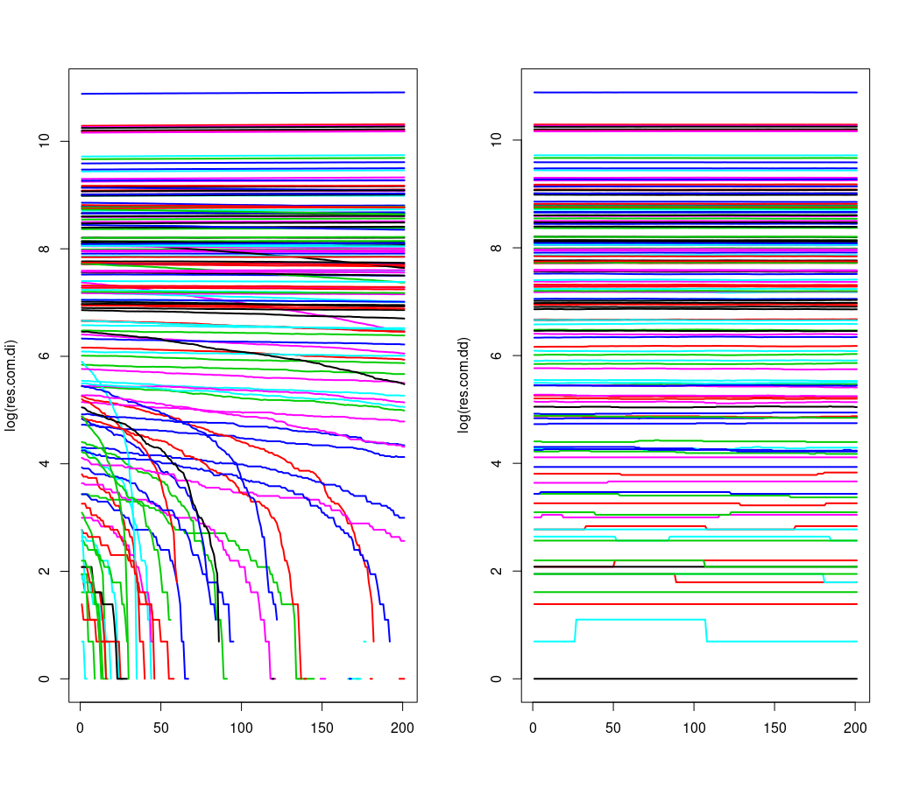
Fig. 1 Simple model based on neutral dynamics showing abundances of 150 herbivore species under density independent (left) and density dependent (right) predation. Abundances of the influx communities were sampled from a negative binomial distribution, and then allowed to colonize a plot eith limit of abundance set by statistical relationship between plant biomass and insect abundance. IN case of density independent feeding predator has a fixed diet, and every time step it removes a fixed ammount of each species depending on its preferences sampled from a Pareto distribution. IN density dependent feeding same ammount of insects is simply randomly sampled from a resident community.

Neither SLA nor LDMC affected plant LRR. LDMC alone reduced leaf damage (T = 3.025 , P = 0.011), whereas SLA was marginally signifiacant in increasing damage (T = -1.945 , P = 0.075).

