Data exploration of the garden experiment food webs.

1. Log ratio analysis
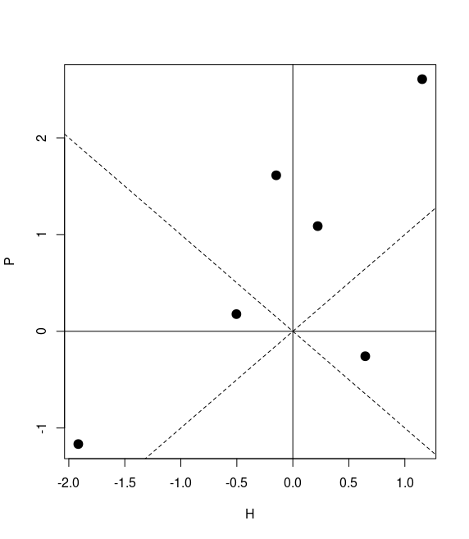Figure 1: Log ratios of the direct effect of carnivores on herbivores (H) vs indirect effect of carnivores on plants (P) measured as a logarithm of a biomass ratios between control and predator removal plots. If the biomass is higher in control plot than the ratio will be > 0 and thus also the logarithm will be positive, which indicate positive effect of carnivores on a given level of food web. Points indicate individual experimental blocks. Dotted lines show lines of equal direct and indirect effect strength.

Interesting thing seen in our data is that the general top-down (carnivores on herbivore) and cascading effect (carnivores on plants) are correlated. This meas, that for the negative effect of carnivores on herbivores we can expect from less negative to positive effects on plants. From Fig. 1 we see, that the points are positively correlated (Pearson’s R = 0.74). Similar pattern was observed, when instead if biomass we used abundance of herbivorous insects. In 4 blocks carnivores had positive indirect effect on plants. This might be a first evaluation of such a complex system of plant herbivore food web and multiple additive and/or multiplicative effects can be present here. It is known, that the strength of the cascading effects might not be present in specialized sap-sucking insects.

Top-down and cascading effects of various families of herbivores

Considering the above we explored responses of various insect families/orders studied here, and how they compare with the general trend. Unfortunately, similarly there are no consistent (all negative or (all positive/negative) top-down effects of predators on herbivores (Fig.2). [We could perform weighted linear model, where the weight for a single point will be given by its biomass proportion in the total herbivore biomass].

Top-down and cascading effects within individual modules

Whether the effects are consistent with the theory when we brake it down into modules (communities). From our analysis on the community detection using the DIRTLPAwb+ algorithm for weighted bipirtatie networks () we found, that in most cases communities are focused on individual plant species within the plots. However, there are some difficulties. We would have to analyze only modules/plant which remained undisturbed i.e. plant species, which are present in both control and predator removal plots (Fig.3).
We performed similar analyses of the log response ratios on each of these plant species. We included plant traits to predict strength of top-down and cascading effects on herbivores, intermediate predators, and plants.
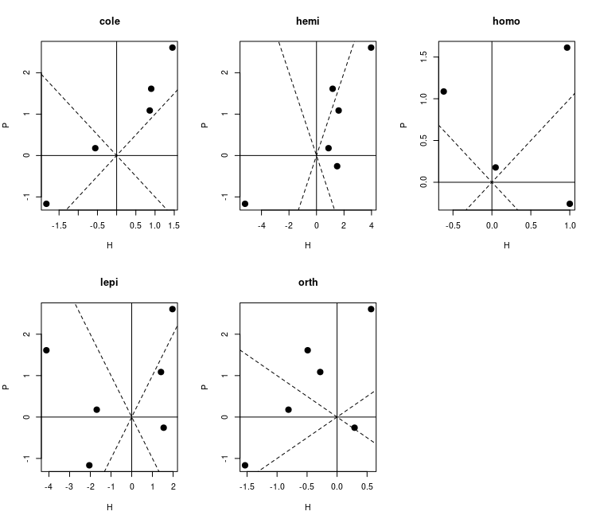Figure 2: Log ratios of the direct effect of carnivores on herbivores (H) vs indirect effect of carnivores on plants (P) measured as a logarithm of a biomass ratios between control and predator removal plots for studied groups (families/orders) of herbivores. If the biomass is higher in control plot than the ratio will be > 0 and thus also the logarithm will be positive, which indicate positive effect of carnivores on a given level of food web. Points indicate individual experimental blocks. Dotted lines show lines of equal direct and indirect effect strength.

2. Diet/habitat domain switching (Enemy-Free Space Hypothesis)

It is interesting to see, how different insect groups/morpho-species switch their resources. If this is the case here we would try to get some evidence for the Enemy Free Space hypothesis. Can I do this with RDA? I would like to know whether some herbivore species remain on their food plants and which are switching and maybe disappearing.
Can I compare two bipartite networks? (https://fukamilab.github.io/BIO202/06-C-matrix-comparison.html)

3. Path analysis of biomasses ?
What are the relationships between presence-absence of carnivores and herbivores, intermediate predator, and plant biomass
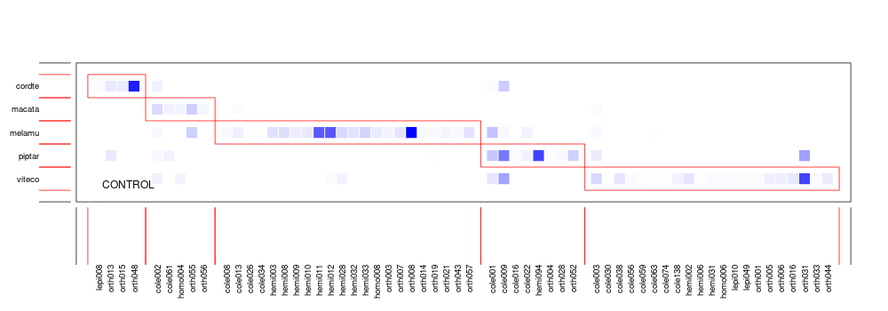
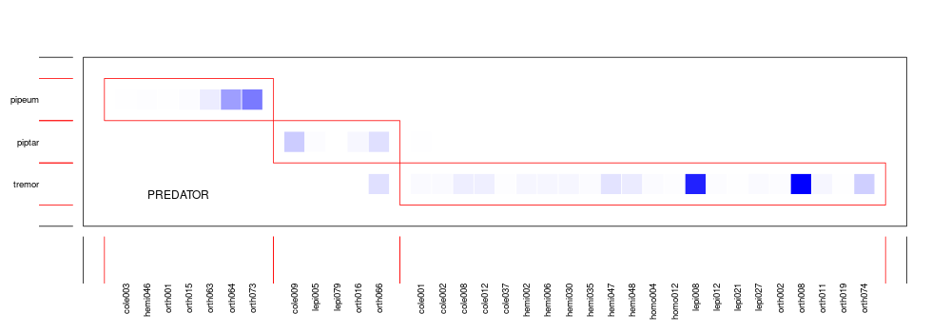Figure 3: Example matrices from the modularity analysis (garden 2). In cases like this we only have one plant species to campare between control and treatment (predator exclusion plot).

4. Interaction networks

5. Effect of predators on arthropod species composition.
We would like to test the hypothesis, that predators have differential impacts on herbivore species in relation to IGP and plant specificity. How could we use

Insecticide treatment helps us to evaluate the type of resource limitation.
At the end I would like to focus on PREDATOR/CONTROL comparison. Then I could use weevil 125 and 25 to evaluate the “effects of generalist herbivores on the system”
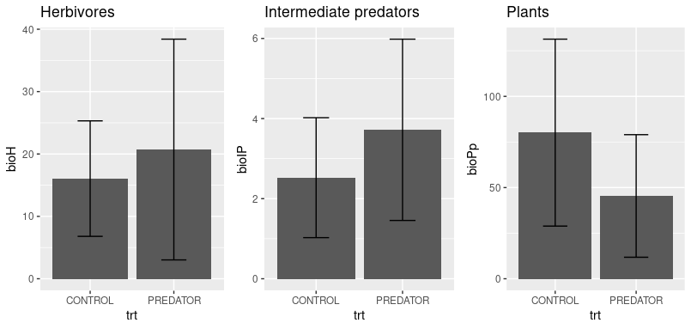Figure 4: Comparison of biomass for control and exclosure treatments
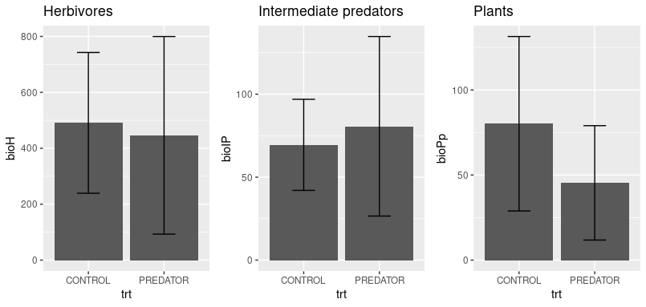Figure 5: Comoparison of abundance (only in case of herbivores and intermediate predators) between control and exclosure treatments
Do the same for families?

To-do:
For now simply focus on predator and control treatments. Along the way I might be able to make use of additional treatments (INSECTICIDE and GENERALIST ADDITION).
Using CONTROL and EXCOLOSURE comparisons we can test both top-down effects of predators on herbivores (removing variation in insect communities explained by plant community comoposition) and their indirect effects on plants (after removing variability in plant community composition explained by plants). Top down effects of insects can be evaluated using Insecticide vs Control treatments.

Is there a general effect of predators on intermediate predators, and herbivores?
- General plots
- tests for general plots
- Plots for each group of herbivores and intermediate predators.
- Tests for families
- For each plant species (that is comparable)….
- Tests for each plants species
- Maybe it is better to focus on diet switching instead? This is also related to EFS hypothesis

pRDA analyses – top down and cascading effects of predators and herbivores
- PC axes for plants with conditioned block.
  - I performed pPCA on plant community to obtain main axes of variation in plant community (I used only woody plants), because of possible co-linearities in species biomass. To remove variability in insect community composition explained by plants I performed partial RDA (pRDA) on insect community data conditioned on block and treatments and selected PC axes (bassed on their significant increase in adjusted R2) as explanatory variables. None of the PC axes were significant in forward selection (using only CONTROL and PREDATOR treatments), which suggests, that majority of variation in arthropod herbivore and intermediate predators might be explained by block and the treatment. These, however, are not significant either. Treatment and block does not explain any significant portion of variability in herbivorous insect community composition on our experimental sites. We can conclude that there is no effect of predators on herbivorous insect community composition. However, using only data for control and predator treatments discards some the information available on plants, insects and predator effect we have from garden experiment.
  - Similar results I obtained using all treatments except for fungicide and insecticide (weevil 125 and weevil 25 treatments had exclosures so these also represent “no predator” treatment) I was able to get PC4 as a significant predictors of herbivore community composition. However, adding this constraint to pRDA model does not qualitatively change the results.
  - Nevertheless, I decided to use pRDA coordinates along “predator effect” axis for herbivorous insects as characterization of predator effect on them. These values were divided in 3 different categories: negative (<37.5% quantile), neutral (> 37.5% and <62.5% quantile) and positive (above 62.5% quantile) effect of predators. To test whether generalists are more vulnerable (either positively or negatively affected by predators) I correlated them with PDI values. Form Figure 7 we can conclude, that similarly to findings of Bosc et al. 2018, in our data we see that generalists are experiencing either strong positive or strong negative effect of predators. It would be cool to explain more this pattern. I think,however, that specialists in general, which are only seen in some sites and in low abundnace, would cluster closer to the center of ordination space. How could I tweak these analyses to obtain some interesting results? I could try, except for plants also remove, or include as a predictor, variation in intermediate predator community composition. To further explore some emerging concepts I have some measure of plant quality on which herbivores feed, size class for each herbivore morphotype.
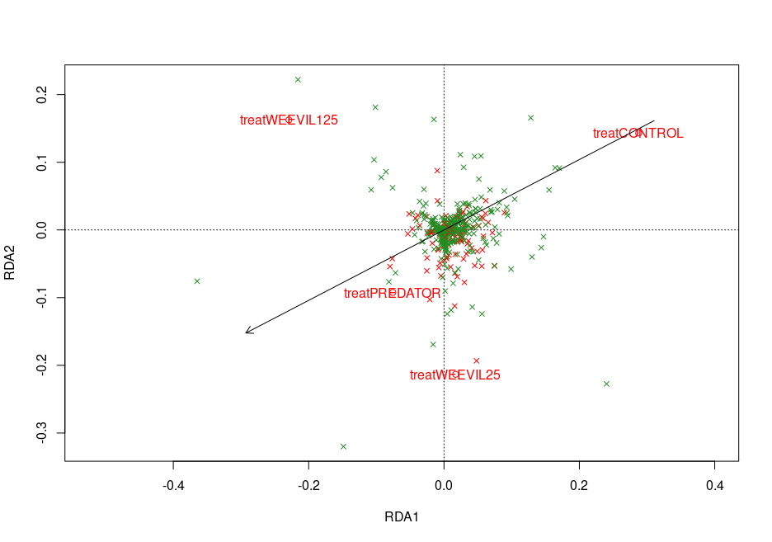Figure 6: pRDA diagram for insect biomass. Qualitatively similar to abundance-based pRDA. Red - intermediate predators, Green – herbivores, arrow represents “predator effect” (from the control to the centroid of all three exclosure plots). Neither pRDA model, axes nor individual treatments are siginificant. pRDA model is constrained on PC4 (only significant axis of plant community variability obtained from pPCA on woody plants) and block.
Adding PC from pPCA for intermediate predators only didn’t result in improving model at all. None of the PC axes were significant predictors of herbivorous insects abundance.
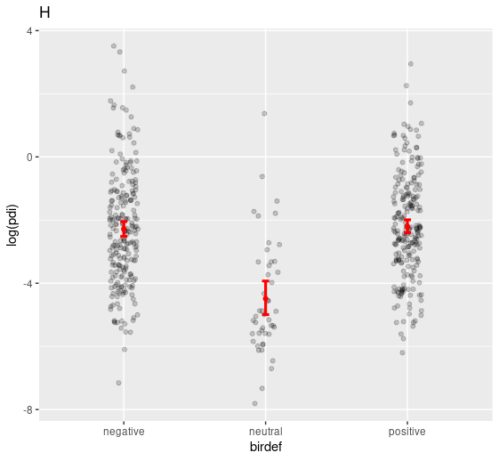Figure 7: Relation between PDI (specialization values) of herbivores and bird effect calculated as projection of pRDA coordinates onto “predator effect” vector, and divided into three categories: negative (<37.5% quantile), neutral (> 37.5% and <62.5% quantile) and positive (above 62.5% quantile). Dots represent empirical data points. Neutrally affected herbivores are significantly more specialized than two other groups.
  - I found that there was no effect of predators on either intermediate predator community composition, nor herbivore community composition. There was no effect of main PC axes of intermediate predator on herbivore community.
  - In conclusion we cannot say anything certain about the community compoosition and how it might be affected by top and intermediate predators, neither about intermediate predator and predators.
- But we found some cascading effects on plants in the previous paper. Lets try to remove variability in plant community composition caused by herbivores (if there is any) and see whether we get more clear effect of top predators PC axes for herbivores with conditioned treatment and block.
- Effects of predators on herbivores (conditioned on plants)
- effect of predators on plants (conditioned on herbivores)
- What about IP arachnids and mantoids????

Is there a difference in biomass/abundance analyses.
Comapre the results obtained from analysing biomasses and abundances. Biomass might be more important from the energetic viewpoint. Smaller insects mature faster. Initially smaller insects need more time to mature. Differences in initial size may influence the way individuals in the population trade off avoiding predators and growth rate/foraging gains Schmitz 2010 p. 128. (size of individuals and quality of food that they eat… whether they react differently to predation.
- Correlation of insect average size and predator effect on them from pRDA scores.

TTI for the analyses of Bosc.
Bosc found that plant generalist may be more vulnerable to birds and/or spiders than plant specialists.
- See, whether the effects for generalists and specialists are modified on plants of different quality (this is an additional test as we dont have good plant quality measure, but maybe we could use combination of SLA LDMC water content and number of herbivores feeding on them, maybe using pRDA to determine this).
- We may have only few comparable species. More commonly both plant and insect community composition change with the treatment and with site. How to include this effect in the test for EFS?

Top-down and cascading effects of herbivores and predators on plants.
Would it be possible to evaluate absolute vs relative resource supply for each morphospecies?
- Top-down effects of herbivores can be tested using I vs C comparisons. We have interactions.

Trophic level complexity 1(ISECTICIDE) → 2(EXCLOSURE) → 3(CONTROL)

Sorry that I couldn’t write earlier but it was challenging to settle on details through e-mail. Finally, however, I can present you our offer: we have 1730 photographs of plant leaves from our experiment in PNG. Your job would be to each time rename the photo, increase its contrast, and draw approximate outline of all leaf blades, holes and missing parts. I will send you the full protocol for this. We are able to pay you 20 CZK per one photo. I realize, that It might be difficult at the beginning and take you around 25 minutes to process your first photos. However, I want to ensure you that with time you would get more skilled in this and it would take less and less time to process one photograph. Consider also the fact that some photos have less leaves than other. It means that you could spend only few minutes on some, but it would take longer on other. Let me know your thoughts, and If you agree I we could discuss your contract.

