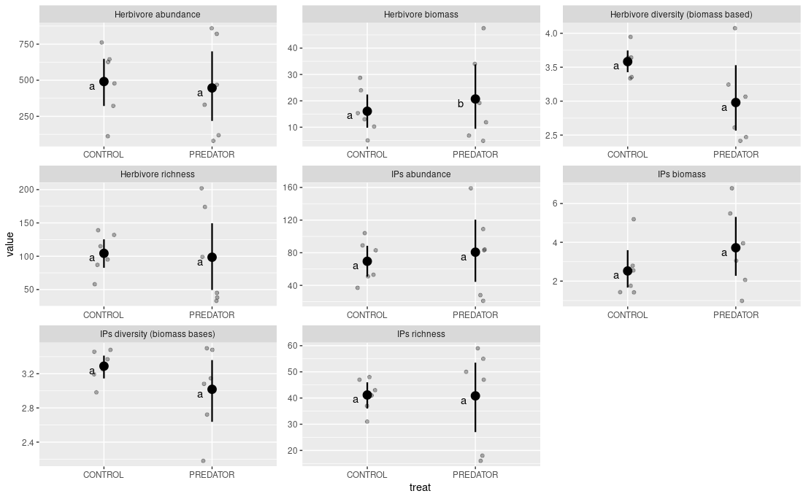
[p1] Values of community indices for the control plot compared to exclosure plots for invertebrate herbivore and IAPs communities. Mean and 95% bootstrapped CIs are showed. Grey points indicate empirical values for six experimental blocks. Differences between means were tested using generalized mixed effect models with experimental block as a random factor.

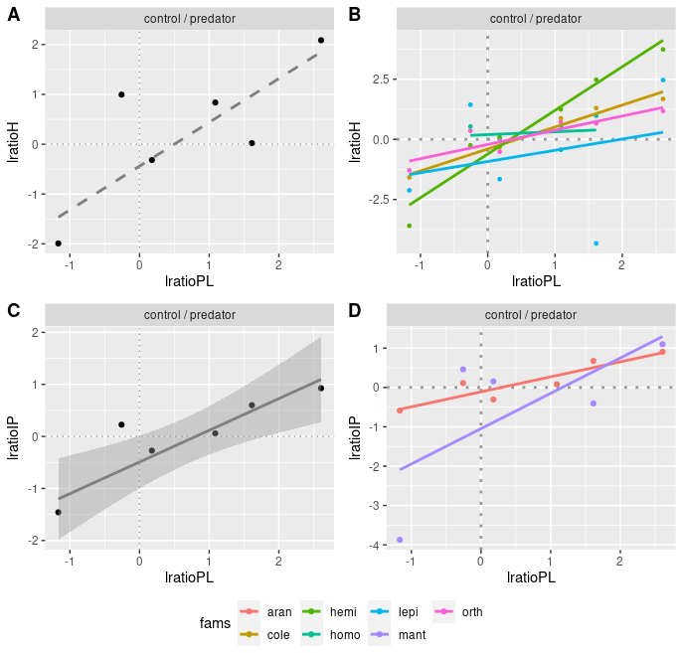
[p2] Relationships in changes between different trophic levels on individual plots: A – herbivores vs. plants; B – herbivores vs. plants for individual orders/groups for herbivores general, broken into orders and for IAPs broken into orders.

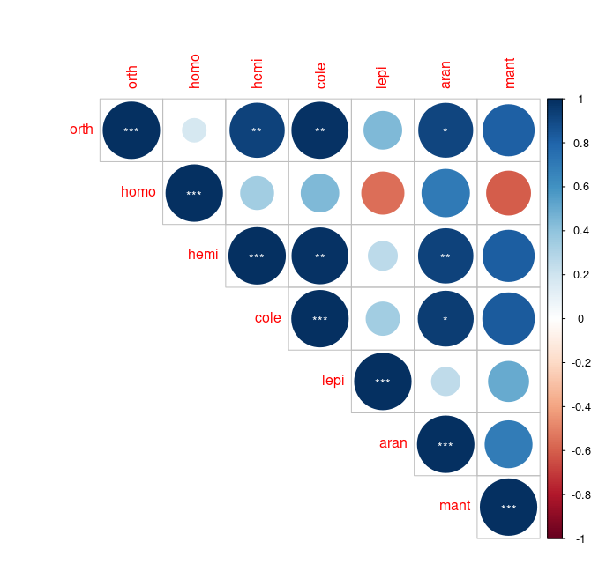
[p2b] Pairwise correlation in log likelihood ratios between different insect orders. Significance is indicated by asterisks: p = 0.001 (***); p = 0.01 (**); p = 0.05 (*). [bio_log_ratio.R]

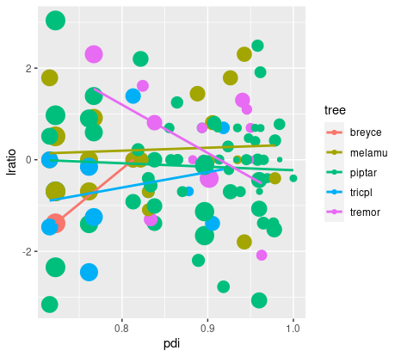
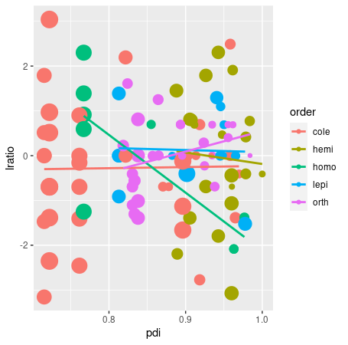

[p3] [plant_species_logratio.R]. Nothing significant: there is no effect of PDI on herbivore species performance on plants. Each point represent a herbivore species for which we found at least xxx individuals. But interestingly it might be seen that there is a PDI value between 0.8-0.9 that shows no change in abundance. For both specialists and generalists these responses are expected to vary more

[p4] Size distribution changes in orders.

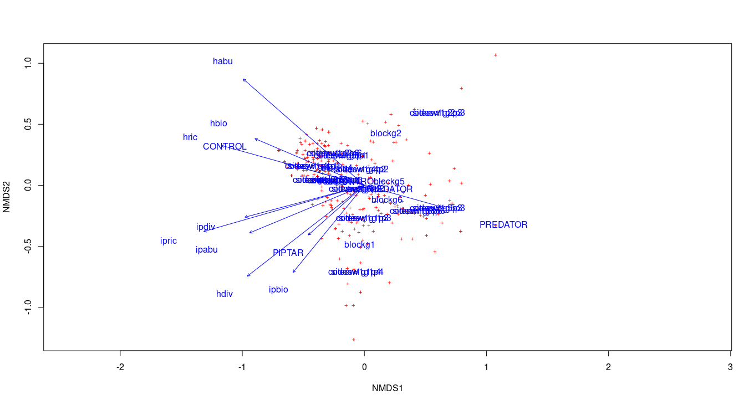

[p5] NMDS for PREDATOR CONTROL plots and invertebrates, perform ANOSIM for two sites. Herbivores were not affected by any plant species. NMDS showed some structure in herbivore community i.e. that there was a gradient of diversity

[pX] Some food quality comparisons.

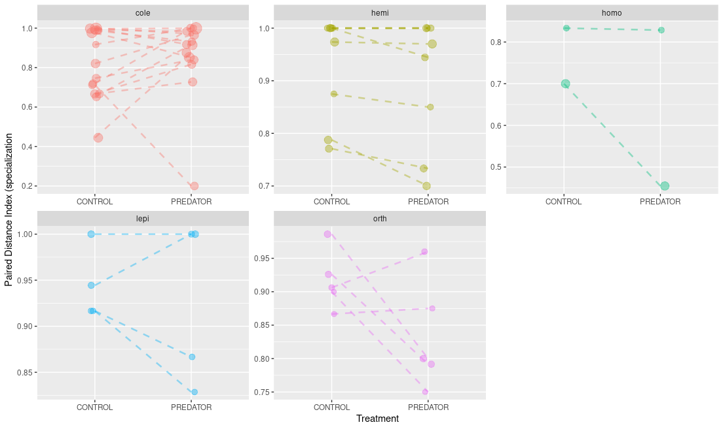
[pX] Some evaluation of diet switching. PDIs relationships in treatment vs control for each herbivory morpho-species from each herbivorous order/group. Statistical test was performed on log ratios of the PDI values. No order showed their change significantly higher or lower than zero [pdi_response_to_treatment.R]. There might be a problem here: In some cases I might have species present in more than 3 blocks for control and exclosure treatment.

[pX] Lack of effect of community composition on herbivore community. Bray Curtis within and between.

