**Limited effects of predators on plant-herbivore interaction network in early tropical secondary forest.**

Piotr Szefer, Kenneth Molem, Austin Sau, Martina Vasutova & Vojtech Novotny

**Abstract**

Succession in canopy gaps is an important part of tropical forest dynamics. Conditions under which natural enemies cause top-down and cascading effects in these habitats is not yet fully understood. In regenerating tropical forest, however, studies of inter-trophic level dynamics are still largely missing.

Here we present results of a replicated exclosure experiment from an early successional vegetation in lowland tropical forest gaps in Papua New Guinea. We assessed strength of the top-down effects of primary predators (birds and bats) on insect herbivores and arthropod predators (AP). Further we evaluated whether change in community composition, individual species specialization, and shifts in body size contributed to previously observed limited cascading effect on vegetation.

Primary predators decreased biomass, increased diversity, but had no effect on abundance. There was a weak indication of intra-guild predation on AP, however, it did not contribute to the effect on herbivores. Herbivore and AP abundance and biomass correlated strongly with the plant biomass. There was no negative correlation between the effect of primary predators on population size of any guild nor arthropod order that would suggest top-down effects or apparent competition. Cascading effects on plant biomass were alleviated by increased proportion of AP in the community. Generalist performed as good as specialist, but there was evidence for their higher plasticity in diet choice. Utilization of enemy free space was unlikely. Surprisingly, modularity decreased in response to predatory pressure, but there was no effect on other network indices.

Our results suggest that in early successional forest gaps vegetation controls arthropod populations, but there are some limited top-down effects on arthropods in this system. Arthropod community composition influence cascading effects on individual plant species and flexibility in diet choice of generalists may have an important consequences for network stability. Further studies are needed to evaluate whether effects of primary predators are truly small or there might be some additional mechanism in place, e.g. alternative energy channels for both vertebrate and invertebrate predators (detritus channels) or limited food availability for herbivorous insects.

**Key words:** tri-trophic interactions, plant-arthropod herbivore networks, intermediate predation, succession, interaction networks, top down effects, cascading effects, tropical secondary forest.

**Introduction**

Secondary succession in tropical forest gaps plays an important role in sustaining hyper-diversity of tropical forest (Fischer et al., 2016; Gripenberg et al., 2014; Schnitzer and Carson, 2001). After a disturbance this competitive replacement process allows for light-demanding species to establish themselves in otherwise impenetrable canopy and has a long-term consequences for the forest structure and diversity. Even today competitive interactions among plants are assumed to be the key force that structures early successional vegetation structure (Velázquez and Wiegand, 2020). This might be a reason why top-down effects of herbivores and their predators on plants have rarely been considered in studies of vegetation dynamics during regeneration (Fischer et al., 2016). In contrast, for primary forest herbivorous insects and pathogenic fungi were shown to strongly affect community assembly process (Bagchi et al., 2014). Despite a generally stronger herbivory pressure found in regenerating tropical forest gaps (Piper et al., 2018) impact of natural enemies is assumed to be muted by acquisitive character of plant species traits (Strauss and Agrawal, 1999; Turner, 2001).

Top-down effects in tropics are found to be highly variable (Maas et al., 2016). While in tropical agro-ecosystems these seem to be strong and prevalent there is contrasting evidence of whether top-down and cascading effects are universal in natural plant communities (Bael et al., 2003; Harrison and Banks-Leite, 2020; Vidal and Murphy, 2018). Correlation patterns between herbivore abundance and various plant community characteristics suggest that arthropod communities in late successional forest are shaped mainly by vegetation (Mottl et al., 2020; Whitfeld et al., 2012). This bottom-up control would result in weak top-down cascades. Recently it was shown that herbivorous insects shape community composition, but predators had surprisingly weak cascading effect on vegetation in early succesional tropical forest gaps (Szefer et al., 2020). This observation seems to be consistent with some theoretical expectations e.g. that higher productivity would result in stronger bottom-up control of herbivores by vegetation (Kagata and Ohgushi, 2006; Mooney et al., 2010). It is unclear whether the same is true for the initial stages where assembly processes are more dynamic and plant natural enemies might be more relevant especially when trophic cascades are expected to be stronger on younger plants (Boege and Marquis, 2006). Unfortunately, strength of top-down control of plants by herbivores was found to be highly site specific and difficult to predict accurately by climatic conditions, productivity or plant growth forms (Jia et al., 2018) and complex natural histories of both predators and herbivores within food-webs might be important.

Studies from temperate region usually report stronger top-down effects on herbivore abundance (Vidal and Murphy, 2018) despite biomass being more indicative measure of a population size (Rossberg, 2013). By focusing on top-down effect on abundance we might miss an important effect of body size shifts in response to predation (Gruner, 2004). Especially when it is known that prey size is crucial for vertebrate predators and can change the size structure of their prey (Detmer et al., 2017; Rodgers et al., 2015). However, simultaneous evaluations of how predators affect herbivore abundance and biomass are surprisingly rare (Gruner, 2004; Harris et al., 2020). Especially studies of arthropod predators (AP) are scarce (Maas et al., 2016).

Strength of a top-down trophic cascade depends on a food web structure (Daugherty et al., 2007; Pujoni et al., 2016). Bats, birds and ants as primary predators effectively limit abundance of tropical arthropods and respond to and reduce leaf damage (Kalka et al., 2008; Morrison and Lindell, 2012; Sam et al., 2015). However, presence of intra-guild predation (IGP) is hypothesized to weaken any top-down cascading effect (Finke and Denno, 2005; Polis and Holt, 1992). Significant role of arthropod predators in tropical food webs can be seen from a recent comparative analysis, that showed up to 82 times higher diversity of AP in the tropics than in temperate climatic zone (Privet and Petillon, 2018). However, at least in tropical monoculture, IGP by vertebrate predators in arthropod-plant interaction seems to be characterised by stronger cascading effects (Karp and Daily, 2014). In natural systems primary predators might feed preferentially on spiders than insects (Bosc et al., 2018; Recalde et al., 2020). Interestingly, however, it was shown that in plant-arthropod herbivore systems top-down effects on IGP and herbivores tend to be positively correlated (Mooney et al., 2010). Therefore, specific circumstances under which IGP attenuates or amplified these effects is still unclear and we need more studies to evaluate its effect in diverse tropical forest. Yet studies reporting top-down or/and cascading effects on plant community composition from tropics are scarce (Bael et al., 2003; Harrison and Banks-Leite, 2020; Kurten, 2013; Letourneau et al., 2004).

Individual herbivore responses to predation can also affect top-down cascade strength (Carson and Root, 1999). Key factors known to mediate predator-prey interactions are specialization, ability to switch between resources (or habitats), mobility and feeding mechanism (guild identity) (Duffy et al., 2007; Maas et al., 2016; Pace et al., 1999; Schmitz, 2017; Singer et al., 2014; Van Bael et al., 2008). Due to hypothesized superior physiological and behavioral adaptations specialist might be able to avoid generalist predators irrelevant of the plant quality on which they feed. This utilization of the enemy free space (EFS) by herbivores should weaken any top-down cascade (Petschenka and Agrawal, 2016; Schmitz et al., 2000). In plant-herbivore interaction networks, the presence of EFS, and its niche reducing effect on herbivorous insects can be evaluated by increase in network modularity in response to predation (Augustyn et al., 2016; Oliveira et al., 2020), whereas presence of generalists tend to reduce this measure of network clustering (Robinson and Strauss, 2020; Ximenes Pinho et al., 2017). However, EFH has not been yet confirmed to be universal for tropical predator-prey interactions (Novotny et al., 1999). In both primary and secondary tropical forests plant-herbivore interaction networks were shown to be highly specialized (Novotny et al., 2004; Redmond et al., 2019). This potentially limits our abilities to detect EFS and mute cascading effects of primary predators on plants.

Under food limitation population size of generalists is predicted to be strongly reduced by their predators as predicted the tri-trophic interaction hypothesis (TTI) (Mooney et al., 2012). However, in complex communities relative strength of bottom-up vs top-down forces on herbivores seems be of a similar magnitude irrespective of their diet breadth (Vidal and Murphy, 2018). It is possible that predatory pressure can force some herbivores to shift their diet and mitigate negative effect of natural enemies on their abundance (Calcagno et al., 2011; Schmitz, 2017). Moreover, in species rich plant communities generalist herbivores should be more flexible in their diet choice (Pfisterer et al., 2003). It was shown that prey will respond in reduced feeding if its own habitat domain (habitat specialization) is narrow, or it will prefer to shift habitat if its mobile and have a broad habitat domain (Schmitz et al., 2004). This flexibility in habitat choice can possibly translate into wider diet breadth as its the case for predators (Stewart and Dudash, 2018).

In this paper we evaluate the strength of top-down effects of key vertebrate predators on insect herbivore and AP communities in a plot-based experiment in early successional large tropical forest gaps. We also explore reasons for weak cascading effects of predator removal on plants. Specifically we predict: (1) weak top-down effects on herbivores, with stronger effects on abundance than on biomass caused by shifts in prey body size; (2) disproportionate predation on AP and different herbivorous guilds resulting in reduced pressure on herbivores and/or compensation for arthropod community biomass; (3) lower performance of generalist than specialists resulting in negative correlation between specialization and absolute value of predator effect and reduced modularity of plant-herbivore interaction networks under predator pressure.

**Materials and methods**

[methods_ms1.doc]

**Results**

We collected 6524 individuals (~100.005 g of dry mass) from seven dominant orders belonging to herbivorous (Coleoptera, Hemiptera, Homoptera, Lepidoptera, Orthoptera) and AP (Aranea, Mantodea) guild, from 753.5 kg of plant biomass and approximate 633.2 m2 of foliage. The most abundant orders belonged to Coleoptera (**Fig S15**) but Orthoptera had generally the highest biomass (**Fig S16**).

We found that abundance of arthropods was strongly correlated with plant biomass and that exclosures did not significantly modify this relationship for any arthropod order **(Fig. S1)**.

Predators decreased biomass and increased diversity of herbivores, but the latter effect was marginally significant (P = 0.052). Abundance and richness were not affected (**Fig.1**). We found no effect of predators on AP community. Additionally, no difference in descriptors was found for any order (**Fig S2**).

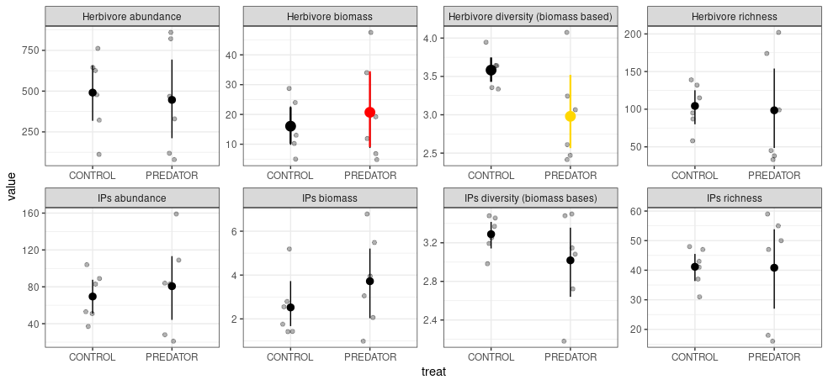

**Figure 1.** Mean and 95% bootstrapped CIs of the invertebrate and intermediate arthropod predator community indices in the control and exclosure plots. Grey points indicate empirical values for six experimental blocks. Differences between means were tested using generalized mixed effect models with experimental block as a random factor. Herbivore diversity is marginally significant (P = 0.052) [maybe LRR analysis would be more appropriate here].

Species size distribution of Orthoptera and Araneae shifted towards larger species in the exclosure (**Fig. S3**). Size shift, however was not consistent between plant species nor sites (**Tab. S1**). i.e. arthropod orders did not respond consistently thorough plant species or sites.

We found significant correlation between LRR of herbivores and AP, and marginally significant correlation between LRR of plants and herbivores (**Fig. 2**). However, when we performed regression analysis independently at the group level the latter relationship became significant. The order identity did not modify this relationships. Correspondingly, we found positive correlation between LRR for each AP order and herbivores. Qualitatively similar patterns were found for LRR based on arthropod biomass (**Fig. S4**) with an exception of Mantodea, where the significance vanished in the order level analysis. In pairwise comparisons we only found significant positive correlation of the predator effects (LRR) between Aranea, Orthoptera, Hemiptera and Coleoptera (**Fig. S5**).

We did not find negative correlation between AP and herbivore population size that might be an indication of a consumer control (**Fig. S6**). Pattern of abundance and biomass correlation between all groups changed qualitatively between control and exclosure plots i.e. exclosure did change the character of correlation. However, whenever a change occurred it was always form a non-significant correlation into a significant positive one and significant positive correlations were more common in the exclosure plots. Moreover, higher AP to herbivore ratio was related to lower cascading effects on plants (**Fig. S7**), i.e. the more AP relative to herbivores more LRR values of plants are near zero. However this relationship vanished at the individual chain level.

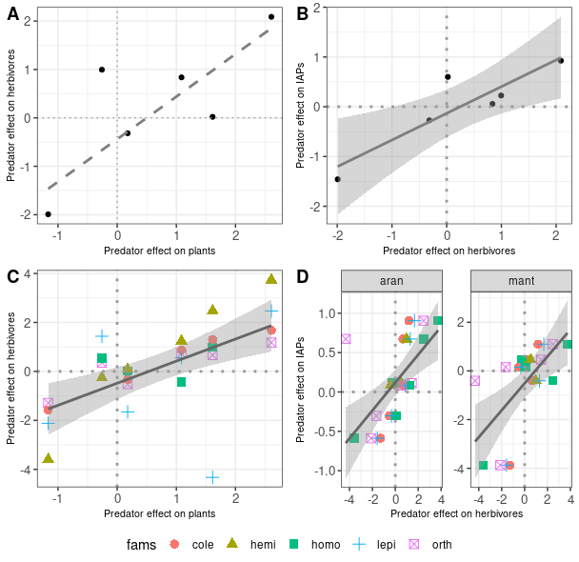**Figure 2.** Relationships in predator effects (LRR – log response ratio) between different trophic levels in individual plots: A – herbivores vs plants; B – herbivores vs. IAPs; C) herbivore vs plants relationship broken into individual orders/groups, and D) for IAPs divided into orders [bio_log_ratio.R]. Solid line represents significance at the 0.05 level and dashed line at the 0.1 level. In case of significance 95% CIs are also plotted.

There was no independent (controlled for the treatment and site) effect of the plant community variability (any of the PCA axes for plant community composition) nor AP community descriptors (biomass, abundance, richness, diversity) on herbivore community composition (**Tab. ???**). Abundance-based AP community was independently influenced by total herbivore abundance and the biomass-based community composition was not independently influenced by herbivore community nor plant composition.

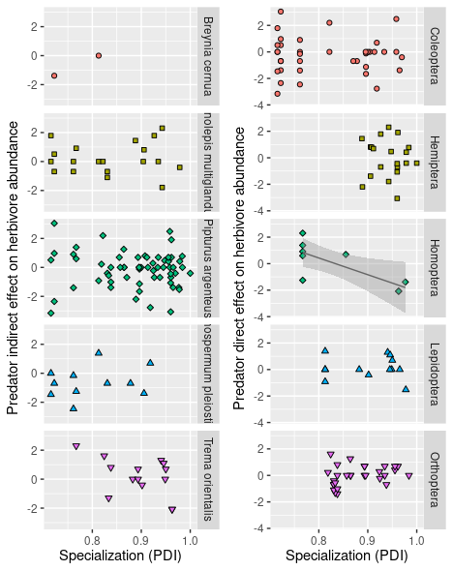

**Figure 3**. Effect of specialization (Paired Dissimilarity Index - PDI) on herbivore species performance (log response ratio - LRR) on plants and for different orders. Each point represent a herbivore species for which we found at least ten individuals in total. Significance of the regression coefficient at the 0.05 level is indicated by a solid line and in that case also 95% CIs are plotted in the graph. Abundance in a given site for each morpho-species was used as a weighting factor and block was set to be a random effect.. [plant_specie_slog_ratio.R]

Partial RDA showed no effect of predators on herbivore nor AP community composition (both biomass- and abundance-based). However, we found high proportion of unconditioned as well as conditioned (site variation) variance (**Tab. X**). Based on pRDA coordinates both biomass and abundance of Coleoptera and Hemiptera were more often positively, and Lepidoptera negatively affected by top predators (**Fig. S8**). However, there was no general difference in LRR of individual species for any order (**Fig. S9**). In case of AP Mantodea abundance and biomass was negatively affected and the latter effect was marginally significant.

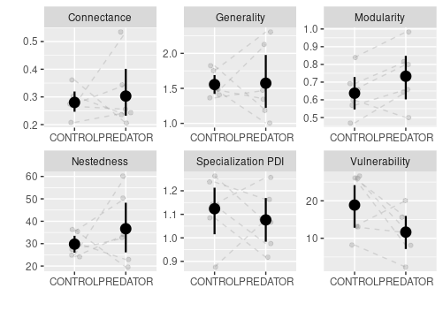

**Figure 4**. Mean and 95% CIs for different network descriptors in control and exclosure plots. **Only modularity has decreased significantly (z value = 2.143, p = 0.032, beta family with the logit link function)**.

Only in case of Homoptera more specialized species showed an increasingly negative response to predators (**Fig. 3**). Otherwise, specialization had no effect on the species’ performance and this lack of correlation prevailed across studied plant species.

Among studied network descriptors we detected only a decrease in modularity as a response to predator pressure (Z = 2.143, P = 0.032, **Fig. 4**). We found that species from Coleoptera, Orthoptera and Lepidoptera that were present in both exclosure and control plots had significantly lower specialization (**Figure SXXX**).

Moreover, there was no interaction between specialization and predator effect for any herbivore group on any plant (**Fig. S10**). We also found that in case of Orthoptera and Homoptera larger species experienced weaker top-down effects **(Fig. S11)**.

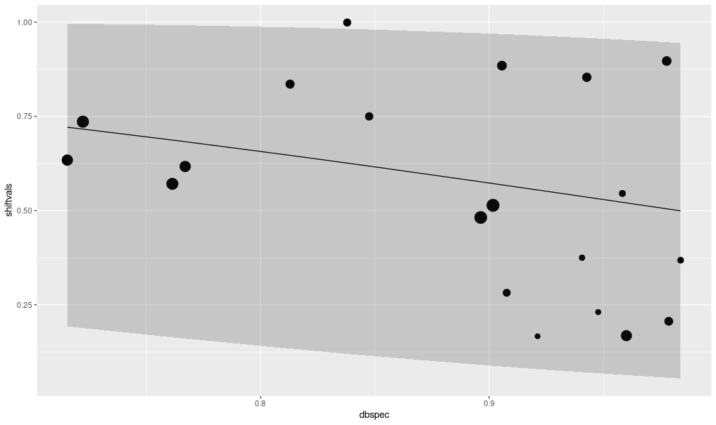

**Figure 5.** Weighted beta regression model with **95% prediction quantiles**. Diet breadth (PDI) vs diet shifts tends to be lower for more specialized species, as expected. Beta regression was significant. Nevertheless their was some evidence of the diet shift, as much as we were able to detect it. **Model explains only ~9% of variation but it is significant**. Logarithm of abundance are indicated by individual point sizes.

There was no consistent shift in diet (change in PDI values) in response to predation for any studied herbivore group (**Fig. S12**). Individually, however, species with higher diet breadth were also more willing to shift their diet (**Fig. 5**).

**Discussion**

In this paper we evaluated the effects of predatory birds, bats and ants on insect herbivores and AP communities during early succession of large, lowland tropical forest canopy gaps. A complete sampling of arthropod communities from 28 individual tree species within our vegetation plots allowed us to asses the strength of top-down effects on arthropod communities and explore some of the main hypothesized mechanisms of arthropod alleviation of cascading effects i.e. differential top-down effects on biomass and abundance, size and compositional shifts in arthropod communities, increased proportion of AP to herbivore, herbivore specialization, and diet shifts of herbivores.

*We found weak top-down effects of predators on artropod community*

Top-predators did not reduce herbivore nor IAP abundance. This result differs from the general observation that the abundance of both herbivores and IAPs in arthropod herbivore – vertebrate predators systems is reduced simultaneously (Mooney et al., 2010). However, our results are in accordance with recent findings from tropical forest in Brazil where similar limited top down effect of vertebrate predator removal on arthropod abundance and no indirect effect on plants was found in the forest edge (Harrison and Banks-Leite, 2020). This lack of effect was attributed to deterioration of insectivore community near the forest edge. Similar reduced foraging might be true for forest gaps.

All arthropods tracked changes in plant biomass, however with variable strength. At least for Orthoptera, Hemiptera and Coleoptera this is suggestive of strong bottom-up control by plant biomass. It was also noted earlier that disturbed forest will favour insect herbivory and there might be a shift form bottom-up control by plant abundance instead of plant secondary metabolites which would lead to herbivore proliferation (Morante‐Filho et al., 2016)

Despite no detectable change in abundance we found ~33% (xxx %, xxx %) reduction of herbivore biomass, but again no significant effect on IAPs. This points out to a differential responses of arthropod abundance and biomass to top-predators an that biomass effects might not be important for cascading effects. There are at least two possible explanation for this discrepancy. First, in our experiment the top-down effects on arthropod abundance could be truly small and due to a low sample size remained undetected. However, small scale experiments usually report higher effects of predators (Bommarco and Banks, 2003). Secondly, as noted previously by (Mooney et al., 2010), effects on abundance can be compensated by a continuous influx of allochthonous herbivores from the surrounding primary forest matrix. It has previously been shown that, at least in case of diversity, herbivorous communities are not saturated with species (Novotny et al., 2012). Strong correlation between plant biomass change and arthropod abundance in our results suggests that the same might be also the case for abundance. Mobile herbivorous Coleoptera and Hemiptera, that were positively affected by birds, either because of smaller size or utilization of EFS, may freely colonize. However we did not detect any shift in the community composition, which excludes compensatory colonization by herbivores (see also discussion below *Disproportionate predation and herbivore diversity)*. Constant colonization can still be true if it colonization success for all arthropod group remains the same and reduction by vertebrate predators in vegetation plots is density independent, as it was found for bats (Wray et al., n.d.).

Secondly, under abundance limit enforced by available plant biomass, and with high quality food plants we should see compensating effect of herbivore body size/mass shifts within the community (Ritchie and Johnson, 2009). We found shifts in the species size distributions for Aranea and Orthoptera, possibly released from primary predator pressure. Birds were shown to prey on lager bodied herbivores (Singer et al., 2017). This preference of top predators can explain increase in biomass and no effect on abundance of herbivores but hard to explain the lack of similar pattern for spiders. However, this shift in biomass at the community level might be present, but our ability to detect it was limited by our sample size.

Weaker effects on population size of AP coupled with biomass reduction of herbivores might be caused by the presence of additional energy channels for arthropod predators and possibly also for primary predators. Specifically detritus channels might be important in early successional gaps as predicted by the apparent trophic cascade hypothesis (Liu et al., 2016; Ward et al., 2015). With rising productivity top predators should derive significant fraction of their diet from an increasingly productive bottom-up controlled detrital channels. We showed earlier that decomposition rates are higher in early successional than in primary forest (Szefer et al., 2017). This possibly translates into more diverse or abundant detritivore and fungivore communities. Detrital channels might also explain why in general intraguild predation amplifies cascading effects on vertebrate predators on plants in tri-trophic systems. Spiders are known to feed on detritivores and fungivores and to cause top-down and cascading effects on detritivores and decomposition rates (Murphy et al., 2020; Wise et al., 1999). This additional subsidies might increase abundance of IAP even when they still under control by vertebrate predators or by inter guild competition and territoriality (Welti et al., 2020).

*Disproportionate predation and herbivore diversity*

Higher ratio of IAPs to herbivores was previously found to translate into stronger positive cascading effects on plants (Mooney et al., 2010). However, in our case the slope of this relationship was negative. This meas that lower proportion of AP in arthropod community translated into positive effect of predators on plants. This supports predictions of food web theory that effects of vertebrate insectivores on herbivores and plants should attenuate trophic cascades in the presence of AP (Daugherty et al., 2007; Holt and Polis, 1997). Plausible explanations are that birds might either prefer to feed on IAP, or that increased abundance of IAP reduce herbivore insects. Direct LRR of IAPs however were positively correlated with those of herbivores (for both abundance and biomass) which suggest that IAPs and herbivores are both positively affected by their resources. It is also worth mentioning that significance of this negative slope vanished when we looked at individual plant species in our experiment. However, general pattern of stronger effects with lower proportion of IAP to herbivores prevailed.

Correlations and pRDA analysis do not support compensating community compositional shifts. It seems to confirm limited compensation abilities of herbivorous communities (Kurten, 2013). In our experiment a change in biomass and abundance of Lepidoptera was as often negatively as positively affected by predators, but this effect was not correlated with indirect effect of predators on plants. This might suggest that caterpillars were attacked more often by predators. However, it is also puzzling why individual Lepidoptera species responses did not translate to consistent negative effects on total abundance. However Lepidoptera are highly variable in their feeding guild (Novotny et al., 2010) that we did take into account here. It seems that mobility might be an important factor mediating herbivore response to predation.

Unexpectedly we found that predators increased diversity of herbivore guild. This might confirm important role of predators in shaping herbivore diversity (Zhang et al., 2018). Diverse communities of herbivores should experience weaker top down effects (Maas et al., 2016). This might suggest high specialization of predatory herbivores in forest gaps, which is unlikely. We would rather expect that more versatile generalist predators would forage in such dynamically occurring habitat. However, as we mentioned earlier, at least for generalist bats foraging seems to be density independent (Wray et al., n.d.).

*Specialization patterns*

In contrasts with expectations (Bosc et al., 2018; Mooney et al., 2012; Singer et al., 2014) in our experiment specialists did not perform better than generalists. (Bosc et al., 2018). Under specific circumstances i.e. high plant quality and specialization of tropical food webs, it might be consistent with predictions of the TTI. However, in the light of lack of general effect on the abundance, community composition and limited effect on arthropod biomass, the most plausible explanation is simply a low predatory pressure in forest gaps.

Against our expectations, modularity decreased in the presence of predators with no effect on specialization or any other network descriptor. This might suggest that in tropical forest gaps EFS is unlikely, as it was previously shown to be doubtful for *Ficus* species in Papua New Guinea (Novotny et al., 1999). Again we show a general lack of a strong predator avoidance behaviour that would be indicative of their weak effect (Belgrad and Griffen, 2016). It is puzzling why least specialize herbivores (or ones that utilize broader habitat ranges) increase in abundance in the presence of predators. It is possible that by decreasing abundance through utilization of broader host plants generalists are able to avoid predation. This might be supported by our findings that generalists were generally more flexible in their diet choice. Generalist modifying their diet might be a community response to a biotic and abiotic factors and be responsible for the network stability as shown recently (Robinson and Strauss, 2020). However, this pattern in modularity might be mainly caused by increased colonization of exclosure plots by species having narrow diet breadth in exclosures as was shown in case of our experiments. This phenomenon would not be captured in our LRR and PDI analysis where we were only able to compare species that were present in both control and exclosure plots.

*Conclusions and Future directions*

Besides general caveats of any exclosure experiments (Maas et al., 2016) there are other possible mechanisms that could affected strength of top-down and cascading effect in our study. These were explored in more detailed in *Supplementary discussion*.

We conclude that in tropical forest gaps effects of predators are limited. In early successional forest gaps herbivores and AP respond mainly to changes in quantity of the vegetation. It is unclear, however, whether these effects are caused by changes in predator foraging or additional energy channels for both arthropod and vertebrate predators..

More thorough evaluation of top predator natural history and foraging behavior in gaps are needed. There is still a need for more systematic studies of tropical systems involving epigeic and soil herbivores and detritivore communities. More thorough studies of natural enemies, including manipulation of lizards, parasitoids combined with plant species manipulations and nutrient additions to study bottom-up effects and productivity gradients. Also increase in sample size would definitely improve our abilities to detect more subtle changes and overcome the problem of high local variation in plant and herbivore community composition. Our conclusions would also benefit from direct comparisons between forest interior and gap comparisons to test whether limited effect of predator effects result from change in forest structure.

**References**

Augustyn, W.J., Anderson, B., Ellis, A.G., 2016. Experimental evidence for fundamental, and not realized, niche partitioning in a plant–herbivore community interaction network. J. Anim. Ecol. 85, 994–1003. https://doi.org/10.1111/1365-2656.12536

Bael, S.A.V., Brawn, J.D., Robinson, S.K., 2003. Birds defend trees from herbivores in a Neotropical forest canopy. Proc. Natl. Acad. Sci. 100, 8304–8307. https://doi.org/10.1073/pnas.1431621100

Bagchi, R., Gallery, R.E., Gripenberg, S., Gurr, S.J., Narayan, L., Addis, C.E., Freckleton, R.P., Lewis, O.T., 2014. Pathogens and insect herbivores drive rainforest plant diversity and composition. Nature 506, 85–88. https://doi.org/10.1038/nature12911

Belgrad, B.A., Griffen, B.D., 2016. Predator–prey interactions mediated by prey personality and predator hunting mode. Proc. R. Soc. B Biol. Sci. 283, 20160408. https://doi.org/10.1098/rspb.2016.0408

Boege, K., Marquis, R.J., 2006. Plant quality and predation risk mediated by plant ontogeny: consequences for herbivores and plants. Oikos 115, 559–572. https://doi.org/10.1111/j.2006.0030-1299.15076.x

Bommarco, R., Banks, J.E., 2003. Scale as Modifier in Vegetation Diversity Experiments: Effects on Herbivores and Predators. Oikos 102, 440–448.

Bosc, C., Roets, F., Hui, C., Pauw, A., 2018. Interactions among predators and plant specificity protect herbivores from top predators. Ecology 99, 1602–1609. https://doi.org/10.1002/ecy.2377

Calcagno, V., Sun, C., Schmitz, O.J., Loreau, M., 2011. Keystone Predation and Plant Species Coexistence: The Role of Carnivore Hunting Mode. Am. Nat. 177, E1–E13. https://doi.org/10.1086/657436

Carson, W.P., Root, R.B., 1999. Top-down effects of insect herbivores during early succession: influence on biomass and plant dominance. Oecologia 121, 260–272. https://doi.org/10.1007/s004420050928

Daugherty, M.P., Harmon, J.P., Briggs, C.J., 2007. Trophic supplements to intraguild predation. Oikos 116, 662–677. https://doi.org/10.1111/j.0030-1299.2007.15378.x

Detmer, T.M., McCutchan, J.H., Lewis, W.M., 2017. Predator driven changes in prey size distribution stabilize secondary production in lacustrine food webs. Limnol. Oceanogr. 62, 592–605. https://doi.org/10.1002/lno.10446

Duffy, J.E., Cardinale, B.J., France, K.E., McIntyre, P.B., Thébault, E., Loreau, M., 2007. The functional role of biodiversity in ecosystems: incorporating trophic complexity. Ecol. Lett. 10, 522–538. https://doi.org/10.1111/j.1461-0248.2007.01037.x

Finke, D.L., Denno, R.F., 2005. Predator diversity and the functioning of ecosystems: the role of intraguild predation in dampening trophic cascades. Ecol. Lett. 8, 1299–1306. https://doi.org/10.1111/j.1461-0248.2005.00832.x

Fischer, R., Bohn, F., Dantas de Paula, M., Dislich, C., Groeneveld, J., Gutiérrez, A.G., Kazmierczak, M., Knapp, N., Lehmann, S., Paulick, S., Pütz, S., Rödig, E., Taubert, F., Köhler, P., Huth, A., 2016. Lessons learned from applying a forest gap model to understand ecosystem and carbon dynamics of complex tropical forests. Ecol. Model., Next generation ecological modelling, concepts, and theory: structural realism, emergence, and predictions 326, 124–133. https://doi.org/10.1016/j.ecolmodel.2015.11.018

Gripenberg, S., Bagchi, R., Gallery, R.E., Freckleton, R.P., Narayan, L., Lewis, O.T., 2014. Testing for enemy-mediated density-dependence in the mortality of seedlings: field experiments with five Neotropical tree species. Oikos 123, 185–193. https://doi.org/10.1111/j.1600-0706.2013.00835.x

Gruner, D.S., 2004. Attenuation of Top-down and Bottom-up Forces in a Complex Terrestrial Community. Ecology 85, 3010–3022.

Harris, S.H., Kormann, U.G., Stokely, T.D., Verschuyl, J., Kroll, A.J., Betts, M.G., 2020. Do birds help trees grow? An experimental study of the effects of land-use intensification on avian trophic cascades. Ecology 101, e03018. https://doi.org/10.1002/ecy.3018

Harrison, M.L.K., Banks-Leite, C., 2020. Edge effects on trophic cascades in tropical rainforests. Conserv. Biol. J. Soc. Conserv. Biol. 34, 977–987. https://doi.org/10.1111/cobi.13438

Holt, R.D., Polis, G.A., 1997. A Theoretical Framework for Intraguild Predation. Am. Nat. 149, 745–764.

Jia, S., Wang, X., Yuan, Z., Lin, F., Ye, J., Hao, Z., Luskin, M.S., 2018. Global signal of top-down control of terrestrial plant communities by herbivores. Proc. Natl. Acad. Sci. 115, 6237–6242. https://doi.org/10.1073/pnas.1707984115

Kagata, H., Ohgushi, T., 2006. Bottom-up trophic cascades and material transfer in terrestrial food webs. Ecol. Res. 21, 26–34. https://doi.org/10.1007/s11284-005-0124-z

Kalka, M.B., Smith, A.R., Kalko, E.K.V., 2008. Bats Limit Arthropods and Herbivory in a Tropical Forest. Science 320, 71–71. https://doi.org/10.1126/science.1153352

Karp, D.S., Daily, G.C., 2014. Cascading effects of insectivorous birds and bats in tropical coffee plantations. Ecology 95, 1065–1074. https://doi.org/10.1890/13-1012.1

Kurten, E.L., 2013. Cascading effects of contemporaneous defaunation on tropical forest communities. Biol. Conserv., Special Issue: Defaunation’s impact in terrestrial tropical ecosystems 163, 22–32. https://doi.org/10.1016/j.biocon.2013.04.025

Letourneau, D.K., Dyer, L.A., C, G.V., 2004. Indirect Effects of a Top Predator on a Rain Forest Understory Plant Community. Ecology 85, 2144–2152. https://doi.org/10.1890/03-0525

Liu, S., Behm, J.E., Chen, J., Fu, S., He, X., Hu, J., Schaefer, D., Gan, J., Yang, X., 2016. Functional redundancy dampens the trophic cascade effect of a web-building spider in a tropical forest floor. Soil Biol. Biochem. 98, 22–29. https://doi.org/10.1016/j.soilbio.2016.03.020

Maas, B., Karp, D.S., Bumrungsri, S., Darras, K., Gonthier, D., Huang, J.C.-C., Lindell, C.A., Maine, J.J., Mestre, L., Michel, N.L., Morrison, E.B., Perfecto, I., Philpott, S.M., Şekercioğlu, Ç.H., Silva, R.M., Taylor, P.J., Tscharntke, T., Bael, S.A.V., Whelan, C.J., Williams‐Guillén, K., 2016. Bird and bat predation services in tropical forests and agroforestry landscapes. Biol. Rev. 91, 1081–1101. https://doi.org/10.1111/brv.12211

Mooney, K.A., Gruner, D.S., Barber, N.A., Bael, S.A.V., Philpott, S.M., Greenberg, R., 2010. Interactions among predators and the cascading effects of vertebrate insectivores on arthropod communities and plants. Proc. Natl. Acad. Sci. 107, 7335–7340. https://doi.org/10.1073/pnas.1001934107

Mooney, K.A., Pratt, R.T., Singer, M.S., 2012. The Tri-Trophic Interactions Hypothesis: Interactive Effects of Host Plant Quality, Diet Breadth and Natural Enemies on Herbivores. PLOS ONE 7, e34403. https://doi.org/10.1371/journal.pone.0034403

Morante‐Filho, J.C., Arroyo‐Rodríguez, V., Lohbeck, M., Tscharntke, T., Faria, D., 2016. Tropical forest loss and its multitrophic effects on insect herbivory. Ecology 97, 3315–3325. https://doi.org/10.1002/ecy.1592

Morrison, E.B., Lindell, C.A., 2012. Birds and bats reduce insect biomass and leaf damage in tropical forest restoration sites. Ecol. Appl. 22, 1526–1534. https://doi.org/10.1890/11-1118.1

Mottl, O., Fibich, P., Klimes, P., Volf, M., Tropek, R., Anderson‐Teixeira, K., Auga, J., Blair, T., Butterill, P., Carscallen, G., Gonzalez‐Akre, E., Goodman, A., Kaman, O., Lamarre, G.P.A., Libra, M., Losada, M.E., Manumbor, M., Miller, S.E., Molem, K., Nichols, G., Plowman, N.S., Redmond, C., Seifert, C.L., Vrana, J., Weiblen, G.D., Novotny, V., 2020. Spatial covariance of herbivorous and predatory guilds of forest canopy arthropods along a latitudinal gradient. Ecol. Lett. 23, 1499–1510. https://doi.org/10.1111/ele.13579

Murphy, S.M., Lewis, D., Wimp, G.M., 2020. Predator population size structure alters consumption of prey from epigeic and grazing food webs. Oecologia 192, 791–799. https://doi.org/10.1007/s00442-020-04619-7

Novotny, V., Basset, Y., Auga, J., Boen, W., Dal, C., Drozd, P., Kasbal, M., Isua, B., Kutil, R., Manumbor, M., 1999. Predation risk for herbivorous insects on tropical vegetation: A search for enemy-free space and time. Aust. J. Ecol. 24, 477–483. https://doi.org/10.1046/j.1440-169x.1999.00987.x

Novotny, V., Miller, S.E., Baje, L., Balagawi, S., Basset, Y., Cizek, L., Craft, K.J., Dem, F., Drew, R.A.I., Hulcr, J., Leps, J., Lewis, O.T., Pokon, R., Stewart, A.J.A., Samuelson, G.A., Weiblen, G.D., 2010. Guild-specific patterns of species richness and host specialization in plant–herbivore food webs from a tropical forest. J. Anim. Ecol. 79, 1193–1203. https://doi.org/10.1111/j.1365-2656.2010.01728.x

Novotny, V., Miller, S.E., Hrcek, J., Baje, L., Basset, Y., Lewis, O.T., Stewart, A.J.A., Weiblen, G.D., 2012. Insects on plants: explaining the paradox of low diversity within specialist herbivore guilds. Am. Nat. 179, 351–362. https://doi.org/10.1086/664082

Novotny, V., Miller, S.E., Leps, J., Basset, Y., Bito, D., Janda, M., Hulcr, J., Damas, K., Weiblen, G.D., 2004. No tree an island: the plant–caterpillar food web of a secondary rain forest in New Guinea. Ecol. Lett. 7, 1090–1100. https://doi.org/10.1111/j.1461-0248.2004.00666.x

Oliveira, J.B.B.S., Faria, M.L., Borges, M.A.Z., Fagundes, M., Araújo, W.S. de, 2020. Comparing the plant–herbivore network topology of different insect guilds in Neotropical savannas. Ecol. Entomol. 45, 406–415. https://doi.org/10.1111/een.12808

Pace, M.L., Cole, J.J., Carpenter, S.R., Kitchell, J.F., Pace, M.L., Cole, J.J., Carpenter, S.R., Kitchell, J.F., 1999. Trophic cascades revealed in diverse ecosystems. Trends Ecol. Evol. 14, 483–488. https://doi.org/10.1016/S0169-5347(99)01723-1

Petschenka, G., Agrawal, A.A., 2016. How herbivores coopt plant defenses: natural selection, specialization, and sequestration. Curr. Opin. Insect Sci., Ecology * Parasites/Parasitoids/Biological control 14, 17–24. https://doi.org/10.1016/j.cois.2015.12.004

Pfisterer, A.B., Diemer, M., Schmid, B., 2003. Dietary shift and lowered biomass gain of a generalist herbivore in species-poor experimental plant communities. Oecologia 135, 234–241. https://doi.org/10.1007/s00442-002-1169-0

Piper, F.I., Altmann, S.H., Lusk, C.H., 2018. Global patterns of insect herbivory in gap and understorey environments, and their implications for woody plant carbon storage. Oikos 127, 483–496. https://doi.org/10.1111/oik.04686

Polis, G.A., Holt, R.D., 1992. Intraguild predation: The dynamics of complex trophic interactions. Trends Ecol. Evol. 7, 151–154. https://doi.org/10.1016/0169-5347(92)90208-S

Privet, K., Petillon, J., 2018. Differences in tropical vs. temperate diversity in arthropod predators provide insights into causes of latitudinal gradients of species diversity. bioRxiv 283499. https://doi.org/10.1101/283499

Pujoni, D.G.F., Maia-Barbosa, P.M., Barbosa, F.A.R., Fragoso Jr., C.R., van Nes, E.H., 2016. Effects of food web complexity on top-down control in tropical lakes. Ecol. Model. 320, 358–365. https://doi.org/10.1016/j.ecolmodel.2015.10.006

Recalde, F.C., Breviglieri, C.P.B., Romero, G.Q., 2020. Allochthonous aquatic subsidies alleviate predation pressure in terrestrial ecosystems. Ecology 101, e03074. https://doi.org/10.1002/ecy.3074

Redmond, C.M., Auga, J., Gewa, B., Segar, S.T., Miller, S.E., Molem, K., Weiblen, G.D., Butterill, P.T., Maiyah, G., Hood, A.S.C., Volf, M., Jorge, L.R., Basset, Y., Novotný, V., 2019. High specialization and limited structural change in plant-herbivore networks along a successional chronosequence in tropical montane forest. Ecography 42, 162–172. https://doi.org/10.1111/ecog.03849

Ritchie, E.G., Johnson, C.N., 2009. Predator interactions, mesopredator release and biodiversity conservation. Ecol. Lett. 12, 982–998. https://doi.org/10.1111/j.1461-0248.2009.01347.x

Robinson, M.L., Strauss, S.Y., 2020. Generalists are more specialized in low-resource habitats, increasing stability of ecological network structure. Proc. Natl. Acad. Sci. 117, 2043–2048. https://doi.org/10.1073/pnas.1820143117

Rodgers, G.M., Downing, B., Morrell, L.J., 2015. Prey body size mediates the predation risk associated with being “odd.” Behav. Ecol. 26, 242–246. https://doi.org/10.1093/beheco/aru185

Rossberg, A.G., 2013. Food Webs and Biodiversity: Foundations, Models, Data. John Wiley & Sons.

Sam, K., Koane, B., Novotny, V., 2015. Herbivore damage increases avian and ant predation of caterpillars on trees along a complete elevational forest gradient in Papua New Guinea. Ecography 38, 293–300. https://doi.org/10.1111/ecog.00979

Schmitz, O., 2017. Predator and prey functional traits: understanding the adaptive machinery driving predator–prey interactions. F1000Research 6. https://doi.org/10.12688/f1000research.11813.1

Schmitz, O.J., Hambäck, P.A., Beckerman, A.P., 2000. Trophic Cascades in Terrestrial Systems: A Review of the Effects of Carnivore Removals on Plants. Am. Nat. 155, 141–153. https://doi.org/10.1086/303311

Schmitz, O.J., Krivan, V., Ovadia, O., 2004. Trophic cascades: the primacy of trait-mediated indirect interactions. Ecol. Lett. 7, 153–163. https://doi.org/10.1111/j.1461-0248.2003.00560.x

Schnitzer, S.A., Carson, W.P., 2001. Treefall Gaps and the Maintenance of Species Diversity in a Tropical Forest. Ecology 82, 913–919. https://doi.org/10.1890/0012-9658(2001)082[0913:TGATMO]2.0.CO;2

Singer, M.S., Clark, R.E., Lichter‐Marck, I.H., Johnson, E.R., Mooney, K.A., 2017. Predatory birds and ants partition caterpillar prey by body size and diet breadth. J. Anim. Ecol. 86, 1363–1371. https://doi.org/10.1111/1365-2656.12727

Singer, M.S., Lichter-Marck, I.H., Farkas, T.E., Aaron, E., Whitney, K.D., Mooney, K.A., 2014. Herbivore diet breadth mediates the cascading effects of carnivores in food webs. Proc. Natl. Acad. Sci. U. S. A. 111, 9521–9526. https://doi.org/10.1073/pnas.1401949111

Stewart, A.B., Dudash, M.R., 2018. Foraging strategies of generalist and specialist Old World nectar bats in response to temporally variable floral resources. Biotropica 50, 98–105. https://doi.org/10.1111/btp.12492

Strauss, S.Y., Agrawal, A.A., 1999. The ecology and evolution of plant tolerance to herbivory. Trends Ecol. Evol. 14, 179–185. https://doi.org/10.1016/S0169-5347(98)01576-6

Szefer, P., Carmona, C.P., Chmel, K., Konečná, M., Libra, M., Molem, K., Novotný, V., Segar, S.T., Švamberková, E., Topliceanu, T.-S., Lepš, J., 2017. Determinants of litter decomposition rates in a tropical forest: functional traits, phylogeny and ecological succession. Oikos 126, 1101–1111. https://doi.org/10.1111/oik.03670

Szefer, P., Molem, K., Sau, A., Novotny, V., 2020. Impact of pathogenic fungi, herbivores and predators on secondary succession of tropical rainforest vegetation. J. Ecol. 108, 1978–1988. https://doi.org/10.1111/1365-2745.13374

Turner, I.M., 2001. The Ecology of Trees in the Tropical Rain Forest, Cambridge Tropical Biology Series. Cambridge University Press, Cambridge. https://doi.org/10.1017/CBO9780511542206

Van Bael, S.A., Philpott, S.M., Greenberg, R., Bichier, P., Barber, N.A., Mooney, K.A., Gruner, D.S., 2008. Birds as predators in tropical agroforestry systems. Ecology 89, 928–934. https://doi.org/10.1890/06-1976.1

Velázquez, E., Wiegand, T., 2020. Competition for light and persistence of rare light-demanding species within tree-fall gaps in a moist tropical forest. Ecology 101, e03034. https://doi.org/10.1002/ecy.3034

Vidal, M.C., Murphy, S.M., 2018. Bottom-up vs. top-down effects on terrestrial insect herbivores: a meta-analysis. Ecol. Lett. 21, 138–150. https://doi.org/10.1111/ele.12874

Ward, C.L., McCann, K.S., Rooney, N., 2015. HSS revisited: multi-channel processes mediate trophic control across a productivity gradient. Ecol. Lett. 18, 1190–1197. https://doi.org/10.1111/ele.12498

Welti, E.A.R., Prather, R.M., Sanders, N.J., Beurs, K.M. de, Kaspari, M., 2020. Bottom-up when it is not top-down: Predators and plants control biomass of grassland arthropods. J. Anim. Ecol. 89, 1286–1294. https://doi.org/10.1111/1365-2656.13191

Whitfeld, T.J.S., Novotny, V., Miller, S.E., Hrcek, J., Klimes, P., Weiblen, G.D., 2012. Predicting tropical insect herbivore abundance from host plant traits and phylogeny. Ecology 93, S211–S222. https://doi.org/10.1890/11-0503.1

Wise, D.H., Snyder, W.E., Tuntibunpakul, P., Halaj, J., 1999. Spiders in Decomposition Food Webs of Agroecosystems: Theory and Evidence. J. Arachnol. 27, 363–370.

Wray, A.K., Peery, M.Z., Jusino, M.A., Kochanski, J.M., Banik, M.T., Palmer, J.M., Lindner, D.L., Gratton, C., n.d. Predator preferences shape the diets of arthropodivorous bats more than quantitative local prey abundance. Mol. Ecol. n/a. https://doi.org/10.1111/mec.15769

Ximenes Pinho, B., Dáttilo, W., Leal, I.R., 2017. Structural breakdown of specialized plant-herbivore interaction networks in tropical forest edges. Glob. Ecol. Conserv. 12, 1–8. https://doi.org/10.1016/j.gecco.2017.08.007

Zhang, J., Qian, H., Girardello, M., Pellissier, V., Nielsen, S.E., Svenning, J.-C., 2018. Trophic interactions among vertebrate guilds and plants shape global patterns in species diversity. Proc. R. Soc. B Biol. Sci. 285, 20180949. https://doi.org/10.1098/rspb.2018.0949