**Supplementary figures**

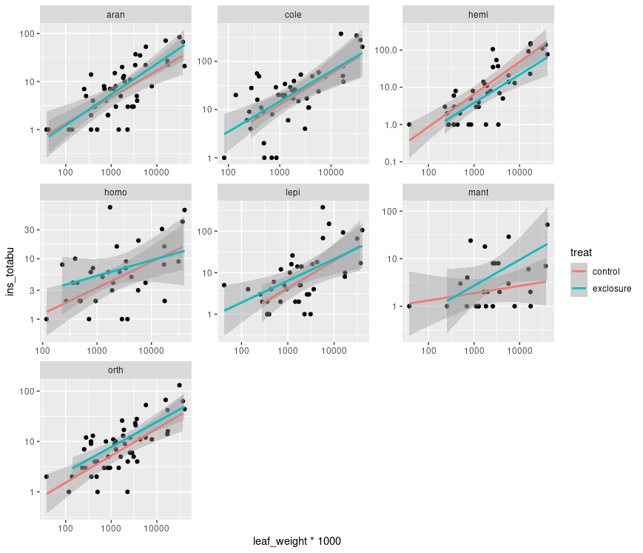

**Figure S1**. Statistical relationship between pallatable plant biomass (**leaf biomass)** (in grams) and abundance of studied arthropod guilds for each. Seems like the upper limit of abundance is only limited by the availability of the plant biomass in a mass action fashion (linear relationship between total **plant biomass and herbivore abundance/biomass** was qualitatively the same). Points represent individual plants, their biomass and arthropod communities.

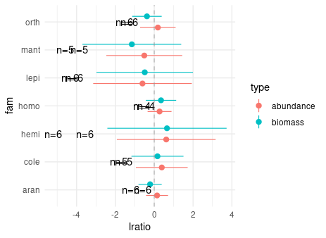

**Figure S2**. [**Add diversity and richness for each order, I could also provide comparisons between effects on abundance and biomass within each order, this would show us in which groups effects on biomass were stronger than on abundnce, maybe also evaluate correlation between biomass and abundance log ratios]**. Log ratio of sampled insect orders in control and exclosure treatments. Mean and 95% bootstrapped CIs are present. No statistical difference from 0 was found for no order and biomass vs abundance. [biomass_abundance_comparisons.R]

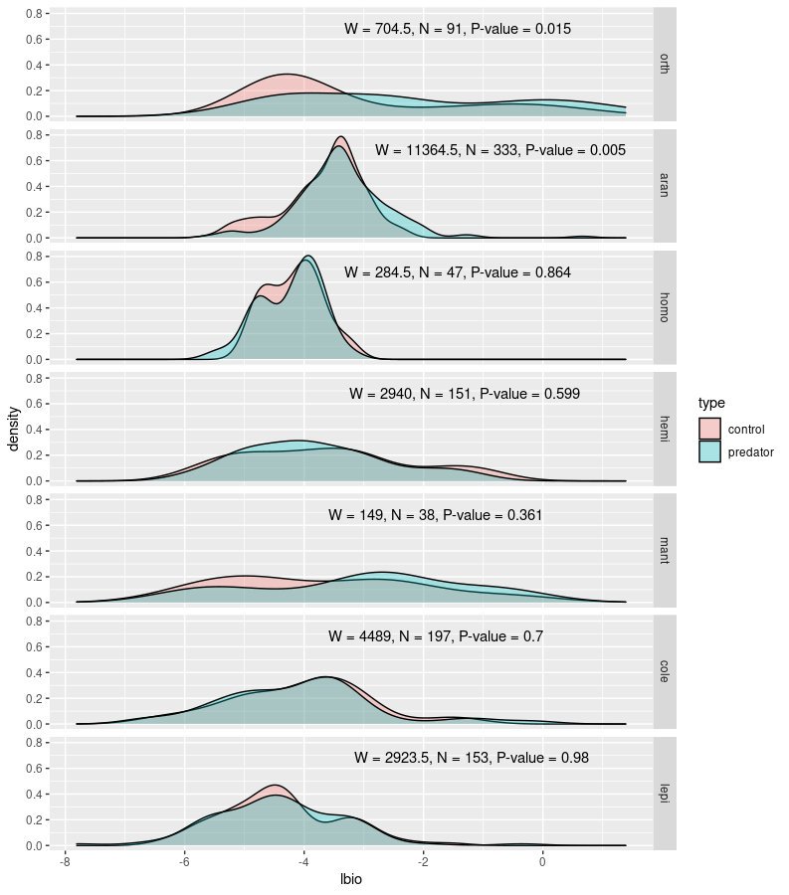

**Figure S3.** Species size distributions for studied insect orders in control and exclosure plots Wilcoxon Test. [I have finally settled on ***species*** - and not ***individuals - size*** ***distributions***. Firstly because of problematic character of this data for analysis i.e. multi-modal distributions and data somewhat artificially duplicated (I didn’t have estimates of size for each individual but instead I used average size over up to 20 randomly chosen individuals from a given morpho-species). Secondly because individual based distribution might be strongly dependent on general abundance of herbivores within a given plot. Nevertheless I did perform some tests and because of non-normality I used Mann-Whitney’s test to compare distributions. For size distributions based on individuals non-parametric tests resulted in significant differences in all insect orders (with different directions of these changes) – this is also interesting because it shows that size of the prey was affected, unfortunately it is difficult to evaluate magnitude of this change in non-parametric signed rank tests. Using power analysis I could provide maximum shift for each herbivore order that would be undetected by our comparisons in Fig. S1. I.e. perform power analysis to estimate how big of a change in biomass can we detect with given sample sizes and then compare that to detected changes in herbivore community But it might not be worth a shot.

**Table S1**. Results of Wilcoxon tests comparing body sizes of control and exclosure plots for all possible combinations of insect order and plant species **[add whether average decreased of increased]**.

| **Order** | **Plant** | **W** | **N** | **pval** |
| --- | --- | --- | --- | --- |
| orth | piptar | 136.5 | 33 | 0.409775691 |
| orth | melamu | 15.0 | 18 | 0.246504693 |
| *orth* | *melos1* | *35.0* | *13* | *0.051282051* |
| **aran** | **piptar** | **2281.5** | **124** | **0.008866179** |
| aran | tremor | 400.5 | 54 | 0.342153682 |
| aran | melamu | 201.0 | 48 | 0.789721088 |
| aran | breyce | 11.0 | 12 | 0.294551629 |
| aran | tricpl | 77.0 | 27 | 0.603975950 |
| **aran** | **melos1** | **123.5** | **40** | **0.021471960** |
| homo | tremor | 23.5 | 13 | 0.771400399 |
| homo | tricpl | 2.0 | 4 | 1.000000000 |
| homo | melamu | 4.5 | 7 | 1.000000000 |
| homo | piptar | 63.5 | 22 | 0.760895370 |
| homo | melos1 | 3.5 | 6 | 0.766432716 |
| hemi | piptar | 467.0 | 66 | 0.551552283 |
| hemi | prems1 | 0.0 | 4 | 0.500000000 |
| hemi | melamu | 148.0 | 33 | 0.420145955 |
| hemi | tricpl | 2.5 | 8 | 0.826238366 |
| hemi | tremor | 13.0 | 11 | 0.921212121 |
| hemi | melos1 | 10.0 | 19 | 0.387459937 |
| mant | piptar | 24.0 | 15 | 0.759795195 |
| mant | tremor | 26.5 | 14 | 0.794703141 |
| cole | prems1 | 7.0 | 10 | 0.334408999 |
| cole | piptar | 1163.5 | 96 | 0.184662407 |
| cole | breyce | 1.5 | 5 | 1.000000000 |
| **cole** | **melamu** | **88.5** | **43** | **0.011557528** |
| cole | tricpl | 71.0 | 26 | 0.722338992 |
| cole | melos1 | 18.5 | 26 | 0.241432076 |
| lepi | prems1 | 1.5 | 3 | 1.000000000 |
| **lepi** | **piptar** | **434.5** | **59** | **0.033800433** |
| lepi | breyce | 6.0 | 7 | 0.840730447 |
| lepi | melamu | 3.5 | 6 | 0.766432716 |
| lepi | tremor | 148.5 | 37 | 0.503148899 |
| lepi | tricpl | 21.0 | 14 | 0.893697261 |
| lepi | melos1 | 20.5 | 17 | 1.000000000 |

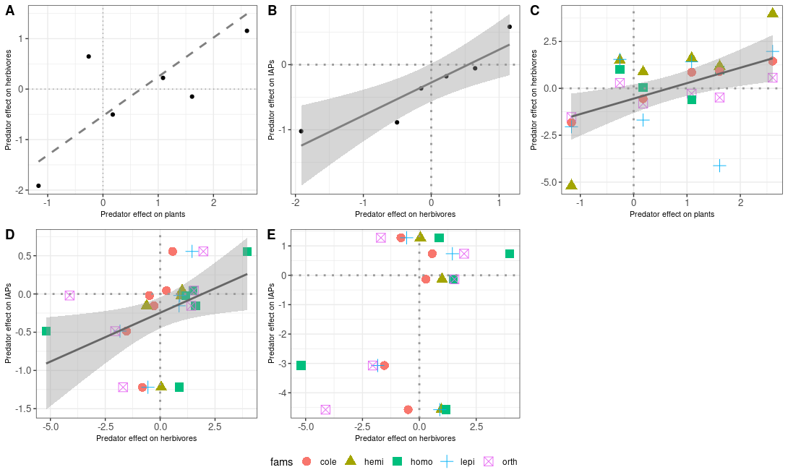

**Figure S4.** Correlation based on arthropod biomass [bio_log_ratio.R]

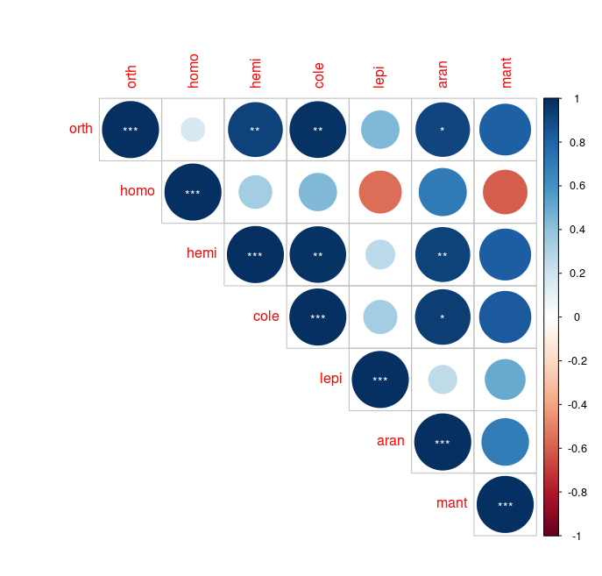

**Figure S5**. Pairwise correlation of log rsponse ratios between different insect orders. Significance is indicated by asterisks: p = 0.001 (***); p = 0.01 (**); p = 0.05 (*). [bio_log_ratio.R]. A Correlation between log ratio changes. B: Correlations between comparisons of abundance (top) and biomass (bottom) of various insect orders in control (left) and excolsure (right) plots.

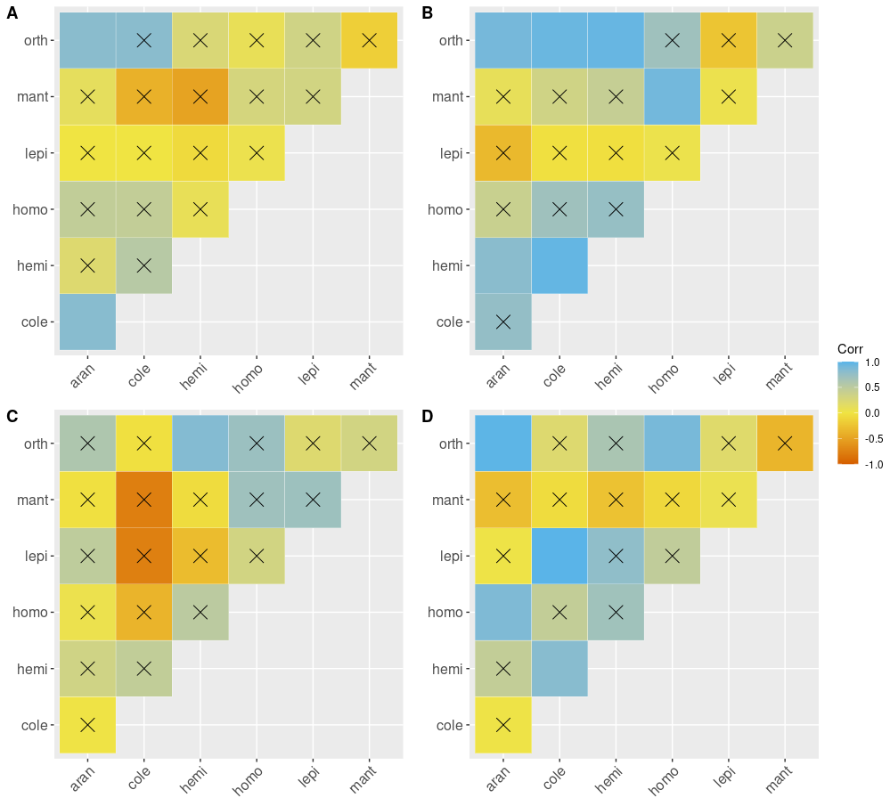

**Figure S6**. Abundance and biomass correlation plots for studied arthropod groups. Barrage indicates non-significant correlations. Correlations were calculated for abundance (A,B) and biomass (C,D) for both control (A,C) and exclosure (B,D) plots. [correlation_cp.R]

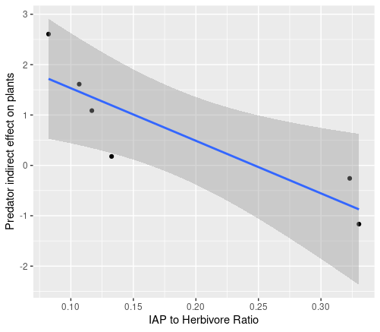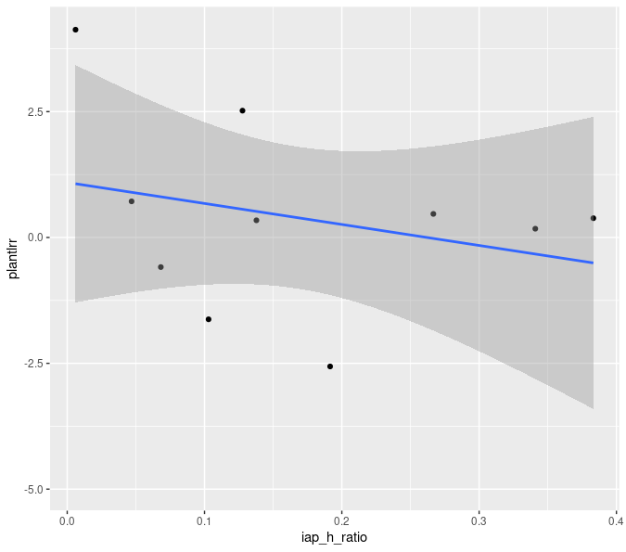

**Figure S7**. Relationship between predator indirect effect on plants and AP/Herbivore ratio in the presence of vertebrate predators [bio_log_ratio.R] . Left: IAP to herbivore ratio and LRR at individual plots, Right) individual comparable plant species.(**non-significant!!**)

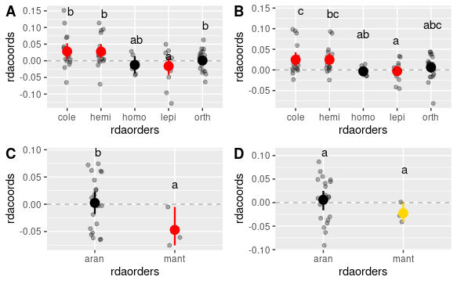

**Figure S8.** It shows NET zero difference [I think that I should remove singletones from this analysis as these species might pull averages closer to zero if there is many species only in one category either predator or control] Predator effects (species scores obtained in pRDA analysis) on different herbivore and IAPs orders. A) herbivores based on abundance, B) herbivores based on biomass (qualitatively similar to the abundance based results), C) IAPs based on abundance, D) IAPs based on biomass. Differences were evaluated using linear model with abundances used as weights for each species. Only species with abundances higher than 10 were included in the analysis. Red and gold color indicate significant and marginally significant (0.05< alpha< 0.1) difference from zero respectively. Letters indicate significance at the 0.05 level obtained from pairwise comparisons with Tukey correction (no random effect here) [ordination_ms1.R]. **Figure S2.** Ordination, RDA1 axis determines variability explained by the exclosure treatment.

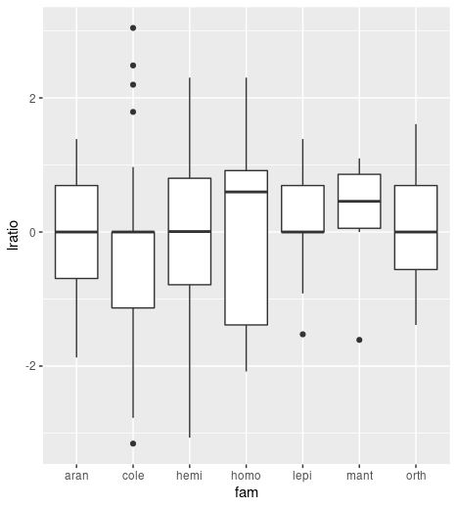

**Figure S9.** LRR of individual species for studied arthropod orders. Nothing significantly different from 0 nor there were no differences between orders [plant_species_logratio.R].

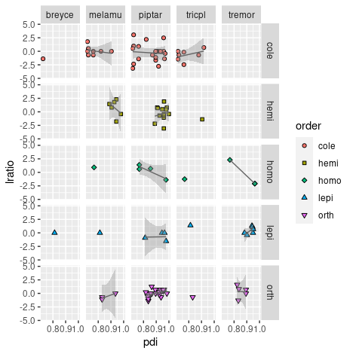

**Figure S10**. Interaction between order and plant species. **Only melamu – hemi** comparison was marginally significant.

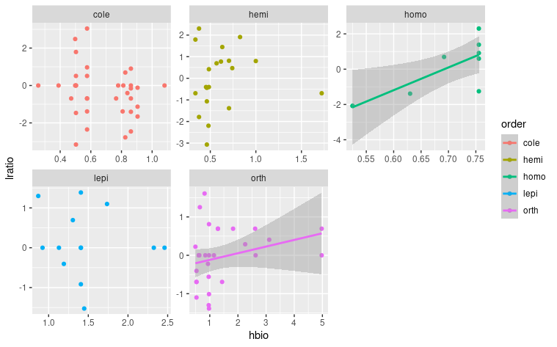

**Figure S11.** LRR as predicted by body length [cm]. Orthoptera is marginally significant. There is an evidence that at least some groups were performing better (perform better tests). [plant_species_logratio.R, **add IAPs**]

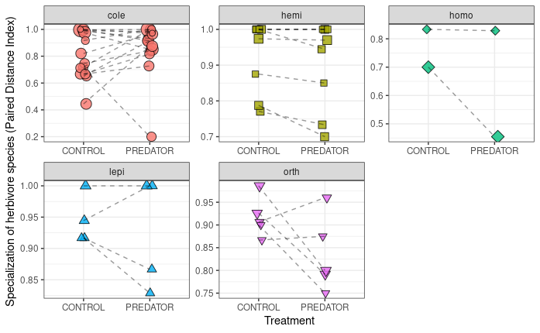

**Figure S12.** Specialzation (PDI) values for comparable species in control vs exclosure (PREDATOR) plots for each morpho-species from studied herbivorous order/guild. Statistical test was performed on log ratios of the PDI values. [*pdi_response_to_treatment.R*].

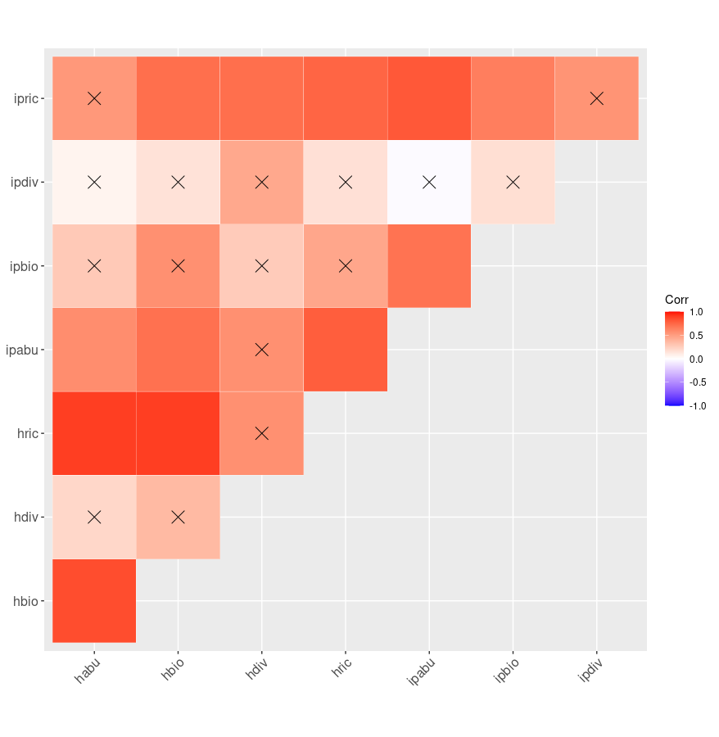

**Figure S12**. Correlations between general characteristics of herbivore and IAPs communities. H* - herbivores, ip* inermediate predators, *abu -abundance, *bio – biomass, *div – diversity, *rich - richness [Address that in the text]

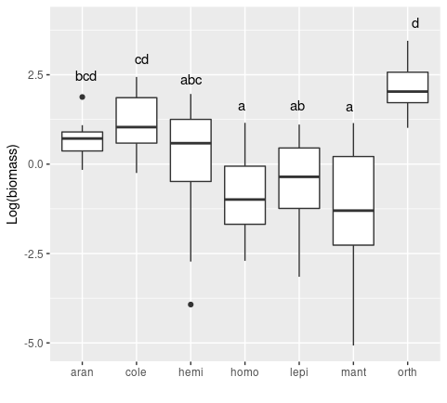**Figure S13**. Comparison of logarithm of biomass for each studied insect order in both exclosure and treatment plots. Letters indicate groups obtained from Tukey comparisons. [biomass_comparisons_families.R]

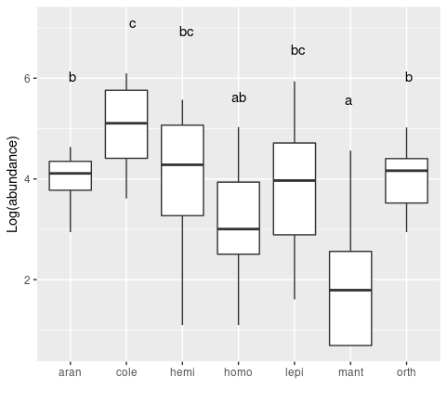**Figure S15**. Abundance for studied arthropod orders.

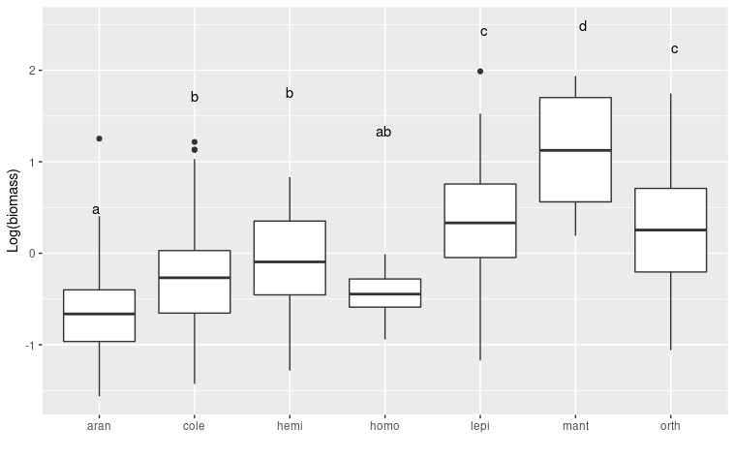**Figure S16**. Orthoptera and lepidoptera were the largest herbivores in our system [plant_species_logratio.R].

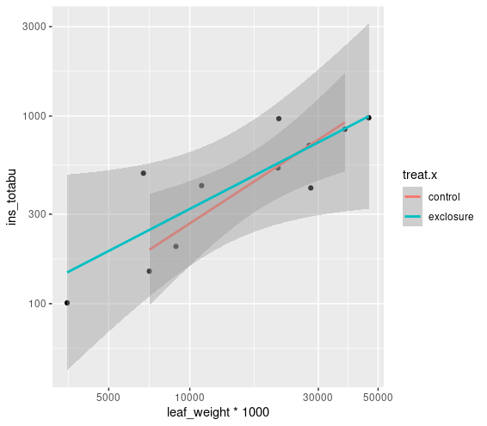

**Multiple R-squared: 0.7311**, **Adjusted R-squared: 0.6159** [plant biomass_vs_herbivore abundance.R] Same as above but for cumulated abundance and leaf weight

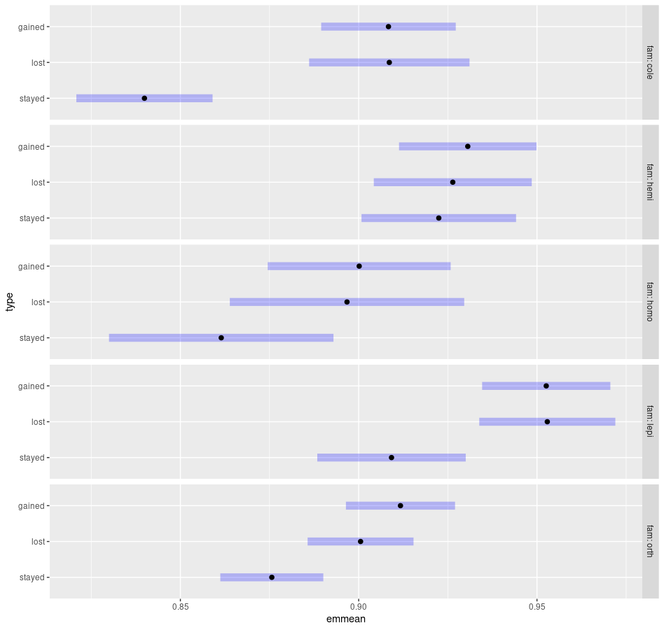

**Figure XXX_specialization and colonization. Emmean here is the PDI value.**

Contrasts for lost stayed gained analysis:

Statistical difference for the plot above showing pairwise comparisons.

fam = **cole**:

contrast estimate SE df t.ratio p.value

stayed - lost -0.068663 0.01421 450 -4.832 **<.0001**

stayed - gained -0.068428 0.01309 450 -5.227 **<.0001**

lost - gained 0.000235 0.01445 450 0.016 0.9999

fam = **hemi**:

contrast estimate SE df t.ratio p.value

stayed - lost -0.003923 0.01502 450 -0.261 0.9631

stayed - gained -0.008128 0.01424 450 -0.571 0.8358

lost - gained -0.004204 0.01443 450 -0.291 0.9543

fam = **homo**:

contrast estimate SE df t.ratio p.value

stayed - lost -0.035268 0.02271 450 -1.553 0.2673

stayed - gained -0.038687 0.02043 450 -1.894 0.1416

lost - gained -0.003419 0.02098 450 -0.163 0.9855

fam = **lepi**:

contrast estimate SE df t.ratio p.value

stayed - lost -0.043689 0.01372 450 -3.185 **0.0044**

stayed - gained -0.043394 0.01338 450 -3.242 **0.0036**

lost - gained 0.000296 0.01268 450 0.023 0.9997

fam = **orth**:

contrast estimate SE df t.ratio p.value

stayed - lost -0.024894 0.00962 450 -2.588 **0.0269**

stayed - gained -0.036083 0.00995 450 -3.627 **0.0009**

lost - gained -0.011189 0.01014 450 -1.104 0.5122

P value adjustment: tukey method for comparing a family of 3 estimates

**Supplementary discussion**

In the light of our results, proving weak top-down effects of predatros on artropods we can rule out plant compensation for herbivore damage by increasing their growth. We did not find effect of leaf damge as well despite that these generally shows a stronger response to bird and bat exclusion than leaf biomass, plant growth, or reproductive output (Maas et al., 2016). Moreover, in complex communities negative top-down effects on individual plant and herbivores species can be compensated by variability in plant quality, that is related to species diversity (Barnes et al., 2020; Bosc et al., 2018; DeLong et al., 2015; Mooney et al., 2012; Schmitz, 2017; Singer et al., 2014). However, functional diversity and leaf nitrogen content peaks in mid-aged forest (Whitfeld et al., 2014). Thus suggesting that early stages might have low functional diversity and be more similar than in later stages. Maybe initial successioanl stages are not as unprotected as we thoght before.

Mechanistic theory of food chains tells us that positive effect of predators on herbivores will occur if herbivores **are limited by relative food shortage** (dependent on their abilities to assimilate plant tissue) as opposed to absolute resource limitation (herbivores can eat all they want but the supply is fixed and limited) (Schmitz, 2010). Even though early successional plants rarely have strong structural defences they might be protected by secondary metabolites. Defenses reduce the amount of biomass that can be eaten by individual herbivores, because they need to maintain low concentration of toxins (ref). It is possible that early successional plants may posses effective chemical defenses (Segar et al., 2017; Volf et al., 2018). Moreover, if herbivores are abundant then leaf damage can accumulate and show higher values in forest gaps.

Weak top-down effects might be also related to the top predator behaviour. It has been long known that birds recognize the structure rather than type of the vegetation (Boege and Marquis, 2006; MacArthur and MacArthur, 1961). Avian predation reduced sawfly larval abundance regardless of the presence of **plant neighbours**; lepidopteran larval abundance only when plant neighbours were removed; and spider abundance only when plant neighbours were left intact. The removal of plant neighbours increased prey accessibility for foraging insectivorous birds and decreased chewer damage on seedlings. The density of concealed‐feeder insects (leaf miners) increased with plant neighbour removal and when seedlings were less damaged by chewer guild, suggesting intraguild competition.(Giffard et al., 2013). And also (Gras et al., 2016) where canopy corve modified predtor effects.

Forest edges are mostly devoid of specialist understoryinsectivore species, which actively avoid border areas(Banks-Leite et al. 2010; Pfeifer et al. 2017) from Harrison 2020.

A third reason migth be that lizards might be more important predators in this habitat. However lizards were found to be key predtaros feeding mostly on spiders in tabonuco forest in Puerto Rico resulted in doubling of their abundance (Beard et al., n.d.).

In the main text we discussed paper by (Bosc et al., 2018). However in this study the Authors used ordination as a proxy for herbivore species performance and specialization. In our opinion, in-field evaluation of specialization and the use of LRR would be more powerful. Nevertheless, we also used similar ordination approach in our study (Fig S2). Since there was a substantial turnover of species pRDA coordinates showed significant effect in case of some arthropod orders **(Fig. S7)** whereas LRR analysis did not (**Fig. S8**). Ordination posits newcoming species as responding str