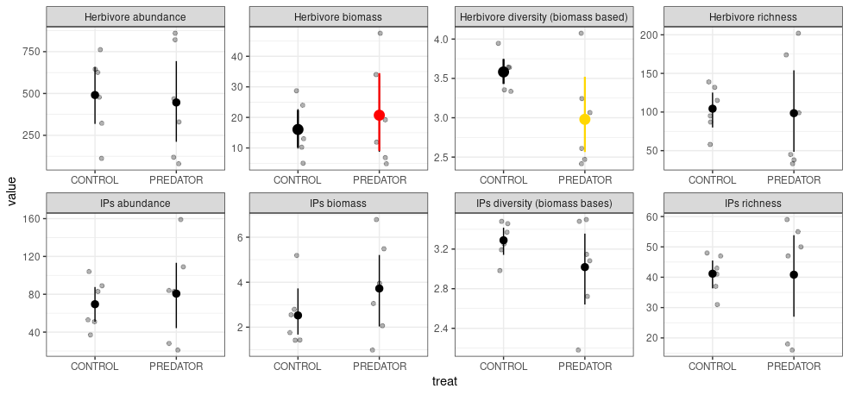**Figure 1.** [Change PREDATOR to EXCLOSURE] Mean and 95% bootstrapped CIs of the invertebrate and intermediate arthropod predator community indices in the control and exclosure plots. Grey points indicate empirical values for six experimental blocks. [\*\*\***IP biomass effect is significant !]** Differences between means were tested using generalized mixed effect models with experimental block as a random factor. Herbivore diversity is marginally significant (P = 0.052) [maybe LRR analysis would be more appropriate here].

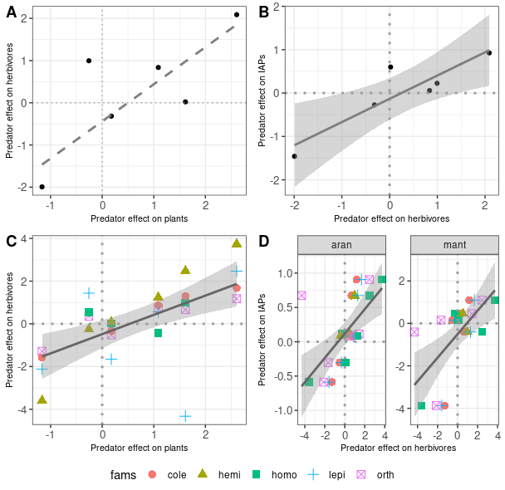**Figure 2.** Relationships in predator effects (LRR – log response ratio) between different trophic levels in individual plots: A – herbivores vs plants; B – herbivores vs. IAPs; C) herbivore vs plants relationship broken into individual orders/groups, and D) for IAPs divided into orders [bio_log_ratio.R]. Solid line represents significance at the 0.05 level and dashed line at the 0.1 level. In case of significance 95% CIs are also plotted.

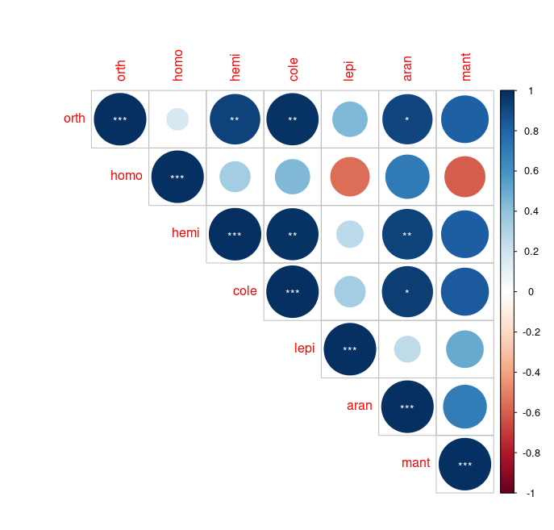

**Figure 3**. Pairwise correlation of log rsponse ratios between different insect orders. Significance is indicated by asterisks: p = 0.001 (***); p = 0.01 (**); p = 0.05 (*). [bio_log_ratio.R]. A Correlation between log-ratio changes. B: Correlations between comparisons of abundance (top) and biomass (bottom) of various insect orders in control (left) and excolsure (right) plots.

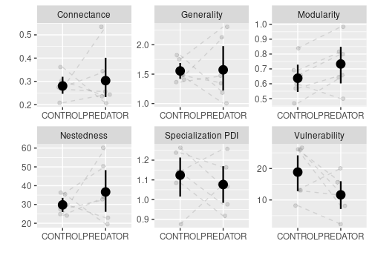

**Figure 4**. Mean and 95% CIs for different network descriptors in control and exclosure plots. **Only modularity has decreased significantly (z value = 2.143, p = 0.032, beta family with the logit link function)**.