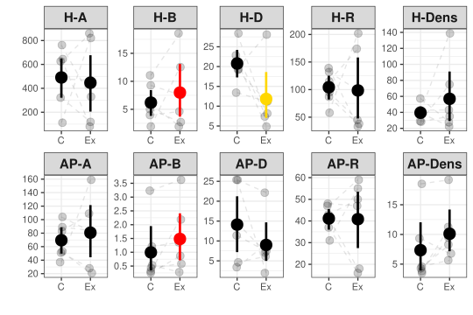**Figure 1.** Mean and 95% bootstrapped CIs of the invertebrate herbivores (H) and arthropod predator (AP) community indices (A – no. of individuals, B – biomass in grams, D – inverse Simpson diversity, R – number of species, Dens – density [individuals/m2]) in the control (C) and exclosure (Ex) plots. Grey points indicate empirical values for six experimental blocks, and dashed lines connect plots within blocks. Differences between means were tested using generalized mixed effect models with random effect of experimental block. Red color indicates significance at the α = 0.05, and yellow at the α = 0.1.

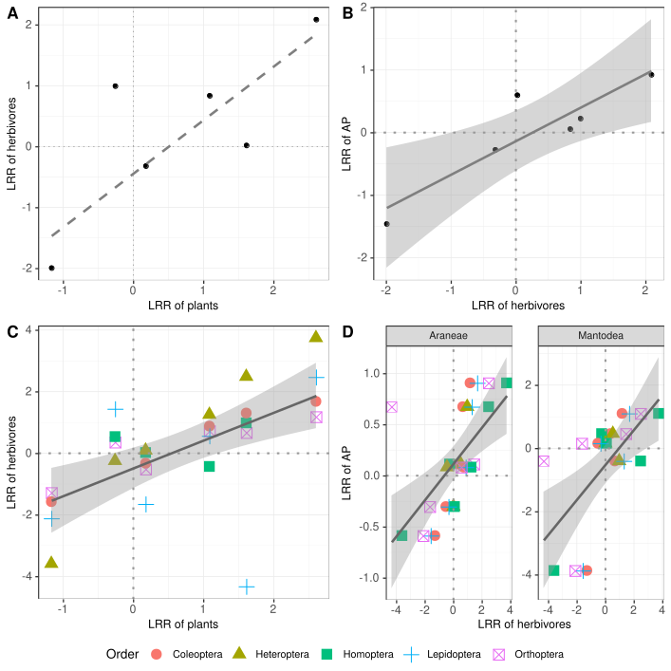**Figure 2.** Relationships for predator effects on biomass (LRR – log response ratio) between different trophic levels in individual plots: A – herbivores vs plants; B – herbivores vs. IAPs; C) herbivore vs plants relationship broken into individual orders, and D) for IAPs divided into orders. Solid line represents significance at the α = 0.05 level and dashed line at the α = 0.1 level. In case of significance 95% CIs are also plotted.

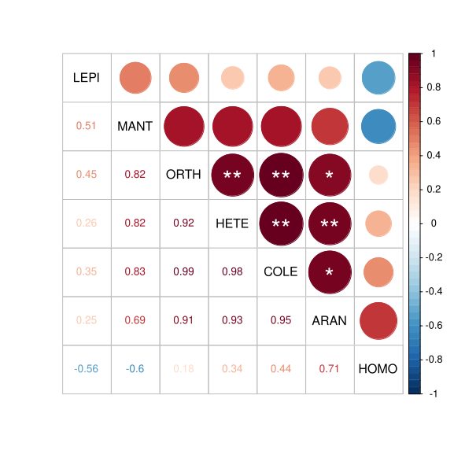

**Figure 3**. Pairwise Perason correlations of the log response ratios (LRR) between studied arthropod orders: LEPI – Lepidoptera; MANT – Mantodea; ORTH – Orthoptera; HEMI – Hemiptera; COLE – Coleoptera; ARAN – Aarneae; HETE – Heteroptera. Significance is indicated with an asterisks: P < 0.001 (***); P < 0.01 (**); p < 0.05 (*).

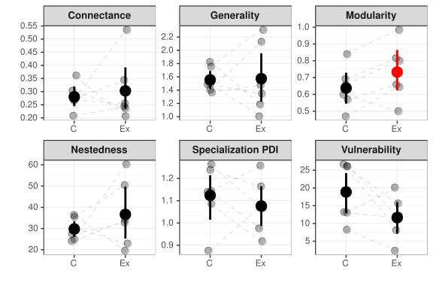**Figure 4**. Mean and 95% bootstrapped CIs for different network descriptors in control (C) and exclosure plots (Ex). Grey dots represent empirical data. Dashed lines connect treatment plots within the same experimental block. Significance is indicated with red color (α = 0.05).