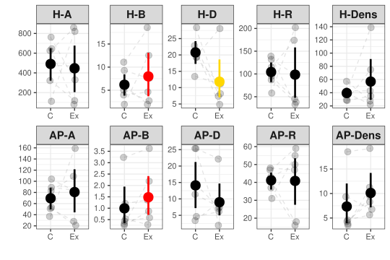**Figure 1.** Mean and 95% bootstrapped CI of the invertebrate herbivores (H) and arthropod predator (AP) community indices (A – no. of individuals, B – biomass in grams, D – inverse Simpson diversity, R – number of species, Dens – density [individuals/m2 of the leaves area]) in the control (C) and exclosure (Ex) plots. Grey points indicate empirical values for six experimental blocks, and dashed lines connect plots within blocks. Differences between means were tested using generalized mixed effect models with random effect of experimental block. Red color indicates significance at the α = 0.05, and yellow at the α = 0.1.

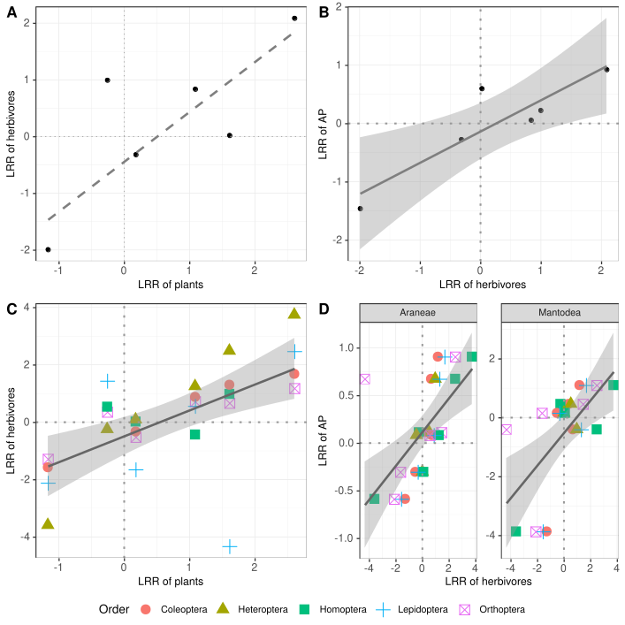**Figure 2.** Relationships for predator effects on biomass (LRR – log response ratio) between different trophic levels in individual plots: A – herbivores vs plants; B – herbivores vs. arthropod predators (AP); C) herbivores divided into orders vs plants, and D) arthropod predators divided into orders vs. herbivores. Solid line represents significance at the α = 0.05 level and dashed line at the α = 0.1 level. 95% CIs are plotted for significant relationships.

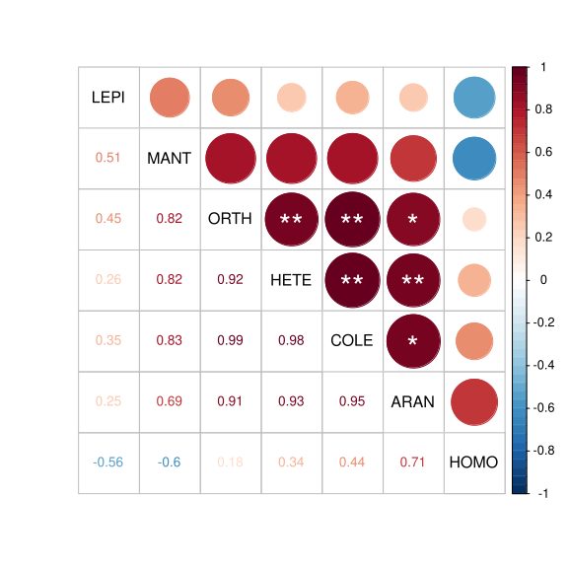

**Figure 3**. Pairwise Pearson correlations of the log response ratios (LRR) between studied arthropod orders: LEPI – Lepidoptera; MANT – Mantodea; ORTH – Orthoptera; HETE – Heteroptera; COLE – Coleoptera; ARAN – Araneae; HOMO – Homoptera. Significance is indicated with an asterisks: P < 0.001 (***); P < 0.01 (**); p < 0.05 (*).

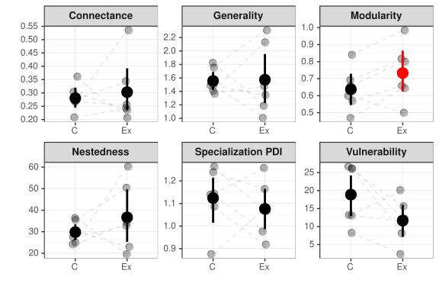**Figure 4**. Mean and 95% bootstrapped CIs for plant-herbivore network descriptors in control (C) and exclosure (Ex) plots. Grey dots represent empirical data. Dashed lines connect treatment plots within the same experimental block. Significance is indicated with red color (α = 0.05).