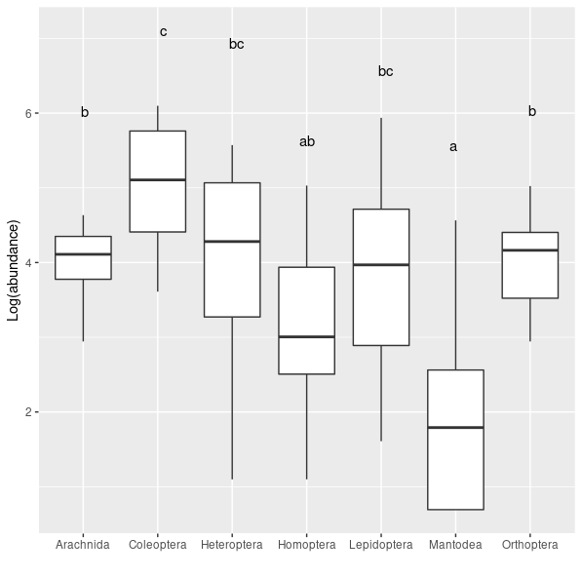

**Figure S1**. Comparisons of abundance of studied insect order in both exclosure and treatment plots. Letters indicate groups for which differences in average are statisticaly significant at the α = 0.05 level obtained from the Tukey pairwise comparisons. *[biomass_comparisons_families.R]*

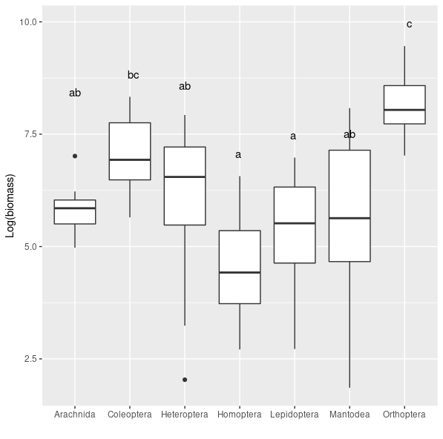

**Figure S2**. Comparisons of dry biomass of studied insect order in both exclosure and treatment plots. Letters indicate groups for which differences in average are statisticaly significant at the α = 0.05 level obtained from the Tukey pairwise comparisons. *[biomass_comparisons_families.R]*

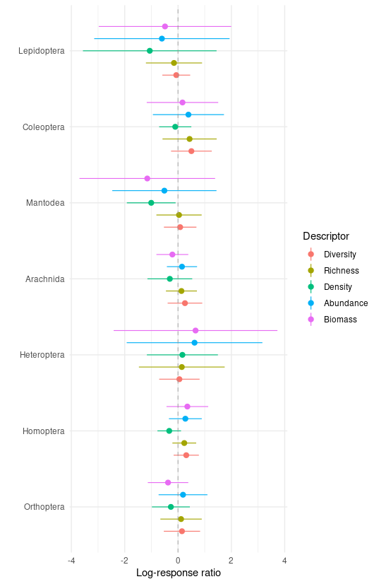

**Figure S3**. Log-response ratios (natural logarithm of exclosure to control value ratios) of various community descriptors for sampled insect orders. Mean and 95% bootstrapped CIs are presented. There was no significant treatment effect for any descriptor within any order. Diversity was measured with the inverse Simpson index. [*biomass_abundance_comparisons.R*]

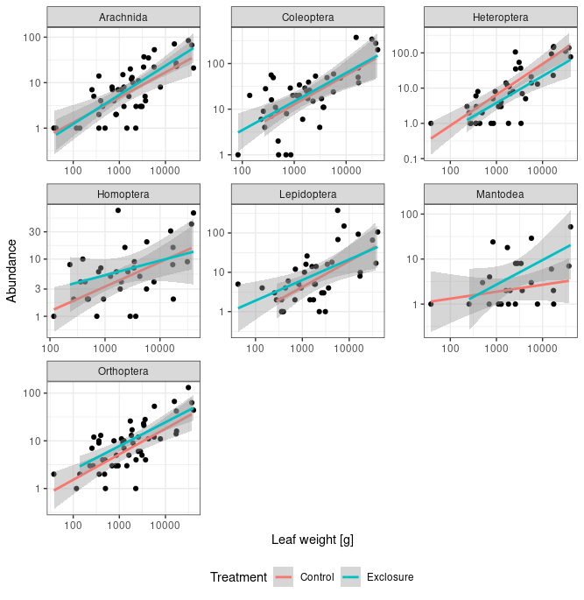

**Figure S4**. Statistical relationship between leaf biomass (in grams) and abundance of studied arthropod orders in exclosure and control plots. Points represent individual plants from experimental plots. Verical ad horizontal axis are in logarithmic scale. [*plant biomass vs herb abundance.R*]

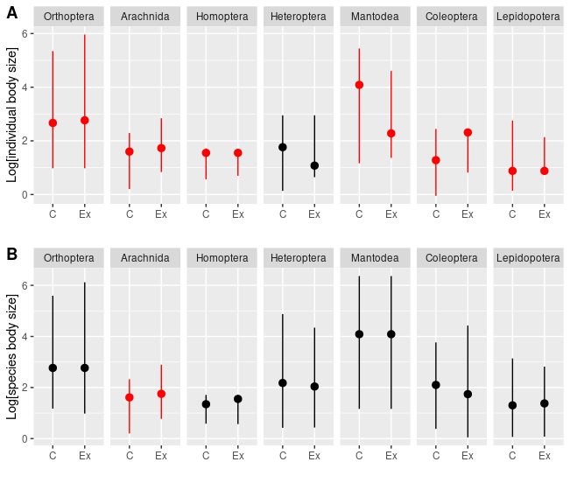

**Figure S5.** Individual (A) and species (B) body length distributions with median and 5th and 95th percentile for studied insect orders in control (C) and exclosure (Ex) plots. Red color indicates significant differences of the medians evaluated using nonparametric Mann-Whitney test. For better visualization of differences between sizes vertical axes are in logarithmic scales.

**Table S1.** Results of the Mann-Whitney’s tests for arthropod individual and species body lengths. NC – number of individuals/species in th econtrol, NEx - number of individulas in the exclosure plots. HL – Hodges-Lehman centrality estimator (median of the differences between individuals from control and exclosure). Direction indicates how median changes from exclosure (no predaors) to the control (Predators present), which is the predator effect on arthropod sizes.

| Individual size distribution | | | | | |
| --- | --- | --- | --- | --- | --- |
| Order | NC | NEx | HL | P | Direction |
| Orthoptera | 422 | 369 | -2.77E+00 | <0.001 | decrease |
| Homoptera | 135 | 252 | -3.10E-05 | 0.019 | decrease |
| Heteroptera | 785 | 362 | -7.27E-05 | 0.208 | ns |
| Aranea | 362 | 351 | -8.88E-01 | <0.001 | decrease |
| Mantodea | 55 | 133 | 1.47E+01 | 0.006 | increase |
| Coleoptera | 1214 | 993 | -1.36E+00 | <0.001 | decrease |
| Lepidoptera | 389 | 702 | 1.10E-05 | 0.016 | increase |
| Species size distribution | | | | | |
| Order | NC | NEx | HL | P | Direction |
| Orthoptera | 118 | 195 | -8.81E-01 | 0.354 | ns |
| Homoptera | 24 | 42 | -1.13E-05 | 0.519 | ns |
| Heteroptera | 61 | 0 | 9.60E-01 | 0.377 | ns |
| Aranea | 129 | 216 | -9.39E-01 | 0.005 | decrease |
| Mantodea | 15 | 26 | -7.69E-06 | 0.701 | ns |
| Coleoptera | 96 | 148 | 1.05E+00 | 0.116 | ns |
| Lepidoptera | 57 | 97 | -3.75E-05 | 0.834 | ns |

**Table S2.** Results of the Mann-Whitney’s tests for arthropod individual body lengths at individual plant species. NC – number of individuals/species in th econtrol, NEx - number of individulas in the exclosure plots. HL – Hodges-Lehman centrality estimator (median of the differences between individuals from control and exclosure). Direction indicates how median changes from exclosure (no predaors) to the control (Predators present), which is the predator effect on arthropod sizes.

Order Plant NC NEx HL P Direction

Orthoptera piptar 84 147 -3.87E+00 0.061 ns

Orthoptera prems1 2 13 -1.67E-06 0.661 ns

Orthoptera tricpl 22 17 2.89E-05 0.931 ns

Orthoptera melos1 131 28 -3.94E+01 0.000 decrease

Orthoptera melamu 71 66 1.71E+00 0.162 ns

Orthoptera macata 17 3 4.03E+00 0.425 ns

Orthoptera cordte 4 3 5.42E+00 0.858 ns

Orthoptera breyce 6 7 9.45E+00 0.350 ns

Orthoptera tremor 64 40 6.94E-01 0.137 ns

Orthoptera manies 10 10 -3.40E+01 0.047 decrease

Homoptera tremor 24 17 1.45E-06 0.422 ns

Homoptera piptar 47 106 -4.42E-05 0.093 ns

Homoptera melamu 34 81 -4.21E-05 0.293 ns

Homoptera tricpl 8 15 -5.58E-05 0.893 ns

Homoptera macata 2 2 8.20E-01 0.617 ns

Heteroptera tricpl 8 28 -1.40E+00 0.379 ns

Heteroptera melamu 356 60 -3.83E-01 0.105 ns

Heteroptera piptar 262 213 7.24E-05 0.963 ns

Heteroptera melos1 111 7 -1.92E+00 0.254 ns

Heteroptera tremor 27 26 1.39E+01 0.002 increase

Arachnida melos1 84 5 -4.37E+00 0.001 decrease

Arachnida tremor 61 62 -8.06E-01 0.061 ns

Arachnida piptar 80 146 -1.35E+00 0.000 decrease

Arachnida melamu 56 55 -6.57E-01 0.189 ns

Arachnida cordte 12 8 -3.26E-01 0.561 ns

Arachnida breyce 10 8 2.05E+00 0.032 increase

Arachnida tricpl 25 29 2.56E-01 0.459 ns

Arachnida macata 6 7 -1.07E+00 0.668 ns

Mantodea piptar 11 67 1.62E-01 0.025 increase

Mantodea melamu 3 18 -1.48E-06 1.000 ns

Mantodea tricpl 5 24 4.98E+01 0.000 increase

Mantodea tremor 30 12 -3.07E-05 0.740 ns

Coleoptera piptar 393 662 -3.65E-05 0.000 decrease

Coleoptera tremor 107 44 5.80E-05 0.485 ns

Coleoptera tricpl 50 79 -4.99E-05 0.347 ns

Coleoptera macata 43 20 -3.36E-05 0.860 ns

Coleoptera melamu 148 81 8.67E-01 0.046 increase

Coleoptera melos1 341 11 -2.31E+00 0.078 ns

Coleoptera prems1 16 17 -1.05E+00 0.824 ns

Lepidoptera piptar 31 234 -3.07E-01 0.002 decrease

Lepidoptera tremor 218 417 3.64E-05 0.000 increase

Lepidoptera tricpl 36 13 -2.86E-01 0.527 ns

Lepidoptera melamu 12 7 4.31E-05 0.966 ns

Lepidoptera macata 4 4 9.71E+00 0.142 ns

Lepidoptera melos1 66 4 5.22E+00 0.323 ns

Lepidoptera breyce 2 8 -3.02E-01 0.891 ns

**Table S3.** Results of the Mann-Whitney’s tests for arthropod species body lengths at individual plant species. NC – number of individuals/species in th econtrol, NEx - number of individulas in the exclosure plots. HL – Hodges-Lehman centrality estimator (median of the differences between individuals from control and exclosure). Direction indicates how median changes from exclosure (no predaors) to the control (Predators present), which is the predator effect on arthropod sizes.

Order Plant NC NEx HL P pred.eff

orth piptar 41 68 -7.1543113216578 0.102 ns

orth prems1 1 9 -8.71993122332942 0.600 ns

orth tricpl 10 9 -0.02801876563142 0.902 ns

orth melos1 28 6 -10.6063244052991 0.268 ns

orth melamu 13 37 1.48859318455633 0.603 ns

orth breyce 3 6 14.6336428467557 0.262 ns

orth tremor 22 19 2.89110847145439 0.539 ns

aran piptar 45 79 -1.46461562465325 0.009 decrease

aran melos1 36 4 -4.02301086302278 0.021 decrease

aran breyce 6 6 0.761615362250338 0.295 ns

aran melamu 10 38 -0.348821996625885 0.790 ns

aran tricpl 11 16 0.434808353068163 0.604 ns

aran tremor 21 33 -0.792056192764109 0.342 ns

homo melamu 2 5 4.98E-07 1.000 ns

homo melos1 5 1 -0.559803751879948 0.766 ns

homo piptar 9 13 -1.15E-05 0.761 ns

homo tricpl 1 3 -5.91E-05 1.000 ns

homo tremor 7 6 -0.829598428805475 0.771 ns

hemi piptar 25 41 0.668892309553781 0.552 ns

hemi prems1 3 1 1.89927005617621 0.500 ns

hemi melos1 17 2 6.89468923137109 0.387 ns

hemi melamu 12 21 -1.1933967463849 0.420 ns

hemi tricpl 1 7 1.92400901610673 0.826 ns

hemi tremor 3 8 -1.93696220366424 0.921 ns

mant piptar 6 9 3.85E-05 0.760 ns

mant breyce 1 1 14.7365315264225 1.000 ns

mant tremor 8 6 -11.5418008456941 0.795 ns

cole prems1 6 4 4.65589684003137 0.334 ns

cole piptar 39 57 -1.34221891351733 0.185 ns

cole melamu 15 28 6.50710059806274 0.012 increase

cole melos1 23 3 4.00673398527026 0.241 ns

cole tricpl 12 14 0.364979351773498 0.722 ns

cole breyce 1 4 -6.12E-05 1.000 ns

lepi prems1 1 2 -0.55539764855905 1.000 ns

lepi piptar 14 45 -1.74335387333281 0.034 decrease

lepi melamu 1 5 -0.286324841181336 0.766 ns

lepi melos1 14 3 0.030138459024546 1.000 ns

lepi breyce 2 5 -0.220182376873217 0.841 ns

lepi tricpl 5 9 0.70639792276664 0.894 ns

lepi tremor 19 18 0.680011082051769 0.503 ns

lepi urenlo 1 1 1.6065683919817 1.000 ns

**Table S4**. Results of the Mann-Whitney’s tests for arthropod individual body lengths in individual blocks. NC – number of individuals/species in th econtrol, NEx - number of individulas in the exclosure plots. HL – Hodges-Lehman centrality estimator (median of the differences between individuals from control and exclosure). Direction indicates how median changes from exclosure (no predaors) to the control (Predators present), which is the predator effect on arthropod sizes.

Order Site NC NEx HL P pred.eff

Orthoptera g5 78 24 -1.20E+01 0.005 decrease

Orthoptera g4 152 74 -2.39E+01 0.000 decrease

Orthoptera g2 37 19 -3.03E+01 0.072 ns

Orthoptera g1 60 42 4.53E-01 0.384 ns

Orthoptera g3 69 116 -5.01E-01 0.560 ns

Orthoptera g6 26 94 2.06E+00 0.145 ns

Homoptera g1 29 17 1.83E+00 0.000 increase

Homoptera g4 11 17 -2.67E-05 0.145 ns

Homoptera g2 8 3 -5.03E-05 0.737 ns

Homoptera g3 63 62 6.31E-05 0.788 ns

Heteroptera g5 168 4 -4.22E-01 0.734 ns

Heteroptera g3 156 143 2.19E+00 0.000 increase

Heteroptera g1 28 36 4.74E+00 0.000 increase

Heteroptera g6 3 109 -3.02E+00 0.025 decrease

Heteroptera g2 263 22 -1.34E+00 0.000 decrease

Heteroptera g4 167 48 -6.91E-01 0.242 ns

Arachnida g4 89 82 -8.06E-01 0.050 decrease

Arachnida g6 35 63 7.62E-01 0.047 increase

Arachnida g3 76 103 -2.02E+00 0.000 decrease

Arachnida g2 49 25 -2.92E+00 0.001 decrease

Arachnida g1 66 59 -7.54E-02 0.458 ns

Arachnida g5 47 19 -1.90E+00 0.003 decrease

Mantodea g3 7 6 7.96E-05 0.382 ns

Mantodea g6 2 96 1.62E-01 0.000 increase

Mantodea g5 6 2 -1.47E+01 0.371 ns

Mantodea g2 2 3 -6.35E-05 0.683 ns

Mantodea g1 38 24 -4.87E-05 0.179 ns

Coleoptera g2 165 45 -4.01E+00 0.000 decrease

Coleoptera g3 320 445 -4.86E-05 0.000 decrease

Coleoptera g4 362 151 -5.04E+00 0.000 decrease

Coleoptera g5 198 37 -1.26E+00 0.000 decrease

Coleoptera g6 65 315 1.62E-06 0.294 ns

Lepidoptera g1 101 24 1.30E-01 0.658 ns

Lepidoptera g2 5 379 5.21E-05 0.000 increase

Lepidoptera g3 18 94 6.24E-05 0.965 ns

Lepidoptera g4 70 40 2.35E+00 0.001 increase

Lepidoptera g5 177 15 -1.81E+00 0.000 decrease

Lepidoptera g6 18 150 1.48E+00 0.070 ns

**Table S5**. Results of the Mann-Whitney’s tests for arthropod species body lengths for each order in individual experimental blocks. NC – number of individuals/species in th econtrol, NEx - number of individulas in the exclosure plots. HL – Hodges-Lehman centrality estimator (median of the differences between individuals from control and exclosure). Direction indicates how median changes from exclosure (no predaors) to the control (Predators present), which is the predator effect on arthropod sizes.

Order Site NC NEx HL P pred.eff

orth g5 1 15 -3.87074924028396 0.663 ns

orth g4 36 35 -1.99915176561254 0.468 ns

orth g6 21 55 1.48867376155187 0.386 ns

orth g1 26 20 -4.07956387742622 0.564 ns

orth g2 6 13 -27.8988102179545 0.38 ns

orth g3 28 57 -3.34593562266908 0.333 ns

aran g4 39 47 -0.64459728197086 0.349 ns

aran g6 28 47 0.606559805792467 0.192 ns

aran g1 25 37 -0.34856759774152 0.425 ns

aran g3 37 55 -2.34785206080011 0 decrease

homo g4 6 7 -0.046800849173893 0.498 ns

homo g1 9 7 5.34E-05 0.914 ns

homo g3 9 15 1.62E-05 1 ns

hemi g5 3 4 4.07487715096236 0.114 ns

hemi g4 25 15 3.86007193155159 0.167 ns

hemi g6 2 32 -9.16869733456237 0.025 decrease

hemi g1 6 3 8.80742382608212 0.241 ns

hemi g3 25 42 2.66670114844075 0.112 ns

mant g6 2 7 0.161979372077914 0.764 ns

mant g1 10 10 -49.8151397284552 0.339 ns

mant g3 3 3 55.0950869419479 0.653 ns

cole g5 6 8 6.37E-05 1 ns

cole g4 28 25 2.54103157720917 0.111 ns

cole g6 27 64 -7.25E-05 0.748 ns

cole g2 7 9 1.33474933659603 0.485 ns

cole g3 28 42 1.87402801713098 0.082 ns

lepi g5 1 6 -0.620312552953291 0.614 ns

lepi g4 15 17 1.04614001479497 0.289 ns

lepi g6 7 38 -0.337366229813838 0.742 ns

lepi g1 28 15 0.390959877218257 0.637 ns

lepi g3 6 15 -0.250953808795079 0.785 ns

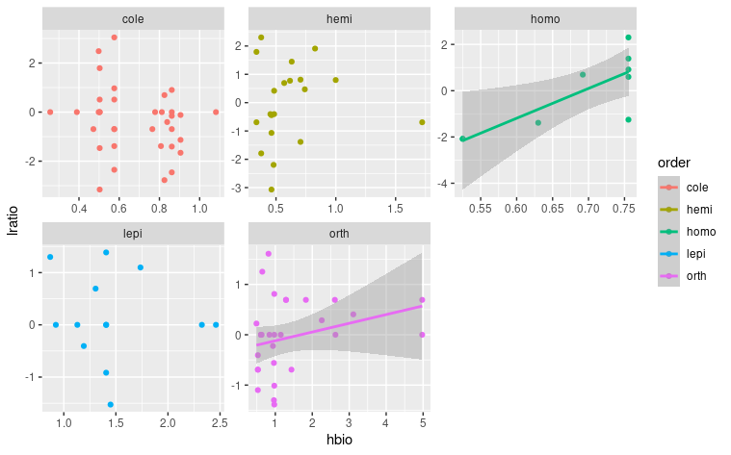

**Figure S6.** Relationship between the predator effect (log-response ratios) and body length [cm] in the studied arthropod orders and comparable set of species. Orthoptera is **marginally significant (T = , P = xxx)**. *[plant_species_logratio.R]*

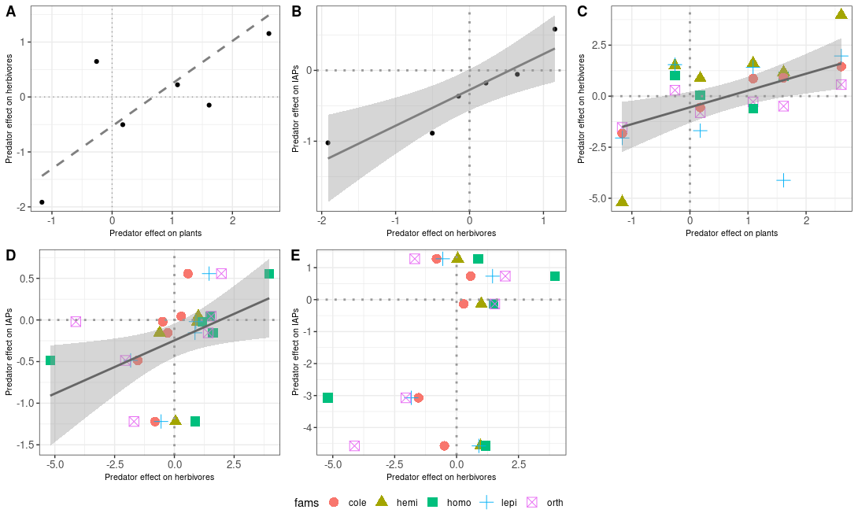**Figure S7.** Correlation**s between predator effects (log-response ratios) of herbivores, plants and arthropod predators (AP)** based on arthropod biomass. Significance is indicated with the line type: solid line: α = 0.05, dashed line α = 0.1. Correlations are present for: A – complete communities of herbivores and plants; B – complete communities of herbivores and AP. C – herbivores and plants for individual herbivore orders; D,E - predator effects of AP and herbivores for individual herbivorous orders and spiders (D) and mantids (E). *[bio_log_ratio.R]*

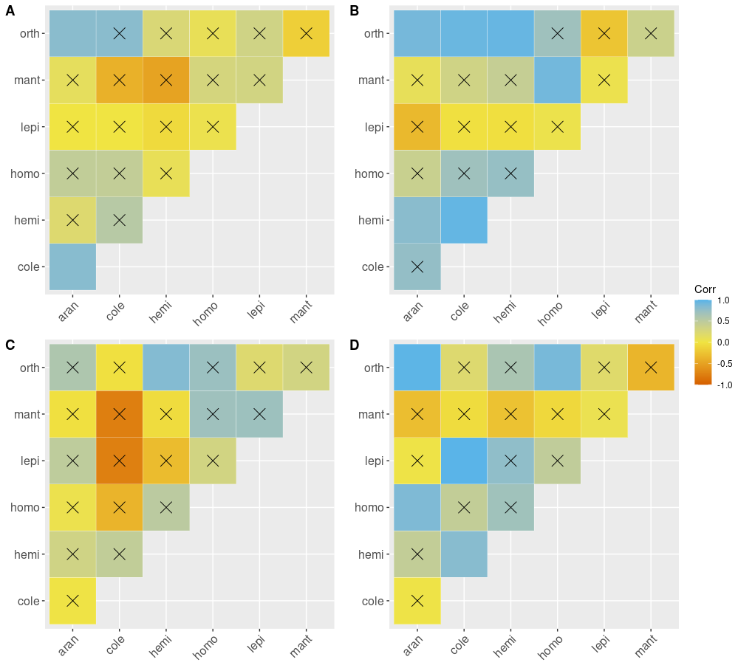

**Figure S8**. Abundance (A,B) and biomass (C,D) correlation plots for studied arthropod orders for both control (A,C) and exclosure (B,D) plots. x- non-significant correlation correlations.*[correlation_cp.R]*

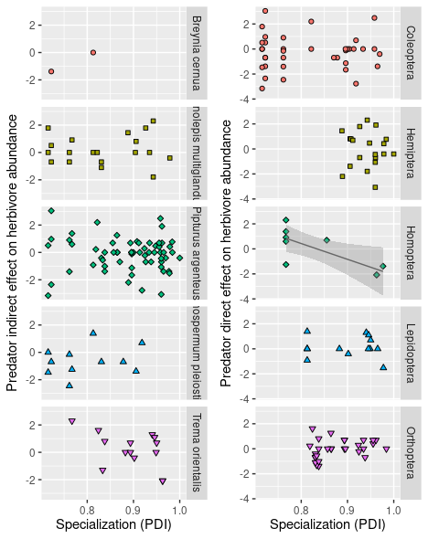

**Figure S9**. Effect of specialization (Paired Dissimilarity Index - PDI) on herbivore species performance (log response ratio - LRR) for plant species and insect orders. Each point represents a herbivore species sampled as ≥ individuals . Only plant species present in both control and treatment plots were analysed. Significance of the regression coefficient at the α = 0.05 level is indicated by a solid line with 95% CIs . For each morphospecies its cumulative abundance at control and exclosures was used as a weighting factor in the regression. Blocks was set to be the random effect. *[plant_species_log_ratio.R]*

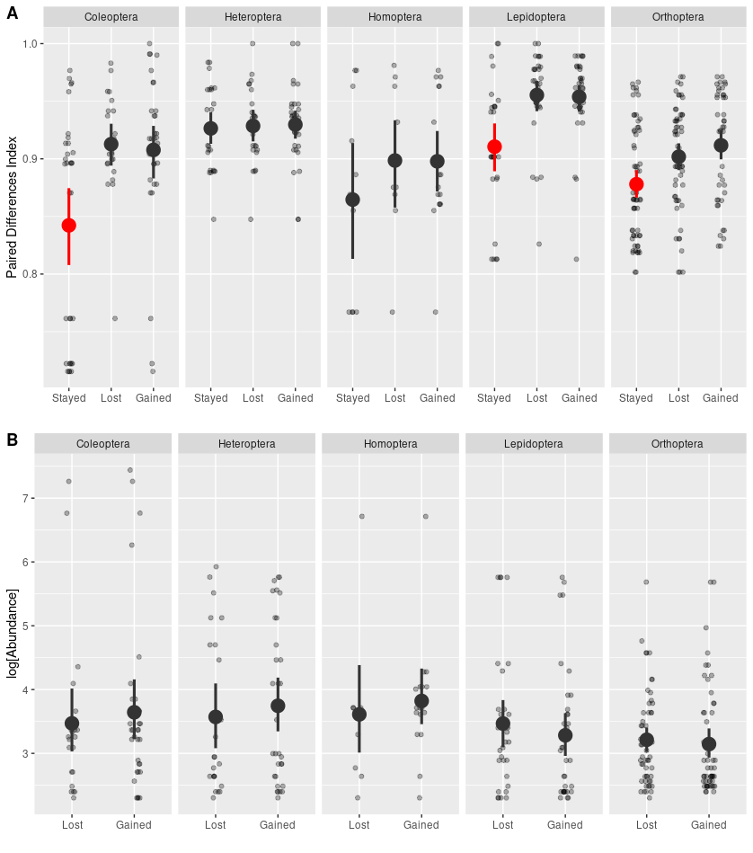

**Figure S10**. Specialization (paired differences index - PDI) of species assigned to three groups based on whether they were lost, gained or remained present in both exclosure and control plot (A). We compared abundance of species form the lost and gained group (B) to visualise colonization and removal of species within the experimental blocks. Minimal abundance for a species to be included is 10 individuals. Red color indicates significant differences from any other group within the order. *[resource_switching.R]*

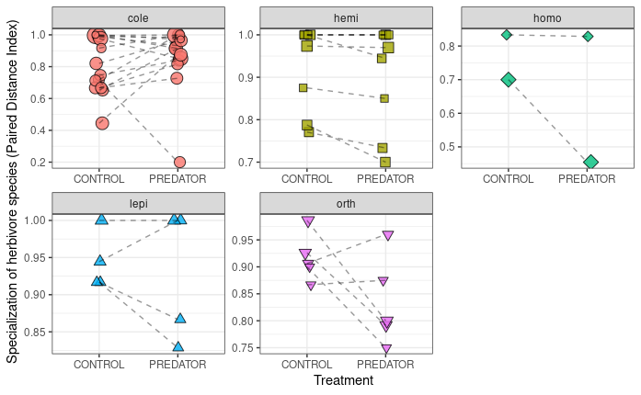

**Figure S11.** Specialization (paired differences index - PDI) values for comparable species in control vs exclosure (PREDATOR) plots for each morpho-species from studied herbivorous order/guild. Statistical test was performed on log ratios of the PDI values. Only orthoptera was marginally significant (T = -2.13, P = 0.066). If we drop the random effect of an experimental block, Heteroptera significantly increase their diet breadth in exclosure (T = -2.16, P = 0.049). Points indicate morphospecies that were present in bothe control and exclosure plots in at least 10 individuals. Sometimes points are the same morphospecies from different blocks. Block was used as a random effect and it still treats same species from different blocks as independent observations. [*pdi_response_to_treatment.R*]

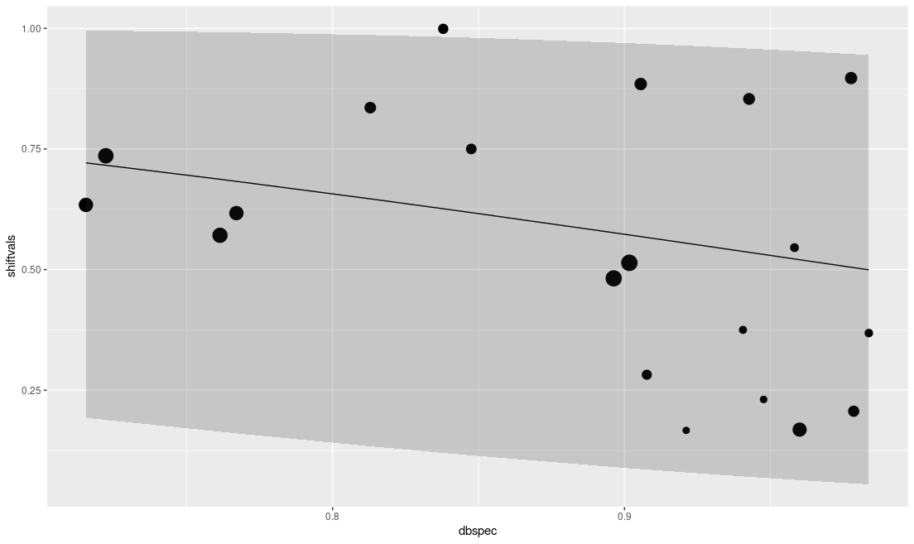

**Figure S12.** Weighted correlation between diet shifts (Bray-Curtis dissimilarity in resources use between exclosure and control plots) and specialization (paired differences index – PDI). Results of a weighted beta regression model with 95% prediction quantiles are presented. Model is significant but explains only ~9% of variation. Each point represents a herbivore species, point size shows log abundance. Log abundance was used as weights for each point in the regresion.

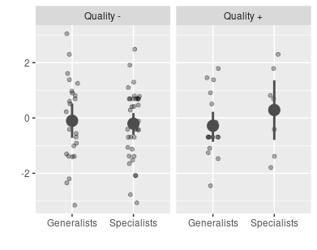

**Figure S13.** Interaction between plant quality (- low, + high, measured as the coordinates along a first axis of PCA performed on SLA and WATER content = predicted values of their correlation) and specialization (measured as PDI values on the left [generalists] or to the right [specialists] from the average) in predicting individual species responses to predation (y axis – log-response ratio). Averages between groups and their interactions were not significant. According to the tri trophic interaction hypothesis reduced quality would results in less negative relationship between PDI and LRR. That would mean that low PDI (generalists) would have a strong negatively response to predators in low quality food, whereas specialists could be unaffected or affeced positively. This is not the case here.

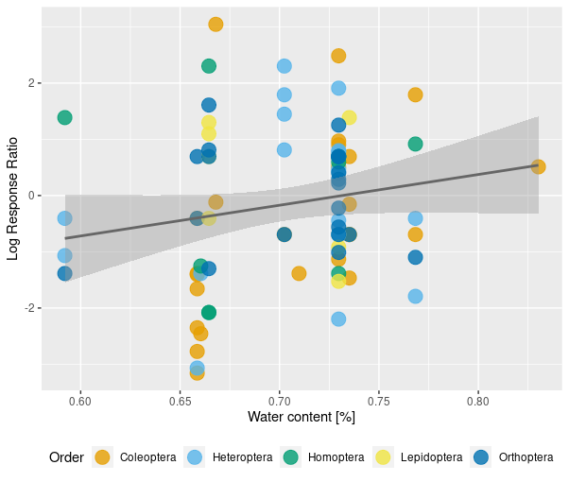

**Figure S14.** Correlation between leaf water content (a proxy for the leaf quality) and predator exclusion effect (log-response ratio) on the abundance of herbivorous species. Regression line and 95% CI are plotted. Points represent different herbivore species from different experimental blocks. *[sla_ldmc_lrr.R]*

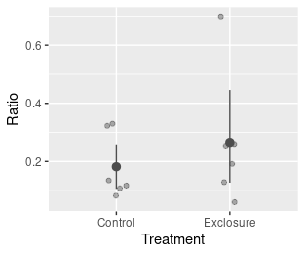**Figure S15.** Arthropod predators (AP) to herbivores ratio in control and exclosure plots. Mean and 95% bootstrapped CI’s are present. The ratio was not significantly affected by predators.

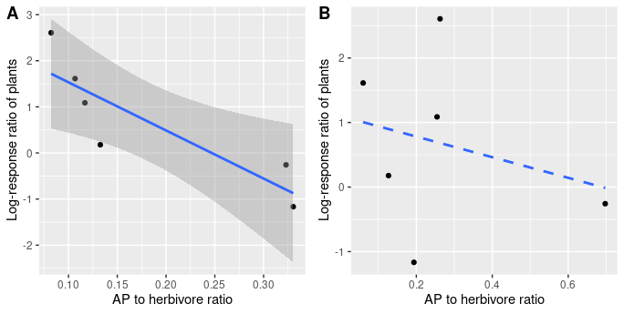

**Figure S16**. Relationship between predator indirect effect on plants and AP/Herbivore ratio in the presence of vertebrate predators. Solid line indicates significance and 95% CI are plotted. A – based on the ratio from the control plots, B- based on the ratio from the exclosure plot. *[bio_log_ratio.R]*

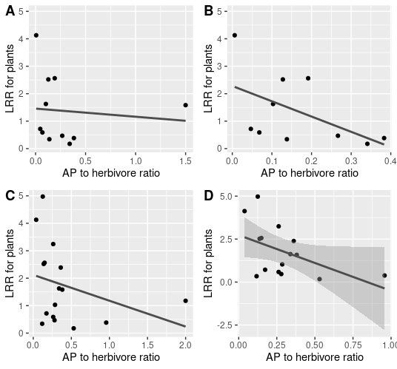

**Figure S17**. *Absolute* plant LRR response to increase in AP to herbivore ratio at individual plant species. Absolute value measure only the strength of a response without considering its direction. A – based on ratio from the control; B – based on ratio from the control plots without one extreme observation; C – ratio based on exclosure plot; D – ratio based on predator plot without one extreme observation. Only D is marginally significant (T = -2.010, P = 0.066). *[individual_chain_analysis.R]*

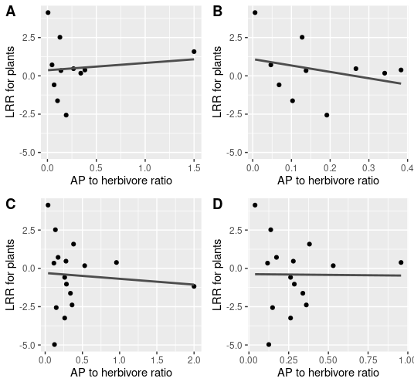

**Figure S18**. Indirect effect of predators on plants (plant log-response ratio) related to the AP to herbivore abundance ratio on individual plant species. None of the regressions is significant. However general pattern of points being concentrated around zero is visible. AP to herbivore ratio from the control plot. A – based on ratio from the control;; C – ratio based on exclosure plot,;