**Individual chains analysis.**

There was no diffence between C and P in case of total biomass and leaf damage. Here’s how leaf damage dataset looks like for individual woody plants (get some signficance and indication of increaser or decrease.

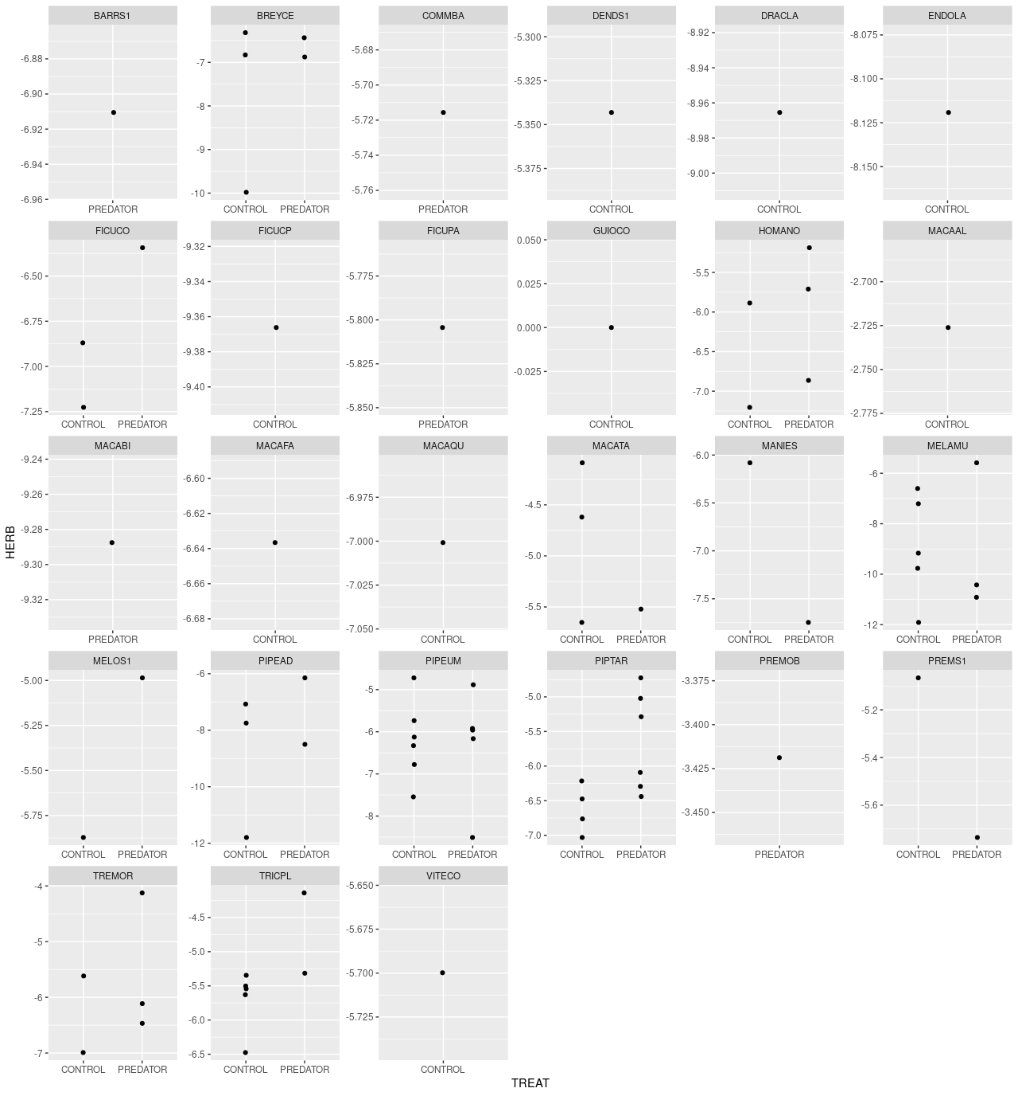

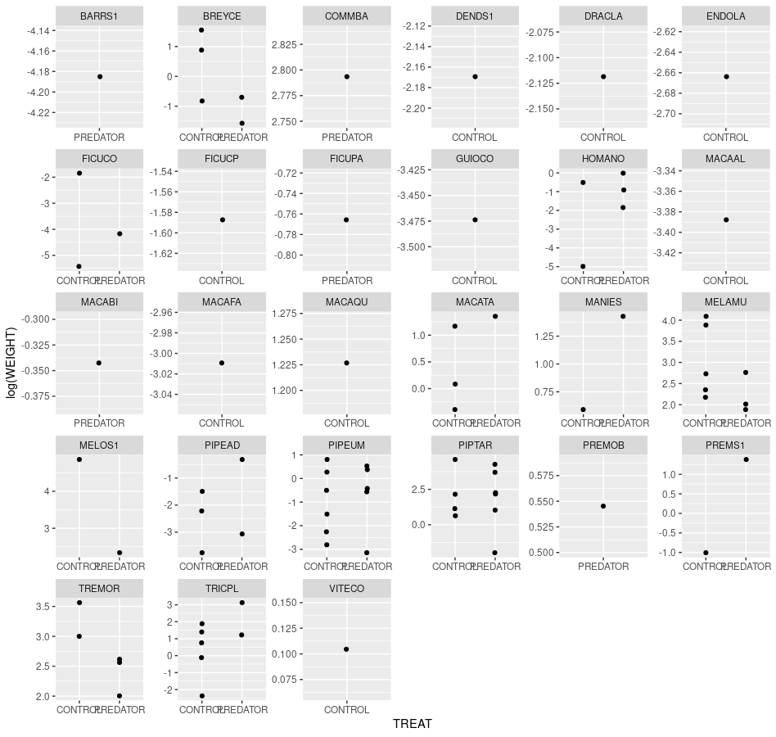And weight (two quite different patterns):

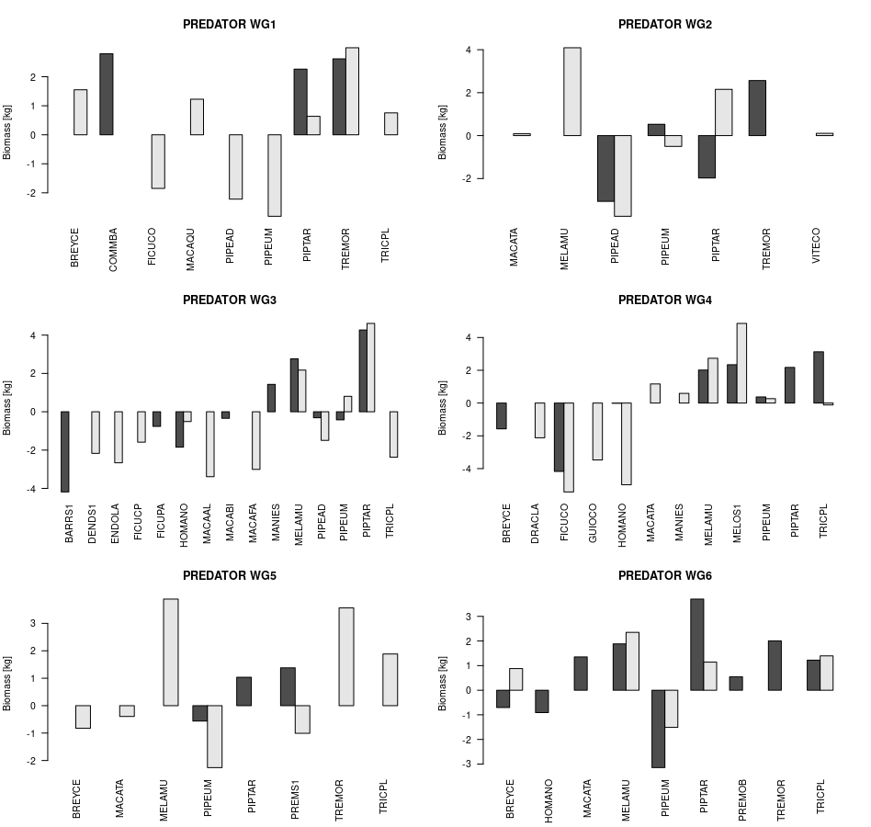

And plant species dominance. In general I would be interested to see how and why individual plants contribute to the overal lack of effect on vegetation biomass and leaf damage. What I plant to do is

1) Use community detection algorithm to show that individual species are usually their own modules

2) Eplore each individual chain in case of its AP vs herbivore abundance biomass diversity etc.

3) Then explore how community composition of various guilds affected response of each plant species. And see whether some plant traits or dominance is able to explain their responses.